Advanced Sensing Development to Support Robot Accuracy Assessment and Improvement
Guixiu Qiao, Senior Member, IEEE
Abstract— Robots can perform various types of automated movements in the workspace. In recent years, robot applications have been expanded to a much wider scope, including robot machining, robot assembly, robot 3D printing, robot inspection, etc. Many of these applications require robots to have higher absolute accuracy compared with conventional robot part handling and welding. The capability to assess a robot’s accuracy, and further, improve accuracy becomes important. In this paper, an advanced sensor and an accompanying methodology are developed that enable manufacturers to perform accuracy assessment to improve their robot systems. A smart target (patent pending) is developed at the National Institute of Standards and Technology (NIST). This sensor is integrated with a vision-based measurement instrument to perform high accuracy measurements of six-dimensional (6-D) information (x, y, and z position, roll, pitch, and yaw orientation) for a moving robot arm. The smart target is motorized. It can constantly rotate toward the vision-based measurement instrument to maximize its line-of-sight. A use case is presented to demonstrate the accuracy degradation assessment by using the smart target on a Universal Robot.

INTRODUCTION
Using standard six-degree of freedom (DOF) industrial robots for precision applications represents a significant market potential [1-3]. The main drawback of industrial robots is that the accuracy may not satisfy the requirements of precision applications. For example, in the automobile and aerospace industries, scanners are widely used in reverse engineering or part inspection for quality control. Scanners are mounted on the robot arm and move around with the arm to measure a large part or panel. The robot’s rotation and position information are used for scanner data registration. Generally, the registration accuracy needed for scanner data is about 0.05-0.1 mm in position and 0.1- 0.5 degrees in orientation [1]. The most exacting commercial robot cannot reach the accuracy within the range. There need to be solutions to assess robot accuracy, perform improvements by calibration, or add an external tracking system that provides accurate position and orientation feedback.
Calibration can improve a robot’s accuracy if errors are repeatable. There are two types of errors: environment-dependent errors and robot-dependent errors [1]. Environment-dependent errors come from robot setup or the changes in the environment, for example, the stability of the floor where the robot is mounted, or the temperature changes that influence the accuracy. Robot-dependent errors can be divided into geometrical errors, non-geometrical errors, and system errors [4]. Geometrical errors deal with the imperfection of linkage parameters. Denavit-Hartenberg (DH) parameters are the most popular correction factors for geometrical error calibration [2]. Gear backlash error is usually classified as geometrical errors. Non-geometrical errors are related to gravity deformation, joint compliance, and hysteresis in gear transformation. System errors result from improper tool calibration or faulty sensor measurements [1]. Robot calibration primarily deals with robot-dependent errors. Before calibration, the robot is fully warmed up and the setup is carefully checked to eliminate the environment-dependent errors. When no force is applied, a robot can be calibrated with a complex model that contains both geometric and non-geometric errors to achieve the improvement in static positioning [5]. But when dynamics is involved or force is applied, for example, in robot machining operations, errors become non-repeatable and process-related. A real-time feedback approach is needed to compensate for the robot trajectory based on some sensor information.
Sensors used for static calibration or real-time feedback can be divided into absolute measurement and relative measurement. Absolute measurement captures the actual positions of the robot tool center position (TCP). The measurement is based on a world coordinate system, for example, theodolite measurement devices [6], laser trackers [4], and probing coordinate measuring machines (CMM) [5]. The measuring equipment can provide high-accuracy measurements. However, they are expensive and require skilled personnel. Relative measurement captures the relative position or orientation of the TCP. These measurements have constraints with single-point, plane, sphere, or distance to derive some of the kinematic parameters [7]. Relative measurements have limitations that work only for certain local areas. Because the measurement is constrained, for example, in a plane, the corrections are usually designed to correct a robot’s operation in a similar constrained operation. In this paper, we focus primarily on the absolute measurement sensors.
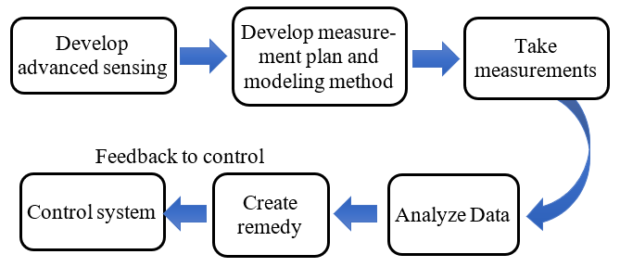
The absolute measurement sensors output 6-D measurements under the equipment’s world coordinate system. The measured position and orientation information can be used for robot accuracy assessment, or calibration, or real-time feedback. Besides being expensive, existing absolute measurement sensors have a challenge in dynamic measurement. For example, a laser tracker system usually mounts three reflective targets on a robot’s TCP. The laser tracker will measure each target in sequence and output the center of the three targets as (x, y, z) positions in the tracker’s coordinate system [8, 9]. The three points can create a local TCP coordinate that represents the position and orientation of the TCP. When the robot arm moves, by remeasuring the three points, the translation and rotation of the TCP are captured with high accuracy. However, the robot needs to be stationary when the tracker is taking measurements of the three targets. Similarly, Lightcap [10] presented a method of using CMM to improve robot position accuracy. An apparatus with three tooling balls is mounted on a robot’s TCP to be measured by a CMM. The CMM measurement process is slow, not suitable to capture dynamic robot movements.
Figure 1. Robot accuracy assessment methodology
Compared with these high-precision systems, optical tracking systems can provide 6-D measurements as well, but with lower accuracy [11]. Optical trackers use infrared (IR) cameras and infrared flash to highlight the reflective spherical targets and measure the sphere centers. The advantage of this type of system is that the vision-based system can capture all sphere centers simultaneously in one snapshot. Combined with a high-speed camera, the optical tracking system can measure at a high frame rate for dynamic movements. The challenge lies in measurement accuracy. The reflective target is captured as a dot in the IR camera. Different distances, ambient light, and target array orientations can influence the measurement uncertainty, particularly the orientation accuracy.
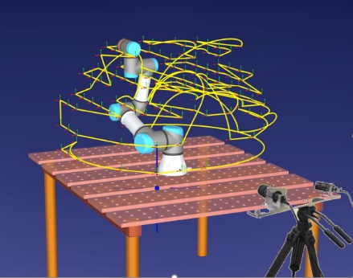
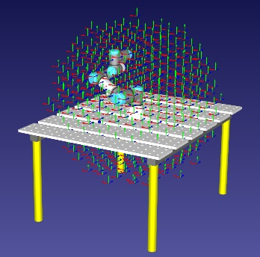
In order to perform high accuracy dynamic measurements of the robot TCP, a new sensor and a methodology were developed at the National Institute of Standards and Technology (NIST) to support robot accuracy assessment and improvement. This work is part of NIST’s Prognostics and Health Management (PHM) for Reliable Operations in Smart Manufacturing project. The goal of this project is to develop and deploy measurement science to promote the implementation, verification, and validation of advanced monitoring, diagnostic, and prognostic technologies to increase reliability and decrease downtime in smart manufacturing systems [12].
Figure 2. Measurement plan development
This paper is organized as follows: Section II describes the smart target sensor and methodology developed at NIST used in robot accuracy assessment and improvement. In Section III, the hardware and software of the smart target sensor are presented. A use case is presented in Section IV to show the accuracy assessment for a Universal Robot.

Robot Accuracy Assessment Methodology
A robot can approach a point in space from different directions using different poses. Accordingly, the accuracy varies with different approaches. It is impractical to take unlimited measurements to assess a robot’s accuracy or perform accuracy improvement (for example, calibration). A methodology is needed to provide an efficient solution.
A methodology developed at NIST is shown in Fig. 1. It consists of multiple modules, including advanced sensing development, measurement plan and modeling method, taking measurements, data analysis, PHM remedy development, and control system feedback. First, an advanced sensor is developed (NIST patent pending) to measure the x, y, z, roll, pitch, and yaw of a moving robot’s TCP. This work is detailed in Section III. In the next module in Fig. 1, a measurement plan is created. The pose of the robot arm cannot be picked arbitrarily. A measurement plan needs to be suitable for parameter identification of the robot error model. To satisfy this purpose, a fixed-loop motion is designed [13]. As shown in the left picture of Fig. 2, a set of poses is created within the robot workspace. These poses are distributed evenly in the robot Cartesian space. The even distribution in the entire workspace is to guarantee all the rigidity conditions - far, near, high, and low are considered. Additionally, the set of robot motions needs to be distributed evenly in the robot’s joint space as well. The robot modeling method needs to identify parameters that can characterize the robot errors. When data is collected that is evenly distributed along the joint angles, the identification of the error model will have less chance to overweight or underweight some areas. These fixed-loop motions need to pass validation and collision checks [13]. The right picture in Fig. 2 shows the fixed-loop motion generated for a Universal Robot (UR5) after passing the checks. Because the robot is mounted on a table, only poses above the table are kept.
After the fixed-loop motions are generated, the program is loaded to a robot. The smart target is mounted on the robot TCP. The robot arm moves based on the designed fixed-loop. A vision-based measurement instrument is placed on the floor opposite to the robot arm. The vision-based measurement system measures the smart target on the TCP, outputting the x, y, z, roll, pitch, and yaw of the robot TCP movement. The Fig. 2 right picture shows a vision-based system capturing a UR5’s fixed-loop motion.
Measurement data is sent to the data analysis module to identify the parameters of the error model and output the result of the accuracy assessment. The measured data can also be used for robot calibration to improve robot accuracy. The detailed modeling and parameter identification algorithms are documented in [14]. Then remedy suggestions are given for PHM purposes, for example, some minor adjustments are needed, or calibration is preferred. Feedback is sent to the control system for changes. This paper focuses on advanced sensing development, including design theory, hardware, and software to support the 6-D information capture for robot accuracy assessment and improvement.

Advanced Sensing Development
The goal of the advanced sensing development is to develop a non-contact 6-D measurement system, with high speed (at a minimum of 30 Hz) and high accuracy (within 0.1 mm). High speed enables the capture of the dynamic movement of the robot arm. High accuracy satisfies the requirement for robot calibration and accuracy assessment. Additionally, being cost-effective is another consideration for the development of advanced sensing in industrial applications.
The advanced sensing system developed at NIST consists of a smart target and a vision-based instrument, as shown in Fig. 3. The smart target is mounted on the robot TCP. The vision-based instrument performs non-contact measurements on the smart target. The smart target uses features to represent the 6-D information. An efficient way to represent 6-D information is to construct a coordinate frame. A coordinate frame carries the position and orientation information and can efficiently calculate transformations using a matrix. Therefore, the design theory of the smart target is to provide measurable features for the vision-based instrument. The vision-based instrument can capture features to construct a coordinate frame in a snapshot.
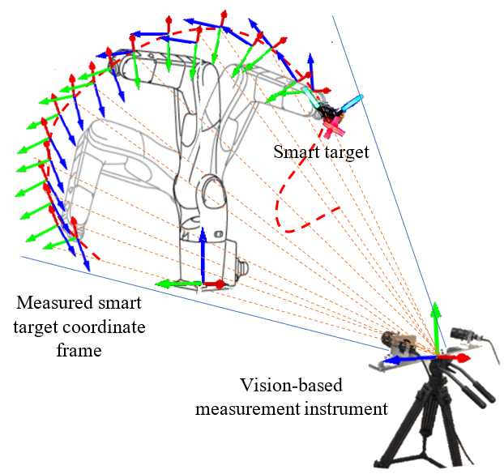
There are many ways to build a coordinate frame. One simple way is to define an origin and two axes directions. The third axis is naturally perpendicular to the other two. For optical tracking systems mentioned in Section I, three spheres are used as the target to create a coordinate frame. One of the sphere centers is used as the origin. The other two are used to define axes. Unfortunately, the uncertainty of the axis direction is high because it is defined by only two points. Moreover, the distance between the two points is short with the limitation of target size, thus, enlarging the error of line-direction calculation. Additionally, there are line-of-sight problems. When the targets rotate with the robot arm, one sphere may block the view of others. For optical tracking systems, users cannot guarantee a target will always be facing the measurement instrument. Some angles may not be sensitive or measurable.
Figure 3. Smart target measurement system
The advanced design of the smart target uses line features. The design enables a more accurate feature measurement than existing targets in the market, particularly in orientation accuracy. It has a mechanism to always rotate toward the measurement instrument. The smart target is robust to ambient light influences, which is a big hurdle in many manufacturing environments. The system will also be more cost-effective compared with a laser-based system that has a line-of-sight problem.

A. Hardware development for the smart target
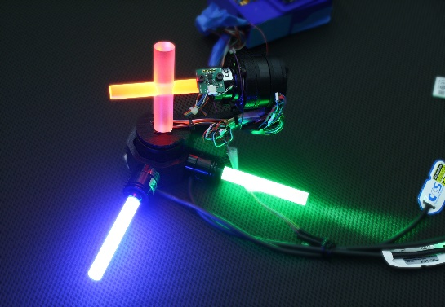
The smart target is developed using line features. The line features are created by fixed-wavelength light pipes. The smart target also has two high-precision rotary gimbals, as shown in Fig. 4. Instead of using point features, the smart target uses line features to construct the coordinate frame. Light pipes are machined precisely in a cylindrical shape and the surface is specially treated to enable the evenness of lighting. Line features are extracted by measuring the light pipes with the vision-based instrument. An origin is created by intersecting the two feature lines capturing from the cross light pipe. The other two light pipes with different colors provide the other two axes directions. By using a cylindrical shape, line features are constructed using hundreds of points. The accuracy is greatly improved by the best-fit of hundreds of points instead of using two spherical center points. The origin is defined by the intersection of two lines, which is more accurate than using a single spherical center. Thus, the smart target can achieve higher accuracy than traditional targets.
AZ gimbal
Cross light pipe
Green light pipe
Blue light pipe
El gimbal
Orientation sensor
To smart target
control board
Figure 4. Smart target hardware design
There are two high-precision rotary gimbals in azimuth (AZ) and elevation (EL) directions, driven by two motors. An orientation sensor is mounted on the EL gimbal. The initial orientation of the smart target is set up to face to the measurement instrument. When the robot arm rotates, the orientation sensor on the smart target will transfer the detected rotation angles to the smart target control board. Then the AZ and EL motors start to rotate back to maintain the facing pose of the smart target toward the measurement instrument. Three fixed-wavelength light powers (red, green, and blue) are used to light up the light pipes. The different colors benefit the algorithms for feature identification. The smart target is scalable to bigger-sized industrial robots, or smaller-sized medical robots.

B. Software development for feature extraction and 6-D information construction
The dynamic measurements of a robot’s motion require high speed and high accuracy. An optimized algorithm for GPU (Graphics Processing Unit) calculation is developed to satisfy the requirements. Computations for 6-D information construction include image un-distortion, feature extraction, 2D to 3D construction, and 6-D information output. A software library (software development kit, SDK) is developed for obtaining 6-D information from image pairs obtained from the vision-based measurement instrument. The SDK requires sub-pixel level accuracy (0.1 pixels) of feature extraction, critical for high precision measurement.
Many factors may create errors when matching two corresponding points in a pair of images, for example, when the images are blurry, or using local instead of global correspondence maximum, etc. The 3D measurement accuracy in the camera plane (also called the XY plane) is shown in Eq. (1). The accuracy aligned with the viewing direction (axis Z) is shown in Eq. (2).
${ σ}_{XY}=\frac{q_{D}}{\sqrt{k}}mδ_{x'},$ (1)
$σ_{z}=\frac{h}{b}\frac{q_{D}}{\sqrt{k}}mδ_{x'},$ (2)
$δ_{x'}$ is the uncertainty of an image measurement. It is can be demonstrated by the subpixel accuracy achieved during calibration. Our design can achieve less than 0.1 - 0.2 pixels residual error of $δ_{x'}$ from calibration results (calibration is not detailed in this paper). The parameter $m$ is the image scale number. A camera system’s m is the ratio of object distance h to the principal distance c. The principle c is lens focal length with the addition of an extension to achieve sharp focus. The larger h and smaller c created less accuracy. k is the mean number of target images per photo. The general value for k is usually set one. When more camera stations are added or using multiple exposures, the k value can be increased. The parameter b is the base distance of the two stereo cameras. The larger the base distance, the smaller $σ_{z}$ error can be achieved. The parameter $q_{D}$ is a design factor. It is related to the design of stereo camera configurations [15].
Fig. 5 shows three typical stereo camera configurations. The configuration in Fig. 5a) has two parallel cameras. It is closer to human eyes with nearly parallel viewing directions. The advantage of this configuration is that the dual cameras have the same scale factor. The disadvantage is the design factor $q_{D}$ is the worst. It will enlarge $σ_{XY} and σ_{z}$error. The Shifted camera configuration in Fig 5b) also has parallel viewing directions but with a shift in depth. This configuration affects the width of the image frame. It also requires different scales and post-processing to shift the images. In the convergent configuration in Fig. 5c), the cameras are toed-in. This configuration has more overlaps for the two-camera view to provide a larger field of view for the measurement system. Also, the design factor is the best among the three configurations. However, because two cameras have more diversity in view, finding common points between the two images is more challenging. The difficulties are on the matching algorithms. Our design uses the convergent configuration to achieve a larger field of view and better accuracy.
b
b
b
a) Normal configuration
b) Shifted configuration
c) Convergent configuration
Camera 1
Camera 2
Camera 1
Camera 2
Camera 1
Camera 2
$σ_{z}=\frac{h}{b}\frac{q_{D}}{\sqrt{k}}mδ_{x'},$Fig. 6 shows one pair of smart target measurements from the stereo cameras.
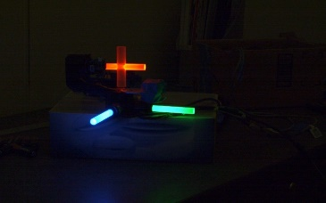
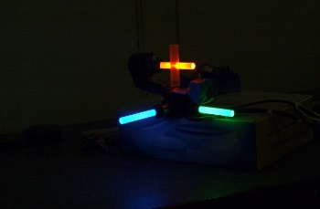
The feature detection algorithm is written in C++. The preliminary detection procedure is as follows.
Figure 6. Smart targets images from left and right cameras

Step 1. Image un-distortion
For smart target 6-D vector detection, the first step is to load the calibration results and use the parameters to undistort the images. A vision-based measurement instrument needs two calibrations – distortion calibration and stereo calibration. Distortion calibration corrects the lens distortions for individual cameras. Stereo calibration finds the relative physical positions of the two cameras. Generally, these two calibrations are mixed. Performing the full camera calibration takes time. After a measurement instrument is shipped or used for a while, the physical positions of the two cameras are feasible to change compared with camera lens distortion. In our research, the stereo calibration is separated from the distortion calibration. The stereo calibration is a much simpler process compared with the full calibration process with distortion calibration. When a test is performed on-site, the separated calibrations save time in system preparation. The calibration algorithms and procedures are detailed in the paper [14].
Step 2. Canny edge detection
In our preliminary approach, the color images are converted to grayscale images before edge detection. Later segmentation of color is developed for faster image processing. The RGB (red, green, and blue) colored images are analyzed using color thresholding to separate for the detection of red, blue, and green light pipes. Multiple edge detection algorithms were tested. Finally, the Canny edge detector is used to detect edges on all three color channels [15].
Step 3. Hugh line detection and clean up
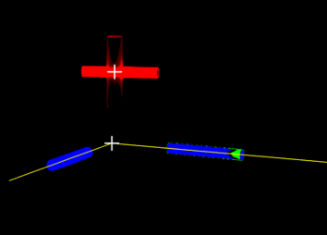
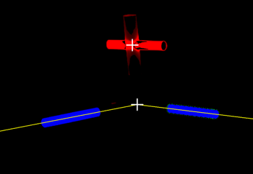
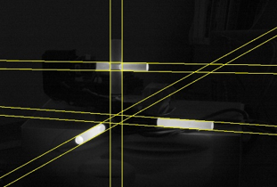
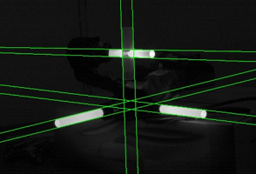
The Hugh line detection algorithm is implemented to detect lines [16]. However, redundant or even false detections may occur. A cleanup algorithm is developed to address this problem. Fig. 7 shows the detected line after cleaning up.
Figure 10. Final detected vectors (yellow lines) and coordinate centers (white cross)

Figure 7. Detected lines from left and right cameras after cleanup

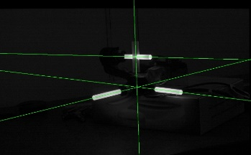
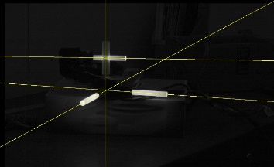
The final four vectors are shown in Fig. 8.
Figure 8. The final 4 vectors cameras after cleanup
Figure 5. Stereo camera configurations

Step 4. Epipolar geometry estimation
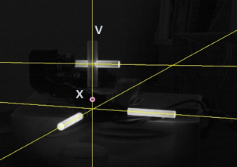
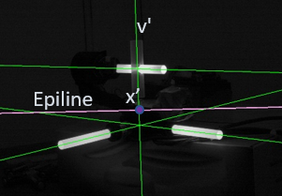
The construction of the 3D vectors from the 2D on stereo image pairs is based upon epipolar geometry [16]. Given the essential matrix and fundamental matrix from stereo calibration results, a vector v and its corresponding vector v' on the left and right camera, and a point x from the left camera on one of the vector, we can calculate the epiline on the right camera, which is shown in Fig. 9. The corresponding point of x on the right camera is the intersection between the epiline and the vector v'. Given the corresponding points x and x', we can reconstruct a 3D point X.
Figure 9. using epipolar geometry to calculate correspondence from two cameras

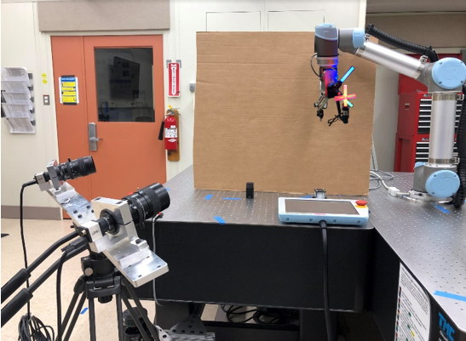
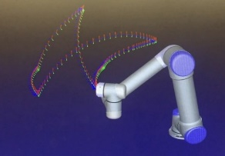
To improve the speed and robustness of detection, the stereo rectification of the pairs of the camera images is introduced. Rectification consists of aligning the image points in both the left and right images to a common global plane. In stereo rectification, the images are transformed so that epipolar lines are merged along with horizontal scan lines of the image. Given the rectified images, the 3D reconstruction is directly correlated to the disparity of the image pairs.
Figure 11. Use case setup
Smart target
Vision-based measurement instrument
UR robot
Step 5. Smart target 3D coordinate construction
We are looking for the following measurements: the intersection of the red cross, and the intersection of the blue and green bars, as shown in the white cross markers in Fig. 10. and the 3D vector of the green bar and blue bar. The final smart target coordinate is constructed using the cross center of the red cross light pipe as the origin. Two axis-directions come from vectors of the green and blue light pipe.

C. Speed analysis
Using a Nvidia Quadro RTX 5000 GPU and 2.4GHZ INTEL Xeon W-10885M CPU (Central Processing Unit), we have the preliminary estimation of the calculation speed for each step as shown in Table 1.
Table 1. Speed analysis (in millisecond (ms))
Upload to GPU time | 1.5 ms
Split channel and thresholding | 5 ms
Un-distortion/remap | 5 ms
Edge detection | 7 ms
Line detection | 3 ms
Line cleanup | 0.05 ms
Download from GPU time | 3.5 ms
Total Time | 25 ms

Currently, the camera can run at 125HZ. The image processing takes 25 ms to finish processing one pair of images. Efforts continue in algorithm improvement and CUDA (Compute Unified Device Architecture) optimization. And the time consumption is based upon the current CPU/GPU combination.

Use Case Analysis and Conclusion
A use case was developed using a UR5 robot to assess the robot accuracy degradation when payload, speed, and temperature changes are considered. As shown in Fig. 11, a smart target was mounted on the last link of the UR5 robot. The vision-based measurement instrument was placed on the floor. The smart target was initialed to face to the measurement instrument. When the robot moved, the smart target maintained the same facing direction. For the test, the same program was repeated to drive the robot’s movement at different conditions of temperature, speed, and payload. A one-second motion halt was added to the program at the waypoint positions to observe how fast the robot can settle to stationary at different speeds. The smart target system measured the absolute positions of the robot arm. The absolute measurements from the smart target system were used to calculate the deviations from the nominal positions (designed positions). Simultaneously, the low-level controller data was collected. When accuracy degradations were found, controller data (includes target joint positions, actual joint positions, target joint velocities, actual joint velocities, etc.) can be used to analyze the root cause of the changes for PHM remedy. A timestamp was saved to align the smart target measurement data and the low-level controller data.
Tests were performed with a combination of payload (half payload and full payload), speed (half speed/full speed), and temperate (cold start to 2-hour warmup,10 degrees Celsius changes in waist joint). The test data set was published in [17]. The dataset shows that temperature and speed have more influence on the robot’s pose deviation compared with the payload influences for this testing robot. The higher operating temperature made the position deviation worse. Overshot and position fluctuations were observed for the position deviation from 80 µm to 180 µm when the robot stopped at waypoints. The fluctuation may impact the part quality if the robot was performing some precision operations such as material removal. The dynamic performance of the robot needs to be carefully monitored. This use case demonstrated the feasibility of using the smart target to perform the robot accuracy degradation assessment based on different payload, speed, and temperatures. The developed sensor and methodology provided manufacturers a tool to quickly detect accuracy problems when a robot work cell was reconfigured, environmental condition changed, or an important action is to be performed.

Summary
This paper presented the advanced sensing development at NIST to support robot accuracy assessment and improvement. The hardware and software design of the smart target enables the high accuracy, high speed, dynamic, and continuous measurement of the moving robot arm’s 6-D information.
Other than robot accuracy assessment, the smart target can be used for other applications that require high accuracy position and orientation as well. The dynamic high accuracy 6-D measurements are important in applications including tracking a moving object precisely, registering multiple instruments, providing feedback to unplanned adaptive control algorithms, etc. Future efforts are underway to develop additional industrial use cases for applications that require high-precision motions.

NIST Disclaimer
Certain commercial entities, equipment, or materials may be identified in this document in order to illustrate a point or concept. Such identification is not intended to imply recommendation or endorsement by NIST, nor is it intended to imply that the entities, materials, or equipment are necessarily the best available for the purpose.

References
[1] T. Kubela, A. Pochyly, and V. Singule, "Assessment of industrial robots accuracy in relation to accuracy improvement in machining processes," in 2016 IEEE International Power Electronics and Motion Control Conference (PEMC), 25-28 Sept. 2016 2016, pp. 720-725, doi: 10.1109/EPEPEMC.2016.7752083.
[2] A. Joubair, L. F. Zhao, P. Bigras, and I. Bonev, "Absolute accuracy analysis and improvement of a hybrid 6-DOF medical robot," Ind. Robot., Article vol. 42, no. 1, pp. 44-53, 2015, doi: 10.1108/ir-09-2014-0396.
[3] W. Zhu, B. Mei, G. Yan, and Y. Ke, "Measurement error analysis and accuracy enhancement of 2D vision system for robotic drilling," Robotics and Computer-Integrated Manufacturing, vol. 30, no. 2, pp. 160-171, 2014/04/01/ 2014, doi: https://doi.org/10.1016/j.rcim.2013.09.014.
[4] Bhatt PM, Rajendran P, McKay K, Gupta SK., "Context-dependent compensation scheme to reduce trajectory execution errors for industrial manipulators," 2019 International Conference on Robotics and Automation (ICRA), 2019 May, pp. 5578-5584.
[5] J. H. Jang, S. H. Kim, and Y. K. Kwak, "Calibration of geometric and non-geometric errors of an industrial robot," ROBOTICA, vol. 19, pp. 311-321, 2001.
[6] B. C. Jiang, R. Duraisamy, G. Wiens, and J. T. Black, "Robot metrology using two kinds of measurement equipment," Journal of Intelligent Manufacturing, vol. 8, no. 2, pp. 137-146, 1997/03/01 1997, doi: 10.1023/A:1018508805175.
[7] S. He et al., "Multiple location constraints based industrial robot kinematic parameter calibration and accuracy assessment," The International Journal of Advanced Manufacturing Technology, vol. 102, no. 5, pp. 1037-1050, 2019, doi: 10.1007/s00170-018-2948-z.
[8] H. Du, X. Chen, D. Zhou, G. Guo, and J. Xi, Integrated fringe projection 3D scanning system for large-scale metrology based on laser tracker (Applied Optics and Photonics China (AOPC2017)). SPIE, 2017.
[9] J. Li et al., "Calibration of a multiple axes 3-D laser scanning system consisting of robot, portable laser scanner and turntable," Optik, vol. 122, no. 4, pp. 324-329, 2011/02/01/ 2011, doi: https://doi.org/10.1016/j.ijleo.2010.02.014.
[10] C. Lightcap, S. Hamner, T. Schmitz, and S. Banks, "Improved Positioning Accuracy of the PA10-6CE Robot with Geometric and Flexibility Calibration," IEEE Transactions on Robotics, vol. 24, no. 2, pp. 452-456, 2008, doi: 10.1109/TRO.2007.914003.
[11] A. Wiles, D. Thompson, and D. Frantz, Accuracy assessment and interpretation for optical tracking systems (Medical Imaging 2004). SPIE, 2004.
[12] G. Qiao and B. A. Weiss, "Advancing measurement science to assess monitoring, diagnostics, and prognostics for manufacturing robotics," International Journal of Prognostics and Health Management, vol. 013, no. 013, 2016.
[13] G. Qiao, C. Schlenoff, and B. A. Weiss, "Quick positional health assessment for industrial robot prognostics and health management (PHM)," in 2017 IEEE International Conference on Robotics and Automation (ICRA), 29 May-3 June 2017 2017, pp. 1815-1820, doi: 10.1109/ICRA.2017.7989214.
[14] G. Qiao and B. A. Weiss, "Industrial Robot Accuracy Degradation Monitoring and Quick Health Assessment," Journal of Manufacturing Science and Engineering, vol. 141, no. 7, 2019, doi: 10.1115/1.4043649.
[15] T. Luhmann, C. Fraser, and H.-G. Maas, "Sensor modeling and camera calibration for close-range photogrammetry," ISPRS Journal of Photogrammetry and Remote Sensing, vol. 115, pp. 37-46, 2016/05/01/ 2016, doi: https://doi.org/10.1016/j.isprsjprs.2015.10.006.
[16] Z. Zhang, "Determining the Epipolar Geometry and its Uncertainty: A Review," International Journal of Computer Vision, vol. 27, no. 2, pp. 161-195, 1998/03/01 1998, doi: 10.1023/A:1007941100561.
[17] G. Qiao, "Degradation measurement of robot arm position accuracy," 2019, doi: https://www.nist.gov/el/intelligent-systems-division-73500/degradation-measurement-robot-arm-position-accuracy.

Guixiu Qiao is with the National Institute of Standards and Technology, Gaithersburg, MD 20899 USA (phone: 301-975-2865; fax: 301-990-9688 e-mail: guixiu.qiao@nist.gov).

