Article
Broadband Dielectric Spectroscopic Detection of Ethanol: A Side-by-Side Comparison of ZnO and HKUST-1 MOFs as Sensing Media#*
Papa K. Amoah ^{a,c,}, Zeinab Mohammed Hassan ^{b}, Pengtao Lin ^{a,c},, Engelbert Redel ^{b}, Helmut Baumgart ^{a,c} and Yaw S. Obeng ^{e§}
ª Department of Electrical and Computer Engineering, Old Dominion University, Norfolk, VA 23529, USA
^{b} Karlsruhe Institute of Technology, Institute of Functional Interfaces (IFG), Hermann-von-Helmholtz-Platz 1, 76344 Eggenstein-Leopoldshafen, Germany
^{c} Applied Research Center at Thomas Jefferson National Accelerator Laboratories, 12050 Jefferson Avenue, Suite 721, Newport News, Virginia 23606, USA
^{e} Physical Measurement Laboratory, National Institute of Standards and Technology, 100 Bureau Drive, Gaithersburg, MD 20899, USA
#Certain commercial equipment, instruments, or materials are identified in this paper in order to specify the experimental procedure adequately. Such identification is not intended to imply recommendation or endorsement by the National Institute of Standards and Technology, nor is it intended to imply that the materials or equipment identified are necessarily the best available for the purpose.
*Contribution of the National Institute of Standards and Technology, not subject to copyright.
§ ORCID: 0000-0002-4880-1689
Abstract: The most common gas sensors are based on chemically induced changes in electrical resistivity and necessarily involve making imperfect electrical contacts to the sensing materials which introduce errors into the measurements. We leverage thermal- and chemical-induced changes in microwave propagation characteristics (i.e., S-parameters) to compare ZnO and surface anchored metal-organic-framework (HKUST-1 MOF) thin films as sensing materials for detecting ethanol vapor, a typical volatile organic compound (VOC), at low temperatures. We show that the microwave propagation technique can detect ethanol, at relatively low temperatures (< 100 °C), as well as afford new mechanistic insights that are inaccessible with the traditional dc resistance-based measurements. In addition, the metrology technique avoids the inimical measurand distortions due to parasitic electrical effects inherent in the conductometric volatile organic compound detection.

Keywords: Broadband dielectric microwave spectroscopy, solid-state ZnO sensing material, HKUST-1 Metal-Organic Framework (MOF) sensing material, ethanol detection

1.0. Introduction
1.1 Volatile Organic Compounds (VOC) Detection
Intrinsic material property changes due to analyte adsorption and reactions of the sensing materials are the basis of many conductometric chemical sensors ¹⁻³. In gas sensing applications, most of the sensing materials tend to be metal oxides (MO, mostly II-VI semiconductors) due to their low cost, simple design and ease of production, short response time, wide detection range, and resistance to harsh working environments ⁴. For these chemical sensors to be successful, there must be (i) charge transfer between the analyte and the sensing materials, and (ii) a reversible analyte concentration dependence of the measurand ⁵. Along these lines, there is a need for effective and efficient methods to monitor volatile organic compounds (VOCs). Highly sensitive analytical chemistry techniques, such as spectrophotometry, fluorometry, gas chromatography (GC) and high-performance liquid chromatography (HPLC) have been used for the accurate quantification of VOCs. However, these techniques are expensive, bulky, have low throughput, require time consuming pre-treatment steps and highly skilled operators, consume substantial amounts of power, and do not provide real-time information for risk mitigations and decision making ⁶. These limitations preclude most of the current VOC detection techniques from being used in the internet of things (IoT, internet edge) applications.
For IoT applications, the sensor should be small, inexpensive, and fast, with high sensitivity, selectivity, and stability for specific applications ⁷⁻⁹. Emerging 2D-material, such as graphene, graphene oxide, phospherene, and transition metal dichalcogenides such (e.g., MoS₂), as well as carbon nanotubes (CNTs), are being co-integrated with digital devices into viable gas sensors, mostly as chemically sensitive resistors (chemoresistors), chemically sensitive field effect transistors (chemFETs), or carbon nanotube field effect transistors (CNTFETs). For example, MoS₂ chemoresistors have been shown to be sensitive to different organic compounds including triethylamine (TEA) and acetone, with detection limits as low as 0.16 parts-per-trillion for nitric oxide gas molecules. In addition to changing the channel resistance, analyte specific changes to the low frequency 1/f noise spectra of graphene chemFETs may be used as a VOC detection measurand in these chemFETs ¹⁰. The selectivity and sensitivity of 2D-material sensors can be tuned with chemical functionalization of the surface of the sensing-material. These devices can be further optimized with device gate bias adjustments to electrostatically change the carrier concentration in the channel to an optimal point ¹⁰. Advances in heterogenous integration schemes are leveraging these emerging materials into three dimensional (3-D) sensors design for IoT applications; for example, a single chip CNTFET nanosystem that senses, stores the data, and classifies ambient gases has been demonstrated ¹¹.
Unfortunately, many of these chemFETs and chemoresistors require energy-intensive internal heating for optimal operation ¹². For IoT and autonomous applications, new metrology that do not require high temperature for transduction, such as analyte-induced volume, and surface capacitance, changes are needed ¹². Metal-organic frameworks (MOFs) have emerged as a novel class of tunable electronic nanomaterials; they combine the advantages of long-range order of inorganic conductors with the synthetic flexibility of organic semiconductors ¹³. These MOF’s have the potential to overcome many of the challenges of selectivity that limit other sensor materials that depend on charge transfer processes to change resistivity^{14, 15}. While altering band structures in MOF-based sensors from analyte surface reactions, similar to those in the metal-oxide semiconductor, is possible^{5, 16}, the ultra-large surface areas, high porosity, and the ability to form coordination complex clathrates-like structures with analyte molecules make the MOFs attractive for selective gas sensing ¹⁷. Furthermore, many of these MOF-based gas sensors work at room temperature, negating the need for heating ¹⁷; ¹².
In addition, the resistivity measurements of the chemoresistor-based sensors necessarily involve making electrical contacts to the sensing materials. This can introduce non-negligible contact impedance in series with the sensing materials, especially in the two-pole measurement techniques often used with the coulometric gas sensors. In such systems, the errors from the connecting cables can be significant, especially when the resistance of the sample is lower than approximately 50 Ω ¹⁸. Non-contact microwave gas sensing is emerging as an alternative to coulometric gas sensing; a microwave resonant cavity technique has also been used to detect and to distinguish between methanol, ethanol and acetone in the 0-200 ppm range at room temperature ¹⁹. Capacitive sensing of VOC, with a dielectric layer comprised of compacted Cu-BTC nanoparticles has also been demonstrated ¹⁷. However, the performance metrics of these microwave gas sensors, such as selectivity, sensitivity, reproducibility, and long-term stability are currently not yet well established. Furthermore, the impact of environmental factors such as temperature and humidity are currently not well understood. ²⁰ Thus, there is a need to improve our fundamental knowledge of microwave gas sensors.
The mechanisms involved in chemo resistive gas sensing are not well understood. For example, while transduction in the metal oxides are temperature dependent, the mechanisms behind the temperature dependence are not well understood ²¹. Similarly, the mechanisms underpinning MOF-based gas sensing are currently not fully understood¹²; presumably, the analyte molecules oxidize when they contact the sensing materials ¹⁴. In traditional conductometric sensing, the redox reactions convert analyte-sensor interactions into measurable dc-resistance through changes in electrical resistivity because of electron injection into, or withdrawal of electrons from, the electronic conduction band structure of the sensing element^{22, 23}. In this regard the electrically active defects in the MOF materials appear to behave like those in semiconducting metal oxides ¹⁶. Here, we compare low temperature sensing of ethanol on substrate anchored ZnO nanorods and TCNQ-doped HKUST-1 MOF, through microwave impedance changes, to gain mechanistic insights into the microwave sensing of ethanol vapor. The TCNQ-doped HKUST-1 SURMOF provides a well characterized platform for such investigations ²⁴. We have shown elsewhere that the thermal conductivities of SURMOF films are commensurate with their single crystalline MOF analogues, and decrease in the presence of adsorbates ²⁵, due to increased vibrational scattering introduced by extrinsic guest-MOF collisions, and guest molecule-induced hybridization of low frequency modes ²⁶. We have also demonstrated elsewhere that in contrast to the traditional coulometric techniques, ZnO nanotubes can sense ethanol at temperatures under 100 °C, using broadband microwave dielectric spectroscopy (BDS) ²⁷.

1.2 Broadband Dielectric Spectroscopy (BDS) Background
Accumulation and alignment of charged defects play significant roles in the VOC detection, as their state changes in the presence of reactive organic molecules. When exposed to electromagnetic waves, the dipolar defects oscillate to keep up with the rapidly changing external electric fields; at some critical frequency the polarizability cannot keep up with the velocity of the applied fields, resulting in dielectric loss. The displacement of the bound charges in the sensing media in an external electric field, E, results in a dipolar moment, m, and a torque, G, as the dipolar moment orientates parallel to the electric field in opposition to the applied field. This produces a net polarization of the material which determines the dielectric response of materials to electromagnetic radiation. In isotropic media, the volume density of polarization is directly proportional to the applied electric field intensity ²⁸. Thus, fundamentally, the elementary processes that underpin VOC detection with metal oxides involve changes in polarizability, and the resultant changes in electrical characteristics, of the sensing media. These changes alter the propagation characteristics of radio frequency or microwaves in such media and instigate microwave absorption / energy dissipation. We define a complex dielectric function that measures the electric displacement field due to the presence of an electric field in a dielectric material as written as Equation 1

ε(ω) = ε1(ω) + iε2(ω) (1)

where, ω = 2cπ/λ is the frequency, c is the speed of light and λ is the wavelength, ε1(ω) describes how much the material is polarized when an electric field is applied, and ε2(ω) is related to the absorption of the material^{29, 30}. The dielectric polarizability at high frequencies sets the scale for radiation absorption, while at low frequencies, it determines the nonlinear effects.
When electromagnetic waves interact with matter the incident microwave signal scatters according to the material’s permittivity. During the signal scattering, a portion of the radiation is transmitted through the sample while the remainder is reflected toward the source, as described by Snell’s law ²⁸. The ratio of transmitted to reflected energies depends in part on the impedance mismatch between the material under test (MUT) and the source. The signal scattering from the electrical interfaces is summarized as a matrix of S-parameters that quantifies how RF energy propagates through a multiport network such as a vector network analyzer (VNA). The S-parameters can be extracted in the frequency domain (FD), time-domain (TD), or hybrid modes based on the form of the interrogating signal³¹. In this work, we used a two-port hybrid technique, in which the input excitation is convolved with the transfer function of the sensor (h(f)) loaded with the MUT. A typical two-port measurement contains four S-parameters (S11, S21, S12, and S22) which are vector quantities representing the magnitude and the phase of the frequency-dependent characteristics of the MUT. A portion of the incident wave is transmitted (i.e., S21 and S12) or reflected (S11 and S22). The portion of the transmitted signal exits the MUT with different magnitude and phase from the incident signal; thus, the S21 and S12 also encode the phase difference between a transmitted signal and an incident signal. The S-parameters can be analytically transformed to produce the characteristic circuit element of the analyte as described elsewhere ³². Broadband microwave dielectric spectroscopy (BDS) measures the dispersive, and dissipative dielectric behavior of the analyte as a function of frequency, i.e., changes in the polarizability of the analyte. Because input excitation is convoluted by the transfer function of the sensor loaded with the MUT, i.e., (h(f)), to generate the output S-parameter the BDS has the advantage of rapidly interrogating a dynamic range of material characteristic ³⁵. Polar functional groups in organic molecules (e.g., VOCs) are electron-rich and highly polarizable, hence readily absorb microwave energy to distort as the electrons transfer from one stable state to an excited state with higher energy, forming the electron polarization, in the rapidly changing magnetic fields. Here, we use the S-parameters to evaluate the chemo-induced changes induced (CIC) in the VOC adsorbed on the MO sensing materials, by measuring the MW insertion loss characteristics (S21) as a function of the experimental variables. Thus, in this work, the S-parameters are functionals of frequency and experimental stress (i.e., F[h(f)]).
Gas monitoring with microwave-based metrology is well known, but the technology has some performance limiting gaps. Specifically, performance metrics such as selectivity, sensitivity, reproducibility, and long-term stability are not yet well established, and the impact of environmental factors such as temperature, humidity are currently not well understood ²⁰. We had previously used microwave-based broadband dielectric spectroscopy (BDS) ³³ to investigate the initial stages of ethanol vapor detection with ZnO nanorods ²⁷. The BDS detection of VOC with semiconductor metal oxides involve changes in polarizability, i.e., the repolarization of the permanent electrical dipoles which instigates microwave absorption / energy dissipation during the rotation and orientation of the dipoles ^{33, 34}. When microwaves interact with the analyte (i.e., MUT) the incident microwave signal scatters according to the material’s permittivity; the signal scattering is a function of frequency and experimental stress (i.e., F[h(f)]). The input excitation is convoluted by the transfer function of the sensor loaded with the MUT, i.e., (h(f)), to generate the output S-parameter³¹. In this paper, using BDS metrology, we compare ethanol vapor sensing on ZnO nanorods and surface anchored metal-organic-frameworks thin films (HKUST-1 SURMOF) as sensing materials at temperatures under 100 °C. We have shown elsewhere that surface ZnO nanorods offer significantly increased sensing surfaces that improves the sensitivity and reduces the long response / recovery times ³⁵. Contactless broadband dielectric spectroscopy (BDS) is most advantageous for monitoring reactions involving some degree of charge transfer regardless of the nature of the charge carriers, i.e., electrons and holes ³⁶. The microwave signals are absorbed when inserted into such materials due to changes in the polarizability of the MO-adsorbate interface. We use the S-parameters to evaluate the redox behavior of ethanol molecules adsorbed on the sensing materials, by measuring the insertion loss characteristics (S₂₁) as a function of the experimental variables^{37, 38}. With proper calibration, the S₂₁ amplitude can be correlated to the total impedance of the GSG waveguide, and gas sensing device. Thus, we can use the S21 magnitude as an index to the changes in the MUT in response to an external perturbation, as shown by equation 2, where Z_{Γ} and Zo are the instantaneous and characteristic impedances of the device under test, respectively

$z_{Γ}=z_{0}\frac{2\left(1-s_{21}\right)}{s_{21}}$ (2)

2.0. Experimental

2.1. Sensing Material Preparation
For the ZnO sensing study, the gas sensor device consisted of hydrothermally synthesized ZnO nanorods grown on a random polycrystalline fine grain ZnO seed layer which was fabricated by atomic layer deposition (ALD) on a native oxide covered p-type boron-doped silicon substrate with resistivity of about 4 Ωcm to about 6 Ωcm and a thickness of about 500 μm to about 550 μm, as we have described previously³⁹ . The surface anchored ZnO nanorods used in the ethanol detection is described elsewhere ³⁸; in our hands, the average ZnO nanorod was ~ 500 nm tall and ~ 50 nm in diameter²⁷. We note that the ZnO nanorods do not all appear to align perfectly at 90 degrees with respect to the small grains of the ZnO seed layer. Whether the hydrothermal ZnO nanorods grow all at 90 degrees or display some angular variation is immaterial for the gas sensing reaction; the most important factor is the resulting surface-to-volume ratio.

Polycrystalline HKUST-1 surface-mounted metal–organic framework thin films (SURMOFs) were grown by quasi liquid phase epitaxy (LPE surface-anchored) on plasma activated borosilicate SiO₂ glass, as described elsewhere⁴⁰. In this work we used ≈ 35 nm thick HKUST-1 films, formed from 30 spray-cycles⁴¹. The greenish color of our films is indicative of Cu²⁺/Cu⁺ defects⁴². Loading of fresh HKUST-1 MOF thin films is accomplished by infiltration with 7,7,8,8-tetracyano-quinodimethane (TCNQ), as described in the open literature ⁴³. Planar view scanning electron micrography (SEM) of the TCNQ loaded SURMOFs films shows uniform distribution of grain size comprised of primarily large grains separated by what appears to be wide cracks between the MOF domains⁴⁰. The cracks are presumably formed as a result of significant unit-cell change when the pristine HKUST-1 is doped with TCNQ ⁴⁰. The substrates with the samples were diced into 1.5 cm by 2.5cm pieces and stored in a pure nitrogen atmosphere prior to use.

Analytical grade ethanol was obtained from Sigma-Aldrich (Milwaukee, St. Louis, MO, USA).

2.2. BDS Setup and Measurements
In this work, the SURMOF film on borosilicate SiO₂ glass substrates were placed directly on a ground-signal-ground (GSG) coplanar waveguide (CPW) housed in a controlled environment, as we have previously described²⁷. The 175 ml reactor was purged with a nitrogen-air mixture; a small volume fraction of pure nitrogen was added to the air flow to dilute out any adventitious water vapor in the purging gas while maintaining an aerobic ambient for the inherent oxidation of the analyte. In the bid to prolong the life of the GSG waveguides all studies were conducted at less than 100 °C, except the initial characterization data in Figure 1.
Varying amounts (0.05ml to 1 ml) of analytical grade ethanol was injected into the reactor via a long-needled hypodermic syringe as needed, while maintain the reactor at a preset temperature in an aerobic atmosphere. ²⁷

3.0. Results and Discussion

3.1 BDC Detection of Ethanol Vapor with ZnO sensors

Chemoresistive metal oxide-based gas sensors, such as ZnO, rely on conductometric transduction principles²³, i.e., the electrical resistance of the active sensing structure changes in response to redox active analyte molecules. For n-type ZnO sensing materials the gas sensing mechanism involves perturbing the electrons concentration in the conduction band. When the ZnO nanorods are exposed to ethanol vapor in an aerobic ambiance at appropriate temperatures, the alcohol molecule is oxidized to form aldehydes in a 3-step charge transfer process⁴⁴:
(1) the sensor activation step involves the formation of a depletion layer at the air/ ZnO-nanorod interface from adsorbed oxygen species on the surface of the ZnO; the speciation of the adsorbed oxygen depends on temperature: O ²⁻ at temperatures of less than 100 °C; O⁻at temperatures between 100 and 300 °C, and O²⁻ at temperature higher than 300 °C ²,
(2) analyte gas molecules adsorb on the oxygen rich ZnO nanorods surface to form adducts,
(3) the adducts oxidize / reduce through charge transfer reactions, in the 200 °C – 400 °C temperature range. This perturbs the electron density in the conduction band to alter the resistivity of the sensing device.
The number of electrons (i.e., coulombs) released into the conduction band is limited by number of adsorbed analyte molecules, the surface area and chemistry of the surface. It has been demonstrated experimentally that the sensitivity and response speed of VOC detection with ZnO appears to depend on numerous factors, including but not limited to the nanoscale morphology, quality, and chemistry of the ZnO surface. For example, while ZnO microrods on SiO₂/Si substrate synthesized by low temperature (95° C) via wet chemical process showed maximum sensitivity and response time for ethanol and methanol vapor detection at 150 °C⁴⁵, we have shown elsewhere that hydrothermally synthesized ZnO nanorods grown on fine grained random nanocrystalline seed ZnO layers³⁹ prepared by atomic layer deposition (ALD) exhibit maximum sensitivity at around 320 °C⁴⁶.
Figure 1 shows the temperature dependence of microwave insertion loss (S₂₁ amplitude, reported at 6 GHz) of ZnO on Si in nitrogen-enriched air (Air-N₂) and in gaseous ethanol environments, respectively, monitored at 6 GHz. While the system impedance (denoted by the insertion loss amplitude (S₂₁ amplitude) was stable below 100 °C, the system impedance increased with increasing temperature above 100 °C, which may be due the speciation changes during the sensor activation step (i.e., as discussed in step 1 above), and changes in interfacial capacitance that results from the surface potential barrier formed from the adsorption of analyte species from the environment onto the ZnO ^{47, 48} ²⁷, along with the temperature dependence of the intrinsic semiconductor resistivity properties of the ZnO-nanotubes grown on silicon substrate. The contribution of the interfacial capacitance is illustrated by the introduction of ethanol vapor into the reactor as shown in Figure 1. It is proposed that at temperatures lower than 100 °C, the ethanol molecules adsorb to form adducts with the preexisting oxygen adsorbed species. At suitably higher temperatures, the adducts further react. This initial adduct formation alters the electrostatics of the ZnO system, manifesting as increased impedance of the system and higher insertion losses. The BDS response to the ethanol analyte at sub-100 °C temperatures is rather remarkable since there is no conductometric response of ethanol vapor on ZnO nanorods at temperatures below 100 °C ²¹

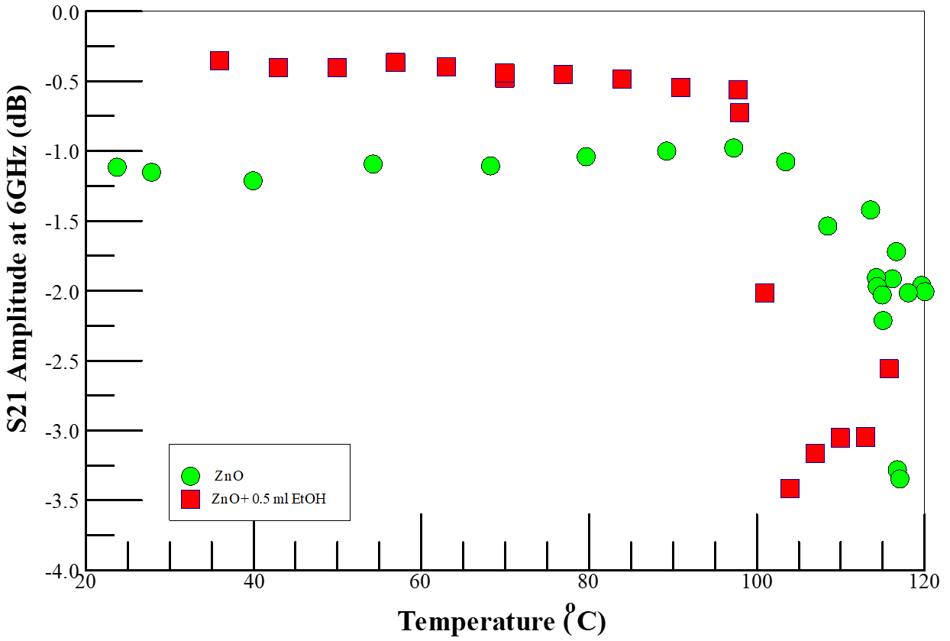
Figure 1. Temperature dependence of microwave insertion loss (S21 amplitude) of ZnO on Si substrate in nitrogen-rich air and gaseous ethanol environments, monitored at 6 GHz. Note that the symbol sizes are much larger than the error bars.

The perturbation of the conductivity of the sensing element is traditionally measured through coulometry, however, each of the elementary processes discussed above involves changes in the surface polarizability which can be discussed with chemisorption models without getting into the details of the surface reactions, and the sensing mechanism ⁴⁹. Such chemisorbed models are easily monitored by corresponding changes in microwave S-parameters. Using BDS, we have previously investigated the three steps discussed above, and shown that ethanol can be detected on our ZnO nanorods, at temperatures well below 100 °C²⁷. As we discuss below, we observed the formation of ethanol-O₂⁻ adducts on the ZnO-nanorod surface which do not have to react chemically to change the impedance of the sensor. Thus, the ability to detect chemisorbed species at low temperatures with BDS negates the need for high temperature charge transfer reactions to capture the quantity of electrons transferred in to infer the number of adsorbed analyte molecules present.

3.2.2. Ethanol Vapor Detection with Pristine and TCNQ-loaded HKUST-1 SURMOF
The potential of metal-organic frameworks (MOFs) for gas mixture separation⁵⁰, and as VOC sensing agents have been discussed in the literature¹⁴ ¹². Furthermore, copper MOFs are widely used in MOF alcohol oxidation, due to the intrinsic activity of copper as an oxidizing catalyst ⁵¹. The HKUST-1 MOF, [Cu₃(BTC)₂(H₂O)₃]_{n} (where BTC is benzene-1,3,5-tricarboxylate), is comprised of square Cu-Cu paddlewheel clusters connected by BTC ligands to form a rigid porous open framework with bimodal pore size distribution^{52, 53}, and two coordination unsaturated Cu²⁺metal sites (open metal sites) per paddlewheel where polar groups can attach through dative bonding ⁵⁴. The open metal sites, formed by removing axial ligands, strongly coordinate to electron rich species (i.e., Lewis bases). The HKUST-1 MOF has three distinct internal pores, two of comparable size (aperture = 14 Å) and a smaller pore (aperture = 10 Å). One of the two larger pores has the Cu-Cu paddlewheels directed into the pores making it suitable for coordinating TCNQ guest molecules. The open metal sites in the smaller pores are still available for coordinating to small molecules. ^{54, 55} The open Cu sites in the small cavities are separated by 8.2 Å which limits the size, stereochemistry, and the number analyte molecules that could be adsorbed at those sites ⁵¹. Small aliphatic alcohol molecules and similar sized polar molecules reversibly adsorb at the available open metal centers in MOF cavity causing the cavity to expand and inducing changes in its physicochemical properties, such as decreased thermal conductivity ²⁶ and the electrical conductivity of the MOF^{13, 56, 57}. Experimental data suggest that charge transfer between the adsorbed analyte and the open metal sites, occur within the pores of the MOF framework¹². The adsorption at the metal sites also results in change in interfacial polarization and permittivity which should be readily detected by microwave energy dissipation ⁵⁸.
Copper MOFs are widely used as catalysts for alcohol oxidation, due to the intrinsic activity of copper as an oxidizing catalyst ⁵¹. For example, Guo et al have demonstrated that mixed-metal CuPd-HKUST-1 MOF exhibits superior catalytic performance compared to the pristine HKUST-1 for the selective aerobic oxidation of benzyl alcohol to benzaldehyde⁵⁹. Defective HKUST-1 thin films ⁶⁰, such as used in this work contain Cu²⁺/Cu⁺ dimers that form reactive adducts with dioxygen molecules which are probably responsible for the catalytic aerobic oxidative properties of the HKUST-1 MOF ⁶¹. These oxidative abilities of defects are similar to the aerobic organisms, such as in respiration⁶². Copper(I)-dioxygen (O₂) adducts, have been proposed intermediates in dioxygen-activating enzymes; they are capable of oxidizing substrates containing weak O–H and C–H bonds. Mechanistic studies for some enzymes and model systems have supported an initial hydrogen-atom abstraction via the cupric-superoxide complex as the first step of substrate oxidation ^{63, 64}. In the rate-determining step, an O-coordinated alcoholate undergoes an H-abstraction reaction from the α-carbon atom of the alcoholate to generate a bound ketyl radical which then intramolecularly converted via a one-electron oxidation to the aldehyde with the reduction of the Cu (II) center into a Cu-I species, which is then later deoxidized O₂ ⁶⁵. Thus, we expect the absorbed alcohol analyte to be aerobically oxidized in the host MOF to the corresponding aldehydes⁶⁶. Such redox reactions at the metal centers should be readily detected by BDS, because of the expected changes in the conductivity of the HKUST-1 SURMOF¹³. . Furthermore, microwave (MW) irradiation is known to rapidly convert alcohols to carbonyl compounds over transition metal catalysts.⁶⁷ MW irradiation of immobilized reactants on inorganic supports reduces the reaction time and promotes the yield, selectivity and purity of products, as the microwave irradiation promotes faster and more efficient internal heating through direct interaction between microwave energy and the reactants ⁶⁸⁻⁷⁰.
In analogy to the aerobic oxidation of aliphatic alcohols on ZnO, we propose conceivable elementary steps involved in the BDS detection of aliphatic alcohols in TCNQ-doped HKUST-1 SURMOF. We expect the adsorbed aliphatic alcohol analyte at the open Cu-sites in the host MOF sites to be aerobically oxidized into aldehydes ⁶⁶ in a process comprised of multiple steps, each with its characteristic polarization dynamics, viz,
- Analyte molecules diffuse into size accessible cavities to coordinate to the available open Cu²⁺ active sites, some of which exist as Cu²⁺-Cu⁺-O₂ adducts, in the HKUST-1 MOFs. This induces an impedance increase in the device under test (DUT) due to distortion of the mechanical structure, as well as changes in the electronic band structure that lead to changes in the conductivity of the MOF. In a pure nitrogen ambient, the N₂ adsorbs on the metal sites⁷¹, but in the presence of Lewis base molecules, such as aliphatic alcohols, the analyte is expected to displace pre-adsorbed N₂ molecules from the open metal sites.
- The aliphatic alcohol probably coordinates to the open metal center via the hydroxyl-oxygen atom. The absorbed alcohol analyte is aerobically oxidized by the Cu-sites ⁷² into carbonyl compounds (e.g., aldehydes from the primary) at room temperature ¹², with electrons transferred into the MOF from the alcohol, as discussed above. This step is dependent on the presence of oxygen in the ambient within the reactor, which is required for the reoxidation of the Cu(I) to Cu(II). The resultant carbonyl compounds, because of their increased electrophilic nature, are more polarizable, and will contribute to the observed increased insertion loss.
- The oxidation of the adsorbed alcohol analyte in the MOF into aldehydes, in step 2, may be aided by the probe microwave stimulus.
There are multiple dielectric mechanisms and polarization processes inherent in the HKUST-1-analyte interactions that can be triggered using different frequencies ⁷³; thus, careful analyses of the BDS spectra could afford deep mechanistic insights into the VOC detection as each event results in changes in polarization and has a characteristic relaxation frequency ⁷⁴.

Nitrogen enriched air, without ethanol, was used in the initial characterization studies to understand the impact of Lewis base coordination to the open Cu²⁺ centers in the SURMOF films, i.e., to investigate step 1 of the proposed mechanism. Figures 3 shows the temperature dependence of microwave insertion loss (S21 amplitude) in TCNQ doped HKUST-1 SURMOF in N₂-rich air. The insertion loss is higher in the nitrogen-rich environment than in pure air and increased with increasing temperature from 22 °C to 40 °C, then leveled off at higher temperatures. Seebeck coefficient measurements indicate holes as the majority charge carriers in TCNQ-HKUST-1 films at room temperature ⁷⁵, and charge transport is only in the vertical direction in the highly oriented films ⁴⁰. The observation of the system becoming more resistive in the nitrogen-enriched-air suggests that the N₂ molecules (Lewis base) coordinate to the open Cu²⁺ centers ⁷⁶, and reduce the concentration of the majority hole carriers ⁷⁵. The behavior of the doped material is also consistent with guest induced electronic and vibrational structures changes of the SURMOF films ²⁶ ⁷⁷. Furthermore, the temperature dependence of the impedance in the SURMOF suggests that either nitrogen adsorption at the open metal sites is gated by thermal-induced conformational changes in the MOF cage to allow access to the open metal sites ^{78, 79}, or the DUT has temperature drifts below 50 °C ⁸⁰. Irrespective of the reason for the S₂₁ saturation above 50 °C, all subsequent experiments were conducted at 65° C or higher temperatures to avoid the S₂₁ drift.

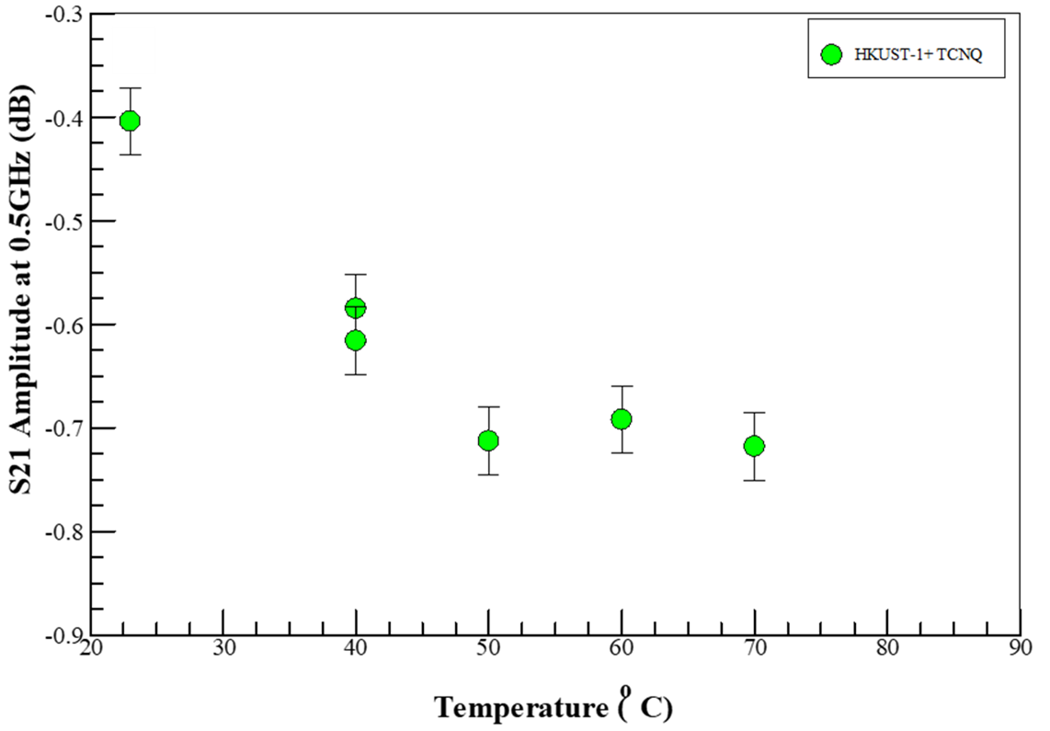
Figure 2. Temperature dependence of microwave insertion loss (S21 amplitude) in TCNQ loaded HKUST-1 MOF on Si sample in N₂-rich air, The error bars represent the standard deviation of at least three measurements on the same sample.
Figure 3 shows the S21 amplitude with increasing concentration of the ethanol vapor at a fixed temperature of 80 °C in air. The S21 appears to saturate above 0.5 ml of injected neat ethanol. As in the nitrogen ambient, the system becomes resistive as the methanol (Lewis base) coordinates to the open Cu²⁺ centers ⁷⁶, and reduces the concentration of the majority hole carriers by donating electrons to the electron deficient metal site. As discussed above, holes are the majority carriers in TCNQ-doped HKUST-1⁷⁵, and charge transport is only in the vertical direction in the highly oriented SURMOF films ⁴⁰, such as those used here. Based on the results from currently ongoing work in our laboratory, we suggest that the ethanol molecules probably coordinate with otherwise free metal centers, as well as hydrogen bond to TCNQ dopant, to reduce the hole concentration by electron injection into the SURMOF from the oxidation of the analyte. This explains the increase in the resistance of the system with increasing analyte concentration.

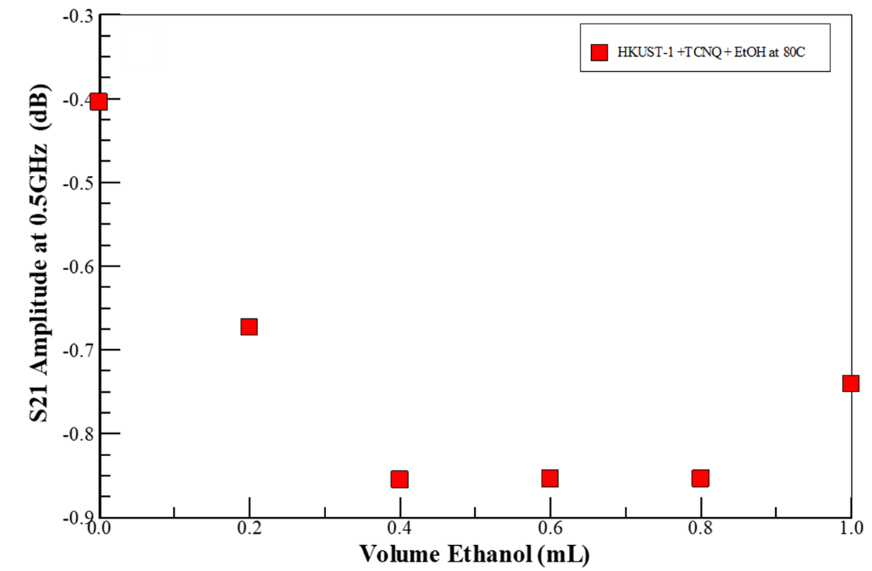
Figure 3 Insertion loss (S21 Amplitude) monitored at 0.5 GHz as a function of volume of neat ethanol injected into vapor reactor (i.e., ethanol vapor concentration) environments at 80 C° in air.
It has been demonstrated that only a single layer adsorbed analyte is formed when the SURMOF layer is exposed to ethanol. The ethanol molecules coordinate to the open Cu-centers via the hydroxyl-oxygen atom from the ethanol, and only a single layer is formed due to the weak hydrogen-bonding interactions from coordinated ethanol molecules with additional adsorbed ethanol molecules ⁸¹Furthermore, the ethanol analyte does not lead to the degradation of the MOF sensing material. In contrast to water, the ethanol sorption capacity of HKUST-1 remained unchanged with the sorption experiment time, at least at 303 K. In contrast to water, ethanol’s weaker interaction with the open Cu(II) sites does not lead to the breaking of the Cu-carboxylate bond in the host HKUST-1 ⁸² . Thus, the evolution of S21 with ethanol volume, as shown in Figure 3, reflects the adsorption of the analyte into the SURMOF sensing layer. Up to 0.4 ml (i.e., ~ 1.1 times the volume of the reactor, or 1.5 X10¹³ times the volume of the SURMOF at 80 °C) of ethanol is adsorbed into the SURMOF sensing layer, which is reminiscent of the adsorption of small molecules into MOF materials ⁸². Beyond analyte saturation of the sensing element additional ethanol volumes do not contribute to the sensor performance; the additional molecules are trapped between the SURMOF substrate and the waveguide or condense on the waveguide end-launch connectors to reduce the system impedance.

3.3. Comparison of BDS detection of Ethanol on MOF and ZnO Sensing Media
Figure 4 compares the microwave insertion loss (S₂₁) dependence on volume of neat ethanol flash vaporized into the reactor at 80 °C for ZnO to TCNQ-doped HKUST-1 SURMOF in nitrogen-enriched air, monitored at 0.1 GHz. The error bars represent the standard deviation of at least 3 replicate measurements. In the case of TCNQ doped MOFs, the charge transfer reactions inject electrons into the metal center to reduce the hole majority carrier and increase the device resistance. In contrast, ethanol adsorption on ZnO induced relatively small concentration dependent changes in the device impedance. Thus, the doped-HKUST-1 SURMOF films were shown to be more sensitive in detecting ethanol at temperatures below 100 °C than their ZnO analogs. As discussed above, while the ZnO was detected through capacitance changes due to the ethanol-O ²⁻ adducts formed on the nanorod’s surface, the detection with the MOF is through direct electron injection into the conduction band. Clearly, the MOF system is more sensitive to ethanol concentration than the ethanol detection on ZnO. We admit that 80 °C is substantially below the optimum VOC detection temperature of around 300 °C for ZnO nanorods but have shown elsewhere that the BDS can detect a VOC at such low temperatures ²⁷. Analysis of the BDS data (at specific frequencies) provides electrical information that can be correlated to elementary processes, such as the adduct formation on oxidized ZnO, and charge-transfer reactions in the doped KHUST-1 SURMOF sensing material⁸³. Clearly, the BDS technique affords the capability to distinguish between different impedance changing mechanisms and provides new mechanistic insights into the elementary events that occur on the ZnO surface during the initial activation step for ethanol detection.

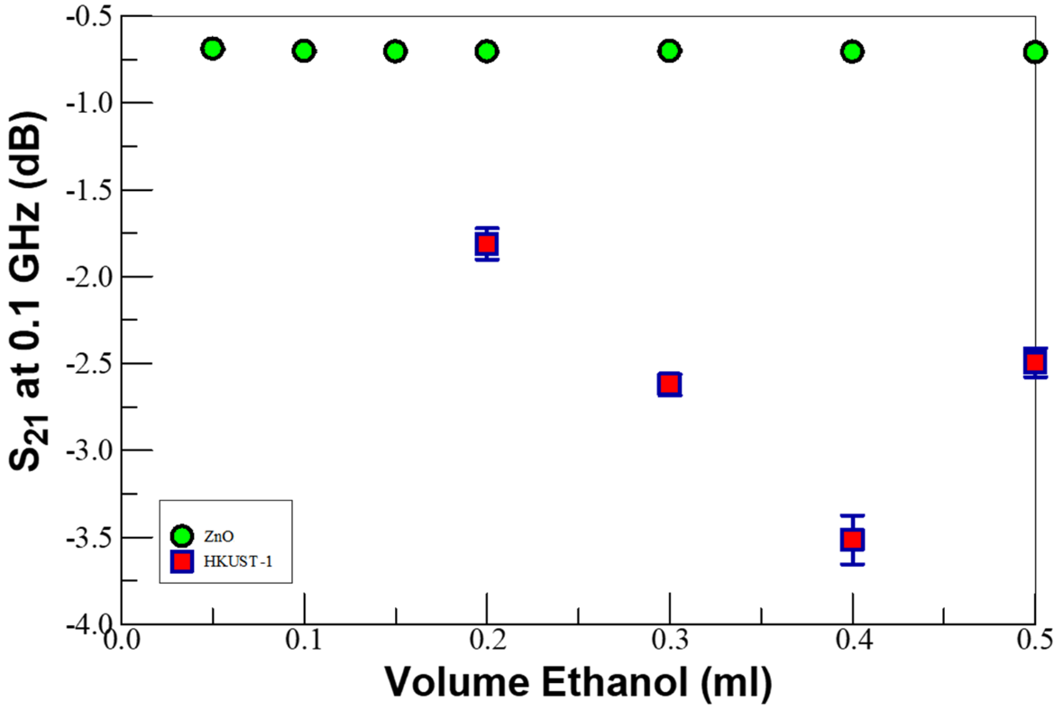
Figure 4. Comparison of the microwave insertion loss (S21) dependence on ethanol concentration on ZnO versus TCNQ-doped HKUST-1 MOF on Si in gaseous ethanol environments, monitored at 0.1 GHz. Note the error bars represent the standard deviation of at least 3 replicate measurements.

4.0 . Conclusions
Using microwave signal attenuation, we have demonstrated physics consistent with analyte-induced physicochemical changes of the sensing media consistent at a temperature as low as 80 ℃ on both ZnO and TCNQ-doped HKUST-1 SURMOF films. In the case of TCNQ-doped HKUST SURMOFs, the charge transfer reactions inject electrons into the metal center to reduce the hole majority carrier and increased device resistance. In contrast, ethanol adsorption on ZnO induced relatively small concentration dependent changes in the device impedance, mostly through changes in surface electrostatics. The doped-HKUST-1 SURMOF films were shown to be more sensitive in detecting ethanol at temperatures below 100 °C than their ZnO analogs. Also, the BDS technique affords new mechanistic insights into the elementary events that occur on the ZnO surface during the initial activation step for ethanol detection.

References
1. G. Korotcenkov, Chemical Sensors: Comprehensive Sensor Technologies Volume 4: Solid State Devices. (Momentum Press, New York, NY 10017 |, 2011).
2. F. Meng, X. Shi, Z. Yuan, H. Ji, W. Qin, Y. Shen and C. Xing, Sensors and Actuators B: Chemical 350, 130867 (2022).
3. G. Korotcenkov, V. Brinzari and B. K. Cho, Microchimica Acta 183 (3), 1033-1054 (2016).
4. A. Dey, Materials Science and Engineering: B 229, 206-217 (2018).
5. W. Gopel, Progress in Surface Science 20 (1), 9-103 (1985).
6. A. Mirzaei, S. G. Leonardi and G. Neri, Ceramics International 42 (14), 15119-15141 (2016).
7. S. R. Mobasser, J.; Zhang, Y.; Shi, W.; Dittrich, T.M.; Miller, C.J. , in 2019 Superfund Research Program (SRP) Annual Meeting (Seattle, WA, USA, 2019).
8. J. Ahn, H. Kim, E. Kim and J. Ko, Ad Hoc Networks 113, 102360 (2021).
9. F. U. M. Chowdhury, J. Gardner, in Fourth Scientific Meeting EuNetAir (Linkoping University, Linkoping, Sweden
2015), pp. 40 - 43.
10. A. Nourbakhsh, L. Yu, Y. Lin, M. Hempel, R.-J. Shiue, D. Englund and T. Palacios, in Beyond-CMOS Technologies for Next Generation Computer Design, edited by R. O. Topaloglu and H. S. P. Wong (Springer International Publishing, Cham, 2019), pp. 43-84.
11. M. M. Shulaker, G. Hills, R. S. Park, R. T. Howe, K. Saraswat, H. S. P. Wong and S. Mitra, Nature 547 (7661), 74-78 (2017).
12. W.-T. Koo, J.-S. Jang and I.-D. Kim, Chem 5 (8), 1938-1963 (2019).
13. J. J. Calvo, S. M. Angel and M. C. So, APL Materials 8 (5), 050901 (2020).
14. L. E. Kreno, K. Leong, O. K. Farha, M. Allendorf, R. P. Van Duyne and J. T. Hupp, Chemical Reviews 112 (2), 1105-1125 (2012).
15. W.-Q. Xu, S. He, C.-C. Lin, Y.-X. Qiu, X.-J. Liu, T. Jiang, W.-T. Liu, X.-L. Zhang and J.-J. Jiang, Inorganic Chemistry Communications 92, 1-4 (2018).
16. Y. Min, Massachusetts Institute of Technology, 2003.
17. S. Homayoonnia and S. Zeinali, Sensors and Actuators B: Chemical 237, 776-786 (2016).
18. M. Sophocleous, in Electrical Resistivity and Conductivity (2017).
19. A. Rydosz, E. Maciak, K. Wincza and S. Gruszczynski, Sensors and Actuators B: Chemical 237, 876-886 (2016).
20. F. Li, Y. Zheng, C. Hua and J. Jian, Frontiers in Materials 6 (101) (2019).
21. F. Xu, C. Zhou and H.-P. Ho, Journal of Alloys and Compounds 858, 158294 (2021).
22. A. M. Lord, T. G. Maffeis, A. S. Walton, D. M. Kepaptsoglou, Q. M. Ramasse, M. B. Ward, J. Köble and S. P. Wilks, Nanotechnology 24 (43), 435706 (2013).
23. I.-D. Kim, A. Rothschild and H. L. Tuller, Acta Materialia 61 (3), 974-1000 (2013).
24. K. Müller, N. Vankova, L. Schöttner, T. Heine and L. Heinke, Chemical Science 10 (1), 153-160 (2019).
25. H. Babaei, M. E. DeCoster, M. Jeong, Z. M. Hassan, T. Islamoglu, H. Baumgart, A. J. H. McGaughey, E. Redel, O. K. Farha, P. E. Hopkins, J. A. Malen and C. E. Wilmer, Nature Communications 11 (1), 4010 (2020).
26. M. E. DeCoster, H. Babaei, S. S. Jung, Z. M. Hassan, J. T. Gaskins, A. Giri, E. M. Tiernan, J. A. Tomko, H. Baumgart, P. M. Norris, A. J. H. McGaughey, C. E. Wilmer, E. Redel, G. Giri and P. E. Hopkins, Journal of the American Chemical Society 144 (8), 3603-3613 (2022).
27. P. K. Amoah, P. Lin, H. Baumgart, R. Franklin and Y. S. Obeng, Journal of Physics D: Applied Physics (2020).
28. R. Zamorano Ulloa, M. Guadalupe Hernandez Santiago and V. L. Villegas Rueda, in Electromagnetic Fields and Waves (IntechOpen,, London, United Kingdom: , 2019).
29. D. T. s. t. t. S. o. I. E. a. M. Rongzhen Chen, Department of Materials Science and Engineering, KTH Royal Institute of Technology, Sweden, , , KTH Royal Institute of Technology, 2017.
30. C. Ambrosch-Draxl and J. O. Sofo, Computer Physics Communications 175 (1), 1-14 (2006).
31. K. Entesari, R. E. Ghiri and E. Kaya, IEEE Microwave Magazine 22 (6), 26-48 (2021).
32. N. B. Obeng YS, Reyes DR, Poster DL, Postek MT, J Res Natl Inst Stan 126: (2021).
33. F. K. a. A. Schönhals, Broadband Dielectric Spectroscopy. (Springer, Berlin, Heidelberg, 2003).
34. M. Marghany, in Synthetic Aperture Radar Imaging Mechanism for Oil Spills, edited by M. Marghany (Gulf Professional Publishing, 2020), pp. 73-92.
35. P. Lin, 2019 (unpublished).
36. A. M. Wernbacher, M. Eichelbaum, T. Risse, S. Cap, A. Trunschke and R. Schlögl, The Journal of Physical Chemistry C 123 (13), 8005-8017 (2019).
37. H.-J. Kim and J.-H. Lee, Sensors and Actuators B: Chemical 192, 607-627 (2014).
38. P. Lin, X. Chen, K. Zhang and H. Baumgart, ECS Journal of Solid State Science and Technology 7 (12), Q246-Q252 (2018).
39. E. Biehler, R. Whiteman, P. Lin, K. Zhang, H. Baumgart and T. Abdel-Fattah, ECS Journal of Solid State Science and Technology 9, 121008 (2020).
40. X. Chen, K. Zhang, Z. M. Hassan, E. Redel and H. Baumgart, Journal of Physics: Condensed Matter (2021).
41. H. K. Arslan, O. Shekhah, J. Wohlgemuth, M. Franzreb, R. A. Fischer and C. Wöll, Advanced Functional Materials 21 (22), 4228-4231 (2011).
42. K. Müller, K. Fink, L. Schöttner, M. Koenig, L. Heinke and C. Wöll, ACS Applied Materials & Interfaces 9 (42), 37463-37467 (2017).
43. A. A. Talin, A. Centrone, A. C. Ford, M. E. Foster, V. Stavila, P. Haney, R. A. Kinney, V. Szalai, F. El Gabaly, H. P. Yoon, F. Léonard and M. D. Allendorf, Science 343 (6166), 66-69 (2014).
44. L. Wang, Y. Kang, X. Liu, S. Zhang, W. Huang and S. Wang, Sensors and Actuators B: Chemical 162 (1), 237-243 (2012).
45. M. Sinha, R. Mahapatra and R. Ghosh, Materials Today: Proceedings 11, 708-713 (2019).
46. P. Lin, X. Chen, K. Zhang and H. Baumgart, ECS Journal of Solid State Science and Technology 7, Q246-Q252 (2018).
47. A. Bejaoui, J. Guerin, J. A. Zapien and K. Aguir, Sensors and Actuators B: Chemical 190, 8-15 (2014).
48. A. Bejaoui, J. Guerin and K. Aguir, Sensors and Actuators B: Chemical 181, 340-347 (2013).
49. S. Steinhauer, Chemosensors 9 (3), 51 (2021).
50. D. Ma, Z. Li, J. Zhu, Y. Zhou, L. Chen, X. Mai, M. Liufu, Y. Wu and Y. Li, Journal of Materials Chemistry A 8 (24), 11933-11937 (2020).
51. A. Dhakshinamoorthy, A. M. Asiri and H. Garcia, Chemical Communications 53 (79), 10851-10869 (2017).
52. S. S.-Y. Chui, S. M.-F. Lo, J. P. H. Charmant, A. G. Orpen and I. D. Williams, Science 283 (5405), 1148-1150 (1999).
53. Q. Min Wang, D. Shen, M. Bülow, M. Ling Lau, S. Deng, F. R. Fitch, N. O. Lemcoff and J. Semanscin, Microporous and Mesoporous Materials 55 (2), 217-230 (2002).
54. C. H. Hendon and A. Walsh, Chemical Science 6 (7), 3674-3683 (2015).
55. K. Dedecker, E. Dumas, B. Lavédrine, N. Steunou and C. Serre, in Metal-Organic Frameworks (MOFs) for Environmental Applications, edited by S. K. Ghosh (Elsevier, 2019), pp. 141-178.
56. L. Cadman, University of Bath, Multi-Component Metal-Organic Frameworks

57. L. Sun, C. H. Hendon, M. A. Minier, A. Walsh and M. Dincă, Journal of the American Chemical Society 137 (19), 6164-6167 (2015).
58. S. Sachdeva, S. J. H. Koper, A. Sabetghadam, D. Soccol, D. J. Gravesteijn, F. Kapteijn, E. J. R. Sudhölter, J. Gascon and L. C. P. M. de Smet, ACS applied materials & interfaces 9 (29), 24926-24935 (2017).
59. P. Guo, C. Froese, Q. Fu, Y.-T. Chen, B. Peng, W. Kleist, R. A. Fischer, M. Muhler and Y. Wang, The Journal of Physical Chemistry C 122 (37), 21433-21440 (2018).
60. L. Heinke and C. Wöll, Advanced Materials 31 (26), 1806324 (2019).
61. W. Wang, D. I. Sharapa, A. Chandresh, A. Nefedov, S. Heißler, L. Heinke, F. Studt, Y. Wang and C. Wöll, Angewandte Chemie International Edition 59 (26), 10514-10518 (2020).
62. R. Y. N. Ho, J. F. Liebman and J. S. Valentine, in Active Oxygen in Biochemistry, edited by J. S. Valentine, C. S. Foote, A. Greenberg and J. F. Liebman (Springer Netherlands, Dordrecht, 1995), pp. 1-36.
63. J. Shearer, C. X. Zhang, L. N. Zakharov, A. L. Rheingold and K. D. Karlin, Journal of the American Chemical Society 127 (15), 5469-5483 (2005).
64. D. A. Quist, D. E. Diaz, J. J. Liu and K. D. Karlin, JBIC Journal of Biological Inorganic Chemistry 22 (2), 253-288 (2017).
65. P. Chaudhuri, M. Hess, J. Müller, K. Hildenbrand, E. Bill, T. Weyhermüller and K. Wieghardt, Journal of the American Chemical Society 121 (41), 9599-9610 (1999).
66. T. F. S. Silva and L. M. D. R. S. Martins, Molecules 25 (3), 748 (2020).
67. B. Maes, T. Marimuthu, S. Alapour and H. B. Friedrich, Arkivoc 2020 (3), 120-135 (2020).
68. M. Sutradhar, E. C. B. A. Alegria, T. R. Barman, M. F. C. Guedes da Silva, C.-M. Liu and A. J. L. Pombeiro, Frontiers in Chemistry 8 (157) (2020).
69. S. Hazra, L. M. D. R. S. Martins, M. F. C. Guedes da Silva and A. J. L. Pombeiro, RSC Advances 5 (109), 90079-90088 (2015).
70. V. Polshettiwar and R. S. Varma, Accounts of Chemical Research 41 (5), 629-639 (2008).
71. S. Bordiga, L. Regli, F. Bonino, E. Groppo, C. Lamberti, B. Xiao, P. S. Wheatley, R. E. Morris and A. Zecchina, Physical Chemistry Chemical Physics 9 (21), 2676-2685 (2007).
72. V. Rubio-Giménez, N. Almora-Barrios, G. Escorcia-Ariza, M. Galbiati, M. Sessolo, S. Tatay and C. Martí-Gastaldo, Angewandte Chemie International Edition 57 (46), 15086-15090 (2018).
73. A. S. Babal, L. Donà, M. R. Ryder, K. Titov, A. K. Chaudhari, Z. Zeng, C. S. Kelley, M. D. Frogley, G. Cinque, B. Civalleri and J.-C. Tan, The Journal of Physical Chemistry C 123 (48), 29427-29435 (2019).
74. A. M. Bottreau, Y. Dutuit and J. Moreau, The Journal of Chemical Physics 66 (8), 3331-3336 (1977).
75. K. J. Erickson, F. Léonard, V. Stavila, M. E. Foster, C. D. Spataru, R. E. Jones, B. M. Foley, P. E. Hopkins, M. D. Allendorf and A. A. Talin, Advanced Materials 27 (22), 3453-3459 (2015).
76. I. Strauss, A. Mundstock, M. Treger, K. Lange, S. Hwang, C. Chmelik, P. Rusch, N. C. Bigall, T. Pichler, H. Shiozawa and J. Caro, ACS Applied Materials & Interfaces 11 (15), 14175-14181 (2019).
77. J. Liu, T. Wächter, A. Irmler, P. G. Weidler, H. Gliemann, F. Pauly, V. Mugnaini, M. Zharnikov and C. Wöll, ACS Applied Materials & Interfaces 7 (18), 9824-9830 (2015).
78. J. Janczak, D. Prochowicz, J. Lewiński, D. Fairen-Jimenez, T. Bereta and J. Lisowski, Chemistry – A European Journal 22 (2), 598-609 (2016).
79. M. M. Deegan, M. R. Dworzak, A. J. Gosselin, K. J. Korman and E. D. Bloch, Chemistry – A European Journal 27 (14), 4531-4547 (2021).
80. A. M. Collier-Oxandale, J. Thorson, H. Halliday, J. Milford and M. Hannigan, Atmos. Meas. Tech. 12 (3), 1441-1460 (2019).
81. N. C. Jeong, B. Samanta, C. Y. Lee, O. K. Farha and J. T. Hupp, Journal of the American Chemical Society 134 (1), 51-54 (2012).
82. J. R. Álvarez, E. Sánchez-González, E. Pérez, E. Schneider-Revueltas, A. Martínez, A. Tejeda-Cruz, A. Islas-Jácome, E. González-Zamora and I. A. Ibarra, Dalton Transactions 46 (28), 9192-9200 (2017).
83. A. Serghei, J. R. Sangoro and F. Kremer, in Electrical Phenomena at Interfaces and Biointerfaces (2012), pp. 241-273.

