Excess Electrons Bound to H₂S Trimer and Tetramer Clusters
Gaoxiang Liu¹, Manuel Díaz-Tinoco², Sandra M. Ciborowski¹, Svetlana Lyapustina^{1,3}, Jay H. Hendricks^{1,4}, Vincent Ortiz^{2*}, Kit H. Bowen^{1*}

Addresses:
¹Department of Chemistry, Johns Hopkins University Baltimore, MD 21218, USA
²Department of Chemistry and Biochemistry, Auburn University Auburn, AL 36849, USA
³Currently at Consortia Management Group, DBR, Washington, DC, 20005, USA
⁴Currently at The National Institute of Standards and Technology, Gaithersburg, MD 20899

Corresponding authors:
J.V.O.: jvo0001@auburn.edu
K.H.B: kbowen@jhu.edu

Abstract
The hydrogen sulfide trimer and tetramer anions, (H₂S)₃– and (H₂S)₄–, were generated by Rydberg electron transfer and studied via a synergy between velocity-map imaging anion photoelectron spectroscopy and high-level quantum chemical calculations. The sharp peaks at low electron binding energy in their photoelectron spectra and their diffuse Dyson orbitals are evidence of them both being dipole-bound anions. While the dipole moments of the neutral (H₂S)₃ and (H₂S)₄ clusters are small, the excess electron induces structural distortions that enhance the charge-dipolar attraction and facilitate the binding of diffuse electrons.

Introduction
As the fundamental species to many areas in physical sciences, solvated electrons play a critical role in radiobiological chemistry¹, atmospheric aerosol chemistry², DNA damage³, and in theoretical studies as the simplest quantum solute.⁴ In condensed phase and gas phase, numerous studies have been conducted on the hydrated electron,⁵ and to a lesser extent, on solvated electrons in ammonia⁶, carbon dioxide⁷, alcohols⁸, and acetonitrile⁹. Despite the large body of work on solvated electrons, many problems still remain open. Possibly the most intriguing one is the nature of the microscopic solvation environment: how does the solvated electron interact with the surrounding molecules, and how will this interaction change upon environment variation?¹⁰
These questions have been widely addressed by experimental and theoretical studies of excess electrons in clusters, which have provided molecular-level insight to the properties of condensed-phase solvated electron species.^{11,12} The excess electrons in water clusters¹³⁻²², as well as in clusters of other polar or nonpolar molecules such as NH₃,²³ HF,²⁴ acetonitrile,²⁵ methanol,²⁶ amides²⁷, and aromatic molecules²⁸, have been subject to extensive research activity. One of the key findings is that the solvated electrons, i.e., internally-bound electrons, are common in large clusters of polar solvent, while the dipole-bound electrons, i.e., surface-bound electrons, dominate for small polar clusters.^{11,12} For example, in small water cluster anions, (H₂O)_{n}– (n= 2~7), the most abundant anions observed are dipole-bound anions with the excess electron localized in the vicinity of a water monomer with two free OH groups.¹³⁻¹⁶
Hydrogen sulfide (H₂S) has identical valence electron count and is structurally similar to H₂O. A major difference in their physical properties is their polarity: the dipole moment of H₂S 3.24e-30 Cm (0.97 D) is significantly smaller than that of H₂O 6.17E-30 Cm (1.85 D). Such difference leads to a weaker intermolecular dipole-dipole interaction among H₂S molecules.²⁹ Since H₂S and H₂O are electrically dissimilar but electronically and structurally alike, the research of excess electrons in H₂S clusters can serve as an ideal case-control study for understanding how electron binding is affected upon polarity change of the microsolvation environment. The anions of H₂S clusters, however, have long evaded both experimental and theoretical investigations.
In this work, we employed our recently developed Rydberg electron transfer-anion photoelectron spectroscopy (RET-aPES) apparatus³⁰⁻³² to prepare and characterize H₂S cluster anions. We found that only H₂S trimer and tetramer clusters can bind an excess electron, while other H₂S clusters undergo dissociative electron attachment. The photoelectron spectra, which were measured via velocity-map imaging (VMI), reveals the signature of a dipole-bound electron in H₂S trimer and tetramer anions. High-level ab initio calculations reproduced the experimentally determined Vertical Detachment Energy (VDE) values for (H₂S)₃– and (H₂S)₄–. It is shown that the interaction between an excess electron and H₂S trimer or tetramer induces structural changes to the neutral clusters, which alter their electrostatic potentials to bind a diffuse excess electron.

Methods
Experimental methods
Rydberg electron transfer (RET) provides a fragile-anion friendly environment in which to form previously inaccessible diffuse and otherwise weakly bound electron states. In RET, an electronically excited Rydberg atom transfers its outer electron to a target neutral cluster during their collision, resulting in an ion pair which separates into atomic cation and cluster anion products. RET is a slow-electron attachment process in which the receding positive ion plays a uniquely stabilizing role. As a result, Rydberg electron transfer provides an unusually gentle, highly quantum state-specific, laser-tunable, anion formation environment. In a typical RET experiment, atoms are optically pumped to specific Rydberg states (n*) at the point where they collide with a beam of neutral target molecules. In the present case, the target is a beam of neutral H₂S clusters, formed in the supersonic expansion of 5% H₂S/He mixed gas from a pulse valve.³³ To generate high intensities of product anions, we use alkali (K) atoms and two pulsed dye lasers. One laser optically pumps to the ²P_{3/2} level of the potassium atoms, while the second laser selectively excites that population to the ns and nd Rydberg levels of interest. Several Rydberg levels, i.e., n*= 12d-15d, were surveyed, and the most intense ion signal occurred at the n* = 14d Rydberg level. Beams of Rydberg-excited K atoms and neutral target molecules cross between the ion extraction grids of our time-of-flight mass analyzer/selector. There, H₂S cluster anions were formed by RET and accelerated into a flight tube, along which they are mass-selected, prior to being photodetached.
Anion photoelectron spectroscopy is conducted by crossing a beam of negative ions with a fixed-frequency photon beam and energy-analyzing the resultant photodetached electrons. This technique is governed by the energy-conserving relationship, hν = EBE + EKE, where hν is the photon energy, EBE is the electron binding energy, and EKE is the electron kinetic energy. The electron energies of the photodetached electrons are measured using a velocity-map imaging (VMI) anion photoelectron spectrometer, which has been described previously. There, mass-selected anions are crossed with 1064 nm linearly polarized photons from a Nd:YAG laser. The resultant photodetached electrons are then accelerated along the axis of the ion beam toward a position-sensitive detector, which is coupled to a CCD camera. The basis set expansion (BASEX)³⁴ Abel transform method is used to reconstruct the two-dimensional image, formed by the sum of these electrons, into the three-dimensional distribution. Our resulting anion photoelectron spectrum is calibrated relative to the well-known photoelectron spectrum of NO–.³⁵
Computational methods
Geometry optimizations on (H₂S)₃⁻ and (H₂S)₄⁻ were executed with the coupled-cluster, single, doubles and perturbative triples, or CCSD(T), method³⁶ and the doubly augmented 6-311+²+²G(2df,p) basis-set.³⁷⁻³⁹ Exponents of the doubly augmented basis were obtained by multiplying the most diffuse exponent of each angular momentum from the initial basis-set, 6-311++G(2df,p), by 0.3. The abundance of diffuse functions requires that the accuracy criterion of two-electron repulsion integrals be set to 10⁻²⁰ a.u.⁴⁰ (atomic units) BDT1 (define BDT1 here)⁴¹⁻⁴⁴ electron-propagator calculations of vertical detachment energies (VDEs) were performed with augmented, correlation-consistent (aug-cc-pVDZ or aug-cc-pVTZ) basis sets.⁴⁵⁻⁴⁷ Double, triple and quadruple augmentation of the basis sets (aug², aug³ and aug⁴, respectively) was defined by exponents obtained by successively multiplying the most diffuse exponent of each angular momentum by 0.3. VEDEs also were inferred from total energy differences at the ΔCCSD(T) level. All pole strengths were above 0.85. Dyson orbitals expressed as a linear combination of approximate Brueckner orbitals in BDT1 calculations were dominated by a single, pseudo-canonical orbital in every case. All calculations were performed with Gaussian 16⁴⁸ except the BDT1 electron-propagator calculations, which employed GDV.⁴⁹ Plots of molecular structures and Dyson orbitals were generated with GaussView.⁵⁰

Results and Discussion
The mass spectrum of H₂S trimer and tetramer cluster anions made by RET is presented in the bottom panel of Figure 1, alongside with the simulated isotope patterns of S–(H₂S)_{2,3} and (H₂S)_{3,4}– in the top panels. The peaks at 100 and 134 amu suggest the existence of S–(H₂S)₂ and S–(H₂S)₃, in which S– comes from the dissociative electron attachment of H₂S. The peaks at 104 and 138 amu confirm the formation of (H₂S)₃– and (H₂S)₄–, as only (H₂S)₃– and (H₂S)₄– have isotopes respectively at these two masses. The two mass peaks in the middle, i.e., at 102 and 136 amu, are mixed peaks of S–(H₂S)₂/(H₂S)₃– and S–(H₂S)₃/(H₂S)₄–, respectively. No anions are observed smaller than 90 amu. At larger mass up to 500 amu, S–(H₂S)_{n} are the major products (Figure 2), implying that dissociative electron attachment prevails in larger H₂S clusters. Therefore, under our experimental conditions, an excess electron can be attached only to (H₂S)₃ and (H₂S)₄. Note that this is surprisingly different from (H₂O)_{n}– clusters, where (H₂O)₃– and (H₂O)₄– are the “missing species”¹³ due to their negative electron affinity (EA),⁵¹ and can only form via an indirect electron attachment process.⁵²
Figure 1 Simulated isotope patterns of S–(H₂S)_{2,3} and (H₂S)_{3,4}– (top two panels), and an experimental mass spectrum due to Rydberg electron transfer at n* = 14d (bottom panel).

Figure 2 Experimental mass spectrum showing the larger-mass anion products made by Rydberg electron transfer at n* = 14d.

Figure 3 presents the anion photoelectron spectra of (H₂S)₃– and (H₂S)₄– with their corresponding photoelectron images embedded. Each spectrum consists of a major, sharp peak at low electron binding energy (EBE), strongly implying that (H₂S)₃– and (H₂S)₄– are dipole-bound anions. For (H₂S)₃–, the EBE peak is centered at 29 meV; for (H₂S)₄–, the EBE peak is centered at 115 meV. We assign these two peaks as the origins of the transitions between the cluster anions and their corresponding neutral clusters. Therefore, the vertical detachment energy (VDE) values for (H₂S)₃– and (H₂S)₄– are 29 and 115 meV, respectively. In addition to the major peak, each spectrum also contains a weaker peak at higher EBE side that is separated from the center of the strong peak by 0.34 eV. These peaks are assigned as the vertical detachment to an excited H₂S vibration mode.
The photoelectron VMI image embedded in Figure 3 reveals significant anisotropy in both the H₂S trimer and tetramer anions. The anisotropy parameters, β, for the photodetached electrons were each calculated to be around 1.7, which is close to the theoretical upper limit. A large β value is consistent with an outgoing p wave, which means that photodetachment occurred from an s-orbital with nearly zero angular momentum. Since both dipole-bound anions have spatially diffuse excess electron states, their excess electrons can be viewed as possessing s-orbital character, consistent with the observed anisotropy.
We also performed the experiment on our nozzle-ion source/PES apparatus.⁵³ The (H₂S)₄– photoelectron spectrum (Figure 3c) taken by this apparatus is consistent with the one taken by the RET-aPES apparatus and shows an improved signal-to-noise ratio. (H₂S)₃–, however, was not observed with the nozzle-ion/PES apparatus as it was detached by the strong electric fields from multiple lenses along the ion path inside the apparatus.

Figure 3 Photoelectron spectra of (H₂S)₃– and (H₂S)₄–. (a) and (b) are obtained with the RET-aPES apparatus; (c) is obtained with the nozzle-ion source/PES apparatus.

The small size of the observed H₂S cluster anions enables applying high-level ab initio calculations on their structures and energetics. Figure 4 presents the optimized structures and the Dyson orbitals of (H₂S)₃–. The two optimized structures have C_{2v} and C₃ symmetry, respectively. Based on CCSD(T)/aug³-cc-pVTZ level of theory, the C_{2v} structure is higher in energy than the C₃ structure by 0.048 eV. In the C_{2v} structure, a central H₂S molecule has H bridges to two equivalent H₂S molecules, with all of the H nuclei oriented toward the red contour of the Dyson orbital of electron detachment. In the C₃ structure, equivalent sulfur nuclei and three hydrogens form a ring below which lie three hydrogens that are oriented toward the red contour that pertains to the Dyson orbital of electron detachment. Both structures of (H₂S)₃– exhibit positive VDE only when the basis set is saturated with diffuse basis functions. Triple augmentation suffices for this purpose. After extra diffuse augmentations, there is little difference between results generated with augmented double and triple ζ basis sets. BDT1 results for VDEs are in agreement with ΔCCSD(T) to within a few meV at basis saturation. The predicted VDEs are 21 and 66 meV respectively for the C₃ and C_{2v} structures. The former result, based on the BDT1 results with quadruple diffuse functions and corresponding to the more stable structure, is in excellent agreement with the observed value, 29 meV.

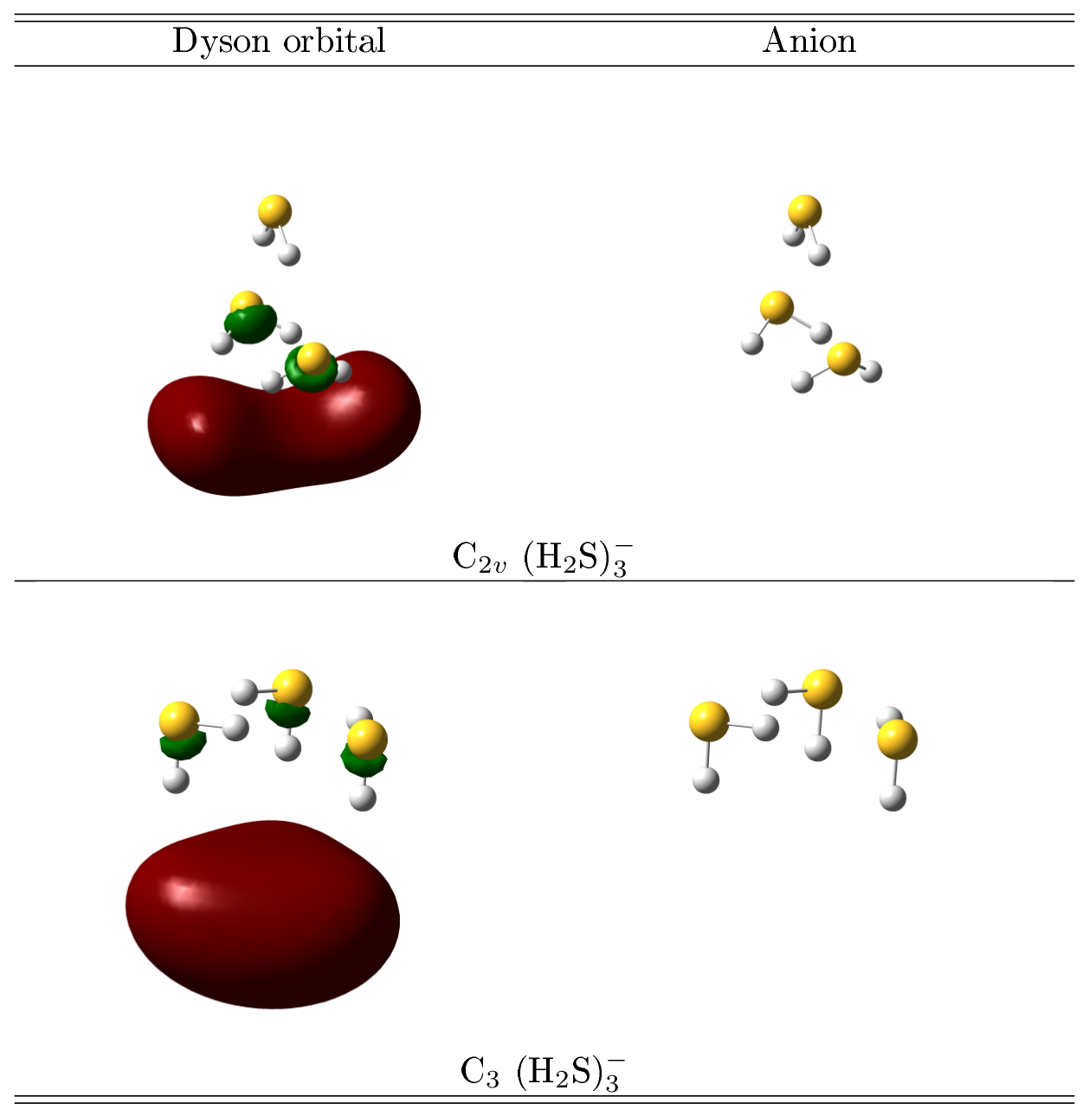
Figure 4 Dyson orbitals and structures for (H₂S)₃–.

Contours of the Dyson orbitals of both isomers indicate that the least bound electron is spread over a volume that lies outside S-H bonds that are oriented to stabilize the extra negative charge. The shapes of the red contours are influenced respectively by the propinquity of three or four H nuclei in the C₃ and C_{2v} structures. Green contours within S-H bonds indicate orthogonalization to the occupied, valence orbitals and delocalization over a larger volume that encloses the molecules in plots of lower contours. The short distance between the majority of the extra negative charge and the nearby H nuclei indicates the importance of electrostatic attraction in stabilizing the extra negative charge. At such distances, exchange and correlation effects are also important.

Table 1 Calculated vertical detachment energies in eV at different levels of theories for (H₂S)₃–.
Expt. VDE | (H₂S)₃– structure | Basis set | Theo. VDE
 |  |  | ΔCCSD(T) | BDT1
0.029 | C₃ | aug-cc-pVDZ | -0.328 | -0.324
 |  | aug²-cc-pVDZ | -0.040 | -0.036
 |  | aug³-cc-pVDZ | 0.011 | 0.014
 |  | aug⁴-cc-pVDZ | 0.018 | 0.021
 |  | aug-cc-pVTZ | -0.243 | -0.252
 |  | aug²-cc-pVTZ | -0.026 | -0.029
 |  | aug³-cc-pVTZ | 0.013 | 0.013
 | C_{2v} | aug-cc-pVDZ | -0.211 | -0.206
 |  | aug²-cc-pVDZ | 0.027 | 0.032
 |  | aug³-cc-pVDZ | 0.059 | 0.064
 |  | aug⁴-cc-pVDZ | 0.058 | 0.066
 |  | aug-cc-pVTZ | -0.138 | -0.148
 |  | aug²-cc-pVTZ | 0.037 | 0.034
 |  | aug³-cc-pVTZ | 0.060 | 0.059

Four optimized structures, labelled by their point groups, are found for (H₂S)₄⁻. The C₄, C_{s}¹, C_{s}² and S₄ (wherein μ=0) clusters are shown in Figure 5. The structures are sensitive to basis sets and to the level of theory; perturbative triples have significant influence on the results. The C₄ structure has the lowest energy at the highest level of theory, ΔCCSD(T)/aug³-cc-pVTZ, with relative energies for C_{s}¹, C_{s}² and S₄ structures being 0.041, 0.027 and 0.024 eV, respectively. All four anions are bound with respect to neutrals when the basis-set is saturated with diffuse functions (see Table 3). BDT1 electron-propagator results for VDEs (53, 126, 100 and 25 meV, respectively, for the C₄, C_{s}¹, C_{s}² and S₄ clusters) are in close agreement with CCSD(T). Results for the two C_{s} structures are in much closer agreement with the experimental value of 115 meV than those for the more symmetric geometries.
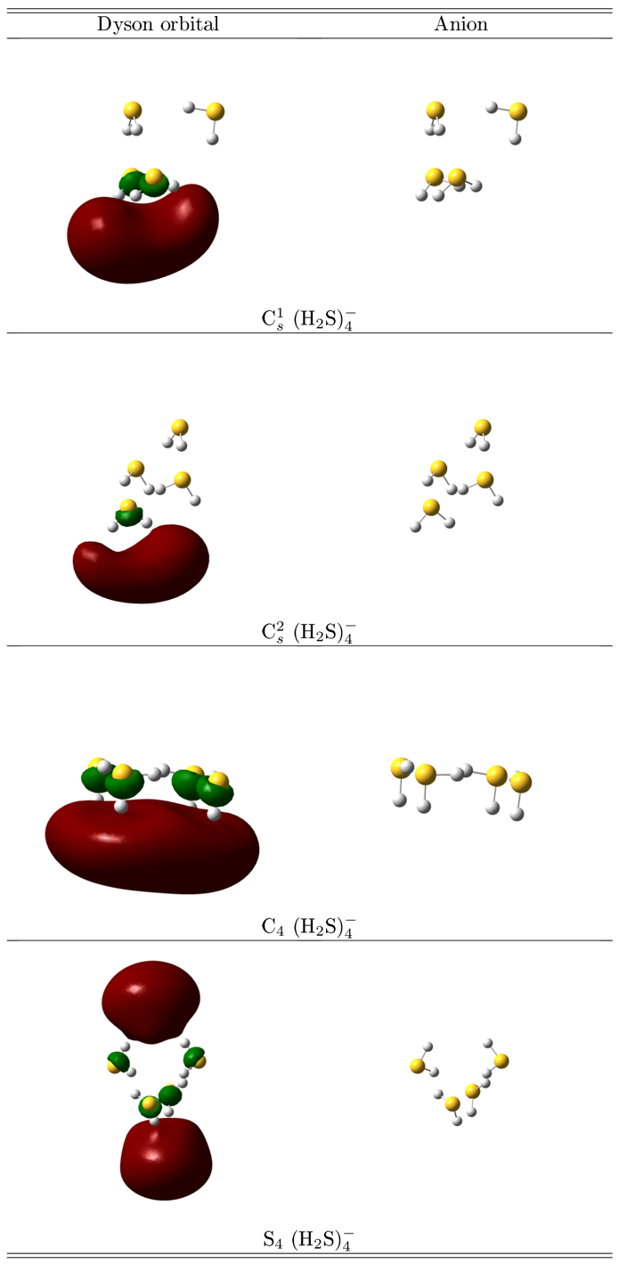
Figure 5 Dyson orbitals and structures of (H₂S)₄–
Table 3 Calculated vertical detachment energies in eV at different levels of theories for (H₂S)₄–.
Expt. VDE | (H₂S)₄– structure | Basis set | Theo. VDE
 |  |  | ΔCCSD(T) | BDT1
0.119 | C₄ | aug-cc-pVDZ | -0.224 | -0.219
 |  | aug²-cc-pVDZ | 0.020 | 0.024
 |  | aug³-cc-pVDZ | 0.052 | 0.057
 |  | aug-cc-pVTZ | -0.148 | -0.156
 |  | aug²-cc-pVTZ | 0.030 | 0.028
 |  | aug³-cc-pVTZ | 0.053 | 0.053
 | C_{s}¹ | aug-cc-pVDZ | -0.070 | -0.064
 |  | aug²-cc-pVDZ | 0.111 | 0.117
 |  | aug³-cc-pVDZ | 0.126 | 0.134
 |  | aug-cc-pVTZ | -0.010 | -0.021
 |  | aug²-cc-pVTZ | 0.118 | 0.113
 |  | aug³-cc-pVTZ | 0.126 | 0.126
 | C_{s}² | aug-cc-pVDZ | -0.154 | -0.150
 |  | aug²-cc-pVDZ | 0.077 | 0.082
 |  | aug³-cc-pVDZ | 0.101 | 0.107
 |  | aug-cc-pVTZ | -0.081 | -0.091
 |  | aug²-cc-pVTZ | 0.085 | 0.082
 |  | aug³-cc-pVTZ | 0.101 | 0.100
 | S₄ | aug-cc-pVDZ | -0.238 | -0.238
 |  | aug²-cc-pVDZ | -0.009 | -0.008
 |  | aug³-cc-pVDZ | 0.024 | 0.028
 |  | aug-cc-pVTZ | -0.167 | -0.182
 |  | aug²-cc-pVTZ | 0.002 | -0.004
 |  | aug³-cc-pVTZ | 0.027 | 0.025
The latter result can be explained with the aid of Figure 6, which shows that both C_{s} clusters have an anchoring molecule that binds two, out-of-plane molecules. (Only one of the two latter molecules is visible for C_{s}² in Figure 6; the anchor is at the top right corner in both cases.) In C_{s}¹, the anchor also binds an in-plane monomer, but in C_{s}², the two out-of-plane molecules bind it. A path with a low energy barrier between the two minima entails the movement of the monomer on the left of both halves of Figure 6. This fluxionality gives an entropic advantage to the C_{s} structures over the more ordered C₄ and S₄ alternatives. (An anchor molecule that symmetrically binds two other molecules also is present in the C_{2v} structure of (H₂S)₃⁻.) The observed VDE, therefore, is associated with the fluxional, C_{s} structures.

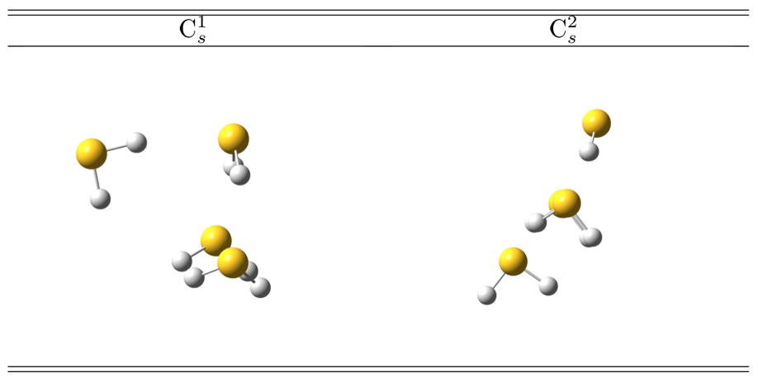
Figure 6 Fluctuation between C_{s}¹ and C_{s}² structures for (H₂S)₄–

Dyson orbitals of electron detachment are close to five or six H nuclei, respectively, in the C_{s}¹ and C_{s}² structures. Volumes enclosed by the corresponding red contours of Figure 6 span regions outside nearby S-H bonds. Orthogonalization to occupied, valence orbitals results in the smaller, green contours and implies delocalization over a larger volume. The C₄ Dyson orbital resembles that of C₃ (H₂S)₃⁻, but with a higher symmetry axis. A symmetric pattern of delocalization results in the S₄ case.
The dipole moments of the optimized neutral (H₂S)₃ and (H₂S)₄, which were calculated in a previous study with MP2/aug-cc-PVTZ^{29b} and verified by us in this study with coupled cluster theory, are not large enough to bind an excess electron to their dipole field. The dipole moments of the uncharged (H₂S)₃ and (H₂S)₄ clusters calculated at the geometries of the anions, on the other hand, turn out sufficiently large (Table 4). This suggests that the excess electron causes nuclear rearrangements to the H₂S clusters to enable the electrostatic binding of the diffuse electron. The short distances between the extra electron’s largest amplitudes and the nearest protons indicates the importance of the neutral cluster’s electrostatic potential, as well as of the exchange and electron correlation, in stabilizing the extra negative charge.

Table 4 Calculated dipole moments at the CCSD/aug²-cc-pVTZ level of theory for neutral (H₂S)₃ at the optimized neutral structure and at the optimized anion structure. The dipole moments are given in Debye.
 | μ_{neutral} | Anion geometry | μ_{anion}
(H₂S)₃ | 0.56 | C₃ | 1.93
(H₂S)₄ | 1.39 | C_{s}¹ | 3.49
 |  | C_{s}² | 4.37

Summary
To summarize, we have prepared and characterized the dipole-bound anions of (H₂S)₃ and (H₂S)₄ with our specialized RET-aPES apparatus. The interaction between the excess electrons and neutral H₂S trimer and tetramer induces structural distortions in the cluster frameworks, which enhance their dipole moments and facilitate the binding of diffuse electrons. This study has furthered our understanding of solvated electrons in clusters.

Acknowledgement
This material is based on work supported by the U.S. National Science Foundation under Grant No. CHE-1664182 (K.H.B.). Vince

Certain commercial equipment, instruments, or materials (or suppliers, or software, ...) are identified in this paper to foster understanding. Such identification does not imply recommendation or endorsement by the National Institute of Standards and Technology, nor does it imply that the materials or equipment identified are necessarily the best available for the purpose.

References
- E.Alizadeh and León Sanche, Chem. Rev., 2012, 112, 5578.
- F. Arnold, Nature, 1981, 294, 732.
- J. Gu, J. Leszczynski and H. F. Schaefer III, Chem. Rev., 2012, 112, 5603.
- L. Turi and P. J. Rossky, Chem. Rev., 2012, 112, 5641.
- (a) J. Savolainen, F. Uhlig, S. Ahmed, P. Hamm and P. Jungwirth, Nat. Chem., 2014, 6, 697. (b) K. R. Siefermann, Y. Liu, E. Lugovoy, O. Link, M. Faubel, U. Buck, B. Winter and B. Abel Nat. Chem., 2010, 2, 274. (c) D. Luckhaus, Y. Yamamoto, T. Suzuki and R. Signorell, Sci. Adv. 2017, 3, e1603224. (d) J. M. Herbert and Marc P. Coons, Annu. Rev. Phys. Chem., 2017. 68, 447.
- (a) W. Weyl, Ann. Phys., 1864, 199, 350. (b) J. Lindner, A. N. Unterreiner and P. Vöhringer, Chem. Phys. Chem., 2006, 7, 363. (c) F. A. Uribe, T. Sawada and A. J. Bard, Chem. Phys. Lett., 1983, 97, 243. (d) E. Zurek, P. P. Edwards and R. A. Hoffmann, Angew. Chem., Int. Ed. 2009, 48, 8198.
- Z. Wang, J. Liu, M. Zhang, R. I. Cukier and Y. Bu, Phys. Rev. Lett., 2012, 108, 207601.
- (a) C. Silva, P. K. Walhout, P. J. Reid and P. F. Barbara, J. Phys. Chem. A, 1998, 102, 5701. (b) M. J. Tauber, C. M. Stuart and R. A. Mathies, J. Am. Chem. Soc., 2004, 126, 3414. (c) A. Thaller, R. Laenen and A. Laubereau, J. Chem. Phys., 2006, 124, 024515. (d) A. T. Shreve, M. H. Elkinsa and D. M. Neumark, Chem. Sci., 2013, 4, 1633.
- (a) C. Xia, J. Peon, and B. J. Kohler, Chem. Phys. 2002, 117, 8855. (b) I. A. Shkrob and J. Sauer, J. Phys. Chem. A, 2002, 106, 9120. (c) S. C. Doan and B. J. Schwartz, J. Phys. Chem. Lett., 2013, 4, 1471.
- (a) R. E. Larsen, W. J. Glover and B. J. Schwartz, Science, 2010, 329, 65. (b) L. Turi, and A. Madarász, Science, 2011, 331, 1387.
- R. M. Young and D. M. Neumark, Chem. Rev., 2012, 112, 5553.
- A. W. Castleman and K. H. Bowen, J. Phys. Chem., 1996, 100, 12911.
- J. V. Coe, G. H. Lee, J. G. Eaton, S. T. Arnold, H. W. Sarkas, C. Ludewigt, H. Haberland, D. R. Worsnop and K. H. Bowen, J. Chem. Phys., 1990, 92, 3980.
- J. R. Roscioli, N. I. Hammer and M. A. Johnson, J. Phys. Chem. A, 2006, 110, 24.
- N. I. Hammer, J. W. Shin, J. M. Headrick, E. G. Diken, J. R. Roscioli, G. H. Weddle and M. A. Johnson, Science, 2004, 306, 675.
- T. Sommerfeld and K. D. Jordan, J. Am. Chem. Soc., 2006, 128, 5828.
- H. M. Lee, S. Lee and K. S. Kim, J. Chem. Phys., 2003, 119, 187.
- J. R. R. Verlet, A. E. Bragg, A. Kammrath, O. Cheshnovsky and D. M. Neumark, Science, 2005, 307, 93.
- L. Turi, W. S. Sheu, P. J. Rossky, Science, 2005, 309, 914.
- L. A. Posey, P. J. Campagnola, M. A. Johnson, G. H. Lee, J. G. Eaton and K. H. Bowen, J. Chem. Phys., 1998, 91, 6536.
- H. Haberland and K. H. Bowen, in Clusters of Atoms and Molecules, ed., H. Haberland (Springer-Verlag: Heidelberg, 1993), 134-153.
- G. H. Lee, S. T. Arnold, J. G. Eaton, H. W. Sarkas, K. H. Bowen, C. Ludewigt and H. Haberland, Z. Phys. D., 1991, 20, 9.
- (a) H. W. Sarkas, S. T. Arnold, J. G. Eaton, G. H. Lee and K. H. Bowen, J. Chem. Phys., 2002, 116, 5731. (b) I. R. Lee, W. Lee and A. H. Zewail, Chem. Phys. Chem. 2008, 9, 83. (c) T. Sommerfeld, J. Phys. Chem. A, 2008, 112, 11817.
- M. Gutowski, C. S. Hall, L. Adamowicz, J. H. Hendricks, H. L. de Clercq, S. A. Lyapustina, J. M. Nilles, S.-J. Xu and K. H. Bowen, Phys, Rev. Lett., 2002, 88, 143001.
- (a) T. Takayanagi, T. Hoshino, K. Takahashi, Chem. Phys., 2006, 324, 679. (b) M. Mitsui,N. Ando, S. Kokubo, A. Nakajima and K. Kaya, Phys. Rev. Lett., 2003, 91, 153002.
- A. Kammrath, Jan R. R. Verlet, G. B. Griffin and Daniel M. Neumark, J. Chem. Phys., 2006, 125, 171102.
- (a)T. Maeyama, K. Yoshida and A. Fujii, J. Phys. Chem. A, 2012, 116, 3771. (b) M. Seydou, A. Modelli, B. Lucas, K. Konate, C. Desfrancois and J.P. Schermann, Eur. Phys. J. D, 2005, 35, 199. (c) T. Maeyama, Y. Negishi, T. Tsukuda, I. Yagia and N. Mikami, Phys. Chem. Chem. Phys., 2006, 8, 827.
- M. Mitsui, A. Nakajimaa and K. J. Kaya, Chem. Phys., 2002, 117, 9740.
- (a) A. Das, P. K. Mandal, F. J. Lovas, C. Medcraft, N. R. Walker. E. Arunan, Angew. Chem. Int. Ed., 2018, 57, 15199. (b) Y. N. Kalugina, D.A. Shuchugashev, V.N. Cherepanov, Chem. Phys. Lett., 2018, 692, 184.
- S. M. Ciborowski, R. M. Harris, G. Liu, C. J. Martinez-Martinez, P. Skurski, and K. H. Bowen, 2019, J. Chem. Phys., 150, 161103.
- S. M. Ciborowski, G. Liu, J. D. Graham, A. M. Buytendyk and K. H. Bowen, Eur. Phys. J. D, 2018, 72, 139.
- E. F. Belogolova, G. Liu, E. P. Doronina, S. Ciborowski, V. F. Sidorkin and K. H. Bowen, J. Phys. Chem. Lett., 2018, 9, 1284.
- X. Zhang, G. Liu, S. Ciborowski and K. Bowen, Angew. Chem. Int. Ed. 2017, 56, 9897.
- V. Dribinski, A. Ossadtchi, V. A. Mandelshtam and H. Reisler, Rev. Sci. Instrum. 2002, 73, 2634.
- J. H. Hendricks, H. L. De Clercq, C. B. Freidhoff, S. T. Arnold, J. G. Eaton, C. Fancher, S. A. Lyapustina, J. T. Snodgrass and K. H. Bowen, J. Chem. Phys., 2002, 116, 7926.
- K. Raghavachari, G.W. Trucks, J.A. Pople and M. Head-Gordon, Chem. Phys. Lett., 1989, 157, 479-483.
- R. Krishnan, J.S. Binkley, R. Seeger and J.A. Pople, J. Chem. Phys., 1980, 72, 650.
- T. Clark, J. Chandrasekhar, G.W. Spitznagel and P.v.R. Schleyer, J. Comput. Chem., 1983, 4 294.
- A.D. McLean and G.S. Chandler, J. Chem. Phys. 1980, 72, 5639.
- M. Czapla, J. Simons and P. Skurski, Phys. Chem. Chem. Phys, 2018, 20, 21739.
- J. V. Ortiz, Chem. Phys. Lett., 1998, 296, 494.
- J. V. Ortiz. Chem. Phys. Lett., 1998, 297, 193.
- J.V. Ortiz, Wiley Interdisciplinary Reviews: Computational Molecular Science, 2013, 3, 123.
- J. V. Ortiz, Annual Reports in Computational Chemistry, 13, 139-182, Elsevier, 2017.
- T. H. Dunning, J. Chem. Phys., 1989, 90, 1007.
- R.A. Kendall, T.H. Dunning and R.J. Harrison, J. Chem. Phys., 1992, 96, 6796.
- D.E. Woon and T.H. Dunning, J. Chem. Phys., 1993, 98, 1358.
- M.J. Frisch, G.W. Trucks, H.B. Schlegel, G.E. Scuseria, M.A. Robb, J.R. Cheeseman, G. Scalmani, V. Barone, G.A. Petersson, H. Nakatsuji, X. Li, M. Caricato, A.V. Marenich, J. Bloino, B.G. Janesko, R. Gomperts, B. Mennucci, H.P. Hratchian, J.V. Ortiz, A.F. Izmaylov, J.L. Sonnenberg, D. Williams-Young, F. Ding, F. Lipparini, F. Egidi, J. Goings, B. Peng, A. Petrone, T. Henderson, D. Ranasinghe, V.G. Zakrzewski, J. Gao, N. Rega, G. Zheng, W. Liang, M. Hada, M. Ehara, K. Toyota, R. Fukuda, J. Hasegawa, M. Ishida, T. Nakajima, Y. Honda, O. Kitao, H. Nakai, T. Vreven, K. Throssell, J. Montgomery, J.A., J.E. Peralta, F. Ogliaro, M.J. Bearpark, J.J. Heyd, E.N. Brothers, K.N. Kudin, V.N. Staroverov, T.A. Keith, R. Kobayashi, J. Normand, K. Raghavachari, A.P. Rendell, J.C. Burant, S.S. Iyengar, J. Tomasi, M. Cossi, J.M. Millam, M. Klene, C. Adamo, R. Cammi, J.W. Ochterski, R.L. Martin, K. Morokuma, O. Farkas, J.B. Foresman and D.J. Fox, Gaussian 16, Gaussian, Inc., Wallingford CT, 2016.
- M. J. Frisch, G. W. Trucks, H. B. Schlegel, G. E. Scuseria, M. A. Robb, J. R. Cheeseman, G. Scalmani, V. Barone, G. A. Petersson, H. Nakatsuji, X. Li, M. Caricato, A. V. Marenich, J. Bloino, B. G. Janesko, R. Gomperts, B. Mennucci, H. P. Hratchian, J. V. Ortiz, A. F. Izmaylov, J. L. Sonnenberg, D. Williams-Young, F. Ding, F. Lipparini, F. Egidi, J. Goings, B. Peng, A. Petrone, T. Henderson, D. Ranasinghe, V. G. Zakrzewski, J. Gao, N. Rega, G. Zheng, W. Liang, M. Hada, M. Ehara, K. Toyota, R. Fukuda, J. Hasegawa, M. Ishida, T. Nakajima, Y. Honda, O. Kitao, H. Nakai, T. Vreven, K. Throssell, J. A. Montgomery, Jr., J. E. Peralta, F. Ogliaro, M.J. Bearpark, J. J. Heyd, E. N. Brothers, K. N. Kudin, V. N. Staroverov, T. A. Keith, R. Kobayashi, J. Normand, K. Raghavachari, A. P. Rendell, J. C. Burant, S. S. Iyengar, J. Tomasi, M. Cossi, J. M. Millam, M. Klene, C. Adamo, R. Cammi, J. W. Ochterski, R. L. Martin, K. Morokuma, O. Farkas, J. B. Foresman and D. J. Fox, Gaussian Development Version, Revision I.14+, Gaussian, Inc., Wallingford CT, 2018.
- R. Dennington, T.A. Keith and J.M. Millam, GaussView, Version 6, Semichem Inc., Shawnee Mission, KS, 2016.
- H. M. Lee, S. B. Suh, P. Tarakeshwar and K. S. Kim, J. Chem. Phys., 2005, 122, 044309.
- (a) N. I. Hammer, J. R. Roscioli, M. A. Johnson, E. M. Myshakin, and K. D. Jordan, J. Phys. Chem. A, 2005, 109, 11526. (b) J. W. Shin, N. I. Hammer, J. M. Headrick and M. A. Johnson, Chem. Phys. Lett., 2004, 399, 349.
- S. N. Eustis, D. Radisic, K. H. Bowen, R. A. Bachorz, M. Haranczyk, G. Schenter, and M. Gutowski, Science, 2008, 319, 936.

