# Electrolytic Conductivity Measurements for Ten Ionic Liquids

Jason E. Bara,1* Alexia Finotello,2 Joseph W. Magee,3* & Richard D. Noble4

1. University of Alabama, Department of Chemical & Biological Engineering, Tuscaloosa, AL USA 35487-0203

2. The Dow Chemical Company, Packaging and Specialty Plastics – Infrastructure, Consumer and Transportation, Lake Jackson, TX USA 77566

3. Applied Chemicals and Materials Division, National Institute of Standards and Technology, Boulder, CO USA 80305-3337

4. University of Colorado, Department of Chemistry, Boulder, CO USA 80309-0215

*Corresponding authors’ email addresses: [jbara@eng.ua.edu](mailto:jbara@eng.ua.edu) (J. E. Bara) and [joe.magee@nist.gov](mailto:joe.magee@nist.gov) (J. W. Magee)

## Abstract

Electrolytic conductivity measurements for a total of ten ionic liquids (ILs) (four N-alkyl-N-methyl pyrrolidinium cations ([Cnmpyr]) and six 1-(methyl)benzyl-3-alkyl imidazolium cations ([Bnmim] or [MeBnCnmim]), all paired with bistriflimide ([Tf2N]) anions) are reported at p = 0.1 MPa over T = 293.15 – 323.15 K. All samples were thoroughly dried under vacuum and their water content before and after measurements was determined by Karl Fischer titration. For the measurements, an impedance bridge technique was used in conjunction with a sealed cell equipped with platinum black electrodes. The cell constant (Kcell = 101 m-1) was determined with standard aqueous KCl solutions before and after measurements. The results show that electrolytic conductivity increases with increasing temperature in both families of ILs, while conductivity decreases as the length of the IL side chain increases, which is associated with increase in IL viscosity. Conductivities of the pyrrolidinium ILs were consistent with other data for these compounds already reported in the literature. The conductivities of the 1-benzyl-3-alkyl imidazolium ILs are reduced by ~67-75% compared to the analogous 1-alkyl-3-methylimidazolium ILs

## Introduction

Ionic liquids (ILs) are defined as organic salts with melting points at or below 100 oC.1 They are composed of a variety of organic cations (e.g., ammonium, imidazolium, phosphonium, etc.) paired with organic or inorganic anions. ILs exhibit a number of interesting properties which have spurred research into their use in many applications.1 Thermal stability, negligible vapor pressures, tunable miscibility and solvation, and high electrolytic conductivities among organic molecules,1-7 are some of the intrinsic properties of ILs which have made them attractive alternatives to conventional organic solvents. The ability to select the functional group(s) on the IL cation (particularly for imidazolium species) and pairing with various anions which provides a facile means of designing ILs with targeted properties. T There are easily 106 ILs which can be designed and directly synthesized using only commercially available substances8 (with vastly more achievable through binary and ternary mixtures of ILs),9, 10 although only a handful of ILs are commonly used in the literature.11

Over the past 20+ years, detailed knowledge of the properties of ILs has been developed through both experiments and computations, developed from Fundamentally, the systematic studies of properties in homologous series of ILs (e.g., the [Cnmim][Tf2N] series).5, 6, 12, 13Density14-16, viscosity,16-18 gas solubility,19 electrolytic conductivity,20 and even IL vaporization can now be accurately predicted/modeled without requiring experimental measurements. .

However, we note that some functionalities, especially benzyl groups, attached to imidazole cations have received very little attention in the literature despite their relative ease of synthesis and low cost.21 The presence of benzylic functional groups on the imidazolium cation is of interest due to the connection of these ILs to poly(IL)22 and ionene23 materials. This study is focused on the temperature dependence of electrolytic conductivity for four pyrrolidinium ILs and six imidazolium ILs, the densities and viscosities of which have been previously reported by our group.21 Both families of ILs have been widely researched for a variety of applications.2, 4, 6, 7, 10, 24-44 Property trends with temperature and increasing alkyl-chain length substituent, as well as comparison between the pyrrolidinium and imidazolium cations are discussed. Empirical models for density and electrolytic conductivity with temperature are presented for each substance.

## Materials

Tables 1 and 2 illustrate the structures of the pyrrolidinium and imidazolium ILs studied in this work. All pyrrolidinium-based ILs were synthesized by W. A. Henderson.38, 43, 45 Benzyl-substituted imidazolium ILs were synthesized as described in our prior works.22, 29, 30, 36

**Table 1****.** The four pyrrolidinium ILs ([Cnmpyr][Tf2N]) studied in this work. Cation structures and molar masses shown in left column, names in center column, acronyms and CAS numbers in right column.

|  |  |  |
| --- | --- | --- |
| **Structure / MW** | **Name** | **Acronym/CAS #** |
| 408.37 g/mol | 1-methyl-1-propylpyrrolidinium bis[(trifluoromethyl)sulfonyl]imide (commonly, bistriflimide) | [C3pyr][Tf2N]  223437-05-6 |
| 422.40 g/mol | 1-methyl-1-butylpyrrolidinium bistriflimide | [C4pyr][Tf2N]  223437-11-4 |
| 436.43 g/mol | 1-methyl-1-pentylpyrrolidinium bistriflimide | [C5pyr][Tf2N]  380497-17-6 |
| 450.46 g/mol | 1-methyl-1-hexylpyrrolidinium bistriflimide | [C6pyr][Tf2N]  380497-19-8 |

**Table 2.** The six imidazolium ILs ([Bnmim][Tf2N] and [MeBCnim][Tf2N]) studied in this work. Cation structures and molar masses shown in left column, names in center column, acronyms and CAS numbers in right column.

|  |  |  |
| --- | --- | --- |
| **Structure / MW** | **Name** | **Acronym/CAS #** |
| 453.37 g/mol | 1-Benzyl-3-methylimidazolium bistriflimide | [Bnmim][Tf2N]  433337-24-7 |
| 481.43 g/mol | 1-[(4-methylphenyl)methyl]-3-ethylimidazolium bistriflimide | [MeBnC2im][Tf2N]  2407944-66-3 |
| 509.48 g/mol | 1-[(4-methylphenyl)methyl]-3-butylimidazolium bistriflimide | [MeBnC4im][Tf2N]  2407944-68-5 |
| 537.54 g/mol | 1-[(4-methylphenyl)methyl]-3-hexylimidazolium bistriflimide | [MeBnC6im][Tf2N]  2407944-70-9 |
| 565.59 g/mol | 1-[(4-methylphenyl)methyl]-3-octyllimidazolium bistriflimide | [MeBnC8im][Tf2N]  2407944-72-1 |
| 593.64 g/mol | 1-[(4-methylphenyl)methyl]-3-decyllimidazolium bistriflimide | [MeBnC10im][Tf2N]  2407944-74-3 |

All IL samples were thoroughly dried under vacuum while stirring at ambient temperature before thermophysical property measurements were made. Samples were stored under an N2 atmosphere (< 5 ppm H2O) inside a glove box after drying.5

Water content of each IL sample before and after electrolytic conductivity measurement was measured using a Metrohm 756 Karl Fischer Coulometer5, 6 and determined to be < 100 ppm (mass fraction < 0.001). The ASTM Test method E 1064-00 procedure was followed for each titration using 1.0 mL samples of each IL delivered by plastic syringes.5, 6

### Electrolytic Conductivity

Electrolytic (ionic) conductivity was determined using an apparatus and experimental procedure that has been previously reported.5, 6 An AC impedance bridge technique was used to determine the IL conductivities, where two electrode plates are used to measure the sample impedance.5, 6, 46 The impedance of an IL is composed of resistive and capacitive contributions. At infinite frequencies, the capacitive component is negligible, which allows for the calculation of the resistance of an IL. The liquid commercial conductivity cell used for these measurements is made of borosilicate glass with two platinum black electrodes and can be sealed from the atmosphere (to keep IL sample dry).5, 6 The conductivity cell was calibrated at 298.15 K using commercially available conductivity standards (potassium chloride solutions) to determine the cell constant (average of 101±0.1 m-1). An Agilent 4284A precision LCR (inductance, capacitance, and resistance) meter was used to generate the drive voltage (1.0 V) and Capacitance(C)-Resistance (R) mode was used to describe the system. An oil bath was used as the heat source for the conductivity cell. IL conductivities were measured at 293.15 K, 298.15 K, 308.15 K, and 323.15 K.

For each measurement, the conductivity cell was cleaned and soaked in EtOH and then dried with hot (~80 oC) N2 gas. Inside of an air-free glove box, the IL sample was loaded into the cell. The conductivity cell was then capped, and removed from the glove box, placed into the oil bath and connected to the LCR meter. At each temperature, frequency (*f*) varied from 800 Hz to 5000 Hz, the C and R values of each were measured. R was calculated at *f* ∞ from the intercept of the slope of R versus *1/f .*6 The resistance at infinite frequency was then used to calculate the conductivity (κ) from Eqn. 1.

** (1)**

Based on the uncertainty of the water bath temperature and the uncertainty of the resistance R, the expanded uncertainty (k = 2) of electrolytic conductivity κ is 2 %.5, 6

## Results and Discussion

### Temperature Dependence of Electrolytic Conductivity of ILs

The electrical properties were measured as a function frequency at each temperature (293.15 K, 298.15 K, 308.15 K, and 323.15 K) using an AC impedance bridge technique.5, 6 The stability of temperature control is ± 0.02 K and standard uncertainty of the temperature measurement, u(T), is 0.05 K.

Figure 1 shows the electrolytic conductivity measurements relative to temperature for [Cnmpyr][Tf2N] ILs. Figure 2 shows the electrolytic conductivity measurements relative to temperature for the [Bnmim][Tf2N] and [MeBnCnim][Tf2N] ILs. The experimental data are provided in tabulated form as Supplementary Information.

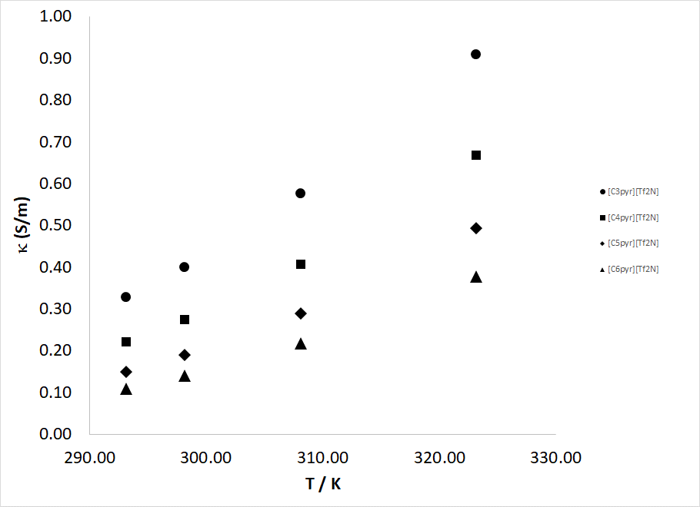

**Figure 1.** Electrolytic conductivity relative to temperature for pyrrolidinium ILs. Filled circles = [C3mpyr][Tf2N]; Filled squares = [C4mpyr][Tf2N]; Filled diamonds = [C5mpyr][Tf2N]; filled triangles = [C6mpyr][Tf2N].

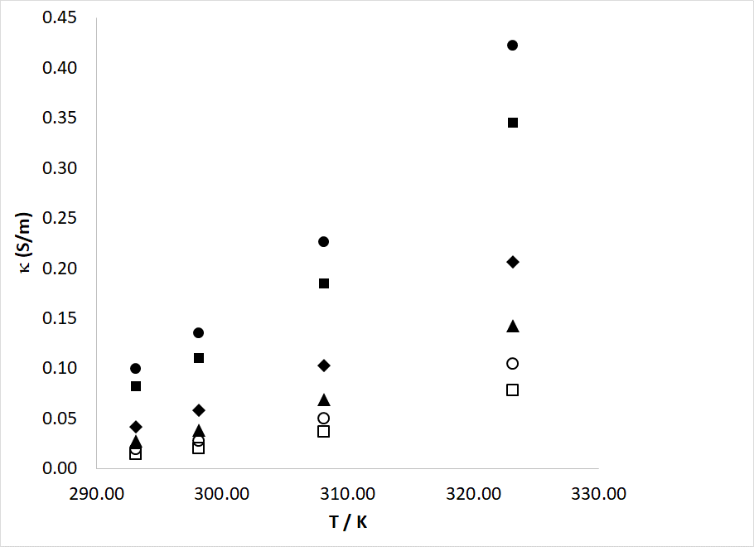

**Figure 2.** Electrolytic conductivity relative to temperature for imidazolium ILs. Filled circles = [Bnmim][Tf2N]; Filled squares = [MeBnC2im][Tf2N]; Filled diamonds = [MeBnC4im][Tf2N]; filled triangles = [MeBnC6im][Tf2N]; hollow circles = [MeBnC8im][Tf2N]; hollow squares = [MeBnC10im][Tf2N].

As temperature increases, conductivity increases for all ILs in this study, which is consistent with published results on other ILs.5, 6 As alkyl-chain substituent increases and viscosity increases, conductivity decreases. The relationship between the measured values of  for each IL in this study and temperature can be described by the 2nd order polynomial equation of the form,

k (S/m) = a · T(K)2 – b · T(K) + c, **(2)**

The coefficients of Eq 2 were determined for each IL and are reported in Table 3 for [Cnmpyr][Tf2N] ILs and Table 4 for [Bnmim][Tf2N] and [MeBnCnim][Tf2N] ILs.

**Table 3:** Coefficients for Eqn. 2 relating conductivity to temperature in [Cnmpyr][Tf2N] ILs.

|  |  |  |  |  |
| --- | --- | --- | --- | --- |
| **IL** |  |  |  | **AAPD (%)** |
| [C3mpyr][Tf2N] | 1.88182 x 10-4 | 9.65537 x 10-2 | 1.24597 x 101 | 0.08 |
| [C4mpyr][Tf2N] | 1.64545 x 10-4 | 8.64745 x 10-2 | 1.14295 x 101 | 0.02 |
| [C5mpyr][Tf2N] | 1.42000 x 10-4 | 7.60 0446x 10-2 | 1.02388 x 101 | 0.01 |
| [C6mpyr][Tf2N] | 1.16939 x 10-4 | 6.31290 x 10-2 | 8.56660 x 100 | 0.10 |

**Table 4:** Coefficients for Eqn. 2 relating conductivity to temperature in [Bnmim][Tf2N] and [MeBnCnim][Tf2N] ILs.

|  |  |  |  |  |
| --- | --- | --- | --- | --- |
| **IL** |  |  |  | **AAPD (%)** |
| [Bnmim][Tf2N] | 1.53464 x 10-4 | 8.38290 x 10-2 | 1.14858 x 101 | 0.25 |
| [MeBnC2im][Tf2N] | 1.26630 x 10-4 | 6.92641 x 10-2 | 9.50440 x 100 | 0.10 |
| [MeBnC4im][Tf2N] | 9.12909 x 10-5 | 5.07839 x 10-2 | 7.08360 x 100 | 0.66 |
| [MeBnC6im][Tf2N] | 7.28212 x 10-5 | 4.10594 x 10-2 | 5.80619 x 100 | 0.44 |
| [MeBnC8im][Tf2N] | 5.41182 x 10-5 | 3.05366 x 10-2 | 4.32064 x 100 | 0.43 |
| [MeBnC10im][Tf2N] | 4.24515 x 10-5 | 2.40561 x 10-2 | 3.41836 x 100 | 0.94 |

## AAPD = average absolute percent deviation between experimental data and fit.

The experimental data for the ILs studied in this work were also found to be well-described by the Vogler-Fulcher-Tammann (VFT) Equation, and these details are provided in the Supporting Information.

An analysis of the conductivities of the [Bnmim][Tf2N] and [MeBnCnim] ILs relative to analogous [Cnmim][Tf2N] ILs5, 6, 47 reveals that the introduction of the benzyl or methylbenzyl functionality reduces conductivity by 70 – 88%, primarily owed to the corresponding increases in viscosity.21 Literature data for each [Cnmpyr][Tf2N] IL and selected analogous [Cnmim][Tf2N] ILs are provided as Supporting Information for comparison.

## Conclusions

The temperature dependence of electrolytic conductivity of four pyrrolidinium and six imidazolium ILs has been reported herein. The experimental results show that in both types of ILs the electrolytic conductivity decreases with increasing length of the n-alkyl substituent and increases with increasing temperature. The measured data are well-described by 2nd order polynomials as well as the VFT Equation. The presence of benzyl groups on the imidazolium cations resulted in greatly reduced conductivity compared to analogous [Cnmim][Tf2N] ILs, which can be attributed to a larger molar volume (i.e., less charge per mass) and increased viscosity.

## Acknowledgements

The authors acknowledge the following agencies for partial financial support of this research: National Science Foundation Grant No. EEC 0437144, the NASA Graduate Student Research Program, the US Department of Education GAANN Fellowship, and the Membrane Applied Science and Technology Center.

**Supplemental Data**

The numerical values of the measurements and their estimate standard uncertainties are reported in the supplemental information, available on the journal Web site. Following the publication by the journal the data and metadata used in this manuscript will be made available at <https://doi.org/10.18434/mds2-2724> by NIST Management of Institutional Data Assets.

**Notes**

Commercial equipment, instruments, or materials are identified only in order to adequately specify certain procedures. In no case does such identification imply recommendation or endorsement by the National Institute of Standards and Technology, nor does it imply that the products identified are necessarily the best available for the purpose. The authors declare no competing financial interest.

**Literature Cited**

(1) Wasserscheid, P.; Welton, T. *Ionic Liquids in Synthesis*; Wiley, 2003.

(2) Camper, D.; Becker, C.; Koval, C.; Noble, R. Diffusion and solubility measurements in room temperature ionic liquids. *Industrial & Engineering Chemistry Research* **2006**, *45* (1), 445-450. DOI: 10.1021/ie0506668.

(3) Husson-Borg, P.; Majer, V.; Gomes, M. F. C. Solubilities of oxygen and carbon dioxide in butyl methyl imidazolium tetrafluoroborate as a function of temperature and at pressures close to atmospheric pressure. *Journal of Chemical and Engineering Data* **2003**, *48* (3), 480-485. <Go to ISI>://000182765600009.

(4) Xu, H. T.; Zhao, D. C.; Xu, P.; Liu, F. Q.; Gao, G. Conductivity and viscosity of 1-allyl-3-methyl-imidazolium chloride plus water and plus ethanol from 293.15 K to 333.15 K. *Journal of Chemical and Engineering Data* **2005**, *50* (1), 133-135. <Go to ISI>://000226330400031.

(5) Widegren, J. A.; Magee, J. W. Density, viscosity, speed of sound, and electrolytic conductivity for the ionic liquid 1-hexyl-3-methylimidazolium bis(trifluoromethylsulfonyl)imide and its mixtures with water. *Journal of Chemical and Engineering Data* **2007**, *52* (6), 2331-2338. <Go to ISI>://000250958800042.

(6) Widegren, J. A.; Saurer, E. M.; Marsh, K. N.; Magee, J. W. Electrolytic conductivity of four imidazolium-based room-temperature ionic liquids and the effect of a water impurity. *Journal of Chemical Thermodynamics* **2005**, *37* (6), 569-575. <Go to ISI>://000229953000005.

(7) Bara, J. E.; Carlisle, T. K.; Gabriel, C. J.; Camper, D.; Finotello, A.; Gin, D. L.; Noble, R. D. Guide to CO2 Separations in Imidazolium-Based Room-Temperature Ionic Liquids. *Industrial & Engineering Chemistry Research* **2009**, *48* (6), 2739-2751, Review. DOI: 10.1021/ie8016237.

(8) Rogers, R. D.; Seddon, K. R. Ionic Liquids--Solvents of the Future? *Science* **2003**, *302* (5646), 792-793. <http://www.sciencemag.org/content/302/5646/792.short>.

(9) Chatel, G.; Pereira, J. F. B.; Debbeti, V.; Wang, H.; Rogers, R. D. Mixing ionic liquids - "simple mixtures" or "double salts"? *Green Chemistry* **2014**, *16* (4), 2051-2083, 10.1039/C3GC41389F. DOI: 10.1039/C3GC41389F.

(10) Finotello, A.; Bara, J. E.; Narayan, S.; Camper, D.; Noble, R. D. Ideal gas solubilities and solubility selectivities in a binary mixture of room-temperature ionic liquids. *J. Phys. Chem. B* **2008**, *112* (8), 2335-2339, Article. DOI: 10.1021/jp0755721.

(11) Scalfani, V. F.; Al Alshaikh, A.; Bara, J. E. Analysis of the Frequency and Diversity of 1,3-Dialkylimidazolium Ionic Liquids Appearing in the Literature. *Ind. Eng. Chem. Res.* **2018**, *57* (47), 15971-15981, 10.1021/acs.iecr.8b02573. DOI: 10.1021/acs.iecr.8b02573.

(12) Slattery, J. M.; Daguenet, C.; Dyson, P. J.; Schubert, T. J. S.; Krossing, I. How to predict the physical properties of ionic liquids: A volume-based approach. *Angewandte Chemie-International Edition* **2007**, *46* (28), 5384-5388. <Go to ISI>://000248063200028.

(13) Tariq, M.; Forte, P. A. S.; Gomes, M. F. C.; Lopes, J. N. C.; Rebelo, L. P. N. Densities and refractive indices of imidazolium- and phosphonium-based ionic liquids: Effect of temperature, alkyl chain length, and anion. *Journal of Chemical Thermodynamics* **2009**, *41* (6), 790-798. DOI: 10.1016/j.jct.2009.01.012.

(14) Gardas, R. L.; Coutinho, J. A. P. Extension of the Ye and Shreeve group contribution method for density estimation of ionic liquids in a wide range of temperatures and pressures. *Fluid Phase Equilib.* **2008**, *263* (1), 26-32. DOI: 10.1016/j.fluid.2007.09.016.

(15) Ye, C. F.; Shreeve, J. M. Rapid and accurate estimation of densities of room-temperature ionic liquids and salts. *Journal of Physical Chemistry A* **2007**, *111* (8), 1456-1461, Article. DOI: 10.1021/jp066202k.

(16) Paduszyński, K. Extensive Databases and Group Contribution QSPRs of Ionic Liquids Properties. 1. Density. *Industrial & Engineering Chemistry Research* **2019**, *58* (13), 5322-5338. DOI: 10.1021/acs.iecr.9b00130.

(17) Paduszyński, K.; Domańska, U. Viscosity of Ionic Liquids: An Extensive Database and a New Group Contribution Model Based on a Feed-Forward Artificial Neural Network. *Journal of Chemical Information and Modeling* **2014**, *54* (5), 1311-1324. DOI: 10.1021/ci500206u.

(18) Sprenger, K. G.; Jaeger, V. W.; Pfaendtner, J. The General AMBER Force Field (GAFF) Can Accurately Predict Thermodynamic and Transport Properties of Many Ionic Liquids. *The Journal of Physical Chemistry B* **2015**, *119* (18), 5882-5895. DOI: 10.1021/acs.jpcb.5b00689.

(19) Shannon, M. S.; Tedstone, J. M.; Danielsen, S. P. O.; Hindman, M. S.; Irvin, A. C.; Bara, J. E. Free Volume as the Basis of Gas Solubility and Selectivity in Imidazolium-Based Ionic Liquids. *Industrial & Engineering Chemistry Research* **2012**, *51* (15), 5565-5576. DOI: 10.1021/ie202916e.

(20) Dhakal, P.; Shah, J. K. A generalized machine learning model for predicting ionic conductivity of ionic liquids. *Molecular Systems Design & Engineering* **2022**, *7* (10), 1344-1353, 10.1039/D2ME00046F. DOI: 10.1039/D2ME00046F.

(21) Bara, J. E.; Finotello, A.; Magee, J. W.; Qian, S.; O’Harra, K. E.; Dennis, G. P.; Noble, R. D. 110th Anniversary: Properties of Imidazolium-Based Ionic Liquids Bearing Both Benzylic and n-Alkyl Substituents. *Industrial & Engineering Chemistry Research* **2019**, *58* (38), 17956-17964. DOI: 10.1021/acs.iecr.9b03159.

(22) Bara, J. E.; Lessmann, S.; Gabriel, C. J.; Hatakeyama, E. S.; Noble, R. D.; Gin, D. L. Synthesis and performance of polymerizable room-temperature ionic liquids as gas separation membranes. *Industrial & Engineering Chemistry Research* **2007**, *46* (16), 5397-5404, Article. DOI: 10.1021/ie0704492.

(23) Mittenthal, M. S.; Flowers, B. S.; Bara, J. E.; Whitley, J. W.; Spear, S. K.; Roveda, J. D.; Wallace, D. A.; Shannon, M. S.; Holler, R.; Martens, R.; et al. Ionic Polyimides: Hybrid Polymer Architectures and Composites with Ionic Liquids for Advanced Gas Separation Membranes. *Industrial & Engineering Chemistry Research* **2017**, *56* (17), 5055-5069. DOI: 10.1021/acs.iecr.7b00462.

(24) Anthony, J. L.; Maginn, E. J.; Brennecke, J. F. Solubilities and thermodynamic properties of gases in the ionic liquid 1-n-butyl-3-methylimidazolium hexafluorophosphate. *Journal of Physical Chemistry B* **2002**, *106* (29), 7315-7320. <Go to ISI>://000176955900029.

(25) Arce, A.; Earle, M. J.; Rodriguez, H.; Seddon, K. R. Separation of benzene and hexene by solvent extraction with 1-alkyl-3-methylimidazolium bis{(trifluoromethyl)sulfonyl}amide ionic liquids: effect of the alkyl-substituent length. *Journal of Physical Chemistry B* **2007**, *111* (18), 4732-4736.

(26) Bara, J. E.; Gabriel, C. J.; Carlisle, T. K.; Camper, D. E.; Finotello, A.; Gin, D. L.; Noble, R. D. Gas separations in fluoroalkyl-functionalized room-temperature ionic liquids using supported liquid membranes. *Chemical Engineering Journal* **2009**, *147* (1), 43-50, Article. DOI: 10.1016/j.cej.2008.11.021.

(27) Bara, J. E.; Gabriel, C. J.; Lessmann, S.; Carlisle, T. K.; Finotello, A.; Gin, D. L.; Noble, R. D. Enhanced CO2 separation selectivity in oligo(ethylene glycol) functionalized room-temperature ionic liquids. *Industrial & Engineering Chemistry Research* **2007**, *46* (16), 5380-5386, Article. DOI: 10.1021/ie070437g.

(28) Cadena, C.; Anthony, J. L.; Shah, J. K.; Morrow, T. I.; Brennecke, J. F.; Maginn, E. J. Why is CO2 so soluble in imidazolium-based ionic liquids? *J. Am. Chem. Soc.* **2004**, *126* (16), 5300-5308. DOI: 10.1021/ja039615x.

(29) Camper, D.; Bara, J.; Koval, C.; Noble, R. Bulk-fluid solubility and membrane feasibility of Rmim-based room-temperature ionic liquids. *Industrial & Engineering Chemistry Research* **2006**, *45* (18), 6279-6283, Article. DOI: 10.1021/ie060177n.

(30) Camper, D.; Bara, J. E.; Gin, D. L.; Noble, R. D. Room-Temperature Ionic Liquid-Amine Solutions: Tunable Solvents for Efficient and Reversible Capture Of CO2. *Industrial & Engineering Chemistry Research* **2008**, *47* (21), 8496-8498, Article. DOI: 10.1021/ie801002m.

(31) Camper, D.; Becker, C.; Koval, C.; Noble, R. Low pressure hydrocarbon solubility in room temperature ionic liquids containing imidazolium rings interpreted using regular solution theory. *Industrial & Engineering Chemistry Research* **2005**, *44* (6), 1928-1933. DOI: 10.1021/ie049312r.

(32) Camper, D.; Scovazzo, P.; Koval, C.; Noble, R. D. Gas solubilities in room-temperature ionic liquids. *Industrial & Engineering Chemistry Research* **2004**, *43* (12), 3049-3054. <Go to ISI>://000221859100021.

(33) Carlisle, T. K.; Bara, J. E.; Gabriel, C. J.; Noble, R. D.; Gin, D. L. Interpretation of CO2 solubility and selectivity in nitrile-functionalized room-temperature ionic liquids using a group contribution approach. *Industrial & Engineering Chemistry Research* **2008**, *47* (18), 7005-7012, Article. DOI: 10.1021/ie8001217.

(34) Every, H. A.; Bishop, A. G.; MacFarlane, D. R.; Oradd, G.; Forsyth, M. Transport properties in a family of dialkylimidazolium ionic liquids. *Physical Chemistry Chemical Physics* **2004**, *6* (8), 1758-1765. DOI: 10.1039/b315813f.

(35) Finotello, A.; Bara, J. E.; Camper, D.; Noble, R. D. Room-temperature ionic liquids: Temperature dependence of gas solubility selectivity. *Industrial & Engineering Chemistry Research* **2008**, *47* (10), 3453-3459, Article. DOI: 10.1021/ie0704142.

(36) Finotello, A.; Narayan, S.; Bara, J.; Noble, R. Effect of Aryl and Alkyl-chain Substituents on CO2 Solubility in Imidazolium-based Room-Temperature Ionic Liquids. *Journal of Physical Chemistry B* **2009**, in progress.

(37) Fredlake, C. P.; Crosthwaite, J. M.; Hert, D. G.; Aki, S.; Brennecke, J. F. Thermophysical properties of imidazolium-based ionic liquids. *Journal of Chemical and Engineering Data* **2004**, *49* (4), 954-964. <Go to ISI>://000222535100042

(38) Henderson, W. A.; Passerini, S. Phase behavior of ionic liquid-LiX mixtures: Pyrrolidinium cations and TFSI- anions. *Chemistry of Materials* **2004**, *16* (15), 2881-2885. DOI: 10.1021/cm049942j.

(39) Henderson, W. A.; Young, V. G.; Pearson, W.; Passerini, S.; De Long, H. C.; Trulove, P. C. Thermal phase behaviour of N-alkyl-N-methylpyrrolidinium and piperidinium bis(trifluoromethanesulfonyl)imide salts. *Journal of Physics-Condensed Matter* **2006**, *18* (46), 10377-10390. DOI: 10.1088/0953-8984/18/46/006.

(40) Muhammad, A.; Mutalib, M. I. A.; Wilfred, C. D.; Murugesan, T.; Shafeeq, A. Thermophysical properties of 1-hexyl-3-methyl imidazolium based ionic liquids with tetrafluoroborate, hexafluorophosphate and bis(trifluoromethylsulfonyl)imide anions. *Journal of Chemical Thermodynamics* **2008**, *40* (9), 1433-1438. <Go to ISI>://000262345800013

(41) Wilkes, J. S.; Zaworotko, M. J. Air and Water Stable 1-Ethyl-3-Methylimidazolium Based Ionic Liquids. *Journal of the Chemical Society-Chemical Communications* **1992**, (13), 965-967. <Go to ISI>://A1992JB04600025.

(42) Yim, T.; Lee, H. Y.; Kim, H. J.; Mun, J.; Kim, S.; Oh, S. M.; Kim, Y. G. Synthesis and properties of pyrrolidinium and piperidinium bis(trifluoromethanesulfonyl)imide ionic liquids with allyl substituents. *Bulletin of the Korean Chemical Society* **2007**, *28* (9), 1567-1572. <Go to ISI>://000251301400022

(43) Zhou, Q.; Henderson, W. A.; Appetecchi, G. B.; Montanino, M.; Passerini, S. Physical and Electrochemical Properties of N-Alkyl-N-methylpyrrolidinium Bis(fluorosulfonyl)imide Ionic Liquids: PY13FSI and PY14FSI. *Journal of Physical Chemistry B* **2008**, *112* (43), 13577-13580. DOI: 10.1021/jp805419f.

(44) Zhou, Z. B.; Matsumoto, H.; Tatsumi, K. Structure and properties of new ionic liquids based on alkyl- and alkenyltrifluoroborates. *Chemphyschem* **2005**, *6* (7), 1324-1332. <Go to ISI>://000230521900018.

(45) Appetecchi, G. B.; Scaccia, S.; Tizzani, C.; Alessandrini, F.; Passerini, S. Synthesis of hydrophobic ionic liquids for electrochemical applications. *Journal of the Electrochemical Society* **2006**, *153* (9), A1685-A1691. DOI: 10.1149/1.2213420.

(46) Bard, A. J.; Faulkner, L. R. *Electrochemical Methods: Fundamentals and Applications*; John Wiley & Sons, Inc., 2001.

(47) Nazet, A.; Sokolov, S.; Sonnleitner, T.; Makino, T.; Kanakubo, M.; Buchner, R. Densities, Viscosities, and Conductivities of the Imidazolium Ionic Liquids [Emim][Ac], [Emim][FAP], [Bmim][BETI], [Bmim][FSI], [Hmim][TFSI], and [Omim][TFSI]. *Journal of Chemical & Engineering Data* **2015**, *60* (8), 2400-2411. DOI: 10.1021/acs.jced.5b00285.