**Reference Correlation for the Thermal Conductivity   
of *n*-Hexadecane from the Triple Point to 700 K and up to 50 MPaa)**

**S. A. Monogenidou,1 M. J. Assael,1,a)**

1 *Laboratory of Thermophysical Properties and Environmental Processes,   
Chemical Engineering Department, Aristotle University, Thessaloniki 54636, Greece*

**M. L. Huber2,b)**

2 *Applied Chemicals and Materials Division, National Institute of Standards and Technology,*

*325 Broadway, Boulder, CO 80305, USA*

This paper presents a new wide-ranging correlation for the thermal conductivity of *n*-hexadecane based on critically evaluated experimental data. The correlation is designed to be used with a recently published equation of state, and it is valid from the triple point up to 700 K and pressures up to 50 MPa. We estimate the uncertainty at a 95% confidence level to be 4% over the aforementioned range, with the exception of the dilute-gas range where the uncertainty is 2.7% over the temperature range 583 to 654 K. The correlation behaves in a physically reasonable manner when extrapolated to the full range of the equation of state, but the uncertainties are larger outside of the validated range, and also in the critical region.

Key words: thermal conductivity; transport properties; *n*-hexadecane.

**J. Phys. Chem. Ref. Data, Vol. 47, No. 1, 013103 (2018)**

**CONTENTS**

1. Introduction
2. The Correlation
   1. The dilute-gas limit
   2. The residual term
   3. The critical enhancement term
3. Recommended Values
4. Conclusion

Acknowledgments

1. References

**List of Tables**

1. Thermal conductivity measurements of *n*-hexadecane.
2. Coefficients of Eq. (7) for the residual thermal conductivity of *n*-hexadecane.
3. Evaluation of the *n-*hexadecane thermal conductivity correlation for the primary data.
4. Evaluation of the *n-*hexadecane thermal conductivity correlation for the secondary data.
5. Thermal conductivity values of *n*-hexadecane along the saturation line, calculated by the present correlation.
6. Thermal conductivity values of *n*-hexadecane at selected temperatures and pressures, calculated by the present correlation.

**List of Figures**

1. Temperature–pressure range of the primary experimental thermal conductivity data for *n-*hexadecane.
2. Temperature–density range of the primary experimental thermal conductivity data for *n-*hexadecane.
3. Primary dilute–gas thermal-conductivity of *n*-hexadecane as a function of temperature.
4. Percentage deviations of the dilute-gas limit thermal-conductivity experimental data of *n-*hexadecane from Eq. (6) as a function of temperature.
5. Percentage deviations of primary thermal conductivity experimental data of *n-*hexadecane from the values calculated by the present correlation as a function of temperature.
6. Percentage deviations of primary thermal conductivity experimental data of *n-*hexadecane from the values calculated by the present correlation as a function of pressure.
7. Percentage deviations of primary thermal conductivity experimental data of *n-*hexadecane from the values calculated by the present correlation as a function of density.
8. Thermal conductivity of *n*-hexadecane as a function of temperature for selected pressures
9. Thermal conductivity of *n*-hexadecane as a function of density for selected temperatures
10. **Introduction**

In a series of recent papers, new reference correlations for the thermal conductivity of normal- and parahydrogen,1 water,2 hexafluoride,3 carbon dioxide,4 toluene,5 benzene,6 *n*-pentane and isopentane,7 *n*-hexane,8 cyclopentane,7 cyclohexane,9 *n*-heptane,10 methanol,11 ethanol,12 ethene and propene,13 and ortho-xylene, meta-xylene, para-xylene, ethylbenzene14 and *n-*undecane15 were reported. The work was also extended to refrigerants; thus reference correlations for the thermal conductivity of R245fa16 and R16117 were reported. In this paper, the methodology adopted in the aforementioned papers is extended to developing a new reference correlation for the thermal conductivity of *n-*hexadecane.

The goal of this work is to critically assess the available literature data, and provide a wide-ranging correlation for the thermal conductivity of *n*-hexadecane that is valid over gas, liquid, and supercritical states, and that incorporates densities provided by the new Helmholtz equation of state of Romeo and Lemmon.18

The analysis that will be described will be applied to the best available experimental data for the thermal conductivity. Thus, a prerequisite to the analysis is a critical assessment of the experimental data. For this purpose, two categories of experimental data are defined: primary data, employed in the development of the correlation, and secondary data, used simply for purposes of comparison. According to the recommendation adopted by the Subcommittee on Transport Properties (now known as The International Association for Transport Properties) of the International Union of Pure and Applied Chemistry, the primary data are identified by a well-established set of criteria.19 These criteria have been successfully employed to establish standard reference values for the viscosity and thermal conductivity of fluids over wide ranges of conditions, with uncertainties in the range of 1%. However, in many cases, such a narrow definition unacceptably limits the range of the data representation. Consequently, within the primary data set, it is also necessary to include results that extend over a wide range of conditions, albeit with a poorer accuracy, provided they are consistent with other more accurate data or with theory. In all cases, the accuracy claimed for the final recommended data must reflect the estimated uncertainty in the primary information.

**2. The Correlation**

The thermal conductivity *λ* can be expressed as the sum of three independent contributions, as

, (1)

where *ρ* is the density, *T* is the temperature, and the first term, *λ*ο(*Τ*) = *λ*(0,*Τ*), is the contribution to the thermal conductivity in the dilute-gas limit, where only two-body molecular interactions occur. The final term, Δ*λ*c(*ρ,Τ*), the critical enhancement, arises from the long-range density fluctuations that occur in a fluid near its critical point, which contribute to divergence of the thermal conductivity at the critical point. The term Δ*λ*(*ρ*,*T*), the residual property, represents the contribution of all other effects to the thermal conductivity of the fluid at elevated densities.

Table 1 summarizes, to the best of our knowledge, the experimental measurements20-37 of the thermal conductivity of *n*-hexadecane reported in the literature. The measurements of Assael *et al*.22and Wada *et al.23* were performed in absolute transient hot-wire instruments employing a complete theoretical model, that operated with uncertainties of 0.5 and 1% respectively. Furthermore, measurements from the two groups have already been successfully employed in previous correlations as primary data (Wada *et al.*23 in Refs. 5, 10, 15 and Assael *et al.*22in Refs. 1, 5-8, 10-12, 14). Hence, these two sets were considered as primary data. Mukhamedzyanov24 and Mukhamedzyanov *et al.*28 also employed a transient hot-wire instrument with an uncertainty of 1.5 and 1% respectively. Those sets of measurements were also considered as primary data, as measurements from this group have already been successfully employed in previous correlations and provide an additional source of high temperature vapor-phase data.6-8, 11-15 Also in the primary data set, the measurements of Velez *et al.*,21 performed in a transient hot-wire instrument with the slightly inferior uncertainty of 2%, were included. The vapor-phase measurements of Tarzimanov and Mashirov,27 performed in a hot-wire instrument, were also included in the primary data set, as they have also been employed in previous reference correlations.6, 11-13, 15 Tarzimanov and Mashirov27 observed decomposition of *n-*hexadecane at temperatures over 675 K, and thus measurements from 660 K and higher, were disregarded and not included in the primary

TABLE 1. Thermal conductivity measurements of *n*-hexadecane.

|  |  |  |  |  |  |  |  |
| --- | --- | --- | --- | --- | --- | --- | --- |
| 1st author | Year Publ. | Technique employeda | Purity (%) | Uncertainty (%) | No. of data | Temperature range (K) | Pressure range (MPa) |
| **Primary Data** |  |  |  |  |  |  |  |
| Feja20 | 2018 | CC | 99.00 | 3.0 | 18 | 293−403 | 0.101 |
| Velez21 | 2015 | THW | 99.00 | 2.0 | 14 | 291−348 | 0.101 |
| Assael22 | 1991 | THW | 99.00 | 0.5 | 10 | 297−337 | 0.101 |
| Wada23 | 1985 | THW | 99.00 | 1.0 | 4 | 295−362 | 0.101 |
| Mukhamedzyanov24 | 1974 | THW | - | 1.5 | 12 | 313−553 | 0.101 |
| Mustafaev25 | 1973 | DCAL | - | 2.0 | 112 | 313−693 | 0.101−50 |
| Mustafaev26,b | 1973 | DCAL | - | 2.0 | 12 | 583−678 | 0.101 |
| Tarzimanov27,b | 1970 | HW | 99.97 | 4.0 | 6 | 584−697 | 0.097 |
| Mukhamedzyanov28 | 1963 | THW | - | 1.0 | 15 | 307−453 | 0.101 |
| **Secondary Data** | | | | | | | |
| Sun29 | 2015 | TTR | - | 10.0 | 1 | 298 | 0.101 |
| Holmen30 | 2002 | GHF | 99.00 | 20.0 | 1 | 291 | 0.101 |
| Tarzimanov31 | 1990 | HW | - | 2.0 | 7 | 325−524 | 0.101 |
| Wang32 | 1989 | THERM | - | 2.0 | 13 | 423−523 | 5−25 |
| Kravchun33 | 1986 | THWPH | - | 2.0 | 1 | 297 | 0.101 |
| Gaitonde34 | 1978 | PP | - | 1.0 | 1 | 298 | 0.101 |
| Powell35 | 1972 | ThComp | - | 3.0 | 1 | 303 | 0.101 |
| Bogatov36 | 1969 | HW | - | 1.5 | 108 | 303−473 | 0.098−49 |
| Sakiadis37 | 1952 | PP | 98.00 | 1.0 | 1 | 316 | 0.101 |

a CC, Concentric Cylinders; DCAL, Double Calorimeter; GHF, Guarded Heat Flow; HW, Hot Wire; PP, Parallel Plate; ThComp, Thermal Comparator; THERM, Thermistor; THW, Transient Hot Wire; THWPH, Transient Hot Wire Periodic Heating; TTR, Transient Thermo-Reflectance.

b Includes vapor-phase measurements.

data set. Additionally, the seven 1990 liquid-phase measurements of Tarzimanov  *et al.*31 were not included in the primary data set, as they are unexplainably lower by up to 15% than all other measurements. The measurements of Feja and Hanzelmann20 were performed in a concentric-cylinder instrument with a 3% uncertainty, and were included in the primary data set, as a full description of the instrument and the calibration procedures was given. Finally, a double calorimeter was employed by Mustafaev25, 26 for measurements in the vapor and liquid phases with an uncertainty of 2%. As measurements from this investigator have previously been employed in other reference correlations,14, 15 these sets were also considered as primary data. The remaining sets were considered as secondary.

We also note that the hot-wire measurements of Bogatov *et al.*36 performed up to 49 MPa with an uncertainty of 2%, were not included in the primary data set as at 0.1 MPa they deviate by up to 15% from all other measurements, probably attributed to an improper calibration of the instrument.

Figures 1 and 2 show the range of the primary measurements outlined in Table 1, along with the saturation curve. The development of the correlation requires densities; Romeo and Lemmon18 developed an accurate, wide-ranging equation of Helmholtz-energy equation of state that is valid from the triple point up to 800 K and 50 MPa, with an uncertainty in saturated liquid density of up to 0.1% in the temperature range 273 to 490 K, 0.1% in all other densities between 318 K and 373 K, and pressures up to 28 MPa; and heat capacities 0.3-0.5% in the temperature range 298 K to 373 K. We also adopt the values for the critical point from their equation of state; the critical temperature, *T*c, and the critical density, *ρ*c, are 722.1 K and 226.441 kg m-3, respectively,18 while the triple-point temperature is 291.329 K.18

**2.1. The dilute-gas limit**

In order to be able to extrapolate the temperature range of the measurements, a theoretically-based scheme was used to correlate the dilute-gas limit thermal conductivity, *λ*ο(*Τ*), over a wide temperature range. The traditional kinetic approach for thermal conductivity results in an expression involving three generalized cross sections.38, 39 However, it is possible to derive an equivalent kinetic theory expression for the thermal conductivity by making use of the approach of Thijsse *et al.*40 and Millat *et al.*,41 where one considers an expansion in terms of total energy, rather than separating translational from internal energy as is done traditionally. In this case, the dilute-gas limit thermal conductivity,

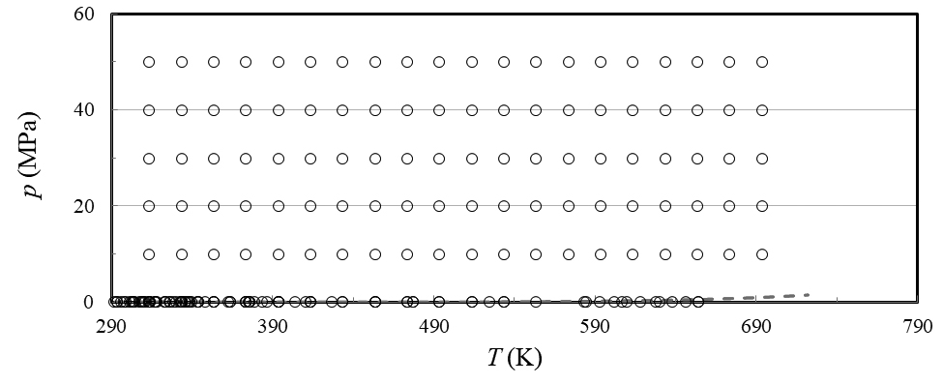

FIG 1. Temperature–pressure range of the primary experimental thermal conductivity data for *n-*hexadecane. (– –) saturation curve.

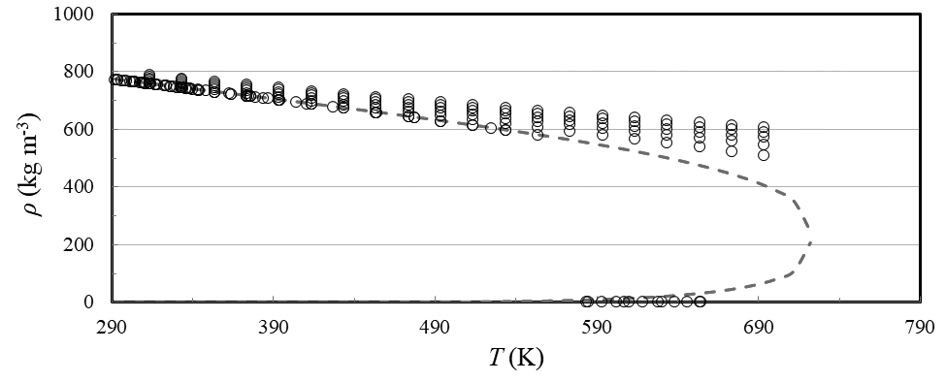

FIG. 2. Temperature–density range of the primary experi­mental thermal conductivity data for *n-*hexadecane. (– –) saturation curve.

*λ*ο(*Τ*) (mW m-1K-1), of a polyatomic gas can be shown to be inversely proportional to a single generalized cross section,38-41 *S*(10*E*) (nm2), as

, (2)

where *k*B is the Boltzmann constant, *T* (K) is the absolute temperature, *f*λ (–) is the dimensionless higher-order correction factor, *m* (kg) is the molecular mass of *n-*hexadecane, and  (m/s) is the average relative thermal speed. The dimensionless quantity *r*2 is defined by *r*2 = 2/5*k*B, where  is the contribution of both the rotational, , and the vibrational, , degrees of freedom to the isochoric ideal-gas heat capacity .

The recent classical trajectory calculations42-44 confirm that, for most molecules studied, the higher-order thermal-conductivity correction factor is near unity. One can take advantage of this finding to define the effective generalized cross section *Sλ* (= *S*(10*E*)/*fλ*) (nm2), and rewrite Eq. (2) for the dilute-gas limit thermal conductivity of *n-*hexadecane, *λ*ο(*Τ*) (mW m-1K-1), as

. (3)

The ideal-gas isobaric heat capacity per molecule,  (= + 2.5 *k*B) in (J/K), can be obtained from Romeo and Lemmon18 as

, (4)

where the values of the coefficients of Eq. (4) are *c*0 = 23.03, *ν*1 = 18.91, *ν*2 = 76.23, *u*1 = 420 K, and *u*2 = 1860 K.

It has been previously noted,41 and recently confirmed39 for smaller molecules, that the cross section *S*(10*E*) exhibits a nearly linear dependence on the inverse temperature. Hence, in order to develop the correlation, we have fitted the effective cross section *Sλ* (nm2), obtained from the only two low-density primary data sets shown in Table 1 (Mustafaev,26 and Tarzimanov and Mashirov27) by means of Eqs. (3) and (4), as a function of the inverse temperature, as:

. (5)

We note here that since Tarzimanov and Mashirov27 observed decomposition of *n-*hexadecane at 675 K, temperatures over 660 K of both these vapor data sets were not included. Eqs. (3) – (5) form a consistent set of equations for the calculation of the dilute-gas limit thermal conductivity of *­n-*hexadecane.

The values of the dilute–gas limit thermal conductivity, *λ*0(*Τ*) in mW m–1 K–1, obtained by the scheme of Eqs. (3) – (5), were fitted as a function of the reduced temperature *T*r = *T / T*c for ease of use to the following equation:

Values calculated by Eq. (6) do not deviate from the values calculated by the scheme of Eqs. (3) –(5) by more than 0.03% over the temperature range from 292 K to 1000 K, the range of validity of Eq.(6). Equation (6) is hence employed in the calculations that will follow.

Figure 3 shows the dilute-gas limit thermal conductivity of the selected investigators, and the values calculated by Eq. (6), as a function of the temperature. In Fig. 4, percentage deviations of the dilute-gas limit

 (6)

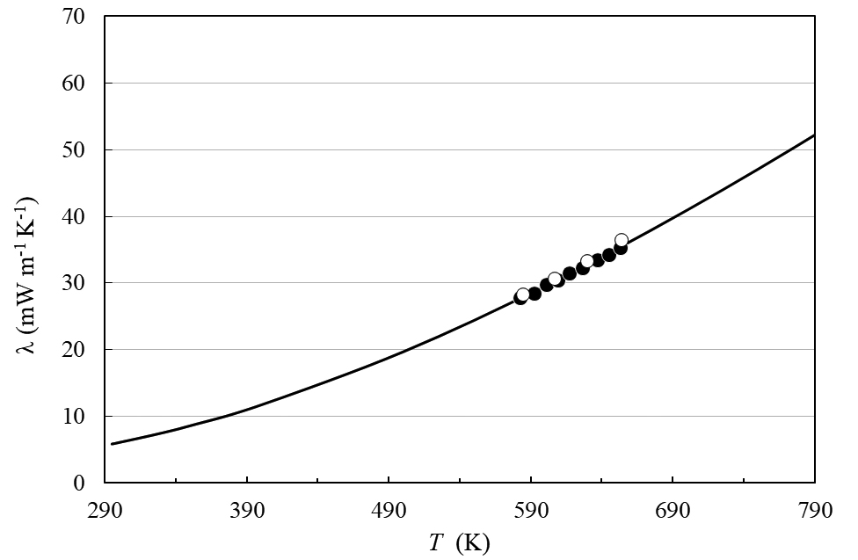

FIG. 3. Dilute-gas limit thermal conductivity of *n*-hexadecane as a function of temperature. Mustafaev26 (**), Tarzimanov and Mashirov27 (o), and Eq. (6) ( __ ).

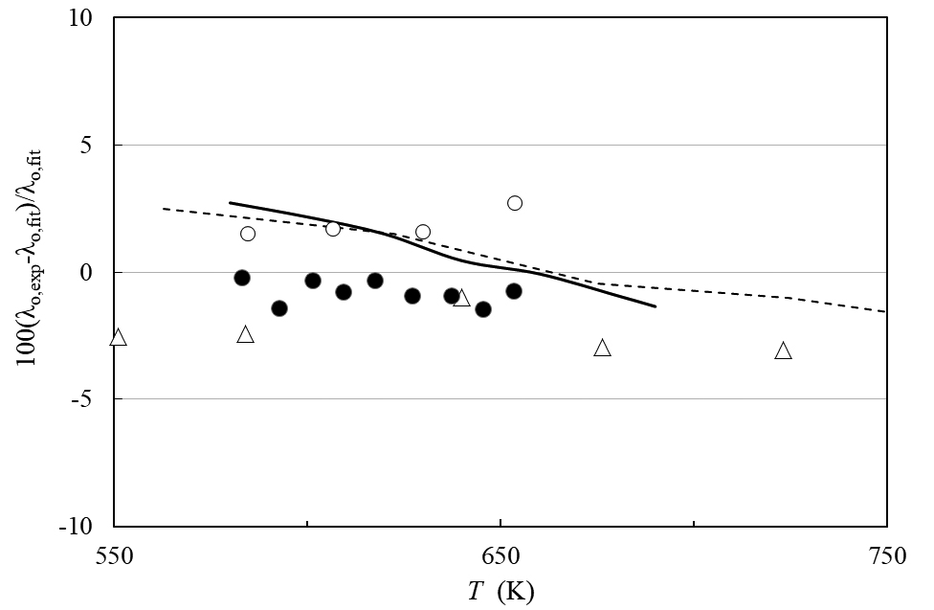

FIG. 4. Percentage deviations of the dilute-gas limit thermal-conductivity experimental data of *n-*hexadecane from Eq. (6) as a function of temperature. Mustafaev26 (**), Tarzimanov and Mashirov27 (o), Vargaftik *et al.*45 ( __ ), Yaws46 ( - - ), and values calculated from the data of Lyusternik and Zdanov47 (Δ).

thermal conductivity of *n-*hexadecane from Eq. (6) are shown. In the same figure values quoted in the books by Vargaftik *et al*.45 and Yaws46 are also shown. Furthermore, values calculated from the viscosity data of Lyusternik and Zdanov,47 through a modified Eucken equation,5 are also shown. They all agree with the present correlation within their mutual uncertainties. Based on these measurements, the uncertainty of the correlation, at the 95% confidence level over the temperature range 583 K to 654 K, is 2.7%. The correlation behaves in a physically reasonable manner over the entire range from the triple pointto the highest temperature of the experimental data, 654 K; however, we anticipate the uncertainty may be larger in the areas where data are not available and the correlation is extrapolated.

**2.2. The residual term**

The thermal conductivity of pure fluids exhibits an enhancement over a large range of densities and temperatures around the critical point and becomes infinite at the critical point. This behavior can be described by models that produce a smooth crossover from the singular behavior of the thermal conductivity asymptotically close to the critical point to the residual values far away from the critical point.48-50 The density-dependent terms for thermal conductivity can be grouped according to Eq. (1) as [Δ*λ*(*ρ*,*Τ*) + Δ*λ*c(*ρ*,*Τ*)]. To assess the critical enhancement theoretically, we need to evaluate, in addition to the dilute-gas thermal conductivity, the residual thermal-conductivity contribution. The procedure adopted during this analysis used ODRPACK (Ref. 51) to fit all primary data simultaneously to the residual thermal conductivity and the critical enhancement, while maintaining the values of the dilute-gas thermal-conductivity data already obtained. The density values employed were obtained by the equation of state of Romeo and Lemmon.18 The primary data were weighted in inverse proportion to the square of their uncertainty.

The residual thermal conductivity was represented with a polynomial in temperature and density:

. (7)

Coefficients *B*1,*i* and *B*2,*i* are shown in Table 2.

TABLE 2. Coefficients of Eq. (7) for the residual thermal conductivity of *n*-hexadecane.

|  |  |  |
| --- | --- | --- |
| *i* | *B*­1,*i*  (mW m−1 K−1) | *B*­2,*i*  (mW m−1 K−1) |
| 1  2  3  4  5 | −0.372 089×10-1  0.935 694×10-1  −0.313 826×10-1  0.201 863×10-2  0.255 103×10-3 | 0.409 813×10-1  −0.101 536×100  0.574 353×10-1  −0.153 161×10-1  0.197 462×10-2 |

**2.3. The critical enhancement term**

The theoretically based crossover model proposed by Olchowy and Sengers48-50 is complex and requires solution of a quartic system of equations in terms of complex variables. A simplified crossover model has also been proposed by Olchowy and Sengers.52 The critical enhancement of the thermal conductivity from this simplified model is given by

, (8)

with

 (9)

and

. (10)

In Eqs. (8) – (10),  (Pa s) is the viscosity, and *Cp* and *Cv* (J kg–1 K–1) are the isobaric and isochoric specific heat obtained from the equation of state. The correlation length *ξ* (m) is given by

.

(11)

As already mentioned, the coefficients *B*1,*i* and *B*2,*i* in Eq. (7) were fitted with ODRPACK (Ref. 51) to the primary data for the thermal conductivity of *n*-hexadecane. This crossover model requires the universal amplitude, *R*D = 1.02 (–), and the universal critical exponents, *ν* = 0.63 and γ =1.239, and the system-dependent amplitudes Γ and *ξ*0.For this work, we adopted the values Γ = 0.063 (-), *ξ*0 = 0.291×10−9m, using the universal representation of the critical enhancement of the thermal conductivity by Perkins *et al*.53 When there are sufficient experimental data available in the critical region, the remaining parameter may be found by regression. In this case, there are no critical-region data available so we instead use the method of Perkins *et al*.53 to estimate the effective cutoff wavelength (m). The estimated value is 9.98×10−10 m.

TABLE 3. Evaluation of the *n-*hexadecane thermal conductivity correlation for the primary data.

|  |  |  |  |
| --- | --- | --- | --- |
| 1st  Author | Year Publ. | AAD (%) | BIAS (%) |
| Feja20 | 2018 | 2.00 | −1.89 |
| Velez21 | 2015 | 0.65 | 0.65 |
| Assael22 | 1991 | 0.59 | −0.44 |
| Wada23 | 1985 | 0.34 | −0.34 |
| Mukhamedzyanov24 | 1974 | 1.88 | 0.70 |
| Mustafaev25 | 1973 | 1.85 | −0.94 |
| Mustafaev26,b | 1973 | 0.72 | −0.72 |
| Tarzimanov27,b | 1970 | 1.95 | 1.95 |
| Mukhamedzyanov28 | 1963 | 2.16 | 2.16 |
| **Entire data set** |  | **1.67** | −**0.45** |

The viscosity required for Eq. (8) was obtained by the very recent correlation of Meng et al.54 The reference temperature *T*ref,far above the critical temperature where the critical enhancement is negligible, was calculated by *T*ref= (3/2)*T*c,55 which for *n*-hexadecane is 1083.2 K.

Table 3 summarizes comparisons of the primary data with the correlation. The average absolute percent deviation of the fit is 1.7%, and its bias is -0.47%. We estimate the uncertainty in thermal conductivity at a 95% confidence level to be 4% for the liquid phase over the temperature range 290 K to 700 K at pressures up to 50 MPa.

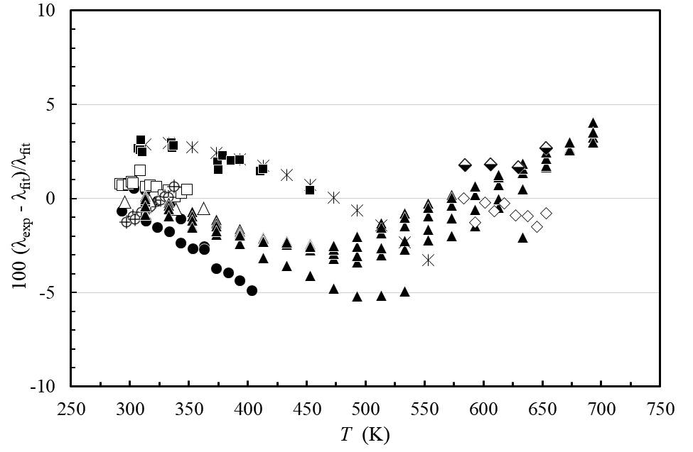

FIG. 5. Percentage deviations of primary thermal conductivity experimental data of *n-*hexadecane from the values calculated by the present correlation as a function of temperature. Feja and Hanzelmann20 (**), Velez *et al.*21 (**), Assael *et al.*22 (circle cross line.png), Wada *et al.*23 (), Mukhamedzyanov24 (), Mustafaev25 (▲), Mustafaev26 (), Tarzimanov and Mashirov27 (romvos black down), Mukha-medzyanov *et al.*28 (****).

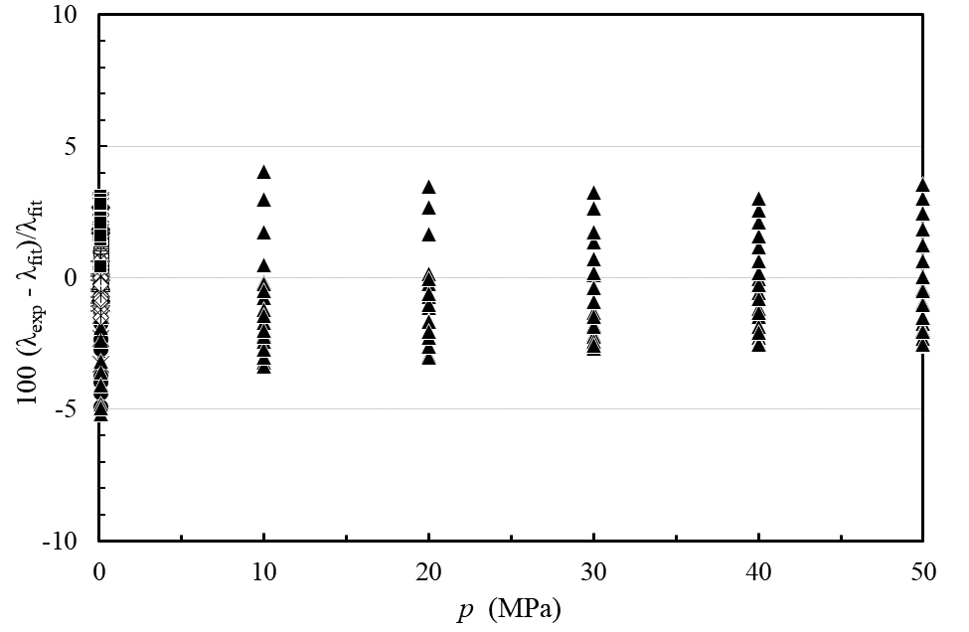

FIG. 6. Percentage deviations of primary thermal conductivity experimental data of *n-*hexadecane from the values calculated by the present correlation as a function of pressure. Feja and Hanzelmann20 (**), Velez *et al.*21 (**), Assael *et al.*22 (circle cross line.png), Wada *et al.*23 (), Mukhamedzyanov24 (), Mustafaev25 (▲), Mustafaev26 (), Tarzimanov and Mashirov27 (romvos black down), Mukha-medzyanov *et al.*28 (****).

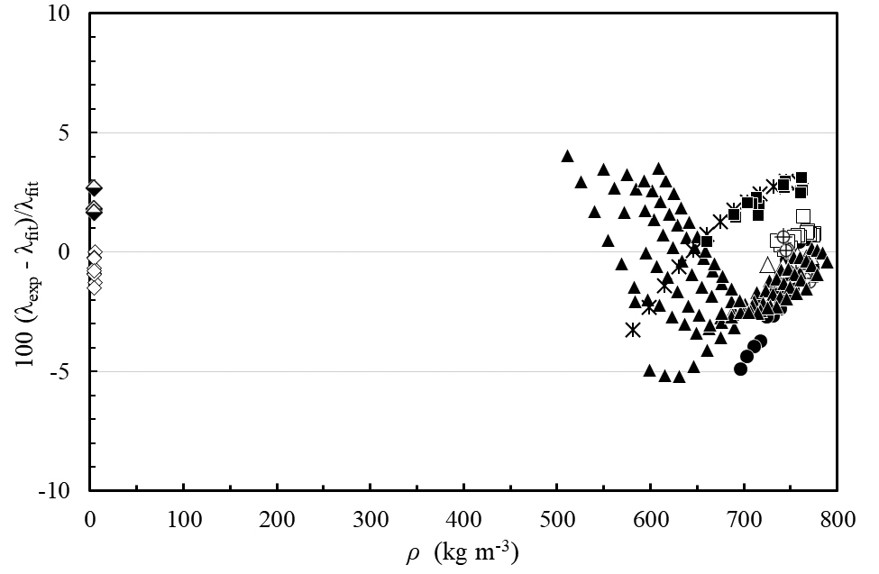

FIG. 7. Percentage deviations of primary thermal conductivity experimental data of *n-*hexadecane from the values calculated by the present correlation as a function of density. Feja and Hanzelmann20 (**), Velez *et al.*21 (**), Assael *et al.*22 (circle cross line.png), Wada *et al.*23 (), Mukhamedzyanov24 (), Mustafaev25 (▲), Mustafaev26 (), Tarzimanov and Mashirov27 (romvos black down), Mukha-medzyanov *et al.*28 (****).

Figure 5 shows the percentage deviations of all primary thermal conductivity data from the values calculated by Eqs. (1) and (6)-(11), as a function of temperature, while Figs. 6 and 7 show the same deviations but as a function of the pressure and the density. Table 4 shows the average absolute percent deviation (AAD) and the bias for the secondary data.Figure 8 shows a plot of the thermal conductivity of *n-*hexadecane as a function of the temperature for different pressures. The plot demonstrates the smooth extrapolation behavior at conditions outside of the range of experimental data (above 700 K and 50 MPa). Finally, Fig. 9 shows the thermal conductivity of *n*-hexadecane as a function of the density for different temperatures, including the critical enhancement.

TABLE 4. Evaluation of the *n-*hexadecane thermal conductivity correlation for the secondary data.

|  |  |  |  |
| --- | --- | --- | --- |
| 1st  Author | Year Publ. | AAD (%) | BIAS (%) |
| Sun29 | 2015 | 2.75 | −2.75 |
| Holmen30 | 2002 | 30.9 | 30.9 |
| Tarzimanov31 | 1990 | 8.54 | −8.54 |
| Wang32 | 1989 | 8.21 | −8.21 |
| Kravchun33 | 1986 | 1.10 | 1.10 |
| Gaitonde34 | 1978 | 5.77 | −5.77 |
| Powell35 | 1972 | 3.39 | 3.39 |
| Bogatov36 | 1969 | 5.22 | −5.22 |
| Sakiadis37 | 1952 | 4.09 | 4.09 |

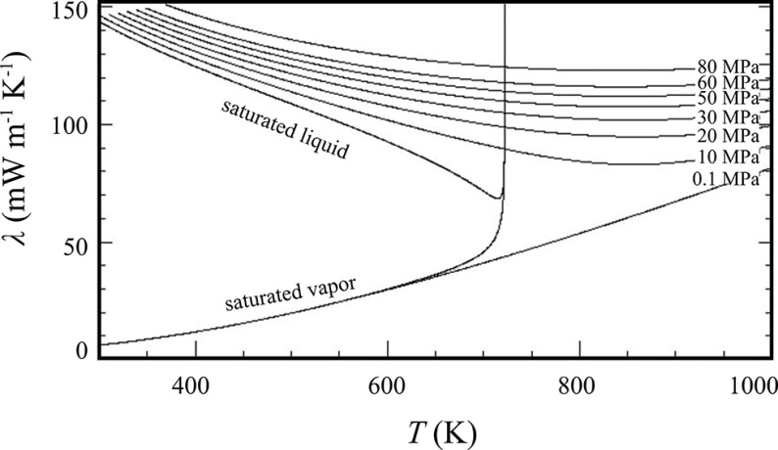

FIG. 8. Thermal conductivity of *n*-hexadecane as a function of temperature for selected pressures.

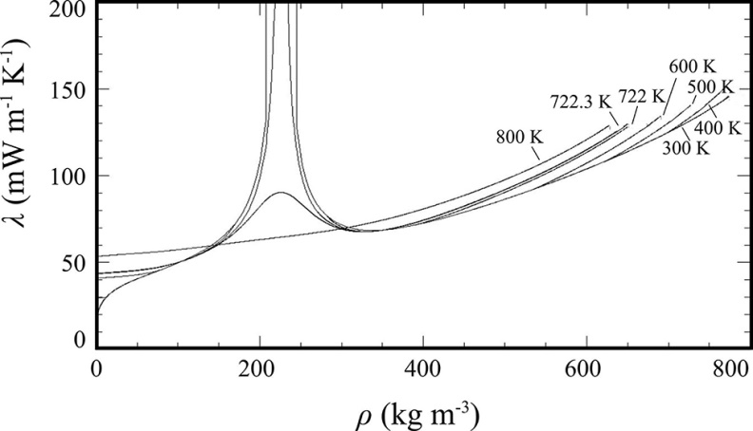

FIG. 9. Thermal conductivity of *n*-hexadecane as a function of density for selected temperatures.

**3. Recommended Values**

In Table 5, thermal conductivity values are given along the saturated liquid line, calculated from the present proposed correlation between 300 and 700 K, while in Table 6 thermal conductivity values are given for temperatures between 350 and 700 K at selected pressures. Saturation pressure and saturation density values for selected temperatures, as well as the density values for the selected temperature and pressure, are obtained from the equation of state of Romeo and Lemmon.18

**4. Conclusions**

A new wide-ranging correlation for the thermal conductivity of *n*-hexadecane was developed based on critically evaluated experimental data. The correlation is expressed in terms of temperature and density and is designed to be used with the equation of state of Romeo and Lemmon.18 The estimated uncertainty at the 95% confidence level is estimated to be 4% from the triple point to 700 K and up to 50 MPa, with the exception of the dilute-gas range where the uncertainty is 2.7% over

TABLE 5. Thermal conductivity values of *n*-hexadecane along the saturation line,   
calculated by the present correlation.

|  |  |  |  |  |  |
| --- | --- | --- | --- | --- | --- |
| *Τ*  (Κ) | *p*  (MPa) | *ρ*liq  (kg m−3) | *ρ*vap  (kg m−3) | *λ*liq  (mW m-1 K-1) | *λ*vap  (mW m-1 K-1) |
| 300 | 2.470×10-7 | 768.87 | 2.242×10-5 | 143.50 | 6.10 |
| 350 | 2.105×10-5 | 733.87 | 1.638×10-3 | 134.77 | 8.60 |
| 400 | 4.609×10-4 | 698.80 | 3.142×10-2 | 126.32 | 11.73 |
| 450 | 4.276×10-3 | 662.94 | 2.607×10-1 | 118.27 | 15.42 |
| 500 | 2.256×10-2 | 625.36 | 1.262×100 | 110.63 | 19.63 |
| 550 | 8.131×10-2 | 584.62 | 4.313×100 | 103.29 | 24.31 |
| 600 | 2.258×10-1 | 538.12 | 1.190×101 | 95.96 | 29.52 |
| 650 | 5.246×10-1 | 480.10 | 2.954×101 | 88.03 | 35.63 |
| 700 | 1.087×100 | 389.94 | 7.882×101 | 77.99 | 46.00 |

TABLE 6. Thermal conductivity values of *n*-hexadecane at selected temperatures and pressures.

|  |  |  |  |
| --- | --- | --- | --- |
| *p*  (MPa) | *T*  (K) | *ρ*  (kg m−3) | *λ* (mW m-1 K-1) |
| 0.1 | 300 | 768.94 | 143.53 |
|  | 350 | 733.96 | 134.80 |
|  | 400 | 698.92 | 126.36 |
|  | 450 | 663.10 | 118.32 |
|  | 500 | 625.54 | 110.68 |
|  | 550 | 584.69 | 103.30 |
|  | 600 | 4.813 | 29.510 |
|  | 650 | 4.367 | 35.083 |
|  | 700 | 4.010 | 40.981 |
| 10 | 300 | 775.36 | 146.53 |
|  | 350 | 742.24 | 138.25 |
|  | 400 | 709.71 | 130.33 |
|  | 450 | 677.41 | 122.93 |
|  | 500 | 644.98 | 116.13 |
|  | 550 | 612.06 | 109.95 |
|  | 600 | 578.18 | 104.36 |
|  | 650 | 542.82 | 99.31 |
|  | 700 | 505.43 | 94.80 |
| 25 | 300 | 784.21 | 150.94 |
|  | 350 | 753.27 | 143.21 |
|  | 400 | 723.48 | 135.89 |
|  | 450 | 694.61 | 129.16 |
|  | 500 | 666.49 | 123.09 |
|  | 550 | 639.00 | 117.72 |
|  | 600 | 612.04 | 113.05 |
|  | 650 | 585.52 | 109.08 |
|  | 700 | 559.38 | 105.81 |
| 50 | 300 | 797.17 | 157.99 |
|  | 350 | 768.87 | 151.02 |
|  | 400 | 742.12 | 144.45 |
|  | 450 | 716.72 | 138.45 |
|  | 500 | 692.52 | 133.10 |
|  | 550 | 669.40 | 128.42 |
|  | 600 | 647.29 | 124.41 |
|  | 650 | 626.10 | 121.07 |
|  | 700 | 605.77 | 118.37 |

the temperature range 583 to 654 K. The correlation behaves in a physically reasonable manner when extrapolated to the full range of the equation of state (to 800 K and 50 MPa), but the uncertainties are larger outside of the validated range, and also in the critical region.

**Acknowledgments**

The authors would like to thank Mr Th. Papalas for his help in the initial stages of this work.

**5. References**

1. M. J. Assael, J. A. M. Assael, M. L. Huber, R. A. Perkins, and Y. Takata, J. Phys. Chem. Ref. Data **40**, 033101 (2011).

2. M. L. Huber, R. A. Perkins, D. G. Friend, J. V. Sengers, M. J. Assael, I. N. Metaxa, K. Miyagawa, R. Hellmann, and E. Vogel, J. Phys. Chem. Ref. Data **41**, 033102 (2012).

3. M. J. Assael, I. A. Koini, K. D. Antoniadis, M. L. Huber, I. M. Abdulagatov, and R. A. Perkins, J. Phys. Chem. Ref. Data **41**, 023104 (2012).

4. M. L. Huber, E. A. Sykioti, M. J. Assael, and R. A. Perkins, J. Phys. Chem. Ref. Data **45**, 013102 (2016).

5. M. J. Assael, S. K. Mylona, M. L. Huber, and R. A. Perkins, J. Phys. Chem. Ref. Data **41**, 023101 (2012).

6. M. J. Assael, E. K. Michailidou, M. L. Huber, and R. A. Perkins, J. Phys. Chem. Ref. Data **41**, 043102 (2012).

7. C.-M. Vassiliou, M. J. Assael, M. L. Huber, and R. A. Perkins, J. Phys. Chem. Ref. Data **44**, 033102 (2015).

8. M. J. Assael, S. K. Mylona, M. L. Huber, and R. A. Perkins, J. Phys. Chem. Ref. Data **42**, 013106 (2013).

9. A. Koutian, M. J. Assael, M. L. Huber, and R. A. Perkins, J. Phys. Chem. Ref. Data **46**, 0131021 (2016).

10. M. J. Assael, I. Bogdanou, S. K. Mylona, M. L. Huber, R. A. Perkins, and V. Vesovic, J. Phys. Chem. Ref. Data **42**, 023101 (2013).

11. E. A. Sykioti, M. J. Assael, M. L. Huber, and R. A. Perkins, J. Phys. Chem. Ref. Data **42**, 043101 (2013).

12. M. J. Assael, E. A. Sykioti, M. L. Huber, and R. A. Perkins, J. Phys. Chem. Ref. Data **42**, 023102 (2013).

13. M. J. Assael, A. Koutian, M. L. Huber, and R. A. Perkins, J. Phys. Chem. Ref. Data **45**, 033104 (2016).

14. S. K. Mylona, K. D. Antoniadis, M. J. Assael, M. L. Huber, and R. A. Perkins, J. Phys. Chem. Ref. Data **43**, 0431041 (2014).

15. M. J. Assael, T. B. Papalas, and M. L. Huber, J. Phys. Chem. Ref. Data **46**, 033103 (2017).

16. R. A. Perkins, M. L. Huber, and M. J. Assael, J. Chem. Eng. Data **61**, 3286 (2016).

17. C. M. Tsolakidou, M. J. Assael, M. L. Huber, and R. A. Perkins, J. Phys. Chem. Ref. Data **42**, 023103 (2017).

18. R. Romeo and E. W. Lemmon, to be submitted (2018).

19. M. J. Assael, M. L. V. Ramires, C. A. Nieto de Castro, and W. A. Wakeham, J. Phys. Chem. Ref. Data **19**, 113 (1990).

20. S. Feja and C. Hanzelmann, Thermochim. Acta (submitted).

21. C. Vélez, M. Khayet, and J. M. Ortiz de Zárate, Applied Energy **143**, 383 (2015).

22. M. J. Assael, E. Charitidou, and L. Karagiannidis, Int. J. Thermophys. **12**, 491 (1991).

23. Y. Wada, Y. Nagasaka, and A. Nagashima, Int. J. Thermophys. **6**, 251 (1985).

24. G. K. Mukhamedzyanov, Thermophys. Prop. Matter and Substances **2**, 254 (1974).

25. R. A. Mustafaev, J. Eng. Phys. Thermophys. **24**, 465 (1973).

26. R. A. Mustafaev, Izv. vyssh.ucheb. Zaved. Neft Gaz **16**, 71 (1973).

27. A. A. Tarzimanov and V. E. Mashirov, Teplofiz. Svoistva Veshchestv Mater, 240 (1970).

28. G. K. Mukhamedzyanov, A. G. Usmanov, and A. A. Tarzimanov, Izv. vyssh.ucheb. Zaved. Neft Gaz **6**, 75 (1963).

29. F. Sun, J. Zhu, and D. Tang, Chi. Sci. Bull. **60**, 1320 (2015).

30. R. Holmen, M. Lamvik, and O. Melhus, Int. J. Thermophys. **23**, 27 (2002).

31. A. A. Tarzimanov, R. A. Sharafutdinov, and F. R. Gabitov, Inzh. Fiz. Zh. **59**, 827 (1990).

32. C. Wang, M. Yang, J. Wang, and P. Liu, J. Chem. Ind. Engin. (China) **40**, 494 (1989).

33. S. N. Kravchun, Russ. J. Phys. Chem **60**, 1304 (1986).

34. U. N. Gaitonde, D. D. Deshpande, and S. P. Sukhatme, Ind. Eng. Chem. Fundam **17**, 321 (1978).

35. R. W. Powell and H. Groot, Int. J. Heat Mass Transfer **15**, 360 (1972).

36. G. F. Bogatov, Y. L. Rastorquev, and B. A. Grigor'ev, Khim. Tekhn. Topl. i Masel. **14**, 31 (1969).

37. B. C. Sakiadis and J. Coates, AIChE J. **3**, 121 (1957).

38. R. Hellmann, E. Bich, E. Vogel, and V. Vesovic, J. Chem. Eng. Data **57**, 1312 (2012).

39. F. R. W. McCourt, J. J. M. Beenakker, W. E. Köhler, and I. Kučšer, *Nonequilibrium Phenomena in Polyatomic Gases* (Clarendon Press, Oxford, 1990).

40. B. J. Thijsse, G. W. Thooft, D. A. Coombe, H. F. P. Knaap, and J. J. M. Beenakker, Physica A **98**, 307 (1979).

41. J. Millat, V. Vesovic, and W. A. Wakeham, Physica A **148**, 153 (1988).

42. S. Bock, E. Bich, Ε. Vogel, A. S. Dickinson, and V. Vesovic, J. Chem. Phys. **120**, 7987 (2004).

43. R. Hellmann, E. Bich, E. Vogel, A. S. Dickinson, and V. Vesovic, J. Chem. Phys. **130**, 124309 (2009).

44. R. Hellmann, E. Bich, E. Vogel, and V. Vesovic, Phys. Chem. Chem. Phys. **13**, 13749 (2011).

45. N. B. Vargaftik, L. P. Filippov, A. A. Tarzimanov, and E. E. Totskii, *Handbook of Thermal Conductivity of Liquids and Gases* (CRC Press, Boca Raton 1994).

46. C. L. Yaws, *Handbook of Thermal Conductivity. Vol. 3* (Gulf Publishing Company, Houston, 1995).

47. V. E. Lyusternik and A. G. Zdanov, *Viscosity of alkanes, alkenes and alkynes in gaseous phase*, edited by V. A. Rabinovich (Teplofiz. Svoistva Veshchestv Mater., Standards Publ., Moscow, 1973).

48. G. A. Olchowy and J. V. Sengers, Phys. Rev. Lett. **61**, 15 (1988).

49. R. Mostert, H. R. van Den Berg, and P. S. van der Gulik, J. Chem. Phys. **92**, 5454 (1990).

50. R. A. Perkins, H. M. Roder, D. G. Friend, and C. A. Nieto de Castro, Physica A **173**, 332 (1991).

51. P. T. Boggs, R. H. Byrd, J. H. Rogers, and R. B. Schnabel, *ODRPACK, Software for Orthogonal Distance Regression, NISTIR 4834, v2.013* (National Institute of Standards and Technology, Gaithersburg, MD, 1992).

52. G. A. Olchowy and J. V. Sengers, Int. J. Thermophys. **10**, 417 (1989).

53. R. A. Perkins, J. V. Sengers, I. M. Abdulagatov, and M. L. Huber, Int. J. Thermophys. **34**, 191 (2013).

54. X. Meng, X. Yang, F. Cao, J. Wu, and V. Vesovic, to be submitted (2018).

55. V. Vesovic, W. A. Wakeham, G. A. Olchowy, J. V. Sengers, J. T. R. Watson, and J. Millat, J. Phys. Chem. Ref. Data **19**, 763 (1990).