Reconciliation of Experimental and Computed Thermodynamic Properties for Methyl-Substituted 3-Ring Aromatics. Part 1: 9-Methylanthracene

Andrei Kazakov,* Eugene Paulechka, and Robert D. Chirico
Thermodynamics Research Center, Applied Chemicals and Materials Division, National Institute of Standards and Technology, Boulder, CO 80305-3337, U.S.A.

* Corresponding author. E-mail address: andrei.kazakov@nist.gov

ABSTRACT: Measurements leading to the calculation of thermodynamic properties in the ideal-gas state for 9-methylanthracene (Chemical Abstracts registry number [779-02-2]) are reported. Experimental methods were adiabatic heat-capacity calorimetry, differential scanning calorimetry (d.s.c.), comparative ebulliometry, inclined-piston manometry, vibrating-tube densitometry, and oxygen bomb calorimetry. The critical temperature, pressure, and density were estimated based on these measurements with well-established correlations. Molar thermodynamic functions for the condensed and ideal-gas states were derived from the experimental results. Statistical calculations were performed based on molecular geometry optimization and vibrational frequencies using B3LYP hybrid density functional theory with def2-QZVPD basis set. Excellent accord between computed and experimentally derived ideal-gas entropies is shown, once account is taken of coupled low-frequency vibrational modes reported in the literature. The enthalpy of formation for 9-methylanthracene in the gas phase was computed with an atom-equivalent based protocol described recently, and excellent agreement with the experimental value is seen. All experimental results are compared with property values reported in the literature. Multiple large inconsistencies in literature property values are resolved here.

1. Introduction
This work is part of our continuing research into quantification of uncertainties for thermodynamic properties derived with computational methods.⁻ Entropies and enthalpies of formation for the ideal-gas state can be derived with structural information and computational methods, as well as through appropriate combination of experimentally determined properties. These methods are independent, and demonstration of accord between the methods provides mutual validation. Careful assessment of uncertainties is essential. The value of reliable ideal-gas properties has been noted previously, as has the value in development of computational methods with demonstrable uncertainties.¹¹ The present work represents the first in which consideration of coupled non-harmonic molecular vibrations was essential in the assessment.
This article describes thermodynamic property measurements for 9-methylanthracene (Chemical Abstracts registry number [779-02-2]; abbreviated “9-MA”). A summary of the experiments is provided in Table 1. Entropies for a wide range of temperatures (298.15 ≤ T/K ≤ 650) and the enthalpy of formation at T/K = 298.15 for the ideal-gas state are derived from the property measurements. These are compared with values calculated independently with the methods of computational chemistry. Coupling of the two lowest-wavenumber vibrations has been reported by Nakagaki et al., and consideration of this in the computations is shown to be essential.
2. EXPERIMENTAL SECTION
All experimental property measurements were done at the National Institute for Petroleum and Energy Research (NIPER) in Bartlesville, Oklahoma, in the 1990s.
2.1 Materials. The sample of 9-MA was synthesized and purified by the research group of Professor E. J. “Pete” Eisenbraun of Oklahoma State University in 1990, using the following reaction sequence.
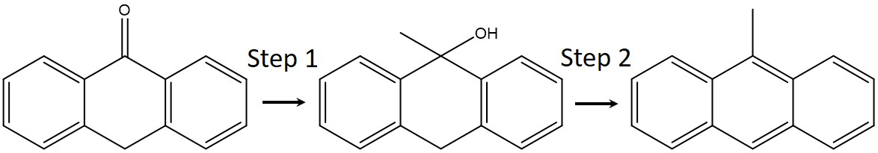
Anthrone |  | 9-MA

Step 1. Anthrone (190 g, 0.96 mol), under an argon atmosphere, was added in small portions to a stirred mixture of dry toluene (500 cm³) and methylmagnesium bromide (3 mol⋅dm^{–3} in ether, 800 cm³), and cooled in an ice/salt bath. The reaction mixture was stirred for 20 h at room temperature under argon, poured onto ice water, acidified with 10 % HCl, and extracted with ether. The extract was washed with brine (500 cm³) and water (3 x 500 cm³), dried with MgSO₄, filtered, and concentrated to 183 g (99 % yield) of orange solid. This solid was eluted with hexane through a 5.5 cm diameter column consisting of 200 g of acidic, neutral, and basic alumina to give, after rotary evaporation, 147 g (79 % yield) of orange-yellow solid with melting range (333 < T/K < 340).
Step 2. A 250 g sample prepared as described above, was treated with picric acid (500 g) in toluene (1.5 L) by heating on a steam bath to aid dissolution. The resulting brown picrate was filtered and recrystallized from toluene to give 298 g of picrate, with melting temperature T_{fus} = (409 ± 2) K (0.95 level of confidence). The picrate was cleaved with basic alumina and ether in a Soxhlet apparatus under argon. The eluate was concentrated, and the resulting 9-MA (60 g) was sealed in a glass ampoule and delivered to the NIPER Thermodynamics Laboratory. The mole fraction purity x = 0.9997₁ was determined by fractional melting in an adiabatic calorimeter, as described later.
Purification of the water and decane used as reference materials in the ebulliometric vapor-pressure measurements has been described. All transfers of samples were completed under nitrogen or helium or by vacuum distillation.
2.2. Physical constants and standards. The molar mass used for 9-MA is M = 192.255 g⋅mol⁻¹ based on the formula C₁₅H₁₂ and the Standard Atomic Weights of the elements published by the International Union of Pure and Applied Chemistry (IUPAC). The gas constant R = 8.314462618 J.K⁻¹.mol⁻¹, the speed of light in vacuum c = 299792458 m⋅s^{–1}, and the Planck constant h =6.62607015⋅10^{–34} J⋅Hz^{–1} adopted by CODATA are used. The gas constant is rounded here to R = 8.31446 J.K⁻¹.mol⁻¹ in all tables. Platinum resistance thermometers were calibrated by comparison with standard thermometers whose constants were determined at the National Bureau of Standards (NBS), now the National Institute of Standards and Technology (NIST). Temperatures were measured in terms of IPTS-68 and were converted to ITS-90 with published temperature increments. The thermometer used in the adiabatic heat-capacity study was calibrated below T/K = 13.81 with the method of McCrackin and Chang. Mass, time, electrical resistance, and potential difference were measured in terms of standards traceable to calibrations at NIST.
2.3. Adiabatic heat-capacity calorimetry. Heat capacities and enthalpy increments for the condensed phases of 9-MA were measured in the temperature range (5.8 < T/K < 440) with an adiabatic calorimetric system that has been described. The enthalpy of melting and the triple point temperature T_{tp} were determined, and no other phase transitions were detected. Characteristics of the sample, the platinum sample container, and sealing conditions are given in Table 2. Energy increments to the filled calorimeter were corrected for enthalpy changes in the empty calorimeter, for the helium exchange gas, and for vaporization of the sample into the free space of the sealed container. The maximum sizes of these corrections are given in Table 2.
2.4. Differential scanning calorimetry. Heat capacities at vapor-saturation pressure C_{sat,m} for the liquid phase in the temperature range (375 < T/K < 655) were determined with a differential scanning calorimeter (d.s.c.). An intermittent heating method was used with sequential measurements involving the sample, pure sapphire calibrant, and the empty sample pan. Heat capacities of sapphire used for calibration were those critically evaluated by Archer. Triple-point temperatures of high-purity indium, lead, and zinc were used to calibrate the temperature scale. A power-compensated d.s.c. was used (Perkin Elmer DSC II), and the method has been fully described., Determination of the critical temperature T_{c} with d.s.c. was not possible in this work due to sample decomposition, and T_{c} for 9-MA was estimated, as described later.
2.5. Comparative ebulliometry. The method for determination of vapor pressures with comparative ebulliometry has been described., A sample of 9-MA was refluxed with standards of known vapor pressure (decane for 2 < p/kPa < 25 and water for 25 < p/kPa < 32) under a common atmosphere of helium gas. Boiling and condensation temperatures of the sample and standard were determined, and the vapor pressure of 9-MA was derived from the condensation temperature of the standard. Vapor pressures for water were derived with the international equation of state for pure water, while those for decane were calculated with eq 1 of reference . The standard uncertainty u for the temperature measurements in the ebulliometric studies was 0.002 K. Standard uncertainties in the pressures are described by:
u(p) = u(T){(dp_{ref}/dT)² + (dp_{x}/dT)²}^{1/2}, (1)
where p_{ref} is the vapor pressure of the reference substance and p_{x} is the vapor pressure of the sample under study. The repeatability of the temperature measurements was 5⋅10⁻⁴ K.
2.6. Inclined-piston manometry. Vapor pressures for 9-MA were measured with an inclined-piston apparatus described initially by Douslin and coworkers., Subsequent changes to the equipment and procedures have been reported.¹³ Standard uncertainties for the measured vapor pressures u(p), based on estimated uncertainties in measuring the mass, area, and angle of inclination of the piston, are described by the expression:
u(p) = (1.5⋅10⁻⁴ p + 0.2) Pa. (2)
The standard uncertainties for the temperatures u(T) are 0.002 K and do not contribute significantly to u(p).
2.7 Densitometry. Densities at vapor saturation pressure ρ_{sat} were obtained with a vibrating-tube densitometer that was designed and built in-house. A detailed description of the apparatus and its calibration with water have been reported. The standard uncertainty u(ρ_{sat}) is 1·10⁻³ ρ_{sat} based on test measurements for benzene between T = 310 K and T = 523 K. The precision of the measurements was approximately 5·10⁻⁴ ρ_{sat}.
2.8. Combustion calorimetry. The experimental procedures, used in the combustion calorimetry of organic C,H,O,N containing compounds, have been described., A rotating-bomb calorimeter (laboratory designation BMR II) and platinum-lined bomb (laboratory designation Pt-3b) with an internal volume of 0.3934 dm³ were used without rotation. Samples (~1 g) of 9-MA were burned as compressed pellets. For each experiment, a volume of 1.0 cm³ of water was added to the bomb, and the bomb was charged at T = 297 K to a pressure of ~3.0 MPa with pure oxygen with flushing. Temperature rises in the combustion and calibration series were the same within 0.04 K, and all experiments were completed within 0.01 K of T = 298.15 K. As the compound of interest was a hydrocarbon and the oxygen used contained less than a few parts per million of nitrogen, no nitric or nitrous acids were formed in the combustions. Temperatures were measured with a quartz-crystal thermometer, that was calibrated by comparison with a standard platinum resistance thermometer. Counts of the crystal oscillation were taken over periods of 100 s throughout the experiments. Integration of the time-against-temperature curve is inherent in the quartz-crystal thermometer readings.
NIST Standard Reference Material benzoic acid (sample 39i) was used for calibration of the combustion calorimeter; its energy of combustion is -(26434.0 ± 3.0) J∙g⁻¹ under certificate conditions. Conversion to standard states, gives -(26413.7 ± 3.0) J∙g⁻¹ for Δ_{c}U°/M, the massic energy of the idealized combustion reaction. The energy equivalent ε(calor) of the calorimeter was determined to be (16774.0 ± 0.6) J∙K⁻¹ (mean and standard deviation of the mean for six combustions). For the cotton fuse, empirical formula CH_{1.774}O_{0.887}, Δ_{c}U°/M was -16945 J⋅g⁻¹.
Auxiliary information, necessary for reducing apparent mass to mass, converting the energy of the actual bomb process to that of the isothermal process, and reducing to standard states,^{39,40} included an estimate for the density of the crystal phase of 9-MA at T = 298.15 K of 1250 kg.m⁻³ and an estimated value of 2.60∙10⁻⁸ m³∙K⁻¹ for (∂Vm/∂T)_{p}. The estimate of (∂Vm/∂T)_{p} is based on a recent literature review of thermal expansion properties for organic crystals, and the density of the crystals was estimated to be 12 percent greater than that of the liquid at T/K = 298.15, which was itself estimated by extrapolation with the Riedel equation (section 3.3) of density values measured in this research. The molar heat capacity at T = 298.15 K used in the data reduction was measured as part of this work and is reported later in this article.
Carbon dioxide was recovered from the combustion products of each experiment. The method has been described. No unburned carbon or other products of incomplete combustion were detected. The carbon dioxide recovery percentage was (100.001 ± 0.003) mean and standard deviation of the mean for the six combustions of benzoic acid and (99.994 ± 0.006) for 9-MA. One anomalously low value for CO₂ recovery in the calibration series was discarded.
2.9 Computation of properties for the ideal-gas state. Computational models used for generation of ideal-gas properties for 9-MA were based primarily on those used in our previous study, where they were shown to provide excellent performance for aromatics and their substituted derivatives. Optimization of geometries and calculation of vibrational frequencies were performed using B3LYP hybrid density functional theory with the def2-QZVPD basis set. The scaling factors for vibrational frequencies were 0.9601 for hydrogen stretches and 0.9689 for all others, as optimized previously⁴³ for the ideal-gas entropies of aromatics.
Contributions of the two lowest-frequency modes involving the methyl torsion were computed with two models; (1) with the methyl group treated as a free rotor and harmonic oscillator (the “free-rotor” model), and (2) with a 2-dimensional model based on coupling of the two lowest-frequency modes (the “2-D” model). As discussed later, the torsional barrier to methyl rotation in 9-MA is small (< 1 kJ⋅mol⁻¹) and, at the temperatures of interest to this study (298.15 ≤ T/K ≤ 650), the hindrance effect is negligible, and a simple free-rotor model can be used. (Support for this assertion is given in Supporting Information, where the very small differences in computed ideal-gas entropies are shown for barriers ranging from zero to 2 kJ⋅mol⁻¹.) Ideal-gas entropies for 9-MA computed with the free-rotor and 2-D models are compared with those derived from the experimental property measurements later in section 4.7.
Implementation of the 2-D model here is based on the work of Nakagaki et al.¹² who reported that their theoretical and spectroscopic results could not be reconciled with a one-dimensional hindered rotor model. They suggested mode coupling as the main cause and, as a remedy, proposed a two-dimensional Hamiltonian with empirical parameters fitted to their spectroscopic results:
$H\left(θ,q\right)=-hcB\frac{∂^{2}}{∂θ^{2}}-\frac{h}{8π^{2}μc}\frac{∂^{2}}{∂q^{2}}+\frac{1}{2}hcV_{6}\left(1-\cos{6θ}\right)+\frac{1}{2}kq^{2}+K_{θq}q\sin{3θ,}$ (3)
where $θ$ is the torsion angle, q is the out-of-plane vibration coordinate, h is the Plank constant, c is the speed of light in vacuum, B = 3.3 cm⁻¹, µ = 2.13 amu, V₆ = 80 cm⁻¹, k = 1.43 N·m⁻¹, and $K_{θq}=-4.77×{10}^{-11}$ N. The coupling between rotation and vibration is accomplished with the last term in the equation. For solution, the wavefunction is cast into products of basis functions for the free rotor and harmonic oscillator resulting in a Hamiltonian matrix, diagonalization of which yields the energy levels of the two-dimensional system. Nakagaki et al.¹² also provided explicit expressions for the matrix elements. In their original solution, Nakagaki et al.¹² used 6 vibrational and 51 free-rotor basis functions (both sin and cos), as they needed just a few converged energy levels for their comparisons. Here, to accommodate conditions at elevated temperatures, we implemented their Hamiltonian matrix with 300 vibrational and 401 free-rotor basis functions.
Additional calculations were made in this research for evaluation of the small methyl torsion barrier as part of our comparisons with literature results (section 4.2). These were performed using Hartree-Fock (HF), B3LYP, the density-fitted implementation of second-order Møller-Plesset perturbation theory (DF-MP2), and the local coupled-cluster LCCSD(T) implementation of Kállay et al. (the 2016 version)., Some cases needed for comparison with literature results were computed with Pople’s 6-31G-series basis sets. DF-MP2 and LCCSD(T) calculations were performed with Dunning’s correlation-consistent aug-cc-pVXZ (X=Q,5) basis sets.
HF and B3LYP calculations were done with Gaussian 16 with “tight” optimization criteria and, for B3LYP, with the “ultrafine” DFT integration grid. DF-MP2 calculations were performed with Psi4 v.1.3.2,, also with “tight” optimization criteria. Single-point energy LCCSD(T) calculations were carried out with MRCC (releases of February 9, 2019 and February 22, 2020) with “tight” setting for local thresholds.
2.10. Computation of the enthalpy of formation for the ideal-gas state. The enthalpy of formation for 9-MA was computed with the “aLL5” protocol described by Paulechka and Kazakov. The total energies were calculated at the LCCSD(T)/aug-cc-pVQZ//DF-MP2/ aug-cc-pVQZ theory level using MRCC,⁵² and the vibrational frequencies were computed at the B3LYP-D3(BJ)/def2-TZVP theory level. For the thermal enthalpy calculations, the frequencies scaled by the factors of 0.96 for hydrogen stretches and 0.985 for all other modes; for zero-point vibrational energy (ZPVE), a single scaling factor of 0.990 was used. Additional detail is given in section 3.8.
3. Experimental Results
3.1 Heat capacities and properties of melting determined with adiabatic calorimetry. Crystals of 9-MA were prepared by slow cooling (~1 mK⋅s⁻¹) the sample to ~30 K below its triple-point temperature T_{tp}, where the sample crystallized. The sample was subsequently cooled slowly to 50 K below T_{tp} and reheated into the partially melted state (~20 percent liquid) under adiabatic conditions. No spontaneous warming was observed and ordering of the crystals was assumed to be complete. The sample was, then, cooled at an effective rate of 1 mK·s⁻¹ to crystallize the remaining liquid. As a final step, the sample was thermally cycled from temperatures near T = 100 K to within 3 K of T_{tp}, where it was held for ~24 h to provide further tempering. All measurement results for the solid phase were performed on crystals pre-treated with this method, and excellent repeatability was observed for the enthalpy of melting Δ${}_{cr}^{l}{H_{m}}$.
The triple-point temperature T_{tp} and the mole fraction purity x were determined by measurement of the equilibrium melting temperatures T(F) as a function of fraction F of the sample in the liquid state. Equilibrium temperatures in the partially-melted state were determined with temperatures at intervals of ~300 s for ~1.2 h after an energy input and extrapolating to infinite time by assuming an exponential decay toward the equilibrium value. The observed temperatures at the end of the equilibration period were within 1 mK of the estimated equilibrium values for F values listed in Table 3 and used in the determination of purity and T_{tp} given there.
Measured molar enthalpy increments for 9-MA are given in Table 4. Results for single-phase regions serve as checks of consistency against the integrated molar heat-capacity values. The final column demonstrates that agreement is within 0.05 percent for all measurements. The value of Δ${}_{cr}^{l}{H_{m}}$ determined as part of the fractional melting study (series 3) was not included in the average because of uncertainty associated with heat leaks during the long equilibration times involved. Corrections for pre-melting caused by impurities were made. Results with the same series number N in Tables 4 and 5 were taken in sequence without interruption of adiabatic conditions.
Equilibrium was reached in less than 1 h for all measurements in the liquid phase, as well as in the solid phase for measurements more than 50 K below T_{tp}. Equilibration times increased to approximately 4 h within 6 K of T_{tp}. The behavior is common for organic compounds near T_{tp} in the solid state.
Molar heat capacities under vapor saturation pressure C_{sat,m} determined by adiabatic calorimetry for 9-MA are listed in Table 5 and shown in Fig. 1. Values in Table 5 were corrected for the effects of sample vaporization into the gas space of the calorimeter, although the size of this correction is very small (Table 2). Pre-melting corrections were also applied, and due to the purity of the sample, these corrections were also small, with a maximum correction of ~0.01C_{sat} near T/K = 340 and falling rapidly to less than ~0.001C_{sat} near T = 310 K (~40 K below T_{tp}). The average heat capacities for a given temperature increment are listed in Table 5. Extrapolation of the heat-capacity results to T→0 K was made with a plot of C_{sat}/T against T² for temperatures T < 10 K.
3.2. Vapor pressures
Experimental vapor pressures for 9-MA are listed in Table 6. The upper pressure limit of the ebulliometric apparatus is p = 270 kPa, but measurements here were limited to p < 32 kPa due to the onset of sample decomposition. This is evidenced by the increase in the difference between the boiling and condensation temperatures of the sample (ΔT/K of Table 6) at the highest pressures.
The Wagner equation in the following form was used to represent the vapor pressures:
ln(p/p_{c}) = (1/T_{r}){A(1–T_{r}) + B(1–T_{r})^{1.5} + C(1–T_{r})^{2.5} + D(1–T_{r})^{3.0}}, (4)
where T_{c} and p_{c} are the critical temperature and critical pressure, and T_{r} = T/T_{c}. This form (abbreviated “1.5/2.5/3.0”, where the numbers represent the equation exponents) was chosen over the more common 1.5/2.5/5.0 form to provide optimum extrapolation to lower temperatures, as discussed later in section 4.7. The value of T_{c} used in the fit was estimated with the method of Joback, with the normal boiling temperature (at p = 101.325 kPa) evaluated in this work. The critical pressure was selected in accord with Waring’s criterion,^{23,} with a minimum at T/T_{c} = 0.85 for the function -R⋅d(ln p)/d(1/T). The fitted parameters and estimated critical constants are listed in Table 7. The range of applicability for the equation is (298.15 ≤ T/K ≤ 650). The uncertainty in the estimated value of T_{c} is large {U(Tc) = 20 K} primarily because parameterization of the method of Joback^{57,58} was based upon experimental results for very few multi-ring molecules and for no molecules with more than two rings.
3.3. Densities. Experimental densities at vapor-saturation pressure ρ_{sat} for 9-MA are listed in table 8. The densities are well represented with the extended corresponding-states equation of Riedel, as formulated by Hales and Townsend:
ρ/ρ_{c} = 1.0 + 0.85(1 - T_{r}) + (1.6916 + 0.9846ω)(1 - T_{r})^{1/3}, (5)
where T_{r} is the reduced temperature T/T_{c}. The acentric factor ω was obtained from the vapor-pressure fit, and the critical density ρ_{c} was evaluated with eq 5 and the densities measured in this research. Relative deviations of the correlation from the experimental density values are included in table 8.
3.4 Derived Enthalpies of Vaporization. Molar enthalpies of vaporization $∆_{l}^{g}H_{m}$ were calculated with the Clapeyron equation:
(dp/dT) = $∆_{l}^{g}$H_{m} / (T⋅$∆_{l}^{g}$V_{m}), (6)
where $∆_{l}^{g}$V_{m} is the increase in molar volume from the liquid to the vapor. The Wagner-equation fit was used to calculate dp/dT, and vapor-phase volumes were estimated with the virial equation of state truncated at the third virial coefficient, with virial coefficients estimated with corresponding-states correlations., Derived molar enthalpies of vaporization are listed in Table 9. The effectiveness of this approach has been demonstrated.¹⁻¹⁰ Relative standard uncertainties for the second and third virial coefficients were estimated to be 10 percent, and these are the dominant contributions to the uncertainties in the derived enthalpies of vaporization for p > 0.1 MPa.
3.5. Heat capacities for the liquid phase measured with d.s.c. Two-phase (liquid + gas) heat capacities $C_{x,m}^{II}$for 9-MA were measured with d.s.c for three cell fillings in the temperature range (375 < T/K < 655) and are given in Table 10. Sample decomposition precluded measurements at higher temperatures. Calculation of C_{sat,m} values from the measured $C_{x,m}^{II}$values has been described.^{22,23} Required vapor pressures were calculated with the Wagner equation (eq 4) and densities for the liquid phase were calculated with eq 5. Parameters for eq 4 and eq 5 are given in Table 7. A polynomial was fit to the liquid-phase heat capacities derived from the d.s.c. results together with values of C_{sat,m} determined with adiabatic calorimetry in this research for the temperature range 358 < (T/K) < 440 with appropriate weighting based on the uncertainties. The measurements with d.s.c. allowed extension of the heat-capacity results from T = 440 K to T = 650 K, as listed in Table 11.
3.6. Thermodynamic functions for the condensed states. Derived molar entropies and molar enthalpies under vapor saturation pressure for the condensed phases of 9-MA relative to that of the crystals at T→0 K are listed in Table 11. Smoothed molar heat capacities were integrated, and the molar entropy and enthalpy of melting are added at T = T_{tp} = 352.46₆ K. Pre-melting corrections were made with published methods⁵⁴ for solid-insoluble impurities and the mole-fraction purity x = 0.9997.
3.7. Enthalpy of combustion and derived enthalpy of formation for the crystalline state. Table 12 lists results of a typical combustion experiment for 9-methyanthracene. Symbols and abbreviations in this table are in accord with reference . Procedures for correction to standard states were recently updated by Paulechka et al.⁴⁰ Measured values of Δ_{c}U°/M for all seven combustions are reported in Table 13, where these refer to the reaction:
C₁₅H₁₂(cr) + 18 O₂(g) = 15 CO₂(g) + 6 H₂O(l). (7)
The derived standard energy of combustion Δ_{c}$U_{m}^{o}$, standard enthalpy of combustion Δ_{c}$H_{m}^{o}$, and the standard enthalpy of formation Δ_{f}$H_{m}^{o}$ for the crystal phase are listed in Table 13. These values are based on the fractional recovery of CO₂, rather than the sample mass, as noted in the table footnote. The difference between results of the two methods for Δ_{f}$H_{m}^{o}$is small (0.5 kJ∙mol⁻¹), as the CO₂ recoveries were only slightly below that expected. Values of Δ_{c}$U_{m}^{o}$ and Δ_{c}$H_{m}^{o}$ refer to eq 7, and the value of Δ_{f}$H_{m}^{o}$ refers to the reaction:
15 C(cr, graphite) + 6 H₂(g) = C₁₅H₁₂(cr). (8)
Uncertainties given in Table 13 are expressed as the "uncertainty interval" defined in reference. This representation is equivalent to the expanded uncertainty with 0.95 level of confidence. The standard enthalpies of formation of CO₂(g), and H₂O(l) were those assigned by CODATA {-(393.51 ± 0.13) kJ∙mol⁻¹ and -(285.830 ± 0.042) kJ∙mol⁻¹, respectively}.
3.8. Thermodynamic functions in the ideal-gas state derived from experiment. Thermodynamic properties in the ideal-gas state (p°= 101.325 kPa) for 9-MA are listed in Table 14. Values were calculated with results given in Tables 9 and 11 and the enthalpy of formation for the crystals at T = 298.15 K (Table 13). Enthalpies and entropies for equilibrium hydrogen were determined from the JANAF tables. Values for graphite were determined with the polynomial used to calculate the values from T = 298.15 K to T = 6000 K listed in the JANAF tables.
3.9. Computed molecular properties, ideal-gas entropies, and the enthalpy of formation in the ideal-gas state. Table 15 lists rotational constants and vibrational frequencies computed in this work with the methods described in section 2.9. The methyl torsion rotational constant was computed for the equilibrium geometry (B3LYP/def2-QZVPD) following reference . The symmetry number for 9-MA is 6. Entropies for the ideal-gas state of 9-MA were computed with both the “free-rotor” and coupled “2-D” model for the two lowest-frequency modes. Results of these two calculations are given in Table 16, together with the explicit contributions of the two lowest-frequency modes.
The enthalpy of formation of 9-MA in the ideal-gas state was computed with the method of Paulechka and Kazakov,⁵³ as described in section 2.10. The standard application of this method includes the assumption that all vibrations are harmonic oscillators for evaluation of the thermal correction from T = 0 to 298.15 K. In the present research, the two lowest-frequency harmonic modes were replaced by the 2-D model described in section 2.9, which decreased the result by 0.9 kJ⋅mol⁻¹. The final computed enthalpy of formation for 9-MA in the ideal gas state is $∆_{f}^{ }H_{m}^{o}$(g, 298.15) = (207.5 ± 3.0) kJ⋅mol⁻¹.
4. Discussion
4.1. Comparison of computed structural information with literature values. Experimental rotational constants for 9-MA in the gas phase are unavailable in the literature. Cox and Sim determined the crystal structure of 9-MA and our computed rotational constants compare well with values derived from the reported structure (Table 15).
Limited experimental portions of the vibrational spectrum for 9-MA in the solid state are available from IR and Raman studies., The molecular size and consequent complexity of the vibrational spectrum makes unambiguous mode assignment difficult. The authors of the experimental studies used B3LYP calculations as a guide in their analysis, and the present results are generally consistent with their findings. More detailed comparisons are not warranted for the scope of the present work.
4.2. Comparison of computed methyl torsion barriers with literature results. The methyl torsion in 9-MA was studied in a number of experimental spectroscopic works over the last 35 years.^{12,-} The overall consensus is that the two lowest-frequency modes are coupled, and these coupled modes involve the methyl torsion and - most likely - the out-of-plane methyl vibration. The only available “experimental” torsion barriers, ~1.2 kJ·mol⁻¹ and 1.4 kJ·mol⁻¹ (reference 72 and 74, respectively) are estimates based on a one-dimensional hindered-rotor model.
Most reported spectroscopic studies^{12,73,74} also included quantum-chemical calculations to aid their analysis. The authors reported computed barriers ranging from 0.23 to 1.95 kJ·mol⁻¹ (Table 17). At the time of these studies, the size of 9-MA made use of higher-level methods and large basis sets computationally prohibitive. Furthermore, the barrier values are obtained as a difference in absolute energies between the saddle point and minimum configurations; two very large (in terms of the absolute value) numbers. To obtain a meaningful result, both energy values need to be converged to a large number of significant digits. Consequently, the reported results can be affected by the default threshold settings used for convergence and the default DFT integration grids used by a quantum-chemical program. Tighter settings and larger DFT grids might have resulted in substantial CPU time penalties or prohibitive hardware requirements at the time of the studies. Presently, these issues do not pose significant problems for molecules such as 9-MA, and the calculations of Mordziński et al.⁷³ (2005), Nakagaki et al.¹² (2006), and Baba et al.⁷⁴ (2009) were repeated here. Results of our computations and barriers reported in the earlier works are given in Table 17, together with the computational methods used.
As seen in Table 17, the barrier reported by Mordziński et al.⁷³ (0.84 kJ·mol⁻¹) exceeds our newly calculated value (0.26 kJ·mol⁻¹) by a factor of ~3. This is likely due to problems with incomplete convergence, as described above. The value of Nakagaki et al.¹² is 0.07 kJ·mol⁻¹ lower than our result for the repeated calculation (0.30 kJ·mol⁻¹); but similar small differences are often seen for quantum-chemical calculations. In this case, the difference is most likely caused by the coarser default DFT integration grid that was used. Finally, the result of Baba et al.⁷⁴ represents a special and more complex case.
Baba et al.⁷⁴ reported that they specifically selected the method and basis set combination that was best matching their experimental estimate of the torsion barrier. It is necessary to note that 9-MA has two configurations: eclipsed and staggered. In the eclipsed configuration, one of the methyl hydrogens is in-plane with the anthracene moiety, while in the staggered configuration, one of the methyl hydrogens is in a plane perpendicular to the anthracene moiety. For the majority of quantum-chemical models considered here, the eclipsed configuration is the minimum energy structure, and the staggered configuration is a saddle point representing the top of the torsion barrier. For the model chosen by Baba et al.,⁷⁴ they claimed that, in addition to having a higher torsion barrier (1.95 kJ·mol⁻¹), the roles for the two configurations are reversed, resulting in the value being negative in Table 17. In the calculations performed here, the value of Baba et al.⁷⁴ (i.e., the energy difference between the staggered and eclipsed configurations with C_{s} symmetry) was reproduced. However, it was also established that this value does not correspond to the torsion barrier and, for MP2/6-31G(d,p) model, the torsion path does not even pass through the C_{s} eclipsed structure. We also found these results to be an artifact of the small size of the basis set used {6-31G(d,p)}; a finding similar to that reported by Moran et al. By increasing the size of the basis set (aug-cc-pVQZ), both the value of the torsion barrier (0.22 kJ·mol⁻¹) and the configuration “roles” become consistent with the other results (0.26 kJ·mol⁻¹ and 0.30 kJ·mol⁻¹). Thus, the results from the different quantum-chemical methods appear consistent and suggest a torsion barrier of about (0.2-0.3) kJ·mol⁻¹.
To further refine this estimate of the torsion barrier, single-point LCCSD(T) energy calculations with aug-cc-pVQZ and aug-cc-pV5Z basis sets were performed, followed by a two-point extrapolation to a complete basis set (CBS). The best theoretical geometries, computed with DF-MP2/aug-cc-pVQZ, were used. The results are shown in the lower portion of Table 17. Clearly, with a target of less than 1 kJ·mol⁻¹, the basis set convergence of the first significant digit does not occur even at the quintuple-zeta level. The CBS-extrapolated value of 0.50 kJ·mol⁻¹ represents this work’s best estimate of the methyl torsion barrier in 9-MA. This value is significantly lower than what was suggested to describe some spectroscopic results^{72,74} with a one-dimensional hindered rotor model (~1.2 kJ·mol⁻¹ and 1.4 kJ·mol⁻¹). As noted earlier, the computations conducted here (see Supporting Information) fully support the conclusion that, at the temperatures of interest to this study, the hindrance effect is negligible and a simple free-rotor model can be used.
The last methyl torsion barrier listed in Table 17 (0.18 kJ·mol⁻¹) was computed with the same method (B3LYP/def2-QZVPD) used here for geometries and wavenumbers used in the calculation of ideal-gas properties (see Table 15; footnote a). The small computed barrier is consistent with the other computational methods.
4.3. Comparisons with literature densities. Krollpfeiffer reported a single value for the density of liquid 9-MA at temperature T/K = 372.5 as part of a compound synthesis. The value is 0.2 percent higher than that evaluated with eq 5, which we consider to be good agreement.
4.4. Comparisons with literature vapor pressures. Vapor pressures have been reported in the literature for 9-MA by Sivaraman and Kobayashi, Mokbel et al., Klochkov, and Hanshaw et al. The results of Sivaraman and Kobayashi,⁸⁰ who used a “high temperature static method,” are in poor agreement with the results of this research, as shown in Figures 2 and 3. We noted similar large deviations for acridine,³ results for which are reported in the same article,⁸⁰ so a systematic error in their measurements is indicated. Mokbel et al.⁸¹ used a static apparatus with a pressure gauge calibrated against literature values for naphthalene. Their values, which are reported without uncertainty, are ~10 percent larger than those of this research. Hanshaw et al.⁸³ reported estimates of the vapor pressure of 9-MA over the temperature range 298.15 < (T/K) < 510 with correlation gas chromatography. Their values deviate from those of this research by ~20 percent (Figure 3), which is good, considering the very approximate nature of their method. Klochkov⁸² reported results in equation form only for the approximate temperature range 355 < (T/K) < 400. These range from 40 percent high at T = 355 K to 40 percent low at T = 400 K. They are not plotted in Figures 2 and 3 for the sake of clarity.
4.5. Comparisons with literature sublimation pressures. Sublimation pressures were estimated in the present research through combination of vapor pressures extrapolated to below T_{tp} (parameters of table 8 with eq 4), the thermodynamic functions for the crystals (table 6), and thermodynamic functions for the supercooled liquid based on linearly extrapolated liquid phase heat capacities (table 6 and plotted in figure 1). The method has been described previously in detail. Sublimation pressures calculated here are represented with the following equation.
ln(p/p°) = 32.1802 – 1.05872⋅10⁴ (T/K)⁻¹ –1.85457⋅10⁵ (T/K)⁻² (9)
where p° = 1 Pa.
Sublimation pressures were reported by Ribeiro da Silva et al. for the temperature range 329.2 < (T/K) < 345.2. Deviations from those derived here are shown in Figure 3. The average deviation is 4 percent, which is in accord with the expected uncertainty in the sublimation measurements.
4.6 Comparison with literature enthalpies of sublimation. Ribeiro da Silva et al.⁸⁵ reported the enthalpy of sublimation at temperature T = 298.15 K for 9-MA {$∆_{cr}^{g}$H_{m}(298.15 K) = (101.8 ± 1.0) kJ⋅mol⁻¹} based on the slope of their measured sublimation pressures plotted as ln(p/p°) against (T/K)⁻¹ for the range 329.2 < (T/K) < 345.2. This method requires estimation of the enthalpy increment $∆_{298.15}^{337.175}$H_{m} for both the gas and crystal phase. We recalculate their value to be (101.0 ± 3) kJ⋅mol⁻¹ (0.95 level of confidence) based on the enthalpy increment for the crystals measured here (Table 11) and gas-phase enthalpies computed as described in section 2.9. The uncertainty (3 kJ⋅mol⁻¹) is primarily due to uncertainty in determining the slope of the ln(p/p°) against (T/K)⁻¹ curve for the 16 K range of the measurements.
The enthalpy of sublimation is derived in the present work through the following relationship.
$∆_{cr}^{g}$H_{m}(298.15 K) = $∆_{298.15}^{337.175}$H_{m}(cr) + $∆_{cr}^{l}$H_{m}(T_{tp}) + $∆_{l}^{g}$H_{m}(T_{tp}) + $∆_{337.175}^{298.15}$H_{m}(g) (10)
The enthalpy increment for the crystal (term 1 on the right-hand side of the equation) is given in Table 11, the enthalpy of fusion at temperature T = T_{tp} (term 2) is given in Table 4, the enthalpy of vaporization at T = T_{tp} (term 3) can be interpolated from values given in Table 9, and the computed enthalpy increment for the gas (term 4) can be interpolated from values in Table 16. The value of $∆_{cr}^{g}$H_{m}(298.15 K) calculated with eq 10 is (98.4 ± 0.9) kJ⋅mol⁻¹ (0.95 level of confidence), which is consistent with that recalculated here from the work of Ribeiro da Silva et al.⁸⁵ {(101.0 ± 3) kJ⋅mol⁻¹}.
The enthalpy of sublimation was also determined by Kiselev et al. using a Calvet-type microcalorimeter. Details of the experiment are not given, but the authors report {$∆_{cr}^{g}$H_{m}(298.15 K) = (99.4 ± 1.0) kJ⋅mol⁻¹} in good agreement with our derived value. Kiselev et al.⁸⁶ cite a value reported by Klochkov⁸² in support of their results, but this is erroneous. Klochkov⁸² reported vapor pressures and did no measurements on solid 9-MA. The numerical agreement is serendipitous and not meaningful.
4.7. Comparison of experimental and computed ideal-gas entropies. Entropies for the ideal-gas state of 9-MA obtained through combination of experimental results (described in section 3.7)$∆_{0}^{T}S_{m}^{o}\left(expt\right)$, are given in Table 14 (column 4), while values derived with computational chemistry (described in section 3.8) $∆_{0}^{T}S_{m}^{o}\left(computed\right)$ are given in Table 16. Values of $∆_{0}^{T}S_{m}^{o}\left(computed\right)$ with the free-rotor model used for the two lowest-frequency modes are given in column 3 of Table 16, while results obtained with the coupled 2-D model are given in column 5.
Deviations between the experimental and computed values for the ideal-gas entropy $\{∆_{0}^{T}S_{m}^{o}\left(expt\right)$ - $∆_{0}^{T}S_{m}^{o}\left(computed\right)\}$ for both models are shown in Figure 4. The solid curves represent the expanded uncertainty (0.95 level of confidence) for $∆_{0}^{T}S_{m}^{o}$(expt). The free-rotor model was used in calculation of $∆_{0}^{T}S_{m}^{o}\left(computed\right)$for the curve represented as open circles, while the 2-D model was used in generation of the dashed curve. Deviations for the free-rotor model are generally larger than the experimental uncertainty (~0.3R), while those for the 2-D model are within the uncertainty bounds for the entire experimental temperature range (298.15 < T/K < 650) with average deviations near 0.1R. Differences between results for the two models are small, but the small uncertainties in the experimental results allow for demonstration that the 2-D model is a superior representation for the lowest-frequency modes.
Figure 5 shows results for {$∆_{0}^{T}S_{m}^{o}\left(expt\right)$ - $∆_{0}^{T}S_{m}^{o}\left(computed\right)\}$ using alternative representations of the experimental vapor pressures in calculation of $∆_{0}^{T}S_{m}^{o}\left(expt\right).$ Only results for the 2-D model were used for $∆_{0}^{T}S_{m}^{o}\left(computed\right)$ here. Deviations at low temperatures represented by the X’s resulted from application of the 1.5/2.5/5 form of the Wagner equation, while the dashed curve was obtained with the 1.5/2.5/3 form. Differences between results within the range of the experimental vapor pressures (Figure 5; double-headed arrow) and at higher temperatures were insignificant. The deviations {$∆_{0}^{T}S_{m}^{o}\left(expt\right)$ - $∆_{0}^{T}S_{m}^{o}\left(computed\right)\}$ for temperatures below the range of the measured vapor pressures were used to aid in selection of the optimum form of the Wagner equation (i.e., 1.5/2.5/3) for 9-MA.
4.8 Comparison of experimental and literature enthalpies of combustion. The enthalpy of combustion for 9-MA in the crystalline state was determined previously by Ribeiro da Silva et al.⁸⁵ Their reported value {$∆_{c}^{ }H_{m}^{o}$ = -(7714.7 ± 3.4) kJ⋅mol⁻¹} differs significantly from that obtained here {$∆_{c}^{ }H_{m}^{o}$ = -(7724.0 ± 0.6) kJ⋅mol⁻¹} (Table 13). The origin of this large difference is not known. This difference is further assessed below.
4.9 Comparison of experimental and computed ideal-gas enthalpies of formation. Enthalpies of formation in the ideal-gas state $∆_{f}^{ }H_{m}^{o}$(g) at the temperature T = 298.15 K derived from experiments (this research and that of Ribeiro da Silva et al.⁸⁵) are compared with the computed value of this research (section 3.8) in Table 18. For the present work, the computed and experimental values of ${}_{f}H_{m}^{o}$(g, 298.15 K) differ by 2.7 kJ⋅mol⁻¹, which is within the stated uncertainties. The value of ${}_{f}H_{m}^{o}$(g, 298.15 K) based on the measurements of Ribeiro da Silva et al. is ~10 kJ⋅mol⁻¹ lower and is clearly inconsistent. This result is surprising because results from the laboratory of this research (NIPER in Bartlesville, Oklahoma) are generally in excellent accord with those of Ribeiro da Silva and his research group (University of Porto, Portugal) (cf. reference 1).
Conclusions
In our work on a variety of aromatic 1- and 2-ring systems,¹⁻¹¹ we have shown that modern methods of computational chemistry can be applied for evaluation of entropies in the ideal-gas state with uncertainties near those of the best measurements available. Similarly, we have reported methods for computation of enthalpies of formation in the ideal-gas state for many compounds with uncertainties comparable to those of state-of-the-art experiments.⁵³ The results of the present work involving a methyl-substituted 3-ring aromatic (9-MA) have highlighted a limitation in the computational approach in the case of coupled low-frequency vibrations. The availability of spectroscopic work¹² that demonstrated the existence and extent of the coupling allowed us to refine our computations in the present case. Future work will include extensions to other substituted 3-ring aromatics, as well as partially saturated multi-ring hydrocarbons, where additional challenges related to low-frequency out-of-plane vibrational modes are anticipated. Practical application of these results in engineering software, such as the NIST ThermoData Engine (TDE) [-], where the method of Paulechka and Kazakov⁵³ for computation of ideal-gas enthalpies of formation has been implemented for many compunds,⁹² provide a great improvement over widely -used group-contribution prediction methods with poorly known uncertainties.

ASSOCIATED CONTENT
Supporting Information. Comparison of ideal-gas entropies of 9-MA computed with different models. These results are available free of charge at …

Acknowledgments
The authors are pleased to contribute this article to the special issue honoring Professor Joan Brennecke for her many years of service to this journal as Editor-in-Chief. Both Professor Brennecke and the new Editor-in-Chief, Professor Ilja Siepmann, have been instrumental in the expansion of the scope of the journal to include well-documented development and application of computational methods within the field of property measurements and evaluations. We believe our contribution here fits well within this expanded scope.
We gratefully acknowledge the contributions of Stephen E. Knipmeyer in the d.s.c. studies, An (Andy) Nguyen in the vapor-pressure measurements, Norris K. Smith in the combustion calorimetric measurements, I. Alex Hossenlopp in vapor transfer of chemical samples in preparation for the physical property measurements, and William V. Steele for helpful guidance to these experimentalists. The authors acknowledge the financial support of the Office of Fossil Energy of the U.S. Department of Energy (DOE). The experimental work was funded within the Processing and Downstream Operations section of the Advanced Oil Recovery (AOR) program. The property measurements were completed in Bartlesville, Oklahoma at the National Institute of Petroleum and Energy Research through BDM-Oklahoma under its contract with DOE for Management and Operations of the National Oil and Related Programs (NORP), Contract Number DE-AC22-94C91008. The article preparation and computations were carried out at the National Institute of Standards and Technology (NIST). Computations, in part, were performed on the NIST Baker-Jarvis HPC cluster. Products or companies are named solely for descriptive clarity and this neither constitutes nor implies endorsement by NIST or by the U.S. government.
References
Table 1. Sample Description and Summary of Experiments for 9-Methylanthracene.

Property Method Temperature Range/K

heat capacity adiabatic calorimetry 6 to 444
triple point temperature (cr, l, g)
enthalpy of melting (cr to l)
heat capacity differential scanning calorimetry 375 to 655
vapor pressure comparative ebulliometry 493 to 580
inclined-piston manometry 395 to 495
density (l) vibrating tube densitometry 373 to 523
enthalpy of combustion rotating-bomb calorimetry 298.15
(without rotation)
sample purity ª fractional melting
(mole fraction purity x = 0.9997₁)

ª Purity was determined by fractional melting in an adiabatic calorimeter, as described in the text.
Table 2. Calorimeter and Sample Characteristics for the Adiabatic Calorimetric Measurements for 9-Methylanthracene.ª

m/g 38.184
V_{i}(298.15 K)/cm³ 59.06
T_{cal}/K 298.2
p_{cal}/kPa 4.13
r(T_{max}) 2.7
r_{min} 1.6
10².(δC/C)_{max} 0.005
x 0.9997

ª m is the sample mass; V_{i} is the internal volume of the calorimeter vessel; T_{cal} is the temperature of the calorimeter when sealed; p_{cal} is the pressure of the helium and sample when sealed; r(T_{max}) is the ratio of the heat capacity of the full calorimeter to that of the empty at the highest temperature T_{max} ≈ 444 K of these measurements; r_{min} is the minimum value of r observed in this study; (δC/C)_{max} is the vaporization correction at the highest temperature measured (i.e., T_{max} ≈ 444 K); and x is the mole-fraction purity used for pre-melting corrections.

Table 3. Summary of the Fractional-Melting Study for 9-Methylanthracene.ª

F T(F) / K

0.1514 352.354
0.2512 352.399
0.4009 352.423
0.6006 352.438
0.8004 352.447

T_{tp} = (352.46₆ ± 0.01) K ^{b}
x = 0.9997₁

ª F is the fraction melted at observed temperature T(F), T_{tp} is the triple-point temperature, and x is the derived purity expressed as mole fraction of the sample. The sample purity x is the same as that used in pre-melting corrections.
^{b} The uncertainty is the expanded uncertainty with 0.95 level of confidence.

Table 4. Measurements of Molar Enthalpy Increment Δ_{tot}H_{m} and Derived Results at Vapor-Saturation Pressure for 9-Methylanthracene.

T_{i} T_{f} T_{trs} Δ_{tot}H_{m} ^{c} Δ_{trs}H_{m} ^{d}
N ª h ^{b}
K K K kJ⋅mol⁻¹ kJ⋅mol⁻¹

single-phase measurements in phase cr
7 1 84.861 201.437 13.752 -0.003
7 1 201.462 302.721 20.008 -0.004
3 1 294.293 343.755 --- 12.436 0.008
8 1 292.469 345.059 13.200 -0.002

cr-to-liquid phase transition
2 2 346.554 355.612 352.46₆ 20.377 17.738
3 6 343.917 354.966 20.876 17.728 ^{e}
8 2 345.112 355.748 20.818 17.742
average 17.740

ª Adiabatic series number.
^{b} Number of heating increments.
^{c} Δ_{tot}H_{m} is the molar enthalpy from the initial temperature T_{i} to the final temperature T_{f}. The relative expanded uncertainty (0.95 level of confidence) for Δ_{tot}H_{m} is 0.002, and the expanded uncertainty for all temperatures U(T) is 0.01 K.
^{d} Δ_{trs}H_{m} is the net molar enthalpy of transition at the transition temperature T_{trs} or the excess enthalpy for single-phase measurements relative to the heat-capacity curve described in the text and defined later in Table 11. The expanded uncertainty (0.95 level of confidence) for Δ_{trs}H_{m} for the cr-to-liquid phase transition (i.e., the enthalpy of fusion) is 0.03 kJ⋅mol⁻¹.
^{e} This value was not included in the average because it was obtained as part of the series used in determination of the purity and T_{tp}, where long equilibration times result in increased uncertainty in heat-leak corrections.
Table 5. Molar Heat Capacities C_{sat,m} at Vapor-Saturation Pressure Measured with Adiabatic Calorimetry for 9-Methylanthracene (R = 8.31446 J⋅K⁻¹⋅mol⁻¹).ª

N ^{b} <T>/K ΔT/K C_{sat,m}/R ^{c} N ^{b} <T>/K ΔT/K C_{sat,m}/R ^{c}

cr
6 5.825 1.012 0.075 4 90.274 8.007 10.010
6 6.802 0.886 0.123 5 95.811 8.481 10.455
6 7.696 0.971 0.181 4 99.002 9.440 10.698
6 8.683 1.027 0.263 5 104.849 9.574 11.155
6 9.706 1.026 0.369 4 108.525 9.594 11.451
6 10.783 1.135 0.496 4 118.196 9.739 12.189
6 11.987 1.266 0.653 4 127.930 9.720 12.931
6 13.297 1.352 0.841 4 137.751 9.845 13.696
6 14.747 1.546 1.047 4 147.575 9.797 14.467
6 16.368 1.695 1.306 4 157.416 9.879 15.268
6 18.157 1.883 1.589 4 167.345 9.972 16.082
6 20.133 2.069 1.901 4 177.344 10.018 16.923
6 22.325 2.318 2.250 4 187.392 10.072 17.787
6 24.755 2.552 2.633 4 197.483 10.104 18.678
6 27.441 2.821 3.053 4 207.615 10.116 19.585
6 30.395 3.090 3.497 4 217.715 10.079 20.507
6 33.642 3.397 3.970 4 227.795 10.077 21.435
6 37.247 3.814 4.481 4 237.874 10.077 22.384
6 41.277 4.248 5.011 4 247.951 10.077 23.342
6 45.741 4.679 5.602 4 258.020 10.062 24.312
6 50.699 5.239 6.185 4 268.066 10.052 25.275
6 56.190 5.742 6.798 4 278.083 10.048 26.239
5 56.296 4.588 6.813 4 288.123 10.044 27.223
5 61.332 5.468 7.389 1 288.732 10.342 27.258
6 62.240 6.357 7.477 4 298.158 10.049 28.184
5 67.046 5.946 7.936 1 299.111 10.380 28.282
5 73.295 6.540 8.546 1 309.532 10.421 29.312
5 80.216 7.110 9.162 1 320.058 10.462 30.346
4 82.750 7.030 9.393 2 330.678 10.509 31.335
5 87.670 7.786 9.795 2 341.166 10.509 32.345

liquid
9 358.806 7.953 38.883 9 382.317 14.195 40.542
3 359.026 8.122 38.892 9 397.553 16.331 41.601
2 359.684 8.115 38.935 9 413.752 16.092 42.708
8 359.723 7.946 38.947 9 428.847 14.190 43.726
2 367.856 8.225 39.512 9 439.931 8.032 44.470
9 368.999 12.328 39.599

ª The relative expanded uncertainties (0.95 level of confidence) for the heat capacities are U_{r}(C_{sat,m}) = (0.0140 – 0.0004(T/K)) for the temperature range (5 ≤ T/K ≤ 30), and 0.002 for temperatures T ≥ 30 K. The expanded uncertainty for all temperatures U(T) is 0.01 K.
^{b} Adiabatic series number.
^{c} Average heat capacity for a temperature increment ΔT with mean temperature <T>

Table 6. Measured Vapor Pressures for 9-Methylanthracene.ª

Method T/K p/kPa Δp/kPa U(p)/kPa ΔT/K

IP 394.969 0.0330 0.0001 0.0004
IP 404.967 0.0581 0.0002 0.0004
IP 414.969 0.0992 0.0003 0.0004
IP 424.964 0.1639 0.0002 0.0004
IP 434.964 0.2638 0.0002 0.0004
IP 444.962 0.4138 0.0001 0.0006
IP 454.959 0.6339 0.0000 0.0006
IP 464.961 0.9500 -0.0004 0.0006
IP 474.959 1.3950 -0.0006 0.0008
IP 484.966 2.0108 -0.0005 0.0010
IP 494.960 2.8453 -0.0006 0.0012
Decane 493.045 2.6663 0.0000 0.0006 0.06
Decane 505.265 4.0003 -0.0004 0.0008 0.05
Decane 514.378 5.3335 0.0003 0.0012 0.05
Decane 527.921 7.999 0.002 0.002 0.04
Decane 538.076 10.666 0.002 0.002 0.04
Decane 546.281 13.332 0.002 0.002 0.04
Decane 561.864 19.932 -0.004 0.003 0.13
Decane 571.163 25.021 -0.014 0.004 0.16
Water 580.434 31.174 0.024 0.006 0.23

ª IP indicates results obtained with inclined-piston manometry. Water or decane refers to the material used as the standard in the reference ebulliometer; T is the condensation temperature of the sample; the pressure p for ebulliometric measurements was calculated from the condensation temperature of the reference substance; Δp is the difference between the experimental vapor pressure and that calculated with eq 4 and the parameters listed in Table 7; U(p) is the expanded uncertainty (0.95 level of confidence) calculated from equations (1) and (2). The expanded uncertainty for all temperatures U(T) is 0.004 K (0.95 level of confidence). ΔT is the difference between the boiling and condensation temperatures (T_{boil} – T_{cond}) for the 9-methylanthracene.

Table 7. Parameters for the Wagner Vapor-Pressure Equation (eq 4), Riedel Density Equation (eq 5), Selected Critical Constants, and Derived Acentric Factor ω.ª

9-Methylanthracene
A -7.419085 T_{c}/K = (895 ± 20)
B -3.519959 p_{c}/kPa = 2915
C 16.589104 ρ_{c}/kg∙m⁻³ = 316.3
D -18.827136 ω = 0.5478

ª The critical temperature T_{c} was estimated with the method of Joback.^{56,57} The critical pressure p_{c} and critical density ρ_{c} were estimated, as described in the text. The estimated values of p_{c} and T_{c} are closely correlated. The uncertainty U(T_{c}) = 20 K corresponds to U(p_{c}) ≈ 0.2 p_{c}. The relative expanded uncertainty for ρ_{c} is U_{r}(ρ_{c}) ≈ 0.1.

Table 8. Measured Liquid Densities at Temperature T and Vapor-Saturation Pressure ρ_{sat} for 9-Methylanthracene. ª

T/K ρ_{sat}/(kg⋅m⁻³) 100 (ρ_{sat-} ρ_{cs})/ρ_{sat}^{b} T/K ρ_{sat}/(kg⋅m⁻³) 100 (ρ_{sat-} ρ_{cs})/ρ_{sat}ª

373.12 1061.7 -0.10 473.11 992.2 -0.01
398.12 1043.6 -0.20 498.11 975.0 0.13
423.11 1026.9 -0.13 523.11 956.4 0.18
448.11 1008.9 -0.16

ª The expanded uncertainties (0.95 level of confidence) are U(T) = 0.01 K and U(ρ_{sat}) = 0.002ρ_{sat}.
^{b} Values of ρ_{cs} were calculated with the corresponding-states correlation given in the text (eq 5).

Table 9. Derived Enthalpies of Vaporization $_{l}^{g}$H_{m} for 9-Methylanthracene.ª

T/K $∆_{l}^{g}$H_{m}/(kJ⋅mol⁻¹) T/K $∆_{l}^{g}$H_{m}/(kJ⋅mol⁻¹) T/K $∆_{l}^{g}$H_{m}/(kJ⋅mol⁻¹)

298.15 ^{b} 83.16 ± 2.32 420.00 73.91 ± 0.30 560.00 64.58 ± 0.28
300.00 ^{b} 83.02 ± 2.23 440.00 72.48 ± 0.28 580.00 63.32 ± 0.34
320.00 ^{b} 81.47 ± 1.47 460.00 71.09 ± 0.26 600.00 ^{b} 62.03 ± 0.42
340.00 ^{b} 79.93 ± 0.96 480.00 69.74 ± 0.25 620.00 ^{b} 60.72 ± 0.54
360.00 ^{b} 78.39 ± 0.63 500.00 68.42 ± 0.24 640.00 ^{b} 59.35 ± 0.68
380.00 ^{b} 76.87 ± 0.44 520.00 67.12 ± 0.24 650.00 ^{b} 58.63 ± 0.76
400.00 75.38 ± 0.34 540.00 65.85 ± 0.25

ª Uncertainties for $∆_{l}^{g}$H_{m} are expanded uncertainties with 0.95 level of confidence.
^{b} The value at this temperature was calculated with extrapolated vapor pressures.

Table 10. Measured Two-phase (Liquid + Vapor) Heat Capacities and Derived C_{sat,m} Values for 9-Methylanthracene (R = 8.31446 J⋅K⁻¹⋅mol⁻¹).ª

T/K $C_{x,m}^{II}$/R $C_{x,m}^{II}$/R $C_{x,m}^{II}$/R T/K C_{sat,m}/R

m/g 0.00954 0.01607 0.02199
V_{cell}/cm³ 0.0535 0.0529 0.0535
375.0 40.27 40.02 39.94 380.0 40.41
395.0 41.28 41.31 41.35 400.0 41.80
415.0 43.12 42.63 42.70 420.0 43.13
435.0 44.38 44.03 43.74 440.0 44.42
455.0 45.47 45.32 44.65 460.0 45.65
475.0 46.59 46.86 46.20 480.0 46.85
495.0 47.75 47.56 47.60 500.0 48.01
515.0 49.15 48.95 48.88 520.0 49.14
535.0 50.61 50.18 49.99 540.0 50.24
555.0 51.57 51.19 51.19 560.0 51.33
575.0 52.59 52.74 52.28 580.0 52.42
595.0 53.88 54.12 53.52 600.0 53.51
615.0 55.68 55.20 54.77 620.0 54.60
635.0 56.99 56.27 55.58 640.0 55.72
655.0 59.91 57.34 57.06 650.0 56.29

ª m is the mass of the sample, V_{cell} is the internal volume of the d.s.c. cell at T = 298.15 K after sealing.
^{b} The relative expanded uncertainty U_{r} for $C_{x,m}^{II}$ is 0.02 with 0.95 level of confidence. The expanded uncertainty for all temperatures U(T) is 0.2 K.

Table 11. Molar Thermodynamic Functions at Vapor-Saturation Pressure for 9-Methylanthracene (R = 8.31446 J⋅K⁻¹⋅mol⁻¹).ª

T C_{sat,m} ΔS_{m} ΔH_{m} T C_{sat,m} ΔS_{m} ΔH_{m}

K R R RT K R R RT

cr
5.00 ^{b} 0.047 0.016 0.012 160.00 15.479 16.163 8.452
10.00 0.402 0.131 0.099 180.00 17.150 18.082 9.325
20.00 1.880 0.838 0.602 200.00 18.902 19.979 10.194
30.00 3.439 1.898 1.290 220.00 20.716 21.865 11.068
40.00 4.846 3.084 2.007 240.00 22.586 23.748 11.949
50.00 6.106 4.305 2.705 260.00 24.502 25.631 12.841
60.00 7.232 5.518 3.365 280.00 26.428 27.517 13.742
70.00 8.226 6.709 3.990 298.15 28.186 29.232 14.568
80.00 9.144 7.869 4.578 300.00 28.367 29.406 14.653
90.00 9.989 8.995 5.133 320.00 30.337 31.300 15.572
100.00 10.776 10.089 5.659 340.00 32.231 33.196 16.496
120.00 12.327 12.192 6.642 352.46₆ ^{b} 33.415 34.378 17.073
140.00 13.871 14.207 7.564
liquid
352.46₆ ^{b} 38.513 40.431 23.127 520.00 49.135 57.423 29.865
360.00 38.963 41.251 23.453 540.00 50.242 59.298 30.599
380.00 40.377 43.395 24.307 560.00 51.334 61.145 31.320
400.00 41.770 45.502 25.145 580.00 52.421 62.965 32.029
420.00 43.131 47.573 25.969 600.00 53.507 64.761 32.727
440.00 44.468 49.610 26.780 620.00 54.604 66.533 33.415
460.00 45.657 51.613 27.575 640.00 55.722 68.284 34.095
480.00 46.850 53.582 28.354 650.00 56.296 69.153 34.432
500.00 48.008 55.518 29.117

ª Relative expanded uncertainties (0.95 level of confidence) U_{r} for all properties Θ for temperatures T/K < 450 are U_{r}(Θ) = (0.0140 – 0.0004(T/K)) for the temperature range (10 ≤ T/K ≤ 30), and 0.002 for temperatures T/K ≥ 30. The expanded uncertainty for all temperatures U(T) is 0.01 K. For temperatures T/K > 450, U_{r} for the heat capacities increases approximately linearly from 0.002 to 0.02 at T/K = 600, while U_{r} for the integrated functions increases from 0.002 to 0.003.
^{b} Values at this temperature were calculated with extrapolated heat capacities.
Table 12. Details of a Typical Combustion Experiment at T = 298.15 K (p° = 101.325 kPa) for 9-Methylanthracene.ª

m'(compound) / g 0.87193
m''(fuse) / g 0.001760
n_{i}(H₂O) / mol 0.05535
p(O₂) / MPa 2.98
m(Pt) / g 19.718
ΔT / K = (T_{f} – T_{i} + ΔT_{corr}) / K 2.09674
ε(calor)(-ΔT) / J -35163.7
ε(cont)(-ΔT) / J -40.42
ΔU_{ign} / J 0.75
ΔU(correction to standard states) ^{b} / J 20.16
-m'' ($∆_{c}^{ }U_{m}^{o}$/M) (fuse) / J 29.76
($∆_{c}^{ }U_{m}^{o}$/M) (compound) / (J∙g⁻¹) -40137.4

ª m'(compound) and m''(fuse) are the masses of the studied compound and cotton fuse, respectively, adjusted to vacuum conditions; n_{i}(H₂O) is the amount of water added to the calorimetric bomb prior to the experiment; p(O₂) is the initial pressure of oxygen in the bomb at room temperature (23.4 °C); m(Pt) is the mass of the platinum crucible; ΔT is the corrected temperature rise; T_{i} and T_{f} are the initial and final temperatures in the main period, and ΔT_{corr} is the heat-exchange correction; ε_{calor} is the energy equivalent of the calorimeter; ε(cont)(ΔT) = ε_{i}(cont)(T_{i} - 298.15 K) + ε_{f}(cont)(298.15 K - T_{f} + ΔT_{corr}); ε_{i}(cont) and ε_{f}(cont) are the energy equivalent of the contents of the bomb in the initial and final states, respectively; ΔU_{ign} is the energy to ignite the sample; ΔU(corrected to standard states) is the energy correction to the standard state; $∆_{c}^{ }U_{m}^{o}$/M is the specific combustion energy of a compound. Symbols and abbreviations in this table are in accord with those of reference 63.
^{b} Items 81 to 85, 87 to 90, 93, and 94 of the computational form of reference 63. See, also the recent update by Paulechka et al.⁴⁰

Table 13. Summary of Experimental Energy of Combustion Results and Molar Thermodynamic Functions for 9-Methylanthracene at T = 298.15 K and p° =101.325 kPa ª

{(Δ_{c}U°/M)(9-Methylanthracene, cr)} / (J∙g⁻¹)
-40136.3 -40139.7 -40129.2 -40131.9 -40137.4 -40137.4 -40139.1

<{($∆_{c}^{ }U_{m}^{o}$/M)(9-Methylanthracene, cr)} / (J.g⁻¹)> -40138.4 ± 4.5 ^{b}
$∆_{c}^{ }U_{m}^{o}$(9-Methylanthracene, cr) / (kJ∙mol⁻¹) -7716.8 ± 0.9 ^{b}
$∆_{c}^{ }H_{m}^{o}$ (9-Methylanthracene, cr) / (kJ∙mol⁻¹) -7724.2 ± 0.9 ^{b}
$∆_{f}^{ }H_{m}^{o}$ (9-Methylanthracene, cr) / (kJ∙mol⁻¹) 106.6 ± 2.1 ^{c}

ª Uncertainties for all molar values are the “uncertainty interval” as defined in reference 64. These values are equivalent to the combined expanded uncertainty with 95 percent level of confidence. The uncertainty listed for the specific energy of combustion is the standard deviation of the mean. The average value of $∆_{c}^{ }U_{m}^{o}$/M is based on the fractional recovery of CO₂ in the combustion products (0.99993₆ ± 0.00005₆). The seven individual energies of combustion given on a mass basis.
^{b} Value for the idealized combustion reaction:
C₁₅H₁₂(cr) + 18 O₂(g) = 15 CO₂(g) + 6 H₂O(l).
^{c} Value for the formation reaction:
15 C(cr, graphite) + 6 H₂(g) = C₁₅H₁₂(cr).

Table 14. Molar Thermodynamic Properties of the Ideal Gas State at p = p° = 101.325 kPa for 9-Methylanthracene. (R = 8.31446 J⋅K⁻¹⋅mol⁻¹) ª

T $∆_{0}^{T}H_{m}^{o}$ $∆_{imp}H_{m}$^{b} $∆_{0}^{T}S_{m}^{o}$ $∆_{imp}S_{m}$^{c} $∆_{f}H_{m}^{o}$ $∆_{f}S_{m}^{o}$ $∆_{f}G_{m}^{o}$

K RT RT R R RT R RT

298.15 ^{d,e} 54.19 ± 0.94 0.00 51.91 ± 0.94 0.00 82.63 ± 1.26 -52.67 ± 0.94 135.29 ± 0.86
300.00 ^{d,e} 54.02 ± 0.90 0.00 52.07 ± 0.90 0.00 82.05 ± 1.22 -52.73 ± 0.90 134.78 ± 0.84
320.00 ^{d,e} 52.29 ± 0.56 0.00 53.78 ± 0.56 0.00 76.27 ± 0.96 -53.41 ± 0.56 129.68 ± 0.80
340.00 ^{d,e} 50.85 ± 0.34 0.00 55.46 ± 0.36 0.00 71.16 ± 0.82 -54.04 ± 0.36 125.21 ± 0.74
360.00 ^{d,e} 49.64 ± 0.22 0.00 57.13 ± 0.22 0.00 66.64 ± 0.74 -54.63 ± 0.22 121.27 ± 0.70
380.00 ^{d} 48.64 ± 0.14 0.00 58.78 ± 0.16 0.00 62.60 ± 0.68 -55.18 ± 0.16 117.78 ± 0.68
400.00 47.81 ± 0.12 0.00 60.42 ± 0.14 0.00 58.98 ± 0.64 -55.68 ± 0.14 114.66 ± 0.64
420.00 47.14 ± 0.10 0.00 62.07 ± 0.12 0.00 55.73 ± 0.60 -56.13 ± 0.12 111.86 ± 0.60
440.00 46.60 ± 0.10 0.00 63.70 ± 0.12 0.00 52.80 ± 0.58 -56.54 ± 0.12 109.34 ± 0.58
460.00 46.17 ± 0.08 0.01 65.34 ± 0.12 0.01 50.15 ± 0.56 -56.91 ± 0.12 107.05 ± 0.56
480.00 45.84 ± 0.08 0.01 66.97 ± 0.12 0.01 47.73 ± 0.54 -57.24 ± 0.12 104.97 ± 0.54
500.00 45.59 ± 0.08 0.02 68.59 ± 0.12 0.02 45.53 ± 0.52 -57.54 ± 0.12 103.07 ± 0.52
520.00 45.42 ± 0.08 0.03 70.20 ± 0.14 0.02 43.51 ± 0.50 -57.81 ± 0.14 101.32 ± 0.50
540.00 45.31 ± 0.10 0.04 71.80 ± 0.14 0.03 41.66 ± 0.48 -58.05 ± 0.14 99.71 ± 0.50
560.00 45.25 ± 0.14 0.06 73.39 ± 0.16 0.05 39.96 ± 0.46 -58.27 ± 0.16 98.23 ± 0.50
580.00 45.24 ± 0.16 0.09 74.97 ± 0.20 0.06 38.40 ± 0.46 -58.46 ± 0.20 96.85 ± 0.50
600.00 45.28 ± 0.20 0.12 76.54 ± 0.24 0.09 36.95 ± 0.46 -58.62 ± 0.24 95.58 ± 0.50
620.00 45.35 ± 0.24 0.15 78.09 ± 0.26 0.11 35.62 ± 0.46 -58.77 ± 0.26 94.39 ± 0.52
640.00 45.45 ± 0.26 0.20 79.64 ± 0.30 0.15 34.38 ± 0.48 -58.90 ± 0.30 93.27 ± 0.54
650.00 45.51 ± 0.28 0.23 80.40 ± 0.32 0.17 33.79 ± 0.48 -58.95 ± 0.32 92.74 ± 0.54

ª Uncertainties given in the table are expanded uncertainties at 0.95 level of confidence.
^{b} Gas-imperfection correction that has been included in the listed molar enthalpy for the ideal gas. The molar enthalpy of the gas is calculated relative to that of the crystals at T→0.
^{c} Gas-imperfection correction that has been included in the listed molar entropy of the ideal gas. $∆_{0}^{T}S_{m}^{o}\left(ideal gas\right)$ = $∆_{0}^{T}S_{m}^{o}\left(real gas\right)$ + $∆_{imp}S_{m}$.
^{d} Values at this temperature were calculated with extrapolated vapor pressures calculated from the fitted parameters (Table 7) of the Wagner equation (eq 4).
^{e} Values at this temperature were calculated with linearly extrapolated heat capacities (Table 11).

Table 15. Molecular Properties of 9-Methylanthracene.ª

Rotational Constants (GHz)
computed ^{b} experimental ^{c}
A 1.407 1.434
B 0.452 0.455
C 0.343 0.346
computed (unscaled) vibrational frequencies (cm⁻¹)^{b,d}
38.8 e 103.3 e 111.0 147.3 236.5 249.7 299.1 346.1 398.9
407.3 425.6 486.0 509.5 531.0 548.7 564.1 607.2 619.2
657.3 701.2 748.8 762.4 772.9 801.4 830.7 859.7 871.2
876.6 914.6 922.7 984.3 988.1 1006.5 1008.9 1023.6 1041.9
1051.5 1052.6 1081.0 1131.1 1173.8 1186.1 1205.7 1212.8 1252.7
1284.7 1310.2 1349.7 1373.1 1398.2 1417.5 1427.1 1433.4 1481.1
1485.9 1492.6 1499.3 1529.0 1565.3 1593.9 1617.7 1657.1 1666.6
3027.4 3065.6 3150.1 3155.7 3159.3 3160.7 3169.4 3169.9 3184.6
3185.3 3203.4 3210.9
Computed methyl-torsion rotational constant (cm⁻¹)^{b,,f} = 5.469
Symmetry number = 6

ª Computed results were obtained at the B3LYP/def2-QZVPD level.
^{b} This work.
^{c} Derived from X-ray crystal geometry data of Cox and Sim.⁶⁹
^{d} Scaling factors used in entropy calculations were 0.9601 for hydrogen stretches and 0.9689 for all others, as noted in the text.
^{e} The numerical values are those computed with the Gaussian⁴⁹ software. For evaluation of ideal-gas thermodynamic properties, the two lowest-frequency modes were treated as (1) a one-dimensional free rotor and harmonic oscillator (“free-rotor” model), and (2) or as a coupled pair with the two-dimensional model of Nakagaki et al.¹² (“2-D” model).
^{f} Computed for equilibrium geometry computed with B3LYP/def2-QZVPD following reference 68.
TABLE 16. Computed Molar Thermodynamic Properties in the Ideal-gas State for 9-Methylanthracene.at p = p° = 101.325 kPa (R = 8.31446 J⋅K⁻¹⋅mol⁻¹).ª

Free-rotor Model 2-D Model

T/K $∆_{0}^{T}S_{m}^{o}$(torsion)/R ^{b} $∆_{0}^{T}S_{m}^{o}(total)$/R ^{c} $∆_{0}^{T}S_{m}^{o}$(torsion)/R ^{b} $∆_{0}^{T}S_{m}^{o}(total)$/R ^{c} $∆_{298.15}^{T}H_{m}^{o}$/RT ^{d} $C_{p,m}^{o}$/R ^{e}

298.15 2.84 51.67 3.01 51.84 0.000 24.77
300.00 2.85 51.82 3.02 51.99 0.153 24.94
320.00 2.94 53.49 3.12 53.66 1.757 26.69
340.00 3.03 55.15 3.21 55.33 3.274 28.41
360.00 3.12 56.82 3.29 57.00 4.717 30.09
380.00 3.20 58.49 3.37 58.67 6.096 31.72
400.00 3.27 60.16 3.45 60.34 7.417 33.30
420.00 3.35 61.82 3.53 62.00 8.686 34.83
440.00 3.41 63.47 3.60 63.66 9.908 36.30
460.00 3.48 65.12 3.66 65.30 11.09 37.71
480.00 3.54 66.75 3.73 66.93 12.22 39.06
500.00 3.61 68.37 3.79 68.56 13.32 40.35
520.00 3.66 69.98 3.85 70.16 14.39 41.59
540.00 3.72 71.57 3.90 71.75 15.42 42.78
560.00 3.77 73.15 3.96 73.33 16.41 43.91
580.00 3.83 74.71 4.01 74.89 17.38 45.00
600.00 3.88 76.25 4.06 76.43 18.32 46.03
620.00 3.93 77.77 4.11 77.96 19.23 47.03
640.00 3.97 79.28 4.16 79.47 20.11 47.98
650.00 4.00 80.03 4.18 80.22 20.55 48.44

ª Contributions of the two lowest-frequency vibrational modes are represented with (1) a “free-rotor” model and (2) a model that accounts for coupling of the two modes; the “2-D” model. Results computed with the various proposed small methyl rotations barriers for 9-MA (Table 17) are indistinguishable from those of the free-rotor model.
^{b} $∆_{0}^{T}S_{m}^{o}$(torsion) is the contribution to the total entropy arising from the methyl torsion.
^{c} $∆_{0}^{T}S_{m}^{o}(total)$ is the total entropy in the ideal-gas state that includes $∆_{0}^{T}S_{m}^{o}$(torsion).
^{d} $∆_{298.15}^{T}H_{m}^{o}$ is the enthalpy of the ideal gas at temperature T relative to that at T = 298.15 K.
^{e} Heat capacity of the ideal gas.

Table 17. Computed and Experimental Methyl-Torsion Barriers for 9-Methylanthracene

Experimental barrier Computed ΔE ª
(kJ·mol⁻¹) Computation method ΔE/(kJ·mol⁻¹) Source

~1.2 Syage et al. (1985)⁷²
HF/6-31G(d,p) 0.84 Mordziński et al. (2005)⁷³
HF/6-31G(d,p) 0.26 This work
B3LYP/6-31+G(d,p) 0.23 Nakagaki et al. (2006)¹²
B3LYP/6-31+G(d,p) 0.30 This work
1.41 MP2/6-31G(d,p) -1.95 Baba et al. (2009)⁷⁴
DF-MP2/6-31G(d,p) -1.95^{b} This work
DF-MP2/aug-cc-pVQZ 0.22 This work

LCCSD(T)/aug-cc-pVQZ ^{c} 0.27 This work
LCCSD(T)/aug-cc-pV5Z ^{c} 0.39 This work
LCCSD(T)/CBS ^{c} 0.50 This work

B3LYP/def2-QZVPD 0.18 This work

ª Energy difference between the staggered and eclipsed conformations
^{b} For MP2/6-31G(d,p), the eclipsed (C_{s}) conformation is not on the torsion path, and the value does not represent the torsion barrier
^{c} Computed using the geometry derived with DF-MP2/aug-cc-pVQZ.

Table 18. Comparison of Computed and Experimental Ideal-gas Enthalpies of Formation $∆_{f}^{ }H_{m}^{o}$(g) for 9-Methylanthracene at Temperature T = 298.15 K.

Source $∆_{f}^{ }H_{m}^{o}$(cr)/(kJ∙mol⁻¹) $∆_{cr}^{g}$H_{m}/(kJ⋅mol⁻¹) $∆_{f}^{ }H_{m}^{o}$(g)/(kJ∙mol⁻¹)

Ribeiro da Silva et al.⁸⁵ 97.1 ± 3.9 ª 101 ± 1 ª 198.1 ± 4.0 ª
98.4 ± 0.9 ^{b} 195.5 ± 4.0 ^{c}

This work (experiment) 106.6 ± 2.1 98.4 ± 0.9 205.0 ± 2.3

This work (computed) ^{d} 207.5 ± 3.0

ª Uncertainties are those reported by Ribeiro da Silva et al.⁸⁵
^{b} This value of the enthalpy of sublimation $∆_{cr}^{g}$H_{m}(298.15 K)/(kJ⋅mol⁻¹) was derived from the experimental property of measurements of this research, as described in section 4.6.
^{c} Calculated with $∆_{cr}^{g}$H_{m}(298.15 K)/(kJ⋅mol⁻¹) and the enthalpy of formation reported by Ribeiro da Silva et al.⁸⁵
^{d} Computed with the method of Paulechka and Kazakov,⁵³ as described in sections 2.10 and 3.8

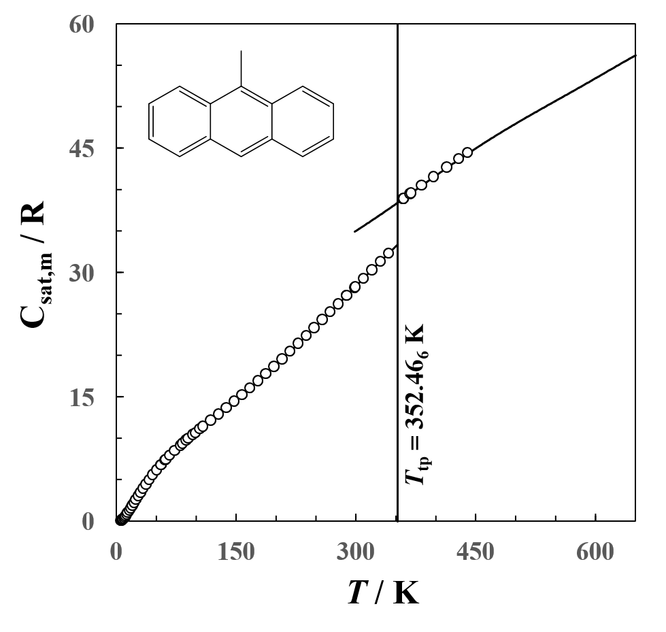
Figure 1. Plot of molar heat capacities at saturation pressure C_{sat,m} against temperature for 9-methylanthracene. The vertical line indicates the triple-point T_{tp} temperature. The smooth curve for temperatures T > 440 K represents results obtained with d.s.c. Heat capacities for the liquid for temperatures T < T_{tp} were estimated by linear extrapolation of measured values for temperatures T < 400 K.

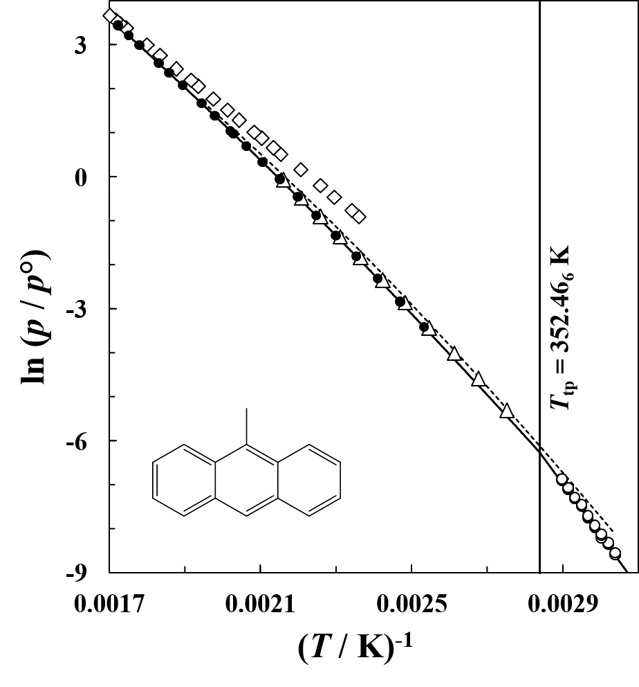
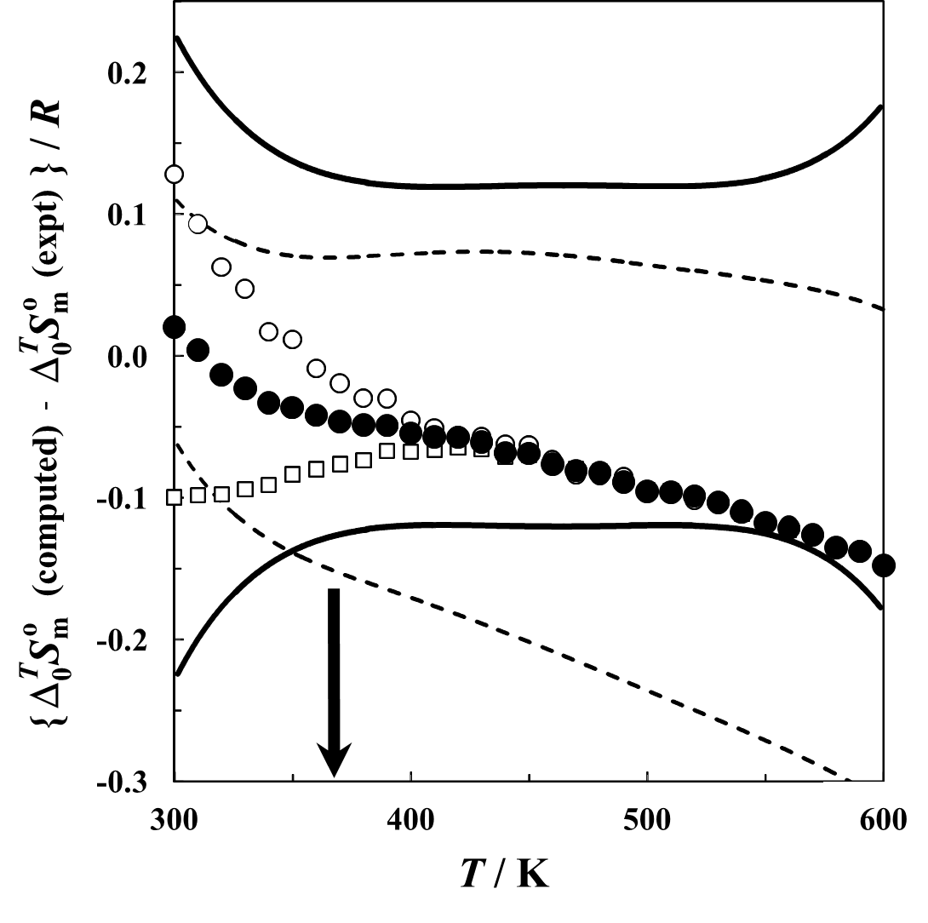
Figure 2. Plot of the natural logarithm of vapor or sublimation pressure ln(p/p°) against inverse temperature for 9-methylanthracene, where p° = 1 kPa. •, this research; ◊, Sivaraman and Kobayashi;⁸⁰ ∆, Mokbel et al.;⁸¹ ○, Ribeiro da Silva et al.;⁸⁵ - - - Hanshaw et al.⁸³ The vertical line indicates the triple-point temperature T_{tp}. The solid curves represent the fitted equations of this research for vapor pressure eq 4 with the fitted parameters of table 7 and sublimation pressure eq 9.

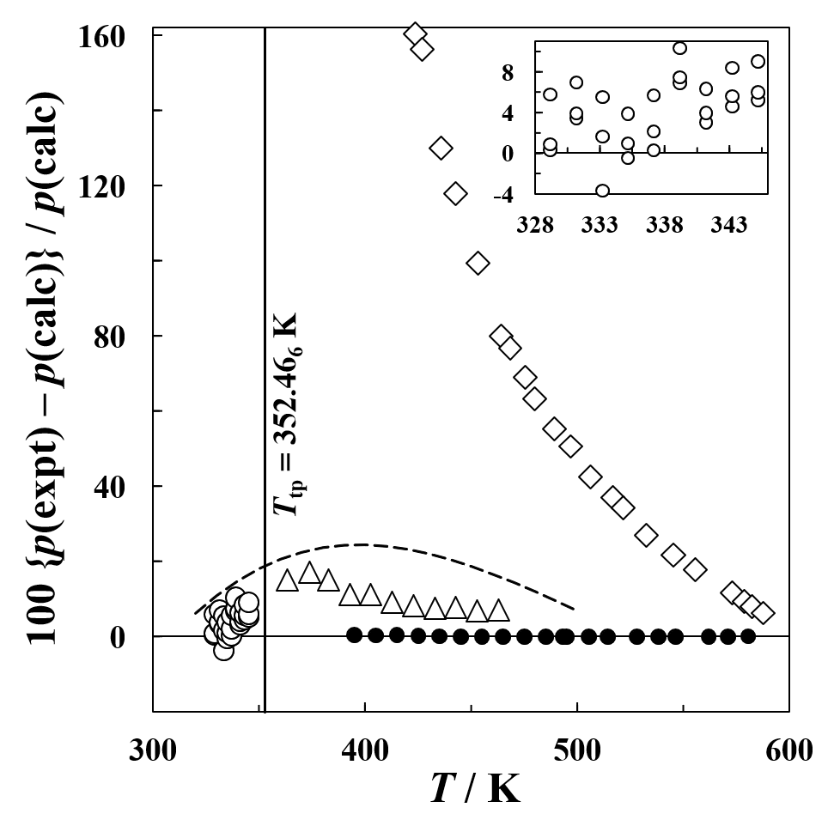
Figure 3. Deviation plot for experimental vapor and sublimation pressures for 9-methylanthracene relative to the fitted equations of this research for vapor pressure (eq 4 and the parameters of table 7) and sublimation pressure (eq 9). . •, this research; ◊, Sivaraman and Kobayashi;⁸⁰ ∆, Mokbel et al.;⁸¹ ○, Ribeiro da Silva et al.;⁸⁵ - - - Hanshaw et al.⁸³ The vertical line indicates the triple-point temperature T_{tp} for 9-methylanthracene. The inset provides details of the deviations for the values of Ribeiro da Silva et al.⁸⁵

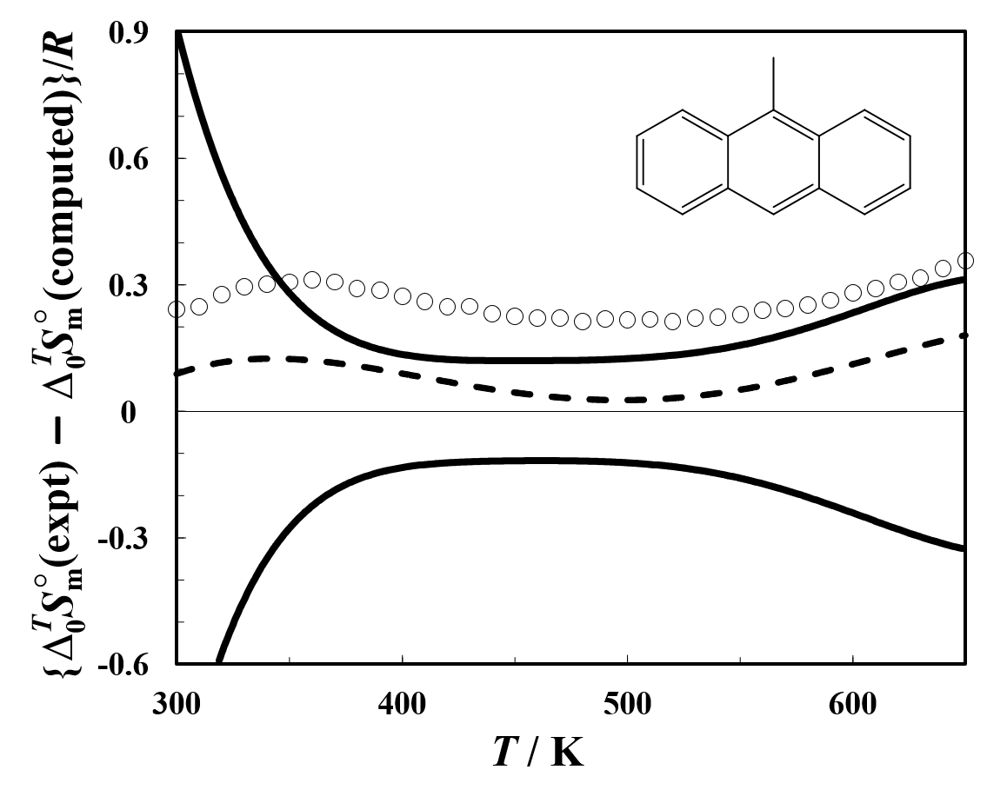
Figure 4. Deviation plot between ideal-gas entropies $∆_{0}^{T}S_{m}^{o}$of 9-methylanthracene derived from the experimental property measurements $∆_{0}^{T}S_{m}^{o}$(expt) (Table 14) and computed $∆_{0}^{T}S_{m}^{o}$(computed) (Table 16). ○, $∆_{0}^{T}S_{m}^{o}$(computed) was evaluated with the “free-rotor” model described in the text; – – –, $∆_{0}^{T}S_{m}^{o}$(computed) was evaluated with the coupled “2-D” model described in the text. The solid curved lines represent the expanded uncertainty (0.95 level of confidence) for $∆_{0}^{T}S_{m}^{o}$(expt). For the sake of clarity, we chose not to plot results computed with the various proposed small methyl rotations barriers for 9-MA (Table 17) because such results are indistinguishable from those of the free-rotor model.
.
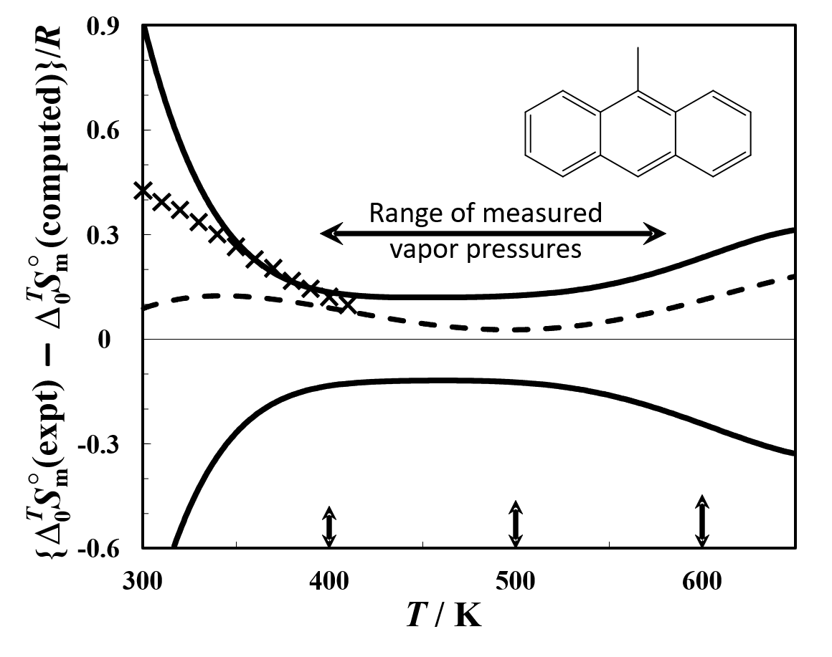
Figure 5. Deviation plot between ideal-gas entropies $∆_{0}^{T}S_{m}^{o}$of 9-methylanthracene derived from the experimental property measurements $∆_{0}^{T}S_{m}^{o}$(expt) (Table 14) and computed values $∆_{0}^{T}S_{m}^{o}$(computed) (Table 16). $∆_{0}^{T}S_{m}^{o}$(expt) was derived with two different forms of the Wagner equation (eq 4). – – –, the 1.5/2.5/3.0 form was used; , the 1.5/2.5/5.0 form was used. In both cases, $∆_{0}^{T}S_{m}^{o}$(computed) (Table 16) was evaluated with the 2-D model described in the text. The solid curved lines represent the expanded uncertainty (0.95 level of confidence) for $∆_{0}^{T}S_{m}^{o}$(expt). The double-headed arrow indicates the range of the measured vapor pressures. The three vertical bars represent 0.2 percent of $∆_{0}^{T}S_{m}^{o}$(expt) at the temperatures indicated.

() Chirico, R. D.; Johnson, R.D. III; Steele, W.V. Thermodynamic properties of methylquinolines: Experimental results for 2,6-dimethylquinoline and mutual validation between experiments and computational methods for methylquinolines. J. Chem. Thermodyn. 2007, 39, 698-711.
() Chirico, R. D.; Steele, W.V. Thermodynamic properties of tert-butylbenzene and 1,4-di-tert-butylbenzene. J. Chem. Thermodyn. 2009, 41, 392-401.
() Chirico, R. D.; Kazakov, A. F.; Steele, W,V. Thermodynamic properties of three-ring aza-aromatics. 1. Experimental results for phenazine and acridine, and mutual validation of experiments and computational methods. J. Chem. Thermodyn. 2010, 42, 571-580.
() Chirico, R. D.; Kazakov, A. F.; Steele, W. V. Thermodynamic properties of three-ring aza-aromatics. 2. Experimental results for 1,10-phenanthroline, phenanthridine, and 7,8-benzoquinoline, and mutual validation of experiments and computational methods. J. Chem. Thermodyn. 2010, 42, 581-590.
() Chirico, R. D.; Kazakov, A. F.; Steele, W. V. Thermodynamic properties of 9-fluorenone: Mutual validation of experimental and computational results. J. Chem. Thermodyn. 2012, 54, 278-287.
() Chirico, R. D.; Steele, W. V. Thermodynamic properties of 1-phenylnaphthalene and 2-phenylnaphthalene. J. Chem. Thermodyn. 2014, 73, 241-254.
() Chirico, R. D.; Kazakov, A. F. Thermodynamic properties of xanthone: Heat capacities, phase-transition properties, and thermodynamic-consistency analyses using computational results. J. Chem. Thermodyn. 2015, 86, 90-95.
() Chirico, R. D.; Steele, W. V.; Kazakov, A. F. Thermodynamic properties of 1-naphthol: Mutual validation of experimental and computational results. J. Chem. Thermodyn. 2015, 86, 106-115.
() Chirico, R. D.; Steele, W. V.; Kazakov, A. F. Thermodynamic properties of indan: Experimental and computational results. J. Chem. Thermodyn. 2016, 96, 41-51.
() Chirico, R. D.; Kazakov, A. F. Thermodynamic properties of pyrrole, 1-methylpyrrole, 2,4-dimethylpyrrole, and 2,5-dimethylpyrrole: Experimental and computational resultsJ. Chem. Thermodyn. 2018, 116, 213-229.
() Chirico, R. D.; Paulechka, E.; Bazyleva, A.; Kazakov, A. F. Thermodynamic properties of 2-methylindole: Experimental and computational results for gas-phase entropy and enthalpy of formation. J. Chem. Thermodyn. 2018, 125, 257-270.
() Nakagaki, M.; Nishi, E.; Sakota, K.; Nakano, H.; Sekiya, H. A model two-dimensional potential for internal rotation of 9-methylanthracene studied by electronic spectroscopy and DFT calculations. Chem. Phys. 2006, 328, 190-196.
() Steele, W. V.; Chirico, R. D.; Cowell, A. B.; Nguyen, A.; Knipmeyer, S. E. Possible precursors and products of deep hydrodesulfurization of gasoline and distillate fuels. Part 2. The thermodynamic properties of 2,3-dihydrobenzo[b]thiophene. J. Chem. Thermodyn. 2003, 35, 1253-1276.
() Commission on Isotopic Abundances and Atomic Weights. Standard Atomic Weights of the Elements 2020. https://www.ciaaw.org/atomic-weights.htm (accessed June 14, 2021).
() Tiesinga, E.; Mohr, P. J.; Newell, D. B.; Taylor, B. N. The 2018 CODATA Recommended Values of the Fundamental Physical Constants" (Web Version 8.1). Database developed by J. Baker, M. Douma, and S. Kotochigova. http://physics.nist.gov/constants, National Institute of Standards and Technology, Gaithersburg, MD 20899. (accessed June 14, 2021).
() Comité International des Poids et Mesures. The International Practical Temperature Scale of 1968. Metrologia 1969, 5, 35-44.
() Goldberg, R. N.; Weir, R. D. Conversion of temperatures and thermodynamic properties to the basis of the international temperature scale of 1990. Pure Appl. Chem. 1992, 64, 1545-1562.
() McCrackin, F. L.; Chang, S. S. Simple calibration procedures for platinum resistance thermometers from 2.5 to 14 K. Rev. Sci. Instrum. 1975, 46, 550-553.
() Steele, W. V.; Archer, D. G.; Chirico, R. D.; Collier, W. B.; Hossenlopp, I. A.; Nguyen, A.; Smith, N. K.; Gammon, B. E. The thermodynamic properties of quinoline and isoquinoline. J. Chem. Thermodyn. 1988, 20, 1233–1264.
() Mraw, S. C.; Naas, D. F. The measurement of accurate heat capacities by differential scanning calorimetry. Comparison of d.s.c. results on pyrite (100 to 800 K) with literature values from precision adiabatic calorimetry. J. Chem. Thermodyn. 1979, 11, 567-584.
() Archer, D. G. Thermodynamic properties of synthetic sapphire (α-Al2O3), standard reference material 720 and the effect of temperature-scale differences on thermodynamic properties. J. Phys. Chem. Ref. Data 1993, 22, 1441-1453.
() Steele, W. V.; Chirico, R. D.; Knipmeyer, S. E.; Smith, N. K. Report NIPER-360, December 1988. Published by DOE Fossil Energy, Bartlesville Project Office. Available from NTIS Order No. DE89000709.
() Steele, W. V. Fifty years of thermodynamics research at Bartlesville: The Hugh M. Huffman legacy. J. Chem. Thermodyn. 1995, 27, 135-162.
() Swietoslawski, W. Ebulliometric Measurements, Reinhold, New York, 1945.
() Osborn, A. G.; Douslin, D. R. J. Chem. Eng. Data 1966, 11, 502-509.
() Wagner, W.; Pruss, A. The IAPWS Formulation 1995 for the Thermodynamic Properties of Ordinary Water Substance for General and Scientific Use. J. Phys. Chem. Ref. Data 2002, 31, 387-535.
() Steele, W. V.; Chirico, R. D.; Cowell, A. B.; Nguyen, A.; Knipmeyer, S. E. Possible precursors and products of deep hydrodesulfurization of gasoline and distillate fuels. III. The thermodynamic properties of 1,2,3,4-tetrahydrodibenzothiophene. J. Chem. Thermodyn. 2004, 36, 497–509.
() Douslin, D. R.; McCullough, J. P. US Bureau of Mines. Report of Investigation 6149, 1963, 11 pp.
() Douslin, D. R, Osborn, A. G. Pressure measurements in the 0.01–30 torr range with an inclined-piston gauge. J. Sci. Instrum. 1965, 42, 369-373.
() Chirico, R. D.; Knipmeyer, S. E.; Nguyen, A.; Smith, N. K.; Steele, W. V. The thermodynamic properties of 4,5,9,10-tetrahydropyrene and of 1,2,3,6,7,8-hexahydropyrene. J. Chem. Thermodyn. 1993, 25, 729-761.
() Chirico, R. D.; Steele, W. V. Reconciliation of Calorimetrically and Spectroscopically Derived Thermodynamic Properties at Pressures Greater Than 0.1 MPa for Benzene and Methylbenzene. The Importance of the Third Virial Coefficient. Ind. Eng. Chem. Res. 1994, 33, 157-167.
() Good, W. D.; Moore, R. T. Enthalpies of formation of ethylenediamine, 1,2,-propanediamine, 1,2,-butanediamine, 2-methyl-1,2-propanediamine, and isobutylamine. C-N and N-F thermochemical bond energies. J. Chem. Eng. Data 1970, 15, 150-154.
() Good, W. D. Enthalpies of combustion of nine organic nitrogen compounds related to petroleum. J. Chem. Eng. Data 1972, 17, 28-31.
() Good, W. D.; Scott, D. W.; Waddington, G. Combustion calorimetry of organic fluorine compounds by a rotating-bomb method. J. Phys. Chem. 1956, 60, 1080-1089.
() Good, W. D.; Douslin, D. R.; Scott, D. W.; George, Ann; Lacina, J. L.; Dawson, J. P.; Waddington, G. Thermochemistry and vapor pressure of aliphatic fluorocarbons. A comparison of the C-F and C-H thermochemical bond energies. J. Phys. Chem. 1959, 63, 1133-1138.
() Smith, N. K.; Stewart, R. C., Jr.; Osborn, A. G.; Scott, D. W. Pyrene: vapor pressure, enthalpy of combustion, and chemical thermodynamic properties. J. Chem. Thermodyn. 1980, 12, 919-926.
() Chirico, R. D.; Hossenlopp, I. A.; Nguyen, A.; Strube, M. M.; Steele, W. V. Thermochemical and Thermophysical Properties of Organic Compounds Derived From Fossil Substances. Thermodynamic Studies Related to the Hydrogenation of Phenanthrene. Dept. of Energy Report No. NIPER-247, April 1987. (NTIS Report No. DE87001252.)
() R.N. Goldberg, R.N. Nuttall, E.J. Prosen, A.P. Brunetti, NBS Report 10437, US Department of Commerce, National Bureau of Standards, June 1971.
() W.N. Hubbard, D.W. Scott, G. Waddington in F.D. Rossini (Ed) Experimental Thermochemistry, Interscience, New York, 1956, pp. 75-128, Chapter 5. For those who cannot obtain a copy of this reference, the following source details the items in question, but in an earlier version in which some of the ancillary data are inaccurate. Hubbard, Ward N.; Scott, Donald W.; Waddington, G. Reduction to Standard States (at 25°C) of Bomb Calorimetric Data for Compounds of Carbon, Hydrogen, Oxygen and Sulfur. J. Phys. Chem. 1954, 58, 152-162.
() Paulechka, E.; Riccardi, D.; Bazyleva, A.; Ribeiro da Silva, M. D. M. C.; Zaitsau, D. Corrections to standard state in combustion calorimetry: An update and a web-based tool. J. Chem. Themodyn. 2021, 158, 106425.
() Good, W. D.; Douslin, D. R.; Scott, D. W.; George, Ann; Lacina, J. L.; Dawson, J. P.; Waddington, G. Thermochemistry and vapor pressure of aliphatic fluorocarbons. A comparison of the C-F and C-H thermochemical bond energies. J. Phys. Chem. 1959, 63, 1133-1138.
() van der Lee, A; Dumitrescu, D. G. Thermal expansion properties of organic crystals: a CSD study. Chem. Sci. 2021, 12, 8537-8547.
() Good, W. D.; Smith, N. K. Enthalpies of combustion of toluene, benzene, cyclohexane, cyclohexene, methylcyclopentane, 1-methylcyclopentene, and n-hexane. J. Chem. Eng. Data 1969, 14, 102-106.
() Chirico, R. D.; Kazakov, A.; Bazyleva, A.; Diky, V.; Kroenlein, K.; Emel′yanenko, V. N.; Verevkin, S. P. Critical Evaluation of Thermodynamic Properties for Halobenzoic Acids Through Consistency Analyses for Results from Experiment and Computational Chemistry. J. Phys. Chem. Ref. Data 2017, 46, 023105.
() Rappoport, D.; Furche, F. Property-optimized Gaussian basis sets for molecular response calculations. J. Chem. Phys. 2010, 133, 134105.
() Nagy, P. R.; Samu, G.; Kállay, M. 2016. An integral-direct linear-scaling second-order Møller–Plesset approach. J. Chem. Theory Comput. 2016, 12, 4897-4914.
() Nagy, P. R.; Samu, G.; Kállay, M. 2018. Optimization of the linear-scaling local natural orbital CCSD (T) method: Improved algorithm and benchmark applications. J. Chem. Theory Comput. 2018, 14, 4193-4215.
() Ditchfield, R. H. W. J.; Hehre, W. J.; Pople, J. A. Self‐consistent molecular‐orbital methods. IX. An extended Gaussian‐type basis for molecular‐orbital studies of organic molecules. J. Chem. Phys. 1971, 54, 724-728.
() Dunning, T. H., Jr, Gaussian basis sets for use in correlated molecular calculations. I. The atoms boron through neon and hydrogen. J. Chem. Phys. 1989, 90, 1007-1023.
() Frisch, M. J.; Trucks, G. W.; Schlegel, H. B.; Scuseria, G. E.; Robb, M. A.; Cheeseman, J. R.; Scalmani, G.; Barone, V.; Petersson, G. A.; Nakatsuji, H. et al. Gaussian 16 Revision B.01. 2016; Gaussian Inc., Wallingford, CT.
() Parrish, R. M.; Burns, L. A.; Smith, D. G. A.; Simmonett, A.C.; DePrince, A. E.; Hohenstein, E. G.; Bozkaya, U.; Sokolov, A. Yu.; Di Remigio, R.; Richard, R. M.; Gonthier, J. F.; James, A. M.; McAlexander, H. R.; Kumar, A.; Saitow, M.; Wang, X.; Pritchard, B. P.; Verma, P.; Schaefer, H. F.; Patkowski, K.; King, R. A.; Valeev, E. F.; Evangelista, F. A.; Turney, J. M.; Crawford, T. D.; Sherrill, C. D. PSI4 1.1: An Open-Source Electronic Structure Program Emphasizing Automation, Advanced Libraries, and Interoperability. J. Chem. Theory Comput. 2017, 13, 3185-3197.
() Smith, D. G. A.; Burns, L. A.; Simmonett, A.C.; Parrish, R. M.; Schieber, M. C.; Galvelis, R.; Kraus, P.; Kruse, H.; Di Remigio, R.; Alenaizan, A.; James, A. M.; Lehtola, S.; Misiewicz, J. P.; Scheurer, M.; Shaw, R. A.; Schriber, J. B.; Xie, Y.; Glick, Z. L.; Sirianni, D. A.; O’Brien, J. S.; Waldrop, J. M.; Kumar, A.; Hohenstein, E. G.; Pritchard, B. P.; Brooks, B. R.; Schaefer, H. F., III; Sokolov, A. Yu.; Patkowski, K.; DePrince, A. E., III; Bozkaya, U.; King, R. A.; Evangelista, F. A.; Turney, J. M.; Crawford, T. D.; Sherrill, C. D. PSI4 1.4: Open-source software for high-throughput quantum chemistry. J. Chem. Phys. 2020, 152, 184108.
() Kállay, M.; Nagy, P. R.; Mester, D.; Rolik, Z.; Samu, G.; Csontos, J.; Csóka, J.; Szabó, P. B.; Gyevi-Nagy, L.; Hégely, B.; Ladjánszki, I. 2020. The MRCC program system: Accurate quantum chemistry from water to proteins. J. Chem. Phys. 2020, 152, 074107.
() Paulechka, E.; Kazakov, A. Efficient estimation of formation enthalpies for closed-shell organic compounds with local coupled-cluster methods. J. Chem. Theory Comput, 2018, 14, 5920-5932.
() McCullough, J. P.; Waddington, G. Melting-point purity determinations: limitations as evidenced by calorimetric studies in the melting region. Anal. Chim. Acta 1957, 17, 80-96.
() Wagner, W. New vapor pressure measurements for argon and nitrogen and a new method for establishing rational vapor pressure equations. Cryogenics 1973, 13, 470-482.
() Poling, B. E.; O’Connell, J.; Prausnitz, J. M. The Properties of Gases and Liquids, fifth ed., McGraw-Hill, New York, 2000.
() Joback, K. G.; Reid, R. C. Estimation of pure-component properties from group contributions. Chem. Eng. Commun. 1987, 57, 233-243.
() Waring, W. Form of a wide-range vapor-pressure equation. Ind. Eng. Chem. 1954, 46, 762–763.
() Riedel, L. Liquid density in the saturated state. Extension of the theorem of corresponding states. II. Chem.-Ing.-Tech. 1954, 26, 259-264.
() Hales, J. L.; Townsend, R. Liquid densities from 293 to 490 K of nine aromatic hydrocarbons. J. Chem. Thermodyn. 1972, 4, 763-772.
() Pitzer, K. S.; Curl, R. F., Jr. Volumetric and thermodynamic properties of fluids. III. Empirical equation for the second virial coefficient. J. Am. Chem. Soc. 1957, 79, 2369-2370.
() Orbey, H.; Vera, J. H. Correlation for the third virial coefficient using T_{c}, P_{c} and ω as parameters AIChE J. 1983, 29, 107-113.
() Hubbard, W. N.; Scott, D. W.; Waddington, G. in: Rossini, F. D. (Ed.), Experimental Thermochemistry, Interscience, New York, 1956, pp. 75–128 (Chapter 5). For those who cannot obtain a copy of this reference, the following source details the items in question, but in an earlier version in which some of the ancillary data are inaccurate. Hubbard, W. N; Scott D. W.; Waddington, G. Reduction to Standard States (at 25 C) of Bomb Calorimetric Data for Compounds of Carbon, Hydrogen, Oxygen and Sulfur. J. Phys. Chem. 1954, 58, 152–162.
() F.D. Rossini, F. D. Assignment of Uncertainities to Thermochemical Data. in F.D Rossini. (Ed) Experimental Thermochemistry, Interscience, New York, 1956, pp. 297-320, Chapter 14.
() Cox, J. D.; Wagman, D. D.; Medvedev, V. A.; Eds; CODATA Key Values for Thermodynamics. Hemisphere: New York, 1989.
() Chase, M.W., Jr.; NIST-JANAF Thermochemical Tables. Fourth edition, Monograph 9 (Parts 1 and 2), J. Phys. Chem. Ref: Data, 1998, p. 1963.
() Chirico, R. D.; Archer, D. G.; Hossenlopp, I. A.; Nguyen, A.; Steele, W. V.; Gammon, B. E. J. Chem. Thermodyn. 1990, 22, 665-682.
() Pitzer, K. S., 1946. Energy levels and thermodynamic functions for molecules with internal rotation: II. Unsymmetrical tops attached to a rigid frame. J. Chem. Phys. 1946, 14, 239-243.
() Cox, P. J. and Sim, G. A. X-ray diffraction studies of 9-methylanthracene and 5-methylnaphthacene. Acta Crystallogr., Sect. B: Struct. Crystallogr. Cryst. Chem. 1979, 35, 404-410.
() Langhoff, S. R.; Bauschlicher, C. W.; Hudgins, D. M.; Sandford, S. A.; Allamandola, L. J. Infrared spectra of substituted polycyclic aromatic hydrocarbons. J. Phys. Chem. A 1998, 102, 1632-1646.
() Rao, D. J.; Mary, Y. S.; Mary, Y. S.; Resmi, K. S.; Thomas, R. Structure, spectral features, bioactivity and light harvesting properties of methyl and dimethyl anthracene: experimental and first principle studies. Polycyclic Aromat. Compd. 2019. Published online: doi:10.1080/10406638.2019.1709083.
() Syage, J. A.; Felker, P. M.; Semmes, D. H.; Al Adel, F.; Zewail, A. H. Picosecond excitation and selective intramolecular rates in supersonic molecular beams. IV. Alkylanthracenes. J. Chem. Phys. 1985, 82, 2896-2908.
() Mordziński, A.; Leś, A.; Stepanenko, Y.; Rycombel, J.; Adamowicz, L. S₀ and S₁ spectroscopy of jet cooled 9-cyano-10-methylanthracene: The methyl group as a molecular rotor. J. Mol. Spectrosc. 2005, 233, 98-109.
() Baba, M.; Mori, K.; Saito, M.; Kowaka, Y.; Noma, Y.; Kasahara, S.; Yamanaka, T.; Okuyama, K.; Ishimoto, T.; Nagashima, U. CH₃ Internal Rotation in the S₀ and S₁ States of 9-Methylanthracene. J. Phys. Chem. A 2009, 113, 2366-2371.
() Baba, M.; Kanaoka, A.; Nishiyama, A.; Misono, M.; Ishimoto, T.; Udagawa, T. Large amplitude motion in 9-methylanthracene: High-resolution spectroscopy and Ab Initio theoretical calculation. Chin. J. Chem. Phys. 2020, 33, 8-12.
() Bootsma A. N.; Wheeler S. Popular Integration Grids Can Result in Large Errors in DFT-Computed Free Energies. ChemRxiv. Cambridge: Cambridge Open Engage; Preprint, Version 5, Posted July 29, 2019. doi:10.26434/chemrxiv.8864204.v5 (Accessed July 7, 2021)
() Moran, D.; Simmonett, A. C.; Leach, F. E., III; Allen, W. D.; Schleyer, P. v. R.; Schaefer, H. F., III Popular Theoretical Methods Predict Benzene and Arenes To Be Nonplanar. J. Amer. Chem. Soc. 2006, 128, 9342-9343.
() Paulechka, E.; Kazakov, A. Efficient ab initio Estimation of Formation Enthalpies for Organic Compounds: Extension to Sulfur and Critical Evaluation of Experimental Data. J. Phys. Chem. A 2021, 125, 8116–8131.
() Krollpfeiffer, F. Spectrochemical investigation of the polynuclear aromatic compounds in solution. Justus Liebigs Ann. Chem. 1923, 430, 161-229.
() Sivaraman, A.; Kobayashi, R. Vapor pressures and enthalpies of vaporization of thianthrene, acridine, and 9-methylanthracene at elevated temperatures. J. Chem. Thermodyn. 1983, 15, 1127-1135.
() Mokbel, I.; Guetachew, T.; Jose, J. Vapor pressures and sublimation pressures of 14 polycyclic aromatic hydrocarbons (C11-C18) at pressures in the range from 0.5 Pa to 30 kPa. ELDATA: Int. Electron. J. Phys.-Chem. Data 1995, 1, 167-179.
() Klochkov, V. P. The saturated vapor pressures of several aromatic compounds. Zh. Fiz. Khim. 1958, 32, 1177.
() Hanshaw, W.; Nutt, M.; Chickos, J. S. Hypothetical thermodynamic properties. Subcooled vaporization enthalpies and vapor pressures of polyaromatic hydrocarbons. J. Chem. Eng. Data 2008, 53, 1903-1913.
() Chirico, R. D.; Knipmeyer, S. E.; Nguyen, A.; Steele, W. V. The thermodynamic properties of biphenyl. J. Chem. Thermodyn. 1989, 21, 1307-1331.
() Ribeiro da Silva, M. A. V.; Amaral, L. M. P. F.; Santos, A. F. L. O. M.; Gomes, J. R. B. Thermochemistry of some alkylsubstituted anthracenes. J. Chem. Thermodyn. 2006, 38, 367-375.
() Kiselev, V. D.; Veisman, E. A.; Solomonov, B. N.; Konovalov, A. I. Enthalpies of sublimation and solvation of 9,10-substituted anthracenes. Zh. Obshch. Khim. 1985, 55, 1965-1969.
() Frenkel M.; Chirico R. D; Diky V.; Yan X.; Dong Q.; Muzny C. ThermoData Engine (TDE): Software Implementation of the Dynamic Data Evaluation Concept. J. Chem. Inf. Model. 2005, 45, 816-838.
() Diky, V.; Chirico, R. D.; Kazakov, A. F.; Muzny, C. D.; Frenkel, M. ThermoData Engine (TDE): Software Implementation of the Dynamic Data Evaluation Concept. 3. Binary Mixtures. J. Chem. Inf. Model. 2009, 49, 503-517.
() Diky, V.; Chirico, R. D.; Kazakov, A. F.; Muzny, C. D.; Frenkel, M. ThermoData engine (TDE): software implementation of the dynamic data evaluation concept. 4. Chemical reactions. J. Chem. Inf., 2883 Model. 2009, 49-2896.
() Diky, V.; Chirico, R. D.; Muzny, C. D.; Kazakov, A. F.; Kroenlein, K.; Magee, J. W.; Abdulagatov, I.; Kang, J. W.; Frenkel, M. ThermoData Engine (TDE) Software Implementation of the Dynamic Data Evaluation Concept. 7. Ternary Mixtures. J. Chem. Inf. Model. 2012, 52, 260-276.
() Diky, V.; Chirico, R. D.; Muzny, C. D.; Kazakov, A. F.; Kroenlein, K.; Magee, J. W.; Abdulagatov, I.; Frenkel, M. ThermoData Engine (TDE): Software Implementation of the Dynamic Data Evaluation Concept. 9. Extensible Thermodynamic Constraints for Pure Compounds and New Model Developments. J. Chem. Inf. Model. 2013, 53, 3418-3430.
() Diky, V.; Chirico, R. D.; Frenkel, M.; Bazyleva, A.; Magee, J. W.; Paulechka, E.; Kazakov, A. F.; Lemmon, E. W.; Muzny, C. D.; Smolyanitsky, A. Y.; Townsend, S.; Kroenlein, K. NIST ThermoData Engine, NIST Standard Reference Database 103b-Pure Compounds, Binary Mixtures, Ternary Mixtures, and Chemical Reactions, version 10.4.2; Standard Reference Data Program, National Institute of Standards and Technology: Gaithersburg, MD, 2021.

