19

Reference nanomaterials to improve the reliability of nanoscale measurements

G. Roebben1, V. A. Hackley2, H. Emons1

1 European Commission, Joint Research Centre, Directorate Health, Consumers and Reference materials, Retieseweg 111, B-2440 Geel, Belgium

2 Materials Measurement Science Division, National Institute of Standards and Technology, U.S. Department of Commerce, Gaithersburg, MD 20899 USA

# Introduction

## 19.1.1 Scope

Reference materials are essential tools to assure the quality of measurement results, from R&D labs to production facilities. They increase the reliability of measurements, as laboratories use reference materials to verify for themselves, and demonstrate for third parties, the precision and trueness of their measurement results.

This chapter does not cover the fine details of the preparation and characterisation (and value assignment) of (certified) reference materials. To learn about these aspects of reference material production, the reader is referred to a number of relevant ISO standards[1],[2],[3],[4] and publications on this subject.[5],[6],[7]

Instead, this chapter focuses on how reference materials are used in practice, with examples from the area of nanoscale measurements. The examples shown correspond with the various intended uses for a reference material (such as quality control, instrument or procedure calibration, and method validation), after which the sections of this chapter are named.

## 19.1.2 Terminology

For an easier understanding of the text, the reader will benefit from the following definitions, taken from the relevant ISO Guide 30 on reference material terminology:[8]

Reference material (RM): material, sufficiently homogeneous and stable with respect to one or more specified properties, which has been established to be fit for its intended use in a measurement process

Certified reference material (CRM): RM characterized by a metrologically valid procedure for one or more specified properties, accompanied by an RM certificate that provides the value of the specified property, its associated uncertainty, and a statement of metrological traceability

The above definitions were developed by the ISO Committee on Reference Materials (ISO/REMCO) for generic use across all scientific disciplines. While the REMCO definitions are increasingly being adopted, it must be acknowledged that currently there still is a multitude of alternative terms to indicate specific types of RMs or CRMs, often used in one or more scientific fields (standards, artefacts, …), or for a specific type of use (calibrants, proficiency test materials, …). A number of these terms are defined in ISO Guide 30, others are mentioned and categorised by Emons.[9] It is also noted that several RM producers have their own coding or classification system, corresponding with various levels of quality or reliability (e.g., NIST Standard Reference Materials (SRM™) or the European Reference Materials (ERM®)).

# Reference materials for quality control

## 19.2.1 Analytical quality assurance

In essence, quality is about meeting expectations. Therefore, appropriate quality of the analysis requires reliability, i.e. also consistency, in the produced measurement results, over long periods of time but also between different laboratories. This is of obvious importance in an industrial production or regulatory setting, but also for (other) laboratories working under a quality assurance program.

Laboratory or analytical quality assurance systems rely heavily on the documented control of the quality of results of analysis. To prove the consistency of the performance of measurement methods, over time, but also between operators, instruments and laboratories, one can perform a series of tests under controlled conditions and compare the results. This will give an indication of the variation between the results and can be used to detect trends or systematic differences that may require intervention at the instrumental or operator level. It is important that the observed variation between measurement results is not due to differences between the samples used in the test series. This concern is at the heart of the RM concept and explains why the principal characteristics required for the RM property of interest are:

1) homogeneity (within and between units of the same RM)

2) stability (over time)

The quantified remaining heterogeneity of RMs describes the potential differences between different samples of the RM, and the stated stability informs about the potential use of the RM samples over time. It is therefore highly beneficial to use RMs for assessing the consistency of measurement results.

## 19.2.2 Example: quality control chart

An example of a nanoscale RM is the colloidal silica IRMM-304.[10] This material was released in 2008 as a RM for nanoparticle size measurements with dynamic light scattering (DLS) and centrifugal liquid sedimentation (CLS), based on the outcome of dedicated homogeneity and stability studies.

In the homogeneity study, a representative number of randomly selected units of IRMM-304 were tested under repeatability conditions (in one laboratory, by one operator, within a short time span). The standard deviation between the results is an estimate of the between-unit heterogeneity. For IRMM-304, the relative standard deviation of the average particle size measured by CLS or DLS was smaller than 1.1 %.

The short-term stability study initially performed on IRMM-304 indicated that there was no detectable effect of a short-term exposure to temperatures representative for transport conditions (between 4 °C and 60 °C). Later, also the long term stability of IRMM-304 at the storage temperature of 18 °C was investigated. The increase of the combined relative standard uncertainty for the average particle size as measured by DLS (cumulants method) due to long term storage was estimated to be < 0.45 % for a period of 24 months. This uncertainty component (0.45 %) covers the maximum time between the periodic (annual) stability monitoring tests that are performed at IRMM on samples of IRMM-304 and the 1-year validity period of the assigned value guaranteed to customers of IRMM-304 samples.

Samples of IRMM-304 have been used over several years to monitor the performance of a specific DLS instrument at IRMM, as recorded in a control chart (Figure 1). After the DLS instrument was brought into use, every month a new sample of IRMM-304 was measured and the measured values were introduced on to the control chart. 

Figure 19.1: Control chart showing the scattering intensity-weighted harmonic mean diameter (DLS, cumulants method) measured on IRMM-304 in the IRMM laboratory over time. The monthly reported values are averages of 3 measurements; the error bars indicate the corresponding standard deviation. The central line (green), the warning lines (red dashed) and the control lines (red full) were calculated based on 10 measurements preceding the indicated period (central line = expected value; warning lines: 2 x standard deviation of the average size values obtained at different time points; control lines: 3 x standard deviation).

Control charts are based on the comparison of a current result with previous ones, taking into consideration the normal variability of a process. They are used for internal quality control to detect sudden changes or gradual changes (trends) in processes (here: measurements). The central line, the warning lines and the control lines indicated in the control chart in Figure 1 have been calculated based on 10 monthly measurements preceding the period indicated in Figure 1. The variation of the control chart data is interpreted in accordance with the classical guidelines of a quality system, specifying actions to take when one entry is outside a control limit, or when two out of three consecutive entries are outside a warning limit.

# Reference materials for instrument calibration

The previous section provided an example requiring the RMs to be stable and homogeneous. A fundamentally different intended use for RMs is that of calibration of a method or of the response of an instrument. In this case, the RM must also have an assigned (preferably certified) property value. This property value is used in the calibration process as a reference value to scale the data obtained with the method. The calibration process, at its core, follows one of two pathways. (a) The *comparison of measurement results with the assigned property value of the calibrant*. When the difference is significant, the instrument response is adjusted to match the assigned value. For example, in the case of electron microscopy, the image scale, expressed as pixels/nm, would be adjusted accordingly, based on a known length scale calibrant. (b) The *conversion of a measured instrument response (e.g., signal intensity) to a known measurand value* based on the calibrant (e.g., mass concentration of silica in a solution).

In the field of nanoparticle characterisation, prime examples of calibrants are polystyrene (PS) latex materials, such as NIST SRM 1963a (100 nm PS spheres) and SRM 1964 (60 nm PS spheres). These CRMs have been widely adopted as calibrants for particle sizing instruments, including electron microscopes, differential mobility analyzers and optical scanning surface inspection systems.[11] The latter are used in the semiconductor industry to quantify contaminant particles on a bare silicon wafer. The wide adoption of these CRMs is due to their intrinsic properties (highly spherical shape, highly monodisperse size) and the metrological traceability of their assigned values. Metrological traceability requires establishment of an unbroken chain of calibrations to specified references, preferably to the realisation of one of the base units of the International System of Units (SI), or to another recognized standard, including property values embedded in CRMs. Certification of size values assigned to SRM 1963a and SRM 1964 involved careful measurements confirmed by multiple techniques and a fully developed uncertainty budget that captured all known sources of measurement uncertainty including variables that impact the principal measurement, such as pressure, temperature and voltage. Both CRMs have also been widely used to establish traceability of the assigned particle size values to the SI via the certified values of a NIST CRM for commercially produced so-called NIST Traceable Reference Materials™.

An example of the utilization of an existing RM for a calibration purpose not originally intended or foreseen, is the recently documented use of NIST RM 8012 and RM 8013 (30 nm and 60 nm gold nanoparticles) for calibration of single particle inductively coupled plasma – mass spectrometry (spICP-MS).[12],[13] ,[14] These RMs have assigned size values obtained by multiple techniques, and mass concentrations provided as NIST information values. At the time of release, spICP-MS was an emerging technique not widely known or utilized. Following release of the NIST RMs, substantial developments in spICP-MS theory and practise led to increased availability and use of spICP-MS. The advantages of spICP-MS are its exceptional detection power for metal containing particles (ng/L range) coupled with the capacity to quantify both particle mass (and a corresponding equivalent size) on a particle-by-particle basis and particle number concentration. Particles are detected as individual signal pulses as they enter and are ionized by the plasma at low concentrations; this is accomplished by operating in a time resolved mode with millisecond dwell times. The frequency of pulses is related to the particle concentration, while the pulse intensity is related to the particle mass. Pace *et al*.,xii first described and evaluated the use of a reference metal nanoparticle (RM 8013) to quantify both size and number concentration. In their widely adopted approach, a two-stage calibration procedure has been described, using a dissolved metal standard and a nanoparticle RM of the same element (gold in this case). First, a dissolved metal standard is used to obtain a conventional signal intensity versus mass concentration calibration curve. To convert pulse intensity to particle mass and pulse frequency to particle concentration, the particle *transport efficiency* must be determined using one or more reference particle materials; transport efficiency is the ratio of the amount of analyte entering the plasma to the amount entering the aspirator/spray chamber. Here, losses from the sample introduction system for particles can differ significantly from that of dissolved metal solutions, and thus the particle transport efficiency must be determined independently. In practise, transport efficiency can be determined from either pulse frequency (and a known particle concentration obtained from the RM mean size and mass concentration) or pulse intensity (and a known particle size). In the second stage, the intensity-mass concentration curve is transformed into intensity versus mass-per-event, by multiplying mass concentration with the measured transport efficiency and the known sample flow rate and dwell time. From this transformed calibration curve, the particle mass associated with individual events (pulses) can be determined, yielding the number-weighted particle mass-based size distribution of an unknown sample. Pace et al. demonstrated the universality of this approach by applying the calibration procedure using RM 8013 (gold) to quantify nanosize silver particles over a range of concentrations.

# Reference materials for method validation

Method validation is a concept that covers several types of actions, which all have in common that they try to assess, among other performance characteristics, the accuracy (i.e., the combination of precision and trueness[15],[16]) of the results produced by the studied method. In this section we illustrate the role of RMs in different types of method validation.

One kind of validation of a method is by comparing its results obtained in different laboratories. This is typically an exercise that is performed on a relatively new method, for example when it is proposed to become a standard method. Another type of method validation, also performed for new methods at the end of their development process, is the comparison of the new method's results with results obtained with other measurement methods assessing the same measurand. This can be done within a single laboratory or in different laboratories. It is a common misperception to consider a method that has been validated in one of both previous ways (between-laboratory, or between-method) as valid for use by any (other) laboratory. This brings us to the third type of method validation, which is a set of tests that are performed by a laboratory when an existing method is implemented in this laboratory for the first time.

## 19.4.1 Example 1: Between-lab reproducibility

To demonstrate that a method is sufficiently robust and mature to be standardised, information on the reproducibility of a method between laboratories is required. This information can be obtained through interlaboratory comparisons (ILCs). ILCs are typically conducted as a blind study, where the participants are provided with a method or protocol, but have no knowledge of the expected result. The added value of using a RM in an ILC is that the contributions of sample-to-sample heterogeneity and in-house measurement precision to the overall expected uncertainty have already been quantified and can therefore be differentiated from the observed variations between laboratory results.

Under the umbrella of the Versailles Project on Advanced Materials and Standards (VAMAS),[17] an organisation for pre-normative studies in the field of materials characterisation, ILCs are regularly organised with this aim. A VAMAS ILC with a stated objective to assess the “real world” in-house measurement precision and between-laboratory variation for the determination of the specific surface area of an industrially relevant metal oxide nanomaterial in powder form was conducted by NIST in 2010.[18] The test material, nanocrystalline titanium dioxide, was a certified reference material (SRM 1898),[19] which had not yet been released to the public. The test protocol used in the study was compliant with existing international standards for determination of the Brunauer-Emmett-Teller (BET) specific surface area of refractory powders.[20],[21] A total of 20 laboratories participated in the study, which included an international sampling of government, academic, and commercial organizations representing a range of competence levels and instrumentation. Participants were asked to report any deviations from the protocol and to self-select their level of expertise. The global results of the study are shown in Figure 2.

The study yielded relatively consistent results across laboratories despite a wide range of measurement platforms and reported levels of expertise,xvi with one notable exception. Lab 18 was rejected, not because it reported a value that is a statistical outlier, but based on a technical evaluation, i.e. a follow-up quality check using a second certified RM. This laboratory subsequently and independently confirmed that the instrument was not operating correctly at the time of the study; in this case the use of a RM proved critical to identify an operationally deficient measurement device. Overall, the variability between laboratories was about 3x larger than within laboratories. This variability could not be attributed to known effects, such as operational experience or instrumentation. Potentially important sources of variability that were not accounted for in this study include gravimetric errors and the degassing process prior to analysis. Gravimetric errors are most likely to arise from incomplete degassing or weighing errors due to powder handling (e.g., static electricity can impact accurate weighing and transfer of fine powders). Such errors will tend to be independent of the nominal mass used in the analysis.

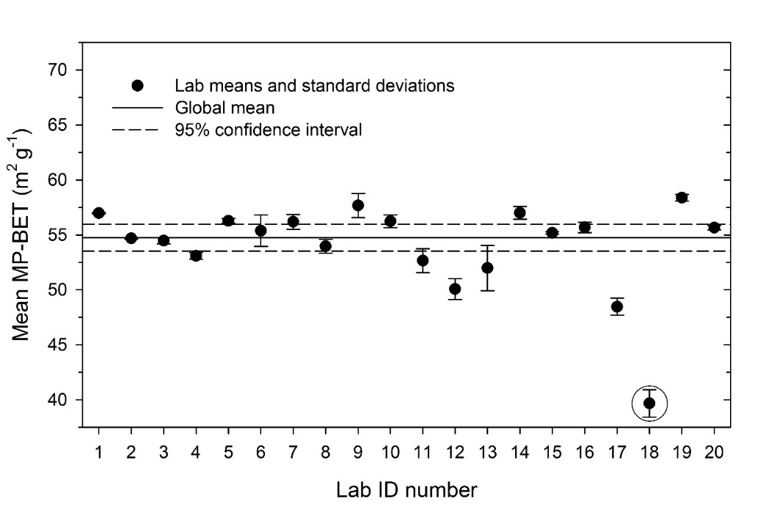

Figure 19.2: Mean multipoint BET (MP-BET) results for all reporting laboratories. Solid line represents the global mean-of-means (54.7 m2/g) and dashed line is roughly 2x the standard error of the mean (se = 1.2 m2/g); *se* = standard deviation/ (where *n* = number of results). A single outlier result is circled.

Some laboratories reported good precision but high bias (e.g., Labs 17 and 19) while others reported low bias but poor precision (e.g., Lab 6); some laboratories reported both good precision and low bias (e.g., Labs 15, 16, 20). The largest difference between lab mean and global mean was about -13 %, though the majority of lab means were within ± 5 % of the certified value for SRM 1898 ((55.55 ± 0.70) m2/g). The level of expertise did not significantly influence bias or precision, suggesting that the protocol is robust and reproducible. The most frequently reported deviation was the use of a powder mass outside the protocol range, primarily due to limitations of the sample container available to individual laboratories; notably, bias was only influenced (statistically) by use of a nanomaterial powder mass below the prescribed range. Overall though, the mass used for analysis did not substantially influence results, again indicating that the method is robust. The results of this interlaboratory study are important, demonstrating the value of RMs to develop or refine protocols for testing in order to verify instrument performance or laboratory proficiency.

## 19.4.2 Example 2: Between-method equivalence

The quantified homogeneity and stability features of RMs also make it easier to detect systematic differences between methods, as illustrated in the ILC described by Lamberty *et al*.[22] For the purpose of this ILC, IRMM prepared a dedicated RM (TS-2009/1, silica nanoparticles). The RM homogeneity was assessed by measuring the particle size with DLS (cumulants method) according to ISO 22412:2008[23] and with CLS according to ISO 13318-1:2001.[24] The resulting estimate of the standard uncertainty contribution from the homogeneity in terms of DLS measurements was extremely small (± 0.08 nm or 0.24 %). For CLS the uncertainty contribution (confidence level of about 68 %) from homogeneity is larger but still satisfactory (± 0.40 nm or 1.2 %). In both cases, this uncertainty contribution is significantly smaller than the relative interlaboratory standard deviation, which was 5.7 % for DLS and 4.7 % for CLS (see Figure 3). Therefore, the material homogeneity meets the RM-defining requirement of "sufficient homogeneity". The stability of the material in terms of particle size was determined by comparing the intensity-weighted harmonic mean particle diameter values measured with DLS at three time points, i.e. at 0, 6 and 13 weeks. From these data, the relative standard uncertainty contribution from stability was evaluated and extrapolated for a period of 30 weeks which covers the duration of the ILC. The result (0.5 %) implied that for the duration of the study no significant effect of test material instability was expected beyond between-lab and between-method variance.



Figure 19.3: Mean of laboratory mean values obtained with specific particle size analysis methods, and the corresponding standard error. Data obtained on a colloidal silica RM (TS-2009/1) with DLS, CLS, electron microscopy (EM) and small angle X-ray scattering (SAXS). (Reproduced with permission from Ref. [22]. Copyright 2011 Springer.)

The results shown in Figure 3 are the means of the laboratory mean values for data obtained with the same method and using the same weighting (here: intensity-, volume- or number-weighted) and averaging (here: harmonic mean, (arithmetic) mean or modal value) approach. The error bars correspond with the standard error (*se*) of the between-laboratory variation of the data.

Since the observed differences are considerably larger than the possible variation between RM samples, the data indicate a significant variation between the average results obtained with specific methods. In other words, not all particle size measurement methods produce equivalent results. Also the effect of different weighting and averaging approaches is clearly revealed. As such, Figure 3 is a perfect illustration of the notion of 'method defined' or 'operationally defined' property.

## 19.4.3 Example 3: Within-laboratory method validation

The main elements of this type of method validation study are an assessment of the intermediate precision of a method (for which non-certified RMs can be used) and the assessment of the trueness of a method (which requires a CRM). Both parts of the validation study lead to the quantification of the corresponding contributions to the combined measurement uncertainty.

The precision of a method is typically assessed by performing repeated tests under conditions varying in ways that are relevant for the intended use of the method after its validation. The statistical analysis of the variation of the measured values leads to Type-A estimates of the corresponding uncertainty contributions (e.g. for repeatability and intermediate precision). The added value of using RMs in this assessment is the known maximum variance due to sample-to-sample differences and due to time (between the different measurements required for the validation study). Whether an RM is suitable for use in this exercise depends on the method performance criteria that are set at the start of the validation study. These criteria can depend on the specific needs of the laboratory or its customers, or they can be taken from reference documents, such as (international) standards. For example, ISO 22412, the ISO standard on particle size analysis by DLS,xxi stipulates a repeatability criterion of better than 2 %. Given the homogeneity data of IRMM-304 (standard deviation < 1.1 %; see section 2), the material is fit for use in the context of ISO 22412.

A detailed example of the assessment of the precision of a nanoscale measurement method is provided by De Temmerman et al,[25] who used ERM-FD304 (colloidal silica, nominal particle diameter 30 nm)[26] and ERM-FD100 (colloidal silica, nominal particle diameter 20 nm)[27] in the validation of a transmission electron microscopy (TEM) method. One sample of ERM-FD100 and one sample of ERM-FD304 were analysed on five consecutive days. On each day, three diluted aliquots were prepared from the original sample and three specimens were independently prepared from each aliquot (vial). From each specimen, TEM micrographs of 10 fields were recorded at two magnifications (18,500 and 68,000 times). A one-way analysis of variance produced estimates of both repeatability and intermediate precision uncertainties, which were varying between 1 % and 2 %, depending on particle size and magnification.

The trueness of a method (quantitatively expressed as bias) can be assessed by performing measurements on one or more certified RMs. The essence of this approach is described in ERM Application Note 1,[28] which explains how to calculate *u*, the combined uncertainty of the certified value of the CRM and the uncertainty of the measurements performed on the CRM in the laboratory validating the method. *U*, the expanded version of *u*, has to be compared with m (= difference between the certified value of the CRM and the value measured by the laboratory). If m ≤ *U* then there is no significant bias, and the only trueness contribution to the method's uncertainty budget is *u*, the uncertainty associated with the trueness assessment. If on the other hand m > *U* then the bias is significant, and m is its estimate. At that point, the laboratory has to decide between investing time and effort to improve the method (preferred) or to include m in the contribution of the trueness assessment to method uncertainty.

An illustration of the top-down approach is provided by De Temmerman *et al*. in the above-mentioned TEM validation study.xxiii The CRMs ERM-FD100 and ERM-FD304 were not only used for precision, but they were also used for trueness assessment because both CRMs have a certified (ERM-FD100) or at least an assigned (ERM-FD304) value for EM analysis of the number-based modal equivalent diameter. The results of De Temmerman *et al*. emphasise the importance of the trueness assessment, which is often contributing more (here: relative uncertainty = 3 % to 3.5 %) to the overall method uncertainty than precision (here: relative uncertainty = 1 % to 2 %).

# Outlook / future trends

## 19.5.1 The 'representative test material' (RTM) concept

The field of nanotechnology is a dynamic research area in which materials and applications, but also measurement methods, are continuously being developed and improved. New measurement methods for use in frontier research areas such as nanotechnology are often lacking general recognition or agreement. In this situation it is difficult to produce RMs, an effort which is largely dependent on consensus in the relevant measurement community on what are important material properties and on how to best perform the related measurements. Obviously tests have to be performed to assess and improve newly developed methods, also in the absence of (C)RMs. Recognising this situation, recently the new term 'representative test material' (RTM), was proposed[29] and formally defined by ISO[30] as follows:

'An RTM is a material, which is sufficiently homogenous and stable with respect to one or more specified properties, and is implicitly assumed to be fit for its intended use in the development of measurement and test methods that target properties other than those for which homogeneity and stability have been demonstrated.'

The term RTM can be used to indicate the status of a RM when it is used outside its defined scope, for example when used in a method assessing a measurand different from the properties for which homogeneity and stability of the RM were investigated, or a new type of measurand altogether. This can be illustrated with the results obtained in the NanoChOp project (2012-2015) on the characterisation of nanoparticles in biologically-relevant media.[31] Figure 4 shows the results of a stability study performed on one of the NanoChOp test materials (i.c. NanoChOp-06, an aminated silica in an aqueous suspension). The data show that the particle size values that are dominated by the diameter of the core silica particles (SAXS values) are stable over the time period chosen as relevant for the project (6 months). Also, particle size values that are not affected by slight agglomeration effects due to changes at the particle surface (such as the modal values corresponding with the main peak in the number-based particle size distribution (PSD) based on DLS measurements and in the scattering-intensity based PSD based on CLS measurements) are stable. Given also the positive outcome of the corresponding homogeneity studies (data not shown), the NanoChOp-06 silica can be considered a RM for the mentioned properties. This material was then further used in development of methods for measurement in more complex media. For these tests, which are beyond the scope of the mentioned homogeneity and stability tests, the NanoChOp-06 material can be considered an RTM.

It must be emphasised that also the use of the term RTM requires careful consideration of the properties of the material. Figure 4 proves that the RM *status* is not necessarily transferable from one material property to another (the zeta potential of NanoChOp-06 is not stable), and not even from one DLS-based size value to another (the modal value of the main peak in the scattering-intensity based DLS PSD increases with time). Therefore, NanoChOp-06 can also not be considered as a RTM when using it to develop a method to measure zeta potential in the more complex biological media chosen in the NanoChOp project.

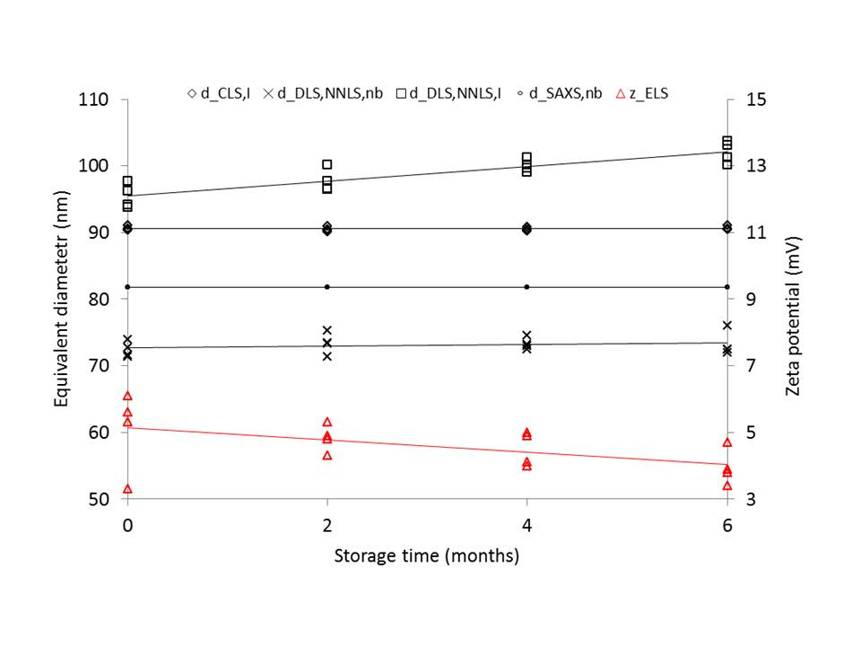

Figure 19.4: Change of equivalent diameters (as measured with CLS, DLS and SAXS) and zeta potential of NanoChOp-06 (aminated colloidal silica) after different periods of storage at 18°C. (Note: the 4 SAXS data per time point cannot be distinguished in this graph due to the excellent repeatability of SAXS) (Graph reproduced with permission from original publisher. (Reproduced with permission from Ref. [31]))

## 19.5.2 Reference materials for use in environmental and health research

An important regulatory player in the fields of environmental and health research is the Organisation for Economic Co-operation and Development (OECD). An extensive test programme was set-up under the auspices of the OECD Working Party on Manufactured Nanomaterials (WPMN) investigating a number of selected nanomaterials, which were representative for the nanomaterials on the market.[32] A number of these test materials were obtained from single sources, homogenised, subdivided and distributed to test laboratories worldwide. Based on their homogeneity and stability for certain physico-chemical properties, they were also considered as RTMs for a number of the other properties among the 59 end-points tested in total.

To help filling the existing gaps in reliable risk-related data Stefaniak *et al*.[33] proposed a dedicated development of RMs for specific applications in environmental and health research, where a well-characterized, relevant nanomaterial is needed, but not necessarily a CRM with certified metrological traceable property values. As it is not always clear which of the physico-chemical parameters of a nanomaterial are responsible for the observed or suspected (eco-)toxicity effects, Orts-Gil *et al*.[34] emphasized that these RMs need to be “multi-parametric” in nature. Such RMs would be provided with data on a range of risk-relevant measurands to facilitate risk assessment, and have properties that permit control of dispersion and agglomeration in, for instance, isotonic test media. One example is the previously mentioned NIST SRM 1898 (nanocrystalline titanium dioxide, see Section 4)xvii, which was released with detailed protocols for dispersion in biological and environmental test media. NIST RM 8017 (polyvinylpyrrolidone (PVP) coated silver nanoparticles) [35] was developed even more specifically as a benchmark and investigative tool for the evaluation of potential environmental, health, and safety risks that may be associated with engineered nanomaterials during their product life-cycle. RM 8017 contains a freeze-dried cake of Ag nanoparticles and PVP stored under vacuum that is fully dispersible by simply mixing with water.[36] Though RM 8017 has size-related assigned reference values, its primary usefulness lies in its shelf-life stability (difficult to achieve with redox active Ag0) and its industrial relevance (PVP coated Ag is widely used in antimicrobial treatments and other applications).

## 19.5.3 Matrix reference materials

All RM examples mentioned so far in this chapter consist of nanoparticles in a pure form (as powder or in suspension). A different type of RMs are the matrix RMs, in which the analyte (here: the nanoparticle) is embedded in a matrix that matches those relevant for the users of the RM, e.g. food or soil. The availability of such RMs is required for the validation of the methods currently being developed and validated to detect, identify and quantify nanoparticles in more complex matrices.[37] The first attempts to produce food-based reference materials were made in the NanoLyse project (finished in 2013), and a few examples of successful (food-particle) combinations have been reported, e.g. a (tomato) soup spiked with silica nanoparticles.[38] Nevertheless, the natural tendency of nanoparticles to agglomerate and to interact with their surroundings via their large surface area is, and will always be, an important challenge in the production of homogeneous and stable nanoparticle matrix RMs.

# Conclusions

Over the last 10 years, a number of reference nanomaterials have been produced and have become available. The above paragraphs have illustrated the main needs that can be met with (C)RMs, using a selection of examples from recent literature. However, it must be admitted that, as the cost and effort in time and resources necessary to develop (C)RMs is substantial, the number of available reference nanomaterials remains limited, with 'demand' exceeding the 'supply' especially in terms of the variety of reference nanomaterials.

On the 'supply' side, there is a need to apply limited resources wisely for optimising the impact. Additionally, cooperative efforts between RM developers and stakeholders, including other government agencies and international bodies, is likely to facilitate faster and more efficient use of resources resulting in RMs that are timely and appropriate for the intended use. On the 'demand' side, the importance of stakeholder input is absolutely critical to identify the most relevant materials, properties and measurands to address the greatest need in the nanotechnology community. An important role is also reserved for the standardisation community. It is not only important for RM producers to be aware of internationally recognised measurement methods, it is also important to see how the documentary standards will describe the method performance criteria, and how far the potential of RMs will be explained within such standards.

# Acknowledgement

The authors wish to thank Mr Vikram Kestens for providing the data of Figure 19.1.

# Disclaimer

The identification of any commercial product or trade name does not imply endorsement or recommendation by the Joint Research Centre of the European Commission nor by the National Institute of Standards and Technology.

# References

1. ISO Guide 34:2009, General requirements for the competence of reference material producers, International Organization for Standardization, Geneva, 2009
2. ISO Guide 35:2006, Reference materials -- General and statistical principles for certification, International Organization for Standardization, Geneva, 2006
3. ISO/TR 79:2015, Reference materials - Examples of reference materials for qualitative properties, International Organization for Standardization, Geneva, 2015
4. ISO Guide 80:2014, Guidance for the in-house preparation of quality control materials (QCMs), International Organization for Standardization, Geneva, 2014
5. Report of Investigation, NIST RM 8011, Gold Nanoparticles, Nominal 10 nm Diameter, 2012
6. A new certified reference material for size analysis of nanoparticles, A. Braun, V. Kestens, K. Franks, G. Roebben, A. Lamberty, T. P. J. Linsinger, J. Nanoparticle Research, Vol. 14, p. 1012-1023 (2012)
7. Nanoscale reference materials, G. Roebben, G. Reiners, H. Emons, in Nanotechnology Standards, Eds V. Murashov, J. Howard, Springer Science+Business Media, New York, NY, ISBN – 978-1-4419-7852-3 (2011)
8. ISO Guide 30:2015, Reference materials -- Selected terms and definitions, International Organization for Standardization, Geneva, 2015
9. The 'RM family' - Identification of all of its members, H. Emons, Accred. Qual. Assur., Vol. 10, p. 690-691 (2006)
10. A colloidal silica reference material for nanoparticles sizing by means of dynamic light scattering and centrifugal sedimentation, O. Couteau, J. Charoud-Got, H. Rauscher, F. Franchini, F. Rossi, V. Kestens, K. Franks, G. Roebben, Particle and particle systems characterization, Vol. 27, p. 112-124 (2010)
11. Measurement of 100 nm and 60 nm Particle Standards by Differential Mobility Analysis, G. W. Mulholland, M. K. Donnelly, C. R. Hagwood, S. R. Kukuck, V. A. Hackley and D.Y.H. Pui, J. Res. NIST, Vol. 111, p. 257-312 (2006).
12. Determining Transport Efficiency for the Purpose of Counting and Sizing Nanoparticles via Single Particle Inductively Coupled Plasma Mass Spectrometry, H. E. Pace, et al., Anal. Chem., Vol. 83, p. 9361–936 (2011)
13. Size Discrimination and Detection Capabilities of Single-Particle ICPMS for Environmental Analysis of Silver Nanoparticles, J. Tuoriniemi et al., Anal. Chem., 84, 3965−3972 (2012)
14. Development and validation of single particle ICP-MS for sizing and quantitative determination of nano-silver in chicken meat, R. J. B. Peters et al., Anal Bioanal Chem, Vol. 406, p. 3875–3885 (2014)
15. ISO/IEC Guide 99 (2007), International Vocabulary of Metrology: Basic and General Concepts and Associated Terms (VIM), International Organization for Standardization, Genva.
16. ISO 5725-1 (1994), Accuracy (Trueness and Precision) of Measurement Methods and Results: Part 1 – General Principles and Definitions, International Organization for Standardization, Geneva.
17. [www.vamas.org](http://www.vamas.org), last accessed 4/2/2016
18. "Real-world" precision, bias, and between-laboratory variation for surface area measurement of a titanium dioxide nanomaterial in powder form, Hackley, V A, Stefaniak, A B, J. Nanoparticle Research, Vol. 15, DOI 10.1007/s11051-013-1724-y, 2013
19. Report of Investigation, NIST SRM 1898, Titanium dioxide nanomaterial, 2012
20. ISO 9277:1995, Determination of the specific surface area of solids by gas adsorption using the BET method, International Organization for Standardization, Geneva, 1995
21. ASTM C1274-00(2006) (Standard test method for advanced ceramic specific surface area by physical adsorption
22. Interlaboratory comparison for the measurement of particle size and zeta potential of silica nanoparticles in an aqueous suspension, A. Lamberty, K. Franks, G. Roebben, A. Braun, V. Kestens, T. Linsinger. Journal of Nanoparticle Research, Vol.13, p. 7317-7329, 2011
23. ISO 22412:2008, Particle size analysis -- Dynamic light scattering (DLS), International Organization for Standardization, Geneva, 2008
24. ISO 13318-1:2001, Determination of particle size distribution by centrifugal liquid sedimentation methods -- Part 1: General principles and guidelines, International Organization for Standardization, Geneva, 2001
25. Measurement uncertainties of size, shape, and surface measurements using transmission electron microscopy of near-monodisperse, near-spherical nanoparticles, P. De Temmerman, J. Lammertyn, B. De Ketelaere, V. Kestens, G. Roebben, E. Verleysen, J. Mast, J. Nanoparticle Research, Vol. 16, citation ID 2177, 2014
26. Certification of the equivalent spherical diameters of silica nanoparticles in aqueous solution, ERM-FD304, K. Franks, A. Braun, J. Charoud-Got, O. Couteau, V. Kestens, A. Lamberty, T. Linsinger, G. Roebben, Report EUR 25018 EN, European Union, Luxembourg, ISBN 978-92-79-21867-5, 2012
27. Certification of equivalent spherical diameters of silica nanoparticles in water, ERM-FD100, A. Braun, K. Franks, V. Kestens, G. Roebben, A. Lamberty, T. Linsinger, Report EUR 24620 EN, European Union, Luxembourg, ISBN 978-92-79-18676-9, 2011
28. ERM Application Note 1, Comparison of a measurement result with the certified value, T P J Linsinger, 2010, [www.erm-crm.org](http://www.erm-crm.org), last accessed 31/5/2016
29. Reference materials and representative test materials: the nanotechnology case, G. Roebben, K. Rasmussen, V. Kestens, T. P. J. Linsinger, H. Rauscher, H. Emons, H. Stamm, J. Nanoparticle Research, Vol. 15, citation ID 1455, DOI 10.1007/s11051-013-1455-2, 2013
30. ISO/TS 16195:2013, Nanotechnologies -- Guidance for developing representative test materials consisting of nano-objects in dry powder form, International Organization for Standardization, Geneva, 2013
31. Reference materials and representative test materials to develop nanoparticle characterization methods: the NanoChOp project case, G. Roebben, V. Kestens, Z. Varga, J. Charoud-Got, Y. Ramaye, C. Gollwitzer, D. Bartczak, D. Geißler, J. Noble, S. Mazoua, N. Meeus, P. Corbisier, M. Palmai, J. Mihály, M. Krumrey, J. Davies, U. Resch-Genger, N. Kumarswami, C. Minelli, A. Sikora, H. Goenaga Infante, Frontiers in Chemistry, Volume 3, Article 56, doi: 10.3389/fchem.2015.00056, 2015
32. Review of achievements of the OECD Working Party on Manufactured Nanomaterials' Testing and Assessment Programme. From exploratory testing to test guidelines, K. Rasmussen, M. Gonzalez, P. Kearns, J. Riego Sintes,

    F. Rossi, P. Sayre, Regulatory Toxicology and Pharmacology, Vol. 74, p. 147-160, 2016
33. Nanoscale Reference Materials for Environmental, Health, and Safety Measurements: Needs, Gaps, and Opportunities, A. B. Stefaniak, V. A. Hackley, G. Roebben, K. Ehara, S. Hankin, M. T. Postek, I. Lynch, Wei-En Fu, T. P. J. Linsinger, A. F. Thünemann, Nanotoxicology, Vol. 7, DOI: 10.3109/17435390.2012.739664, p. 1325-1337, 2013
34. Multi-parametric reference nanomaterials for toxicology: state of the art, future challenges and potential candidates, Orts-Gil, G, Natte, K, Österle, W, RSC Advances, Vol. 3, p. 18202-18215, DOI 10.1039/c3ra42112k, 2013
35. Report of Investigation, Reference Material 8017, Polyvinylpyrrolidone coated silver nanoparticles, National Institute of Standards and Technology, 2015
36. Just add water: reproducible singly dispersed silver nanoparticle suspensions on-demand, R.I. MacCuspie, A.J. Allen, M.N. Martin and V.A. Hackley, J Nanopart Res 15:1760, 2013
37. Validation of methods for the detection and quantification of engineered nanoparticles in food, T.P.J. Linsinger, Q. Chaudhry, V. Dehalu, P. Delahaut, A. Dudkiewicz, R. Grombe, F. von der Kammer, E.H. Larsen, S. Legros, K. Loeschner, R. Peters, R. Ramsch, G. Roebben, K. Tiede, S. Weigel, Food Chemistry, Vol. 138, p. 1959-1966, 2013
38. Production of reference materials for the detection and size determination of silica nanoparticles in tomato soup, Grombe, R, Charoud-Got, J, Emteborg, H, Linsinger, T P J, Seghers, J, Wagner, S, Von der Kammer, F, Hofmann, T, Dudkiewicz, A, Llinas, M, Solans, C, Lehner, A, Allmaier, G, Anal. Bioanal. Chem., Vol. 406, p. 3895-3907, 2014