Design Strategy for Additive Manufacturing Ti-Al-Fe alloys with Calculation of Phase Diagram Method

Zhi Liang1, Ursula Kattner1, Carelyn Campbell1

1 Materials Science and Engineering Division, Material Measurement Laboratory, National Institute of Standards and Technology, 100 Bureau Drive, Gaithersburg, MD 20899, USA

Corresponding Author: Zhi Liang, [zliang@questek.com](mailto:zliang@questek.com), Tel: 859-327-8447

Abstract

Calculation of Phase Diagram (CALPHAD) method was used to develop an additive manufacturing (AM) titanium alloy design strategy for new alloys in the Ti-Al-Fe system. This design strategy includes five key criteria addressing AM-processing suitability, mechanical properties and heat treatment capability. The methods for evaluating the design criteria were determined considering both physical implications and computational efficiency. Available experimental results agree well with CALPHAD predictions in the design map. CALPHAD method in this work can be applied for high-throughput early-stage assessments in large composition space for new AM titanium alloy development.

Keywords: CALPHAD; Additive Manufacturing; Titanium alloys; Materials design

1. Introduction

Titanium alloys are of interest for high performance applications requiring high-strength and good property-to-weight ratios [1] compared with steels and other lightweight alloys, such as aluminum and magnesium. However, the high chemical reactivity and low thermal conductivity of Ti alloys result in the high costs for conventional manufacturing processes, such as casting and machining. Therefore, to further expand titanium alloy applications, novel alloys and manufacturing processes need to be developed.

Additive manufacturing (AM) provides an excellent opportunity for titanium alloys since it is a near net-shape process, avoids the component-mold reaction issue that may occur during casting [2] and does not require the cost-consuming metal-removal step associated with machining. With AM processing, the titanium alloy could be cost-acceptable for massive production components in civil applications, such as automotive components. However, current commercial Ti alloys, like Ti-6Al-4V[1] (Ti64), are not designed to take advantage of the rapid solidification and subsequent potential heating and cooling processes associated with AM processing. New AM titanium alloys need to be developed to optimize critical properties associated with AM processing and application requirements, such as micro-segregation during solidification and β-α phase transformation, expected strength, and density.

One potential design opportunity is to re-consider alloying elements that were previously considered detrimental in conventional manufacturing. Eutectoid β stabilizers, such as Fe and Mn, are usually prohibited or only included with trace amount because β undergoes eutectoid decomposition, which causes the macro-scale melting-segregation called “β fleck” during ingot processing. These β-stabilizer-rich regions are weaker, promoting early crack nucleation and are detrimental to mechanical properties [3]. In contrast, the rapid solidification during AM processing results in melting and solidification processes that are highly localized within several millimeters to hundreds of micrometers and the long-range thermal gradients are minimized. In addition, the initial rapid solidification also restricts elemental partitioning. Therefore, it may be possible to re-consider these eutectoid β stabilizers in AM titanium alloy design. Compared with isomorphous β stabilizers, such as V, eutectoid β stabilizers are more efficient in decreasing both liquidus and β transus by lowering both the alloy reactivity and the post-fabrication annealing temperature. Liang et al. designed a potential low-cost Ti-Al-Fe based alloy using a Calculation of Phase Diagram (CALPHAD) method that appears to have promising mechanical properties and avoids the formation of the TiFe intermetallics [4]. The AM performance of this new alloy has also been investigated using an ICME-CALPHAD (Integrated Computational Materials Engineering – Calculation of Phase Diagram) framework. This work successfully proved the potential of this alloy for the use in laser melting processes [5]. The present work presents a systematic CALPHAD design strategy to investigate promising Ti-Al-Fe alloy compositions based on several key criteria for selected structural titanium alloys suitable for laser melting AM processes.

1. Modelling Approach

In this work, the design criteria are evaluated using thermodynamic calculations, which require a thermodynamic description of the target alloy system. Liang et al. developed a customized Ti-Al-Fe thermodynamic description, which was applied earlier and successfully predicted the phase transformation with laser-heat-induced thermal profiles [5]. (The development of these descriptions will be described in a separate paper.) In the present work, the thermodynamic descriptions of three phases from Liang et al. are used: Liquid (LIQUID, (Al, Fe, Ti)1), β (BCC_A2, (Al, Fe, Ti)1(Va)3) and α (HCP_A3, (Al, Fe, Ti)1(Va)0.5) [5]. It is noted that since martensite was not experimentally shown in previous work, the thermodynamic description does not include martensite.

The five design criteria evaluated in this work to determine whether a Ti-Al-Fe alloy composition is a potential AM Ti alloy include the following: 1) minimize the liquid-solid micro-segregation, 2) minimize the as-fabricated β→α phase transformation, 3) minimize the β transus to be less than 1193 K, which is the β transus of Ti-64, 4) optimize the yield strength, calculated based on solid solution strengthening, with an acceptable range of 900 MPa-1100 MPa, and 5) minimize the density, with a maximal threshold of 4.5 g/cm3, which is the density of pure Ti. Criterion 1) and 2) are phenomena that occur during conventional manufacturing techniques and involve melting and solidification processes. The extreme heating and cooling rates associated with AM processing will generate different microstructures. Ideally, AM processing conditions will result in a uniform microstructure without liquid-solid micro-segregation and as-fabricated β→α solid-state phase transformation. However, the previous study indicated that if solid-state phase transformation can be specifically engineered and uniform through the component, it can be beneficial [5]. For the present work, to simplify the design criteria and calculation, the target is set to avoid any liquid-solid micro-segregation and the β→α solid-state phase transformation. Criterion 3) to 5) are set to optimize the material performance. β transus is critical to determine the hot isostatic pressing temperature for AM titanium alloy component, which is a common practice for as-fabricated AM components to eliminate micro-scale porosities and normally designed to be 20-50 K above the β transus. The yield strength design criterion is based on the as-cast material, which is the closest net shape manufacturing process to AM. The density is minimized to maintain the strength to weight ratio to maintain the advantage of the titanium alloy. The specific computation details for each design criterion are explained in the following sections.

* 1. Minimization of solidification micro-segregation and avoidance of as-fabricated β→α phase transformation during AM laser powder bed fusion.

An ideal method to evaluate solidification micro-segregation and solid-state β→α phase transformation is the application of finite element method (FEM) methods and CALPHAD-based diffusion/precipitation simulations. FEM models are used to correlate measured surface laser-processed thermal profiles to internal-location thermal profiles, which are then used in CALPHAD-based simulations to predict micro-segregation and phase transformations. This method was established by the authors in a FEM-CALPHAD ICME framework to predict laser-processed phase transformation in a Ti-Al-Fe alloy [5] and micro-segregation in IN625 [6]. However, to enable an efficient mapping of the design space, this methodology is too computation-heavy, which generally takes several days to simulate a single composition with pre-defined laser parameters, and is therefore inefficient to examine large number of compositions. On the other hand, an extremely computation-efficient approach will be the minimization of the differences between liquidus and solidus temperature and between the β-transus temperature and mandatory threshold values. However, these threshold values cannot be justified theoretically and alone do not provide any meaningful design space as shown in Figure 1. For example, if the threshold value for liquidus-solidus difference is set as less than 100 K, the design space suggests that alloys with over 3Fe will have solidification micro-segregation. Earlier experimental results by by Liang et al. [5] clearly showed that this is not the case. For example, if using this criterion, the alloy composition investigated by Liang et al., 6Al-5Fe [5], exceeded this criterion by a factor of two, but it did not have any measurable solidification micro-segregation, solid state β→α phase transformation, and hot cracks as shown by the microstructures in Figure 2. Thus, this temperature minimization approach is over-simplified for the application of alloy design.



Figure 1. Design space with calculated liquidus-solidus and β transus-298.15 K (room temperature) temperature differences.

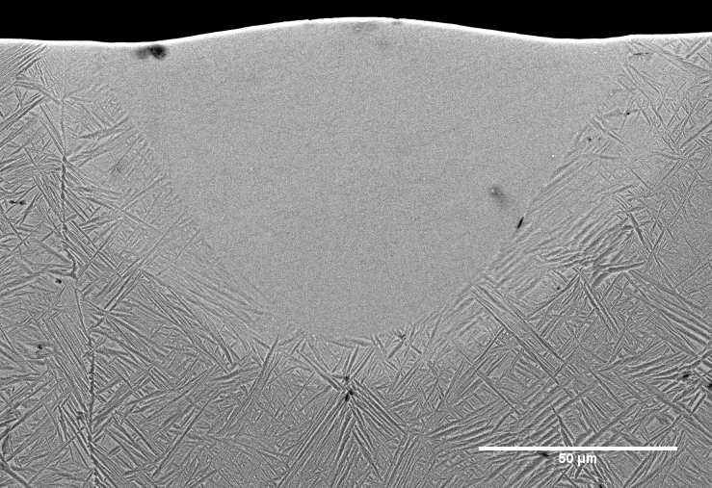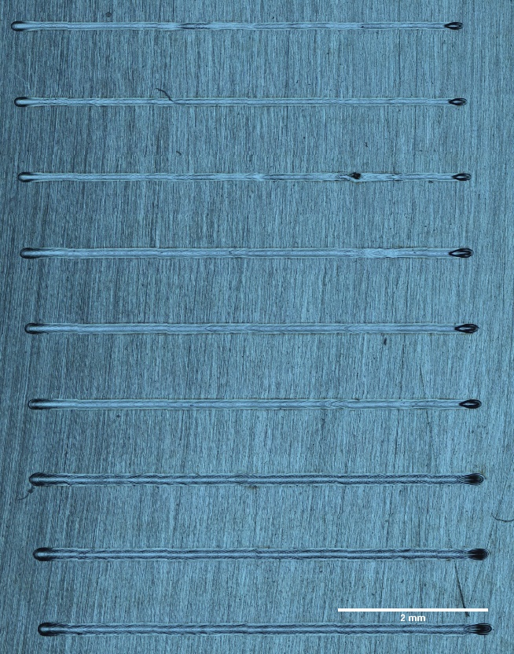

(a)

(b)

Figure 2. (a) Back-scattered electron image of single laser track melt pool cross-section of Ti-6Al-5Fe, showing no solidification micro-segregation, solid state β→α phase transformation, and hot cracks. (b) Optical microscopy of Ti-6Al-5Fe single laser track surfaces at different laser speeds, showing no hot cracks.

Therefore, an alternative approach is considered where in addition the equilibrium concentration of critical nuclei is evaluated. The equilibrium concentration of critical nuclei approach considers only the thermodynamic aspects in the nucleation process, defining an upper limit for the thermodynamically stable nucleus that can potentially form in a system. This upper limit can be used as criterion to determine whether a transformation will occur. This assumption is considered reasonable for AM where the nucleation and growth kinetics are suppressed by the high cooling rate. The following equations are used to evaluate this criterion:

|  |  |  |
| --- | --- | --- |
|  |  | Eq. 1 |
|  |  | Eq. 2 |
|  |  | Eq. 3 |
|  |  | Eq. 4 |

where is the equilibrium fraction of critical nucleation sites in a system with possible nucleation sites, , and sites with critical nuclei, , calculated from the Arrhenius term of critical driving force, , of critical nucleus size, , at a certain temperature, . The driving force, , is composed of the bulk chemical driving force, , with nucleus volume, , and interfacial energy, , with nucleus surface area, . The nucleus geometry is assumed as spherical with radius,, and the critical nucleus radius, , is derived at . is gas constant. and are composition and temperature dependent.

As shown by the flowchart in Figure 3, for each composition, is calculated within two designated temperature regimes for the solidification micro-segregation and for the solid-state β→α phase transformation. Hence the two temperature regimes are from liquidus () to solidus (), and from β transus () to 700 K, respectively. It is assumed that no significant solid-state diffusion occurs below 700 K since calculated diffusivities of Al and Fe in BCC Ti at 700 K from the database are 7.68x10-19 m2/s and 8.51x10-17 m2/s respectively, and the estimations of diffusion length ( with t = 1s) are 0.877 nm and 9.22 nm respectively, which are considered as no significant solid-state diffusion. At each temperature, is calculated. If the pre-defined threshold volume fraction, 0.01 (1%, volume fraction) is reached, this temperature is determined as “diffusional phase transformation starting temperature”, and the calculation stops. If the volume fraction is less than 0.01, the calculation proceeds until the minimum temperature of the regime is reached. If the equilibrium volume fraction of critical nuclei does not exceed 0.01 within the specified temperature range, the minimum of temperature of the range is defined as , indicating that no phase transformation will occur. In the design map in Figure 4, the temperature ranges in which the transformation is possible ( - or -700K) are plotted as a function of composition, and the smaller the value, the less likely the phase transformation will occur. It should be noted that in a layer-based AM process, β→α phase transformation will eventually happen due to “annealing” contributed from the intensive heat from neighboring laser track, which is expected to happen within 10-3-10-2s [5]. However, excluding the β→α phase transformation during the first thermal cycle, when solidification takes place, will ensure homogeneity during the “annealing” in the second and third thermal cycles, is justified and benefits computational efficiency.

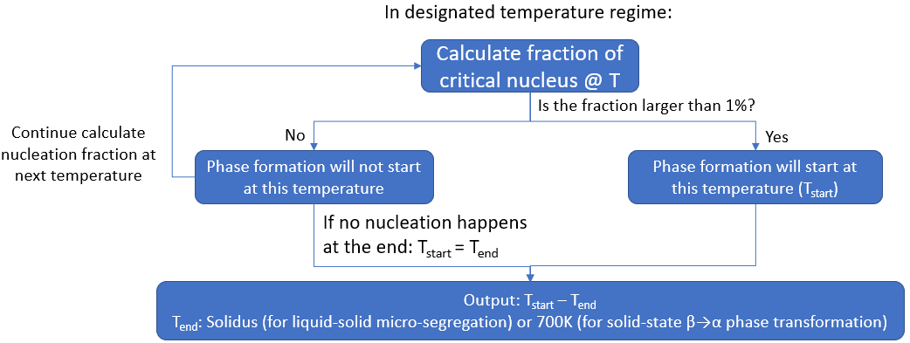

Figure 3. Flowchart of phase transformation possibilities under AM high cooling condition

* 1. Minimization of β transus

The β transus is one of the key properties for titanium alloys to determine the temperature of the β annealing treatment, which is commonly set 20 K above the β transus. Especially for AM titanium alloys, a β annealing treatment is usually mandatory since hot isostatic pressing (HIP) is required to remove as-fabricated defects. The HIP temperature is usually selected to be close to β transus to avoid β grain growth and retain grain boundary strengthening. Therefore, a β transus of 1193 K is set as the maximal threshold of this design objective to keep the β transus low for lower HIP process temperature, which is the β transus of Ti-64 [5] as the signature α+β titanium alloy.

* 1. Optimization of yield strength

Targeting structural applications, the yield strength is another important criterion in the design. Solid solution strengthening (SSS) is the dominating mechanism defining the alloy yield strength. Specifically, for Ti alloys, the yield strength is the superposition of the SSS contributions from the α and β phases [3]. Ultimately the SSS of α and β phases is controlled by phase composition, morphology and size distribution; however, these aspects are dependent on specific as-fabricated thermal profile and post-fabrication heat treatment. As it is difficult to evaluate influence of the as-fabricated thermal and post-fabrication heat treatment, this work just considers the alloy-composition-based SSS. The SSS-based yield strength in this work is modeled with a polynomial, representing contributions of both, the respective elements and their interactions, with the following equation:

|  |  |  |
| --- | --- | --- |
|  |  | Eq. 5 |

in which is the calculated yield strength; is the yield strength of as-cast pure element; is the elemental mole fraction in the alloy; is the binary interaction parameter. Since there is no AM fabricated Ti-Al-Fe alloy mechanical test data, this model uses the as-cast yield strength, which is the closest net shape manufacturing process to AM and has sufficient experimental data for modeling as listed in Minimization of Density in the next section [2]. Table 1 shows the yield strengths of various as-cast Ti-Al-Fe alloys that were collected from literature and used to determine the model parameters.

Table 1. Yield strengths of multiple as-cast Ti-Al-Fe alloys and determined model parameters for Eq. 5

|  |  |  |  |  |  |
| --- | --- | --- | --- | --- | --- |
| Yield strengths of multiple as-cast Ti-Al-Fe alloys | | | | | |
| Al (%, mass fraction) | | Fe (**%, mass** fraction) | | As-cast yield strength (MPa) | |
| 0 | | 0 | | 392 [7]1 | |
| 100 | | 0 | | 24.1 [8]2 | |
| 0 | | 100 | | 50 [9]3 | |
| 0 | | 1 | | 616 [7]4 | |
| 6 | | 1.65 | | 882 [7]5 | |
| 5 | | 1 | | 781[7]6 | |
| 6 | | 5 | | 1023 [4] | |
| 5 | | 2.5 | | 820 [10] | |
| Model parameters in Eq. 5 | | | | | |
|  |  |  |  |  |  |
| 392 | 24.1 | 50 | 4288.30656 | 23469.73405 | -127293.18916 |
| 1CP-Ti, ASTM Grade 2  21100 alloy  3After zone refining  4Ti-1%Fe-0.35%O-0.01%N  5TIMETAL 62S, Ti-6%Al-1.65%Fe-0.1%Si  6Super-TIX 51AF, Ti-5%Al-1%Fe | | | | | |

* 1. Minimization of Density

As minization of the density is desired, the density criterion is set with a maximal threshold of 4.5 g/cm3, which is the density of pure Ti. The density of an alloy composition is calculated from Rule of Mixture (RoM).

* 1. Implementation of Design Strategy

The design space is defined by the composition range (Al: 0 % to 10 %) and (Fe: 0 % to 10 %) with a resolution of 0.1 %. The upper limits of the composition space are determined based on respective binary phase diagrams, in which high amount of Al and Fe result in the potential formation of detrimental Ti3Al and TiFe intermetallics. The Thermo-Calc TC-Python Software Development Kit [11][2] was used to determine the composition and temperature dependent bulk chemical driving force, α-β interfacial energy, liquidus, solidus, and β transus for the evaluation of the five design criteria.

1. Results and Discussion
   1. Calculation Map

First the composition space is evaluated to minimize both the solidification micro-segregation and the β→α phase transformation. Figure 4 (a) and (b) show the maps of (Tstart - Tsolidus) for the liquid-solid segregation, and (Tstart - 700 K) for the β→α phase transformation, representing the probabilities of occurrence for both transformations. The solid-state β→α phase transformation is expected to happen easier with lower Fe content, because higher Fe content will decrease both β transus and α+β temperature range, resulting in lower chemical driving force in α+β region. The liquid-solidus micro-segregation is expected to happen only at both high Al and high Fe contents due to the increase in the difference between liquidus-solidus temperature difference.

In Figs. 4 (a) and (b) the white regions indicate that no liquid-solid or solid-solid diffusional phase transformation occurs in these composition regimes, and their overlapping area is the desired design space marked by white region, shown in Figure 4 (c).

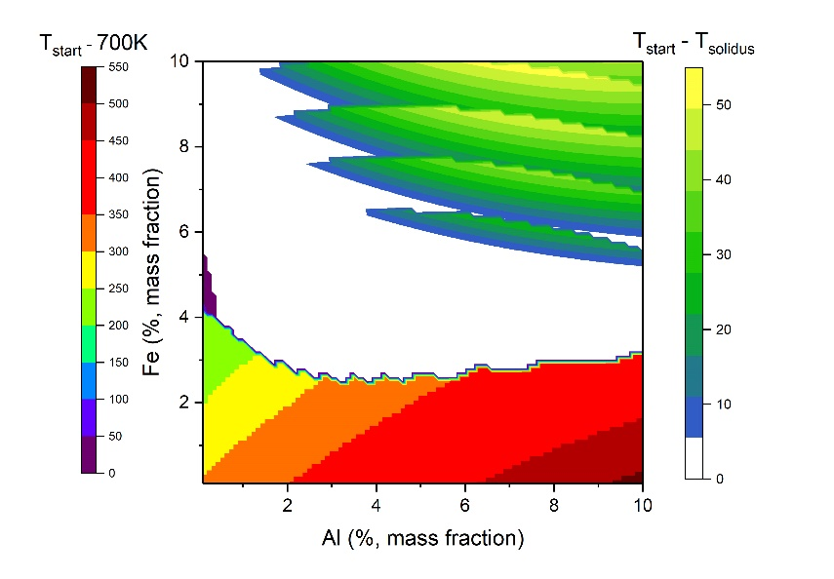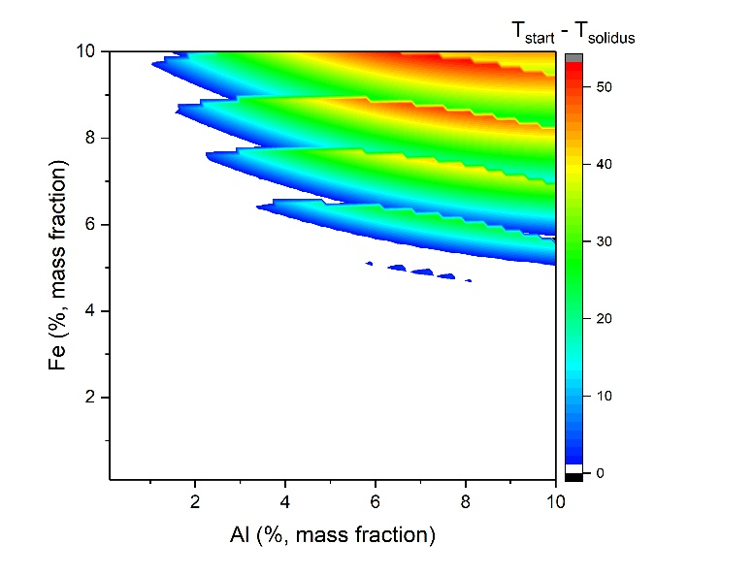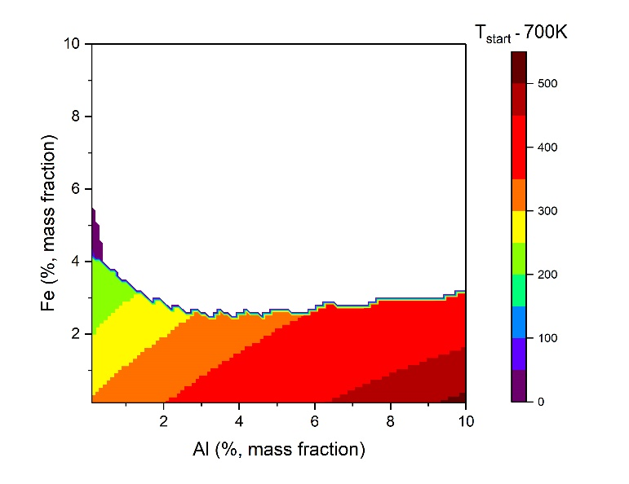

(a)

(b)

(c)

Figure 4. Design space with (a) temperature differences of solid state β→α phase transformation (Tstart - 700 K) and (b) liquid-solid micro-segregation (Tstart-TSolidus), representing possibilities of respective phase transformation. The combined map (c) represents the overlapped region (light blue region) between two contours where both differences are zero (white regions in (a) and (b)), which is the preferred design space. Isolated blue patches in (b) are the result of the numerical resolution.

Figure 5 shows the β transus, density, and expected yield strength as function of Al and Fe composition, and the design space determined by the design thresholds as well. Figure 6 shows the steps taken to determine design space by stacking different criteria and the evolution of the design space. The three steps in Figure 6 consecutively added yield strength, density, β transus, liquid-solid and β→α phase transformation criteria. As shown, each criteria further contrained the design regime and resulted in Figure 7, which shows the final design map by combining all five criteria and the optimal design space. As indicated by the final design map, the Al and Fe contents both need to be limited to meet all criteria.

A number of Ti-Al-Fe alloys were developed and investigated for conventional hot forging processes [12-14]. Most of these alloys intentionally include only low Fe content to avoid β fleck issue and therefore are not within the design space of this work, except for Ti-5Al-2.5Fe (%, mass fraction), which is located at the edge of the design space. The new Ti-Al-Fe alloy developed by Liang et al. [5] is located inside the design space. Evaluation of this alloy in Figure 2 showed neither solidification micro-segregation nor solid-state β→α phase transformation with laser processing, validating this design strategy.

The main limitation of this design strategy is that the upper limits of as-fabricated nucleation events restrict the composition space. Considering the suppression of kinetics under AM high cooling condition, even if a certain composition meets the nucleation upper limit threshold, the diffusional phase transformation could still be suppressed and thus limit the computed design space compare to the actual design space.



Figure 5. Design space with calculated β transus, expected yield strength, and density.

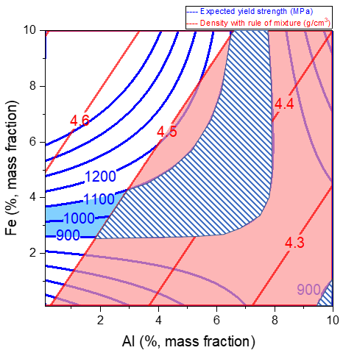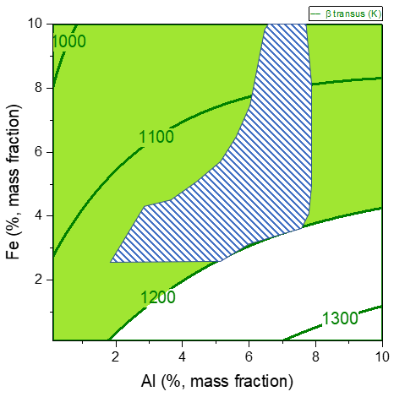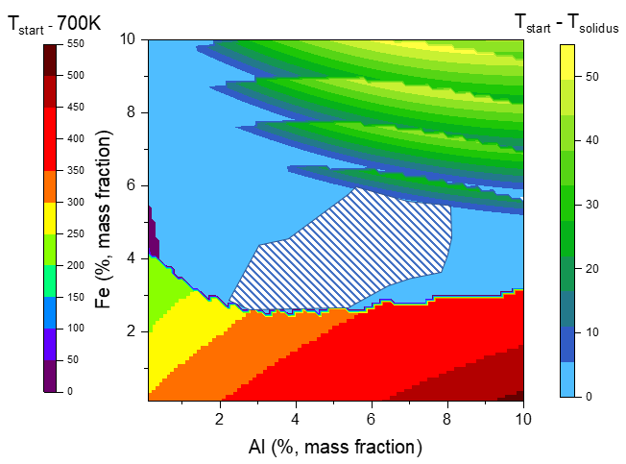

Step 1

Step 2

Step 3

Figure 6. Steps to determine the final design space by adding different constraints: (Step 1) The striped region fulfilling yield strength requirements between 900 MPa and 1100 MPa and density less than 4.5 g/cm3; (Step 2)The striped region now includes the contraints in Step 1 and the β transus constraint of less than 1193 K; (Step 3) The final design space is represented by adding liquid-solid and β→α phase transformation constraints to Step 2. The shaded regions in all steps represent the design space determined by respective criteria.

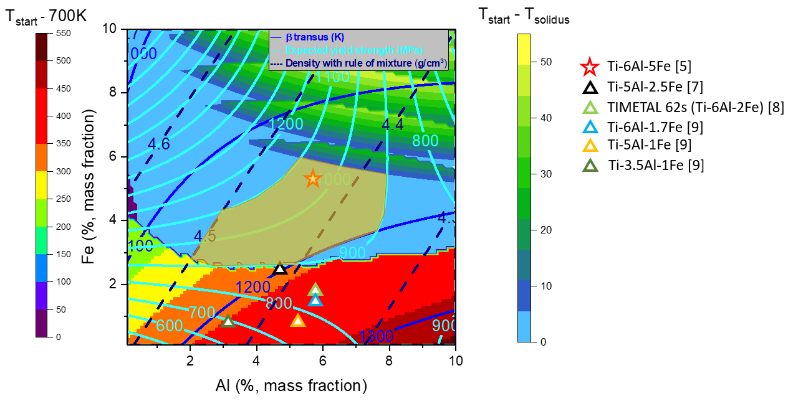

Figure 7. Full design map with all criteria and marked with literature reported Ti-Al-Fe alloy compositions in the map. The design space defined by thresholds in Figure 6 is highlighted in olive color.

* 1. Comparison between calculated and measured properties of selected alloys

Table 2 provides a comparison between calculated and measured properties of two alloy compositions within or close to the final design space in Figure 7, Ti-6Al-5Fe and Ti-5Al-2.5Fe. The notable discrepancy is the yield strength for Ti-5Al-2.5Fe. This discrepancy suggests that the yield strength estimation in this work has a higher uncertainty, which will potentially reduce the design space by pushing the 900 MPa contour line towards the upper left direction and removing Ti-5Al-2.5Fe from the design space. On the other hand, it should be noted that the as-cast experimental data used to establish the model could be measured under different casting conditions, such as permanent mold or investment casting, which may have significantly different cooling profiles and thus different α volume fractions and morphology. Therefore, such discrepancy is not unexpected.

Table 2. Comparison between calculated and measured properties of 2 compositions in the final design space, Ti-6Al-5Fe and Ti-5Al-2.5Fe. The measured properties are from references [10] [15] .

|  |  |  |  |  |
| --- | --- | --- | --- | --- |
| Composition (%, mass fraction) | | Properties: Calculated (Measured) | | |
| Al | Fe | β transus (K) | Yield Strength (MPa) | Density (g/cm3) |
| 6 | 5 | 1155.43 (N/A) | 1007.50 (1023 ± 20) | 4.424 (4.45) |
| 5 | 2.5 | 1201.81 (1223.15) | 890.12 (820) | 4.406 (4.45) |

1. Conclusion

In summary, the present work presents a useful approach for designing a novel Ti-Al-Fe AM alloy with the following highlights:

1. This work shows that with a well-established thermodynamic database, reasonable computational alloy properties can be determined to evaluate the alloy design space in relatively unknown alloy systems, such as Ti-Al-Fe. The approach is generally suitable for the evaluation of candidate alloys in Ti-based systems for AM processes.
2. This work provides computational-efficient phase transformation criteria for AM processes. Given that under extreme heating and cooling conditions, the kinetic assumptions in this strategy are both valid and high-throughput friendly. These criteria can be justified with reasonable physical meaning and be used to determine the alloy design space.
3. Combing phase transformation and physical property criteria, the preferred composition space for AM Ti-Al-Fe alloys was determined, including minimizations of solidification segregation and as-fabricated β→α phase transformation, minimization of β transus, and optimization of yield strength and density.
4. As demonstrated by Liang et al. [5], a new Ti-Al-Fe alloy located in the design space was validated by both experiment and full-scale FEM-CALPHAD simulation for powder-bed AM process, especially demonstrating the avoidance of solidification segregation and as-fabricated β→α phase transformation. This proves that compositions determined by this strategy are potentially valid and beneficial for the application in full-scale simulations that take into account thermodynamics and kinetics perspectives to provide a more specific alloy design prediction, such as quantitative time- and location-specific phase transformation and physical properties.
5. This design strategy, with well-established thermodynamic descriptions, can be feasible for other alloy systems that need to evaluate phase transformation under rapid AM cooling conditions, in which the nucleation and growth kinetics can be assumed negligible, such as precipitation in Al alloys and γ’ formation in superalloys.
6. This design strategy is suitable for high-throughput analysis to determine potential alloy compositions in large composition spaces with high compositional resolution for further investigation.

Therefore, this design strategy can be successfully applied to quickly screen a composition space of interest and identify selected prototype compositions for additional computational-intensive ICME simulations and thus improve the overall efficiency of the computational design of new alloys.

Conflict of Interest Statement

On behalf of all authors, the corresponding author states that there is no conflict of interest.

References

1. Banerjee, D., Williams, J.C. (2013): Perspectives on Titanium Science and Technology. Acta Materialia 61(3), 844-879. doi:<https://doi.org/10.1016/j.actamat.2012.10.043>

2. Liu, S., Shin, Y.C. (2019): Additive manufacturing of Ti6Al4V alloy: A review. Materials & Design 164, 107552. doi:<https://doi.org/10.1016/j.matdes.2018.107552>

3. Lütjering, G., Williams, J.C. (2007): Titanium, 2nd ed. Springer Berlin Heidelberg

4. Liang, Z., Miao, J., Brown, T., Sachdev, A.K., Williams, J.C., Luo, A.A. (2018): A low-cost and high-strength Ti-Al-Fe-based cast titanium alloy for structural applications. Scripta Materialia 157, 124-128. doi:<https://doi.org/10.1016/j.scriptamat.2018.08.005>

5. Liang, Z., Zhirnov, I., Zhang, F., Jones, K.K., Deisenroth, D., Williams, M., Kattner, U., Moon, K.-w., Liu, W.-K., Lane, B., Campbell, C. (2020): Development of computational framework for titanium alloy phase transformation prediction in laser powder-bed fusion additive manufacturing. Materialia 14, 100934. doi:<https://doi.org/10.1016/j.mtla.2020.100934>

6. Keller, T., Lindwall, G., Ghosh, S., Ma, L., Lane, B.M., Zhang, F., Kattner, U.R., Lass, E.A., Heigel, J.C., Idell, Y., Williams, M.E., Allen, A.J., Guyer, J.E., Levine, L.E. (2017): Application of finite element, phase-field, and CALPHAD-based methods to additive manufacturing of Ni-based superalloys. Acta Materialia 139, 244-253. doi:<https://doi.org/10.1016/j.actamat.2017.05.003>

7. Koike, M., Fujii, H., Guo, Q., Brezner, M., Okabe, T. (2007): Evaluation of Cast Ti-Al-Fe Alloys for Dental Prostheses. Paper presented at the Ti-2007 Science and Technology, Kyoto, Japan,

8. Aluminum Alloys - Mechanical Properties (2008). <https://www.engineeringtoolbox.com/properties-aluminum-pipe-d_1340.html>. Accessed Feburary 25th 2021

9. Nayer, A. (1997): The Metals Databook. McGraw-Hill

10. Welsch, G., Boyer, R., Collings, E.W. (1993): Materials Properties Handbook: Titanium Alloys. ASM International

11. ThermoCalc: TC-Python API Programmer Guide 2021a. <https://www.thermocalc.com/support/documentation/>. Accessed 19 Jan 2021

12. K.H. Borowy, K.H.K.: On the properties of a new Titanium alloy (Ti–5Al–2.5Fe) as implant material (1984). Paper presented at the Titanium 84, Science and Technology, Munich,

13. Bania, P.J., Hutt, A.J., Adams, R.E., Parris, W.M. (1992). Paper presented at the Titanium '92 Science and Technology, San Diego, California, USA,

14. Fujii, H.T., K. (2002): Nippon Steel Tech. Rep. In, vol. 85. pp. 113-117.

15. Liang, Z., Miao, J., Sachdev, A.K., Williams, J.C., Luo, A.A. (2020). Titanium alloy design and casting process development using an Integrated Computational Materials Engineering (ICME) approach. MATEC Web of Conferences 321, 10013.

1. All composition units in this manuscript are %, mass fraction unless otherwise stated.
2. Certain commercial equipment, instruments, or materials are identified in this paper to foster understanding. Such identification does not imply recommendation or endorsement by the National Institute of Standards and Technology, nor does it imply that the materials or equipment identified are necessarily the best available for the purpose. The opinions, recommendations, findings, and conclusions in this publication do not necessarily reflect the views or policies of NIST or the United States Government.