Measuring Tie Chains and Trapped Entanglements in Semicrystalline Polymers¥
Amanda. G. McDermott,†, § Paul J. DesLauriers,‡ Jeff S. Fodor,‡ Ronald L. Jones,† Chad R. Snyder†*
†Materials Science and Engineering Division, National Institute of Standards and Technology, Gaithersburg, Maryland 20899, USA.
‡Chevron Phillips Chemical Company LP, Bartlesville, OK 74004, USA

KEYWORDS: polyolefins, stress transmitters, tie-molecules, strain hardening modulus, vapor swelling

ABSTRACT
A label-free method for quantifying stress-transmitter (or elastically effective molecule) content (p) in semicrystalline polymers, including both tie molecules and bridging entanglements, is developed and demonstrated based on swelling with deuterated vapor and characterization with small angle neutron scattering. The p results are compared with the predictions of recent semi empirical, statistical values for tie molecule content and structural characterization parameters, including strain hardening modulus and an infrared spectroscopy derived parameter ($β$) that describes the degree of difficulty for the amorphous content to align and reshape over a distance with applied load. A strong correspondence is observed, suggesting that the initial network of elastically active molecules, dictated by the molecular architecture and crystallization conditions, can be directly correlated to the post yield tensile values irrespective of the subsequent morphological changes that result during the tensile deformation. These comparisons are also consistent with simulations indicating that polyethylene homopolymers have more bridging entanglements than copolymers and that the average tie molecule has a larger impact on mechanical properties than the average bridging entanglement. Contrary to high temperature bulk swelling measurements, it is found that the Michaels-Hausslein vapor-swelling theory cannot fit the experimental data while our modified Flory-Rehner theory can fit the data.
INTRODUCTION
Many modern products are based on semicrystalline polymers. As the most tailorable class of soft materials, they provide a range of mechanical properties from elastomers to metal replacements, and electrical properties from insulators to conductors. The key to this tailorability is believed to be the nature of the amorphous sea of macromolecules trapped between the rigid, ordered crystalline regions. In mechanical applications the amorphous regions between crystallites largely determine the response to stress, imparting desirable qualities, such as ductility and toughness.¹ In electronic applications, tie molecules spanning adjacent crystalline lamellae are believed to improve field-effect charge carrier mobility.^{2–4}
Over the past half-century or so, structural measurement methods for semicrystalline polymers have focused on the crystalline phase. Methods have been developed to quantify a myriad of aspects including, for example, volume or mass fraction, size, shape, lattice properties, and interfacial width. Unfortunately, due to the challenges associated with characterizing the “structure” of a disordered material, information regarding the amorphous phase has largely been limited to mass fraction, thickness, and dynamics.
In particular, for high density polyethylene (HDPE),⁵ the product of ethylene polymerization having a density greater than about 0.94 g/cm³, many researchers have shown that the mechanical performance involves the orientation of amorphous interlamellar layers upon deformation that consequently dictates the deformation of the crystalline phase through a network of connected lamellae via bridging entanglements and tie molecules.^{1,6–12} Whether amorphous links in HDPE are dominated by tie molecules or bridging entanglements (Fig.1) is still debated in the literature.^{1,13,14} A schematic illustrating the possible polymer chain topologies in the interlamellar amorphous region is shown in Fig. 1.

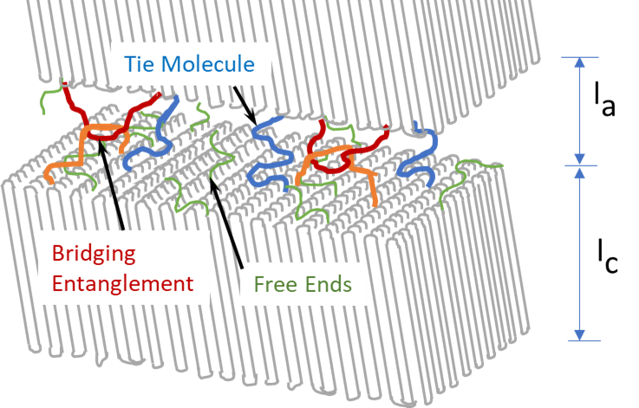

Figure 1. General schematic showing some possible polymer chain topologies in the interlamellar amorphous region. (Note that chain tilt angle is variable depending upon the polymer and processing conditions,¹⁵ so the angle chosen is for illustrative purposes only.)

For polyethylene (PE), one important mechanical property for fabricated articles, such as pipe and geomembrane sheet (e.g., municipal retention pond liners), is slow crack growth (SCG) resistance.^{16,17} SCG refers to a failure mode common to PE resins whereby failure, over timescales ranging from hours to decades, occurs at stress levels well below the resin’s short-term strength. SCG failures are the result of crack initiation and subsequent growth. When subject to stress, internal defects produce stress risers, which in turn promote localized yielding and craze zone development. Bridging entanglements and tie chains connecting lamellae are thought to act as stress transmitters under such deformation.¹ The strain hardening modulus (SHM) measured at 80 °C has been used as an accelerated (most buried pipes are below ambient temperature) resin test for SCG resistance in PE pipe (ISO 18488:2015E).¹⁸ In SHM testing, the tensile load subjects the polymer material to deformation along the stretching direction. Correlations to SCG performance have shown that the SHM increases with increasing resistance of PE resins to SCG failures.^{19,20} It is widely accepted that SCG resistance increases as tie molecule content (i.e., stress transmitters) increases as a result of network formation as described above.^{1,21–25}
In recent studies by Mukherjee and others, laser directed polarized infrared imaging results on tensile strained samples and subsequent modelling showed a clear correlating trend (R² = 0.9202) between a structural parameter ($β$) and the strain hardening moduli for architecturally different HDPE samples.^{26,27} The samples included monomodal (mPE) homopolymers and bimodal 1-hexene copolymers, bimodal Ziegler Natta 1-hexene and 1-butene copolymers as well as a trimodal blend consisting of a bimodal Ziegler Natta 1-hexene and mPE homopolymer. In those studies, anisotropy imaging of polarization sensitive −CH2 vibrations (1476 cm⁻¹) for thin (≈10 μm) tensile samples were evaluated after straining to 100 %. The polymer deformation process was followed by noting the change in anisotropy with strain (ε) with distance from a denoted pre-yield value. The deformation process from the experimentally derived strain was then modeled using a modified Eyring model, from which the activation length for change in distance per unit load, β, was determined.
The magnitude of the β parameter obtained in these studies reflects the degree of difficulty for the amorphous content to align and reshape over a distance with the application of a load. In other words, the more stable the molecular network (i.e., the lamella segments connected via bridging entanglements and tie molecules), the less strain is observed (i.e., higher β values) when a load is applied. The observed correlation between β values (measured at only 100 % strain) and strain hardening moduli strongly suggests the network of HDPE samples existing at 100 % strain can be directly correlated to the post-yield tensile values irrespective of the subsequent morphological changes that result during the tensile deformation past 100 % strain. However, these methods only demonstrate the network nature of the resins tested and the mechanical consequences, they do not quantify the amounts of bridging amorphous structure present in these polymers.
In the past, small-angle neutron scattering (SANS) has been the most successful experimental method for quantifying tie molecules through the introduction of a dilute concentration of deuterated polymer via solution or melt blending.^{28,29} This earlier SANS method estimated the number of deuterated tie molecules by determining the average number of crystalline stems per cluster in one lamella and the total number of stems per deuterated molecule. From these quantities the number of crystalline clusters could be determined and from that the minimum number of tie molecules estimated. Unfortunately, these methods required the use of blends of the polymers of interest with deuterated chains, which limited the application of the technique to a small range of available materials and processing parameters. They were also limited by concerns related to phase separation of protonated from deuterated chains ^{30–32} and changes in the crystallization kinetics.^{33–36}
A more widely used but more approximate experimental method is based on equilibrium swelling theory. The swelling behavior of a network system is determined by the crosslink content as well as interactions between the polymer matrix and absorbed molecules.^{37,38} In equilibrium swelling models, the free energy of mixing, driven by interactions between the solvent and amorphous polymer, is balanced against the elastic entropic cost of stretching tie molecules as the amorphous layer thickness increases. The elastic restoring force resulting from the entropic costs associated with the loss of polymer conformations is also the basis for the elastic response of the polymer at low strain rates. Hence, the solvent-induced swelling constitutes a nano-mechanical test that is conducted at very low stress and strain values relative to typical tensile properties as illustrated in Fig. 2.
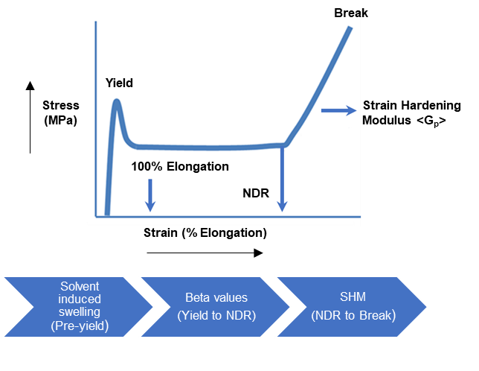
Figure 2. Represented stress and strain regions of the data presented in this work.
The application of swelling theory to semicrystalline polymers derives primarily through one of two theoretical frameworks. The first is a modification of the Flory-Rehner network model that treats the crystallites as the crosslink points between the tie molecules (modified Flory-Rehner).^{39–41} The second is based on the assumption that the tension on elastically active chains (tie molecules and bridging entanglements) is in equilibrium with the free energy of crystallization (Michaels-Hausslein).^{42–44} As a result, measurements of the change in molecular state due to swelling caused by a solvent that selectively swells only the amorphous phase was believed to provide a direct insight into the thermodynamic environment of the elastically active chains and the fraction that restrict swelling. Because the solvent uptake was measured gravimetrically, these experiments assumed that the swelling occurred only within the interlamellar amorphous region. This assumption could easily be violated, because there was no way to ensure that solvent uptake was also not occurring at the grain boundaries and other amorphous regions or at the expense of dissolution of small crystallites within the bulk material.
Probabilistic models are often employed to estimate the number of tie molecules. By assuming that, at an appropriate length scale, a polymer molecule’s conformation can be represented by a random walk,⁴⁵ early models examined the probability of forming a tie molecule given an amorphous layer thickness.⁴⁶ These early models did not take into account the effects of molar mass, but a later extension by Huang and Brown did, and given the crystal (l_{c}) and amorphous (l_{a}) layer thicknesses (or the long period L = l_{a} + l_{c}) the probability that a molecule of a given length spans at least two lamellae could be estimated.⁶
Further advancements to the Huang and Brown model were made using Primary Structure Parameter (PSP) methods.^{9,11,12,47} Multiple generations of PSP models (PSP2, PSP3*, PSP4) have been developed, largely focused on accounting for the effect of the short chain branching (SCB), introduced by copolymerization of ethylene with higher 1-alkenes, on the expected morphology and resulting tie molecule probability. The PSP2 involves calculation of probabilities of individual slices of the molar mass distribution and short chain branching (SCB) distribution (as a function of molar mass) as measured by size exclusion chromatography coupled to an infrared detector (SEC-FTIR), then combining them into a single overall parameter termed PSP2.⁹ In this parameter, lamellar distances (l_{c} and l_{a}) were estimated through several empirical relationships in order to calculate the tie (or bridge) probabilities. For PSP3*, differential scanning calorimetry (DSC) was added to obtain the crystallite size distribution and hence a more realistic estimate for the lamella size distribution of the polymer.^{11,12} PSP3* also incorporates the effects of SCB on the statistical chain step length during a random walk through a “digital” lattice and accounts for the probability of a single chain spanning more than one crystalline-amorphous-crystalline lamella set, and thus forming multiple crystallite bridges. Recent advances incorporate a semi-empirical chain folding equation coupled with the new structure parameters (PSP4 or tie molecule content) and the average number of lamella segments per chain (ALSC).⁴⁷ These parameters augment the PSP3* calculation by capturing the number of times a chain folds in each lamella, the subsequent effects on the root mean square end-to-end distance <R> and lamella orientation. PSP4 gives the probability, obtained from a 3-D random walk, that the end-to-end distance is longer than what is needed to form multiple ties, while ALSC provides an estimate of the number of lamellae crossed to get to that end to end distance. Results from those studies showed that homopolymers had a significantly higher level of chain folding compared to copolymers. Moreover, as the length of the SCB increased from ethyl (ethylene-co-1-butene) to butyl (ethylene-co-1-hexene), less folding was measured thereby leaving more of the polymer chain to form tie molecules. The quantity PSP4³/ALSC exhibited a linear relationship with SHM with excellent correlation (correlation coefficient r² = 0.9845) for a diverse set of unimodal and bimodal resins made using different catalyst systems, which included homopolymers, copolymers, and blends of different catalyst type and modality.
Although some equilibrium swelling studies of semicrystalline polymers continue to be performed using bulk measurements,^{44,48–50} the morphological complexity of these systems discussed previously has prevented confident application of the results toward improving mechanical properties and understanding molecular interactions. In this work, we combine the two primary experimental methods, SANS and vapor swelling, to develop a polymer agnostic method for quantifying the topology in the interlamellar amorphous region and compare the results to probabilistic estimates of lamella connectivity (PSP4 and ALSC) from SEC-FTIR and DSC data. The application of quantitative SANS measurements to vapor swelling addresses the difficulties with gravimetric methods by providing three independently measured quantities instead of one: l_{a} and l_{c} in Fig. 1, as well as the scattering contrast, a measure of phase composition and density.
By using a deuterated solvent instead of a deuterated polymer, the limitations of prior SANS methods are removed, and as-synthesized systems can be examined. Here, the large change in scattering intensity in the lamellar scattering peak corresponds directly to the volume fraction of deuterated solvent within the interlamellar amorphous layers (Fig. 5), a unique property arising from the isotopic sensitivity of neutrons. This quantity is easily extracted from scattering patterns and is superior to a total mass uptake measurement. Most importantly, by modeling the SANS data the composition solely within the interlamellar amorphous region can be extracted.
Our focus in this study is on high density polyethylene (HDPE) homopolymer and copolymer samples, since it is known that adding specific comonomers to polyethylene introduces branches that restrict the thickness of crystalline lamellae in a predictable manner,⁵¹ reducing the distance that a polymer chain must span in order to form a tie molecule. A second benefit to using polyethylene in SANS is the lack of contrast in PE in the absence of a deuterated vapor, resulting in a large increase in scattering contrast upon introducing small quantities of the probe vapor. In fact, Glinka and coworkers demonstrated the effectiveness of swelling fully protonated polyethylene in a deuterated organic solvent vapor to highlight the strain response of interlamellar amorphous layers on sub-nanometer length scales, while crystalline lamellae remain intact.⁵²
In this work, we provide the first direct, systematic measurements of the number of tie molecules within the nanoscopically confined interlamellar amorphous region. By applying a thermodynamic model to the swelling induced by a probe gas as measured by small-angle neutron scattering, the volume fraction p of molecules in the amorphous region that transmit stress (ties and/or bridging entanglements) was estimated for a set of architecturally varied high density polyethylene (HDPE) samples.

EXPERIMENTAL METHODS
Materials and Sample Preparation.
In this study we examined various types of HDPE samples. Both copolymers and homopolymers were examined. The bimodal (BM), 1-hexene copolymers (C6) accessed were Ziegler-Natta (ZN) catalyzed resins made by extruder blending a low molar mass homopolymer (mass averaged molar mass M_{w} = 40 kg/mol) and high molar mass (HM) 1-hexene copolymer (M_{w} = 427 kg/mol) at various compositions. The composition for these blends ranged from mass fractions of 35 % HM for BM-C6 ZN 1 to 65 % HM for BM-C6 ZN 6. Consequently, all these bimodal samples had more short chain branching (SCB) in the higher molar mass portion of the molar mass distribution. Also examined was a monomodal 1-hexene copolymer produced using a chromium oxide catalyst where the majority of SCB is located in the lower molar mass portion of the molar mass distribution. Homopolymer samples were synthesized using supported metallocene catalysts and ranged in mass average molar mass (M_{w}) values from (241 to 400) kg/mol. All experimental 1-hexene copolymers and homopolymers used in this study were provided by Chevron Phillips Chemical Company LP.⁵³ The homopolymer HDPE NIST Standard Reference Material (SRM) 1475 was included as well. In addition to the 1-hexene samples, a commercially available BM, 1-butene (C4), ZN copolymer sample was also examined. The SCB distribution in the molar mass distribution of this sample is similar to the 1-hexene ZN samples. All HDPE samples had similar mass average molar masses and densities (Table 1).
Molar masses and molar mass distributions were obtained using a PL220 SEC high temperature chromatography unit (Agilent) with trichlorobenzene (TCB) as the solvent, with a flow rate of 1 mL/min at a temperature of 145 °C. BHT (2,6-di-tert-butyl-4-methylphenol) at a concentration of 0.5 g/L was used as a stabilizer in the TCB. An injection volume of 200 μL was used with a nominal polymer concentration of 1.5 mg/mL. The columns used were three Waters Styrogel 6E columns and were calibrated with a broad linear polyethylene standard (Phillips Marlex BHB 5003) for which the molar mass had been determined using a Dawn EOS multiangle light scattering detector (Wyatt). Short chain branching profiles across the molar mass distributions were measured using SEC-IR as previously described.⁵ Samples for density measurements were molded according to ASTM standards (ASTM D4703; Annex A1, Procedure C) and measured using a gradient column (ASTM D1505). Perdeuterated cyclohexane-d₁₂ used in the swelling experiments was obtained from Cambridge Isotopes, Inc., with a purity of 99.5 %.
Samples with thicknesses of ≈50 μm were prepared according to ASTM D4703 with an average cooling rate of ≈1 °C/min. Sample thickness was determined using a custom thickness gauge (combining a micrometer with a linear voltage transducer to provide a resolution of ≈ ±0.1 μm) with a ball-to-plane geometry and was characterized at 10 separate regions across the sample. The mean value of the measurements was used for computing the SANS transmission values.

Table 1. Molecular characteristics of samples
Polymer type | Sample | M_{n} (g/mol) | M_{w} (g/mol) | M_{z} (g/mol) | M_{w}/M_{n} | SCB /1000 TC ª | Density (g/cm³)
Bimodal 1-hexene Copolymers | BM-C6 ZN 1 | 10,950 | 186,130 | 1,276,810 | 17 | 0.9 | 0.959
 | BM-C6 ZN 2 | 12,170 | 215,110 | 1,351,550 | 17.7 | 1.1 | 0.954
 | BM-C6 ZN 3 | 11,390 | 223,820 | 1,219,550 | 19.7 | 1.5 | 0.953
 | BM-C6 ZN 4 | 13,640 | 241,850 | 1,257,270 | 17.7 | 1.4 | 0.951
 | BM-C6 ZN 5 | 15,630 | 266,400 | 1,309,770 | 17 | 1.7 | 0.949
 | BM-C6 ZN 6 | 19,600 | 293,930 | 1,362,510 | 15 | 1.9 | 0.947
Bimodal 1-butene Copolymer | BM-C4 ZN 1 | 11,704 | 276,080 | 1,501,477 | 23.6 | 3.0 | 0.947
Monomodal 1-hexene Copolymer | MM-C6 Cr 1 | 14,000 | 241,000 | 1,711,000 | 17.2 | 2.4 | 0.945
Monomodal Homopolymers | SRM1475 | 20,545 | 61,780 | 151,625 | 3.03 | 0 | 0.970
 | mPE-2 | 63,000 | 289,000 | 589,000 | 4.59 | 0 | 0.949
 | mPE-3 | 95,000 | 400,000 | 785,000 | 4.21 | 0 | 0.945

ªShort Chain Branches per 1000 total carbons (SCB/1000 TC). M_{n}, M_{w}, and M_{z} are the number, mass, and z-average (or third moments of the molar mass distribution) molar masses, respectively.

Vapor flow SANS. The vapor flow apparatus employed in the study was a modification of the system developed by Kim and coworkers.^{52,54} Solvent activity (a₁=P/P_{sat}, where P is the partial pressure of the vapor and P_{sat} is the saturation pressure) was set using calibrated mass flow controllers and a temperature control bath in which a solvent bubbler was immersed. The temperature bath was used to change the saturation pressure P_{sat} of the cyclohexane-d₁₂ based on the following vapor pressure equation⁵⁵
 | $$\ln\left(\frac{P_{sat}}{P_{0}}\right)=\frac{A}{T^{3}}+\frac{B}{T^{2}}+\frac{C}{T}+D$$ | (1)
where P₀=101.325 kPa, A=49053636 K³, B=-691209 K², C=-994.044 K, and D=7.279. Mixing flows of pure N₂ and the N₂ saturated with cyclohexane-d₁₂ vapor at varying flow rates set the final activity, as described using the “Dilution mode” equations of Kim and coworkers⁵⁴ at a total gas flow rate of ≈0.001689 Pa m³/s (10 sccm).⁵⁴ Due to concerns related to dissolution of small crystallites or strain induced crystallization as discussed later, thermodynamic analysis was performed only to activities up to 0.4 for cyclohexane-d₁₂ at 25 °C. SANS measurements were performed at the NIST Center for Neutron Research on the NG-B 10 m SANS instrument. Sample equilibration was established through plots of total detector counts as a function of time measured in a medium q range ($q=4π(sinθ)/λ$, where $2θ$ is the scattering angle and $λ$ is the wavelength) to maximize count statistics while capturing as much of the lamellar scattering as possible. After equilibration, measurements across the full q range were performed. The SANS data were reduced and converted to absolute intensity as described elsewhere.⁵⁶ The resulting q-dependent differential scattering cross sections ($dΣ/dΩ$) were modeled via a smeared generalized real-space paracrystalline model to determine the solvent volume fraction v_{2a} from the scattering invariant (Q). The model used was based on the one developed by Murthy and coworkers,^{57,58} but with the diffuse scattering term replaced by a more generic power law term to better fit the data as $q→0$.
 | $$\frac{dΣ}{dΩ}=I_{b}+\frac{a}{q^{d}}+I_{L}(q)$$ | (2)
where I_{b} is the incoherent background term (taken to be independent of q), a and d are fitting constants, and I_{L} is given by
 | $$I_{L}(q)=\frac{{\left[F_{step}\left(l_{a}\right)\right]}^{2}}{q^{2}}{\left[\text{Gauss}\left(D,E,F\right)+\text{Gauss}(D,2E,F\right]}^{2}$$ | (3)
where
 | $$F_{step}(l_{a})=\frac{2\sin\left(l_{a}q/2\right)}{(l_{a}q)}$$ | (4)
 | $$\text{Gauss}\left(D,E,F\right)=D\exp\left[-{\left(\frac{q-E}{F\sqrt{2}}\right)}^{2}\right]$$ | (5)
with D the intensity of the lamellar scattering peak, $E=2π/(l_{a}+l_{c})$, $F=4π/[L_{coh}\sqrt{8\ln{2}}]$, and $L_{coh}$ the lamellar stack coherence length. Fits to the smeared model described by Eq. 2 were performed using BUMPS and SASmodels using the DREAM (Differential Evolution Adaptive Metropolis) fitting engine.^{59,60} From the model fits, the invariant Q was obtained from:
 | $$\text{Q=}\int_{0}^{∞}{I_{L}\left(q\right)q^{2}dq }$$ | (6)
and using the following relationship:
 | $$\text{Q=}2π^{2}ϕ_{c}\left(1-ϕ_{c}\right){\left(Δρ_{b}\right)}^{2}$$ | (7)
where the $ϕ_{c}$ is crystalline volume fraction calculated as $ϕ_{c}$=l_{c}/(l_{a}+l_{c}) and $Δρ_{b}$ is the scattering length density difference, or contrast factor. In practice, the integral in eq 6 was evaluated from q= (0 to 10) Å⁻¹, which was found to be a sufficiently wide range to capture the entire integral. The solvent volume fraction $ϕ_{s}$ and amorphous polymer volume fraction $ϕ_{2a}$ were then determined from the following
 | $$ϕ_{s}=\left(1-ϕ_{2a}\right)=\frac{ρ_{b_{c}}-ρ_{b_{a}}±Δρ_{b}}{ρ_{b_{s}}-ρ_{b_{a}}}$$ | (8)
With $ρ_{b_{x}}$ being the following scattering length densities: $ρ_{b_{c}}=-3.59x{10}^{-7} Å^{-2}$ (polyethylene crystal), $ρ_{b_{a}}=-3.06x{10}^{-7} Å^{-2}$ (amorphous polyethylene), and $ρ_{b_{s}}=6.70x{10}^{-6} Å^{-2}$ (cyclohexane-d₁₂). Fits to the SANS data are shown in Fig.S1. Replicate measurements (including separate melt pressed sample preparation) were made on three samples BM-C6 ZN 4,BN C6 ZN 5, and BM-C6 ZN 6.After thermodynamic model fits, the mean values for these samples are plotted with the error bars approximating one standard deviation in the mean = 1.84σ/√2.
Differential scanning calorimetry (DSC). DSC was performed on all samples on either a TA Instruments Q1000 DSC equipped with an RCS90 intracooler in T4P mode under a dry nitrogen purge or a Perkin Elmer DSC8500 equipped with a CLN2 liquid nitrogen chiller under a dry helium purge. Samples were run at a heating rate of 10 °C/min. Temperatures were calibrated against adamantane, benzophenone, indium, tin, and lead reference standards at the same heating rate. Heat flow was calibrated against indium. DSC was performed on ≈4 mg samples prior to and after vapor flow SANS measurements. (Note that the samples measured after vapor exposure were allowed to dry under ambient conditions and showed no traces of residual solvent by DSC.) DSC traces are shown in Fig. S2.

RESULTS & DISCUSSION
Analysis of vapor swelling SANS data
Here we present SANS measurements of a series of polyethylene films at 25 °C at several cyclohexane-d₁₂ vapor activities. Sample/vapor equilibration was determined during the measurements by plots of total detector counts in a medium q range as a function of measurement time (see Fig. 3a). Measurements at activities higher than 0.4 showed irreversible changes in the sample, as can be seen in Fig. 3b, where the intensity initially increased and then dropped. Subsequent measurements after drying the sample and re-equilibrating at the same activities showed reductions in the intensity. For this reason, only activities up to 0.4 were studied. (Two samples with thicknesses on the order of ≈50 μm separated by an ≈1 mm spacer were chosen for each experiment to minimize equilibration time while maintaining sufficient scattering statistics. Studies on thicker samples showed much longer full equilibration times with definite positive slopes in the “plateau” regime.) Typical results obtained at equilibrium are shown in Fig. 4 for several of the samples studied. DSC measurements made prior to and after solvent vapor exposure were also used to validate that the sample crystallinity and lamellar thicknesses were not changed by the measurements. Samples that showed changes were excluded from the analysis.

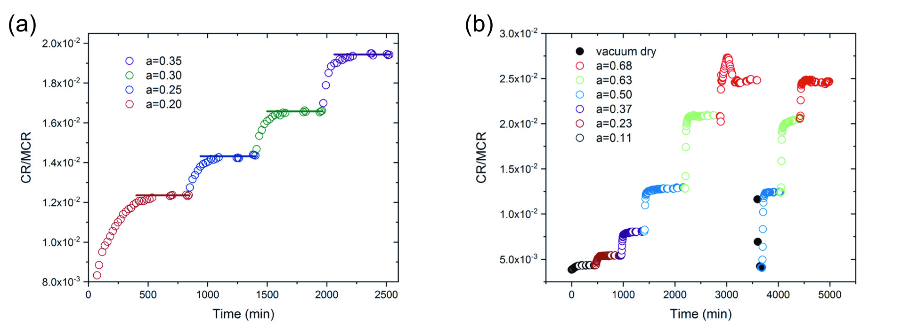
Figure 3. (a) Typical plot of detector count rate (CR) normalized by monitor count rate (MCR) in a medium q range as a function of experiment time. The lines correspond to an average of the last five data points. (b) Similar plot showing changes induced for a>0.4. Different colors correspond to different solvent activity levels. The data spacing increases at equilibration due to additional measurements being performed at different SANS configurations (sample-to-detector distance and wavelength) to span the required q range.

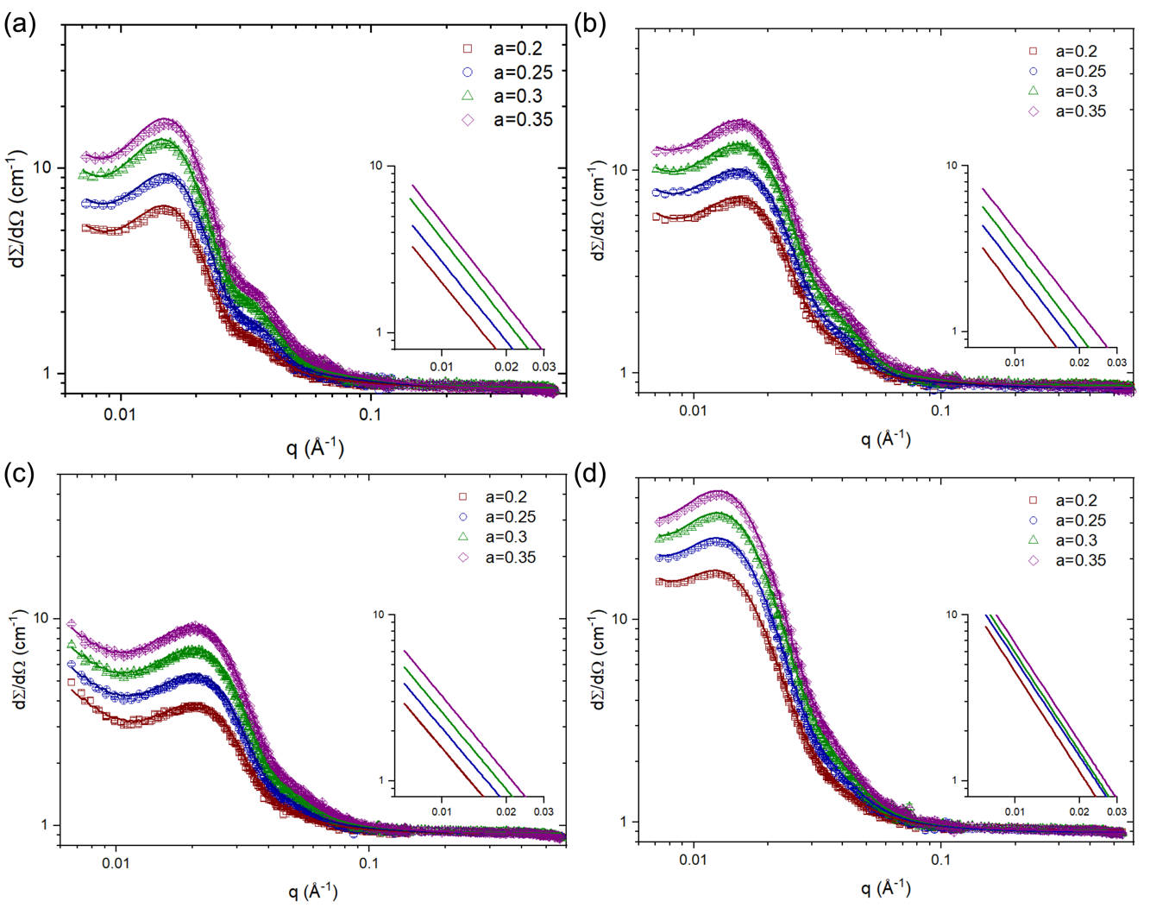
Figure 4. Typical equilibrium plots of SANS differential scattering cross sections (dΣ/dΩ) as a function of q for high-density polyethylene (HDPE) exposed to varying activities (a) of cyclohexane-d₁₂. (a) bimodal physical blend BM-C6 ZN 1, (b) bimodal physical blend BM-C6 ZN 6, (c) bimodal reactor blend BM-C4 ZN 1, and (d) monomodal mPE3. (Error bars, which are the best estimate of one standard deviation in the experimental uncertainty, are often smaller than the data points.) Fits to the data (solid lines), as described in the text, are shown as well. The insets are plots of $\frac{a}{q^{d}}$ vs. q (see eq 2) for each system, showing the q-dependent scattering not attributed to the lamellar stack.

In Appendix I, we derive the following equation that links the applied solvent activity a₁ and the measured polymer volume fraction in the interlamellar amorphous region $ϕ_{2a}$ to the fraction of molecules in the amorphous region that are elastically effective p (stress-transmitters)

 | $$\ln\left(a_{1}\right)={\ln\left(1-ϕ_{2a}\right)+ϕ_{2a}+χ}_{1}ϕ_{2a}^{2}+3p\left(\frac{v_{1}}{v_{2}}\right)\left(\frac{1}{ϕ_{2a}}\right)$$ | (9)
and
 | $$\ln\left(a_{1}\right)={\ln\left(1-ϕ_{2a}\right)+ϕ_{2a}+χ}_{0}\left(1+\frac{2ϕ_{2a}}{3}+\frac{ϕ_{2a}^{2}}{2}\right)ϕ_{2a}^{2}+3p\left(\frac{v_{1}}{v_{2}}\right)\left(\frac{1}{ϕ_{2a}}-\frac{ϕ_{2a}}{2}\right)$$ | (10)
where $v_{1}$ and $v_{2}$ are the molar volume of the solvent and polymer, respectively, $χ_{1}$ is the Flory-Huggins interaction parameter, and $χ_{0}$ is defined as the infinite dilution Flory-Huggins parameter. Equation 9 is based on the classical Flory-Huggins approach to the Flory-Rehner model (FR model) whereas eq 10 is based on Liu and Neogi’s implementation⁴¹ of the Evans and Napper⁶¹ perturbation method for including concentration dependence of $χ_{1}$ into the Flory-Huggins theory (FREH model). Because a different approach based on the original work of Michaels and Hausslein,⁴² is currently used^{44,49,50} in modeling vapor sorption in semicrystalline polyethylene, these Flory-Rehner type models will be compared with Doong and Ho’s 1-dimensional solubility parameter version of the Michaels and Hausslein approach (DHMH model):⁴³
 | $$\ln\left(a_{1}\right)=\ln\left(a_{comb}\right)+\ln\left(a_{fv}\right)+\ln\left(a_{int}\right)+ln⁡(a_{elastic})$$ | (11)
where the terms on the right-hand side are the contributions from the combinatorial entropy, free volume, enthalpy of interaction, and elastic factors, respectively, given by
 | $$\ln\left(a_{comb}\right)=\ln\left(1-ϕ_{2}'\right)+ϕ_{2}'$$ | (12)
where $ϕ_{2}^{'}$ is the polymer segment fraction given by
 | $$ϕ_{2}^{'}=\frac{m_{2}v_{2}^{*}}{{m_{1}v_{1}^{*}+m}_{2}v_{2}^{*}}$$ | (13)
with $v_{i}^{*}$ and $m_{i}$ being the specific hard-core volume and mass fraction, respectively, of component i
 | $$\ln\left(a_{fv}\right)=3C_{1}\ln\left(\frac{{\overline{v}}_{1}^{\frac{1}{3}}-1}{{\overline{v}}_{m}^{\frac{1}{3}}-1}\right)-C_{1}\left[\left(\frac{{\overline{v}}_{1}}{{\overline{v}}_{m}}-1\right){\left(1-\frac{1}{{\overline{v}}_{1}^{\frac{1}{3}}}\right)}^{-1}\right]$$ | (14)
where 3C₁ is the number of external degrees of freedom per solvent molecule (for our system C₁ ≈1.1,⁶² ${\overline{v}}_{i}=v_{i}/v_{i}^{*}$ (with $v_{i}$ the specific volume of component i), ${\overline{v}}_{m}=v_{m}/v_{m}^{*}$ (mixture) with⁶²
 | $$v_{m}=m_{1}v_{1}+m_{2}v_{2}$$ | (15)
and
 | $$\frac{1}{v_{m}^{*}}=\frac{m_{1}}{v_{1}^{*}}+\frac{m_{2}}{v_{2}^{*}}$$ | (16)
$v_{1}^{*}$ and $v_{2}^{*}$ can be calculated⁶² as 0.9336 cm³/g cyclohexane and 0.9340 cm³/g for polyethylene, respectively.
 | $$\ln\left(a_{int}\right)=v_{1}ϕ_{2a}^{2}{\left(δ_{1}-δ_{2}\right)}^{2}/RT$$ | (17)
with v_{i} the molar volume of component i, $δ_{i}^{'}$ the solubility parameter of component i, R the gas constant, and temperature T.
 | $$\ln\left(a_{elastic}\right)=\left\{\frac{{\text{v}}_{1}}{{\text{v}}_{2}}\left[\frac{ΔH_{f}}{R}\left(\frac{1}{T}-\frac{1}{T_{m}}\right)\right]-\left(1-ϕ_{2a}\right)+\left(\frac{\ln{a_{int}}+\ln{a_{fv}}}{ϕ_{2}^{2}}\right){\left(1-ϕ_{2a}\right)}^{2}\right\} \\ {×\left(\frac{3}{2fϕ_{2}}-1\right)}^{-1}$$ | (18)
where f is the fraction of elastically effective molecules (analogous to p but derived from different assumptions) in the amorphous regions and $ΔH_{f}$ is the molar heat of fusion of the polymer crystal. For ease of comparison between the methods we fit ${\left(δ_{1}-δ_{2}\right)}^{2}$ and computed $χ_{1}$ from
 | $$χ_{1}={\frac{\ln\left(a_{int}\right)+\ln\left(a_{fv}\right)}{ϕ_{2a}^{2}}}$$ | (19)
Based on the above equations, we now have a framework within which to analyze our vapor swelling SANS data. As can be seen in Fig. 4, the long period (as estimated from the peak maximum) does not appear to shift, but this is to be expected as will be explained shortly. While significant expansion of the long period is seen in high activity measurements, the results reported here use small activities where the amorphous layer thickness was unchanged to within experimental uncertainty. We therefore calculated the amorphous layer swelling ratio from the solvent volume fraction. The insets of Fig. 4, showing the scattering not attributed to solvent uptake in the interlamellar amorphous regions, demonstrate the necessity of using a SANS-type measurement over gravimetric measurements, as the latter would include solvent uptake in other regions of the sample such a grain boundaries.
The lack of observable change in long period in Fig. 4 can be understood from the extracted solvent volume fractions. The largest possible change would be expected in the lowest crystallinity sample (mass fraction crystallinity ≈0.55). For that sample, the maximum solvent volume fraction in the amorphous phase was 0.09 (the maximum solvent volume fraction observed for all samples was 0.1) and the long period (L=l_{a}+l_{c}) was ≈370 Å. If we approximate the linear crystallinity l_{c}/L with the mass fraction crystallinity, the peak would be expected to shift approximately from $\frac{2π}{370 Å}=0.0170 Å^{-1}$ to $\frac{2π}{(0.55×370+1.09×0.45×370 ) Å}=0.0163 Å^{-1}$ or by ${0.0007 Å}^{-1}$. Comparing this value to the q-spacing of ${0.000633 Å}^{-1}$ of our SANS data demonstrates why no observable shift would have been expected.

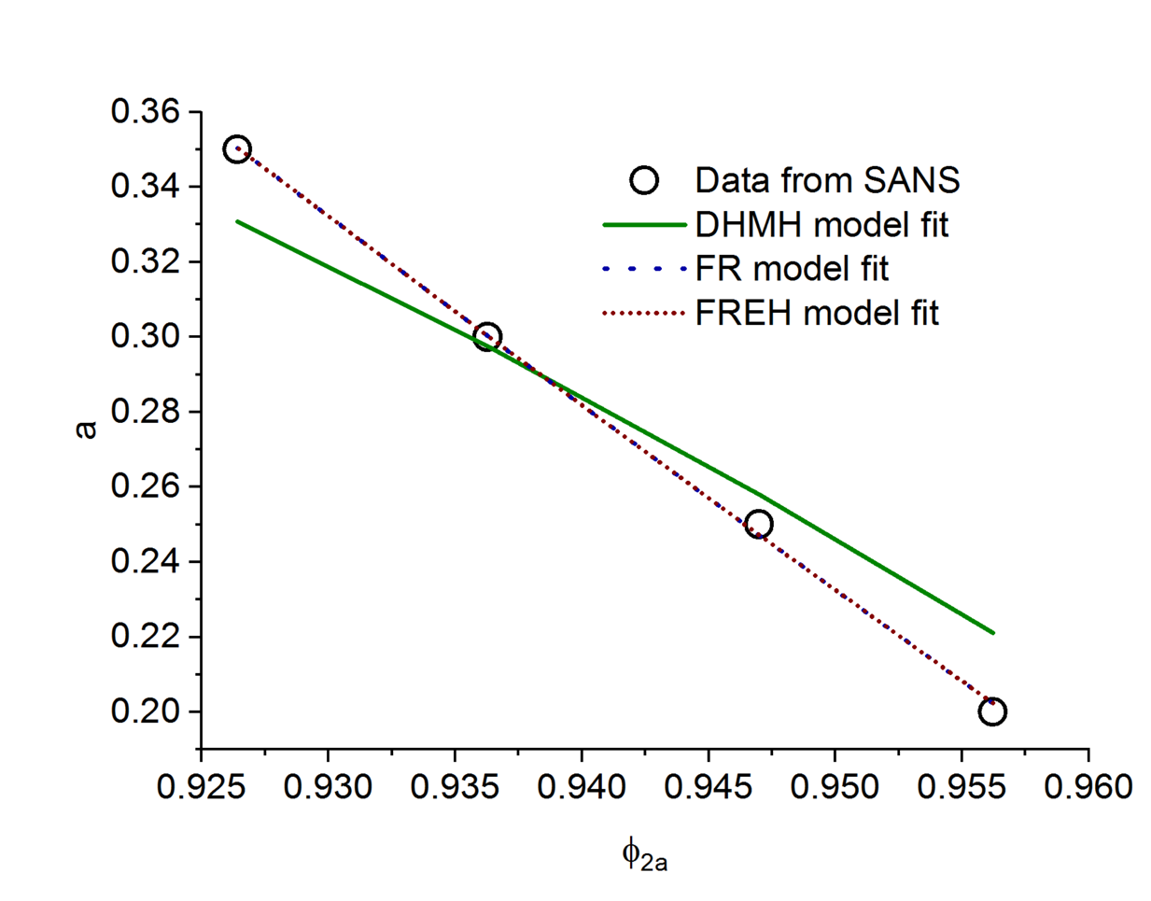
Figure 5. Typical fits based on the three models (FR, FREH, and DHMH) examined to the activity of the cyclohexane-d₁₂ vapor as a function of the amorphous polymer volume fraction determined from the SANS fits for bimodal physical blend BM-C6 ZN 1. (Error bars, which are the best estimate of one standard deviation in the experimental uncertainty, are often smaller than the data points.)

Figure 5 shows plots of activity a vs. equilibrium amorphous polymer volume fraction ($ϕ_{2a}$) for the three models studied for the four materials whose SANS curves were shown in Fig. 4. The FR and FREH models are indistinguishable on the plots, but clearly fit the data better than the DHMH model. The results of the fits (Table S1) show that the models based on the modified Flory-Rehner approach consistently fit the data better than the model based on the Michaels-Hausslein approach with r² values of 0.997±0.003 (FR), 0.997±0.003 (FREH), and 0.95±0.03 (DHMH). The poor fits from the DHMH model were not unexpected as close examination of the data in Doong and Ho’s original paper showed the best agreement between the model and data for far higher temperatures. Because the uncertainties for the fit parameters from the DHMH model were in most cases several orders of magnitude greater than the parameters themselves no further analyses will be performed with this model. In addition to p, both models provide an estimate of the Flory-Huggins interaction parameter. As has been reported in the literature, the values for $χ_{1}$ obtained from the FR model vary a great deal and seem to take highly unphysical values. However, the $χ_{0}$ values derived from the FREH model do not vary nearly as much with the average being $χ_{0}$=0.13±0.06 and with a linear fit extrapolation to p=0 yielding 0.28±0.05. Because the FREH model produces the most “physically realistic” $χ$, our focus will be limited to the FREH model; however, it should be noted that the p values obtained from the FR model varied only slightly from that of the FREH model and would not change any of the subsequent conclusions.

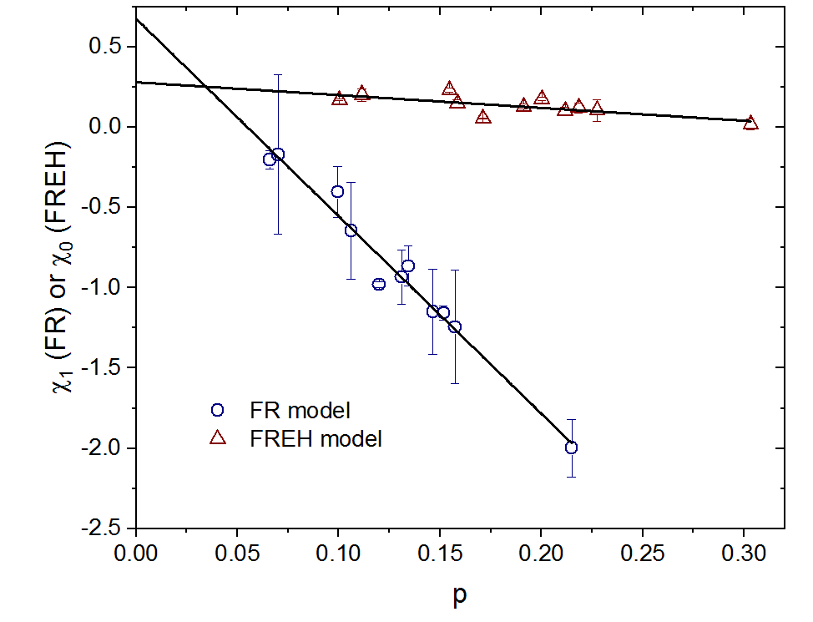
Figure 6. Derived Flory-Huggins interaction parameters as a function of the fraction of elastically effective molecules p for the FR and FREH models. Error bars correspond to the best estimate of one standard deviation in the model fit parameters. (Note that the error in p has been excluded from the plot, since it is primarily the trend with χ that is being examined.)

Structural implications
The first set of HDPE samples we will discuss are the BM ZN-C6 samples as described in Table 1. These samples are extruder blended resins composed of a low molar mass homopolymer and high molar mass copolymer (HM CP). The measured SHM value of BM-C6 ZN 6 (72.7 MPa) with the highest HM CP content far exceeds that of BM-C6 ZN 1 (27.0 MPa) that contains the lowest amount of HM CP component. This simple structural variation results in an enhanced mechanical performance attributed to the increase in connectivity between lamella segments due to the known effects of increased molar mass and SCB content as well as decreased lamella thickness.
By examining values obtained by vapor SANS for this particular data set and a plot of SHM values against these same values we should be able to assess (1) whether the swelling studies capture a systematic rise in the elastic response as the amount of HM CP is increased and (2) if data obtained from a minimally perturbed microstructure, measured at very low stresses, can be correlated to measured post yield SHM values (see Fig. 2). From the table inset in Fig. 7a, a linear correlation between the HM CP content and p values was obtained. Although this correlation may seem trivial, any other result would indicate experimental issues, for example, if significant and unsystematic scattering were observed between samples. These results demonstrate the expected relationship between gross structural composition and elastic response. Secondly, Fig. 7b shows that the measured strain hardening modulus values for the BM-C6 ZN CP blend series correlate very well (r² = 0.941) with the elastic response as measured by p values from the swelling studies. The other sample types tested also correlate but increase the total scatter (R² = 0.916) compared to the fit to the BM-C6 ZN CP samples only. However, more chromium monomodal 1-hexene and ZN 1-butene bimodal copolymers need to be tested to further confirm these results.
A similar result is found when we compare the p values with measured β values for several of these samples (Fig. 7c). These observations suggest that the initial network of the HDPE samples, dictated by the architecture and crystallization conditions, can be directly correlated to the post-yield tensile values irrespective of the subsequent morphological changes that result during the tensile deformation.

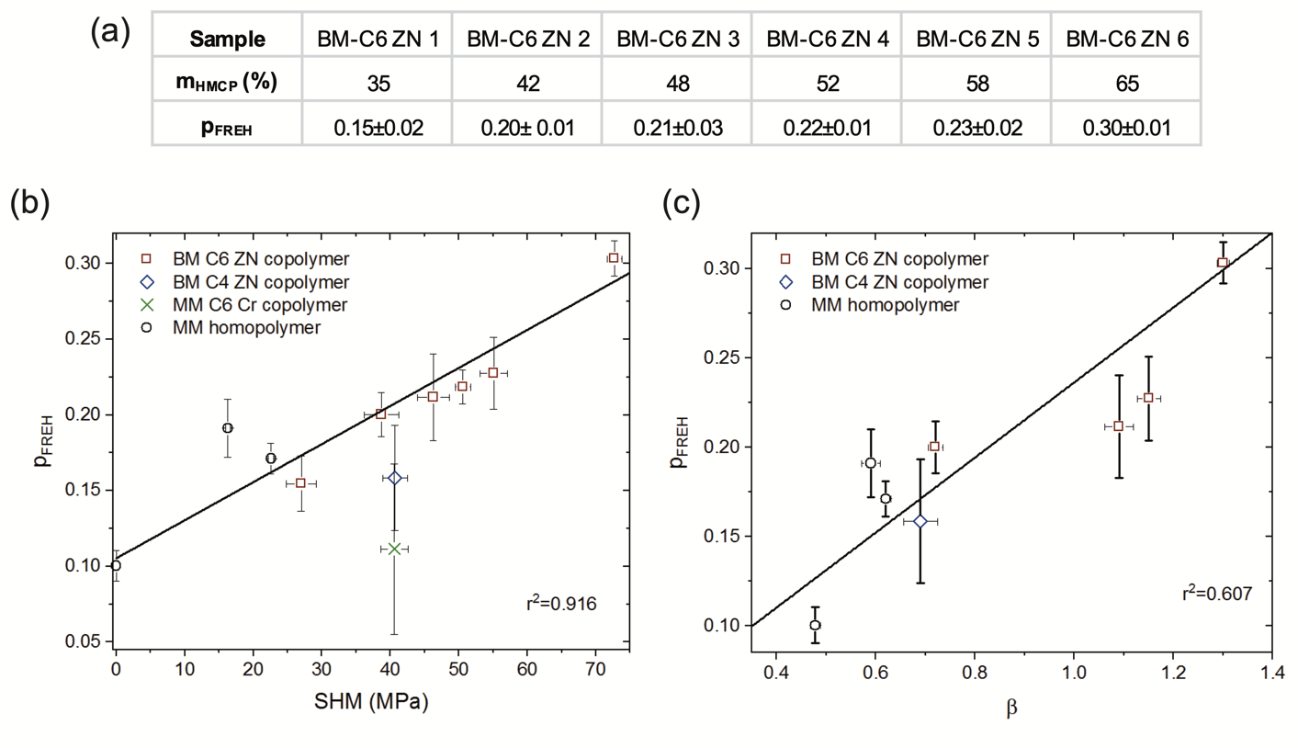
Figure 7. (a) Comparison of mass fraction HP CP (mHPCP) and corresponding p value. (b) Data from vapor-flow small-angle neutron scattering demonstrating a direct correlation to the strain hardening process and elastic response as measured by p values. The SHM values reported for HDPE NIST Standard Reference Material (SRM) 1475 was estimated from measurements of a HDPE sample with similar molar mass and molar mass distribution. (c) Plot of the $β$ parameter measured for several of our samples^{26,27} and p values obtained in this study. The reported $β$ value for HDPE NIST Standard Reference Material (SRM) 1475 was estimated from its molar mass. The lines and r² values shown are for weighted (y error only) linear least squares fits including all samples. Error bars correspond to the best estimate of one standard deviation in either the fit parameters or the experimental uncertainty.

To better understand the vapor SANS measurements in terms of various architectures other than the BM-C6 ZN CP blends, we compared p values to the primary structure parameters PSP4 and ALSC; these parameters capture and predict the connectivity between lamella segments primarily by tie molecules. As stated earlier, PSP4 gives the model probability, obtained from a 3-D random walk, that the end to end distance is longer than what is needed to form multiple ties, while ALSC provides an estimate of the number of lamellae crossed to get to that end to end distance (i.e., tie molecules = ALSC-1). A comparison of these parameters with the measured p values for the BM ZN blends are shown in Fig. 8a and b. In both comparisons, the p values measured for the BM-C6 ZN CP samples show a very good correlation with both PSP4 and ALSC when a simple linear fit is used. Similar results were shown for the other two copolymer types as indicated in the plots, although there is less scatter in the data for the copolymer samples as a whole when the p values are correlated to the ALSC values compared to the PSP4. This latter observation suggests that the p values may better correlate with ALSC values; however, a comparison of the three homopolymer samples in both plots clearly show a positive deviation off the correlation line for the copolymer samples.
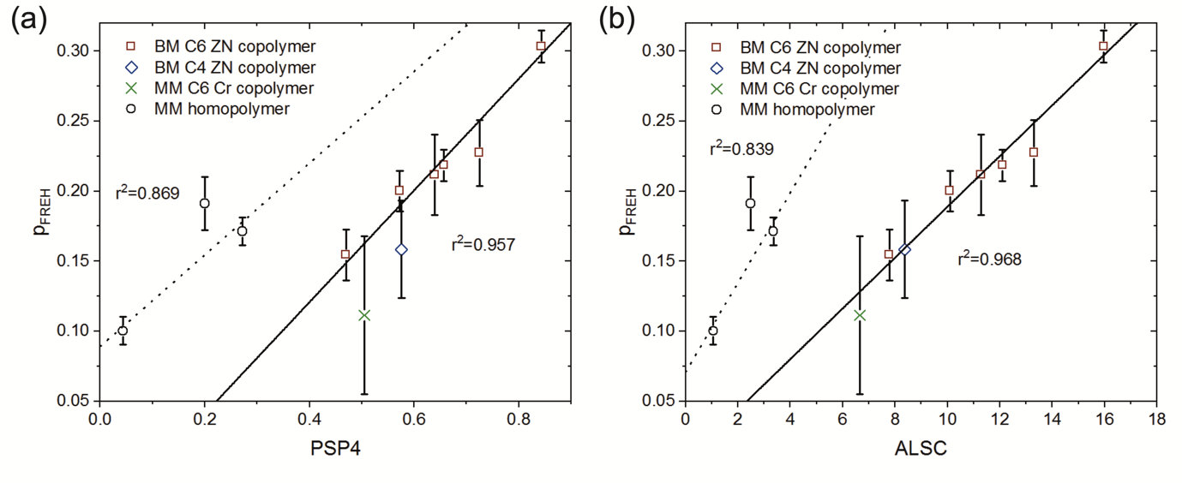
Figure 8. p from the FREH model (p_{FREH}) as a function of (a) PSP4 and (b) ALSC. Separate weighted linear least squares fits were performed on the monomodal homopolymers (dotted lines) and copolymers (solid lines).

One possible reason for the clustering of the values for the two sample types shown in Fig. 8 (i.e., copolymers and homopolymers) may be associated with what the two methodologies capture. For the vapor SANS measurement, the tertiary microstructures responsible for the elastic response include both bridging entanglements and tie molecules, whereas the parameters PSP4 and ALSC primarily estimate the amount of tie molecules in a sample. For example, molecular simulation studies have suggested that PE homopolymers have more bridging entanglements than copolymers.⁶³ In those studies, homopolymers were determined to have approximately 1/3 tie molecules and 2/3 bridging entanglements. The estimated value for tie molecules in a homopolymer system is consistent with other studies.⁶⁴ The converse was found for copolymers (i.e., 2/3 tie molecules and 1/3 bridging entanglements).²⁵ For polyethylenes with relatively small interlamellar amorphous regions (such as copolymers), this is not that surprising based simply on random walk statistics. Similarly, Kurz and coworkers have argued that in systems with larger interlamellar amorphous regions (such as homopolymers), bridging entanglements are a large contributor to stress transmission between crystallites.¹⁴
When the samples are further analyzed using data acquired during the PSP4 and ALSC calculations (i.e., number of amorphous steps > 20 before a chain reentered its starting lamella) we find that the homopolymers have more loops than tie molecules and that the converse is true for the copolymers. Acknowledging that not every loop will have associated with it a corresponding entangling loop, the probability of that structure forming should be higher for homopolymer samples than in copolymers especially when we consider that a higher number of amorphous steps are seen in the homopolymer samples relative to the copolymers. For example, the average number (n) of amorphous steps (of length k) for a polymer chain with a molar mass of ≈79,000 g/mol and the corresponding values for <R>/(nk) for mPE3 was estimated as 338 and 2, respectively. Conversely, for the BM-C6 ZN 6 copolymer, the average values for these same parameters were estimated to be 52 and 1.3, respectively. These comparative values, along with the corresponding ALSC values (7 for the homopolymer and 58 for the copolymer), suggest that a polymer chain with this molar mass in the homopolymers has enough length to form a bridge but instead meanders before once again traversing another crystalline lamella. Consequently, it seem reasonable that the vapor SANS derived values for homopolymer samples which captures all bridging molecules that are elastically effective would be higher than those obtained by PSP4 and ALSC which captures primarily tie molecule content.
To further explore this possible interpretation, the p values were grossly adjusted to reflect only tie molecule content by subtracting 2/3 of the measured p value for homopolymers and 1/3 for copolymers. The resulting adjusted p values were then compared to PSP4 and ALSC values (see Fig. 9). The results shown in Fig. 9a and b demonstrate a significant improvement in the correlations between PSP4 and ALSC in particular by using the adjusted p values. Correlations between both the measured SHM and $β$ valves with the adjusted p values (Fig 9c and d) were also significantly improved compared to the correlations made with the unadjusted p values.
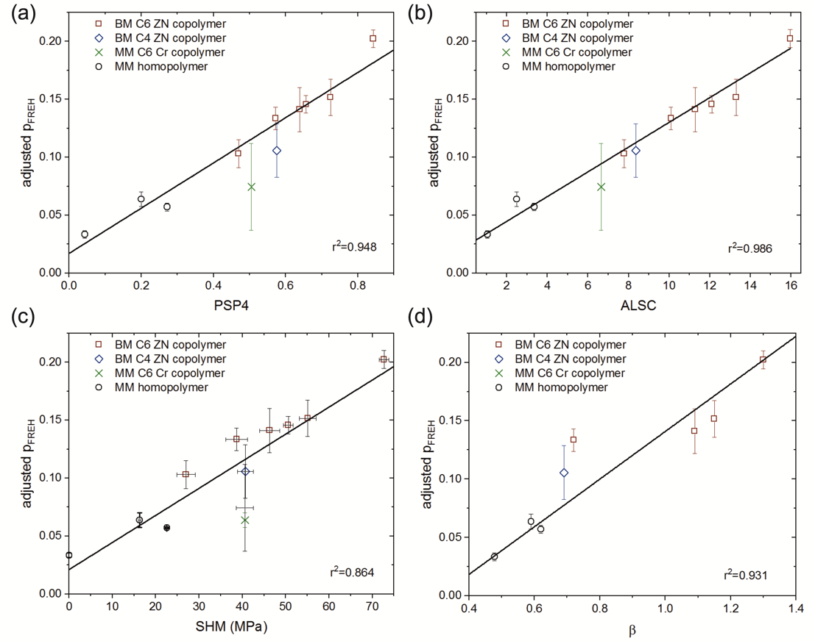
Figure 9. Adjusted p_{FREH} (see text) as a function of (a) PSP4, (b) average number of lamella segments per chain (ALSC), (c) strain hardening modulus (SHM), and (d) β parameter. All lines are weighted linear least squares fits to the data. (The previously demonstrated correlation values for SHM as a function of PSP4 and ALCS are 0.9730 and 0.9514, respectively.⁴⁷)

The fact that we can use tie molecule content alone to predict post tensile values strongly suggests that tie molecule content is a larger contributor to stress transmission in semicrystalline polyethylene than are bridging entanglements. One possible explanation for the larger contribution of the tie molecule is to recognize that mechanical properties are dependent on both the overall number of bridging molecules and on the tautness of the molecules. Simulation studies have suggested that the stretch potentials for bridging entanglements were in general greater than for tie molecules, indicating that the average tie molecule has a greater impact on the mechanical properties of the polymer than the average bridging entanglement.⁶³

CONCLUSIONS
We have demonstrated a capacity to make quantitative measurements of the combined fraction of amorphous bridging entanglements and tie-molecules, deriving their mechanical response from the swelling response in a generic probe solvent vapor. Specifically, we have shown that the vapor swelling method properly captures the total stress transmitter response of the interlamellar amorphous region for HDPE homopolymer and copolymer samples. When roughly adjusted to reflect solely tie molecule content, we have demonstrated good agreement between our vapor flow SANS derived value and a statistical model for estimating tie molecule fractions, as well as with measured post yield tensile data for HDPE samples. Our results also show that tie molecule content is a larger contributor to stress transmission in semicrystalline polyethylene than are bridging entanglements. Lastly, this study demonstrated that the initial network of HDPE samples, dictated by the architecture and crystallization conditions, can be directly correlated to the post yield tensile values irrespective of the subsequent morphological changes that result during the tensile deformation. Finally, as a result of the correlations within these studies, we have demonstrated the superiority of a Flory-Rehner network approach to that of the Michaels-Hausslein approach at the temperatures and activities studied herein. These results will lead to a new capability to explore the limits of semicrystalline polymers in a variety of fields based on mechanical and electrical properties, using a full range of mechanical, thermal, and chemical process parameters.

APPENDIX I. Modified Flory-Rehner theory for quantifying the fraction of elastically effective molecules
The solvent activity a₁ is given by
 | $$\ln\left(a_{1}\right)=\frac{μ_{1}-μ_{1}^{0}}{RT}$$ | (A1)
where R is the gas constant, $μ_{1}$ is the chemical potential of the solvent and $μ_{1}^{0}$ is the chemical potential of the solvent in its reference state. We first compute the chemical potential for the system⁶⁵
 | $$μ_{1}-μ_{1}^{0}=N_{A}{\left(\frac{∂ΔF}{∂n_{1}}\right)}_{T,P}=N_{A}{\left(\frac{∂ΔF_{mix}}{∂n_{1}}\right)}_{T,P}+N_{A}{\left(\frac{∂ΔF_{elastic}}{∂λ}\right)}_{T,P}{\left(\frac{∂λ}{∂n_{1}}\right)}_{T,P}$$ | (A2)
With $ΔF_{mix}$ and $ΔF_{elastic}$ the mixing and elastic free energies, respectively, n₁ is the number of solvent molecules, N_{A} is Avogadro’s number, and $λ$ is the strain. The first term can be approximated by the Flory-Huggins approach as
 | $$N_{A}{\left(\frac{∂ΔF_{mix}}{∂n_{1}}\right)}_{T,P}=RTχϕ_{2a}^{2}+RT\left[\ln\left(1-ϕ_{2a}\right)+\left(1-\frac{1}{x_{n}}\right)ϕ_{2a}\right]$$ | (A3)
where x_{n} is the number averaged degree of polymerization and $ϕ_{2a}$ is the volume fraction of polymer in the interlamellar amorphous region. While we will make the typical assumption in ignoring the degree of polymerization term for simplicity, it should be recognized that there might be possible contributions from folds, cilia, and tie molecules.
According to Treloar⁶⁶ the polymer chain entropy is given by
 | $$S=C-k_{B}b^{2}r^{2}$$ | (A4)
where C is a constant, k_{B} is Boltzmann’s constant, r² is the mean-square separation of the chain ends and b² is given by
 | $$b^{2}=\frac{3}{2nl^{2}}$$ | (A5)
with l being the Kuhn length and n the number of Kuhn segments in the chain. The entropy change on stretching the chain ends is simply (final f minus initial i)
 | $$ΔS=-k_{B}b^{2}(r_{f}^{2}-r_{i}^{2})$$ | (A6)
Rearranging and setting $λ=r_{f}/r_{i}$ (1D swelling as previously suggested by Brown⁴⁰)
 | $$ΔS=-k_{B}b^{2}r_{i}^{2}(λ^{2}-1)$$ | (A7)
Assuming no enthalpic contributions and multiplying by Np where N is the number of polymer chains in the amorphous region and p is the fraction that form ties
 | $$ΔF_{elastic}=-TΔS_{elastic}Np$$ | (A8)
substituting and taking the derivative with respect to $λ$
 | $$N_{A}\frac{∂ΔF_{elastic}}{∂λ}=2RTb^{2}r_{i}^{2}λNp$$ | (A9)
Flory has shown that $∂λ/∂n_{1}$ can be approximated as
 | $${\left(\frac{∂λ}{∂n_{1}}\right)}_{T,P}=\frac{v_{1}}{V_{0}N_{A}}$$ | (A10)
Where v₁ is the molar volume of the solvent and V₀ is the volume of the unswollen polymer. Substituting Eq. A3, A9, and A10 into Eq. A2 yields
 | $$μ_{1}-μ_{1}^{0}=RT\left[χ_{1}ϕ_{2a}^{2}+\ln\left(1-ϕ_{2a}\right)+ϕ_{2a}\right]+RT\left(2b^{2}l_{a}^{2}λNp\right)\left(\frac{v_{1}}{V_{0}N_{A}}\right)$$ | (A11)
substituting Eq. A5 for b² yields
 | $$μ_{1}-μ_{1}^{0}=RT\left[χ_{1}ϕ_{2a}^{2}+\ln\left(1-ϕ_{2a}\right)+ϕ_{2a}\right]+RT\left(3l_{a}^{2}λNp/nl^{2}\right)\left(\frac{v_{1}}{V_{0}N_{A}}\right)$$ | (A12)
To compute n, the length of the tie molecule in units of the Kuhn length, we employ the DiMarzio-Rubin result for a chain of infinite length confined between two infinite parallel walls:⁶⁴
 | $$n=\frac{l_{a}}{l}\left(\frac{l_{a}}{l}-2\right)$$ | (A13)
and simplify, yielding:
 | $$μ_{1}-μ_{1}^{0}=RT\left[χ_{1}ϕ_{2a}^{2}+\ln\left(1-ϕ_{2a}\right)+ϕ_{2a}\right]+RT\left[\frac{3\left(\frac{l_{a}}{l}\right)λNp}{\frac{l_{a}}{l}-2}\right]\left(\frac{v_{1}}{V_{0}N_{A}}\right)$$ | (A14)
Under conditions of large amorphous layer thickness, this can be approximated as:
 | $$\frac{μ_{1}-μ_{1}^{0}}{RT}=\ln\left(a_{1}\right)=χ_{1}ϕ_{2a}^{2}+\ln\left(1-ϕ_{2a}\right)+ϕ_{2a}+3\left(\frac{l_{a}}{l_{a}^{0}}\right)\left(\frac{Np}{N_{A}}\right)\left(\frac{v_{1}}{V_{0}}\right)$$ | (A15)
, with l_{a}⁰ the unswollen interlamellar thickness. Because swelling in the directions parallel to the lamellar crystal surface can be ignored, we can write (assuming again an incompressible system):
 | $$\frac{l_{a}}{l_{a}^{0}}=\frac{1}{ϕ_{2a}}$$ | (A16)
Combining the two previous equations, using N/(N_{A}V₀) =1/v₂, and rearranging yields (FR model):
 | $$\ln\left(a_{1}\right)={\ln\left(1-ϕ_{2a}\right)+ϕ_{2a}+χ}_{1}ϕ_{2a}^{2}+3p\left(\frac{v_{1}}{v_{2}}\right)\left(\frac{1}{ϕ_{2a}}\right)$$ | (A17)

Setting eq A17 equal to Brown’s original version⁴⁰ of eq A17 yields, after some simplification, the following relationship between p and M_{c} (the molar mass between crosslinks):
 | $$p=\frac{M_{0}}{{3M}_{c}}$$ | (A18)
where M₀ is the polymer repeat unit molar mass. We will therefore interpret p more generally as the fraction of elastically effective molecules (trapped loops and ties).
Liu and Neogi⁴¹ used a similar assumption to Brown for 1D swelling only but with a slightly different expression for the elastic free energy and the addition of a composition dependent $χ$ for the free energy of mixing based on the work of Evans and Napper to obtain the following equation
 | $$\ln\left(a_{1}\right)={\ln\left(1-ϕ_{2a}\right)+ϕ_{2a}+χ}_{0}\left(1+\frac{2ϕ_{2a}}{3}+\frac{ϕ_{2a}^{2}}{2}\right)ϕ_{2a}^{2}+\left(\frac{{Ev}_{1}}{3RT}\right)\left(\frac{1}{ϕ_{2a}}-\frac{ϕ_{2a}}{2}\right)$$ | (A19)

where $χ_{0}$ is the infinite dilution value of the Flory-Huggins parameter and E is the elastic modulus ($E=3ρ_{a}RT/M_{c}$). Substitution of eq A18 into eq A19 results in the following equation (FREH model)
 | $$\ln\left(a_{1}\right)={\ln\left(1-ϕ_{2a}\right)+ϕ_{2a}+χ}_{0}\left(1+\frac{2ϕ_{2a}}{3}+\frac{ϕ_{2a}^{2}}{2}\right)ϕ_{2a}^{2}+3p\left(\frac{v_{1}}{v_{2}}\right)\left(\frac{1}{ϕ_{2a}}-\frac{ϕ_{2a}}{2}\right)$$ | (A20)

ASSOCIATED CONTENT
Supporting Information
The Supporting Information is available free of charge on the ACS publications website at DOI: 10.1021/acs.macromol.XXXXXXX.
Figures S1-S3 and Table S1 (PDF)

AUTHOR INFORMATION
Corresponding Author
*Chad R. Snyder, chad.snyder@nist.gov
Present Addresses
§Center for Naval Analyses, Arlington, VA
Author Contributions
The manuscript was written through contributions of all authors. All authors have given approval to the final version of the manuscript.
ACKNOWLEDGMENT
A.G.M. thanks the NIST/National Research Council (NRC) Postdoctoral Research Associateship Program and NIST nSoft Consortium for support. This work benefited from the use of the SasView application, originally developed under NSF Award DMR-0520547. SasView also contains code developed with funding from the EU Horizon 2020 programme under the SINE2020 project Grant No 654000.

REFERENCES
(1) Seguela, R. Critical Review of the Molecular Topology of Semicrystalline Polymers: The Origin and Assessment of Intercrystalline Tie Molecules and Chain Entanglements. Journal of Polymer Science Part B: Polymer Physics 2005, 43 (14), 1729–1748. https://doi.org/10.1002/polb.20414.
(2) Mollinger, S. A.; Krajina, B. A.; Noriega, R.; Salleo, A.; Spakowitz, A. J. Percolation, Tie-Molecules, and the Microstructural Determinants of Charge Transport in Semicrystalline Conjugated Polymers. ACS Macro Lett. 2015, 708–712. https://doi.org/10.1021/acsmacrolett.5b00314.
(3) Jones, M. L.; Huang, D. M.; Chakrabarti, B.; Groves, C. Relating Molecular Morphology to Charge Mobility in Semicrystalline Conjugated Polymers. J. Phys. Chem. C 2016, 120 (8), 4240–4250. https://doi.org/10.1021/acs.jpcc.5b11511.
(4) Gu, K.; Snyder, C. R.; Onorato, J.; Luscombe, C. K.; Bosse, A. W.; Loo, Y.-L. Assessing the Huang–Brown Description of Tie Chains for Charge Transport in Conjugated Polymers. ACS Macro Lett. 2018, 7 (11), 1333–1338. https://doi.org/10.1021/acsmacrolett.8b00626.
(5) McDaniel, M. P.; DesLauriers, P. J. Ethylene Polymers, HDPE. In Kirk‐Othmer Encyclopedia of Chemical Technology; American Cancer Society, 2015; pp 1–40. https://doi.org/10.1002/0471238961.0809070811091919.a01.pub3.
(6) Huang, Y.-L.; Brown, N. The Effect of Molecular Weight on Slow Crack Growth in Linear Polyethylene Homopolymers. Journal of Materials Science 1988, 23 (10), 3648–3655. https://doi.org/10.1007/BF00540508.
(7) Huang, Y.-L.; Brown, N. Dependence of Slow Crack Growth in Polyethylene on Butyl Branch Density: Morphology and Theory. Journal of Polymer Science Part B: Polymer Physics 1991, 29 (1), 129–137. https://doi.org/10.1002/polb.1991.090290116.
(8) YEH, J.; RUNT, J. Fatigue Crack-Propagation in High-Density Polyethylene. J. Polym. Sci. Polym. Phys. 1991, 29 (3), 371–388.
(9) DesLauriers, P. J.; Rohlfing, D. C. Estimating Slow Crack Growth Performance of Polyethylene Resins from Primary Structures Such as Molecular Weight and Short Chain Branching. Macromolecular Symposia 2009, 282 (1), 136–149. https://doi.org/10.1002/masy.200950814.
(10) Afeworki, M.; Brant, P.; Lustiger, A.; Norman, A. Solid-State 13C NMR and Synchrotron SAXS/WAXS Studies of Uniaxially-Oriented Polyethylene. Solid State Nuclear Magnetic Resonance 2015, 72, 27–40. https://doi.org/10.1016/j.ssnmr.2015.10.003.
(11) Fodor, J. S.; Lamborn, M. J.; DesLauriers, P. J. Correlating Polyethylene Microstructure to Stress Cracking: Development of Primary Structure Parameters. Polymer 2018, 147, 8–19. https://doi.org/10.1016/j.polymer.2018.05.064.
(12) DesLauriers, P. J.; Lamborn, M. J.; Fodor, J. S. Correlating Polyethylene Microstructure to Stress Cracking; Correlations to Post Yield Tensile Tests. Polymer 2018, 153, 422–429. https://doi.org/10.1016/j.polymer.2018.08.023.
(13) Cho, T.-Y.; Shin, E. J.; Jeong, W.; Heck, B.; Graf, R.; Strobl, G.; Spiess, H. W.; Yoon, D. Y. Effects of Comonomers on Lamellar and Noncrystalline Microstructure of Ethylene Copolymers. Macromolecular Rapid Communications 2006, 27 (5), 322–327. https://doi.org/10.1002/marc.200500831.
(14) Kurz, R.; Schulz, M.; Scheliga, F.; Men, Y.; Seidlitz, A.; Thurn-Albrecht, T.; Saalwächter, K. Interplay between Crystallization and Entanglements in the Amorphous Phase of the Crystal-Fixed Polymer Poly(ϵ-Caprolactone). Macromolecules 2018, 51 (15), 5831–5841. https://doi.org/10.1021/acs.macromol.8b00809.
(15) Fritzsching, K. J.; Mao, K.; Schmidt-Rohr, K. Avoidance of Density Anomalies as a Structural Principle for Semicrystalline Polymers: The Importance of Chain Ends and Chain Tilt. Macromolecules 2017, 50 (4), 1521–1540. https://doi.org/10.1021/acs.macromol.6b02000.
(16) Lustiger, A.; Corneliussen, R. D. The Role of Crazes in the Crack Growth of Polyethylene. Journal of Materials Science 1987, 22 (7), 2470–2476. https://doi.org/10.1007/BF01082132.
(17) Rowe, R. K.; Sangam, H. P. Durability of HDPE Geomembranes. Geotextiles and Geomembranes 2002, 20 (2), 77–95. https://doi.org/10.1016/S0266-1144(02)00005-5.
(18) Polyethylene (PE) Materials for Piping Systems -- Determination of Strain Hardening Modulus in Relation to Slow Crack Growth -- Test Method, ISO 18488:2015(En). 2015.
(19) Kurelec, L.; Teeuwen, M.; Schoffeleers, H.; Deblieck, R. Strain Hardening Modulus as a Measure of Environmental Stress Crack Resistance of High Density Polyethylene. Polymer 2005, 46 (17), 6369–6379. https://doi.org/10.1016/j.polymer.2005.05.061.
(20) Havermans-van Beek, D. J. M.; Deblieck, R.; McCarthy, M.; Kloth, R.; Kurelec, L. An Elegant and Fast Method to Predict the Slow Crack Growth Behaviour Of High Density Polyethylene Pipe Materials. In Proceedings of Plastic Pipes XV; Vancouver, BC Canada, 2010.
(21) Takayanagi, M.; Nitta, K. Application of a Tie Molecule Model to the Postyielding Deformation of Crystalline Polymers. Macromolecular Theory and Simulations 1997, 6 (1), 181–195. https://doi.org/10.1002/mats.1997.040060113.
(22) Lee, S.; Rutledge, G. C. Plastic Deformation of Semicrystalline Polyethylene by Molecular Simulation. Macromolecules 2011, 44 (8), 3096–3108. https://doi.org/10.1021/ma1026115.
(23) Bartczak, Z. Evaluation of Effective Density of the Molecular Network and Concentration of the Stress Transmitters in Amorphous Layers of Semicrystalline Polyethylene. Polymer Testing 2018, 68, 261–269. https://doi.org/10.1016/j.polymertesting.2018.04.027.
(24) Chvalun, S. N.; Odarchenko, Ya. I.; Meshchankina, M. Y.; Shcherbina, М. А.; Bessonova, N. P.; Deblieck, R. A. C.; Boerakker, M.; Remerie, K.; Litvinov, V. Looking for the Simplicity in Polymer Networks – Structure Changes and Comparative Analysis of Theoretical Approaches to Deformation of Semi-Crystalline Polymers. Polymer 2018, 157, 67–78. https://doi.org/10.1016/j.polymer.2018.10.010.
(25) Moyassari, A.; Gkourmpis, T.; Hedenqvist, M. S.; Gedde, U. W. Molecular Dynamics Simulations of Short-Chain Branched Bimodal Polyethylene: Topological Characteristics and Mechanical Behavior. Macromolecules 2019, 52 (3), 807–818. https://doi.org/10.1021/acs.macromol.8b01874.
(26) Mukherjee, P.; Ghosh, A.; Spegazzini, N.; Lamborn, M. J.; Monwar, M. M.; DesLauriers, P. J.; Bhargava, R. Relating Post-Yield Mechanical Behavior in Polyethylenes to Spatially Varying Molecular Deformation Using Infrared Spectroscopic Imaging: Homopolymers. Macromolecules 2018, 51 (10), 3836–3844. https://doi.org/10.1021/acs.macromol.8b00363.
(27) Mukherjee, P.; Ghosh, A.; Lamborn, M. J.; Monwar, M. M.; Fodor, J. S.; DesLauriers, P. J.; Bhargava, R. Relating Strain Hardening Moduli in High Density Polyethylene Copolymers to Anisotropic Molecular Deformation Using Infrared Spectroscopic Imaging. Polymer 2019, 172, 398–403. https://doi.org/10.1016/j.polymer.2019.04.012.
(28) Fischer, E. W.; Hahn, K.; Kugler, J.; Struth, U.; Born, R.; Stamm, M. An Estimation of the Number of Tie Molecules in Semicrystalline Polymers by Means of Neutron Scattering. Journal of Polymer Science: Polymer Physics Edition 1984, 22 (8), 1491–1513. https://doi.org/10.1002/pol.1984.180220813.
(29) Fischer, E. W. Neutron Scattering Studies on the Crystallization of Polymers. Polym J 1985, 17 (1), 307–320.
(30) Stehling, F. C.; Ergos, E.; Mandelkern, L. Phase Separation in N-Hexatriacontane-n-Hexatriacontane-D74 and Polyethylene-Poly(Ethylene-D4) Systems. Macromolecules 1971, 4 (6), 672–677. https://doi.org/10.1021/ma60024a003.
(31) Bates, F. S.; Wignall, G. D.; Koehler, W. C. Critical Behavior of Binary Liquid Mixtures of Deuterated and Protonated Polymers. Phys. Rev. Lett. 1985, 55 (22), 2425–2428. https://doi.org/10.1103/PhysRevLett.55.2425.
(32) Nicholson, J. C.; Finerman, T. M.; Crist, B. Thermodynamics of Polyolefin Blends: Small-Angle Neutron Scattering Studies with Partially Deuterated Chains. Polymer 1990, 31 (12), 2287–2293. https://doi.org/10.1016/0032-3861(90)90314-O.
(33) Reddy, K. R.; Tashiro, K.; Sakurai, T.; Yamaguchi, N. Isotope Effect on the Isothermal Crystallization Behavior of Isotactic Polypropylene Blends between the Deuterated and Hydrogenated Species. Macromolecules 2009, 42 (5), 1672–1678. https://doi.org/10.1021/ma802568c.
(34) Kummara, S.; Tashiro, K.; Monma, T.; Horita, K. Isotope Effect on the Melt–Isothermal Crystallization of Polyoxymethylene D/H Random Copolymers and D/H Blend Samples. Macromolecules 2015, 48 (22), 8070–8081. https://doi.org/10.1021/acs.macromol.5b01448.
(35) Jakowski, J.; Huang, J.; Garashchuk, S.; Luo, Y.; Hong, K.; Keum, J.; Sumpter, B. G. Deuteration as a Means to Tune Crystallinity of Conducting Polymers. J. Phys. Chem. Lett. 2017, 8 (18), 4333–4340. https://doi.org/10.1021/acs.jpclett.7b01803.
(36) Li, L.; Chang, D.; Arras, M. M. L.; Li, W.; Li, T.; Keum, J. K.; Bonnesen, P. V.; Peng, X.; Hong, K. Isotope Effects on the Crystallization Kinetics of Selectively Deuterated Poly(ε-Caprolactone). Journal of Polymer Science Part B: Polymer Physics 2019, 0 (0). https://doi.org/10.1002/polb.24831.
(37) Flory, P. J.; Rehner, J. Statistical Mechanics of Cross‐Linked Polymer Networks II. Swelling. J. Chem. Phys. 1943, 11 (11), 521–526. https://doi.org/10.1063/1.1723792.
(38) Flory, P. J. Statistical Mechanics of Swelling of Network Structures. The Journal of Chemical Physics 1950, 18 (1), 108–111.
(39) Rogers, C. E.; Stannett, V.; Szwarc, M. The Sorption of Organic Vapors by Polyethylene. J. Phys. Chem. 1959, 63 (9), 1406–1413. https://doi.org/10.1021/j150579a017.
(40) Brown, H. R. Flory–Huggins–Rehner Theory and the Swelling of Semicrystalline Polymers by Organic Fluids. Journal of Polymer Science: Polymer Physics Edition 1978, 16 (10), 1887–1889. https://doi.org/10.1002/pol.1978.180161017.
(41) Liu, C. P. A.; Neogi, P. Sorption of Benzene and N-Hexane in Polyethylene. Journal of Membrane Science 1988, 35 (2), 207–215. https://doi.org/10.1016/S0376-7388(00)82444-8.
(42) Michaels, A. B.; Hausslein, R. W. Elastic Factors Controlling Sorption and Transport Properties of Polyethylene. Journal of Polymer Science Part C: Polymer Symposia 1965, 10 (1), 61–86. https://doi.org/10.1002/polc.5070100107.
(43) Doong, S. J.; Ho, W. S. W. Sorption of Organic Vapors in Polyethylene. Ind. Eng. Chem. Res. 1991, 30 (6), 1351–1361. https://doi.org/10.1021/ie00054a042.
(44) Banaszak, B. J.; Lo, D.; Widya, T.; Ray, W. H.; de Pablo, J. J.; Novak, A.; Kosek, J. Ethylene and 1-Hexene Sorption in LLDPE under Typical Gas Phase Reactor Conditions: A Priori Simulation and Modeling for Prediction of Experimental Observations. Macromolecules 2004, 37 (24), 9139–9150. https://doi.org/10.1021/ma0491107.
(45) de Gennes, P.-G. Scaling Concepts in Polymer Physics; Cornell University Press: Ithaca, 1979.
(46) Guttman, C. M.; DiMarzio, E. A.; Hoffman, J. D. Modelling the Amorphous Phase and the Fold Surface of a Semicrystalline Polymer—the Gambler’s Ruin Method. Polymer 1981, 22 (11), 1466–1479. https://doi.org/10.1016/0032-3861(81)90315-3.
(47) Fodor, J. S.; DesLauriers, P. J.; Lamborn, M. J.; Hamim, S. U. Further Investigation of the Relationship between Polymer Structure and HDPE Post Yield Properties. Polymer 2019, 180, 121730. https://doi.org/10.1016/j.polymer.2019.121730.
(48) Ro, H. W.; Akgun, B.; O’Connor, B. T.; Hammond, M.; Kline, R. J.; Snyder, C. R.; Satija, S. K.; Ayzner, A. L.; Toney, M. F.; Soles, C. L.; DeLongchamp, D. M. Poly(3-Hexylthiophene) and [6,6]-Phenyl-C61-Butyric Acid Methyl Ester Mixing in Organic Solar Cells. Macromolecules 2012, 45 (16), 6587–6599. https://doi.org/10.1021/ma3008527.
(49) Rausch, J. L.; Schulz, T. C.; Danner, R. P. Solubility and Diffusivity of Cyclohexane in High Density Polyethylene. Journal of Applied Polymer Science 2012, 124 (5), 4315–4321. https://doi.org/10.1002/app.35433.
(50) Schulz, T. C.; Danner, R. P. Solubility and Diffusivity of Cyclohexane in Two Different Polyethylenes. Polymer Engineering & Science 2015, 55 (3), 688–692. https://doi.org/10.1002/pen.23943.
(51) Crist, B. Thermodynamics of Statistical Copolymer Melting. Polymer 2003, 44 (16), 4563–4572. https://doi.org/doi: DOI: 10.1016/S0032-3861(03)00331-8.
(52) Kim, M.-H.; Glinka, C. J. Application of in Situ Vapor Sorption Small-Angle Neutron Scattering (SANS) to Semicrystalline Polymers: Vapor Pathway and Structure Evolution in Semicrystalline Linear Polyethylene. Journal of Applied Crystallography 2005, 38 (5), 734–739.
(53) Certain commercial equipment, instruments, or materials are identified in this paper in order to specify the experimental procedure accurately. Such identification is not intended to imply recommendation or endorsement by the National Institute of Standards and Technology, nor is it intended to imply that the materials or equipment identified are necessarily the best available for the purpose.
(54) Kim, M.-H.; Glinka, C. J.; Carter, R. N. In Situ Vapor Sorption Apparatus for Small-Angle Neutron Scattering and Its Application. Review of Scientific Instruments 2005, 76 (11), 113904. https://doi.org/10.1063/1.2134151.
(55) Zhao, H.; Unhannanant, P.; Hanshaw, W.; Chickos, J. S. Enthalpies of Vaporization and Vapor Pressures of Some Deuterated Hydrocarbons. Liquid−Vapor Pressure Isotope Effects. J. Chem. Eng. Data 2008, 53 (7), 1545–1556. https://doi.org/10.1021/je800091s.
(56) Kline, S. Reduction and Analysis of SANS and USANS Data Using IGOR Pro. J. Appl. Cryst. 2006, 39 (6), 895–900. https://doi.org/10.1107/S0021889806035059.
(57) Murthy, N. S.; Akkapeddi, M. K.; Orts, W. J. Analysis of Lamellar Structure in Semicrystalline Polymers by Studying the Absorption of Water and Ethylene Glycol in Nylons Using Small-Angle Neutron Scattering. Macromolecules 1998, 31 (1), 142–152. https://doi.org/10.1021/ma9707603.
(58) Murthy, N. S.; Wang, Z.-G.; Hsiao, B. S. Interactions between Crystalline and Amorphous Domains in Semicrystalline Polymers: Small-Angle X-Ray Scattering Studies of the Brill Transition in Nylon 6,6. Macromolecules 1999, 32 (17), 5594–5599. https://doi.org/10.1021/ma990475e.
(59) Kienzle, P. A.; Krycka, J.; Patel, N.; Sahin, I. Bumps (Version 0.7.11) [Computer Software].; University of Maryland: College Park, MD, 2011.
(60) Doucet, M.; Cho, J. H.; Alina, G.; Bakker, J.; Bouwman, W.; Butler, P.; Campbell, K.; Gonzales, M.; Heenan, R.; Jackson, A.; Juhas, P.; King, S.; Kienzle, P.; Krzywon, J.; Markvardsen, A.; Nielsen, T.; O’Driscoll, L.; Potrzebowski, W.; Ferraz Leal, R.; Richter, T.; Rozycko, P.; Washington, A. SasView Version 4.1; 2017. https://doi.org/10.5281/zenodo.438138.
(61) Evans, R.; Napper, D. H. Perturbation Method for Incorporating the Concentration Dependence of the Flory–Huggins Parameter into the Theory of Steric Stabilization. J. Chem. Soc., Faraday Trans. 1 1977, 73 (0), 1377–1385. https://doi.org/10.1039/F19777301377.
(62) Oishi, T.; Prausnitz, J. M. Estimation of Solvent Activities in Polymer Solutions Using a Group-Contribution Method. Ind. Eng. Chem. Proc. Des. Dev. 1978, 17 (3), 333–339. https://doi.org/10.1021/i260067a021.
(63) Nilsson, F.; Lan, X.; Gkourmpis, T.; Hedenqvist, M. S.; Gedde, U. W. Modelling Tie Chains and Trapped Entanglements in Polyethylene. Polymer 2012, 53 (16), 3594–3601. https://doi.org/10.1016/j.polymer.2012.05.045.
(64) DiMarzio, E. A.; Rubin, R. J. Adsorption of a Chain Polymer between Two Plates. The Journal of Chemical Physics 1971, 55 (9), 4318–4336.
(65) Flory, P. J. Principles of Polymer Chemistry; Cornell University Press: Ithaca, New York, 1953.
(66) Treloar, L. R. G. The Physics of Rubber Elasticity, 3rd ed.; Ox: Ox, 1975.

for Table of Contents use only
Measuring Tie Chains and Trapped Entanglements in Semicrystalline Polymers
Amanda. G. McDermott,†, § Paul J. DesLauriers,‡ Jeff S. Fodor,‡ Ronald L. Jones,† Chad R. Snyder†*
†Materials Science and Engineering Division, National Institute of Standards and Technology, Gaithersburg, Maryland 20899, USA.
‡Chevron Phillips Chemical Company LP, Bartlesville, OK 74004, USA

¥ Official contribution of the National Institute of Standards and Technology; not subject to copyright in the United States.

