Controlled Vapor Deposition Approach to Generating
Surface Energy/Chemistry Gradients
Julie N. L. Albert,¹ Joey D. Kim,¹ Christopher M. Stafford,² Thomas H. Epps, III^{1,}*
¹University of Delaware, Chemical Engineering Department, Newark, DE 19716
²Polymers Division, National Institute of Standards and Technology, Gaithersburg, MD 20899
*Corresponding author. Email: thepps@udel.edu

Abstract
Substrate surface energy/chemistry gradients provide a means for high-throughput exploration of the surface interactions that are important for many chemical and biological processes. We describe the implementation of a controlled vapor deposition approach to surface modification that enables the facile production of substrate surface energy/chemistry gradients while maintaining versatility in both the gradient profile and surface chemistry. Gradient formation relies on cross-deposition of functionalized chlorosilanes onto the substrate surface via vaporization of the deposition materials from liquid reservoirs under dynamic vacuum. The effects of liquid reservoir size, reservoir position relative to the substrate, vacuum application, and volatility of deposition materials are examined in detail and demonstrate the level of gradient tunability afforded by this vapor deposition approach.

- Introduction
Surface interactions are a vital consideration in many chemical and biological processes, such as adhesion and surface wettability in the manufacture of surface coatings,¹⁻⁴ molecular self-assembly of novel materials for templating and membrane applications, ³⁻¹¹ and mimicry of biological interfaces for protein adsorption or cell attachment, growth, and proliferation.^{3, 12} Exploration of these interactions with surface energy/chemistry gradients enables a continuous range of surface energies/chemistries to be examined on a single surface.³ This type of high-throughput approach lends itself to faster screening and discovery of materials and surface phenomena. Additionally, surface energy/chemistry gradients have been employed to direct dynamic phenomena such as the motion of water droplets on a surface,¹³ movement of dendritic macromolecules on surfaces,¹⁴ and cell migration.³ Given the range of applications for gradient surfaces, there is a need for versatile gradient generation methods that can be applied to a variety of systems.
Typically, a gradient monolayer or polymer brush layer is used to chemically modify a substrate surface.³ Each approach previously presented in the literature possesses unique advantages and weaknesses regarding ease of implementation and versatility of gradient profile. For example, in vapor and liquid diffusion approaches to monolayer formation, a gradient in surface coverage (e.g., of a hydrophobic component on a hydrophilic substrate) is used to generate a single-component gradient with the option of back-filling with a second component.^{12, 13, 15, 16} Although these diffusion approaches are easily implemented, the resulting gradients have steep sigmoidal profiles that are not easily tuned. Other monolayer approaches include contact printing, which offers access to tunable gradient profiles but can be limited by chemical compatibility considerations and complexity;^{17, 18} graded ultraviolet-ozone (UVO) treatment of a hydrophobic monolayer, a facile approach restricted to oxygenated surface chemistries;^{19, 20} and replacement lithography, which provides some versatility in gradient profile, but it is also a time-consuming process with limited use due to a desorption step.³ Polymer brush gradients can be generated by grafting or synthesizing two types of polymers on a surface in a gradient fashion or by synthesizing statistical copolymers on the surface with a gradient in composition;^{3, 21} these methods offer versatility but often require detailed understanding of polymer synthesis techniques and the associated complex kinetic processes in order to achieve the desired profile.
Controlled vapor deposition takes advantage of the facile implementation of vapor diffusion methods while significantly enhancing gradient tunability. Gradient formation relies on cross-deposition of functionalized chlorosilanes onto the substrate surface via vaporization from liquid reservoirs under dynamic vacuum. We have previously demonstrated the utility of this method by generating a linear gradient appropriate for exploring the morphological changes of a cylinder-forming poly(styrene-b-methyl methacrylate) block copolymer thin film across the gradient.²² Surface chemistry was readily tuned by selecting appropriate chlorosilane functionalities, while the use of dynamic vacuum facilitated a linear gradient profile. ²² We now provide an extensive set of data demonstrating the gradient tunability afforded by implementation of a controlled vapor deposition setup, illustrating the effects of liquid reservoir size, reservoir position relative to the substrate, vacuum application, and volatility of deposition materials.

- Device Concept
Controlled vapor deposition is a versatile, single-step process for creating multi-component substrate surface energy/chemistry gradient profiles over centimeter length scales. Our setup is shown schematically in Figure 1.²² Gradient formation relies on cross-deposition of functionalized chlorosilanes onto ultraviolet-ozone (UVO) cleaned silicon substrates under dynamic vacuum. The cross-deposition approach (in contrast to back-filling with a second component) and use of monochlorosilanes eliminates the time dependency of the gradient profile as long as full coverage of the surface is achieved. The use of vapor deposition (versus liquid deposition), eliminated both the need for compatibility between the substrate and a deposition solvent and the requirement of solubility of the deposition molecule in the solvent, making the technique amenable to a variety of substrate surfaces, including, potentially, polymer surfaces, which are often incompatible with common organic deposition solvents. Surface chemistry was readily tuned by selecting appropriate chlorosilane functionalities, while the use of dynamic vacuum affected the gradient profile by establishing directional flow within the deposition chamber during the deposition process.²²
The three primary experimental parameters used to control the gradient profiles are reservoir size, reservoir position, and vacuum direction. Additionally, the volatilities of the chlorosilane materials chosen for surface modification affect the gradient profile; however, the abovementioned experimental parameters can be used to accommodate volatility differences to achieve a gradient with a target composition spread.

- Experimental setup and operation
  - Controlled vapor deposition apparatus
The gradient fabrication device consists of a Teflon insert and a vacuum chamber, as depicted schematically in Figure 1.²² The Teflon insert houses the chlorosilane reservoirs and the substrate, restricting vertical vapor movement to a small gap (≈1.5 mm) above the substrate surface. This vapor confinement limits mixing of the chlorosilanes above the surface prior to attachment to the substrate. The reservoirs and substrate can be placed in any of the six positions illustrated in Figure 1a to control the gradient profile. Typically, reservoirs containing the two deposition materials are placed on either side of the substrate to achieve the cross-deposition effect. The Teflon insert is placed inside the vacuum chamber (Figure 1b) which contains ports on either side so that vacuum can be pulled from one or both ends, symmetrically or asymmetrically. The ports also could be used to fill the chamber with an inert gas for deposition; however, the elevated boiling points of all materials examined herein require the use of vacuum to achieve sufficient vapor concentrations above the substrate. The setups employed to achieve particular gradient profiles will be illustrated schematically throughout the manuscript following the conventions depicted in Figure 1c; this schematic shows reservoirs of each component placed immediately to either side of the substrate, vacuum applied to the right side of the vacuum chamber, and relevant dimensions marked in green.
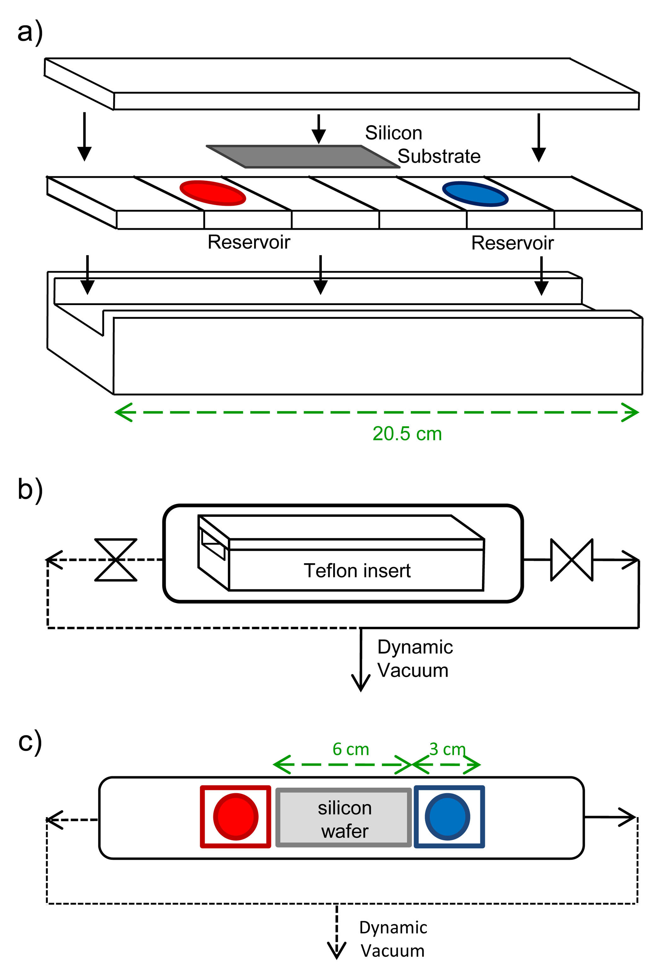
Figure 1: (a) Reservoirs and substrate are placed in a Teflon insert that confines chlorosilane movement to a small gap (≈1.5 mm) above the substrate surface. (b) The insert is loaded into the deposition chamber and deposition occurs under dynamic vacuum. Vacuum connections can be made at one or both sides of the chamber – illustrated here with the vacuum connection on the right side of the chamber open and the left side closed. (c) Schematic representation used to describe setup specifics (reservoir sizes, positions, vacuum direction, and materials) discussed in this work. Adapted with permission from ACS Nano. ²²

  - Materials
Chlorosilanes were obtained from Gelest, Inc. and used as received. The materials included 2-acetoxyethyldimethylchlorosilane (CAS 18306-45-1) [aceto silane], benzyldimethylchlorosilane (CAS 1833-31-4) [benzyl silane], n-butyldimethylchlorosilane (CAS 1000-50-6) [n-butyl silane], ((3,3,3,4,4,5,5,6,6-nonafluorohexyl)dimethylchlorosilane) (CAS 119386-82-2) [fluoro silane], and 3-methacryloxypropyldimethylchlorosilane (CAS 24636-31-5) [methacryl silane]. The normal boiling points of these materials are provided in Table 1 as a reference to the relative volatilities of these materials (vapor pressures not available). Silicon wafers (N<100>, Wafer World, Inc.) were rinsed with toluene, placed in a UVO cleaner (model 342, Jelight Co., Inc.) for 1 h, then re-rinsed with toluene prior to use. The toluene used for cleaning the substrates was argon-purged and further purified by passage through a neutral alumina column and a Q5 catalyst column before use.

Table 1: Boiling points of chlorosilanes.
Chlorosilane | Boiling point* | Normal boiling point (°C)
aceto silane | 108-109 °C at 50 mmHg | 198**
benzyl silane | 75-76 °C at 15 mmHg | 192**
n-butyl silane | 138 °C | 138
fluoro silane | 162-164 °C | 163
methacryl silane | 78 °C at 1 mmHg | 250**
*reported by Gelest, Inc. on the respective Material and Safety Data Sheets
**extrapolated using a pressure-temperature nomograph²³

  - Gradient Characterization.
The gradients were characterized with static diiodomethane (99 %, stabilized, Acros Organics) contact angle measurements taken on a First Ten Ångstroms (FTÅ) 125 contact angle measuring system. Liquid drops (2 µL) were dispensed and placed on the surface with a Distriman pipet. Angle analysis was performed using FTÅ software, and the drop shape method applied after 0.3 s. These measurements were correlated with composition using X-ray photoelectron spectroscopy (XPS) data as described in Albert, et al.²² (see Supplementary Material). XPS measurements were carried out at the National Institute of Standards and Technology on a Kratos AXIS Ultra DLD spectrometer at a vacuum of 8 × 10⁻⁹ Torr with a monochromatic Al source and power of 140 W.

- Results
The effects of reservoir size, reservoir placement, and vacuum direction were examined using gradients of benzyl silane and methacryl silane (benzyl/methacryl gradients). We then assessed the effects of chlorosilane volatility by replacing the methacryl silane (less volatile than the benzyl silane) with either the aceto silane (similar volatility as benzyl silane), the fluoro silane (more volatile than the benzyl silane), or the n-butyl silane (more volatile than the fluoro silane) (see Table 1 for normal boiling points).

  - Reservoir Size
We varied reservoir diameter while locating the reservoirs immediately to the sides of the substrate (position 4.5 cm) and opening the vacuum port on the same side as the more volatile benzyl silane (see schematics in Figure 2a,b). First, we examined the effect of changing the diameter of the benzyl reservoir while keeping the methacryl reservoir at ½’’ (12.7 mm) (see Figure 2a). As expected, the mole fraction of methacryl silane at each position decreased as the benzyl silane reservoir size was increased. Conversely, as the methacryl silane reservoir size was increased while holding the benzyl reservoir size at ⅜’’ (9.5 mm), the gradients exhibited a higher fraction of methacryl silane at each position (see Figure 2b). Thus, the component mole fractions along the gradient were positively correlated with the corresponding reservoir size. Additionally, the gradient profile generated with the largest methacryl reservoir size (1’’, 25.4 mm) exhibited a plateau at ≈90% methacryl silane (starting at the 4 cm position on the substrate), suggesting that the more volatile benzyl silane diffused to the far end of the substrate faster than the methacryl silane could attach to all available sites on that end of the substrate.

Table 2: Setups with equivalent surface area ratios.
methacryl reservoir diameter (in) | benzyl reservoir diameter (in) | Surface area ratio (B/M)
0.5 | 0.25 | 0.25
0.75 | 0.375 | 0.25
0.5 | 0.5 | 1
0.375 | 0.375 | 1

To more closely examine the reservoir size effect, we also compared two pairs of setups for which the surface area ratio of benzyl silane to methacryl silane was the same (Table 2). As illustrated in Figure 2c, the surface area ratio can provide a general guideline for the gradient profile as the higher B/M ratio gradients (purple) were lower in methacryl silane compared to the lower B/M ratio gradients (green). However, comparison of the setups that were equivalent according to surface area ratio (open versus filled markers) indicated that the comparable gradients spanned the same composition range, but displayed different gradient profiles.

  - Reservoir Placement
For studying the effects of reservoir placement, the reservoir sizes were fixed at ½’’ for the methacryl silane and ⅜’’ for the benzyl silane, and the vacuum port on the benzyl silane reservoir side was open (see Figure 3a). These parameters were chosen because in the previous reservoir size experiments, these conditions produced a gradient that spanned nearly the full composition range (≈15% methacryl to ≈80% methacryl) without plateaus. All distances were measured from the center of the substrate to the center of the reservoir. Initially, both the methacryl silane and benzyl silane reservoirs were located immediately to the sides of the substrate (position 4.5 cm). Upon increasing the distance of the benzyl silane reservoir to 7.5 cm, the gradient became more saturated with the methacryl silane, with a plateau at the end of the substrate of ≈90% methacryl silane. Similarly, when the methacryl silane was moved to 7.5 cm while holding the benzyl silane at 4.5 cm, the gradient became less saturated with methacryl silane, with a plateau at the beginning of the substrate of ≈0% methacryl (≈100% benzyl) silane. The degree of change compared to the original setup (both reservoirs at 4.5 cm) was slightly greater when the methacryl reservoir was moved. Seemingly, the lower volatility of the methacryl silane enhanced the effect of reservoir placement. Finally, the gradient generated with both reservoirs at 7.5 cm was the same as the gradient generated with both reservoirs at 4.5 cm. Thus, the gradient profiles depended on the relative positions of the reservoirs.
Additionally, one may consider using multiple reservoirs of a component to increase the overall surface area of that component. In this case, the positions of the reservoirs relative to the substrate are important. Figure 3b shows the case for a ½” methacryl silane reservoir with a ¼’’and a ½” diameter benzyl silane reservoir. When the ½” benzyl reservoir was placed closer to the substrate, the gradient was less saturated with methacryl silane compared to placing the ¼” benzyl silane reservoir closer to the substrate.

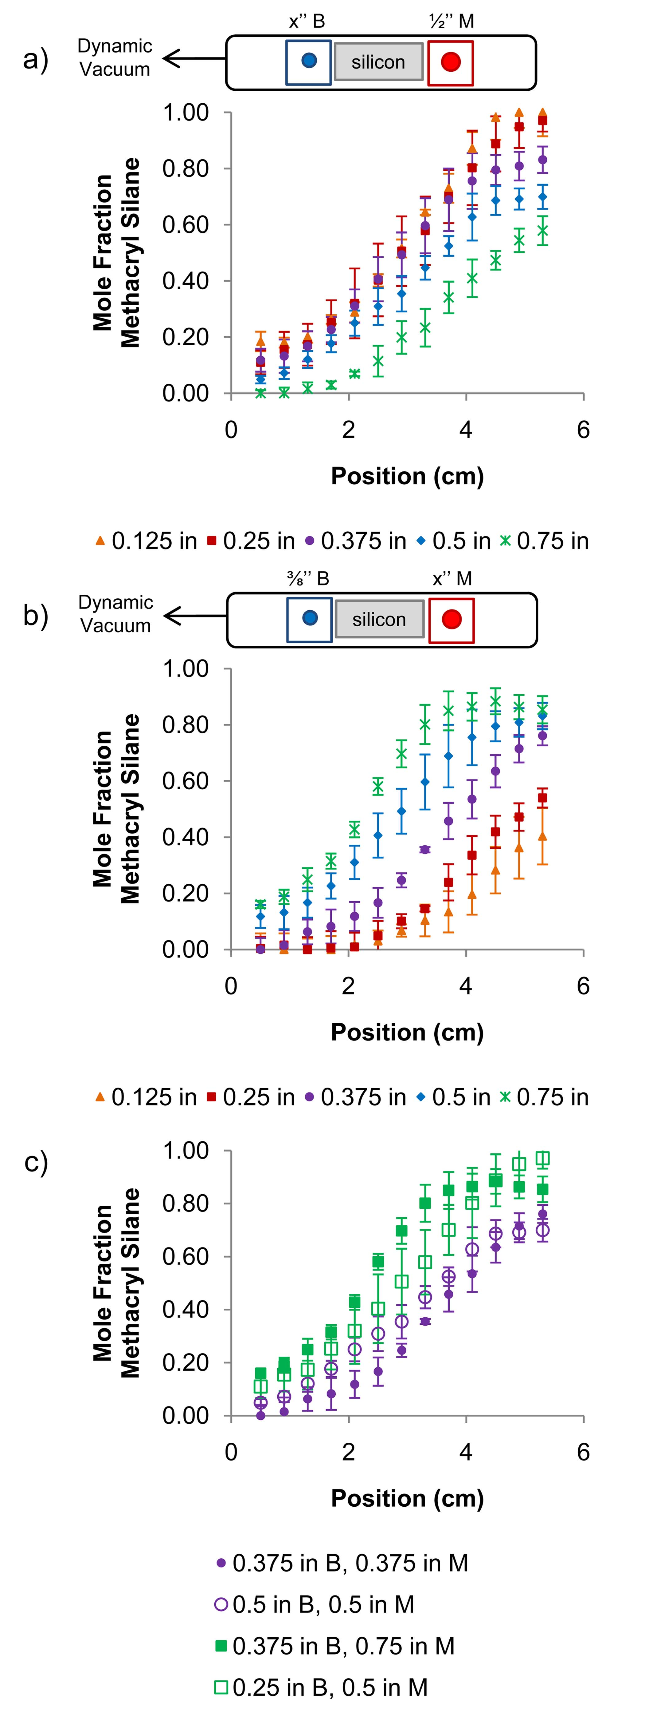
Figure 2: (a) Effect of changing the benzyl reservoir size on gradient profiles (keeping ½’’ diameter methacryl silane reservoir). (b) Effect of changing methacryl silane reservoir size on gradient profiles (keeping ⅜’’ diameter benzyl silane reservoir). (c) Comparison of setups with the same B/M area ratio: B/M = 1 in purple, B/M = 0.25 in green. The error bars represent one standard deviation of the data from repeated measurements, which is taken as the experimental uncertainty of the measurement.
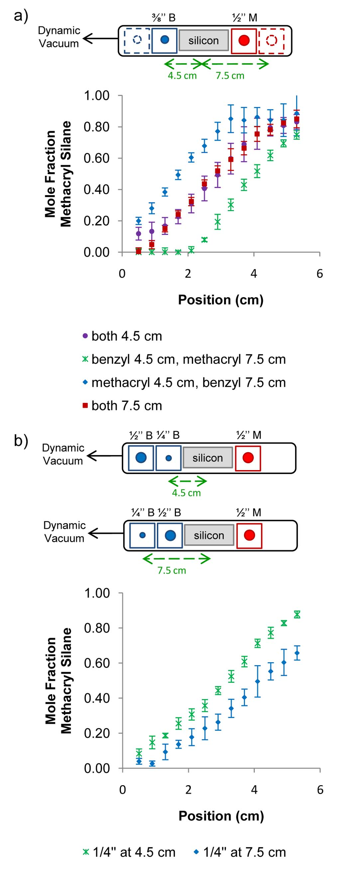
Figure 3: (a) Effect of reservoir placement on gradient profiles. The reservoir sizes were fixed at ½’’ diameter methacryl silane and ⅜’’ diameter benzyl silane and dynamic vacuum was applied to the benzyl silane reservoir side. (b) Effect of reservoir placement when two differently sized (½’’ and ¼’’) reservoirs of the benzyl component are used. The error bars represent one standard deviation of the data from repeated measurements, which is taken as the experimental uncertainty of the measurement.

  - Vacuum Direction
To examine the effect of vacuum direction, the reservoir sizes were fixed at ½’’ methacryl silane and ⅜’’ benzyl silane, and the reservoir positions were both 4.5 cm (see Figure 4). Compared to opening the vacuum port on the benzyl silane side (see Figure 4, purple), opening the vacuum port on the methacryl silane side (see Figure 4, red) led to a gradient with significantly less methacryl silane at each position. However, opening both vacuum ports (see Figure 4, green), which was expected to produce a gradient profile intermediate to those described above, instead resulted in a gradient very similar in profile to the gradient generated with only the methacryl silane side port open. The volatility differences between the benzyl silane and the methacryl silane likely contribute to this outcome. Thus, vacuum direction appears to provide a more subtle means for tuning the gradient profiles compared with changing reservoir size or position.

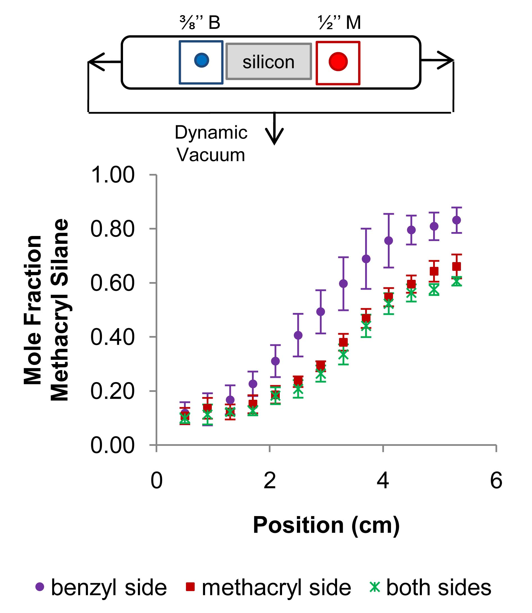
Figure 4: Effect of vacuum application on gradient profiles. The reservoir sizes were fixed at ½’’ diameter methacryl silane and ⅜’’ diameter benzyl silane and both reservoir positions were fixed at 4.5 cm. The error bars represent one standard deviation of the data from repeated measurements, which is taken as the experimental uncertainty of the measurement.
  - Chlorosilane Volatility
The initial setup selected to examine the effect of chlorosilane volatility on the gradient profile was as follows: ⅜’’ methacryl silane reservoir, ⅜’’ benzyl silane reservoir, both positioned at 4.5 cm, with the vacuum direction on the benzyl silane reservoir side. The methacryl silane (less volatile than the benzyl silane) was then replaced with aceto silane (approximately the same volatility as the benzyl silane), fluoro silane (more volatile than the benzyl silane), or n-butyl silane (more volatile than the fluoro silane). Figure 5 shows that the mole fraction of the non-benzyl component across the gradient generally increases with increasing chlorosilane volatility. (Note: The similarity between the benzyl/aceto and benzyl fluoro gradients suggests that the aceto silane may be closer in volatility to the fluoro silane than initially expected from its extrapolated normal boiling point (see Table 1).) Figure 6 demonstrates how chlorosilane reservoir size, reservoir position, and vacuum direction can be used to compensate for volatility differences in order to generate gradients that span nearly the full composition range (≈20% non-benzyl silane up to ≈80% non-benzyl silane).

Figure 5: Effect of chlorosilane volatility on gradient profile. Reservoir sizes were fixed at ⅜’’ diameter non-benzyl silane and ⅜’’ diameter benzyl silane. Reservoir positions were fixed at 4.5 cm, and dynamic vacuum was applied to the benzyl silane reservoir side. Relative volatilities of the chlorosilanes were as follows: methacryl < benzyl ≈ aceto < fluoro < n-butyl.

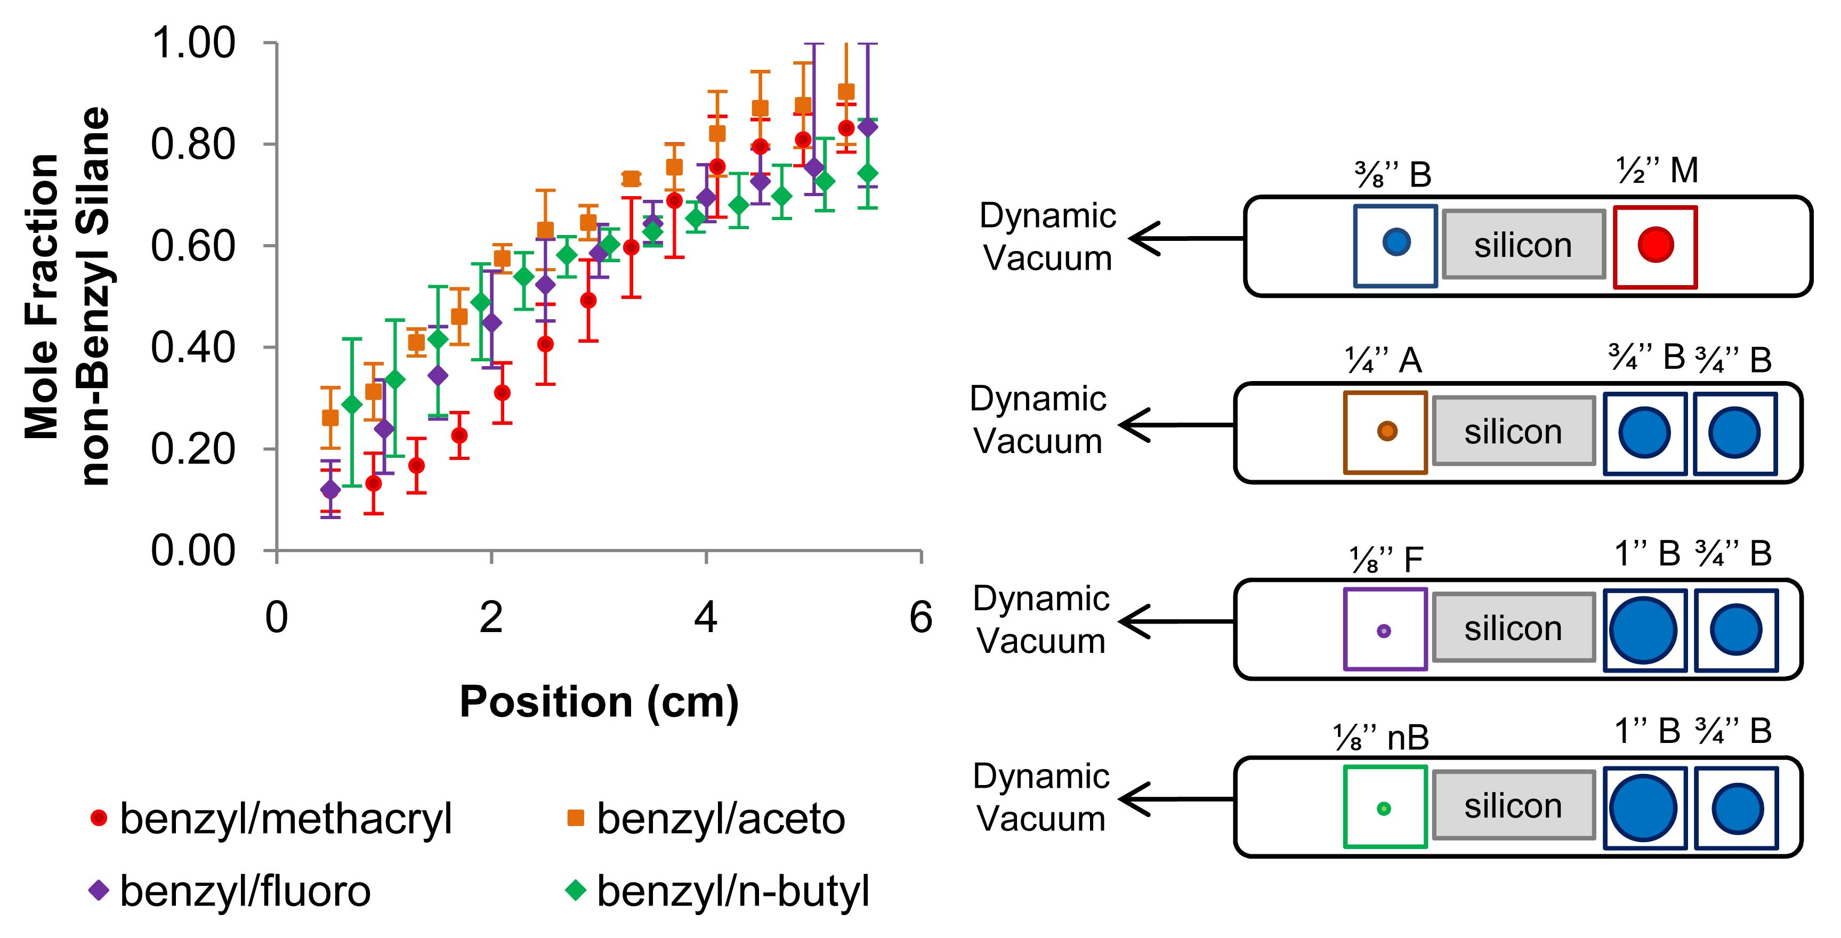
Figure 6: By manipulating reservoir size, reservoir placement, and vacuum direction, gradients with compositions spanning ≈20% non-benzyl silane up to ≈80% non-benzyl silane were achieved. In the schematics on the right, the chlorosilane names are abbreviated as follows: A – aceto silane, B – benzyl silane, F – fluoro silane, M – methacryl silane, and nB – n-butyl silane.

Acknowledgement
This work was supported by the National Science Foundation through DMR-0645586 and a National Science Foundation Graduate Research Fellowship to J.N.L.A. J.D.K. was partially supported by the University of Delaware, Science and Engineering Scholars Program. We thank T. Beebe, Jr., Department of Chemistry, University of Delaware, for use of his contact angle measuring system and the National Institute of Standards and Technology for the use of their XPS facility.

Supplementary Material
See supplementary material at [URL will be inserted by AIP] for XPS spectra and contact angle/composition correlations for the benzyl/aceto, benzyl/fluoro, and benzyl/n-butyl gradient systems.

References
1. Genzer, J.; Kramer, E. J. Phys. Rev. Lett. 1997, 78, (26), 4946-4949.
2. Ashley, K. M.; Raghavan, D.; Douglas, J. F.; Karim, A. Langmuir 2005, 21, (21), 9518-9523.
3. Genzer, J.; Bhat, R. R. Langmuir 2008, 24, (6), 2294-2317.
4. Albert, J. N. L.; Epps, T. H., III. Materials Today 2010, 13, (6), 24-33.
5. Epps, T. H., III; DeLongchamp, D. M.; Fasolka, M. J.; Fischer, D. A.; Jablonski, E. L. Langmuir 2007, 23, (6), 3355-3362.
6. Mansky, P.; Liu, Y.; Huang, E.; Russell, T. P.; Hawker, C. Science 1997, 275, (5305), 1458-1460.
7. Han, E.; Stuen, K. O.; La, Y.-H.; Nealey, P. F.; Gopalan, P. Macromolecules 2008, 41, (23), 9090-9097.
8. Ruiz, R.; Kang, H.; Detcheverry, F. A.; Dobisz, E.; Kercher, D. S.; Albrecht, T. R.; De Pablo, J. J.; Nealey, P. F. Science 2008, 321, 936-939.
9. Olson, D. A.; Chen, L.; Hillmyer, M. A. Chem. Mater. 2007, 20, (3), 869-890.
10. Yang, S. Y.; Ryu, I.; Kim, H. Y.; Kim, J. K.; Jang, S. K.; Russell, T. P. Adv. Mater. 2006, 18, (6), 709-712.
11. Phillip, W. A.; O'Neill, B.; Rodwogin, M.; Hillmyer, M. A.; Cussler, E. L. Appl. Mater. Interfaces 2010, 2, (3), 847-853.
12. Elwing, H.; Welin, S.; Askendal, A.; Nilsson, U.; Lundstrom, I. J. Colloid Interface Sci. 1987, 119, (1), 203-210.
13. Chaudhury, M. K.; Whitesides, G. M. Science 1992, 256, (5063), 1539-1541.
14. Chang, T.; Rozkiewicz, D. I.; Ravoo, B. J.; Meijer, E. W.; Reinhoudt, D. N. Nano Lett. 2007, 7, (4), 978-980.
15. Genzer, J.; Efimenko, K.; Fischer, D. A. Langmuir 2006, 22, (20), 8532-8541.
16. Morgenthaler, S.; Lee, S.; Zurcher, S.; Spencer, N. D. Langmuir 2003, 19, (25), 10459-10462.
17. Choi, S.-H.; Newby, B. Z. Langmuir 2003, 19, (18), 7427-7435.
18. Kraus, T.; Stutz, R.; Balmer, T. E.; Schmid, H.; Malaquin, L.; Spencer, N. D.; Wolf, H. Langmuir 2005, 21, (17), 7796-7804.
19. Berry, B. C.; Stafford, C. M.; Pandya, M.; Lucas, L. A.; Karim, A.; Fasolka, M. J. Rev. Sci. Instrum. 2007, 78, (7), 072202.
20. Julthongpiput, D.; Fasolka, M. J.; Zhang, W.; Nguyen, T.; Amis, E. J. Nano Lett. 2005, 5, (8), 1535-1540.
21. Xu, C.; Barnes, S. E.; Wu, T.; Fischer, D. A.; DeLongchamp, D. M.; Batteas, J. D.; Beers, K. L. Adv. Mater. 2006, 18, (11), 1427-1430.
22. Albert, J. N. L.; Baney, M. J.; Stafford, C. M.; Kelly, J. Y.; Epps, T. H., III. ACS Nano 2009, 3, (12), 3977-3986.
23. Pressure-Temperature Nomograph. Sigma-Aldrich. Accessed Feb. 2011 <http://www.sigmaaldrich.com/chemistry/solvents/learning-center/nomograph.html>

