A quantitative characterization of spatial arrangement of air voids in mortars via X-ray CT and numerical calculations Kai Lyu^{a,b,c,*}, E.J. Garboczi^{b}, Xiaoyan Liu ^{d}
ª College of Civil and Transportation Engineering, Hohai University, Nanjing 210098, China
^{b}National Institute of Standards and Technology, Applied Chemicals and Materials Division, Boulder, CO 80305, USA
^{c}Key Laboratory of Ministry of Education for Geomechanics and Embankment Engineering, Hohai University, 210098 Nanjing, China
^{d} College of Mechanics and Materials, Hohai University, Nanjing 211100, China

Abstract
Compared with overall air void content and size distribution, the spatial arrangement of air voids is probably of more importance in the durability of cement-based materials subjected to repeated freeze-thaw cycles. In this paper, a method for computing the three-dimensional distribution of air voids according to the void–void proximity and the paste–void proximity definitions based on X-ray computed tomography (XCT) images is proposed, For better illustration of the method, six mortar samples with varying fine aggregate size and blended proportions were prepared and examined. Characteristic parameters, including average spacing, SF50, SF95, and Gaussian expectation were quantitatively derived from the various distribution curves in various ways, which follow the same trends among the six mortar samples. Then, the Lu and Torquato equations were used to analytically calculate the spacing and compared with the results obtained via numerical calculation, showing good agreement for both paste-void proximity and void-void proximity. Based on the results of this paper and on a previous paper on these same mortars, we propose an alternative method for quantifying the three-dimensional arrangement of air voids with less time and higher accuracy than two-dimensional methods.
Key words: air void spacing distribution; void–void proximity; paste–void proximity; growing spheres dilation method; random points method; X-ray computed tomography; sand specific surface area

- Introduction
The influences of the dispersed inclusion phase on the bulk properties of a composite such as cement-based materials mainly depend on the volume fraction, size distribution, and spatial distribution of the inclusion phases [1]. Durability is one property affected by inclusions in mortars, which at the 100 µm scale are composites consisting of a cement paste matrix and sand and air void inclusions. The volume fraction of the sand phase is typically around 50 % and the volume fraction of the air void phase is typically around 1 % to 10 %. When considering the durability of cement-based materials subjected to repeated freeze-thaw cycles and salt scaling (frost resistance), the spatial distribution of the air void phase plays a more important role than does the total air void content [2]. It is accepted that high frost resistance can be achieved when the spacing factor does not exceed a certain value [3, 4]. To characterize the spatial distribution of the air voids, Powers [5] introduced the spacing factor concept as a single number, with which to summarize the air void spatial distribution and proposed equations to calculate the spacing factor, which were the basis for the ASTM C457 standard [6]. ASTM C457 has been widely used for quantifying the void system, using either the manual linear traverse line method or modified point count method, which are both time consuming to implement [6]. In both approaches, parameters including air content (A), void frequency (n), average chord length ($\overline{l}$), specific surface ($α$), and paste content (p) can be obtained and applied to calculate the spacing factor (($\overline{L}$) calculation (Powers’ equation). In Powers’ equation, the real arrangement of the voids in the cement paste was simplified with a geometrically regular pattern of mono-sized voids evenly distributed in a uniform three-dimensional grid [7]. However, when considering the spacing between air voids in real mortar or concrete, there is of course a distribution of air void spacings rather than a single value, and a single defined spacing parameter is only some kind of statistical quantity averaged over the distribution. Though it is convenient to evaluate the spacing distribution with a single value, this single value cannot possibly yield enough information about the expected variability in the evaluation of the air void system. Since Powers’ early work, a great amount of research has been done by Philleo [8], Attiogbe [9], and Pleau and Pigeon [10], among others, proposing new equations to calculate new spacing factors that are hopefully better summaries of the spacing distributions and thus more useful for classifying varying frost-resistance behaviors. These various equations were all based on an assumption of air void spherical shape and did not take into account the real measured spatial distribution of the voids.
Since the definition of spacing factor proposed by Powers has been used for more than sixty years, calculations of a spacing factor should be improved or at least refined based on the advances of analysis techniques and methodologies. Basically, the air voids should be treated as elements of a spatial set and quantified by statistical functions, with a distance variable that is directly correlated to the evaluation of frost resistance [11]. In previous research, the spacing factor was mainly defined in two ways: paste–void proximity and void–void proximity, which should be defined on the full 3D air void structure. The paste–void proximity equations are based on the idea that water in cement paste needs to travel to the nearest void before freezing, to avoid frost damage, so the volume fraction of paste within some distance from the nearest void surface is calculated in this method, as a function of distance. The void–void proximity spacing equations focus on the distance between pairs of nearest neighbor air voids. With advances in image analysis and numerical calculation, the assessment of the air void system has been improved and refined. It is no longer necessary to assume a regular spatial arrangement of the air voids, as in the calculation used in the ASTM C457 procedure [11]. The spacing factors could be calculated based on the statistics of obtained 2D digital images, either manually or automatically [7, 12-14]. However, calculations based on 2D images, even with the use of stereological principles, still cannot always accurately interpret the spatial characteristics of the air void system since the full volume is not sampled. Compared with 2D plane section analysis, X-ray computed tomography (XCT) is able to overcome these limitations and directly image the full 3D internal microstructure of cement-based composites. XCT is a non-destructive 3D method that has been widely adopted for the microstructural characterization of cement-based materials by producing a large number of consecutive cross-sectional slices [15, 16]. Considering the 3D nature of air voids, it is reasonable to use 3D techniques to segment the air voids [17-21]. XCT has been previously used in several studies concerning the air void system to determine the total content and spatial size distribution of the voids [22-25]. For air void spacing evaluation, by applying a series of linear traverse lines on the imaged 3D air void structure, Tae Sup Yun [26, 27] estimated the spacing factor and compared the result with Power’s model. However, even performed on the 3D structure, the linear traverse line method was essentially a 1D analysis. Numerical methods have also been applied to the air void system. Recently, Mayercsik et al. proposed a probabilistic method for air void analysis [28]. In their research, based on a stochastic process, the 3D random spatial structure of a poly-dispersed system can be evaluated from the 2D images and the maximum distance from an arbitrary location in the cement paste to the void surface was numerically determined. Snyder calculated the spacing distributions and various spacing factors based on a numerically generated 3D air void structure and compared the numerical results with various spacing equations, which indicated that Lu and Torquato equations performed well for both paste–void and void–void spacing distributions [29]. However, the spherical air void size distribution in his model structures followed two distributions: mono-sized and log normal, which can both be different from a real air void system.
- Given the limitations of the existing methods, we have proposed a methodology to rapidly and accurately evaluate the three-dimensional arrangement of air voids in mortars. Six mortar samples with varying fine aggregate size and blended proportions were prepared and examined. The methodology includes XCT scanning, image analysis, void shape determination via spherical harmonics functions [30], and calculation of various spacing distributions characterized by various spacing factors. A detailed illustration of the XCT scanning process, void structure determination, as well as results about void content, shape, and size distribution, were presented in previous research [31]. This present paper describes air void spacing distribution calculations based on the real air void size and spatial distributions based on the XCT images. Since we do not consider any mechanisms of frost damage, the spacing distributions were numerically calculated according to both definitions (void–void proximity and paste–void proximity) with varying methodologies (nearest surface (NS) function for void–void proximity, random points method and growing sphere dilation (GSD) method for paste–void proximity). Then, the relevant Lu and Torquato equations were applied to carry out analytical calculations. The results obtained from analytical calculation and numerical calculation were mutually verified and showed excellent consistency. The illustration and verification of the applied methodologies were all based on one mortar sample and then were applied to the other five mortar samples. The relationship between the average spacing factor and sand specific surface area (SSA) reveals the effect of sand size and blended proportions. In general, built upon our work, the air void system of the composites can be automatically and rapidly evaluated with more accuracy. The derived characteristic parameters of the air void spacing distribution is expected to guide the mix design of mortar/concrete with frost resistance and provide a basis for evaluating the frost resistance of prepared mortar/concrete. Materials and experiments
In this research, Chinese standard sand was sieved into four size classes: #1 (2.36 mm to 1.18 mm), #2 (1.18 mm to 0.6 mm), #3 (0.6 mm to 0.3 mm), and #4 (0.3 mm to 0.0 mm). Then, six mortars were prepared with a constant water to cement mass ratio w/c = 0.35 and cement to sand mass ratio c/s = 1. The main difference among the six mortars lies in the sands used. The detailed mix proportions are shown in Table 1. Furthermore, the effect of size distribution and blended proportions of the sand were combined via calculation of the fine aggregate specific surface area (SSA). For a sphere particle with diameter of D_{mean}, the SSA can be calculated as Eq. (1), with $ρ$ being the sand density (approximate value of 2500 kg/m³) [31]. In the real case, for simplification, an averaged D_{mean} value of sand in each size class was calculated according to the Eq. (2), where d_{up} and d_{down} are the upper and lower limits of each size class as determined by the bounding sieves. Thus, the SSA can then be obtained based on the sand mass fractions in each class according to Eq. (3), with ${SSA}_{i}$ being the specific surface area and $m_{i}$ the mass fraction of sand in the i^{th} sieve range. The SSA values for the six mortars are listed in the last row of Table 1.
$SSA=\frac{A}{M}=\frac{A}{Vρ}==\frac{πD_{mean}^{2}}{\frac{1}{6}πD_{mean}^{3}ρ}=\frac{6}{D_{mean}}\frac{1}{ρ}$ (1)
$D_{mean}=\sqrt{\frac{d_{up}^{2}+d_{down}^{2}}{2}}$ (2)
$SSA=\sum_{i=1}^{n}{{SSA}_{i}m_{i}}$ (3)
No superplasticizer or any other chemical admixtures was added during the casting process. However, in most cement manufacture organic grinding aids are used, which can often cause air voids to be entrained even without added chemical admixtures [32]. This was observed as all the air voids were fairly spherical.
For each mortar sample, a small cubic piece with edge length about 10 mm was cut from the specimen and scanned using a ZEISS Versa XRM500 XCT system after hydration termination and a vacuum drying process. For each sample, two high-resolution scans were performed with a voxel size about 4 µm. Using a combination of digital image processing and spherical harmonic functions analysis, the void content, number of voids, and void size distribution in each mortar was quantitatively determined, as listed in Table 2. The detailed description of experiments methodology, void content, and void size distribution can be found in Ref. [31], since the main purpose of this paper is to investigate the spatial arrangement of the air voids within the mortar.

Table 1: Mixture proportions for six mortar samples.

Sample | Blended sand volume fraction (%) |  |  |  | SSA
 | 2.36-1.18 (mm) | 1.18-0.6 (mm) | 0.6-0.3 (mm) | 0.3-0.15 (mm) (mm)
M1 | 100 |  |  |  |  | 1.28
M2 |  | 100 |  |  |  | 2.56
M3 |  |  | 100 |  |  | 5.05
M4 |  |  |  | 100 |  | 10.12
M5 |  | 15 | 35 | 50 |  | 7.21
M6 | 50 | 35 | 15 |  |  | 2.34

Table 2: Approximate specific surface area of six sand proportions, and measured air void content and number of voids detected in each sample via two XCT high resolution-scans.

 | M1 | M2 | M3 | M4 | M5 | M6
Air void content (%) | 0.76 | 0.87 | 1.45 | 3.53 | 2.65 | 1.32
Number of voids detected | 573 | 824 | 1562 | 3905 | 2642 | 574

- Definition and methodology
Many equations have been proposed in the literature to estimate the air void spacing distribution. They can be divided into two classes. Some equations focus on the proximity of the cement paste matrix to the air voids, while others calculate the distances between air voids. In both cases, the air voids are assumed to be spherical - real entrained air voids are indeed usually nearly spherical. The distribution of distances, using either technique, is always depicted by a probability density function (PDF) and a cumulative distribution function (CDF). The PDF represents the fraction of spacings located in the size interval $\left[s, s+ds\right]$, for the differential element $ds$, while the CDF means the fraction of spacings smaller than $s$, which increases monotonically from zero to unity when the maximum value of $s$ is reached. For consistency in what follows, the average values were calculated from the PDF curves and the median values were determined from the CDF curves for each spacing distribution.
  - Void–void proximity
Void–void proximity means developing nearest neighbor equations that estimate the distance from a given air void to its nearest neighbor air void. Here, the nearest neighbor function employed for calculating void–void proximity was based on the segmented 3D structure built from the XCT mortar images [31].
In real mortars, there must exist a distribution of distances between air voids in the random air void system. For simplification, Murotani viewed the voids as dispersed points and evaluated the distances between these discrete points [33]. The effect of void size was introduced by applying a point intensity parameter. Of course, this procedure causes some errors and deviations with real situations. The nearest neighbor of a given air void can be defined by measuring the surface-to-surface distance of adjacent air voids [5]. Obviously, in a mono-dispersed air void system, the nearest surface-surface or nearest centroid-centroid distances identifies the same nearest neighbor, since the air voids are of the same size.
The void system in mortar sample M4 was selected to illustrate the methodology used, based on the high-resolution images. Voids larger than 125 voxels in the 3D measured XCT system were recorded and analyzed [31]. For each void, spherical harmonic functions were used to analyze its size and shape. The centroids x_{i} and equivalent spherical radius (radius of sphere with same volume as air void) r_{i} of each void were saved. For each sample, the centers and radii of all the voids detected were saved as clusters: X={x_{i}: i=1,2,…,n}; R={r_{i}: 1,2,…,n}, where n is the number of voids detected during each XCT scan. The results of shape analysis [31] indicated that the voids detected are at worst somewhat (10 % to 20 % difference in major axes) ellipsoidal in shape and most are quite spherical (less than 10 % difference in major axes). Subsequently, in the calculation in this section, all the voids were assumed to be perfect spheres and used the equivalent spherical radius.
For each pair of voids, the surface to surface distance was denoted by d_{ss} :
$d_{ss,ij\left(j≠i\right)}=\left|\left|x_{i}-x_{j}\right|\right|-r_{i}-r_{j}$ (4)
In Eq. (1), $d_{ss,ij\left(j≠i\right)}$is the distance between the surfaces of the ith void and the jth void, and $r_{i}$ and $r_{j}$ are the radii of the ith and jth air voids. For each void i, the distance of this void to any other void was saved as $D_{ss,i}=d_{ss,j\left(j≠i\right)}:j=1,2,…,n$. For all voids, $D_{ss}=d_{ss,ij\left(j≠i\right)}:i=1,2,…,n;j=1,2,…,n$ for surface to surface distances. The average surface to surface distance of a given void i can be calculated over all voids, according to Eqs. (5).
$〈D_{ss, i}〉=\frac{\sum_{j=1, j≠i}^{n}{d_{ss,j}}}{n-1}$ (5)
The nearest neighbor of the ith air void is denoted by the quantities ${sf}_{cc,i}$ and ${sf}_{ss,i}$, which are determined by Eqs. (6):
${sf}_{ss,i}=min{d_{ss,i,j\left(j≠i\right)}:j=1,2,…,n}$ (6)
The spacing distributions of each mortar sample’s air void system were then obtained by collecting all the individual nearest neighbor distances and denoted by ${SF}_{ss}={sf}_{ss,i}:i=1,2,…,n$.
The spacing distributions for the two high resolution scans for sample M4 are shown in Fig. 1. A Gaussian function appeared to fit each distribution well. The Gaussian expectation, xc, which is defined by the (x-xc)² term in the exponent of the exponential, was also extracted. The near coincidence of these two curves, whether for PDF or CDF, enabled the results of the two scans, A and B, to be combined into a single distribution. The small difference between the two scans reflects the randomness of the air void spatial distribution, since the two scans sample different VOIs in the whole sample. To quantify this difference, an F-test was performed. The calculated variance for the two distributions was 28.50 (Scan A) and 34.12 (Scan B) with the F value being 1.20. By comparing with the F distribution table ($α=0.01$), the two distributions were proved to be statistically similar.
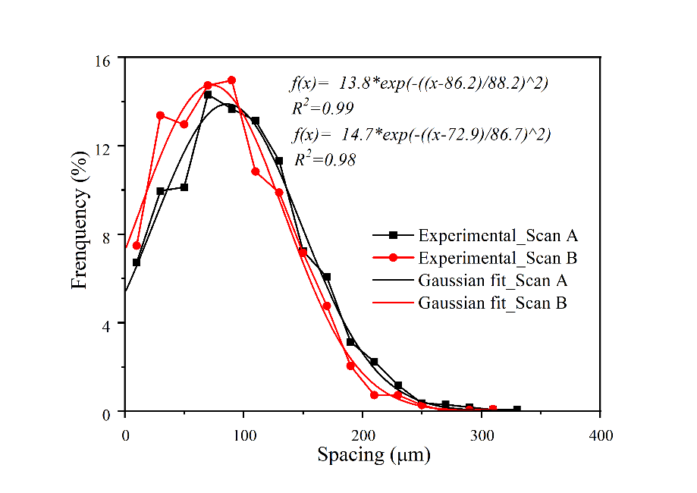
Figure 1. Comparison of spacing PDF distribution obtained via scans A and B for M4 using the NS distance function.

The PDF and CDF spacing distributions can be used to compute various parameters: average spacing (denoted by $〈{SF}_{ss}〉$), 50th percentile value or median (denoted by $SF$50, meaning 50 % of spacings are smaller than this value), 95th percentile value (denoted by $SF$95, meaning 95 % of spacings are smaller than this value), and expectation or peak value of the Gaussian fit (denoted as GE). For scans A and B, the results for the four parameters are listed and compared in Table 3. The values of $〈SF〉$ and $SF$50 for scan A are slightly larger than those for scan B, while the value of $SF$50 shows a significant difference between scans. Considering the fact that 1698 air voids were found in scan A and 2207 air voids were detected in scan B for the same size of VOI, this difference is expected.

Table 3: Summary of average spacing, 50th percentile value ($SF$50), 95th percentile value ($SF$95), and expectation of Gaussian fit for the air voids found in the two high-resolution M4 scans

 | $〈SF〉$ (μm) | $SF$50 (μm) | $SF$95 (μm) | GE(μm)
Scan A | 98 | 92 | 222 | 86
Scan B | 87 | 82 | 174 | 73

  - Paste–void proximity
The definition of paste–void proximity is inspired by the microscopic mechanism of freezing in porous media. It has been accepted that the presence of air voids can significantly reduce the effect of freezing and thawing by playing a role as “pressure release valves” for ice formation [29, 34, 35]. The closer the paste to the average air void, the higher the probability that this paste will not suffer from frost damage, since freezing water can get to the air voids from the paste. Overall, there are two simple ways to calculate this definition of spacing. The first is to assume that each air void is surrounded by a shell with thickness of s and the volume fraction of the paste within the shell is equivalent to the volume fraction of paste within a distance s to the air void surface. With increasing shell thickness, the shells may overlap with each other, but not the air voids themselves. The second method is to randomly choose a number of points in the paste phase, calculating for each point the distance to the nearest air void surface. The relative number of distances less than s is an estimate of the volume fraction of paste within this distance from the air void surface. Using more random points will systematically improve this estimate. These two methods and their results will be discussed in detail in the following sections. Note that the void-void proximity algorithm and the past-void proximity algorithm measure related but different quantities. Therefore, we should not expect them to be equal to each other and we will find that to be the case.
    - Simple dilation and the growing spheres dilation method
The morphological dilation and erosion operation are local morphological transformations on an image and were originally used for pattern recognition [36-38]. The basic theory of mathematical morphology is set theory [39]. Suppose there exists two sets: the original image, f(x,y), and the structuring element, B(u,v), where (x,y) and (u,v) are the pixel coordinates of f and B, respectively. The dilation can be mathematically represented by $f⊕B$ [40]. In 2D image processing, dilation can be applied by applying a structuring element to a target pixel and the pixels around this pixel. How the target pixel grows depends mainly on the shape and size of the structuring element. A square structuring element is commonly used for the dilation operation. Dilating with a square structuring element will eventually, after repetition, lead to the target pixel being enlarged and approaching the shape of a square. In Ref. [25], the shape characterization of the voids indicated that the voids are close to spherical. If a cubic structuring element was applied, the dilated voids will gradually lose their original shape.
A spherical structuring element was then considered to make sure the shape of dilated voids stays spherical and consistent with the definition of paste–void proximity. However, for a digital sphere to appear spherical, it must have a diameter of at least 11 voxels. If we use an 11-voxel diameter sphere, centered on a surface voxel of an air void, then the radius of the air void will be increased at each step by about 5.5 voxels. Even for the high-resolution scans, this corresponds to a physical distance of more than 20 μm. With the average surface-surface spacing being about 80 μm (see Table 3), in two dilation steps most of the paste would be covered. This would result in a very low-resolution tracking of the actual paste-void proximity function. Therefore, a simplified dilation method was generated to overcome this problem that was based on the concept of “growing spheres”.
The “growing spheres” method includes the following two steps. The first step is preparing a near-replica of the air void structure.
Replica air void microstructure: A container with same size and shape as the chosen VOI was created and the air voids were placed into the container according to their numerical centers and equivalent spherical diameters. Since the obtained equivalent spherical diameters are not always integers, the diameter in voxels can be determined via Eq. (7), where rr_{i} represent the maximum integer no larger than r_{i}. The non-integer diameters were all converted into integer diameters and saved as RR={rr_{i}: 1,2,…,n}.. In this way, the real air void shape information was ignored, which is a reasonable assumption [31]. However, the real spatial distribution information was preserved, which has a much more important influence on the spacing distributions. This was necessary for the growing spheres method, which needs each original air void to be spherical. In the replica microstructure, the sand and the cement paste are treated as one combined matrix phase. Using integer diameter spheres greatly reduced the computational cost of the growing spheres dilation (GSD) method.
$r_{i}=\left\{\begin{aligned}{rr}_{i}, while r_{i}-{rr}_{i}<0.5 \\ {rr}_{i}+1, while r_{i}-{rr}_{i}≥0.5\end{aligned}\right.$ (7)
Any differences between the experimentally imaged air void structure and the replica air void structure were primarily of two kinds. Since all the equivalent diameters were converted into integers, there must be some small difference between simulated and real volume fraction. The deviations caused by this factor were determined to be less than 1 % of the total volume fraction for all six mortar samples and can thus be ignored.
Another possible deviation is overlapping with the boundary and overlapping between adjacent particles, which could be caused by a non-spherical air void being approximated as a sphere. A schematic 2D example is shown in Fig. 2. In Fig. 2, two ellipsoidal voids could be found in the simulated experimental image, with no observed overlap. In the replica microstructure in Fig. 4b, the two ellipsoidal voids were changed to area-equivalent circles and now the two circles overlap with each other and the container boundary. The deviation from this kind of overlap, which did occur in 3D, was evaluated to be again less than 1 % of the total air void volume fraction and thus could also be neglected.
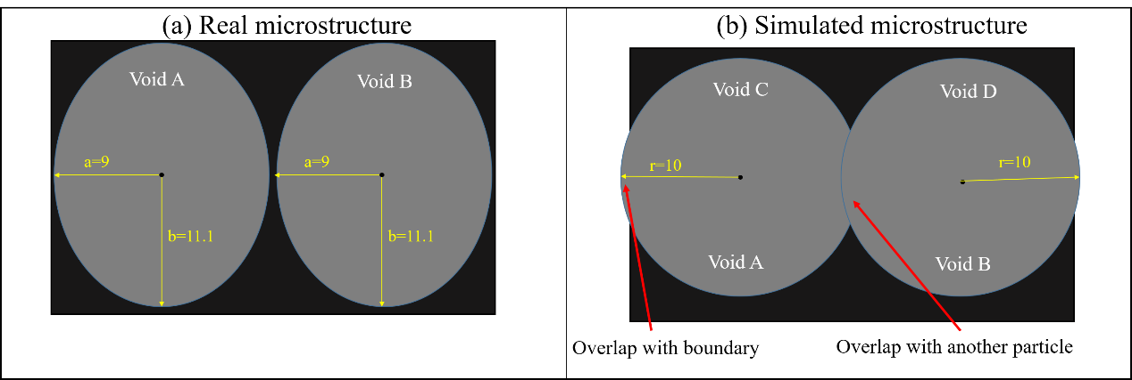
Figure 2. Schematic map of possible overlap errors in replica microstructure process: (a) simulated microstructure; (b) replica microstructure based on obtained centers and diameters.
Growing spheres dilation (GSD) method: In the actual growing spheres, a sphere with diameter M voxels larger than the original air void of diameter D voxels was centered on an air void in the replica air void microstructure. The shell between the sphere and the air void contains all the volume that is within M/2 voxels of the original air void surface. As M increases in steps of 2 voxels with a starting value of 2 voxels, the volume within M/2 voxels from the original air void surface was computed. This computation is approximate since the spheres are made from voxels. One could easily do this computation with continuum spheres as long as the mathematical sphere did not overlap any other air void. Once that happens, the only way to compute the matrix volume contained within the mathematical sphere is by treating the spheres as digital, composed of voxels. In all the scans, the maximum air void diameter was about 100 voxels. Using the GSD method resulted in coverage of the entire sample volume, for any sample, for M equal to about 200 (100 growing spheres dilation steps).
With an increasing number of GSD steps, the shell of one air void may overlap with one or more shells belonging to a near-by air void. To avoid over-counting, the number of unique matrix voxels contained in the growing spheres were counted and normalized by the total voxel volume of the sample to obtain the volume fraction of void phase after each dilation step [13, 41]. The results for mortar M4 are shown in Fig. 3, which averages together scans A and B. The differential volume fraction increases at first with distance, reaches a peak, and decreases nearly to zero as the shells mostly overlap and little new volume is added with larger growing spheres diameters. By about 400 μm, all the matrix has been covered. The PDF distribution is fit well with a Gaussian function. Note that the CDF goes to zero at zero spacing, as it should, since if the growing spheres shell around each air void has zero thickness, no matrix volume will be counted. However, the PDF in Fig. 2 is non-zero at zero spacing. This is because at small shell thickness, the CDF can be approximated to first order in the shell thickness by the surface area of all the voids times the shell thickness divided by the total sample volume, to give a volume fraction. The PDF is the derivative of the CDF with respect to the shell thickness, so its value at zero shell thickness should be the total air void surface area divided by the sample volume. Using digital approximations will cause this value to be only approximate. Comparing Figure 3 to Figure 1, it is apparent that the curves in Fig. 3 are smoother than those in Fig. 1. This is because the bin size in Fig. 3 is about 8 µm and the bin size in Fig. 1 was about 20 µm.
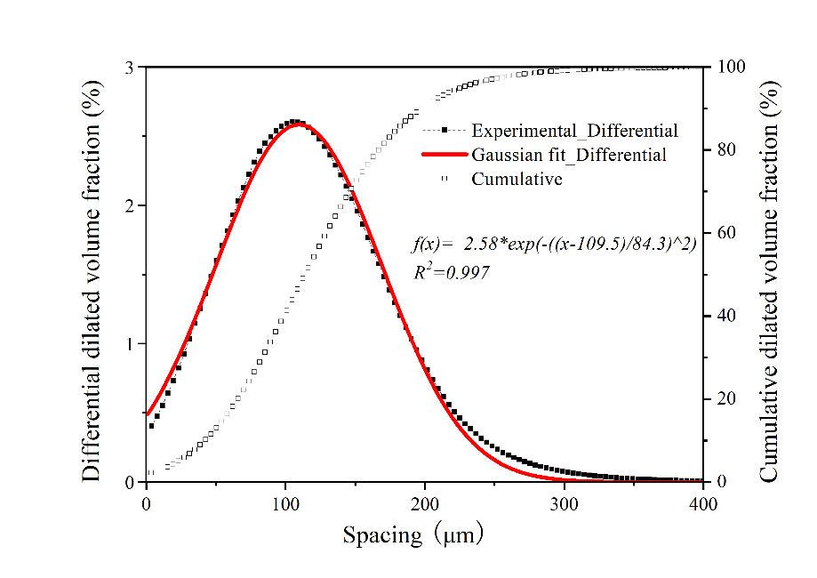
Figure 3. Spacing PDF and PDF distribution obtained via GSD method on mortar M4. The cement paste and the sand have been treated as a single solid matrix phase and high-resolution scans A and B have been averaged together.
Characteristic spacing values, which can all be thought of as spacing factors, can be generated from this data in several ways. Two measures of spacing factor would simply be the peak value of the PDF curve in Fig. 3, and the value in the exponential term in the Gaussian fit. If the Gaussian fit was perfect, these values would be identical. Another way is to calculate average spacing factor values $〈{SF}_{cd}〉$using the numerical differential distribution curve in Fig. 3 based on Eq. (8):
$〈{SF}_{cd}〉=\frac{1}{N}\sum_{i=1}^{N}{t_{i}P\left(i\right)}$ (8)
where N is the growing spheres dilation step by which more than 99 % of the total sample volume has been covered, $P\left(i\right)$ means the new volume fraction dilated in each step, and $t_{i}$ is the shell thickness after the ith operation, which is equal to i ⋅ res, with $res$ being the voxel edge length used in a given scan. The quantities $SF$50 and $SF$95 can also be computed, which are defined as the length at which 50 % and 95 % of the total sample volume has been covered. Table 4 compares these five spacing factor parameters. Apart from $SF$95, the value of other four parameters are quite close and could equally serve as the GSD-based spacing factor for this air void system.
Table 4: Summary of peak or modal value, average spacing, 50th percentile value, 95th percentile value, and expectation of Gaussian fit mortar M4 void system

 | Peak value (μm) | $〈SFcd〉$ (μm) | $SF$50 (μm) | $SF$95 (μm) | GE (μm)
M4 | 105 | 116 | 114 | 225 | 110

    - Random points method
In this method, 10 000 random voxel centers in the matrix were chosen throughout each system. For each point, the minimum distance of this point to all void voxel centers were calculated, ${sf}_{rp,i}$, and was picked to be the spacing associated with this point. The 10 000 minimum values were saved as ${SF}_{rp}={sf}_{rp,i}:i=1,2,…,10000$, where the subscript ‘rp’ is the abbreviation for random point method. Fig. 4 schematically illustrates the methodology, with all random points (shown in yellow) chosen only in cement paste or sand voxels [29].
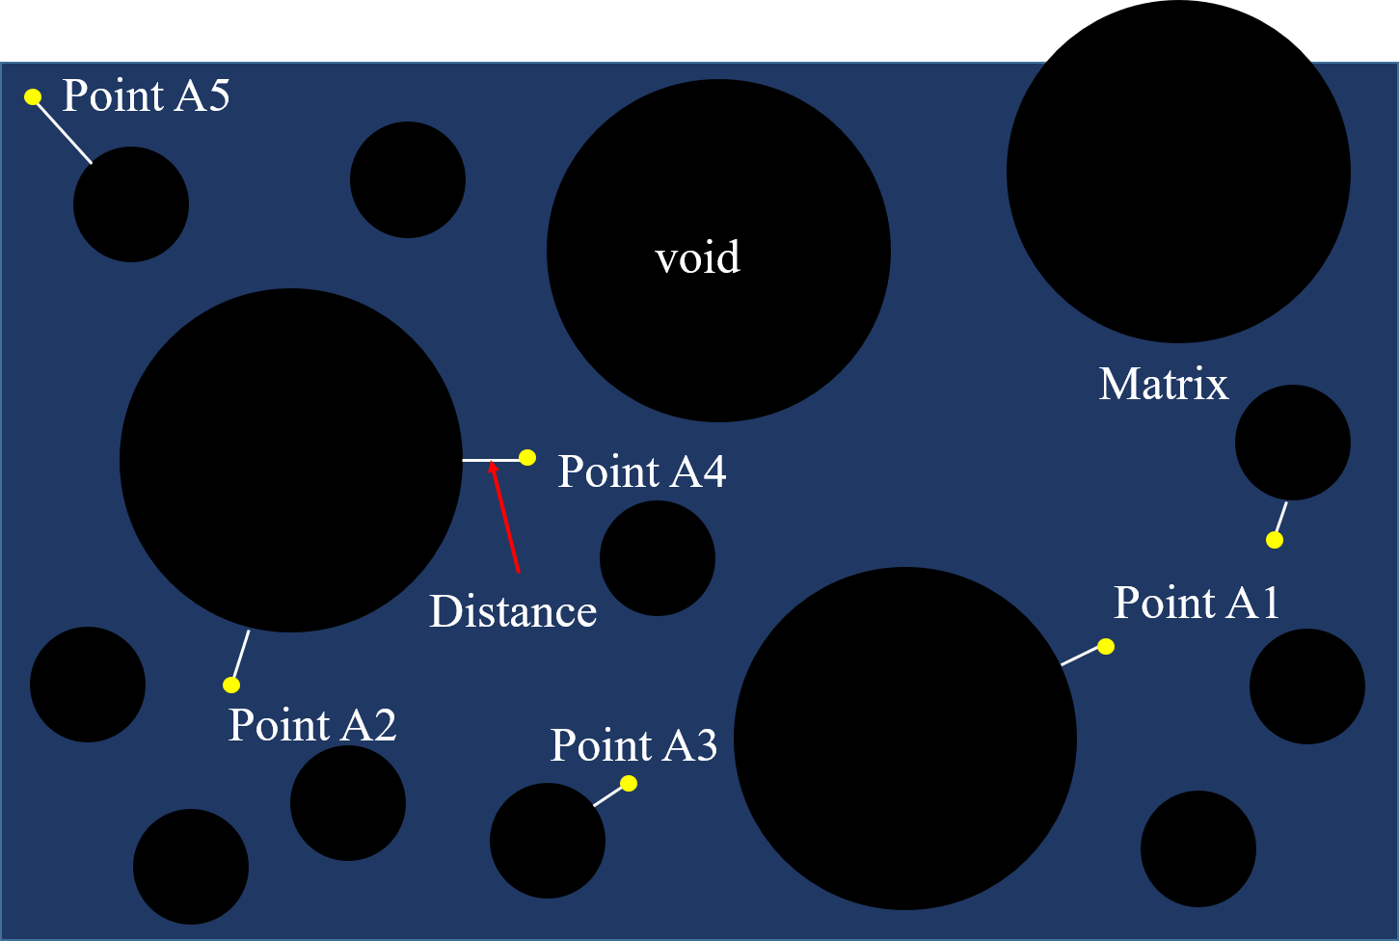
Figure 4. Schematic map of random points method: matrix (dark blue); air void (black); random points (yellow).
For each specimen, only the replica microstructure was employed rather than the full XCT 3D microstructure. The main difference between the two is that in the replica microstructure, voids smaller than 125 voxels were eliminated while in the full XCT microstructure the smaller voids were retained. This part of the air void system accounts for little of the total void volume fraction but will have an effect on the calculated spacing factor, lowering its value. Whether these small voids really increase the frost resistance as much as the reduced spacing factor would seem to imply is beyond the scope of this paper but is an interesting research question.
The M4 air void system was again used. The PDF and CDF distribution of spacings obtained on the replica microstructure are shown in Fig. 5. The PDF obtained via the random points method is fit well with a Gaussian function.
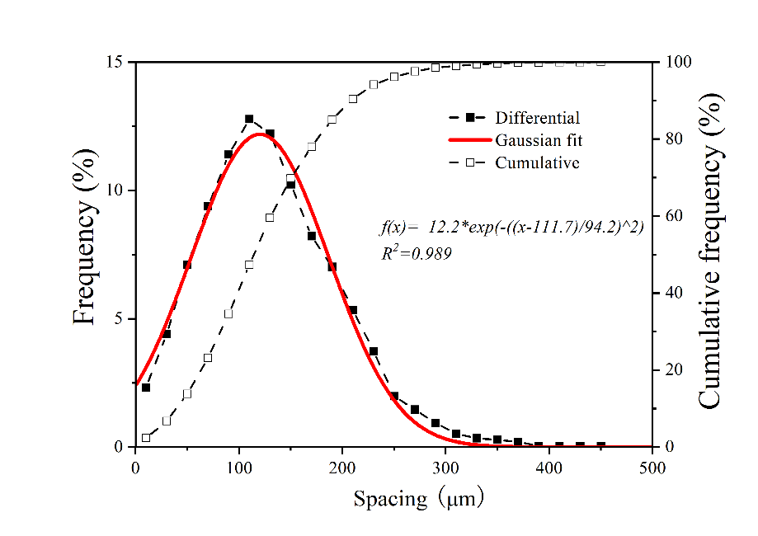
Figure 5. Spacing PDF, obtained via the random points method, for the replica M4 air void microstructure.
The average spacing, the 50th percentile value, the 95th percentile value, and the expectation value of the Gaussian fit were computed from the curves in Fig. 5 and are listed in Table 5.
Table 5: Comparison of average spacing, 50th percentile value (SF50), 95th percentile value (SF95), and expectation of Gaussian fit for the replica air void systems of mortar M4 as seen in Fig. 5 for the 10 000 random points method.

 | $〈SF〉$ (μm) | $SF$50 (μm) | $SF$95 (μm) | GE(μm)
Random points | 121 | 116 | 229 | 112

After a series of trials with different numbers of random points, it was determined that N = 5000 points were enough to have the PDFs converge to within a few percent to their large N = 10000 value. Later in the paper, N = 5000 was used when looking at all the samples together.
  - Comparison of different methods
The air void spacing distributions defined from both the void–void proximity and the paste–void proximity definitions have been numerically calculated using different methods for mortar M4 and are compared in Fig.6. Figure 6 shows that the results of paste-void proximity calculated from the growing spheres dilation and random points methods nearly coincide with each other, while an obvious difference can be observed between the NS function and other two methods. The GSD method and the random points method purport to measure the same thing – the distance of matrix from an air void surface, while the NS function measures the distances between air voids. It is not surprising that these are related but they do not measure the same quantity.
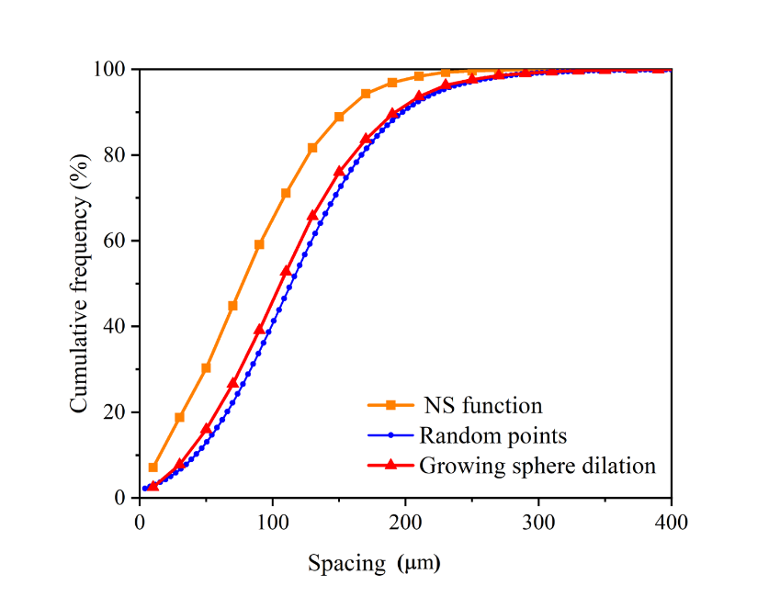
Figure 6. Comparison of spacing CDFs derived from NS function (based on the derived centers and diameters for the real system), growing spheres dilation, and random points methods (based on the replica microstructure) for mortar sample M4.

A comparison of these numerical methods with analytical approximations was also made. Alternative equations have been proposed by Philleo [8], Pleau and Pigeon [10, 42], although many approximations and simplifications were used in their respective derivations. Because of these simplifications, a NS function approximation with no simplifications, which was derived by Lu and Torquato [43], was employed. The approach of Lu and Torquato, which was based on many simulations of poly-dispersed sphere systems [43], was to derive the (void exclusion) probability that a point chosen randomly throughout the entire system lies within a distance s from an air void surface. Positive distance s is taken to be outside an air void surface with negative values inside a void [5]. In the terminology of this paper, the paste-void proximity and void-void proximity distributions were both approximated by Lu and Torquato equations [43]. For both paste-void and void-void proximity calculations, the following defined quantities (Eqs. 9-12) were needed:
$p_{k}=\frac{π}{3}n2^{k-1}〈R^{k}〉$ (9)
$c=\frac{4〈R^{2}〉}{1-A}$ (10)
$d=\frac{4〈R〉}{1-A}+\frac{12p_{2}}{{\left(1-p_{3}\right)}^{2}}〈R^{2}〉$ (11)
$g=\frac{4}{3\left(1-A\right)}+\frac{8p_{2}}{{\left(1-A\right)}^{2}}〈R〉+\frac{16}{3}\frac{B{p_{2}}^{2}}{{\left(1-A\right)}^{3}}〈R^{3}〉$ (12)
where $A$ is the volume fraction of air voids; n is the number of air voids per unit volume; and B is a coefficient with varying values (0, 2, or 3) depending on the analytical approximation chosen in the theory (B = 0 selected here [43]); and $〈R^{k}〉$ means an average over the air void size distribution in terms of number, of the particle radius to the kth power. In the terminology of Ref. [10], the void exclusion probability and particle exclusion probability equations were used to estimate the paste-void and void-void proximity, respectively.
Paste-void proximity: The calculation of the paste-void proximity via either growing sphere dilation or random points method considered only the volume outside the voids, since all paste and aggregates are located outside the voids. To correlate with the numerical calculation, the void exclusion probability can be written as Eq. (13), in which s is the distance to the void surface – s represents the spacing in this research. The quantity $e_{v}\left(s\right)$ was defined as the probability of a random point being at a distance s of a void surface, and the probability of finding the nearest void surface with a distance s of a random chosen point can be calculated as Eq. (14). The probability of finding the nearest air void surface a distance s away can be calculated as Eq. (15).
$e_{v}\left(s\right)=\left(1-A\right)\exp\left(-πn\left(cs+ds^{2}+gs^{3}\right)\right)$ (13)
$E_{v}^{'}\left(s\right)=1-e_{v}\left(s\right)$ (14)
$E_{v}=\frac{E_{v}^{'}\left(s\right)-A}{1-A}=1-\exp\left(-πn\left(cs+ds^{2}+gs^{3}\right)\right)$ (15)
Figure 7 compares the numerically calculated paste-void proximity based on the GSD and random points methods with the appropriate Lu and Torquato function. The random points method was based on the replica microstructure and for each sample the two high resolution scans were combined. Since the detailed shape of the PDF curves is closely related to the bin size used to construct the PDFs, only the CDFs were compared here. Statistical quantities for the different methods are listed in Table 7.
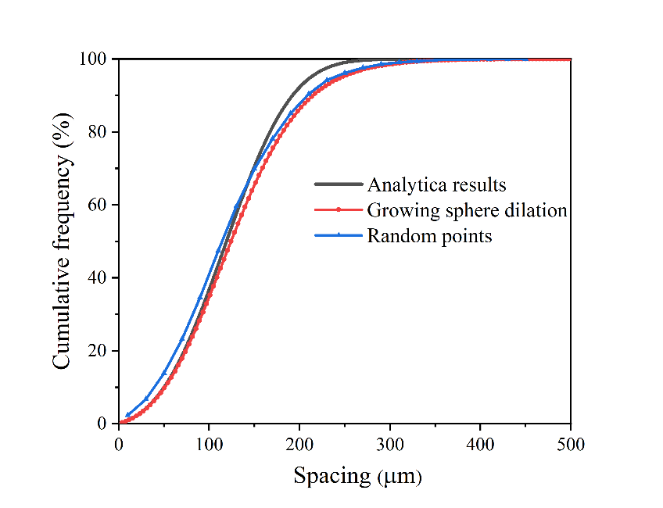
Figure 7. Comparison of spacing CDFs derived from growing spheres dilation and random points methods (both based on the replica microstructure) compared to Lu and Torquato analytical expression in Eq. 10 (based on the derived centers and radius distribution from XCT) for mortar sample M4.
Figure 7 shows that the random points and GSD spacing CDFs agree well with the Lu and Torquato analytical calculation, since they are all measuring or estimating the same quantity – the amount of paste within a distance s of an air void surface. In particular, the GSD method nearly coincides with this expression when the spacing factor is small. With gradually increasing spacing factor, the deviation between two curves grows steadily. The difference may be attributed to boundary conditions. In the Lu and Torquato equation, no boundaries were assumed, while in the GSD method, any overlap of the shells with the XCT sample boundary was eliminated.
Void–void proximity: A similar approach was applied for the void–void proximity calculation (NS function). Given that a point is located at the center of a void with radius R, the probability that the nearest air void is within a distance w from the center of an air void can be expressed as Eq. (16). The c, d, and g parameters are the same as those defined in Eqs. 9-12.
$E_{P}^{'}\left(w,R\right)=1-exp\left(-πn\left(c\left(w-R\right)+d\left(w^{2}-R^{2}\right)+g\left(w-R^{3}\right)\right)\right), w>R$ (16)
Accordingly, let s represent the shortest surface to surface distance between two voids. The probability the nearest air void surface is within s of the surface of the void with radius R can be calculated as Eq. (17). The function $E_{p}\left(s,R\right)$ is theoretically equivalent to the spacing CDF calculated via the NS function.
$E_{p}\left(s,R\right)=E_{P}^{'}\left(s+R,R\right)$ (17)
It should be noted that in Eq. (16), the $E_{p}\left(s,R\right)$ function is relevant to the void size R and for a mono-dispersed system, a unique distribution of $E_{p}\left(s,R\right)$ can be obtained. However, in the poly-dispersed system, $E_{p}\left(s,R\right)$ is a continuous function of R. For a poly-dispersed system with a continuous distribution of radius, there may exist an infinite number of possible $E_{p}\left(s,R\right)$ distributions. To deal with this, a possible solution is to calculate an ensemble average based on either the number density or volume density derived from the air void size distribution curve. For the number density approach, the ensemble average can be calculated as Eq. (18).
$〈E_{p}\left(s\right)〉=\int_{0}^{∞}{E_{p}\left(s,r\right)f\left(r\right)dr}$ (18)
However, in this research, the void size distribution was obtained via XCT scans and the void size distribution is not a continuous function. Thus, the calculation of $E_{p}\left(s,R\right)$ was repeated for each obtained R value and an average value was derived, as indicated in Eq. (19), in which N represents the number of voids detected in each sample. In mortar M4, N = 3905.
$〈E_{p}\left(s\right)〉=\frac{\sum_{i=1}^{N}{E_{p}\left(s,R_{i}\right)}}{N}$ (19)
A simplification was considered, in which the poly-dispersed system was treated as a mono-dispersed system with the average radius $〈R〉$ adopted to calculate the $E_{p}\left(s,〈R〉\right)$ function. The results of these two approaches are shown in Fig. 12 and compared with the computed NS function. Figure 12 shows that the distribution of $〈E_{p}\left(s\right)〉$ and $E_{p}\left(s,〈R〉\right)$ nearly coincide with each other, only with slight differences at small spacing values. Moreover, they are both close to the distribution curve obtained via the NS function, with the slight difference attributed to the different boundary conditions.
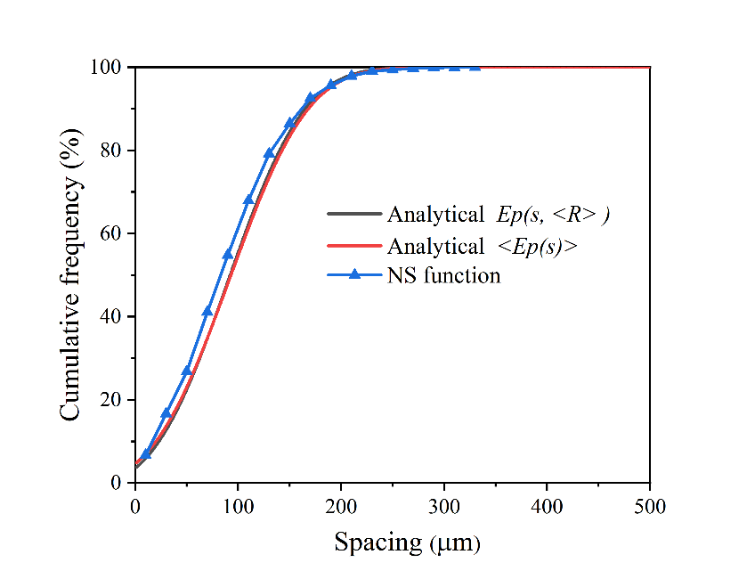
Figure 8. Comparison of spacing CDFs derived from NS function compared to Lu and Torquato analytical calculations obtained via two approaches: either using eq. (14) to get <Ep(s)> or using <R> in the monosized version of Eq. (14) to get Ep(s, <R>). Both curves are based on the derived centers and radius distribution from XCT for mortar sample M4.
Table 6 lists various characteristic parameters of the numerical and analytical paste-void and void-void distributions. For both distributions, the numerically calculated results agree well with the analytical results. The significant difference observed between the void-void and paste-void distributions originates from the varying definitions of these two statistical objects. However, they both convey useful information of how voids are spatially arranged in mortar samples and both generate characteristic values that may relate well to frost resistance.

Table 6: Comparison of average spacing, 50th percentile value, 95th percentile value, and Gaussian expectation computed for the paste-void and void-void numerical distributions with the Lu and Torquato analytical calculations (Analytical).

 | Peak value (μm) | $〈SF〉$ (μm) | $SF$50 (μm) | $SF$95 (μm) | GE(μm)
 | Paste–void proximity
GSD | 105 | 116 | 114 | 225 | 110
Random points |  | 121 | 116 | 229 | 112
Analytical | 111 | 112 | 112 | 204 | 111
 | Void–void proximity
NS function |  | 92 | 87 | 184 | 79
Analytical, $E_{p}\left(s,〈R〉\right)$ | 92 | 87 | 93 | 189 | 91
Analytical, $〈E_{p}\left(s\right)〉$ | 90 | 85 | 92 | 185 | 90

- Results for all mortar samples
The spacing distributions were calculated for the air void system in all six mortar samples. The relation between the spacing distributions and the sand specific surface area (SSA) was clearly seen. Only the results of the two high resolution scans were used, with both scans combined for each mortar sample.

4.1 Void–void proximity
The void-void proximity differential spacing distributions, using the NS function for all six samples and based on the replica microstructures, are shown in Fig. 9.
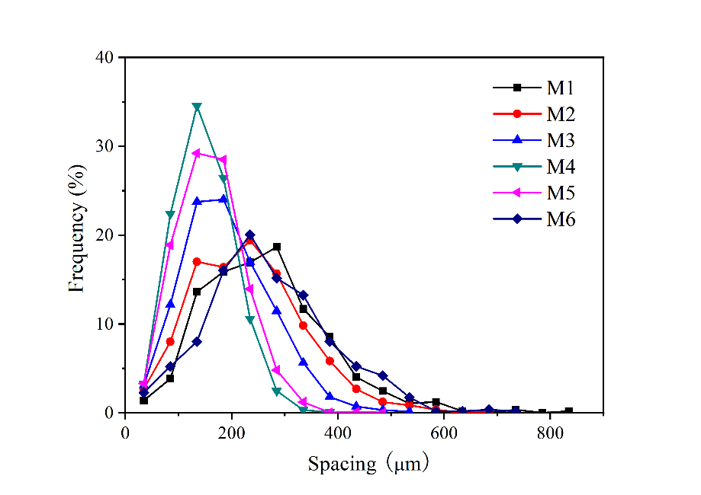
Figure 9. Differential void-void spacing distributions (NS) for all six mortar samples based on the replica air void systems. Area under each curve was normalized to 100 %.

The spacing distribution in all six samples can each be fit with a Gaussian function. The finest sand, used in samples M4 and M5, leads to considerable formation of smaller voids [31], which causes the spacing factor to be more narrowly distributed and peaked at smaller sizes. Sample M3 used only the next finest sand, 0.6 mm to 0.3 mm, which caused it to have a spacing distribution similar to M5. The other three mortars, which used larger sands, are peaked at similar but larger spacing factors. The characteristic parameters for all six samples are listed in Table 7. For the first four mortars prepared with roughly mono-sized sands, the values of all characteristic indices decrease gradually going from sample M1 to sample M4. For the last two mortars, prepared with blended sand sizes, all parameters increase going from mortar M5 to mortar M6. The lowest values of all the parameters are always found for mortars M3, M4, and M5, reflecting Fig. 9.

Table 7: Summary of average spacing factor, 50th percentile value, 95th percentile value, and expectation of Gaussian fit of all six mortars (void-void proximity method)

 | M1 | M2 | M3 | M4 | M5 | M6
Average spacing (μm) | 191 | 165 | 126 | 92 | 105 | 191
${SF}_{ss}$50 (μm) | 175 | 159 | 115 | 87 | 104 | 176
${SF}_{ss}$95 (μm) | 381 | 356 | 278 | 184 | 216 | 410
GE(μm) | 166 | 135 | 89 | 79 | 90 | 152

4.2 GSD method
The differential spacing distribution from the paste–void proximity method, calculated using the growing spheres dilation method for all six samples, is shown in Fig. 10. From Table 2, the value of SSA runs from low to high (M1-M6-M2-M3-M5-M4). It can be seen the larger the SSA, the more narrowly distributed is the spacing factor and the smaller is the peak position. The characteristic parameters are listed in Table 8, which is qualitatively similar to Table 7.
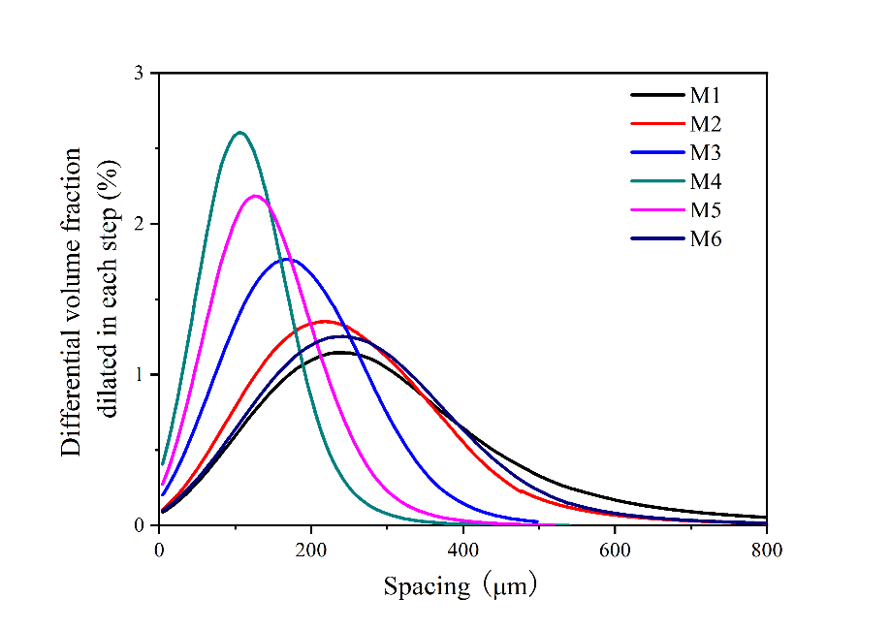
Figure10. Differential distribution of spacing factor derived from GSD method for all six samples.

Table 8: Summary of peak value, average spacing factor, 50th percentile value, 95th percentile value, and Gaussian expectation for all six mortars obtained from the GSD method.
 | M1 | M2 | M3 | M4 | M5 | M6
Peak value (μm) | 238 | 218 | 169 | 105 | 124 | 241
Average spacing (μm) | 263 | 226 | 184 | 116 | 142 | 249
${SF}_{ss}$50 (μm) | 278 | 240 | 182 | 114 | 138 | 272
${SF}_{ss}$95 (μm) | 616 | 462 | 349 | 225 | 277 | 519
GE (μm) | 259 | 231 | 175 | 110 | 132 | 250

4.3 Random points
The spacing PDFs, obtained from the random points method and based on the replica microstructures, are shown in Fig. 11, and the corresponding characteristic parameters are listed in Table 9. Like Fig. 10, it can be seen that a larger value of the SSA produces a narrower spacing distribution and a lower value of the peak position.
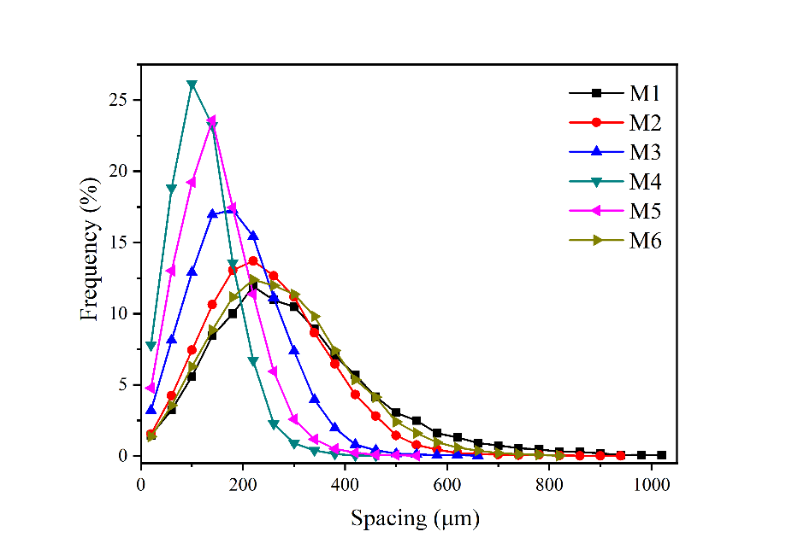
Figure 11. Differential distribution of spacing factor derived from random points method based on replica microstructures for all six samples.

Table 9: Summary of average spacing factor, 50th percentile value, 95th percentile value, and Gaussian expectation of six mortars obtained from random points method

 | M1 | M2 | M3 | M4 | M5 | M6
Average spacing (μm) | 297 | 249 | 187 | 121 | 148 | 272
${SF}_{ss}$50 (μm) | 274 | 238 | 180 | 116 | 142 | 262
${SF}_{ss}$95 (μm) | 597 | 454 | 344 | 229 | 276 | 501
GE(μm) | 260 | 232 | 176 | 112 | 138 | 254

4.4 Summary of characteristic or spacing factors obtained by three methods
The close agreement between the various numerical methods for computing the spacing distribution to the two analytical Lu and Torquato approximations is evident that these methods can provide a good estimate of the spacing distribution. The various distribution curves appear similar in shape and all can be fit well with a Gaussian function. The linear relationships between all the average spacing factors and SSA is plotted in Fig. 12, which shows that the average spacing factor decreases with increasing SSA in a roughly linear relationship. The SSA=0 intercept for the linear expressions shows how the spacing factor behaves in the limit of large sand grains (small SSA) [14]. As indicated in Table 7, 8, and 9, in each methodology, the values of average spacing, SF50, SF90, and GE change with SSA is a similar fashion.
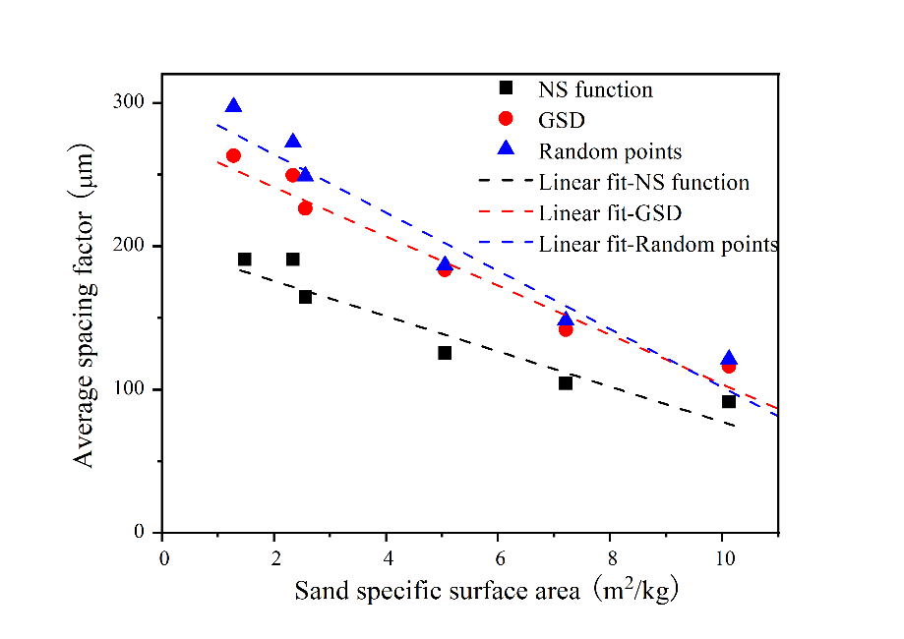
Figure 12. Summary of relationship between averaging spacing factor obtained from different methods and calculated sand SSA. The equations of the linear fits (dashed lines) are: NS function f(x) = -12x+200 (R² = 0.87), GSD f(x) = -17x+276 (R² = 0.95), Random points f(x) = -20x+305 (R² = 0.92).

The slopes of the linear expressions show how much additional sand specific surface area causes the average air void spacing factor to decrease. This behavior may be attributed to the fact that the higher the SSA, the more voids will form inside the mix, which results in smaller spaces between adjacent air voids [31]. For each sample, the values obtained from the random points method is always slightly larger than those obtained with the GSD method, while the values computed from the NS function are always smaller than those from the other two methods, which is in qualitative agreement with Fig. 8. Again, note that the average spacing factors computed from the void-void proximity and the paste-void proximity functions are not expected to be the same numerically. All the data are accurately fit by straight lines with negative slope, so that the spacing factor decreases as SSA increases. This is clear evidence that the average size of the sand does significantly affect the air void system spacing factor. Since the volume of sand is invariant, as the sand size gets smaller, the average distance between sand grains gets smaller. Since the air voids are physically confined to the cement paste spaces between sand grains, this forces clusters of air voids to be closer together, on average.

4.5 Application of analytical calculation
As indicated in Section 3.3, the Lu and Torquato equation (NS function approximation) results agreed well with the results obtained via the NS function, random points method, and GSD method.
Then, for all six mortar samples, the paste-void proximity was calculated via the relevant Lu and Torquato equation. The results are shown in Fig. 13, with Fig. 13(a) being the differential and Fig. 13(b) being the cumulative distribution. The average spacings for the six mortars derived from the spacing distribution were listed and compared in Table 10.
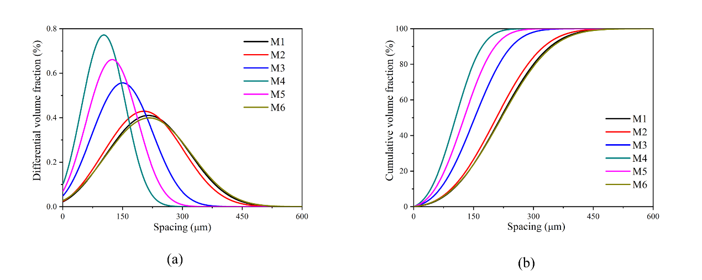
Figure 13. Differential distribution of spacing factor derived from analytical calculation based on replica microstructure for all six samples.

Table 10: Summary of average spacing factor of six mortars obtained from analytical calculation
 | M1 | M2 | M3 | M4 | M5 | M6
Averaging spacing (μm) | 245 | 215 | 166 | 113 | 133 | 243

The relationship between the average spacing and SSA is shown in Fig. 14. A linear relationship can also be observed, which indicates that the average spacing decreases with increasing SSA. Therefore, the Lu and Torquato equations performed quite well for spacing distribution calculations. Not only can they predict arbitrary statistics of distributions, but also accurately predict the average spacing as a function of void radius. Due to the accuracy of the Lu and Torquato equation in predicting the spacing distribution, it appears that other spacing equations are not needed, as well as the numerical calculation for all NS function, random points, and GSD methods. If the size distribution of the void system could be quantitatively obtained via XCT or other techniques, the spacing could be analytically calculated and its frost resistance could also be evaluated. Even with the XCT measurement, the amount of testing time needed could be comparable with the ASTM C457 method, which is time consuming and requires several hours of measurement to gain a statistically representative amount of information. Moreover, since the calculation would be based on a real 3D void system, measured only once, more accurate information could be acquired compared with the quantification on selected 2D planes either by the linear traverse or point counting methods.

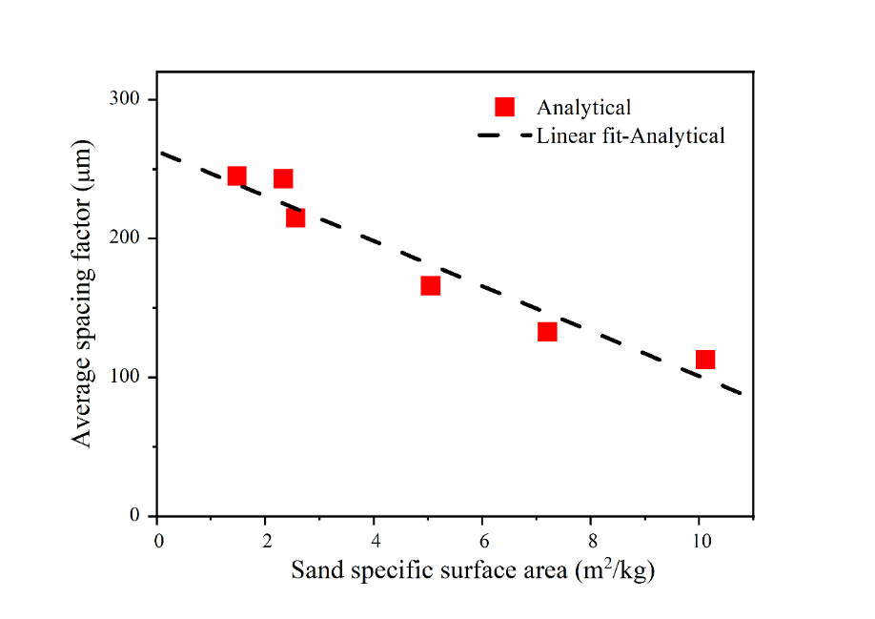
Figure 14. Summary of relationship between averaging spacing factor obtained from analytical calculation (Lu and Torquato equation) and sand SSA. f(x) = -16.21x + 263 (R² = 0.94)
- Summary and Conclusions
In this study, a methodology to rapidly and accurately evaluate the air void spacing was proposed. The spacings were defined in two distinct ways: void–void proximity and paste–void proximity. For void–void proximity, the spacing was calculated as the distance between a void and its nearest neighbor as defined by either the nearest air void surface distance or the nearest air void centroid distance. The paste–void proximity, being the volume fraction of matrix material within a certain distance of an air void, was calculated in two ways: growing spheres dilation (GSD) method and random points method. The effect of fine aggregate size on the air void spacing distribution in mortars was presented. The following conclusions can be drawn:
- Numerical methods, including image analysis methods, can be developed and used on 3D air void structures measured using XCT scanning to compute spacing distributions. Clear differences were seen between the full XCT air void structure and replica air void microstructures, since the real data had a small air void size cutoff value.
- The spacing distributions obtained from the GSD method and the random points method agreed well with each other, as they should have, since they represent two algorithms to approximately calculate the same quantity. Both results, including various averages to determine characteristic parameters computed from the distributions, also agreed well with the relevant analytical Lu and Torquato equation. The only differences with the analytical equation were caused by the finite boundary in the XCT images, since no boundary was assumed in the equation, and this tended to occur at larger values of the spacing factor, well past the peak in the PDF distribution.
The computed void-void proximity spacing distribution agreed well with the relevant Lu and Torquato equation and had characteristic parameters that were all somewhat smaller than that from the paste-void proximity analysis. The differences originate from the two different spacing definitions, which measured related but different quantities.
All the various spacing distribution curves were qualitatively similar in shape and conveyed useful information of how air voids are spatially arranged in mortars. In addition, all three computation methods produced PDF distributions that were well-fit by Gaussian distributions. In these cases, the cement paste and the sand were treated as one matrix phase, as is the usual case in experimental measurements.
- The effect of sand size distribution was characterized by a single parameter, the sand specific surface area (SSA). A linear relationship with negative slope was found between the average spacing factor and SSA for both the void-void and paste-void proximity distributions, so that the average spacing factor decreased as the value of the sand SSA increased. This was true even when treating the cement paste and sand as a single matrix phase.
- Via calculations of both paste–void proximity and void–void proximity, the relevant Lu-Torquato equations were shown to be very accurate, compared to the various experimental results. Since these equations only need as input the air void size distribution, one can dispense with numerical calculations of the air void spacings and simply use these analytical calculations.
(5) In general, built upon the results of this paper and previous work [31], the air void system of the composites can be automatically and rapidly evaluated with more accuracy. The derived characteristic parameters from each air void spacing distribution should basically paly a role similar to the spacing factor proposed by Powers but based on the real spatial distribution of the air voids, not a assumed regular cubic arrangement. When comparing mortar/concrete samples with approximative spacing factors, the exact spacing distribution of air voids obtained in our research should be able to more precisely evaluate the frost resistance. An air void system that is more evenly distributed spatially, is believed to paly a more positive role in improving the frost resistance of the mortar/concrete. However, further study is still needed to better reveal how the air voids protect the matrix from frost damage and whether the size of the affected zone is related to the single void size. The protected paste zone (PPV) theory, combined with this 3D method, should provide a more solid and accurate basis for guiding mix design and predicting the frost resistance of prepared mortar/concrete.

Acknowledgements:
The authors gratefully acknowledge partial financial support from the National Natural Science Fund of China (Grant Nos: 52108206 and 52178202), the National Key R&D Program of China (2021YFB2601204), the Fundamental Research Funds for the Central Universities (B220202010). The authors thank Jiangsu Research Institute of Building Science Co., Ltd. and the state key laboratory of high-performance civil engineering materials for funding this research project. The first author (KL) would like to thank the National Institute of Standards and Technology for making possible his extended stay, during when this research was carried out.

References
1. Torquato, S. and H. Haslach Jr, Random heterogeneous materials: microstructure and macroscopic properties. Appl. Mech. Rev., 2002. 55(4): p. B62-B63.
2. Ley, M.T., et al., Determining the air-void distribution in fresh concrete with the Sequential Air Method. Construction and Building Materials, 2017. 150: p. 723-737.
3. Neville, A.M., Properties of concrete. Vol. 4. 1995: Longman London.
4. Aligizaki, K.K., Pore Structure of Cement-Based Materials: Testing, Interpretation, and Requirements. Crc Press, 2004.
5. Powers, T.C., Air requirement of frost-resistant concrete. Highway Research Board Proceedings, 1949. 29.
6. ASTM, C457-08d, in Standard Test Method for Microscopical Determination of Parameters Of The Air-Void System in Hardened Concrete. 2003, ASTM International, West Conshohocken, PA, 2016, www.astm.org.
7. Dequiedt, A.-S., et al., Distances between air-voids in concrete by automatic methods. Cement and Concrete Composites, 2001. 23(2-3): p. 247-254.
8. Philleo, R.E., A Method for Analyzing Void Distribution in Air-Entrained Concrete. Cement Concrete & Aggregates, 1983. 5(2): p. 3.
9. Attiogbe, E.K., Mean spacing of air voids in hardened concrete. Aci Materials Journal, 1993. 90(2): p. 174-181.
10. Pleau, R., et al., The Use of the Flow Length Concept to Assess the Efficiency of Air Entrainment with Regards to Frost Durability: Part II—Experimental Results. Cement Concrete & Aggregates, 1996. 18(1): p. 64-7.
11. Murotani, T., S. Igarashi, and H. Koto, Distribution analysis and modeling of air voids in concrete as spatial point processes. Cement and Concrete Research, 2019. 115: p. 124-132.
12. Wong, H.S., et al., Effect of entrained air voids on the microstructure and mass transport properties of concrete. Cement & Concrete Research, 2011. 41(10): p. 1067-1077.
13. Dequiedt, A.S., et al., Distances between air-voids in concrete by automatic methods. Cement & Concrete Composites, 2001. 23(2): p. 247-254.
14. Jakobsen, U.H., et al., Automated air void analysis of hardened concrete — a Round Robin study. Cement & Concrete Research, 2006. 36(8): p. 1444-145210.
15. Morgan, I.L., et al., EXAMINATION OF CONCRETE BY COMPUTERIZED TOMOGRAPHY. Journal of the American Concrete Institute, 1980. 77(1): p. 23-27.
16. Chen, Y., et al., Characterization of air-void systems in 3D printed cementitious materials using optical image scanning and X-ray computed tomography. Materials Characterization, 2021. 173.
17. Lu, H., et al., Measurement of air void system in lightweight concrete by X-ray computed tomography. Construction and Building Materials, 2017. 152: p. 467-483.
18. Lu, H., K. Peterson, and O. Chernoloz, Measurement of entrained air-void parameters in Portland cement concrete using micro X-ray computed tomography. International Journal of Pavement Engineering, 2018. 19(2): p. 109-121.
19. Fonseca, P. and G. Scherer, An image analysis procedure to quantify the air void system of mortar and concrete. Materials and Structures, 2015. 48(10): p. 3087-3098.
20. Chen, Y., et al., Characterization of air-void systems in 3D printed cementitious materials using optical image scanning and X-ray computed tomography. Materials Characterization, 2021. 173: p. 110948.
21. Koenig, A., Analysis of air voids in cementitious materials using micro X-ray computed tomography (µXCT). Construction and Building Materials, 2020. 244: p. 118313.
22. Yuan, J., Y. Wu, and J. Zhang, Characterization of air voids and frost resistance of concrete based on industrial computerized tomographical technology. Construction & Building Materials, 2018.
23. Wang, Z. and J. Xiao, Evaluation of Air Void Distributions of Cement Asphalt Emulsion Mixes Using an X-Ray Computed Tomography Scanner. Journal of Testing & Evaluation, 2012. 40(2): p. 103881.
24. Wong, R.C.K. and K.T. Chau, Estimation of air void and aggregate spatial distributions in concrete under uniaxial compression using computer tomography scanning. Cement & Concrete Research, 2005. 35(8): p. 1566-1576.
25. Chung, S.Y., et al., Evaluation of the anisotropy of the void distribution and the stiffness of lightweight aggregates using CT imaging. Construction & Building Materials, 2013. 48(19): p. 998-1008.
26. Kim, K.Y., et al., Determination of air-void parameters of hardened cement-based materials using X-ray computed tomography. Construction & Building Materials, 2012. 37(12): p. 93-101.
27. Yun, T.S., et al., Quantifying the distribution of paste-void spacing of hardened cement paste using X-ray computed tomography. Materials Characterization, 2012. 73(11): p. 137-143.
28. Mayercsik, N.P., et al., A probabilistic technique for entrained air void analysis in hardened concrete. Cement and concrete research, 2014. 59: p. 16-23.
29. Snyder, K.A., A Numerical Test of Air Void Spacing Equations. Advanced Cement Based Materials, 1998. 8(1): p. 28-44.
30. Garboczi, E.J., Three-dimensional mathematical analysis of particle shape using X-ray tomography and spherical harmonics: Application to aggregates used in concrete. Cement & Concrete Research, 2002. 32(10): p. 1621-1638.
31. Lyu, K., et al., Relationship between fine aggregate size and the air void system of six mortars: I. Air void content and diameter distribution. Cement and Concrete Composites, 2022. 131.
32. Rashed, A.I. and R.B. Williamson, Microstructure of entrained air voids in concrete, Part I. Journal of materials research, 1991. 6(9): p. 2004-2012.
33. T. Murotani, S.I., H. Koto Distribution analysis and modeling of air voids in concrete as spatial point processes. Cement and Concrete Research, 2019. 115: p. 124-132.
34. Sokhansefat, G., et al., Using X-ray computed tomography to investigate mortar subjected to freeze-thaw cycles. Cement and Concrete Composites, 2020. 108.
35. Bentz, D.P. and K.A. Snyder, Protected paste volume in concrete: Extension to internal curing using saturated lightweight fine aggregate. Cement & Concrete Research, 1999. 29(11): p. 1863-1867.
36. Urbach, E.R. and M.H. Wilkinson, Efficient 2-D grayscale morphological transformations with arbitrary flat structuring elements. IEEE Transactions on Image Processing A Publication of the IEEE Signal Processing Society, 2008. 17(1): p. 1.
37. Liang, J.I., J. Piper, and J.Y. Tang, Erosion and dilation of binary images by arbitrary structuring elements using interval coding. Pattern Recognition Letters, 1989. 9(3): p. 201-209.
38. Urbach, E.R. and M.H.F. Wilkinson, Efficient 2-D grayscale morphological transformations with arbitrary flat structuring elements. IEEE Transactions on Image Processing A Publication of the IEEE Signal Processing Society, 2008. 17(1): p. 1.
39. Bai, X., Morphological operator for infrared dim small target enhancement using dilation and erosion through structuring element construction. Optik, 2013. 124(23): p. 6163-6166.
40. Cheng, X. Fast Binary Dilation/Erosion Algorithm Using Reference Points. in International Conference on Networking & Digital Society. 2009.
41. Haralick, R.M., Image Analysis and Mathematical Morphology, Volume 2: Theoretical Advances, Jean Serra (Ed.). Academic Press, New York (1988). Computer Vision Graphics & Image Processing, 1988. 44(2): p. 230-231.
42. Pleau, R., M. Pigeon, and J.L. Laurencot, Some findings on the usefulness of image analysis for determining the characteristics of the air-void system on hardened concrete. Cement & Concrete Composites, 2001. 23(2): p. 237-246.
43. Lu, B. and S. Torquato, Nearest-surface distribution functions for polydispersed particle systems. Physical Review A Atomic Molecular & Optical Physics, 1992. 45(8): p. 5530.

*Corresponding author at: College of Civil and Transportation Engineering, Hohai University, Nanjing 210098, China E-mail addresses: 15651851126@163.com (K. Lyu)
Certain commercial equipment, software and/or materials are identified in this paper in order to adequately specify the experimental procedure. In no case does such identification imply recommendation or endorsement by the National Institute of Standards and Technology, nor does it imply that the equipment and/or materials used are necessarily the best available for the purpose.

