Improved Correlations for the Static Dielectric Constant of Hydrogen

Guinevere M. Sellner^{1,2} (https://orcid.org/0009-0007-2350-5043), Liam D. Tenardi^{1,2} (https://orcid.org/0009-0006-7569-4598), Paul L. Stanwix¹ (https://orcid.org/0000-0002-7069-8569), Eric F. May^{1,2}* (https://orcid.org/0000-0001-5472-6921), Allan H. Harvey³* (https://orcid.org/0000-0002-0072-2332)

¹ Fluid Science and Resources Research Group, School of Engineering, The University of Western Australia, Crawley, Western Australia, 6009, Australia
² Future Energy Exports Cooperative Research Centre (FEnEx CRC), Crawley, Western Australia, 6009, Australia
³ Applied Chemicals and Materials Division, National Institute of Standards and Technology (NIST), Boulder, Colorado, 80305, U.S.A.
*Corresponding authors: eric.may@uwa.edu.au; allan.harvey@nist.gov

Abstract

Accurate values of the static dielectric constant of hydrogen are important for both fundamental thermophysical property calculations and emerging dielectric-based sensing applications in hydrogen liquefaction, storage, and processing systems. Previous work has shown that the existing reference correlations for hydrogen exhibit deficiencies at cryogenic conditions, particularly for ortho-rich hydrogen and liquid states. In this work, improved correlations are developed for the static dielectric constant of para- and ortho-hydrogen over temperatures from (1 to 1000) K. The low-density contribution was recalculated using modern ab initio rovibrational energy levels and state-dependent molecular polarizabilities. A new functional representation was developed that reproduces the temperature dependence of the first dielectric virial coefficient over the full temperature range considered, including the strongly non-linear behavior at cryogenic temperatures. An extensive review of the available dielectric-constant measurements for normal and para-hydrogen was conducted, extending significantly upon the data used by previous dielectric correlations. These data were then used to develop revised correlations for the higher-density dielectric behavior of para- and ortho-hydrogen. The resulting correlations provide substantially improved agreement with available experimental data compared with previous models and better reproduce independent literature measurements that were not used in the fitting process, including recent measurements of the dielectric contrast between hydrogen spin isomers. However, the available experimental database remains limited, and the temperature dependences assumed for the higher-order terms remain only weakly constrained.
Keywords dielectric constant · hydrogen · polarizability

Introduction

As hydrogen continues to attract global interest as a low-emission energy carrier, accurate prediction of its thermophysical properties has become increasingly important. Among these properties, the static dielectric constant is of particular interest due to both its practical applications in hydrogen sensing and its connection to the underlying fundamental molecular behavior of hydrogen [1]. As a property that links a fluid’s electromagnetic behavior to its thermodynamic state that can also be measured at sub-ppm level precision [1], it is a property with many potential applications. In particular, at cryogenic conditions relevant to hydrogen liquefaction, there is significant opportunity for the application of sensors based on hydrogen’s dielectric constant in liquid hydrogen tank level sensing [2, 3], liquid hydrogen boil-off [4], and hydrogen spin-isomer composition monitoring in liquefaction processes [5].
In regards to the latter, recent work [5] demonstrated the potential of dielectric measurements as a high-precision sensing mechanism for cryogenic hydrogen systems, with specific application to resolving the spin-isomer (ortho-hydrogen (o-H₂) and para-hydrogen (p-H₂)) composition of hydrogen via the very small difference in their thermophysical properties. Dielectric measurements using a microwave resonant cavity were shown to provide an effective means of monitoring ortho–para (o-p) hydrogen conversion and composition under cryogenic conditions relevant to hydrogen liquefaction [5]. However, that work also demonstrated how the currently available predictive models for hydrogen’s static dielectric constant exhibit significant deficiencies at these cryogenic conditions, particularly for ortho-rich hydrogen, thereby limiting the broader implementation of dielectric-based sensing approaches in industrial systems.
These current models for hydrogen are based on the framework published in 2005 by Harvey and Lemmon for the static dielectric constant of natural gas [6]. Because hydrogen is a component of some natural gases, correlations were included for the dielectric constants of pure p-H₂ and equilibrium H₂ (e-H₂) (temperature-dependent “equilibrium” o-p composition arising from the Boltzmann population of rotational states, as determined by the rotational partition function of the hydrogen molecule [7]; which was labeled only as “H₂” in Ref. [6]). The low-density portions of these correlations were based on quantum statistical mechanics and ab initio polarizabilities, similar to the calculations presented in Sec. 2 below. The terms for higher density were fitted only to a portion of the data of Stewart [8], who measured the dielectric constant of p-H₂ at liquid and supercritical states from 24–100 K. Harvey and Lemmon [6] only used the data above 50 K, since their application was for natural gas and not liquid hydrogen.
There is room for improvement in several aspects of the Harvey and Lemmon [6] correlations, especially if they are to be applied to cryogenic states; we list the following deficiencies in no particular order.
First, Harvey and Lemmon [6] had no correlation for normal hydrogen (n-H₂, defined as the high-temperature limiting composition of 25 mol% p-H₂ and 75 mol% o-H₂) or o-H₂, only p-H₂ and e-H₂. This is not a serious problem at ambient temperatures where e-H₂ is close in composition to n-H₂, but it prevents application to n-H₂ and high ortho-fraction mixtures at cryogenic temperatures.
Second, the low-density calculation considered only the ground vibrational state of H₂. This is an excellent approximation at cryogenic and ambient temperatures, but at higher temperatures, such as 500 K, the population of the first excited vibrational state becomes non-negligible.
Third, the low-density parts of the correlations were fitted to a simple form that was linear in temperature. These fits were focused on the range (100 to 500) K, with application to natural gas in mind. However, as we will see in Sec. 2, such a linear fit does not correctly describe the polarizability’s behavior at liquid hydrogen temperatures.
Fourth, there are additional experimental data that should inform the correlations. In addition to several sources of data for liquid hydrogen, high-quality measurements were published in 2009 by May et al. [1] for the compressed gas at pressures up to 6.5 MPa. The experimental data of Stewart [8] below 50 K should also be taken into account to more accurately represent cryogenic states.
In this work, we first derive the low-density part of the dielectric-constant behavior for p-H₂ and o-H₂, representing it with a functional form that is accurate over the entire temperature range considered (up to 1000 K). We then survey the available experimental data for the static dielectric constant of both p-H₂ and n-H₂. Finally, we develop reference correlations to describe the dielectric constant of p-H₂ and o-H₂ over the entire fluid region up to 1000 K.

Low-density Limit
The low-density behavior of the static dielectric constant ($ε$) of a fluid is rigorously described by the dielectric virial expansion:
 | $\frac{ε-1}{ε+2}=P=ρ\left(A_{ε}\left(T\right)+B_{ε}\left(T\right)ρ+C_{ε}\left(T\right)ρ^{2}+…\right),$ | (1)
where $P$ is electric polarization, $ρ$ is the molar density, and $A_{ε},$ $B_{ε}$, and $C_{ε}$ are respectively the first, second, and third dielectric virial coefficients. $A_{ε}$ depends on properties of a single molecule, while $B_{ε}$ and $C_{ε}$ are corrections (usually small) for interactions involving two and three molecules, respectively. For molecules with no dipole moment, $A_{ε}$ is directly proportional to the static mean polarizability ($α$, cm³·mol⁻¹) according to
 | $A_{ε}=\frac{4πN_{A}}{3}α,$ | (2)
where $N_{A}$ is the Avogadro constant.
For a molecule that can vibrate and rotate, $α$ is not a simple constant, because each rovibrational state has a slightly different polarizability (due, for example, to centrifugal stretching at higher rotational states). Therefore, accurate computation of $A_{ε}(T)$ requires knowledge of the distribution of molecular states (which will change with temperature since the states have different energies) and of the mean polarizability of each state. For the H₂ molecule, with only two electrons, these quantities can be obtained with high accuracy from ab initio quantum calculations. Information about energy levels can also be obtained from spectroscopy.
The mean polarizability is computed as a function of temperature by
 | $α\left(T\right)=\sum_{i}{x_{i}\left(T\right)α_{i}},$ | (3)

where the sum extends over all molecular rovibrational states $i$, $x_{i}(T)$ is the fraction of molecules in state $i$ at temperature $T$, and $α_{i}$ is the expectation value of the mean polarizability for state $i$.

  - Energy levels

The energy levels of the H₂ molecule have been well studied, both by spectroscopic methods and by ab initio quantum calculations. While Harvey and Lemmon [6] used spectroscopic energy levels reported in 1984 by Dabrowski [9], whose uncertainties are unclear, in this work we use the first-principles energy levels given in 2011 by Komasa et al. [10]. Komasa et al. included nonadiabatic (post-Born–Oppenheimer) effects along with the effects of relativity and quantum electrodynamics (QED), claiming an uncertainty in the calculated energy levels (which were quantified using wavenumbers) near 0.001 cm⁻¹. Subsequent work [11] refined some of the calculations, but the complete set of energy levels was not reported in the later paper and the few examples presented show that the refinements were on the order of 0.001 cm⁻¹, which is negligible in our context.
While Ref. [6] only considered the ground vibrational state ($ν = 0$), the first excited vibration ($ν = 1$) becomes significant by the time the temperature reaches 500 K, so the first few rotational levels in that vibrational state should be included. By including rotational states up to $J = 13$ ($J$ is the rotational quantum number) for $ν = 0$ and up to $J = 9$ for $ν = 1$, we included all states whose fractional population exceeds 5 × 10⁻⁶ at temperatures up to 1000 K. The omitted states are much more insignificant at lower temperatures; at 500 K, no omitted state has $x_{i}$ more than 10⁻¹⁰. It is convenient when working with partition functions to write the energy of a state divided by the Boltzmann constant, giving it units of temperature; the conversion factor from the wavenumbers reported in the literature is 1 cm⁻¹ = 1.438776877 K [12].

  - State-dependent polarizabilities

Harvey and Lemmon [6] made use of the polarizabilities of Rychlewski [13], who performed accurate calculations of $α$ for the ground vibrational state for rotational states up to $J = 15$ and for the $J = 0$ and $J = 1$ states of several excited vibrational states. However, these calculations were performed in the Born–Oppenheimer (BO) approximation, which loses accuracy when low-mass nuclei like hydrogen are involved. Recently, Sun et al. [14] performed high-accuracy calculations of the polarizability without the BO simplification. They provided values in the ground vibrational state for the three lowest rotational states ($J = 0, 1, 2$). The polarizabilities for those three states were larger than those of Rychlewski by factors of 1.000082, 1.000083, and 1.000086, respectively. To capture what may be a trend, we multiplied the values of $α$ provided by Rychlewski by 1.00009 for all $J > 2$.
We require estimates for the polarizability of states with $ν = 1$ and $2 ≤ J ≤ 9$ that Rychlewski did not calculate. We observe that, in the table given by Rychlewski [13], the ratio of polarizabilities of the $J = 1$ state to the $J = 0$ state is nearly identical for the $ν = 0$ and the $ν = 1$ vibrational states. We therefore assume that the computed ratio between higher-$J$ states and $J = 1$ for the ground vibrational state can also be applied for the $ν = 1$ vibrational state. This approximation will make no difference except at high temperatures; at 500 K none of the states approximated have $x_{i}$ above 2 × 10⁻⁶.

  - Calculations, including spin isomers

Once the energy levels are known for each rovibrational state, the fraction of molecules in each state can be computed from the partition function. Since translation of molecules does not affect the polarizability, we write a rotation–vibration partition function $q$. The Boltzmann factors in the partition function must be combined not only with a factor taking into account the multiplicity according to the rotational quantum number $J$, but also the appropriate factor for the number of symmetric or antisymmetric spin functions [7], which for H₂ is 1 for even (para-) rotational states and 3 for odd (ortho-) states.
The resulting partition function for p-H₂ is [7]
 | $q_{p}=\sum_{even J}{\left(2J+1\right)\exp\left(-\frac{E_{i}}{kT}\right)},$ | (4)

while for o-H₂ it is
 | $q_{o}=3\sum_{odd J}{\left(2J+1\right)\exp\left(-\frac{E_{i}}{kT}\right)},$ | (5)
where the sums extend over all rovibrational states (with the appropriate restriction to odd or even spins), $E_{i}$ is the energy of state $i$, and $k$ is the Boltzmann constant. If one considers equilibrium hydrogen (e-H₂) where there is no restriction on rotational states, the partition function is simply the sum of these two functions:
 | $$q_{e}=q_{p}+q_{o}.$$ | (6)
The fraction of molecules in a given state $i$, $x_{i}$, with rotational quantum number $J$, can be calculated from the partition function according to its energy. For example, for p-H₂ the calculation is

 | $x_{i}\left(T\right)=\frac{\left(2J+1\right)\exp\left(-\frac{E_{i}}{kT}\right)}{q_{p}} \left(even J\right),$ | (7)
while for o-H₂ it is
 | $x_{i}\left(T\right)=\frac{3\left(2J+1\right)\exp\left(-\frac{E_{i}}{kT}\right)}{q_{o}} \left(odd J\right).$ | (8)

  - Low-density results and correlation
Calculations of $A_{ε}(T)$ were performed with Eqs. (2) and (3) for both p-H₂ (with the distribution of states determined by Eq. (7)) and o-H₂ (with the distribution of states determined by Eq. (8)). The temperature range extended from 1 K to 1000 K. Fig. 1(a) shows the results for p-H₂ up to 600 K (the function remains roughly linear up to 1000 K). It is obvious that the linear form used by Harvey and Lemmon [6] does not adequately represent $A_{ε}(T)$ at the low temperatures of interest for cryogenic applications.
Fig. 1(b) shows our calculated results for o-H₂; again, the behavior from the 600 K limit of the plot up to 1000 K is roughly linear.

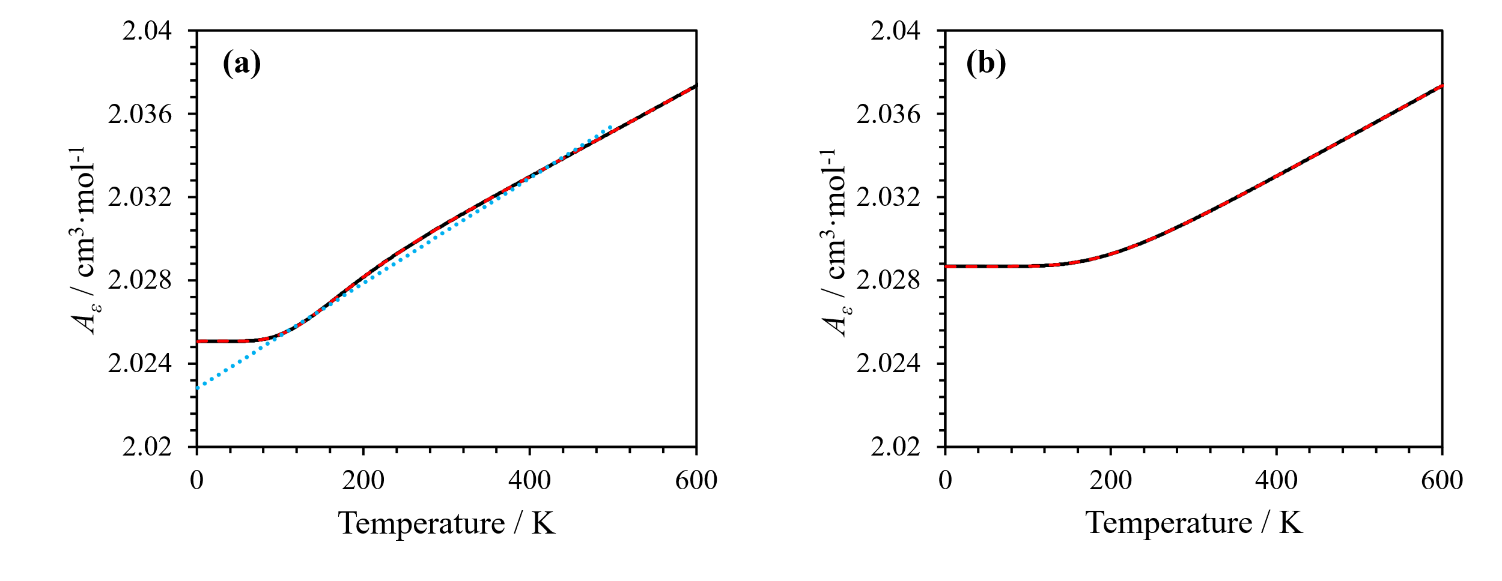Fig. 1 Calculated values of $A_{ε}(T)$ (—) for (a) para-hydrogen; and (b) ortho-hydrogen. The linear approximation for p-H₂ used by Harvey and Lemmon [6] is shown (···), as well as the new SITH function (this work) for approximating $A_{ε}(T)$ for both p-H₂ and o-H₂ (- - -).
A functional representation of $A_{ε}(T)$ was developed to more accurately describe the behavior of the ab-initio calculations as shown in Fig. 1: it captures the low-temperature asymptotic behavior and the curvature at intermediate temperatures that are not reproduced by the linear approximation of Harvey and Lemmon [6]. Both p-H₂ and o-H₂ could be accurately represented using a modified Padé approximant of the form:
 | $A_{ε}\left(T\right)=\exp\left(\frac{\sum_{i=0}^{N}{m_{i}{\left(\frac{T}{T_{0}}\right)}^{\frac{i}{2}}}}{1+\sum_{i=1}^{N}{n_{i}{\left(\frac{T}{T_{0}}\right)}^{\frac{i}{2}} }}\right),$ | (9)
with fitting parameters $m_{i}$ and $n_{i}$, and reference temperature $T_{0}=273.16 K$ as in Ref. [6]. For both p-H₂ and o-H₂, the fitting parameters were determined by a weighted nonlinear least-squares regression to the ab initio calculations across the full temperature range. The weighting factors were taken as the inverse square of the combined standard uncertainty associated with each calculated $A_{ε}(T)$ value. These uncertainties were estimated using a GUM-style propagation based on uncertainties in the rotational-state energies ($E_{i}$) from Komasa et al. [10] and molecular polarizabilities ($α_{i}$). Sensitivities of the rotational populations to the energy levels were determined analytically and propagated through the population-weighted polarizability calculation using covariance-matrix methods. An additional relative standard uncertainty of 10 ppm was included to account for uncertainty in the state-dependent polarizabilities arising from scaling the values of Rychlewski [13].
Table 1 reports the fitted $m_{i}$and $n_{i}$ coefficients for both p-H₂ and o-H₂, with the resulting correlation hereafter referred to as the “SITH” (Sellner-Incerti-Tenardi-Harvey) function. Fig. 1 shows the agreement between the SITH correlation and the calculated $A_{ε}(T)$ values, while residuals are presented in Fig. 2. A value of $N=5$ in Eq. (9) was required to ensure that residuals remained below the estimated calculation uncertainty over the full temperature range considered, particularly at the low-temperature and high-temperature end-points. Furthermore, seven decimal places in the reported $m_{i}$and $n_{i}$ coefficients are required to preserve this level of accuracy. As $A_{ε}\left(T\right)$ is fundamentally additive with respect to molecular populations, $A_{ε}\left(T\right)$ for mixtures of o-p hydrogen (such as e-H₂ and n-H₂) can be combined linearly with molar composition.

Table 1.
Fitted coefficients for the new SITH function (see Eq. (9)) that describes the temperature-dependent behavior (1 K to 1000 K) of $A_{ε}$ for both p-H₂ and o-H₂ for use in the improved static dielectric-constant model for hydrogen.
Fit Parameter | para-hydrogen | ortho-hydrogen
$$m_{0}$$ | 0.7056009 | 0.7073774
$$m_{1}$$ | -2.4277525 | -2.1065695
$$m_{2}$$ | 3.2764357 | 2.8754738
$$m_{3}$$ | -2.0434530 | -2.1691939
$$m_{4}$$ | 0.6911754 | 1.0050498
$$m_{5}$$ | -0.0974687 | -0.1633760
$$n_{1}$$ | -3.4406965 | -2.9780896
$$n_{2}$$ | 4.6432065 | 4.0657432
$$n_{3}$$ | -2.8946261 | -3.0691570
$$n_{4}$$ | 0.9776579 | 1.4249117
$$n_{5}$$ | -0.1379077 | -0.2333652

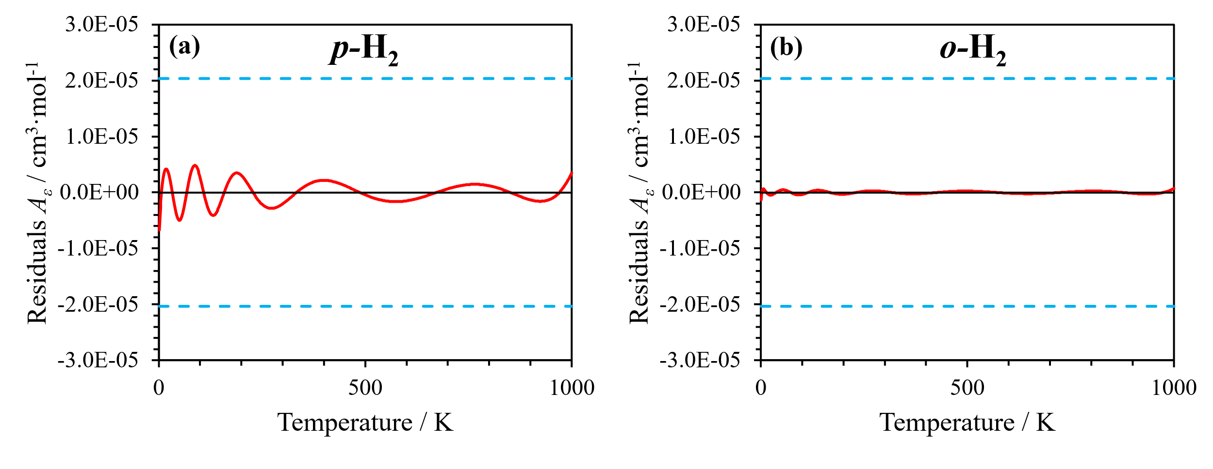
Fig. 2 Residuals of SITH function fit to calculated $A_{ε}\left(T\right)$ values (—) for (a) p-H₂ and (b) o-H₂. The residuals across the entire temperature range are within the standard uncertainty (- - -) of the calculated ab initio values.
The SITH function provides a substantially improved continuous representation of the calculated $A_{ε}\left(T\right)$ values for both spin-isomers. Its functional form captures all observed trends in the discrete data while reproducing values across the full temperature range to well within the calculated uncertainty. The correlations are consistent with the experimental measurements of Hermans et al. [15], who reported a low-density polarizability for normal hydrogen that is about 0.15% greater than for para-hydrogen at 20.4 K. Under these conditions, the polarizability is approximately proportional to $A_{ε}\left(T\right)$. The corresponding difference calculated by the SITH function in the present work is 0.13%. Similarly, the $A_{ε}$ values predicted for n-H₂ (taken as the appropriate linear combination of o-H₂ and p-H₂) are in good agreement with other experimental determinations at approximately room temperature. These are listed in Table 2 in which the deviations from the SITH function are all of a similar order of magnitude as the reported uncertainties.

Table 2.
Low-density coefficient $A_{ε}$ for n-H₂ as reported in the literature compared to new SITH function results in this work.
Source | $T$ / K | $A_{ε}$ / cm³·mol⁻¹ | Reported Uncertainty / cm³·mol⁻¹ | $A_{ε}$ This Work / cm³·mol⁻¹ | Absolute Difference / cm³·mol⁻¹
May et al. [1] | 273 | 2.0307 | 1.00 × 10⁻⁵ | 2.0304 | 3 × 10⁻⁴
May et al. [1] | 293 | 2.0311 | 1.00 × 10⁻⁴ | 2.0307 | 4 × 10⁻⁴
Orcutt & Cole [16] | 322.15 | 2.033 | 1.00 × 10⁻³ | 2.0313 | 2 × 10⁻³
Newell & Baird [17]* | 273.15 | 2.0300 | 8.00 × 10⁻⁴ | 2.0303 | 3 × 10⁻⁴
Nie [18] | 297.53 | 2.031027 | 7.10 × 10⁻⁵ | 2.0308 | 1.91 × 10⁻⁴
*Originally refractive index measurements, required correction to $A_{ε}$ is two orders of magnitude less than the reported precision

  - Isotope effects

One conceivable source of error in these calculations is that they are performed for isotopically pure H₂. Naturally occurring hydrogen on Earth is roughly 0.0156% deuterium [19]. This means that approximately one in 3200 hydrogen molecules will be an HD molecule. One could in principle perform a similar calculation of $A_{ε}$ for the HD isotopologue, but for our purposes it is sufficient to note that the calculated polarizabilities of HD in its rovibrational states [14] are roughly 1% smaller than the corresponding H₂ polarizabilities. When diluted by a factor of 3200, this difference is negligible in our context. The HD molecule also has a very small dipole moment (approximately 0.0009 Debye units), but the effect of this dipole on $A_{ε}$ has been analyzed [20] and found to be many orders of magnitude smaller than the contribution from the polarizability.

Experimental Database

While the low-density limit of the dielectric constant is well-established from theory as described in Sec. 2, experimental data are required to describe the higher-order effects of finite density. In this section, we review the available experimental data (excluding sources of low precision that are on the order of 100 years old or possess only a single datapoint).
In developing the database for fitting a correlation, it is necessary to convert data measured as a function of temperature and pressure to the independent variables of temperature and density used in our model. Computations of density were performed with the reference equations of state for n-H₂ and p-H₂ developed by Leachman et al. [21]. While changes in temperature due to the use of different temperature scales are unlikely to be significant compared to the accuracy of the experimental data, for consistency we converted all data to the International Temperature Scale of 1990 (ITS-90) [22] using established procedures [23]. The complete set of dielectric data for both p-H₂ and n-H₂ is illustrated in Fig. 3, converted for visual clarity to electric polarization ($P$) divided by density ($ρ$) as a rearrangement of Eq. (1).
  - Data for para-hydrogen

A large number of data for the dielectric constant of p-H₂ were reported in 1964 by Stewart [8]. These data were the source for the high-density behavior of the correlations presented by Harvey and Lemmon [6]. However, there are some subtleties in these data that were not fully appreciated in the previous work.
The first issue is the temperature scale. Because the official international scale of the time had its lower limit near 90 K, cryogenic work of that era employed a variety of special scales, and care must be taken to convert reported data to a modern temperature scale such as ITS-90. The Stewart data were reported on the NBS-55 scale developed at the National Bureau of Standards. Conversion of these temperatures to ITS-90 is a two-step process. First, the NBS-55 temperatures are converted to the International Practical Temperature Scale of 1968 (IPTS-68) using tables for the difference between the scales published by Bedford et al. [24]. Then, standard methods can be applied to convert the IPTS-68 temperatures to ITS-90 [23, 25]
Second, the paper of Stewart reported mass density, when molar density is needed for our correlation. We make this conversion with the molar mass employed in the Leachman et al. [21] equation of state, which is 2.01588 g·mol⁻¹. In principle, the hydrogen used by Stewart might have had a slightly different isotopic composition (and therefore molar mass) due to its production by electrolysis of water. However, any error arising from the molar mass will be negligible compared to the uncertainty in reported densities.
Third, the densities reported by Stewart were not measured. Stewart measured temperature and pressure, and derived densities based on an unreported smoothing equation fitted to the experimental data of Goodwin et al. [26]. Unfortunately, the original measured pressures were not reported, so we are unable to obtain densities corresponding to the current reference equation of state [21]. The additional uncertainty introduced by these density calculations is difficult to estimate, because we do not know how accurately the smoothing equation fitted the data of Goodwin et al. At a minimum, the uncertainty must be at least as much as the uncertainty of Goodwin’s density measurements (stated to be 0.1%) and the deviations of those data from the reference equation of state of Leachman et al. (who reported an average absolute deviation of 0.18%). Considering these factors, it is reasonable to estimate a standard uncertainty of 0.2% for the densities reported by Stewart. Especially for high-density states, this is a much larger source of uncertainty than the uncertainty in measuring the dielectric constant.
Charignon et al. [27] reported precise measurements for subcooled liquid hydrogen at pressures up to 1 MPa from 15 K to 23 K. They used e-H₂ prepared at 20 K, which would be almost entirely p-H₂. We made two small corrections to their reported data. Their temperature measurement was not calibrated to a temperature scale, but rather to the vapor pressure of p-H₂. While the paper does not say, according to the corresponding author [28] they would have obtained hydrogen properties from an early-2000s version of NIST’s REFPROP software. This would have used the now-obsolete equation of state reported by Younglove [29] in 1982. We therefore adjusted the reported temperatures by finding the ITS-90 temperature at which the current reference equation of state of Leachman et al. [21] gives the same vapor pressure as that given by the Younglove equation at the reported temperature. These corrections were no larger than 0.01 K, but this is not insignificant since Ref. [27] reported temperature uncertainties on the order of 0.001 K.
A second correction can be estimated for the calibration of the vacuum capacitance. Charignon et al. filled their cell with helium at a pressure near 0.2 MPa at several temperatures. Dividing the measured capacitance by a calculated value of helium’s dielectric constant gave the vacuum capacitance. The density of helium would have been computed from the equation of state of McCarty and Arp [30], which has been superseded by that of Ortiz Vega et al. [31]. The dielectric constant of helium would have been obtained from the simple function of density used by Arp et al. [32], but it can now be computed with much better accuracy by ab initio methods with the dielectric virial expansion (Eq. (1)). For the helium atom, $A_{ε}$ has been computed from first principles with an extraordinarily small relative uncertainty near 10⁻⁷ [33]. This value of $A_{ε}$ is lower than that used in Ref. [32] by approximately 0.006%. $B_{ε}(T)$ has been computed with relative uncertainties at liquid hydrogen temperatures on the order of 2% [34]. These $B_{ε}$ values are roughly one order of magnitude smaller than those from Ref. [32], perhaps because the older work used this term to fit liquid helium data where higher-order terms must be significant. First-principles results have recently been reported for $C_{ε}(T)$ [35]. Their uncertainties are somewhat larger, but the contribution of this term is negligible at the gas pressure of 0.2 MPa.
At the experimental temperatures and 0.2 MPa, the dielectric constant of helium computed by the methods of Arp et al. [32] is slightly smaller than that obtained from the best current information, meaning that Ref. [27] would have overestimated the vacuum capacitance (and therefore underestimated the hydrogen dielectric constant). We therefore multiplied the reported dielectric constants from Ref. [27] by these computed factors, which ranged from 1.000004 to 1.000007. This correction is of marginal significance at best when compared to the experimental uncertainty.
Guillien [36] reported measurements of the dielectric constant of various fluids near their melting points. Included in these measurements were those of saturated liquid hydrogen near the melting line over the temperature range (14 to 21) K. Based on the temperatures measured, we can assume the hydrogen to be effectively pure p-H₂. The reported data were extracted from Fig. 7 of Ref. [36], giving estimated uncertainties of at least the marker size in both dielectric constant and temperature (approximately 0.001 and 0.1 K, respectively). As was common prior to the widespread availability of calibrated cryogenic thermometers, the experimental temperatures were determined from hydrogen vapor-pressure thermometry using data from the Leiden Physical Laboratory [37]. To convert these measurements to ITS-90, the vapor pressures corresponding to the reported temperatures were first obtained by linear interpolation of the Leiden data [37] after which the equivalent ITS-90 saturation temperatures were calculated using the p-H₂ equation of state of Leachman et al. [21]. The magnitude of the conversions vary widely across the dataset, with the largest being on the order of 0.1 K.
Milenko and Sibileva [38] measured the dielectric constant of saturated liquid hydrogen for several o-p mixtures, including 99.8% p-H₂. Their temperature measurements were referenced to the vapor pressure of p-H₂ given in the 1948 compilation of Woolley et al. [39]. The corresponding ITS-90 temperatures were estimated by finding the ITS-90 temperature at which the current reference equation of state for p-H₂ of Leachman et al. [21] gave the vapor pressure produced by the correlation of Woolley et al. at the temperature reported in Ref. [38]. These corrections to the reported temperatures were 0.01 K or smaller.
Pashkov and Lobko published two papers, one in 1979 [40] and the other in 1980 [41], reporting the dielectric constant of the saturated liquid (for both p-H₂ and n-H₂) between roughly 15 K and 32 K. The relationship between these reports is unclear; the data tables have several points that coincide, or occasionally differ by one in the last digit, but neither table is a subset of the other. Based on the exact temperatures reported, it is possible that Ref. [41] is a combination of experimental and fitted data, although this is not what is implied in the text. The data at (18, 25, 29, and 31) K are identical between the sources, and so these were removed from the dataset of Ref. [41] for fitting purposes. We treat the remaining points as distinct sources, recognizing that there are likely further repeated measurements or conversions between the datasets. In the absence of information about their temperature measurement, we assume, based on the date of publication, that the temperatures were on the IPTS-68 scale and have calculated the density for saturated liquid p-H₂ at these converted temperatures from the Leachman et al. [21] equation of state.
Sellner et al. [5] recently demonstrated the use of a microwave cavity resonator for measurement of hydrogen o-p composition through the dielectric contrast between the spin isomers. In that work, the natural o-p conversion of hydrogen was monitored at five cryogenic conditions between approximately (10 and 40) K, including measurements in the solid, liquid, and supercritical phases. Due to the deficiencies of the Harvey and Lemmon dielectric model [6] at cryogenic conditions (as described above), the measured dielectric constants could not be directly converted to o-p composition. Instead, the measured data were fit to a second-order conversion model with fitted equilibrium end-points which permitted estimation of the dielectric constant of p-H₂ at each experimental condition. Four of these measurements corresponded to liquid or supercritical hydrogen states. Temperatures were measured directly on the ITS-90 scale using calibrated cryogenic resistance thermometers, while densities were calculated directly from the measured conditions with the equation of state of Leachman et al. [21].
As part of a study that was mainly concerned with solid properties, Younglove [42] reported 14 data points for the dielectric constant of compressed liquid p-H₂ at temperatures in the range (17 to 23) K. The pressure range extended up to approximately 32 MPa. Younglove’s temperatures were converted to ITS-90 from the NBS-55 scale as described above, and densities were calculated from these converted temperatures and reported pressures with the Leachman et al. [21] equation of state for p-H₂.

  - Data for normal hydrogen

In Harvey and Lemmon [6], the high-density correlations for both e-H₂ and p-H₂ were fit solely to the p-H₂ data of Stewart [8]. In the present work, separate correlations are instead developed for o-H₂ and p-H₂ individually, rather than treating e-H₂ as an independent fluid. Unfortunately, pure o-H₂ is not naturally occurring – the maximum possible equilibrium composition is achieved in n-H₂ (75%). Consequently, the high-density correlations for o-H₂ in this work are determined indirectly by first fitting the available p-H₂ data and then fitting the remaining o-H₂ parameters to the available measurements for n-H₂. The available n-H₂ data consist primarily of near-room-temperature measurements and saturated-liquid data, with relatively few measurements at intermediate temperatures and densities.
In 2009, May et al. [1] performed high-precision measurements of the relative dielectric permittivity of vapor-phase n-H₂ at (273 and 293) K using a quasi-spherical cavity resonator calibrated with helium. They used their results to determine values of hydrogen’s molecular electric polarizability which agreed with theory (from Rychlewski’s ab initio calculations [13]). Moreover, they also calculated estimates for the first and second dielectric virial coefficient of n-H₂ ($A_{ε}$ and $B_{ε}$) at the experimental temperatures. No corrections were made to the data.
Constable et al. [43] measured the dielectric constant of saturated liquid n-H₂ between approximately (13.5 and 19.4) K. Their temperature scale was not stated; based on the year of publication we assumed it to be IPTS-68 with conversion to ITS-90 as described above.
Kogan et al. [44] reported the dielectric constant of saturated n-H₂ between approximately (14 and 20.4) K. Their temperature measurement was based on the vapor pressure of p-H₂ as given by Woolley et al. [39]. We converted those temperatures to ITS-90 by finding the temperature at which the same vapor pressure was given by the reference equation of state of Leachman et al. [21]; the adjustments were no greater than 0.01 K.
Michels et al. [45] measured the dielectric constant of hydrogen at high pressures (up to 145 MPa) and two temperatures (298 and 373) K. The spin-isomer composition for the measurements was not stated, but the hydrogen can be reasonably assumed to be n-H₂ based on the experimental temperatures. The temperature scale used was not explicitly stated. However, Michels et al. described the work as a continuation of an earlier study [46], in which temperatures were measured with mercury thermometers calibrated against standards from the Physikalisch-Technische Reichsanstalt in Berlin. The measurements were therefore likely reported on ITS-27, which, in this temperature range, is identical to ITS-48 [23]. These temperatures were subsequently converted to IPTS-68 using the relations from Douglas [47], and then to ITS-90 as described above.
Milenko and Sibileva [38] reported results for the saturated liquid at several o-p compositions, including o-H₂ compositions above 75% achieved through preferential adsorption of o-H₂ on alumina (following Ref. [48]). In the present work, only the n-H₂ measurements were included in the fitting procedure, while the remaining non-equilibrium o-p composition data were reserved for independent validation of the correlation (see Sec. 4.4). The temperatures reported in Ref. [38] were converted to ITS-90 as described for their p-H₂ data in Sec. 3.1.
Pashkov and Lobko [40, 41] reported dielectric constants for saturated liquid n-H₂ between approximately (15 and 32) K. As discussed for the corresponding p-H₂ measurements in Sec 3.1, the relationship between the two reports is unclear, with several measurements appearing to be duplicated between the sources. Consequently, points exactly repeated between the datasets were removed for fitting purposes; these corresponded to measurements at (17, 18, and 29) K. The reported temperatures were converted to ITS-90 as described for the corresponding p-H₂ data in Sec. 3.1.
Pashkov et al. [49] reported dielectric constants for saturated liquid mixtures of n-H₂ and neon; this included endpoints corresponding to pure H₂ at four temperatures. Of the four points, three are identical to measurements reported in Pashkov and Lobko’s previous 1980 work [41], and so were unlikely to have been measured independently. As such, for fitting purposes, these three points (corresponding to the data at (25, 29, and 31.14) K) were removed. As with other works from Pashkov [40, 41], the temperature scale was not stated but assumed to be IPTS-68 with conversions to ITS-90 as described above.
As well as estimates of p-H₂ (described above), Sellner et al. [5] also estimated the dielectric constant of n-H₂ at four different liquid and supercritical phase conditions in their experiments. Temperatures were measured directly on the ITS-90 scale using calibrated cryogenic resistance thermometers, while densities were calculated directly from the measured conditions with the equation of state of Leachman et al. [21].
Finally, Watson et al. [50] reported the dielectric constants of various gases at room and liquid air temperatures reduced to standard conditions with the ideal gas law (298.15 K and 1 atm). However, the original measurement conditions were also given allowing for reconstruction of the original experimental data. For hydrogen, the spin-isomer composition was not stated. Since purification was performed with activated charcoal at liquid-air temperatures, some o-p conversion may have occurred prior to measurement [51]. The temperature scale was not specified. The room-temperature measurements were assumed to be on ITS-27 and converted to ITS-90 as described above for Ref. [45]. The liquid-air temperatures (~80 K) were determined from oxygen vapor-pressure thermometry, likely using the correlation of Cath [52]. As such, the oxygen vapor pressures were back-calculated using the correlation in Ref. [52] and then used to determine the ITS-90 experimental temperatures using the oxygen saturation curve of Stewart et al. [53] as implemented in the software REFPROP 10.0 [54].

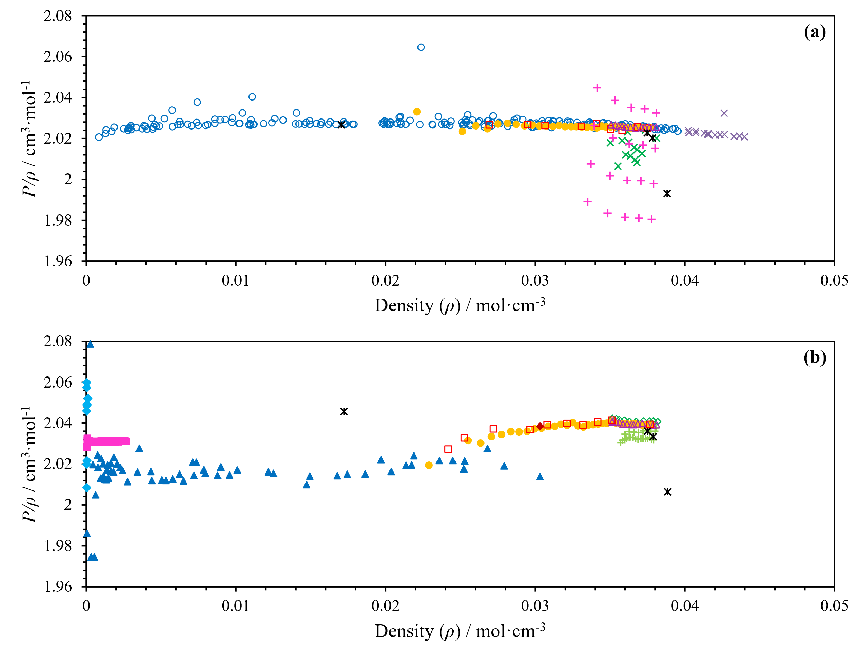
Fig. 3 Dielectric data available in the literature for p-H₂ and n-H₂ converted to molar polarization ($P/ρ)$ by a rearrangement of Eq. (1). (a) p-H₂ data of (+) Charignon et al. 2007 [27], (×) Guillien 1940 [36], (△) Milenko & Sibileva 1975 [38], (●) Pashkov & Lobko 1979 [40], (□) Pashkov & Lobko 1980 [41], (✱) Sellner et al. 2026 [5], (○) Stewart 1964 [8], and (×) Younglove 1968 [42]. (b) n-H₂ data of (+) Constable et al. 1975 [43], (◇) Kogan 1971 et al. [44], (■) May et al. 2009 [1], (▲) Michels et al. 1935 [45], (△) Milenko & Sibileva 1975 [38], (●) Pashkov & Lobko 1979 [40], (□) Pashkov & Lobko 1980 [41], (◆) Pashkov et al. 1987 [49], (✱) Sellner et al. 2026 [5], and (◆) Watson et al. 1931 [50].

Correlations

Higher-order coefficients $B_{ε}(T)$ and $C_{ε+}(T)$

$B_{ε}$, the second dielectric virial coefficient in Eq. (1), represents the contribution of intermolecular pair interactions to the dielectric response. As with $A_{ε}$, $B_{ε}$ can theoretically be calculated from quantum statistical mechanics using ab initio intermolecular pair potentials together with interaction-induced pair polarizabilities, as demonstrated by Garberoglio and Harvey [34] for helium, neon, and argon. Whilst highly accurate ab initio intermolecular potentials have been developed for hydrogen [55, 56], the published collision-induced polarizabilities [57] have relatively high uncertainties due to the complexity of the calculation for anisotropic molecules, and so no corresponding calculation of $B_{ε}$ has been performed for H₂. For molecules without permanent dipoles, such as hydrogen, $B_{ε}$ has been shown to vary approximately linearly with $1/T$ [58].
The higher-order terms $C_{ε}$ and beyond become increasingly important at higher densities; however, they are extremely difficult to calculate theoretically due to the large number of degrees of freedom associated with three-body and higher-order intermolecular interactions. As such, for this work, we approximate the dielectric virial coefficients $C_{ε}$ and above by a single empirical term, $C_{ε+}(T)$, a function of temperature that multiplies density raised to the power of a temperature-independent empirical exponent $D$. Hence, we come to the empirical form of the correlation as in Harvey and Lemmon’s work [6]:
 | $\frac{ε-1}{ε+2}=P=ρ\left(A_{ε}\left(T\right)+B_{ε}\left(T\right)ρ+C_{ε+}\left(T\right)ρ^{D}\right),$ | (10)
with $A_{ε}\left(T\right)$ for p-H₂ and o-H₂ as determined above in Sec. 2. In the absence of correlations for $B_{ε}\left(T\right)$ and $C_{ε+}\left(T\right)$, we approximate both as linear functions in $1/T$, following Harvey and Lemmon [6]:
 | $B_{ε}\left(T\right)=b_{0}+b_{1}\left(\frac{T_{0}}{T}-1\right),$ | (11)
 | $C_{ε+}\left(T\right)=c_{0}+c_{1}\left(\frac{T_{0}}{T}-1\right),$ | (12)
with $T_{0}=273.16$ K. The coefficients $b_{0}$, $b_{1}$, $c_{0}$, and $c_{1}$ for p-H₂ and o-H₂ are determined through fitting to the experimental literature data summarized in Sec. 3.

Correlation for para-hydrogen

The dielectric data sources described in Sec. 3.1 were used to fit the four coefficients for p-H₂ in Eq. (11) and Eq. (12). The exponent ($D$) was not treated as a free parameter and was fixed at $D = 2$, consistent with the original Harvey and Lemmon [6] correlation, as there were insufficient data to justify the introduction of an additional degree of freedom. This was also the case for the correlation for o-H₂ in Sec. 4.3 below.
The fitting procedure first converted the measured dielectric constants ($ε$), to electric polarization ($P$, as in Eq. (10)). The low-density contribution, $A_{ε}(T)$, was fixed using the SITH function developed in Sec. 2.4. The remaining density-dependent terms were then fitted by weighted linear least-squares regression to Eq. (10), with free parameters $b_{0}$, $b_{1}$, $c_{0}$, and $c_{1}$. Experimental weighting factors were determined from the combined uncertainty associated with the dielectric constant and molar density. The uncertainty contribution arising from density was estimated using a relative uncertainty of 0.1% for densities calculated from the Leachman et al. equation of state (the predicted equation of state uncertainty at temperatures below 250 K [21]), and 0.2% for the Stewart [8] data based on the estimate discussed in Sec 3.1. To limit the influence of measurements that were inconsistent with their assigned uncertainties, an iterative “sigma-clipping” procedure was applied [59, 60] where after each weighted regression, any point with a calculated absolute normalized residual greater than three standard deviations ($σ$) was excluded. The regression was then repeated until the set of retained points remained unchanged. The final correlation coefficients ($b_{0}$, $b_{1}$, $c_{0}$, and $c_{1}$) were then rounded to the minimum number of digits required to ensure that the induced rounding error remained below 1% of the combined experimental uncertainty of all the data.
Data from Charignon et al. [27], Guillien [36], and Sellner et al. [5] were excluded from the fitting procedure. As shown in Fig. 3(a), the datasets of Refs. [27] and [36] exhibit systematic deviations relative to the remaining literature data. For Ref. [36], these deviations are likely associated with the experimental methods together with the substantial uncertainty introduced through our data extraction method and reconstruction of temperatures from historical vapor-pressure data (see Sec. 3.1). The data of Charignon et al. [27] display a pronounced systematic offset that follows the experimental isobars, suggesting a pressure-dependent systematic error, potentially associated with the capacitance calibration procedure in which the authors reported a 4% increase in vacuum capacitance following their hydrogen measurements. The data of Sellner et al. [5] were not included because the reported dielectric constants were inferred from fitted o-p conversion curves rather than measured directly. Comparisons of these excluded data with the optimized model are nevertheless presented in the residual plots below (Fig. 4).
The residuals of the experimental data relative to the resulting correlation are shown in Fig. 4, together with those of the previous Harvey and Lemmon correlation [6], which employed a linear approximation for $A_{ε}(T)$ and was fitted only to the Stewart [8] data above 50 K. The fitted coefficients obtained in the present work are reported in Table 3. Strong correlations were observed between several fitted coefficients in the covariance matrix, reflecting the limited independence of the temperature-dependent basis functions over the available experimental data range. Examination of the fitted parameters indicated that the principal improvement relative to the Harvey and Lemmon correlation [6] arose from two effects: the revised low-density representation of $A_{ε}(T)$ developed in Sec. 2.4, and the introduction of a non-zero temperature dependence in $C_{ε+}(T)$ through the $c_{1}$ parameter. In particular, retaining the Ref. [6] values for $B_{ε}(T)$ and $C_{ε+}(T)$ (listed in Table 3) while substituting only the revised $A_{ε}(T)$ did not fully remove the systematic residual trends observed at high densities (as apparent in the previous model in Fig. 4(b)). The fitted $c_{1}$ term was found to play the dominant role in correcting these remaining deviations, substantially improving the representation of the high-density cryogenic data.
Of the 275 data points included in the fitting procedure, only two exhibited normalized residuals exceeding three standard deviations ($σ$) after convergence of the iterative regression and were therefore classified as outliers. One point belonged to Stewart [8] and the other to Younglove [42]. It should also be noted that all available p-H₂ experimental data are below 100 K, meaning that no direct low-density gas-phase measurements were available to constrain the correlation at higher temperatures. Consequently, while the low-density behavior remains primarily constrained by $A_{ε}$, the absence of data at higher temperatures makes it difficult to fully justify the use of the linearized forms for $B_{ε}(T)$ and $C_{ε+}(T)$ in Eq. (11) and Eq. (12) respectively. The predicted behavior of these functions at higher temperatures therefore remains largely an extrapolation of the available high-density cryogenic data.
The root-mean-square of the residuals of the retained points normalized by their combined experimental uncertainties (${RMS}_{z}$) was 0.45, indicating that the retained data were reproduced well within their assigned uncertainties. The average absolute deviation (AAD) in dielectric constant was 0.0060%. Rounding each of the four fitted coefficients $b_{0}$, $b_{1}$, $c_{0}$, and $c_{1}$ to three significant figures changed the predicted values by less than 1% of the combined experimental uncertainty for every data point, and hence is determined as the level of precision required for the correlation coefficients. With the Harvey and Lemmon correlation [6], the same data produced a ${RMS}_{z}$ of 0.52 and an AAD of 0.0098%.

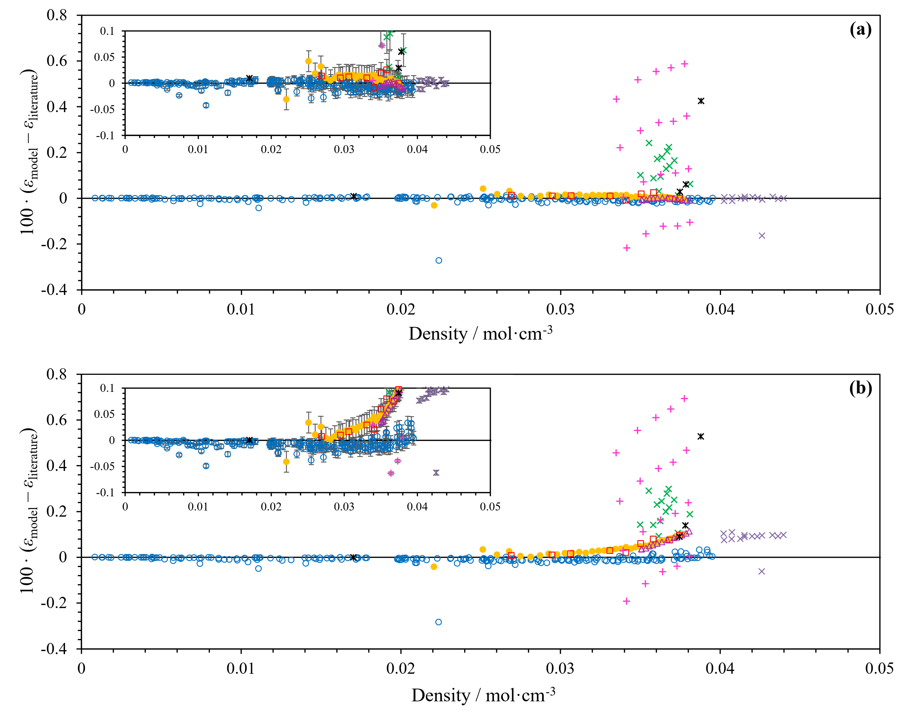
Fig. 4 Residuals of the p-H₂ literature data to the fitted model in Eq. (10) (100 times scaling) against molar density of (a) this work, and (b) Harvey and Lemmon [6]. Each panel includes an inset zoomed into the (-0.1, 0.1) residuals range. Experimental uncertainties of the dielectric data as reported in the literature sources are shown as error bars. The data included are those listed in Sec 3.1: (+) Charignon et al. 2007 [27], (×) Guillien 1940 [36], (△) Milenko & Sibileva 1975 [38], (●) Pashkov & Lobko 1979 [40], (□) Pashkov & Lobko 1980 [41], (✱) Sellner et al. 2026 [5], (○) Stewart 1964 [8], and (×) Younglove 1968 [42]. Note, the data from Refs. [5, 27, 36] (✱, +, ×) were not used in the fit for this work ((a)), and only data from Ref. [8] (○) above 50 K were used in the fit of Harvey and Lemmon [6] ((b)).

Table 3.
Fitted coefficients for $b_{0}$, $b_{1}$, $c_{0}$, and $c_{1}$ for the p-H₂ and o-H₂ correlations in this work and Harvey and Lemmon (H&L) [6].
 | para-hydrogen |  | ortho-hydrogen
 | This work* | H&L | This work | H&L
$$b_{0}$$ | 0.2096 | 0.181 | 0.2076 | 0.181
$$b_{1}$$ | 0.02870 | 0.021 | 0.03552 | 0.021
$$c_{0}$$ | -6.031 | -7.4 | -7.564 | -7.4
$$c_{1}$$ | -0.7348 | 0 | -0.1381 | 0
*Only 3 digits are required to maintain the fit quality, however 4 are shown for consistency with o-H₂

Correlation for ortho-hydrogen

Unlike for p-H₂, direct dielectric measurements for pure o-H₂ are not available in the literature. The o-H₂ $B_{ε}(T)$ and $C_{ε+}(T)$ correlations were therefore determined indirectly from the experimental n-H₂ dielectric-constant measurements using polarization ($P$) mixing with the p-H₂ correlation defined in Sec. 4.2. Mixture polarization can be defined by combining pure-fluid polarizations according to the mixing rule proposed by Harvey and Prausnitz [61], which uses scaled volume fractions dependent on critical volumes of the pure components. For hydrogen, the critical volumes of o-H₂ and p-H₂ predicted by the Leachman et al. equation of state [21] differ by only 0.6%, and the critical volumes of o-H₂ and n-H₂ have not been experimentally validated. More elaborate Onsager-type treatments for combining o-p dielectric constants have been considered [62], but these approaches are highly complex and were reported to yield only marginal differences compared to a simple linear mixing assumption. Given both the minimal expected deviation from ideal polarization mixing and the limited availability and consistency of the experimental n-H₂ dielectric data (see Fig. 3(b)), the additional complexity introduced by higher-order mixing treatments cannot presently be justified and the polarization of o-p mixtures was therefore approximated in this work as a linear combination of the pure-component polarizations at fixed temperature and molar density.
For all the n-H₂ datasets listed in Sec. 3.2, the o-H₂ composition was not independently measured, with the sources either specifying the hydrogen as “normal” or not defining it at all. In this work, all n-H₂ experimental data were therefore assumed to correspond to a composition of 0.749 mol/mol o-H₂, representative of e-H₂ between (272 and 313) K. The polarization of n-H₂ ($P_{nH_{2}}$) for the experimental data considered in this work may therefore be taken to be
 | $P_{nH_{2}}=0.251*P_{pH_{2}}+0.749*P_{oH_{2}},$ | (13)
with $P_{pH_{2}}$ and $P_{oH_{2}}$ being the p-H₂ and o-H₂ pure-component polarizations, respectively.
The fitting procedure otherwise followed a similar methodology as that described for p-H₂ in Sec. 4.2, including iterative “sigma-clipping” for outlier exclusion, and weighting based on the combined dielectric and density uncertainties. Density uncertainties of 0.1% were assigned below 250 K and 0.04% above 250 K based on the estimated uncertainty of the Leachman et al. equation of state [21] in the corresponding temperature regions.
However, the fitting procedure differed from that used for p-H₂ in several minor respects. First, the coefficients were determined using bounded weighted least-squares optimization implemented with the “least_squares” function in SciPy [63]. The default “Trust Region Reflective” algorithm [64] was used to impose lower and upper bounds on each fitted coefficient. These bounds restricted the coefficients to be within the same order of magnitude as the corresponding p-H₂ coefficients listed in Table 3. Secondly, soft prior constraints were imposed on each coefficient based on the fitted p-H₂ values. These priors were introduced because the available n-H₂ data provided only weak constraints on the intermediate-density temperature dependence of the correlation. In particular, the available measurements consist primarily of saturated-liquid cryogenic data together with low-density room- and high-temperature measurements, leaving a substantial gap in moderate-density intermediate-temperature states. The only available moderate-density measurements were those of Michels et al. [45], which possess comparatively large uncertainties, uncertain spin-isomer composition, and discrepancies with the low-density data of May et al. [1] (see Sec. 3.2 and Fig. 3(b)). The values of the priors were determined to be that which minimized the resulting ${RMS}_{z}$ and AAD of the fit.
Without these additional constraints, the optimization was found to converge toward non-physical parameter combinations with unrealistically large coefficients while producing only modest improvements in residuals. The prior constraints therefore served to stabilize the optimization while remaining physically reasonable, as o-H₂ and p-H₂ possess identical electronic structure and nearly identical intermolecular potentials, and so significant differences in the higher-order dielectric terms are not expected despite the differing rotational-state populations that primarily influence $A_{ε}(T)$.
The n-H₂ data of Constable et al. [43], Watson et al. [50], and Sellner et al. [5] were excluded from the fitting procedure. The data of Sellner et al. [5] were excluded for the same reason as discussed above for p-H₂. The low-density data of Watson et al. [50] exhibit a clear systematic offset from the more recent measurements of May et al. [1] and do not extrapolate toward the theoretically predicted low-density limit discussed in Sec. 2.4. Moreover, it is likely that the H₂ measured was not n-H₂ because the purification step intended to remove impurities used activated charcoal at liquid-air temperatures. This would have facilitated at least partial o-p conversion, resulting in an unknown spin-isomer composition [51]. The data of Constable et al. [43] similarly display a systematic offset relative to the remaining literature data (see Fig. 3(b)) and contain one point reported below the n-H₂ triple-point temperature which is classified as liquid data, suggesting possible issues with experimental temperature determination or phase identification. As for p-H₂, these excluded datasets are still presented in the residuals plots below (Fig. 5).
The resulting residuals relative to the new fitted correlation are shown in Fig. 5 together with those of the Harvey and Lemmon correlation [6]. The fitted coefficients are reported alongside the p-H₂ coefficients in Table 3. As would be expected, the parameters for o-H₂ are similar to those for p-H₂; all the same sign and order of magnitude. With an extended density range for fitting compared to p-H₂, only moderate correlations were observed between the fitted coefficients in the covariance matrix, save for the temperature-dependent terms $b_{1}$ and $c_{1}$. Compared with the Harvey and Lemmon model [6], the present correlation substantially improves the representation of the high-density saturated-liquid data of Pashkov and colleagues [40, 41, 49], Milenko and Sibileva [38], and Kogan et al. [44]. However, a residual structure remains evident across the full density range. Attempts to fully remove these trends through unconstrained fitting resulted in non-physical parameter values and unstable extrapolation behavior.
These remaining systematic deviations likely reflect the limited availability and consistency of the experimental n-H₂ dielectric data. In particular, the absence of intermediate-temperature moderate-density measurements makes it difficult to fully justify the applicability of the linearized forms for $B_{ε}\left(T\right)$ and $C_{ε+}\left(T\right)$ over the entire temperature range considered, especially for liquid H₂ where it is possible the simplified three-term virial form in Eq. (10) may be insufficient to reflect the higher-order interactions. It is therefore possible that the true temperature dependence of the higher-density dielectric terms cannot be adequately represented by only the simple forms of Eq. (11) and Eq. (12). However, the currently available experimental data are insufficient to justify the introduction of higher-order temperature terms or additional fitting coefficients.
Of the 171 data points included in the fitting procedure, 16 exhibited normalized residuals exceeding three standard deviations ($σ$) after convergence of the iterative regression and were therefore classified as outliers. Fifteen of these outliers belonged to mid-range densities of Michels et al. [45] and the remaining one belonged to Pashkov and Lobko [40]. The final correlation yielded an AAD in dielectric constant of 0.0215% and an ${RMS}_{z}$ of 1.03. The fitted coefficients ($b_{0}$, $b_{1}$, $c_{0}$, and $c_{1}$) required rounding to a minimum of four digits to preserve the fit to deviations of less than 1% of the combined experimental uncertainty. With the Harvey and Lemmon correlation [6], the same data produced a ${RMS}_{z}$ of 2.11 and an AAD of 0.0389%, indicating a significant improvement.
To assist users in computer-program verification of these new correlations, we supply a table of calculated values in the Appendix (Table 6) for $A_{ε}$, $B_{ε}$, $C_{ε+}$, $P$, and $ε$ for four different $T$ and $ρ$ points and four different spin-isomer compositions, including pure o-H₂ and p-H₂, a 50/50 o-p mixture, and n-H₂. The values for n-H₂ were calculated with coefficients as defined in Table 5 in the Appendix.

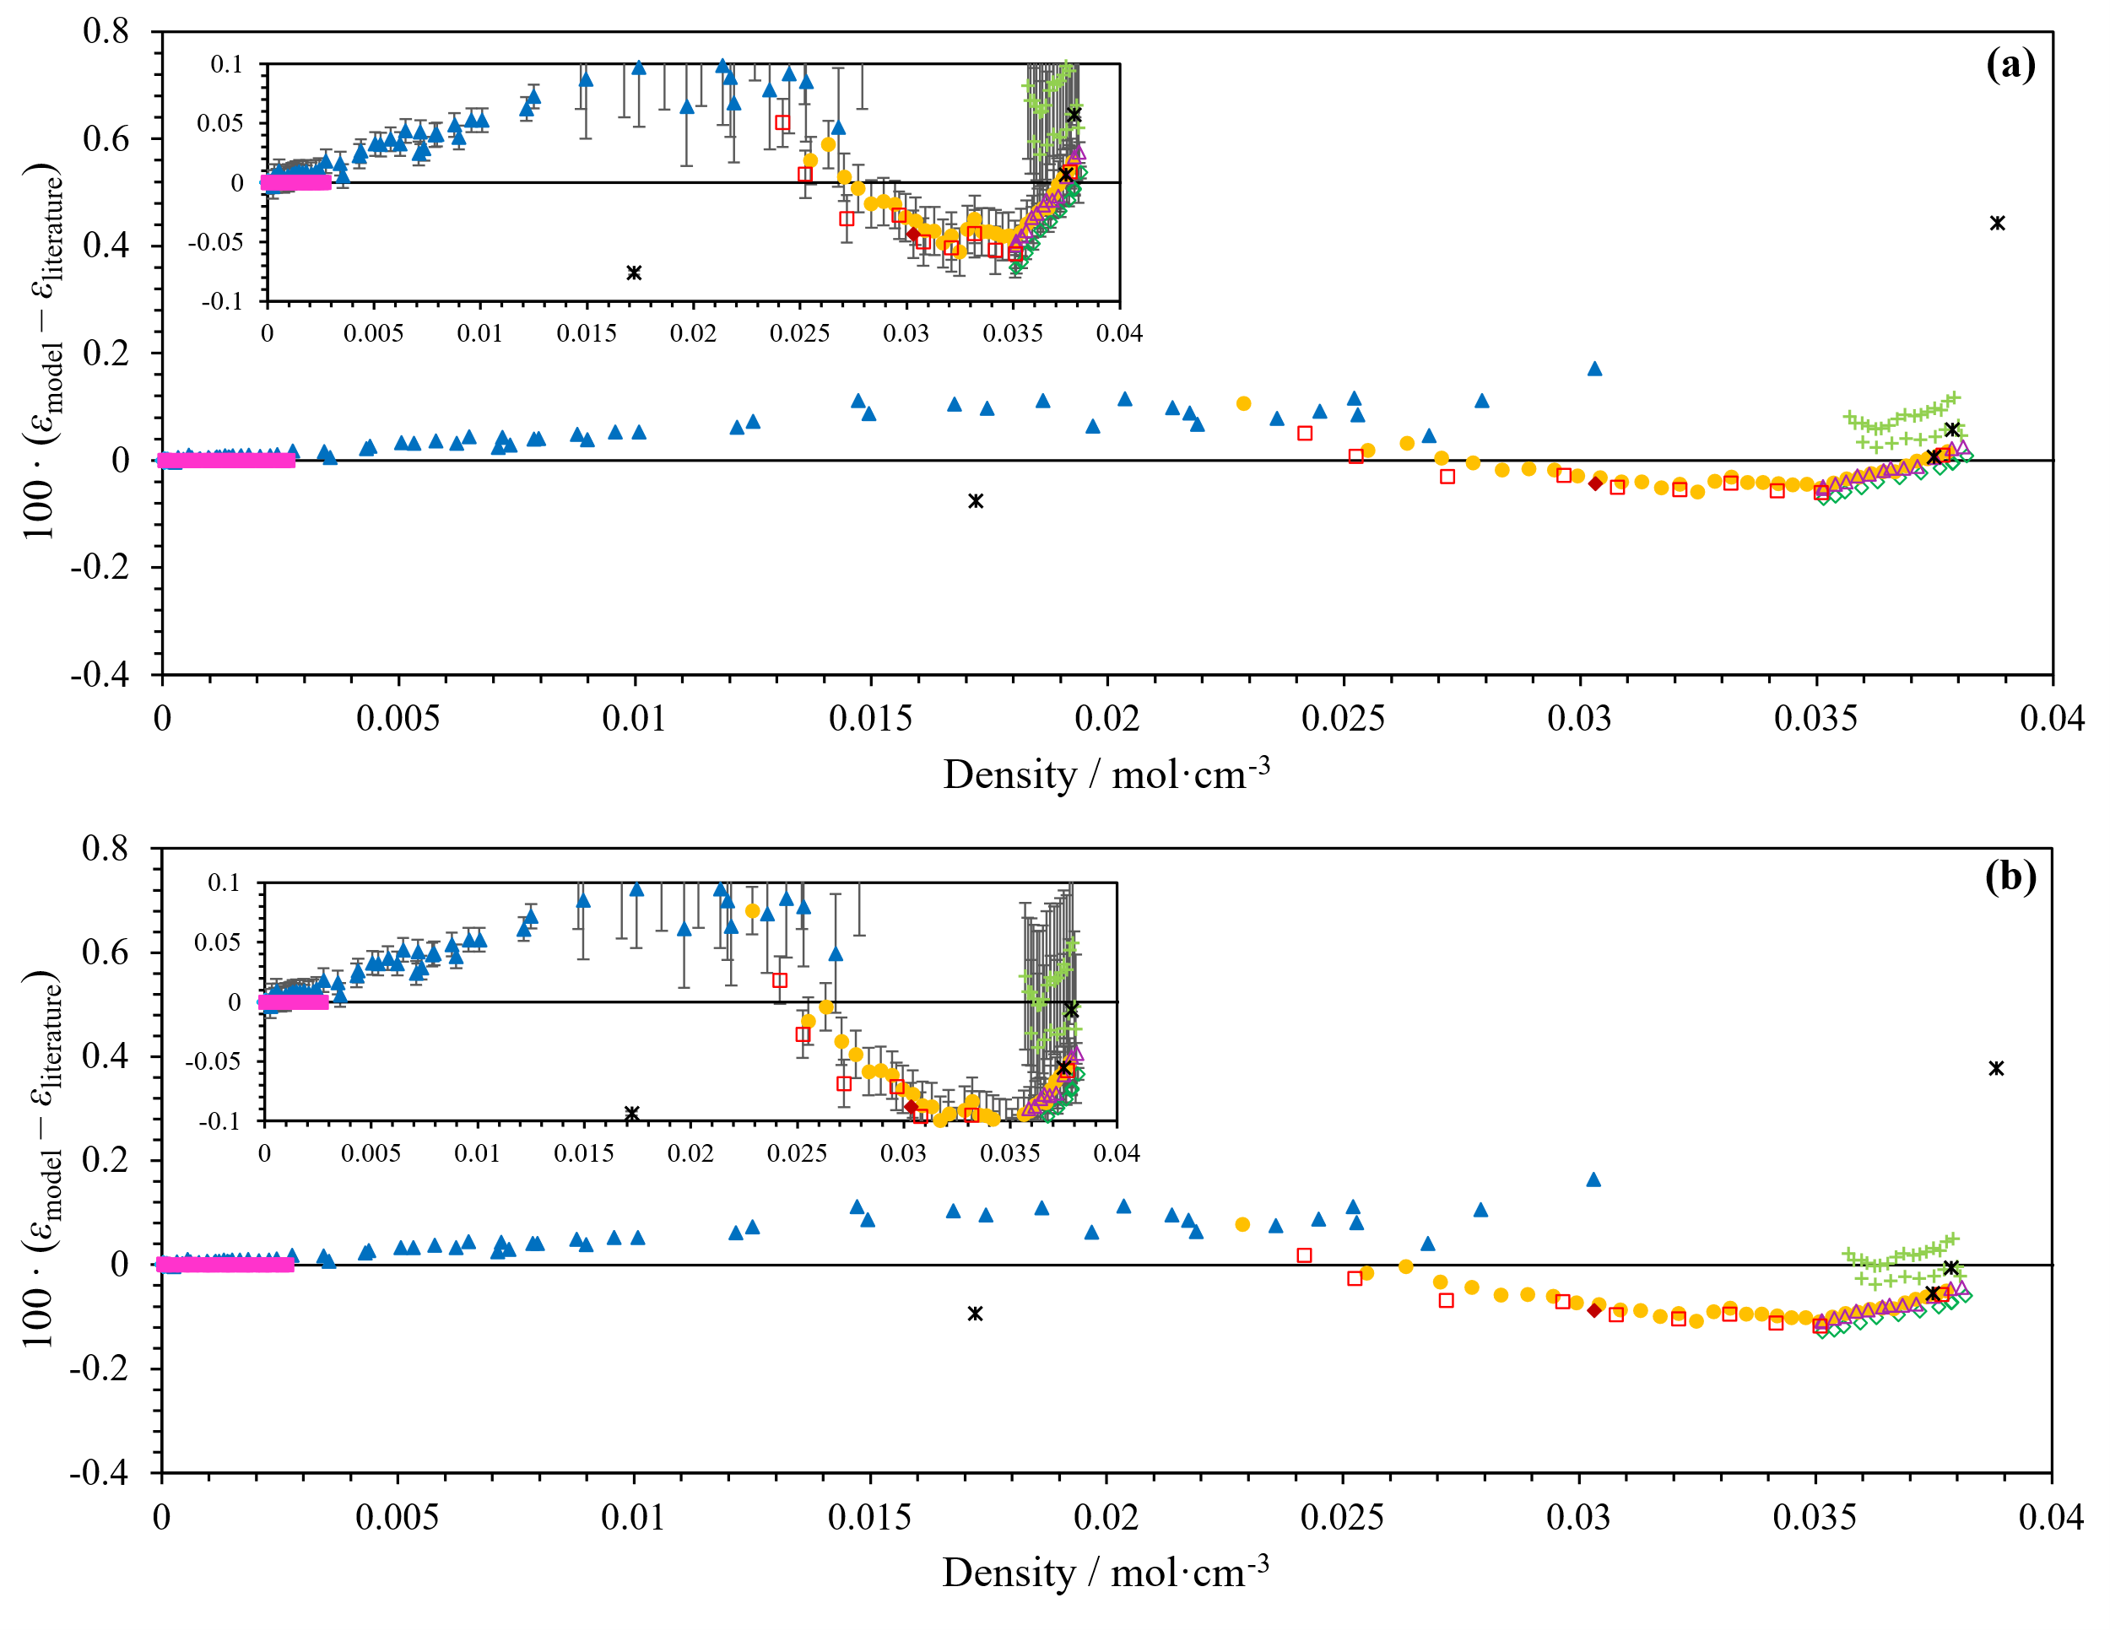
Fig. 5 Residuals of the n-H₂ literature data to the fitted model in Eq. (10) (100 times scaling) against molar density of (a) this work, and (b) Harvey and Lemmon [6]. Each panel includes an inset zoomed into the (-0.1, 0.1) residuals range. Experimental uncertainties of the dielectric data as reported in the literature sources are shown as error bars. The data included are those listed in Sec 3.2: (+) Constable et al. 1975 [43], (◇) Kogan 1971 et al. [44], (■) May et al. 2009 [1], (▲) Michels et al. 1935 [45], (△) Milenko & Sibileva 1975 [38], (●) Pashkov & Lobko 1979 [40], (□) Pashkov & Lobko 1980 [41], (◆) Pashkov et al. 1987 [49], (✱) Sellner et al. 2026 [5], and (◆) Watson et al. 1931 [50]. Note, the data from Refs. [5, 43, 50] (✱, +, ◆) were not used in the fit for this work ((a)), and only p-H₂ data from Ref. [8] above 50 K were used in the fit of Harvey and Lemmon [6] ((b)).

Comparisons with other literature

$B_{ε}$ has previously only been reported in studies of low-density n-H₂ [1, 16]. Because $A_{ε}$ dominates the dielectric response in the low-density limit, literature estimates of $B_{ε}$ are subject to substantial uncertainty. A comparison of the literature values with those predicted by the present correlation and the correlation of Harvey and Lemmon [6] is shown in Table 4 where $B_{ε}$ (and $A_{ε}$) have been calculated as an appropriate linear molar combination of o-H₂ and p-H₂ at the temperature and density conditions.
The new correlation predicts slightly larger values of $B_{ε}$ than Harvey and Lemmon [6], although both correlations yield values above the experimental estimates. Given the relatively large uncertainty associated with the experimental determinations of $B_{ε}$, the currently available data are insufficient to determine whether this difference reflects limitations in the adopted functional form or uncertainty in the experimental estimates themselves. Nevertheless, despite being fitted primarily to cryogenic measurements, the present correlation predicts room-temperature values of $B_{ε}$ that remain comparable to the independent estimates of May et al. [1] and Orcutt and Cole [16], suggesting that the adopted temperature dependence provides a physically reasonable extrapolation beyond the temperature range of most of the fitted data.

Table 4.
Reduced second dielectric virial coefficient for n-H₂ ($b_{ε}=B_{ε}/A_{ε}$) as reported in the literature compared to new correlations in this work and the Harvey & Lemmon [6] correlation.
Source | $T$ / K | $b_{ε}$ / cm³·mol⁻¹ | Reported Uncertainty / cm³·mol⁻¹ | $b_{ε}$ This Work / cm³·mol⁻¹ | $b_{ε}$ Ref. [6] / cm³·mol⁻¹
May et al. [1] | 273 - 293 | 0.03 | 0.05 | 0.10 | 0.09
Orcutt & Cole [16] | 322.15 | 0.03 | 0.1 | 0.10 | 0.09

One motivation for this work was the findings of Sellner et al. [5], in which the relative shift in dielectric constant measured between n-H₂ and p-H₂ showed clear discrepancies with the Harvey and Lemmon correlation [6], but was consistent with the measurements of Pashkov and Lobko [41]. Fig. 6 reproduces the same comparison presented in Fig. 14 of Ref. [5], now including the relative dielectric-constant shift predicted by the new correlations developed in this work. While the n-H₂ and p-H₂ measurements of Pashkov and Lobko [41] contributed to the fitted correlations (see Secs. 4.2 and 4.3 above), the measurements of Sellner et al. [5] were excluded from the fitting procedure.
As well as n-H₂ and p-H₂, Milenko and Sibileva [38] also investigated the variation of dielectric constant with ortho-fraction in saturated liquid H₂. High ortho-fraction mixtures (up to 94.4 mol%) were prepared through preferential adsorption on alumina following the methods of Cunningham et al. [48] with composition monitored using a thermal-conductivity analyzer calibrated against n-H₂ and p-H₂. Since ortho-fractions above 75 mol% required extrapolation of the calibration, the reported compositions likely possess additional uncertainty of an unknown magnitude. Consequently, only the n-H₂ measurements were used in the fitting procedure described in Sec. 4.3. The resulting model residuals in Fig. 7 therefore provide an independent test of the model at non-equilibrium o-p compositions by comparing the residuals of all dielectric-constant measurements reported by Milenko and Sibileva [38] with both the present correlation and that of Harvey and Lemmon [6]. Overall, the scatter in the residuals is significantly reduced with the new correlations. As a quantitative comparison, the total RMS of the residuals is approximately halved for the present work (RMS = 0.053) compared with Harvey and Lemmon [6] (RMS = 0.097). As is evident from Fig. 7(b), the largest improvement occurs at low ortho-fractions, reflecting the significant improvement of the high-density description of p-H₂ in this work (see Fig. 4). The increased scatter observed at higher ortho-fractions could reflect either greater uncertainty in the reported ortho-fractions above the n-H₂ composition, limitations of the derived o-H₂ correlation at high density, or a combination of both.

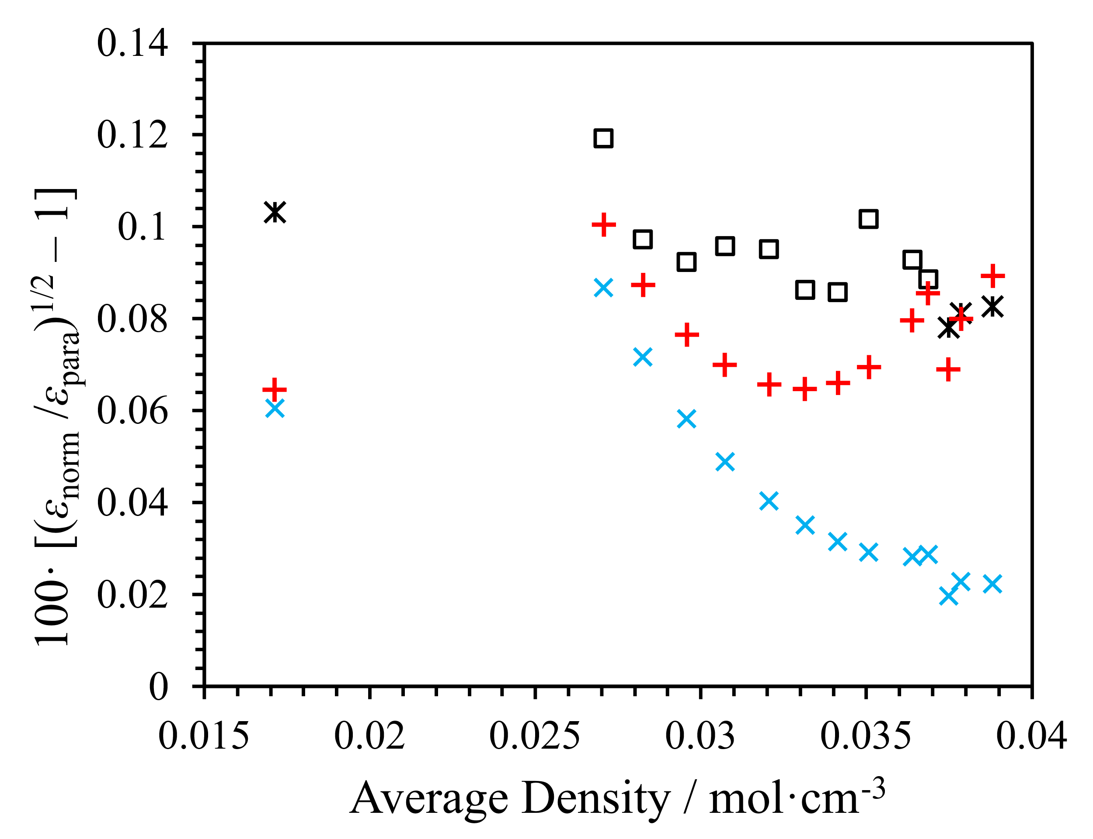
Fig. 6 (Reproduced from Sellner et al. [5]). Relative change in dielectric constant arising from the transition between n-H₂ and p-H₂ as a function of average density. Shown are the experimental data from Pashkov and Lobko [41] (□) and Sellner et al. [5] (✱), compared to the new model of this work (+) and the Harvey and Lemmon model [6] (×). Note: the data from Ref. [5] were not used in developing the new correlation in this work.
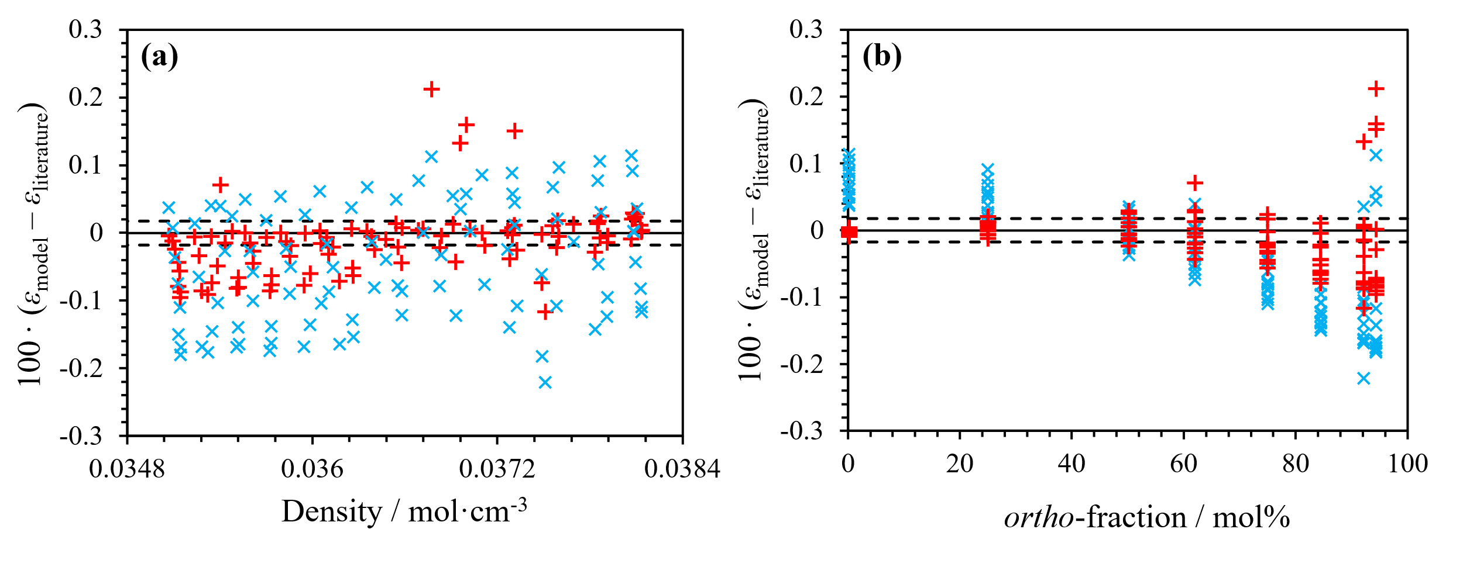
Fig. 7 Residuals of the new model in this work (+) and the Harvey and Lemmon model [6] (×) from the dielectric-constant measurements from Milenko and Sibileva [38] of liquid H₂ at various o-p compositions. $k=2$ uncertainty of the reported dielectric measurements in Ref. [38] are also shown (---). (a) Residuals as a function of density. (b) Residuals as a function of ortho-fraction. Note: only the data at ortho-fractions labelled 0 and 0.75 from Ref. [38] were used for the new correlations in this work.

- Conclusion

Improved correlations have been developed for the static dielectric constant of p-H₂ and o-H₂ over temperatures from 1 K to 1000 K. The work extends and revises the correlations of Harvey and Lemmon [6], with particular emphasis on conditions relevant to cryogenic hydrogen applications.
The low-density contribution, represented by the first dielectric virial coefficient ($A_{ε}$), was recalculated from modern ab initio rovibrational energy levels and state-dependent polarizabilities. Unlike the previous correlation of Harvey and Lemmon [6], which employed a simple linear temperature dependence, the resulting SITH function accurately reproduces the calculated behavior of $A_{ε}\left(T\right)$ over the full temperature range considered, including the strong curvature and asymptotic behavior observed at cryogenic temperatures. The new representation is also consistent with available experimental determinations of molecular polarizability and low-density dielectric behavior.
An extensive review of the available dielectric-constant measurements for hydrogen was performed, including reassessment of historical temperature scales, density determinations, and calibration procedures. Using this database, a revised correlation for the higher-density dielectric behavior of p-H₂ was developed. Relative to Harvey and Lemmon [6], the new correlation provides a substantially improved description of the available cryogenic experimental data, particularly in the liquid and supercritical regions where the previous correlation exhibited systematic deviations. A correlation for o-H₂ was also developed for the first time by fitting to the available measurements of n-H₂ (approximated as 74.9 mol% o-H₂) through linear polarization mixing with the p-H₂ correlation.
Independent tests were performed using literature data not included in the fitting procedure. The new correlations provide improved agreement with measurements of the dielectric contrast between p-H₂ and n-H₂ at high densities reported by Sellner et al. [5]. Improved agreement was also observed for dielectric-constant measurements of non-equilibrium o-p mixtures reported by Milenko and Sibileva [38].
Despite these improvements, several limitations remain. The higher-density terms ($B_{ε}(T)$ and $C_{ε+}(T)$) are represented using empirical forms originally developed for gaseous systems, yet much of the experimental information available for fitting originates from liquid hydrogen. While the resulting correlations reproduce the available data well, it remains unclear whether the adopted dielectric-virial functional form fully captures the behavior of the dielectric constant in the liquid region. Similarly, the temperature dependences assumed these higher-density terms are only weakly constrained by the available experimental database and should therefore be regarded as provisional. The limitations are particularly significant for o-H₂ where the absence of direct dielectric measurements necessitates indirect determination through n-H₂ data and mixture assumptions.
Future improvements will require both new experimental measurements and theoretical developments. In particular, dielectric-constant measurements of p-H₂, n-H₂, and well-characterized o-p mixtures at moderate densities and intermediate temperatures would significantly improve constraints on the higher-order dielectric terms. Additional low-density measurements for p-H₂ would also provide insight into the temperature dependence of $B_{ε}$. From a theoretical perspective, ab initio calculations of $B_{ε}$, analogous to those available for the noble gases, would provide valuable guidance for future correlation development and may ultimately allow the empirical treatment of the term to be replaced by a more physically rigorous description.
Overall, the correlations developed in this work provide the most comprehensive representation currently available for the static dielectric constant of hydrogen spin isomers and significantly improve the predictive capability of dielectric property calculations at cryogenic conditions relevant to hydrogen liquefaction, storage, and sensing applications.

Acknowledgements

We thank Ala Bazyleva for assistance with Russian-language literature. We thank Lewis Incerti for assistance in developing the new SITH function and fitting code for the new coefficients.

Author Contributions

Guinevere M. Sellner: conceptualization, writing – original draft, writing – review and editing, investigation and analysis, data collection. Liam D. Tenardi: supervision, writing – review and editing. Paul L. Stanwix – supervision, writing – review and editing. Eric F. May: conceptualization, supervision, writing – review and editing. Allan H. Harvey: conceptualization, writing – original draft, writing – review and editing, supervision, investigation, data collection.

Funding

This research was supported in part by an Australian Government Research Training Program (RTP) scholarship, and the Future Energy Exports CRC (www.fenex.org.au), whose activities are funded by the Australian Government’s Cooperative Research Centre Program. This is a FEnEx CRC Document 2026/25.RP1.0257-FNX-MILE1000. NIST work was funded solely by the United States Government.

Data Availability

All experimental data analyzed in this study were obtained from the published sources cited in the manuscript and are available in those publications.

Conflict of interest

The authors declare that they have no conflict of interest.

References

[1] E. F. May, M. R. Moldover, and J. W. Schmidt, "Reference measurements of hydrogen's dielectric permittivity," Molecular Physics, 107, 1577-1585, 2009, doi: 10.1080/00268970902980052.
[2] A. J. O. Winter and K. Kochan, "Liquid hydrogen in aviation: A critical review of usage and level sensing technologies," Progress in Aerospace Sciences, 162, 101205, 2026, doi: 10.1016/j.paerosci.2026.101205.
[3] L. D. Tenardi, M. G. Hopkins, M. Richter, E. F. May, and P. L. Stanwix, "A Composite Microwave Cavity for Liquid Volume Fraction and Simultaneous Phase Permittivity Measurements," International Journal of Thermophysics, 45, 168, 2024, doi: 10.1007/s10765-024-03451-y.
[4] M. T. J. Barwood, L. D. Tenardi, P. L. Stanwix, and E. F. May, "A microwave-resonant cavity for liquid hydrogen boil-off studies," in 23rd European Conference on Thermophysical Properties (ECTP2026), Serge Kampf les Fontaines Castle, France, 2026.
[5] G. M. Sellner, M. G. Hopkins, M. Goryachev, L. D. Tenardi, E. F. May, and P. L. Stanwix, "Measuring hydrogen ortho-para composition with a microwave cavity resonator," PRX Energy, 5, 013010, 2026, doi: 10.1103/lf6d-nnr8.
[6] A. H. Harvey and E. W. Lemmon, "Method for Estimating the Dielectric Constant of Natural Gas Mixtures," International Journal of Thermophysics, 26, 31-46, 2005, doi: 10.1007/s10765-005-2351-5.
[7] D. A. McQuarrie, Statistical Mechanics. New York: Harper & Row, 1976.
[8] J. W. Stewart, "Dielectric Polarizability of Fluid Para‐Hydrogen," The Journal of Chemical Physics, 40, 3297-3306, 1964, doi: 10.1063/1.1724998.
[9] I. Dabrowski, "The Lyman and Werner bands of H2," Canadian Journal of Physics, 62, 1639-1664, 1984, doi: 10.1139/p84-210.
[10] J. Komasa, K. Piszczatowski, G. Łach, M. Przybytek, B. Jeziorski, and K. Pachucki, "Quantum Electrodynamics Effects in Rovibrational Spectra of Molecular Hydrogen," Journal of Chemical Theory and Computation, 7, 3105-3115, 2011, doi: 10.1021/ct200438t.
[11] J. Komasa, M. Puchalski, P. Czachorowski, G. Łach, and K. Pachucki, "Rovibrational energy levels of the hydrogen molecule through nonadiabatic perturbation theory," Physical Review A, 100, 032519, 2019, doi: 10.1103/PhysRevA.100.032519.
[12] P. J. Mohr, D. B. Newell, B. N. Taylor, and E. Tiesinga, "CODATA recommended values of the fundamental physical constants: 2022," Journal of Physical and Chemical Reference Data, 54, 033105, 2025, doi: 10.1063/5.0279860.
[13] J. Rychlewski, "An accurate calculation of the polarizability of the hydrogen molecule and its dependence on rotation, vibration and isotopic substitution," Molecular Physics, 41, 833-842, 1980, doi: 10.1080/00268978000103191.
[14] D. Sun, Y. P. Zhang, X. J. Wei, L. M. Wang, and Z.-C. Yan, "Polarizabilities of hydrogen molecules calculated without using the Born-Oppenheimer approximation," Physical Review A, 103, 062813, 2021, doi: 10.1103/PhysRevA.103.062813.
[15] L. J. F. Hermans, J. J. De Groot, H. F. P. Knaap, and J. J. M. Beenakker, "The polarizability of the hydrogen-isotopes and of ortho and para hydrogen," Physica, 31, 1567-1574, 1965, doi: 10.1016/0031-8914(65)90125-4.
[16] R. H. Orcutt and R. H. Cole, "Dielectric Constants of Imperfect Gases. III. Atomic Gases, Hydrogen, and Nitrogen," The Journal of Chemical Physics, 46, 697-702, 1967, doi: 10.1063/1.1840728.
[17] A. C. Newell and R. C. Baird, "Absolute Determination of Refractive Indices of Gases at 47.7 Gigahertz," Journal of Applied Physics, 36, 3751-3759, 1965, doi: 10.1063/1.1713942.
[18] Z.-L. Nie et al., "Polarizability of molecular hydrogen and gas metrology," Physical Review A, 111, 012801, 2025, doi: 10.1103/PhysRevA.111.012801.
[19] J. Meija et al., "Isotopic compositions of the elements 2013 (IUPAC Technical Report)," Pure and Applied Chemistry, 88, 293-306, 2016, doi: 10.1515/pac-2015-0503.
[20] A. H. Harvey, "Influence of Isotopologue Dipole Moments on Precision Dielectric-Constant Measurements," Journal of Research of the National Institute of Standards and Technology, 124, 1-4, 2019, doi: 10.6028/jres.124.031.
[21] J. W. Leachman, R. T. Jacobsen, S. G. Penoncello, and E. W. Lemmon, "Fundamental Equations of State for Parahydrogen, Normal Hydrogen, and Orthohydrogen," Journal of Physical and Chemical Reference Data, 38, 721-748, 2009, doi: 10.1063/1.3160306.
[22] H. Preston-Thomas, "The International Temperature Scale of 1990 (ITS-90)," Metrologia, 27, 3-10, 1990, doi: 10.1088/0026-1394/27/1/002.
[23] A. H. Harvey, "Conversion of Reported Temperatures from Historical Scales to the ITS-90," International Journal of Thermophysics, submitted, 2026.
[24] R. E. Bedford, M. Durieux, R. Muijlwijk, and C. R. Barber, "Relationships Between the International Practical Temperature Scale of 1968 and the NBS-55, NPL-61, PRMI-54, and PSU-54 Temperature Scales in the Range from 13.81 to 90.188 K," Metrologia, 5, 47-49, 1969, doi: 10.1088/0026-1394/5/2/003.
[25] R. L. Rusby, "The conversion of thermal reference values to the ITS-90," The Journal of Chemical Thermodynamics, 23, 1153-1161, 1991, doi: 10.1016/S0021-9614(05)80148-X.
[26] R. D. Goodwin, D. E. Diller, H. M. Roder, and L. A. Weber, "Pressure-Density-Temperature Relations of Fluid Para Hydrogen From 15 to 100 °K at Pressures to 350 Atmospheres," Journal of Research of the National Bureau of Standards, 67A, 173-192, 1963, doi: 10.6028/jres.067A.017.
[27] T. Charignon, D. Celik, A. Hemmati, and S. W. Van Sciver, "Dielectric coefficient and density of subcooled liquid hydrogen," Cryogenics, 47, 252-256, 2007, doi: 10.1016/j.cryogenics.2007.02.004.
[28] S. W. Van Sciver, personal communication, 2024.
[29] B. A. Younglove, "Thermophysical properties of fluids, 1. Argon, ethylene, parahydrogen, nitrogen, nitrogen trifluoride, and oxygen," Journal of Physical and Chemical Reference Data, 11, Suppl. 1, 1982.
[30] R. D. McCarty and V. D. Arp, "A New Wide Range Equation of State for Helium," in Advances in Cryogenic Engineering, 35, R. W. Fast Ed. Boston, MA: Springer US, 1990, 1465-1475, doi: 10.1007/978-1-4613-0639-9_174.
[31] D. O. Ortiz Vega, K. R. Hall, J. C. Holste, A. H. Harvey, and E. W. Lemmon, "An Equation of State for the Thermodynamic Properties of Helium," NIST Internal Report 8474, 2023, doi: 10.6028/NIST.IR.8474.
[32] V. D. Arp and R. D. McCarty, "Thermophysical Properties of Helium-4 from 0.8 to 1500 K with Pressures to 2000 MPa," NIST Technical Note 1334, 1989, doi: 10.6028/NIST.TN.1334.
[33] M. Puchalski, K. Szalewicz, M. Lesiuk, and B. Jeziorski, "QED calculation of the dipole polarizability of helium atom," Physical Review A, 101, 022505, 2020, doi: 10.1103/PhysRevA.101.022505.
[34] G. Garberoglio and A. H. Harvey, "Path-Integral Calculation of the Second Dielectric and Refractivity Virial Coefficients of Helium, Neon, and Argon," Journal of Research of the National Institute of Standards and Technology, 125, 125022, 2020, doi: 10.6028/jres.125.022.
[35] G. Garberoglio, A. H. Harvey, J. Lang, M. Przybytek, M. Lesiuk, and B. Jeziorski, "Path-integral calculation of the third dielectric virial coefficient of helium based on ab initio three-body polarizability and dipole surfaces," The Journal of Chemical Physics, 161, 144111, 2024, doi: 10.1063/5.0232505.
[36] R. Guillien, "La constante diélectrique au voisinage du point de fusion," Journal de Physique et Le Radium, 1, 29-33, 1940, doi: 10.1051/jphysrad:019400010102900.
[37] P. G. Cath and H. Kamerlingh Onnes, "On the measurement of very low temperatures. XXVII. Vapour-pressures of hydrogen in the neighbourhood of the boiling point and between the boiling point and the critical temperature," in Proceedings of the Royal Netherlands Academy of Arts and Sciences (KNAW), 1918, 20, 1155-1159.
[38] Yu. Ya. Milenko and R. M. Sibileva, "Dependence of dielectric constant of liquid hydrogen on ortho-para composition," Ukrainskii Fizicheskii Zhurnal, 20, 1806-1814, 1975.
[39] H. W. Woolley, R. B. Scott, and F. G. Brickwedde, "Compilation of thermal properties of hydrogen in its various isotopic and ortho-para modifications," Journal of Research of the National Bureau of Standards, 41, 379-475, 1948, doi: 10.6028/jres.041.037.
[40] V. V. Pashkov and M. P. Lobko, "The dielectric properties of liquid normal and parahydrogen," Soviet Journal Low Temperature Physics, 5, 203-206, 1979, doi: 10.1063/10.0029848.
[41] V. V. Pashkov and M. P. Lobko, "Dielectric Properties of Liquid Hydrogen," in Advances in Cryogenic Engineering, 25, K. D. Timmerhaus and H. A. Snyder Eds. Boston, MA: Springer US, 1980, 709-714, doi: 10.1007/978-1-4613-9856-1_81.
[42] B. A. Younglove, "Polarizability, Dielectric Constant, Pressure, and Density of Solid Parahydrogen on the Melting Line," The Journal of Chemical Physics, 48, 4181-4186, 1968, doi: 10.1063/1.1669757.
[43] J. H. Constable, C. F. Clark, and J. R. Gaines, "The dielectric constant of H2, D2, and HD in the condensed phases," Journal of Low Temperature Physics, 21, 599-617, 1975, doi: 10.1007/BF01141613.
[44] V. S. Kogan, Yu. Ya. Milenko, and T. K. Grigorova, "Dielectric constant measurement of hydrogen isotopes in the liquid phase," Physica, 53, 125-131, 1971, doi: 10.1016/0031-8914(71)90108-X.
[45] A. Michels, P. Sanders, and A. Schipper, "The dielectric constant of hydrogen at pressures up to 1425 ATM., and at temperatures of 25°C and 100°C," Physica, 2, 753-756, 1935, doi: 10.1016/S0031-8914(35)90153-7.
[46] A. Michels and C. Michels, "The influence of pressure on the dielectric constant of carbon dioxide up to 1000 atmospheres between 25° and 150° C," Philosophical Transactions of the Royal Society of London, Series A, 231, 409-434, 1933, doi: 10.1098/rsta.1933.0011.
[47] T. B. Douglas, "Conversion of Existing Calorimetrically Determined Thermodynamic Properties to the Basis of the International Practical Temperature Scale of 1968," Journal of Research of the National Bureau of Standards, 73A, 451-470, 1969, doi: 10.6028/jres.073A.035.
[48] C. M. Cunningham, D. S. Chapin, and H. L. Johnston, "Separation of Orthohydrogen from Parahydrogen and of Paradeuterium from Orthodeuterium by Preferential Adsorption," Journal of the American Chemical Society, 80, 2382-2384, 1958, doi: 10.1021/ja01543a010.
[49] V. V. Pashkov, M. P. Lobko, and V. S. Marinin, "Dielectric properties of liquid solutions of neon and normal hydrogen," Soviet Journal Low Temperature Physics, 13, 70-73, 1987, doi: 10.1063/10.0031644.
[50] H. E. Watson, G. G. Rao, and K. L. Ramaswamy, "The dielectric coefficients of gases.— Part I. The rare gases and hydrogen," Proceedings of the Royal Society of London. Series A, 132, 569-585, 1931, doi: 10.1098/rspa.1931.0119.
[51] E. Ilisca, "Ortho-para conversion of hydrogen molecules physisorbed on surfaces," Progress in Surface Science, 41, 217-335, 1992, doi: 10.1016/0079-6816(92)90019-E.
[52] P. G. Cath, "On the measurement of very low temperatures. XXIX. Vapour pressures of oxygen and nitrogen for obtaining fixed points on the temperature-scale below 0ºC," in Proceedings of the Royal Netherlands Academy of Arts and Sciences (KNAW), 1919, 21, 656-663.
[53] R. B. Stewart, R. T. Jacobsen, and W. Wagner, "Thermodynamic Properties of Oxygen from the Triple Point to 300 K with Pressures to 80 MPa," Journal of Physical and Chemical Reference Data, 20, 917-1021, 1991, doi: 10.1063/1.555897.
[54] E. W. Lemmon, I. H. Bell, M. L. Huber, and M. O. McLinden, NIST Standard Reference Database 23: Reference Fluid Thermodynamic and Transport Properties-REFPROP, 10.0 ed. National Institute of Standards and Technology, 2018, doi: 10.18434/T4/1502528.
[55] K. Patkowski et al., "Potential energy surface for interactions between two hydrogen molecules," The Journal of Chemical Physics, 129, 094304, 2008, doi: 10.1063/1.2975220.
[56] H. Jóźwiak et al., "Accurate reference spectra of HD in an H2–He bath for planetary applications," Astronomy & Astrophysics, 687, A69, 2024, doi: 10.1051/0004-6361/202449889.
[57] X. Li et al., "Collision-induced dipoles and polarizabilities of pairs of hydrogen molecules: Ab initio calculations and results from spherical tensor analysis," AIP Conference Proceedings, 1504, 100-135, 2012, doi: 10.1063/1.4771707.
[58] A. D. Buckingham and J. A. Pople, "The dielectric constant of an imperfect non-polar gas," Transactions of the Faraday Society, 51, 1029-1035, 1955, doi: 10.1039/TF9555101029.
[59] P. J. Rousseeuw and A. M. Leroy, Robust Regression and Outlier Detection. John Wiley & Sons, 2003, doi: 10.1002/0471725382.
[60] M. Vallisneri and R. van Haasteren, "Taming outliers in pulsar-timing data sets with hierarchical likelihoods and Hamiltonian sampling," Monthly Notices of the Royal Astronomical Society, 466, 4954-4959, 2017, doi: 10.1093/mnras/stx069.
[61] A. H. Harvey and J. M. Prausnitz, "Dielectric constants of fluid mixtures over a wide range of temperature and density," Journal of Solution Chemistry, 16, 857-869, 1987, doi: 10.1007/bf00650755.
[62] V. V. Pashkov and V. S. Marinin, "Dielectric-constant anomalies of liquid ortho/para hydrogen mixtures," Soviet Journal Low Temperature Physics, 13, 706-709, 1987, doi: 10.1063/10.0031835.
[63] P. Virtanen et al., "SciPy 1.0: fundamental algorithms for scientific computing in Python," Nature Methods, 17, 261-272, 2020, doi: 10.1038/s41592-019-0686-2.
[64] M. A. Branch, T. F. Coleman, and Y. Li, "A Subspace, Interior, and Conjugate Gradient Method for Large-Scale Bound-Constrained Minimization Problems," SIAM Journal on Scientific Computing, 21, 1-23, 1999, doi: 10.1137/s1064827595289108.

Appendix

Correlations for n-H₂
For readers wishing to calculate the dielectric constant for n-H₂ (defined as 25 mol% p-H₂ as in Ref. [21]) without requiring a mixture calculation, we present here coefficients for $A_{ε}(T)$, $B_{ε}(T)$, and $C_{ε+}(T)$ for the same functional forms as those presented above for o-H₂ and p-H₂. $A_{ε}(T)$ for n-H₂ was determined through the same fitting procedure as in Sec. 2.4 (the SITH function Eq. (9)), where the value at each discrete temperature point is the linear combination of those for o-H₂ and p-H₂. The functional forms of $B_{ε}(T)$ and $C_{ε+}(T)$ result in the $b_{0}, b_{1}, c_{0}$, and $c_{1}$ coefficients simply being the linear combination of those for o-H₂ and p-H₂. The coefficients are available in Table 5.
The computer implementation verification values reported in Table 6 also include implementation of these coefficients for n-H₂ for each ($T,ρ$) point, represented by $x$ = 0.25 mol·mol⁻¹.

Table 5.
Dielectric model coefficients for n-H₂.
$$A_{ε}(T)$$ |  | $$B_{ε}\left(T\right) \& C_{ε+}(T)$$
SITH parameter | Value | Parameter | Value
$$m_{0}$$ | 0.7069294 | $$b_{0}$$ | 0.2081
$$m_{1}$$ | -2.5563191 | $$b_{0}$$ | 0.2081
$$m_{2}$$ | 5.0316856 | $$b_{0}$$ | 0.2081
$$m_{3}$$ | -5.1502338 | $$b_{1}$$ | 0.033815
$$m_{4}$$ | 3.3316738 | $$b_{1}$$ | 0.033815
$$m_{5}$$ | -0.6182756 | $$b_{1}$$ | 0.033815
$$n_{1}$$ | -3.6163233 | $$c_{0}$$ | -7.18075
$$n_{2}$$ | 7.1199637 | $$c_{0}$$ | -7.18075
$$n_{3}$$ | -7.2945737 | $$c_{0}$$ | -7.18075
$$n_{4}$$ | 4.7296826 | $$c_{1}$$ | -0.287275
$$n_{5}$$ | -0.8861433 | $$c_{1}$$ | -0.287275

Comparison values for computer-implementation
Table 6.
Test values for computer implementation of the o-H₂ and p-H₂ dielectric model with coefficients as in Table 1 and Table 3. $x$ is the p-H₂ fraction. $A_{ε}$, $B_{ε}$, $C_{ε+}$ are each the linear combinations of those calculated for o-H₂ and p-H₂.

$T$ / K | $ρ$ / mol·cm⁻³ | $x$ / mol·mol⁻¹ | $A_{ε}$ / cm³·mol⁻¹ | $B_{ε}$ / cm⁶·mol⁻² | $C_{ε+}$ / cm⁹·mol⁻³ | $$P$$ | $$ε$$
20 | 0.036 | 0 | 2.0286703 | 0.65721216 | -9.3120698 | 7.3449413 × 10⁻² | 1.2378157
20 | 0.036 | 0.25* | 2.0277704 | 0.63613027 | -10.817077 | 7.3319476 × 10⁻² | 1.2373617
20 | 0.036 | 0.5 | 2.0268732 | 0.61504838 | -12.322084 | 7.3189638 × 10⁻² | 1.2369081
20 | 0.036 | 1 | 2.0250761 | 0.57288460 | -15.332098 | 7.2929863 × 10⁻² | 1.2360011
50 | 0.01 | 0 | 2.0286712 | 0.36613286 | -8.1803679 | 2.0315145 × 10⁻² | 1.0622092
50 | 0.01 | 0.25* | 2.0277719 | 0.35902311 | -8.4629158 | 2.0305159 × 10⁻² | 1.0621780
50 | 0.01 | 0.5 | 2.0268701 | 0.35191335 | -8.7454636 | 2.0295147 × 10⁻² | 1.0621467
50 | 0.01 | 1 | 2.0250690 | 0.33769384 | -9.3105594 | 2.0275149 × 10⁻² | 1.0620842
100 | 0.001 | 0 | 2.0286796 | 0.26910643 | -7.8031340 | 2.0289409 × 10⁻³ | 1.0060992
100 | 0.001 | 0.25* | 2.0278583 | 0.26665405 | -7.6781954 | 2.0281172 × 10⁻³ | 1.0060967
100 | 0.001 | 0.5 | 2.0270370 | 0.26420168 | -7.5532568 | 2.0272936 × 10⁻³ | 1.0060942
100 | 0.001 | 1 | 2.0253944 | 0.25929692 | -7.3033797 | 2.0256464 × 10⁻³ | 1.0060893
273.16 | 0.00004 | 0 | 2.0304211 | 0.20760000 | -7.5640000 | 8.1217176 × 10⁻⁵ | 1.0002437
273.16 | 0.00004 | 0.25* | 2.0303425 | 0.20810000 | -7.1807500 | 8.1214032 × 10⁻⁵ | 1.0002437
273.16 | 0.00004 | 0.5 | 2.0302626 | 0.20860000 | -6.7975000 | 8.1210838 × 10⁻⁵ | 1.0002437
273.16 | 0.00004 | 1 | 2.0301041 | 0.20960000 | -6.0310000 | 8.1204500 × 10⁻⁵ | 1.0002436
500 | 0.0001 | 0 | 2.0351674 | 0.19148529 | -7.5013468 | 2.0351864 × 10⁻⁴ | 1.0006107
500 | 0.0001 | 0.25* | 2.0351660 | 0.19275881 | -7.0504191 | 2.0351852 × 10⁻⁴ | 1.0006107
500 | 0.0001 | 0.5 | 2.0351643 | 0.19403234 | -6.5994914 | 2.0351837 × 10⁻⁴ | 1.0006107
500 | 0.0001 | 1 | 2.0351613 | 0.19657938 | -5.6976359 | 2.0351809 × 10⁻⁴ | 1.0006107
* Uses correlation coefficients for n-H₂ in Table 5.

