Comparative analysis of voltage losses in perovskite and GaAs solar cells at low temperatures

Hurriyet Yuce-Cakir,^{1,2,a)} Isaac B. Ogunniranye,³ Margaret A. Stevens,⁴ Matthew P. Lumb,⁵ Kenneth J. Schmieder,⁶ Susanna M. Thon,^{2,7,8} Zhaoning Song,³ Behrang H. Hamadani^{9, a)}

AFFILIATIONS
¹PREP Associate, Engineering Laboratory, National Institute of Standards & Technology, Gaithersburg, Maryland 20899, USA.
²Ralph O’Connor Sustainable Energy Institute, Johns Hopkins University, Baltimore, Maryland 21218, USA.
³Department of Physics and Astronomy and Wright Center for Photovoltaics Innovation and Commercialization, The University of Toledo, Toledo, Ohio 43606, USA.
⁴U.S. Naval Research Laboratory, 4555 Overlook Ave. SW, Washington, DC 20375, USA.
⁵Formerly of George Washington University, 2121 I Street NW, Washington, DC 20037, USA.
⁶Formerly with the U.S. Naval Research Laboratory, 4555 Overlook Ave. SW, Washington DC 20375, USA.
⁷Department of Electrical and Computer Engineering, Johns Hopkins University, Baltimore, Maryland 21218, USA.
⁸Department of Materials Science and Engineering, Johns Hopkins University, Baltimore, Maryland 21218, USA.
⁹Engineering Laboratory, National Institute of Standards & Technology, Gaithersburg, Maryland 20899, USA.

^{a)}Authors to whom correspondence should be addressed: hurriyet.yucecakir@nist.gov and behrang.hamadani@nist.gov

ABSTRACT
This study presents a comparative analysis of the open circuit voltage behavior of perovskite vs. gallium arsenide (GaAs) solar cells at low temperatures relevant to space applications. While GaAs solar cells demonstrate high power conversion efficiencies and superior environmental stability, their widespread adoption is limited by high manufacturing costs. In contrast, perovskite solar cells have emerged as a promising alternative due to their high efficiency, excellent optoelectronic properties, and low fabrication costs. To evaluate and compare their optoelectronic characteristics and voltage losses at low temperatures, we have characterized both devices using temperature-dependent current–voltage (J-V) and photoluminescence-based radiative efficiency measurements in the range of 300 K to 160 K. GaAs devices exhibited a linear increase in open-circuit voltage (V_{oc}) with decreasing temperature, consistent with theory. In contrast, perovskite devices showed suppressed V_{oc} enhancements and an S-shaped J–V response below 240 K. Using temperature-dependent external radiative efficiency measurements, we show that temperature-dependent entropic losses related to nonradiative recombination are higher in perovskite devices compared to GaAs at high temperatures but the gap between the two shrinks substantially at lower temperatures. These findings provide valuable insight into temperature-dependent V_{oc} in perovskite solar cells, particularly relevant for space deployment applications.

Photovoltaic (PV) technologies are used in wide-ranging applications such as grid-tied systems, small off-grid systems and space missions. One common factor that can influence the performance of PV devices under all these applications is temperature , through the impact of thermal cycling on the long-term reliability and lifetime of these devices.^{1,2} For low Earth orbit satellites, temperature fluctuations from -120 °C to +120 °C are possible, though the actual temperature range is generally smaller due to system controls.³ Therefore, maintaining the efficiency and durability of solar cells is critical for their continued viability under such harsh conditions. Gallium arsenide (GaAs) solar cells fulfill many of the requirements for space applications and have been widely adopted in these settings¹ due to their flexibility,⁴ stability,^{5,6} and high power conversion efficiency (PCE), which has reached up to 29.1 %.⁷ Recently, perovskite solar cells, whose PCE has rapidly increased to 26.9 %,⁷ have emerged as a promising alternative to GaAs, primarily due to their excellent optoelectronic properties, radiation resistance, and low-cost fabrication.⁸ While GaAs cells are limited by high manufacturing costs, perovskites offer a more affordable solution.^{9,10} Even though perovskite solar cells are reported to be structurally less stable, the stability of successive generations of the technology has steadily improved over time.^{11–13}

Considering the importance and impact of temperature (T) on the electrical characteristics of PV devices, temperature-dependent characterization of perovskite solar cells has been under-investigated and reported. The temperature dependence of the band gap energy (E_{g}) of perovskites, for example, shows an opposite behavior compared to traditional semiconductors,^{14,15} impacting their optoelectronic properties. The open-circuit voltage (V_{oc}) trend with temperature is significantly influenced by the E_{g} vs T variation and also by the temperature-dependence of the photoluminescence (PL) characteristics of the active semiconductor absorber. Indeed, the external radiative efficiency (ERE) of PL is an important figure-of-merit when examining how the current density vs. voltage (J-V) characteristics evolve with temperature. The V_{oc} represents the maximum voltage of a solar cell at zero current, reflecting the maximum potential difference generated at a given photocurrent. However, both calculated and experimental V_{oc} values are always lower than ${E_{g}}/q$ due to energy and entropic losses.¹⁶

The purpose of this study is to systematically analyze the optoelectronic characteristics of perovskite photovoltaic devices as a function of temperature (ranging from 300 K to 160 K) with a focus on analyzing and explaining the temperature dependence of the V_{oc}. However, since perovskites are a relatively new class of PV materials with limited low temperature characterization, more useful insight is obtained when their temperature-dependent characteristics are compared with a traditional, well-understood PV material such as GaAs. We have performed illuminated J–V measurements and compared the device parameters of both types of solar cells, with an emphasis on the V_{oc}, as a function of temperature. Additionally, we have conducted absolute PL measurements to evaluate PL and PL-ERE variations over the same temperature range. We then calculated the theoretical V_{oc} and temperature-dependent entropic voltage losses of both solar cells. Comparing the calculated V_{oc} and voltage losses for GaAs and perovskite devices at low temperatures is essential to understanding the fundamental physics of these semiconductors and assessing their performance under cryogenic conditions.

We fabricated rear junction GaAs and p-i-n perovskite (Rb_{0.05}Cs_{0.05}FA_{0.85}MA_{0.05}Pb(I_{0.95}Br_{0.05})₃, RbCsMAFA) solar cells, with the device structures illustrated in Fig. 1(a) (see Supplementary Material for details). For low temperature J-V and PL measurements, these solar cells were placed in a liquid-nitrogen-cooled optical cryostat maintained under vacuum (~ 10⁻⁶ Torr). The light J-V curves (air mass 1.5 global illumination condition under an irradiance of 100 mW/cm²) of the GaAs and perovskite solar cells between 300 K and 160 K are shown in Figs. 1(b) and 1(c), respectively (reverse sweep direction shown), with Fig. 1(d) showing a summary of the device parameters as a function of T. At 300 K, the J-V curve of the GaAs solar cell exhibited a PCE of 19.68 %, with a V_{oc} of 1.02 V, a fill factor (FF) of 72.58 %, and a short circuit current density (J_{sc}) of 26.5 mA/cm². In comparison, the perovskite solar cell showed a PCE of 22.08 % (See Supplementary Material Table S1 for temperature-dependent PCEs of the GaAs and perovskite solar cells), with a V_{oc} of 1.15 V, a FF of 78.70 %, and a J_{sc} of 24.28 mA/cm². As the temperature decreased, the V_{oc} of the GaAs cell increased linearly from 1.02 V at 300 K to 1.28 V at 160 K, consistent with the expected V_{oc}-temperature dependence that will be discussed in detail later. The V_{oc} of the perovskite device also increased with decreasing temperature, reaching up to 1.27 V at 160 K. Although the perovskite cell J-V curves show some hysteresis behavior depending on the voltage sweep direction, we did not observe a significant hysteresis-dependent V_{oc} over this temperature range as shown in the Supplementary Materials. However, this increase of V_{oc} is relatively weak with T, and hence the GaAs cell ends up with a slightly higher V_{oc} at 160 K than the perovskite cell even though it started with a much lower V_{oc} near room temperature.

Furthermore, as the temperature decreases, the perovskite cell develops a slight S-shaped J-V curve at 240 K, with the S-shape behavior becoming more pronounced as the temperature drops below 240 K. This S-shaped behavior has been observed in prior studies, and is attributed to a loss of contact selectivity,¹⁷ resulting in charge accumulation due to unfavorable charge extraction.¹⁸ This suppressed device behavior which results in a systematic reduction in the PCE may arise from restricted charge extraction: Electron-hole pairs are still generated, as evidenced by the relatively unchanged V_{oc} but the FF drops significantly below 240 K. This indicates that charge carriers cannot be effectively extracted from the device, likely due to a deterioration in the energetic alignment of the bands between the contact layers and the perovskite active layer. This accumulation of carriers at the contacts without an efficient collection mechanism can impact the fill factor of the cell similar to the impact of a Schottky contact at the interface.¹⁹

The trend in J_{sc}​ versus temperature is similar for both GaAs (~ 26 mA/cm²) and perovskite devices (~ 24 mA/cm²), showing a slight decrease with temperature for the GaAs cell and relatively flat for the perovskite cell. The substantial drop in the FF, which starts to be noticeable at 240 K, causes the perovskite PCE to drop to 15.3 %. As the temperature is further lowered to 220 K, the FF drops to 32.50 %, leading to a continued decline in PCE to 9.6 %. [Fig. 1(d)].
As mentioned above, in this work we focus on investigating the temperature dependence of the V_{oc} between the two cells and acknowledge that analysis of FF and J_{sc} temperature dependence is beyond the scope of this work. As such, it is important to study and understand the behavior of ERE and E_{g} of each cell as a function of T. Using absolute PL measurements as a function of T, we calculated the ERE values for each device using the relationship:
ERE = $η_{ext}$ = $\frac{φ_{ext}^{tot}}{φ_{abs}}$ (1)
where $φ_{ext}^{tot}$ is the total external luminescence photon flux in photons/m²s, and $φ_{abs}$ is the absorbed excitation (laser) photon flux.
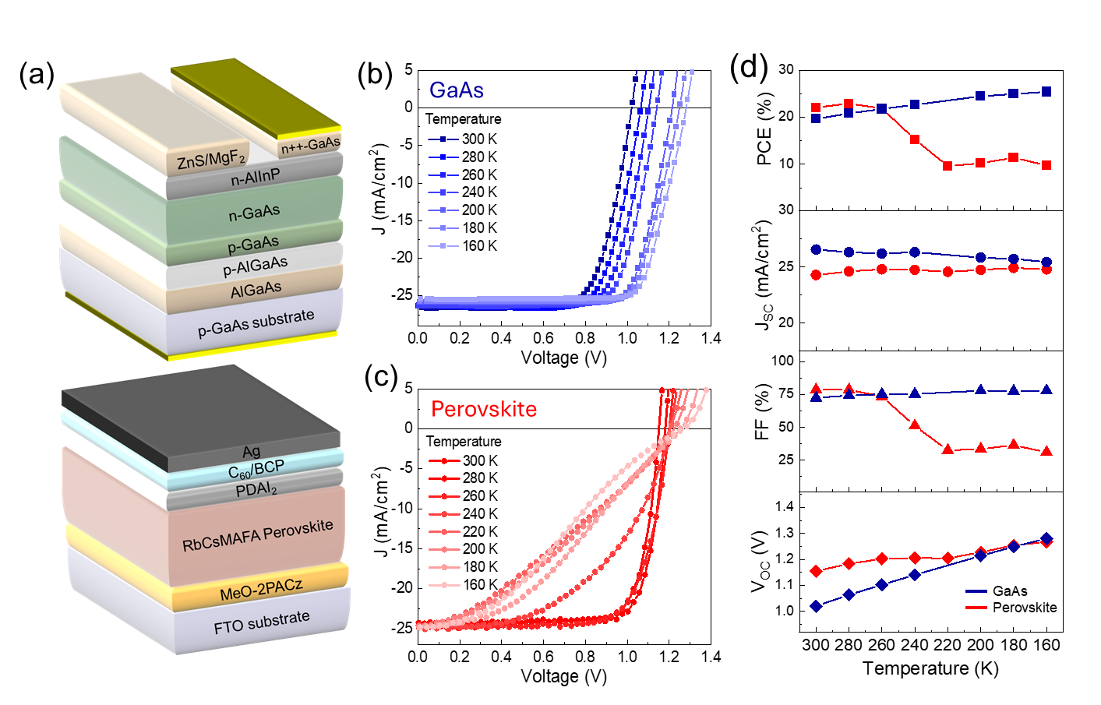
FIG. 1. (a) Schematic device structures of GaAs (top) and perovskite (bottom) solar cells. Temperature dependent light J-V curves of (b) GaAs and (c) perovskite solar cells. (d) Comparison of device parameter temperature dependence for both solar cells.

At low temperatures, available thermal energy decreases, reducing the activation of non-radiative recombination centers. This results in a higher number of radiatively recombined charge carriers within the lattice. Cryogenic cooling suppresses non-radiative recombination because the truncation of carrier thermal energy prevents charge carriers from classically surmounting the substantial activation energy barriers associated with deep-level defect centers.¹⁵ As the temperature rises, literature indicates heightened intrinsic structural disorder and elevated exciton/polaron mobility in halide perovskites facilitate carrier transport, thereby accelerating their capture at deep non-radiative recombination centers.²⁰ Consequently, the PL emission photon flux of both the perovskite and GaAs devices increases with decreasing temperature [Figs. 2(a) and 2(b)]. The one notable difference between the two devices is that as the temperature decreases, the PL peak energy position of the GaAs device shifts to higher energies (blue shift), while that of the perovskite device shifts to lower energies (red shift). The underlying reasons for this difference in PL peak shifts are discussed in a later section. At 300 K, the ERE of the GaAs device is calculated at ≈ 0.6 %, increasing to ≈ 1.8 % at 160 K. In contrast, the perovskite device exhibits a PL ERE of ≈ 0.2 % at 300 K, which rises to ≈ 2.0 % at 160 K [Fig. 2(c)]. This faster ERE increase with decreasing temperature for the perovskite device suggests a higher density of non-radiative recombination centers, which freeze out at lower temperatures, enhancing the radiative efficiency of the material.
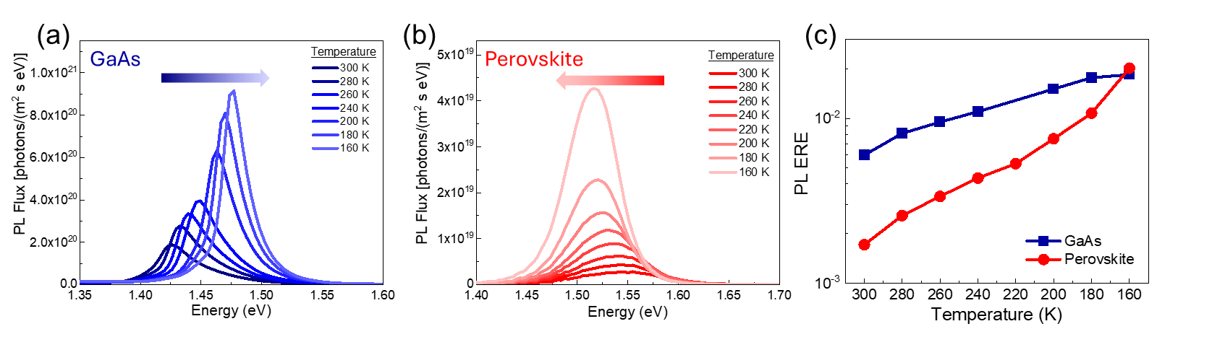
FIG. 2. Temperature-dependent PL spectra of (a) GaAs and (b) perovskite solar cells. (c) Comparison of the ERE of the solar cells as a function of temperature.

In order to see the impact of the observed differences in the ERE vs T trends, i.e., Fig. 2(c), on the V_{oc} vs T measurements [Fig. 1(d)], we need to evaluate the entropic losses associated with the ERE differences between the two devices. Eq. (2) defines the V_{oc} in terms of the various entropic losses that act as voltage penalties incurred by the cell under sunlight to reduce the voltage from the maximum value $\frac{E_{g}}{q}$ to the measured voltage. In this equation, q, k, T, $Ω_{s}$, $η_{ext}$, and $T_{S}$ represent the electron charge, the Boltzmann constant, the device temperature, the solid angle of the sun, the ERE (Calculated from Eq. (1)), and the temperature of the sun, respectively¹⁶:
$V_{oc}= \frac{E_{g}}{q}-\frac{kT}{q}\ln\left(\frac{π}{Ω_{s}}\right)+\frac{kT}{q}\ln\left(η_{ext}\right)+\frac{kT}{q}\ln\left(\frac{T_{S}}{T}\right)-2\frac{kT}{q}\ln\left(\frac{E_{g}}{{kT}_{S}}\right)+\frac{kT}{q}\ln\left(\int_{x_{g}}^{∞}{\frac{x^{2}}{e^{x}-1}}dx\right)$ (2)

According to this equation, the V_{oc} will not be equal to $\frac{E_{g}}{q}$ because of entropic losses originating from the radiative losses, $S_{rad}=k ln⁡(η_{ext})$, the solid angle of the sun $S_{solid angle}=k ln⁡(\frac{π}{Ω_{s}})$ photon cooling $S_{PC}=k ln⁡(\frac{T_{s}}{T})$ and the density of state modification $S_{DOS}=2k\ln\left(\frac{E_{g}}{{kT}_{S}}\right)+k\ln\left(\int_{x_{g}}^{∞}{\frac{x^{2}}{e^{x}-1}}dx\right)$ where $x_{g}={E_{g}}/{kT}$. We note that $S_{rad}$ captures all entropic losses associated with the combined nonradiative recombination, parasitic absorption and light trapping as represented by the ERE parameter $η_{ext}$.²¹ Therefore, other than the first term in Eq. (2), all other terms are entropy loss-related voltage penalties that reduce the voltage.

Using the temperature-dependent PL spectra shown in Figs. 2(a) and 2(b), we extracted the E_{g} of the GaAs and perovskite devices using Gaussian fitting (Supplementary Material Tables S2 and S3) to the emission curves and extracting the maximum of the PL emission peaks, as presented in Fig. 3(a). We note that this method produces the so-called “radiative band gap” energy, which is an acceptable proxy for the band gap. The radiative band gap could be slightly (tens of meV) different from the band gap energy extracted from absorption measurements,²² but since we did this extraction consistently for both sets of devices at all the measured temperatures, we can conveniently use these measurements in our temperature dependent V_{oc} analysis. As the temperature is lowered, the E_{g} of GaAs increases from 1.43 eV at 300 K to 1.48 eV at 160 K, whereas the E_{g} of the perovskite cell decreases from 1.542 eV at 300 K to 1.514 eV at 160 K [Fig. 3(a)]. In conventional semiconductors like GaAs, thermal vibrations of the lattice atoms decrease at low temperatures. This reduction in lattice vibrations causes the energy difference between the valence band and the conduction band to increase, resulting in a larger band gap energy²³. For perovskite materials, the E_{g} reduces with decreasing temperature due to the shrinking of the perovskite lattice, which causes an increase in the overlap between Pb-6s and I-5p antibonding atomic bonds that generates the valence band maximum²⁴. Therefore, these two opposite trends of bandgap energy with temperature impact the slope of the V_{oc} vs. T plots for each type of cell.

The temperature dependence of the radiative voltage penalty, $\frac{kT}{q} ln⁡(η_{ext})$, for the solar cells, shown in Fig. 3(b), closely follows the trend of the ERE variations with temperature in Fig. 2(c), as the entropic radiative voltage loss is a function of the ERE. This plot shows that even though the perovskite devices suffer from higher nonradiative voltage losses than GaAs at 300 K, the difference between the two cells shrinks as the cells are cooled such that at 160 K, they both produce a similar nonradiative voltage loss (≈ 60 mV). The other entropic voltage losses, based on$S_{solid-angle}+S_{PC}+S_{DOS}$ exhibit nearly identical temperature dependence for both devices, with only a slight deviation at higher temperatures, attributed to the difference in their bandgap energies and they increase linearly with decreasing temperature. Overall, these losses reduce linearly with decreasing temperature [Fig. 3(c)].
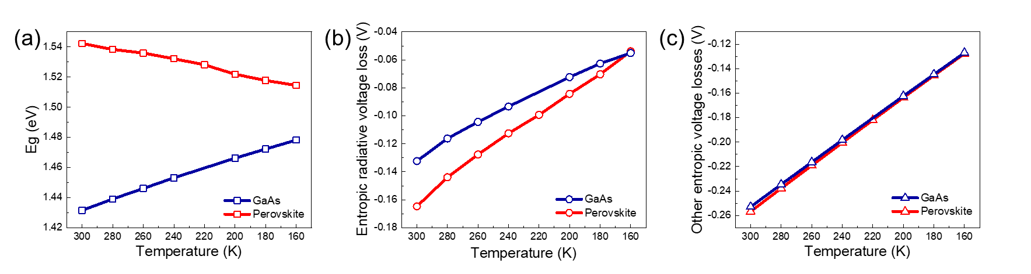
FIG. 3. Temperature-dependent variation of (a) bandgap energy, Eg, (b) entropic radiative voltage loss originated from S_{rad}, and (c) sum of the other entropic voltage losses originated from $S_{solid-angle}+S_{PC}+S_{DOS}$for GaAs and perovskite solar cells at low temperatures.

In Fig. 4(a), the V_{oc} vs. temperature trends of GaAs and perovskite solar cells are compared based on both experimental (V_{oc(exp)}) measurements and theoretical calculations (V_{oc(calc)}) based on Eq. (2). For the GaAs device, the V_{oc(exp)} increases linearly with decreasing temperature, in excellent agreement with the theoretical prediction. The difference between calculated and experimental values, ΔV_{GaAs} = V_{oc(calc)} - V_{oc(exp)}, remains negligible, with a value of approximately 25 meV at 300 K and 15 meV at 160 K. A similar linear trend is predicted, via calculations, for the perovskite device; however, its experimental V_{oc} deviates from the theoretical curve in a non-steady way with temperature [Fig. 4(b)]. At 300 K, ΔV_{Perovskite} is about - 34 meV, and this difference increases to + 65 meV at 160 K, indicating a growing discrepancy at lower temperatures. We attribute this deviation to formation of an energy barrier at the perovskite/contact layer. As shown in Figs. 1(c) and 1(d), the FF begins to deteriorate below 240 K, which we previously attributed to charge accumulation at the interfaces, resulting in reduced charge extraction efficiency.^{25,26} The theoretical treatment in Eq. (2) ignores charge injection bottlenecks and is only concerned with energy and entropic losses, hence predicting a linear increase in V_{oc} with decreasing temperature. However, as discussed in Fig. 1(d), the V_{oc(exp)} vs. T behavior of the perovskite device mostly rolls over at temperatures below 240 K and shows only a slight rise below this temperature.

In previous work,^{25,26} we presented low temperature electroluminescence imaging data of perovskite solar cells revealing formation of local areas of low injection efficiency, which expand as temperature is lowered and eventually choke off the charge injection or collection process into the device. These unfavorable charge injection regions likely originate from poor contact selectivity, such as low-quality hole- or electron-selective layers or energy barriers at the contacts. To compare the temperature-dependent selectivity of the solar cells studied, we calculated a parameter previously labeled as the open-circuit selectivity (S_{oc}) using Eq. (3)²⁷:
$V_{oc}=S_{oc}×{iV}_{oc}$ (3)
where ${iV}_{oc}$ refers to the internal voltage, corresponding to V_{oc(calc)} obtained directly from Eq. (2) using the absolute PL ERE measurements. The ratio of the V_{oc(exp)} to the V_{oc(calc)} decreases with poor selectivity. Previous reports indicate that the conductivity and charge mobility of the transport layer decrease at lower temperatures, thereby hindering efficient charge extraction.²⁸ This phenomenon has also been implicated in the emergence of S-shaped J-V curves in organic solar cells, a behavior specifically attributed to the reduced conductivity of C₆₀.²⁹ The temperature-dependent reduction in the doping density of C₆₀ appears to be the primary driver behind the diminished Voc ,whereas the MeO-2PACz HTL being a monolayer, introduces a surface dipole that remains largely constant with temperature. In Fig. 4(c), the S_{oc} for the GaAs solar cell is around 0.98 and remains stable with temperature, indicating good contact selectivity. In contrast, the S_{oc} for the perovskite solar cell is maximum at slightly above unity at 300 K but decreases with temperature reaching ~ 0.95 at 160 K, which is lower than the S_{oc} of GaAs solar cell at the same temperature. The reason the S_{oc} for the perovskite cell is slightly shifted above unity at higher temperatures is due to uncertainties related to the estimation of the V_{oc(calc)} values which are slightly under the experimental V_{oc(exp)} values. This discrepancy originates from high measurement uncertainties for absolute PL measurements and other possible errors (see experimental section), as shown by the shaded red and blue regions in Fig. 4(a). The observed trends, however, clearly demonstrate that while the selectivity of the perovskite cell is similar to, or higher, (within the margin of uncertainty) than that of the GaAs cell at 300 K, its selectivity falls below that of GaAs at 160 K. These results are therefore consistent with the S-shaped behavior of the I-V curves of the perovskite solar cell at low temperatures [Fig. 1(c)], caused by the loss of contact selectivity.
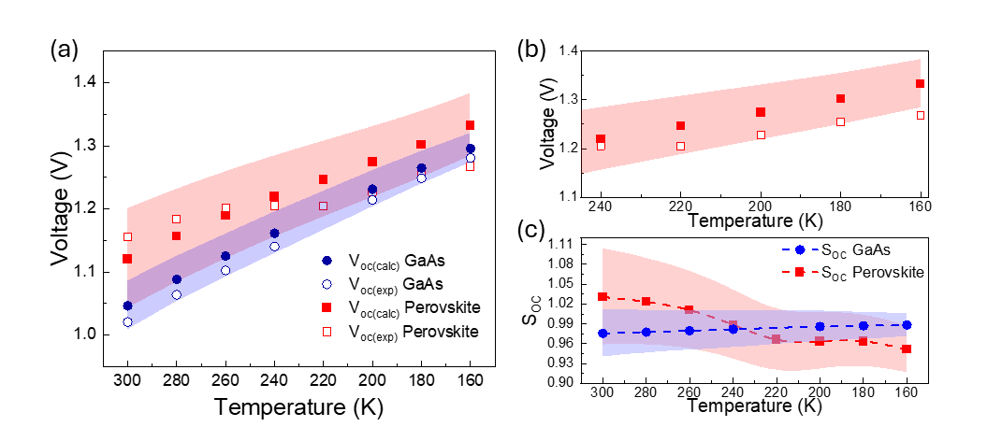
FIG. 4. (a) Solid symbols represent the calculated V_{oc}, while open symbols indicate the V_{oc} extracted from experimental J-V measurements. (b) Magnified view of the voltage variations of the perovskite solar cell between 240 K and 160 K from Fig. 4(a). (c) Temperature dependence of selectivity in GaAs and perovskite solar cells. Our estimated uncertainties for the calculated V_{oc} for GaAs and perovskite solar cells are shown in light blue and red shades, respectively.

In conclusion, while both GaAs and perovskite solar cells demonstrate relatively stable J_{sc}​ values across the 300 K - 160 K temperature range, the V_{oc}​ vs. T trend in the perovskite device is notably different than that of the GaAs cell, while the perovskite device FF is impacted by charge injection bottlenecks at the contacts. This resulted in reduced performance, likely due to interface-induced charge accumulation and loss of contact selectivity. Temperature-dependent PL measurements and ERE calculations revealed key differences in the defect landscapes of the two materials. Even though both devices show enhanced radiative recombination at lower temperatures, the perovskite device exhibited a significantly larger relative increase in ERE, from approximately 0.2 % at 300 K to ~ 2.0 % at 160 K, indicating a higher density of non-radiative recombination processes that freeze up at low temperatures. Analysis of entropic radiative voltage losses revealed a strong correlation with ERE trends, with overall losses decreasing as temperature decreased. At 300 K, the entropic radiative voltage loss is higher in the perovskite device; however, this difference narrowed with decreasing temperature. By 160 K, the entropic losses of GaAs and perovskite solar cells became nearly identical. Overall, this work highlights a comparative study for low-temperature behaviors of GaAs and perovskite solar cells and provides insight into the critical role of interfacial quality and recombination dynamics in determining device performance, particularly for space applications.

Data availability statement: The data that supports the findings of this study are available from the corresponding author upon reasonable request.
See the supplementary material for the experimental section, and Tables S1, S2, and S3.

H.Y-C. acknowledges the generous support of the Professional Research Experience Program (PREP) under the award number PREP0002351. Z.S. acknowledges support from faculty startup funds at The University of Toledo.
NIST disclaimer: Certain equipment, instruments, software, or materials are identified in this paper in order to specify the experimental procedure adequately. Such identification is not intended to imply recommendation or endorsement of any product or service by NIST, nor is it intended to imply that the materials or equipment identified are necessarily the best available for the purpose.

REFERENCES

¹ R. Verduci, V. Romano, G. Brunetti, N. Yaghoobi Nia, A. Di Carlo, G. D’Angelo, and C. Ciminelli, “Solar Energy in Space Applications: Review and Technology Perspectives,” Adv. Energy Mater. 12(29), 2200125 (2022).
² Z. Huan, Y. Zheng, K. Wang, Z. Shen, W. Ni, J. Zu, and Y. Shao, “Advancements in radiation resistance and reinforcement strategies of perovskite solar cells in space applications,” J. Mater. Chem. A Mater. 12(4), 1910–1922 (2024).
³ A.W.Y. Ho-Baillie, H.G.J. Sullivan, T.A. Bannerman, H.P. Talathi, J. Bing, S. Tang, A. Xu, D. Bhattacharyya, I.H. Cairns, and D.R. McKenzie, “Deployment Opportunities for Space Photovoltaics and the Prospects for Perovskite Solar Cells,” Adv. Mater. Technol. 7(3), 2101059 (2022).
⁴ M. Yu, J. Long, Q. Sun, Z. Chen, X. Wu, Z. Wu, X. Luo, Q. Gong, W. Yan, Q. Chen, J. Zhu, and S. Lu, “Achieving flexible higher efficiency GaInP/GaAs/InGaAs solar cells by 40-period quantum well superlattices,” Nano Energy 136, 110718 (2025).
⁵ M. Qian, X. Mao, M. Wu, Z. Cao, Q. Liu, L. Sun, Y. Gao, X. Xuan, Y. Pan, Y. Niu, and S. Gong, “POSS Polyimide Sealed Flexible Triple-Junction GaAs Thin-Film Solar Cells for Space Applications,” Adv. Mater. Technol. 6(12), 2100603 (2021).
⁶ L. Sayre, F. Lang, J. Bundesmann, A. Denker, P. Pearce, A. Johnson, and L. Hirst, “Ultra-thin Single-junction GaAs Solar Cells for Extreme Space Environments,” Conference Record of the IEEE Photovoltaic Specialists Conference, 1621–1625 (2020).
⁷Best Research-Cell Efficiency Chart | Photovoltaic Research | NLR (2026)
⁸ Y. Tu, J. Wu, G. Xu, X. Yang, R. Cai, Q. Gong, R. Zhu, and W. Huang, “Perovskite Solar Cells for Space Applications: Progress and Challenges,” Advanced Materials 33(21), 2006545 (2021).
⁹ S.W. Lee, S. Bae, D. Kim, and H.S. Lee, “Historical Analysis of High-Efficiency, Large-Area Solar Cells: Toward Upscaling of Perovskite Solar Cells,” Advanced Materials 32(51), 2002202 (2020).
¹⁰ R. Ji, A. Mallick, B. Rivkin, H. Yuce-Cakir, O.D. Jurchescu, and Y. Vaynzof, “Solvent-Free Fabrication Methods of Metal Halide Perovskites,” Advanced Materials 37(40), 2416604 (2025).
¹¹ H. Yuce-Cakir, D. Dremann, J.L. Morel, S. Khan, M. Deconinck, V. V. Shilovskikh, W. Nie, Y. Vaynzof, and O.D. Jurchescu, “Enabling Optoelectronics in Harsh Environments: Laser-Printed Perovskite Films with Exceptional Stability Under Extreme Radiation, Thermal Stress, and Humidity,” Adv. Energy Mater. 15(16), 2405370 (2024).
¹² J. Suo, B. Yang, E. Mosconi, D. Bogachuk, T.A.S. Doherty, K. Frohna, D.J. Kubicki, F. Fu, Y.J. Kim, O. Er-Raji, T. Zhang, L. Baldinelli, L. Wagner, A.N. Tiwari, F. Gao, A. Hinsch, S.D. Stranks, F. De Angelis, and A. Hagfeldt, “Multifunctional sulfonium-based treatment for perovskite solar cells with less than 1% efficiency loss over 4,500-h operational stability tests,” Nat. Energy 9(2), 172–183 (2024).
¹³ X. Zhao, P. Zhang, T. Liu, B. Tian, Y. Jiang, J. Zhang, Y. Tang, B. Li, M. Xue, W. Zhang, Z. Zhang, and W. Guo, “Operationally stable perovskite solar modules enabled by vapor-phase fluoride treatment,” Science 385(6707), 433–438 (2024).
¹⁴ A.D. Wright, C. Verdi, R.L. Milot, G.E. Eperon, M.A. Pérez-Osorio, H.J. Snaith, F. Giustino, M.B. Johnston, and L.M. Herz, “Electron-phonon coupling in hybrid lead halide perovskites,” Nat. Commun. 7, 11755 (2016).
¹⁵ B.H. Hamadani, M.A. Stevens, B. Conrad, M.P. Lumb, and K.J. Schmieder, “Visualizing localized, radiative defects in GaAs solar cells,” Sci. Rep. 12(14838), 1–10 (2022).
¹⁶ O.D. Miller, “Photonic Design: From Fundamental Solar Cell Physics to Computational Inverse Design,” Ph.D. Thesis, University of California, Berkeley, (2012).
¹⁷ W. Tress, J.P. Correa Baena, M. Saliba, A. Abate, and M. Graetzel, “Inverted Current–Voltage Hysteresis in Mixed Perovskite Solar Cells: Polarization, Energy Barriers, and Defect Recombination,” Adv. Energy Mater. 6(19), 1600396 (2016).
¹⁸ M. Yavari, F. Ebadi, S. Meloni, Z.S. Wang, T.C.J. Yang, S. Sun, H. Schwartz, Z. Wang, B. Niesen, J. Durantini, P. Rieder, K. Tvingstedt, T. Buonassisi, W.C.H. Choy, A. Filippetti, T. Dittrich, S. Olthof, J.P. Correa-Baena, and W. Tress, “How far does the defect tolerance of lead-halide perovskites range? The example of Bi impurities introducing efficient recombination centers,” J. Mater. Chem. A Mater. 7(41), 23838–23853 (2019).
¹⁹ R. Hoheisel, and A.W. Bett, “Experimental analysis of majority carrier transport processes at heterointerfaces in photovoltaic devices,” IEEE J. Photovolt. 2(3), 398–402 (2012).
²⁰ M. Baranowski, J.M. Urban, N. Zhang, A. Surrente, D.K. Maude, Z. Andaji-Garmaroudi, S.D. Stranks, and P. Plochocka, “Static and Dynamic Disorder in Triple-Cation Hybrid Perovskites,” Journal of Physical Chemistry C 122(30), 17473–17480 (2018).
²¹ U. Rau, U.W. Paetzold, and T. Kirchartz, “Thermodynamics of light management in photovoltaic devices,” Phys. Rev. B 90(3), 035211 (2014).
²² S. Siebentritt, U. Rau, S. Gharabeiki, T.P. Weiss, A. Prot, T. Wang, D. Adeleye, M. Drahem, and A. Singh, “Photoluminescence assessment of materials for solar cell absorbers,” Faraday Discuss. 239, 112–129 (2022).
²³ Y.P. Varshni, “Temperature dependence of the energy gap in semiconductors,” Physica 34(1), 149–154 (1967).
²⁴ M.I. Dar, G. Jacopin, S. Meloni, A. Mattoni, N. Arora, A. Boziki, S.M. Zakeeruddin, U. Rothlisberger, and M. Grätzel, “Origin of unusual bandgap shift and dual emission in organic-inorganic lead halide perovskites,” Sci. Adv. 2(10), e1601156 (2016).
²⁵ H. Yuce-Cakir, M. Makala, G.R. Neupane, M. Deconinck, V. V Shilovskikh, X. Zhou, R. Holley, Q.C. Burlingame, Y. Vaynzof, Y. Loo, B.H. Hamadani, and O.D. Jurchescu, “Controlling Phase Transition Dynamics in Laser-Printed Perovskite Films via Additive-Driven Strain Engineering,” ACS Energy Lett., (2026).
²⁶ B.H.H. H. Yuce-Cakir, H. Chen, I. Ogunniranye, S. M. Thon, Y. Yan, Z. Song, “Comparison of Electroluminescence and Photoluminescence Imaging of Mixed-Cation Mixed-Halide Perovskite Solar Cells at Low Temperatures,” Adv. Opt. Mater. 14(7), e03522 (2026).
²⁷ A. Onno, C. Reich, S. Li, A. Danielson, W. Weigand, A. Bothwell, S. Grover, J. Bailey, G. Xiong, D. Kuciauskas, W. Sampath, and Z.C. Holman, “Understanding what limits the voltage of polycrystalline CdSeTe solar cells,” Nat. Energy 7(5), 400–408 (2022).
²⁸ T.J. Jacobsson, W. Tress, J.P. Correa-Baena, T. Edvinsson, and A. Hagfeldt, “Room Temperature as a Goldilocks Environment for CH3NH3PbI3 Perovskite Solar Cells: The Importance of Temperature on Device Performance,” Journal of Physical Chemistry C 120(21), 11382–11393 (2016).
²⁹ W. Tress, Organic Solar Cells Theory, Experiment, and Device Simulation (Springer Series in Materials Science, 2014).

