Reference Correlation of the Thermal Conductivity of Neon

Marc J. Assael^{1,a)}, Sofia G. Sotiriadou¹, Monika Thol², and Marcia L. Huber³

¹ Chemical Engineering Department, Aristotle University, Thessaloniki 54636, Greece
² Ruhr University Bochum, Universitätsstraße 150, 44801 Bochum, Germany
³ Applied Chemicals and Materials Division, National Institute of Standards and Technology,
325 Broadway, Boulder, CO 80305, USA

A new wide-ranging correlation for the thermal conductivity of neon, based on the most recent ab initio dilute gas theoretical calculations, a simplified crossover critical enhancement contribution, and critically evaluated experimental data, is presented. The correlation is designed to be used with a high-accuracy Helmholtz equation of state (EOS) over the range of temperatures from 24.5561 K (the triple-point temperature) to 700 K and at pressures up to 700 MPa. The model includes a zero-density correlation based on recent ab initio values, valid from 5 K to 5000 K with an expanded uncertainty (k=2) ranging from 0.15% at the triple-point temperature to 0.028% at 5000 K. In the range 200 K to 700 K for pressures up to 0.1 MPa, the estimated uncertainty of the full correlation (as indicated by comparisons with the most accurate measurements) is 0.3% and rises to 0.7% for temperatures from 85 K to 200 K. For pressures between 0.1 MPa to 40 MPa for temperatures between 100 and 463 K, the uncertainty is 1.5%. In the liquid phase the estimated expanded uncertainty rises to 15% due to the lack of high-quality experimental data. The correlation behaves in a physically reasonable manner when extrapolated to temperatures and pressures above the limits of the EOS, however below approximately 100 K the correlation should be considered preliminary pending additional experimental low-temperature data.

Key words: neon; thermal conductivity; transport properties.

_________________________________________________
- Author to whom correspondence should be addressed (marc.assael@gmail.com)

1 Introduction
In a recent companion paper, a reference correlation for the viscosity of neon was presented [1]. In that paper it was stated that accurate modeling of neon's viscosity, as well as thermal conductivity, is needed for the efficient design and operation of several industrial technologies [1]. Neon is employed in a variety of low-temperature (below 70 K) refrigeration applications such as Claude-cycle, turbo-Brayton, and Joule-Thomson refrigerators [2-5]. An improved understanding of neon thermal conductivity and viscosity is also critical for enhancing the design of large-scale hydrogen liquefaction facilities, which may incorporate refrigeration cycles utilizing helium-neon mixtures [6].
Recent advances in quantum-chemical ab initio computations allow improvement in the representation of the dilute-gas thermal conductivity of neon. It is our goal to incorporate ab initio results to develop an improved correlation for the thermal conductivity of neon that is valid over the entire fluid range covering gas, liquid, and supercritical regions.
The current thermal conductivity correlation employed in the NIST program REFPROP [7], developed in 2018 by Huber [8], is valid over liquid, vapor, and supercritical states. However, it was based on an extended-corresponding states estimation method and fit to limited data [9-12]. Based on comparisons with these data sources, the estimated uncertainty of the thermal conductivity in the liquid phase is 10% at saturation, and 5% for the gas at atmospheric pressure.
The goal of this work is to develop a new thermal conductivity reference correlation that will
- incorporate the new dilute-gas limit ab initio calculations [13] for thermal conductivity in order to extend the temperature range and to lower the uncertainty in the dilute-gas region,
b) incorporate the new low-uncertainty measurements of the thermal conductivity of neon,
c) incorporate the equation of state of Thol et al. [14],
d) be based on critically evaluated literature data, and have lower uncertainty and extend to a higher pressure than the current formulation of Huber [8].

Over the last decade-plus, we reported new thermal-conductivity reference correlations valid over wide ranges of temperature and pressure for hydrocarbons [15-25], alcohols [26, 27], refrigerants [28-31] and some simple fluids [32-38]. In this paper, this same methodology is employed to develop a new correlation for the thermal conductivity of neon. We use an analysis based on the best available experimental data. A prerequisite to this analysis is critical assessment of the experimental data. Here we define two categories of experimental data: primary data, employed in the development of the correlation, and secondary data, used simply for comparison purposes. According to the recommendation adopted by the Subcommittee on Transport Properties (now known as The International Association for Transport Properties) of the International Union of Pure and Applied Chemistry, the primary data are identified by a well-established set of criteria [37]. These criteria have been successfully employed to establish standard reference values for the viscosity and thermal conductivity of fluids over wide ranges of conditions, with uncertainties in the range of 1%. However, in many cases, such a narrow definition unacceptably limits the range of data representation. Consequently, within the primary data set, it is also necessary to include results that extend over a wide range of conditions, albeit with poorer accuracy, provided they are consistent with other more accurate data or with theory. In all cases, the accuracy claimed for the final recommended data must reflect the estimated uncertainty in the primary information.
The form of correlation we use expresses thermal conductivity as a function of temperature and density. Since experimental data are generally reported in terms of pressure and temperature, an equation of state (EOS) is needed to obtain densities. We first convert temperatures to ITS-90 [39, 40] if necessary, then use the Helmholtz EOS equation of state developed by Thol et al. [14] to obtain the density for a given temperature-pressure state point. We also use the critical and triple point associated with this EOS; the critical point and other constants for this EOS are given in Table 1. The uncertainty in density of the EOS for temperatures up to 95 K and pressures, p, up to 30 MPa is less than 0.5% except for the critical region, in the temperature range 95 K to 250 K 0.08% (p ≤ 10 MPa), 0.2% (10 MPa < p ≤ 30 MPa), and 0.6% (30 MPa < p ≤ 200 MPa), for temperatures and pressures up to 430 K and 300 MPa 0.08%, and in the temperature range 430 K to 700 K 0.2% (p ≤ 10 MPa) and 3% (10 MPa < p ≤ 50 MPa). The EOS is recommended for use from the melting line to 700 K at pressures up to 700 MPa, but gives physically reasonable extrapolation behavior up to very high pressures and temperatures [14].

Table 1 Critical point and fixed constants for the EOS of Thol et al. [14]

Property | Symbol | Units | Value
Critical temperature | T_{c} | K |  | 44.4
Critical pressure | p_{c} | MPa |  | 2.66163
Critical density | ρ_{c} | kg·m⁻³ |  | 486.3139
Triple-point temperature | T_{tp} | K |  | 24.5561
Molar mass | M | g·mol⁻¹ |  | 20.179
Molar gas constant | R | J·mol⁻¹·K⁻¹ |  | 8.3144598

2 The correlation
The thermal conductivity λ is expressed [15-38] as the sum of three independent contributions,

(1)

where ρ is the density, T is the absolute temperature, and the first term, λ₀(Τ) = λ(0,Τ), is the contribution to the thermal conductivity in the dilute-gas limit, where only two-body molecular interactions are considered. The critical enhancement term, Δλ_{c}(ρ,Τ), the critical enhancement, arises from the long-range density fluctuations that occur in a fluid near its critical point, which contributes to divergence of the thermal conductivity at the critical point. Finally, the residual term Δλ(ρ,T), represents the contribution of all other effects to the thermal conductivity of the fluid at elevated densities.

Table 2 Thermal conductivity measurements of neon.

Investigators/reference | Publ.  Year | Technique  employedª | Purity  (%) | Uncertainty  (%) | No. of data | Temperature  range  (K) | Pressure  range  (MPa)
Primary data
Perkins and Roder [41]¹ | 1999 | 2THW | 99.999 | 3 | 715 | 100-303 | 0.3-70
Millat et al. [10] | 1988 | 2THW | 99.995 | 0.3 | 33 | 308, 338 | 1-10
Hemminger [42] | 1987 | GHP | 99.99 | 0.8 | 5 | 303-463 | 0.1
Tsarev et al. [43] | 1986 | CC | 99.986 | 1.5 | 59 | 85-275 | 0.01-4
Assael et al. [44] | 1981 | 2THW | 99.9995 | 0.2 | 14 | 308 | 1-11
Fleeter et al. [45] | 1981 | 2THW | 99.999 | 0.3 | 21 | 300 | 1-32
Kestin et al. [46] | 1980 | 2THW | 99.995 | 0.3 | 31 | 300 | 1-36
Shashkov et al. [47]² | 1980 | THW | 99.8 | 1 | 9 | 94-274 | 0.1
Vidal et al. [48] | 1980 | CC | na | na | 11 | 298 | 0.1-1000
Tufeu and Le Neindre [49] | 1979 | CC | na | na | 19 | 295-606 | 0.01-20
de Groot et al. [50] | 1978 | 2THW | 99.995 | 0.4 | 44 | 300 | 0.5-35
Marchenkov and Aleinikova [51] | 1977 | THW | 99.882 | 3 | 12 | 373-1503 | 0.1
Stefanov et al. [52]³ | 1976 | HW | na | 3 | 23 | 1110-2200 | 0.1
Jody and Saxena [53] | 1975 | THW | 99.995 | 1.5 | 19 | 323-2724 | 0.1
Vargaftik et al. [54] | 1975 | HW | 99.9 | 2 | 17 | 324-868 | 0.1
Garrabos et al. [55] | 1973 | CC | na | 1.3? | 42 | 273-603 | 0.1-20
Bewilogua and Yoshimura [9]^{LIQ} | 1972 | PP | >99 | 3 | 4 | 25-29 | 0.05-0.22
Golubev and Shpagina [56]⁴ | 1971 | CC | 99.87 | 1.5 | 313 | 96-320 | 0.1-50
Vasilkovskaya and Golubev [57]⁵ | 1971 | CC | 99.87 | 1.5 | 67 | 295-566 | 0.1-41
Tufeu et al. [58] | 1970 | CC | na | na | 66 | 305-606 | 0.1-95
Haarman [59] | 1969 | 2THW | 99.99 | 0.2 | 8 | 328-468 | 0.1
Saxena and Saxena [60] | 1968 | 2THW | SPC | 2 | 13 | 350-1500 | 0.1
Vargaftik and Yakush [12] | 1968 | HW | 99.9 | 1 | 16 | 309-1073 | 0.1
Sengers et al. [61] | 1964 | PP | 99.9 | 1 | 106 | 298-348 | 0.1-271
Löchtermann [62]^{6,LIQ} | 1963 | GHP | 99.8 | 5 | 36 | 25-29 | 0.05-0.22
Thomas and Golike [63] | 1954 | HW | Airco | 0.25 | 6 | 308-338 | 0.1
Secondary data
Perkins and Roder¹ [41] | 1999 | 2THW | 99.999 | 3.0 | 115 | 59 | 0.6-63.1
Timrot and Makhrov [64] | 1976 | ThEL | na | na | 7 | 273-369 | 0.1
Clifford et al. [65] | 1975 | 3HWC | SPC | 0.3 | 1 | 323 | 0.1
Irving et al. [66] | 1973 | HW | 99.95 | 2 | 1 | 323 | 0.1
Springer and Wingeier [67] | 1973 | CC | na | na | 4 | 900-1500 | 0.1
Dijkema et al. [68] | 1972 | CC | na | 0.5 | 1 | 333 | 0.1
Saxena and Tondon [11] | 1971 | THW | SPC | 2.0 | 15 | 313-451 | 0.002-0.1
Gray et al. [69] | 1970 | THW | SPC | na | 2 | 323, 373 | 0.1
Saxena and Gupta [70] | 1970 | THW | SPC | 2.0 | 3 | 313-366 | 0.1
Tondon and Saxena [71] | 1970 | THW | SPC | 2.0 | 3 | 313-366 | 0.1
Burge and Robinson [72] | 1968 | THW | na | na | 1 | 297 | 0.1
Correia et al. [73] | 1968 | HW | na | na | 6 | 278-770 | 0.1
Gibbons and Kuebler [74] | 1968 | CC | na | 4 | 57 | 52-92 | 0.1-21
Mathur et al. [75] | 1968 | THW | SPC | 2 | 3 | 313-363 | 0.002
Saxena and Tondon [76] | 1968 | THW | na | 2 | 3 | 313-363 | 0.002
van Dael and Cauwenbergh [77] | 1968 | Thm | 99.95 | na | 1 | 298.8 | 0.1
Gambhir et al. [78] | 1967 | THW | SPC | na | 4 | 308-363 | 0.1
Gandhi and Saxena [79] | 1967 | THW | na | na | 4 | 303-363 | 0.1
Saxena and Gupta [80] | 1967 | THW | na | na | 10 | 366 | 0.001-0.07
Srivastava and Das Gupta [81] | 1967 | ThHW | na | 1.5 | 5 | 314-472 | 0.1
Collins and Menard [82] | 1966 | ShT | na | na | 19 | 304-4969 | 0.1
Saxena et al. [83] | 1966 | THW | na | na | 31 | 323-723 | 0.01-0.08
Barua [84] | 1960 | ThHW | SPC | na | 4 | 303, 318 | 0.1
Srivastava and Barua [85] | 1960 | ThHW | SPC | na | 2 | 303, 318 | 0.1
Thornton [86] | 1960 | Kath | SPC | 4 | 1 | 291 | 0.1
Barua [87] | 1959 | ThHW | SPC | na | 2 | 303, 318 | 0.1
von Ubish [88] | 1959 | HW | SPC | na | 2 | 302, 793 | 0.1
Zaitseva [89] | 1959 | HW | na | na | 7 | 412-800 | 0.1
Keyes [90] | 1954 | CTGC | na | na | 5 | 91-273 | 0.1
Srivastava and Madan [91] | 1954 | Thm | SPC | na | 1 | 317 | 0.1
Davidson and Music [92] | 1953 | CC | na | na | 1 | 273 | 0.1
Kannuluik and Carman [93] | 1952 | HW | na | na | 6 | 90-579 | 0.1
Kannuluik and Donald [94] | 1950 | CC | na | na | 1 | 273 | 0.1
Kannuluik and Martin [95] | 1934 | HW | na | na | 2 | 273 | 0.1
Curie and Lepape [96] | 1931 | HW | na | na | 1 | 273 | 0.1
Weber [97] | 1927 | HW | na | na | 1 | 273 | 0.1
Weber [98] | 1917 | HW | na | na | 1 | 273 | 0.1
Bannawitz [99] | 1915 | HW | na | na | 1 | 273 | 0.1
a CC, Concentric Cylinders; CTGC, Constant Temperature Gradient Cell; GHP, Guarded Hot Plate; HW, Hot Wire; PP, Kath, Katharometer; PP, Parallel Plates; ShT, Shock Tube; SPC, Spectroscopy grade; ThEL, Thermoelectric Loop; Thm, Thermistor; ThHW, Thick Steady-State Hot Wire; THW, Transient Hot Wire; 2THW, 2-Wires Transient Hot Wire; 3HWC, 3 Hot-Wire Comparative.
^{LIQ} Liquid-phase measurements
na Not available.
¹ The 59 K isotherm (114 points) was not included in the primary dataset – see discussion in text.
² Data only in graph form but included in the primary data set as they extend to low temperatures.
³ Data in equation form.
⁴ The 77 K isotherm (48 points) of Golubev and Shpagina [56] was not included in the primary data set as it was consistently lower by 10% from all other measurements in that temperature range.
⁵ From the Vasilkovskaya and Golubev [57] data set, 2 points (75.15 K, and pressures 0.1 and 10 MPa) were disregarded as they were 20% off the other sets.
⁶ Data presented graphically.

In addition to performing literature searches and utilizing content in previous correlations, we made extensive use of the NIST ThermoData Engine [100] to identify data sources. Table 2 summarizes, to the best of our knowledge, the experimental measurements of the thermal conductivity of neon reported in the literature.
In the primary dataset we only included measurements where the technique employed, the purity of the sample, and the uncertainty of the technique are specified. Furthermore, with the exceptions discussed below, we preferred measurements with uncertainty less than 1.5%. Hence, measurements performed in the following instruments were included in the primary sets:
- Transient hot-wire instruments
The following investigators were included in the primary data set:
- The measurements of Millat et al. [10], Assael et al. [44], Fleeter et al. [45], Kestin et al. [46], de Groot et al. [50], and Haarman [59] were all performed in two-wire transient hot-wire instruments, with a full theory, and with uncertainties of less than 0.4%. These are the most accurate measurements today.
- The measurements of Perkins and Roder [41] and Saxena and Saxena [60] were also performed in a two-wire transient hot-wire instrument with a full theory, but with 3% and 2% uncertainty respectively. As these extend to a wide range of temperatures and pressures, they were included in the primary data set. We note however, that the 59 K isotherm (114 points) of Perkins and Roder [41] was not included in the primary data set as, a) the very low-density measurements were found to be up to 5% higher than the correlation of Kochan-Eilers et al. [101] that is based on the ab initio calculations of Hellmann et al. [13], and b) the very high-density measurements were found to be inconsistent with the available liquid data during the fitting process. Further discussion on this isotherm is included in the comparison section, in the discussion of Fig. 6.
- A transient hot-wire instrument but with a single wire was employed by Shashkov et al. [47], Jody and Saxena [53], and Marchenkov and Aleinikova [51], with corresponding uncertainties 1%, 1.5% and 3% - the later included because the measurements extended to high temperatures.
- Finally a steady-state hot-wire instrument was employed by Thomas and Golike [63], Vargaftik and Yakush [12], Vargaftik et al. [54], and Stefanov et al. [52], with corresponding uncertainties 0.25%, 1%, 2% and 3% - again the later included because the measurements extended to high temperatures.

- Concentric-cylinders instruments
- The group of Tufeu and Le Neindre [48, 49, 55, 58] employed a concentric-cylinders instrument to reach very high temperatures and pressures, with an uncertainty generally of about 1.5% (even if it is not quoted in all their publications).
- A similar instrument was employed by Tsarev et al. [43], Golubev and Shpagina [56], Vasilkovskaya and Golubev [57] with 1.5% uncertainty.

- Other instruments
We have also included in the primary data set the measurements of
- Hemminger [42] performed in a guarded heat-flow instrument with an uncertainty of 0.8%.
- Sengers et al. [61] performed in a parallel-plate instrument with an uncertainty of 1%.

- Liquid-phase measurements
As the correlation should cover the liquid phase, we also included the measurements of
- Bewilogua and Yoshimura [9] performed in 1972 in a parallel-plate instrument with an uncertainty of 3% in the temperature range 25-29 K. These investigators specifically measured the thermal conductivity of liquefied ²⁰Ne and ²²Ne isotopes, and we computed values for natural neon using the isotopic proportions cited in their work.
- Löchtermann [62] performed in 1963 in a guarded hot-plate instrument with an uncertainty of 5%.
Note that these two sources are the only available and they differ by as much as 10%, and are inconsistent with each other. In addition, Löchtermann [62] presented the results only in graphical form and digitization of the plot was necessary to obtain the data. Furthermore, both data sets are at saturation and there are no other data available for the compressed liquid phase.

All remaining experimental data were considered secondary as they did not satisfy the criteria. We also note that although the measurements of Collins and Menard [82] extend to 4969 K, they were performed in a shock-tube instrument without a quoted uncertainty and are consistently lower (about 6% at the low temperatures) from all other investigators. Therefore, they were not included in the primary data set.
Figure 1 shows the ranges of the primary measurements outlined in Table 2. As shown in the figure, there is a large amount of data covering a wide range of temperatures and pressures. Measurements in the range 1100 K to 2724 K are not shown as they are all at 0.1 MPa.

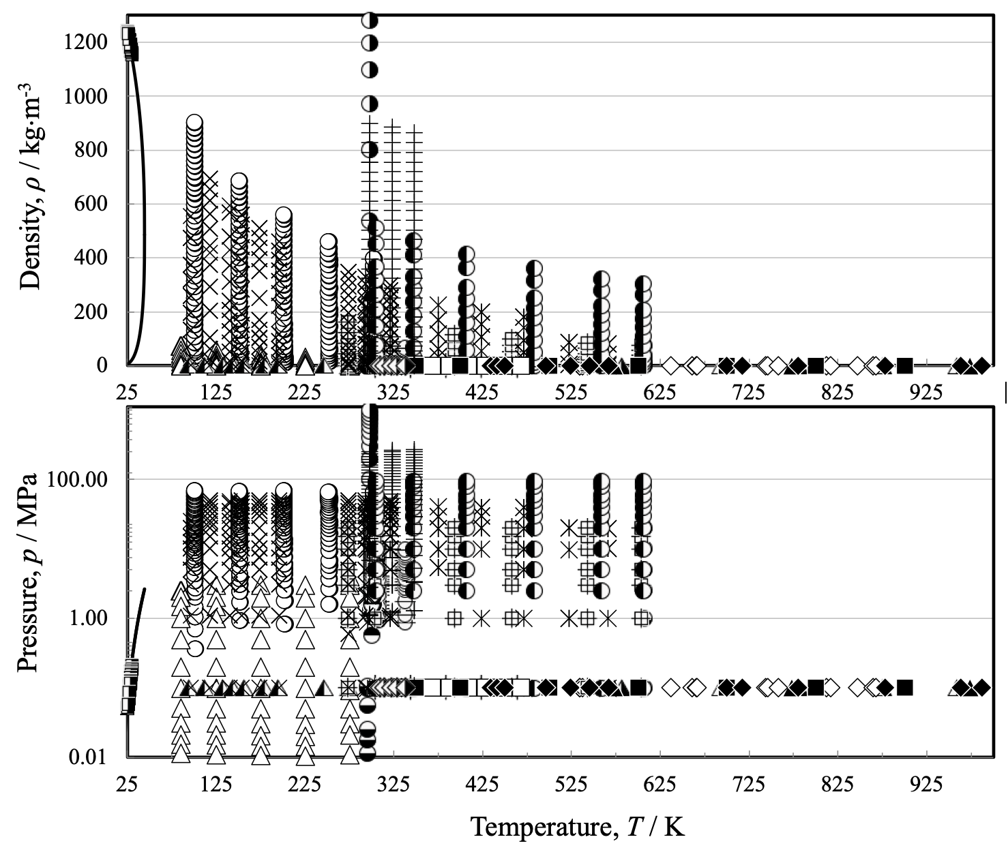
FIG. 1 Temperature-density (top) and temperature-pressure (bottom) ranges of the primary experimental thermal-conductivity data for neon, (––) saturation curve. Perkins and Roder [41] (), Millat et al. [10] (), Hemminger [42] (), Tsarev et al. [43] (), Assael et al. [44] (), Fleeter et al. [45] (), Kestin et al. [46] (), Shashkov et al. [47] (), Vidal et al. [48] ( ), Tufeu and Le Neindre [49] (), de Groot et al. [50] (), Marchenkov and Aleinikova [51] (), Stefanov et al. [52] (…), Jody and Saxena [53] (▲), Vargaftik et al. [54] (), Garrabos et al. [55] (), Bewilogua and Yoshimura [9] (), Golubev and Shpagina [56] (x), Vasilkovskaya and Golubev [57] (), Tufeu et al. [58] (), Haarman [59] (), Löchtermann [62] (), Saxena and Saxena [60] (), Vargaftik and Yakush [12] (), Sengers et al. [61] (+), Thomas and Golike [63] ().
2.1 The dilute-gas term
The dilute-gas limit thermal conductivity, λ₀(Τ) is a function only of temperature and can be analyzed independently of all other contributions in Eq. 1. In relation to viscosity, the thermal conductivity is far more difficult to measure accurately, particularly for dilute gases [37]. Assael et al. [44] used a transient hot-wire instrument to measure the thermal conductivity of several noble gases with an estimated accuracy of 0.20% at 308.15 K and pressures as low as 0.5 MPa. However, at the lower pressures relevant to dilute gas conditions, accurate measurements of thermal conductivity become extremely challenging. Nevertheless, at least for the noble gases, comparable or even smaller uncertainties can be obtained from direct ab initio calculations of the thermal conductivity [13, 102-107]. By combining ratios of ab initio thermal conductivities with both a Prandtl number calculated ab initio and a reference viscosity ratio linking the noble gas to helium, the smallest uncertainty is achieved.
In 2020, Xiao et al. [108] presented a reference correlation for the dilute-gas thermal conductivity of neon with an uncertainty of about 0.1% (at the k=1 confidence level), based on the ab initio computations of Bich et al. [103]. This was very recently improved by Kochan-Eilers et al. [101] who provided a correlation for the zero-density thermal conductivity of neon based on the newer ab initio calculations of Hellmann et al. [13]. The correlation of Kochan-Eilers et al. [101] represents the data of Hellmann et al.[13] to within their stated uncertainties (at k=2) of 0.15% at the triple point of neon (24.5561 K), 0.014% at 298.15 K, and 0.028% at 5000 K. The correlation of Kochan-Eilers et al. [101] is given as

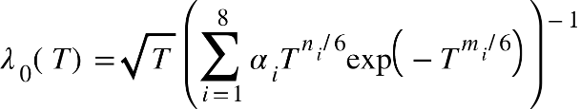 (2)
with the parameters a_{i} , n_{i} and m_{i} listed in Table 3.

Table 3 Parameters a_{i}, n_{i}, and m_{i} of Eq. 2
i | a_{i} | n_{i} | m_{i}
1 | +0.47456629502×10⁰ | 0 | 0
2 | +0.50382627053×10¹ | 0 | 2
3 | +0.88404800309×10⁰ | 1 | 1
4 | +0.41801012690×10¹ | 2 | 3
5 | −0.23521889815×10¹ | 7 | 4
6 | −0.15416266259×10⁻⁴ | 8 | 1
7 | +0.10166708819×10⁻¹ | 12 | 3
8 | +0.14197148158×10⁰ | 13 | 6

In Figure 2 the new dilute-gas thermal conductivity correlation of Kochan-Eilers et al. [101], the correlation of Xiao et al. [108], and the corresponding-states correlation of Huber are shown. The first two correlations agree within 0.1% until below about 35 K where the Xiao et al. [108] begins to deviate strongly from the other curves and displays unphysical behavior. In the Supplementary Information, Xiao et al. [108] proposed an alternative dilute-gas correlation based on the Chapman-Enskog theory [108] for extrapolation to lower temperatures. As seen in Figure 2 (embedded graph), this alternative correlation – marked with SI - extrapolates better, but it is lower than the Kochan-Eilers et al. [101] correlation. The Huber correlation increasingly deviates from the theoretical values as the temperature increases. For this work we will use the Kochan-Eilers et al. [101] correlation because it has better agreement with the ab initio results of Hellmann et al. [13] and is consistent with our companion work on the viscosity [1].

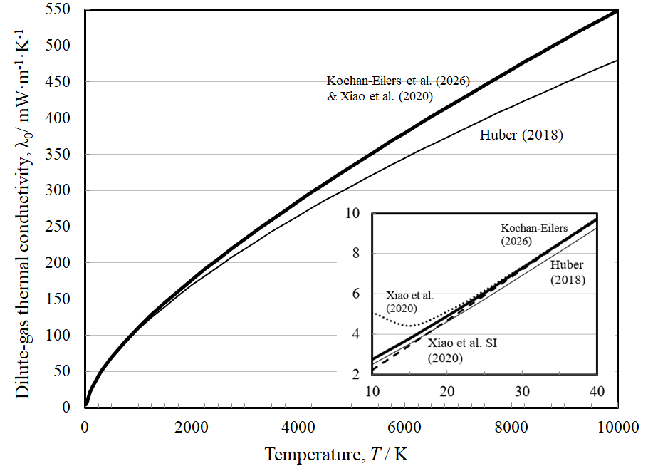
FIG. 2 Dilute-gas thermal conductivity as a function of temperature. Huber (__), Xiao et al. [108] (….), Xiao et al. SI [108] (----), Kochan-Eilers et al. (▬).

2.2 The residual term
The thermal conductivities of pure fluids exhibit an enhancement over a large range of densities and temperatures around the critical point and become infinite at the critical point. This behavior can be described by models that produce a smooth crossover from the singular behavior of the thermal conductivity asymptotically close to the critical point to the residual values far away from the critical point [109-111]. The density-dependent terms for thermal conductivity can be grouped according to Eq. 1 as [Δλ(ρ,Τ) + Δλ_{c}(ρ,Τ)]. To assess the critical enhancement theoretically, we need to evaluate, in addition to the dilute-gas thermal conductivity, the residual thermal-conductivity contribution. The procedure adopted during this analysis used ODRPACK (Ref. [112]), a weighted Orthogonal Distance Regression software, to fit all the primary data simultaneously to the residual thermal conductivity and the critical enhancement, while computing the values of the dilute-gas thermal-conductivity data using Eq. (2). The density values employed were obtained from the equation of state of Thol et al. [14]. The primary data were weighted in inverse proportion to the square of their uncertainty.
The residual thermal conductivity was represented with a polynomial in temperature and density:
(3)
Coefficients B_{1,i} and B_{2,i} are shown in Table 4.

Table 4 Coefficients of Eq. 3 for the residual thermal conductivity of neon.
i | B_{1,i} (mW·m⁻¹·K⁻¹) | B_{2,i} (mW·m⁻¹·K⁻¹)
1  2  3  4  5
  11.3517
  7.25074
  4.46114
  −3.45890
  0.993219
  0.767249
  −0.919057
  0.675233
  0.182137
  −0.0836462

2.3 The critical-enhancement term
The theoretically based crossover model proposed by Olchowy and Sengers [109-111] is complex and requires solution of a quartic system of equations in terms of complex variables. A simplified crossover model has also been proposed by Olchowy and Sengers [113]. The critical enhancement of the thermal conductivity, Δλ_{c} (mW·m⁻¹·K⁻¹), from this simplified model is given by
, (4)
with

(5)
and

. (6)

In Eqs. 4 – 6, k_{B} is the Boltzmann constant, (1.380649×10^{–23} J·K^{–1}) [114], (Pa s) is the viscosity, and c_{p} and c_{v} (J·kg^{–1}·K^{–1}) are the isobaric and isochoric specific heat capacities obtained from the equation of state. The correlation length ξ (m) is given by

. (7)
This crossover model requires the universal amplitude, R_{D} = 1.02, the universal critical exponents, ν = 0.63 and γ =1.239, and the system–dependent amplitudes Γ and ξ₀. For this work, we adopted the values Γ = 0.060 (-), ξ₀ = 0.131×10⁻⁹ m, using the universal representation of the critical enhancement of the thermal conductivity by Perkins et al. [115]. We also used this method to estimate the effective cutoff wavelength 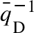(m), and obtained 3.3×10⁻¹⁰ m. If there are sufficient data in the critical region, one can determine the cutoff wavelength by regressing data, but in our case such data are unavailable so we used the estimation procedure of Perkins et al. [115]. The viscosity required for Eq. 4 was obtained from our recent viscosity correlation [1]. The reference temperature T_{ref}, far above the critical temperature where the critical enhancement is negligible, was calculated by T_{ref} = (³/₂) T_{c} [116], which for neon is 66.6 K. Thus, the present critical enhancement calculation is consistent with the equation of state of Thol et al. [14] and should provide reasonable estimates of the thermal conductivity critical enhancement, although the uncertainty is larger in this area.

3 Comparison with data
The final correlation consists of Eqs. 1 - 7. Table 5 summarizes comparisons of the primary data with the present work, and Table 6 gives comparisons with the present work for the secondary data. We use the following expressions for the percent deviation (PCT_{i}), average absolute relative deviation (AARD) and BIAS

(8)
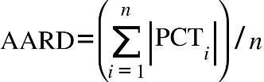, (9)

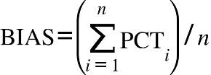, (10)

where n is the number of data points, λ_{exp} is the experimental value of the thermal conductivity and λ_{fit} is the value fitted value calculated from the correlation. The maximum deviation (positive or negative), MAX, is also given.

Table 5 Evaluation of the neon thermal-conductivity correlation for the primary data.
Investigators/reference | Publ.  Year | AARD  (%) | BIAS  (%) | MAX  (%)
Perkins and Roder [41] | 1999 | 0.89 | 0.05 | −3.87
Millat et al. [10] | 1988 | 0.44 | 0.33 | 0.97
Hemminger [42] | 1987 | 0.46 | −0.46 | −0.58
Tsarev et al. [43] | 1986 | 1.14 | −1.14 | −4.50
Assael et al. [44] | 1981 | 0.51 | 0.51 | 0.76
Fleeter et al. [45] | 1981 | 0.33 | 0.29 | 1.03
Kestin et al. [46] | 1980 | 0.47 | 0.43 | 1.44
Shashkov et al. [47] | 1980 | 0.36 | 0.09 | 0.76
Vidal et al. [48] | 1980 | 1.73 | 1.73 | 3.55
Tufeu and Le Neindre [49] | 1979 | 1.68 | −1.68 | −6.02
de Groot et al. [50] | 1978 | 1.43 | −1.43 | −1.77
Marchenkov and Aleinikova [51] | 1977 | 1.19 | 1.09 | 2.52
Stefanov et al. [52] | 1976 | 2.21 | −2.21 | −3.20
Jody and Saxena [53] | 1975 | 2.47 | 2.02 | −5.31
Vargaftik et al. [54] | 1975 | 3.05 | 2.05 | 5.48
Garrabos et al. [55] | 1973 | 1.09 | −0.83 | −1.72
Bewilogua and Yoshimura [9]^{LIQ} | 1972 | 11.40 | −11.40 | −16.17
Golubev and Shpagina [56] | 1971 | 1.09 | −0.15 | 6.63
Vasilkovskaya and Golubev [57] | 1971 | 1.73 | 1.58 | 4.17
Tufeu et al. [58] | 1970 | 1.04 | −0.91 | −2.18
Haarman [59] | 1969 | 0.37 | −0.37 | −0.42
Saxena and Saxena [60] | 1968 | 0.64 | 0.09 | −1.62
Vargaftik and Yakush [12] | 1968 | 1.51 | 1.28 | 3.53
Sengers et al. [61] | 1964 | 0.53 | −0.05 | 1.52
Löchtermann [62]^{LIQ} | 1963 | 2.02 | 0.48 | −5.54
Thomas and Golike [63] | 1954 | 0.26 | −0.18 | −0.42
Total |  | 1.06 | −0.11
^{LIQ Liquid Phase}

Table 6 Evaluation of the neon thermal-conductivity correlation for the secondary data.
Investigators/reference | Publ.  Year | AARD  (%) | BIAS  (%) | MAX  (%)
Perkins and Roder [41] | 1999 | 5.91 | 5.91 | 13.55
Timrot and Makhrov [64] | 1976 | 0.59 | −0.03 | −0.94
Clifford et al. [65] | 1975 | 0.18 | 0.18 | 0.18
Irving et al. [66] | 1973 | 0.52 | −0.52 | −0.52
Springer and Wingeier [67] | 1973 | 0.27 | −0.22 | −0.61
Dijkema et al. [68] | 1972 | 4.21 | −4.21 | −4.21
Saxena and Tondon [11] | 1971 | 1.07 | 0.32 | −3.93
Gray et al. [69] | 1970 | 0.58 | −0.58 | −0.74
Saxena and Gupta [70] | 1970 | 1.08 | −1.08 | −2.52
Tondon and Saxena [71] | 1970 | 0.43 | −0.41 | −1.27
Burge and Robinson [72] | 1968 | 4.31 | −4.31 | −4.31
Correia et al. [73] | 1968 | 4.46 | −4.46 | −7.00
Gibbons and Kuebler [74] | 1968 | 9.81 | 9.09 | −19.38
Mathur et al. [75] | 1968 | 1.10 | 0.76 | 1.71
Saxena and Tondon [76] | 1968 | 1.16 | 1.06 | 2.11
van Dael and Cauwenbergh [77] | 1968 | 0.50 | −0.50 | −0.50
Gambhir et al. [78] | 1967 | 0.64 | −0.25 | −1.35
Gandhi and Saxena [79] | 1967 | 1.27 | −1.27 | −1.74
Saxena and Gupta [80] | 1967 | 1.95 | −1.80 | −8.90
Srivastava and Das Gupta [81] | 1967 | 1.12 | −0.57 | −2.22
Collins and Menard [82] | 1966 | 7.76 | −7.76 | −11.12
Saxena et al. [83] | 1966 | 2.51 | −0.85 | −7.67
Barua [84] | 1960 | 2.15 | −2.15 | −2.35
Thornton [86] | 1960 | 0.23 | 0.23 | 0.23
Barua [87] | 1959 | 2.37 | −2.37 | −2.47
von Ubish [88] | 1959 | 4.40 | 4.40 | 4.54
Zaitseva [89] | 1959 | 3.22 | 3.22 | 4.84
Keyes [90] | 1954 | 1.23 | −1.23 | −1.52
Srivastava and Madan [91] | 1954 | 16.71 | 16.71 | 16.71
Davidson and Music [92] | 1953 | 2.35 | −2.35 | −2.35
Kannuluik and Carman [93] | 1952 | 0.88 | −0.80 | −2.84
Kannuluik and Donald [94] | 1950 | 2.32 | −2.32 | −2.32
Kannuluik and Martin [95] | 1934 | 0.67 | 0.67 | 1.35
Curie and Lepape [96] | 1931 | 1.45 | −1.45 | −1.45
Weber [97] | 1927 | 0.37 | −0.37 | −0.37
Weber [98] | 1917 | 1.73 | −1.73 | −1.73
Bannawitz [99] | 1915 | 1.53 | −1.53 | −1.53

Figure 3 shows the percentage deviations of all primary thermal-conductivity data from the values calculated by Eqs. 1 - 7 as a function of temperature. No systematic trends are shown. The AARD and BIAS for all primary data is 1.06% and -0.11% respectively. The higher deviations at the very low temperatures noticed in Fig. 3 refer to liquid-phase measurements. These are shown more clearly in Fig. 4. The estimated expanded uncertainty in the liquid range is estimated to be 15% based on comparisons with the limited experimental data available from two groups [9, 62], all of which are the saturation boundary. As mentioned earlier, the data sets differ by ~10%. Due to the larger number of points in the Löchtermann [62] data set, the fitter favored this set over Bewilogua and Yoshimura [9]. Initial fitting results including the 59 K isotherm of Perkins and Roder [41] indicated that especially for the highest density points on the 59 K isotherm, the liquid phase measurements (both sets) were inconsistent with the trends indicated by the 59 K isotherm. We were unable to reconcile the differences, so a compromise approach was taken where we fit only the liquid phase measurements and considered the 59 K isotherm as secondary. Since there are no primary experimental data below 85 K other than the two liquid sets, the correlation should be considered preliminary at low temperatures, and should be revisited when additional low-temperature measurements become available. More comprehensive and accurate measurements in the liquid region are necessary to improve any future correlations, as the present measurements are very limited and do not agree to within their estimated uncertainties.

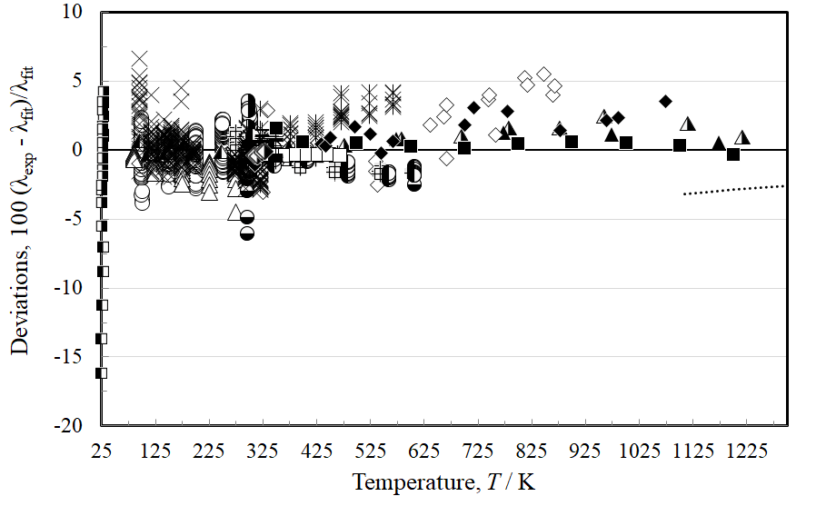
FIG. 3 Percentage deviations of primary experimental thermal-conductivity data of neon from the values calculated by the present scheme, Eqs. 1 - 7, as a function of temperature. Perkins and Roder [41] (), Millat et al. [10] (), Hemminger [42] (), Tsarev et al. [43] (), Assael et al. [44] (), Fleeter et al. [45] (), Kestin et al. [46] (), Shashkov et al. [47] (), Vidal et al. [48] ( ), Tufeu and Le Neindre [49] (), de Groot et al. [50] (), Marchenkov and Aleinikova [51] (), Stefanov et al. [52] (…), Jody and Saxena [53] (▲), Vargaftik et al. [54] (), Garrabos et al. [55] (), Bewilogua and Yoshimura [9] (), Golubev and Shpagina [56] (x), Vasilkovskaya and Golubev [57] (), Tufeu et al. [58] (), Haarman [59] (), Löchtermann [62] (), Saxena and Saxena [60] (), Vargaftik and Yakush [12] (), Sengers et al. [61] (+), Thomas and Golike [63] ().

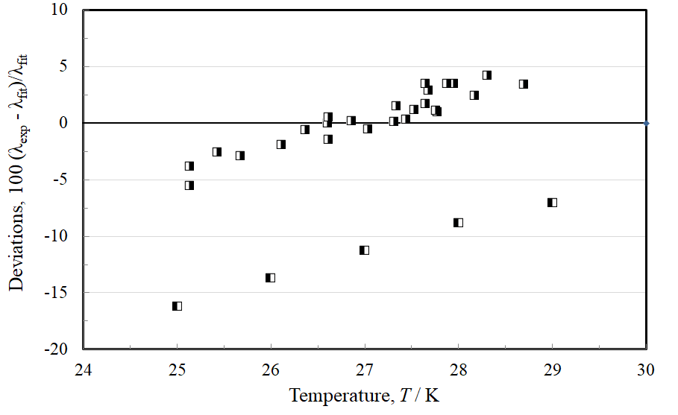
FIG. 4 Percentage deviations of primary experimental liquid-phase thermal-conductivity data of neon from the values calculated by the present scheme, Eqs. 1 - 7, as a function of temperature. Bewilogua and Yoshimura [9] (), Löchtermann [62] ().

Figure 5 shows the percentage deviations of all thermal-conductivity data (excluding the liquid) from the values calculated by Eqs. 1 - 7 as a function of pressure. As shown in the inset, above 100 MPa there are only two sets of measurements: that of Vidal et al. [48] that are limited to a single temperature of 298.15 K that extend to 1000 MPa, and those of Sengers et al. [61] cover the temperature range 298 K to 348 K and reach an upper pressure of 271 MPa. The deviations for Vidal et al. [48] are within 3.5%, and for Sengers et al. [61] the deviations do not exceed 1.5%. The data of Perkins and Roder [41] cover the temperature range from 100 K to 303 K at pressures up to 70 MPa, with an estimated uncertainty of 3%; all deviations are within this level of uncertainty. The measurements of Tufeu et al. [58] cover a temperature range from 305 K to 606 K at pressures from 0.1 MPa to 95 MPa. As indicated in Table 2, these measurements are represented by the correlation within 3%.

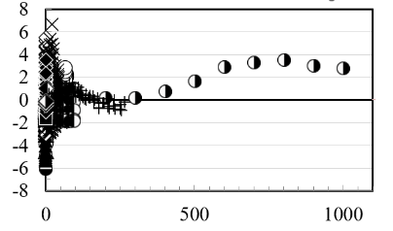
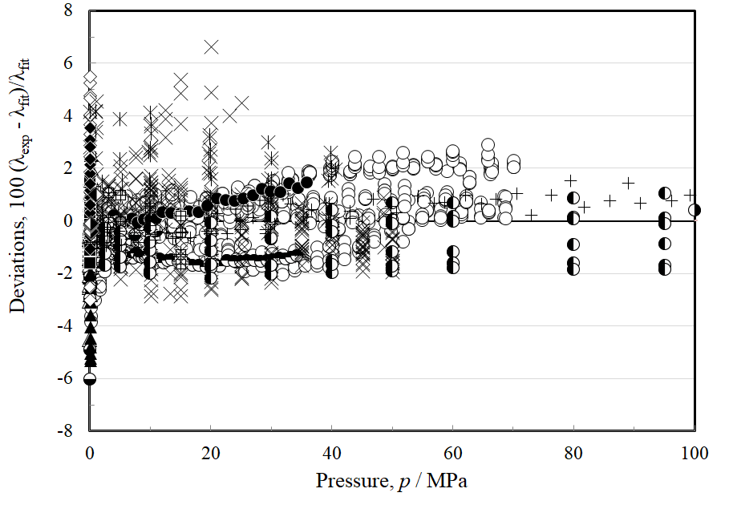
FIG. 5 Percentage deviations of primary experimental thermal-conductivity data of neon from the values calculated by the present scheme, Eqs. 1 - 7, as a function of pressure, (excluding the liquid phase) for pressures up to 100 MPa. The inset shows pressures up to 1000 MPa. Perkins and Roder [41] (), Millat et al. [10] (), Hemminger [42] (), Tsarev et al. [43] (), Assael et al. [44] (), Fleeter et al. [45] (), Kestin et al. [46] (), Shashkov et al. [47] (), Vidal et al. [48] ( ), Tufeu and Le Neindre [49] (), de Groot et al. [50] (), Marchenkov and Aleinikova [51] (), Stefanov et al. [52] (…), Jody and Saxena [53] (▲), Vargaftik et al. [54] (), Garrabos et al. [55] (), Golubev and Shpagina [56] (x), Vasilkovskaya and Golubev [57] (), Tufeu et al. [58] (), Haarman [59] (), Saxena and Saxena [60] (), Vargaftik and Yakush [12] (), Sengers et al. [61] (+), Thomas and Golike [63] ().

Figure 6 shows the percentage deviations of the primary thermal-conductivity data from the values calculated by Eqs. 1 - 7 as a function of density, excluding the liquid phase. In the embedded figure at the top-right corner, the deviations of the 59 K isotherm of Perkins and Roder [41] that was designated as secondary data and not included in the regression, are also displayed. It can be seen that this isotherm has larger deviations than the other data shown, with deviations extending to almost 15% at the highest density (that corresponds to a pressure of 63 MPa) and a systematic ~5% offset. Although there is a small contribution from the critical enhancement at this temperature, it cannot explain the magnitude of the deviations and their shape, and we do not know the reason for the discrepancies. More information on the critical enhancement is included in Figure S1 in the supplementary information. As noted earlier, more low-temperature data is needed to resolve the discrepancies shown in the 59 K isotherm.

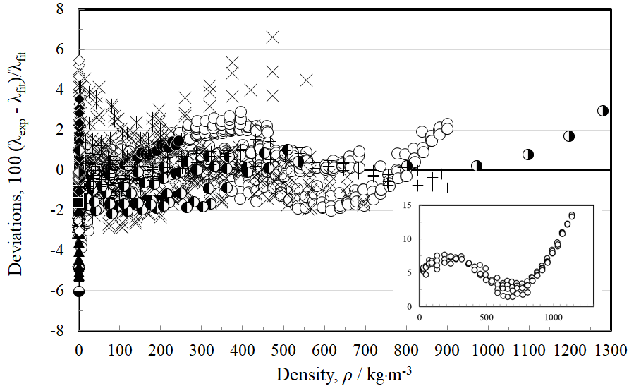FIG. 6 Percentage deviations of primary thermal-conductivity experimental data of neon from the values calculated by the present scheme, Eqs. 1 - 7, as a function of density (excluding the liquid phase). The inset shows the 59 K isotherm of Perkins and Roder [41] from the secondary data. Perkins and Roder [41] (), Millat et al. [10] (), Hemminger [42] (), Tsarev et al. [43] (), Assael et al. [44] (), Fleeter et al. [45] (), Kestin et al. [46] (), Shashkov et al. [47] (), Vidal et al. [48] ( ), Tufeu and Le Neindre [49] (), de Groot et al. [50] (), Marchenkov and Aleinikova [51] (), Stefanov et al. [52] (…), Jody and Saxena [53] (▲), Vargaftik et al. [54] (), Garrabos et al. [55] (), Golubev and Shpagina [56] (x), Vasilkovskaya and Golubev [57] (), Tufeu et al. [58] (), Haarman [59] (), Saxena and Saxena [60] (), Vargaftik and Yakush [12] (), Sengers et al. [61] (+), Thomas and Golike [63] ().

It is helpful to examine the results in more detail in specific regions of pressure, and to consider only the measurements with the lowest uncertainty. In this case we will only consider measurements with uncertainty equal or less than 1% and examine pressures up to 40 MPa. Included are the very accurate measurements of Millat et al. [10], Assael et al. [44], Fleeter et al. [45], Kestin et al. [46], de Groot et al. [50], and Haarman [59], which are performed in two-wire transient hot-wire instruments, with a full theory, and with uncertainties of less than 0.4%. Less than 1% uncertainty was also stated by Hemminger [42], Shashkov et al. [47], Sengers et al. [61], and Thomas and Golike [63] (we did not include the measurements of Vargaftik and Yakush [12] as the uncertainty of this group has a large degree of variability in each publication). Figure 7 shows the deviations of these measurements from the present correlation as a function of pressure, and Figure 8 displays the same data as a function of temperature.

The measurements shown cover a range of pressures up to 40 MPa and temperatures from 85 K to 463 K. At 85 K Tsarev et al. [43] provide data at low pressures from 0.01 to 4 MPa, and are represented to within 0.7%. For pressures between 0.1 MPa and 40 MPa at temperatures from 100 K to 463 K, the expanded uncertainty is less than 1.5%. For very low pressures, as mentioned previously, very accurate measurements are extremely difficult. But for pressures up to 0.1 MPa and at temperatures above 300 K, the thermal conductivity differs from the zero-density value by less than 0.05%. The difference is larger at lower temperatures, but even at 200 K it is still less than 0.1%. In this region uncertainty is dominated by uncertainty in the zero-density contribution, and we estimate an uncertainty of 0.3%.

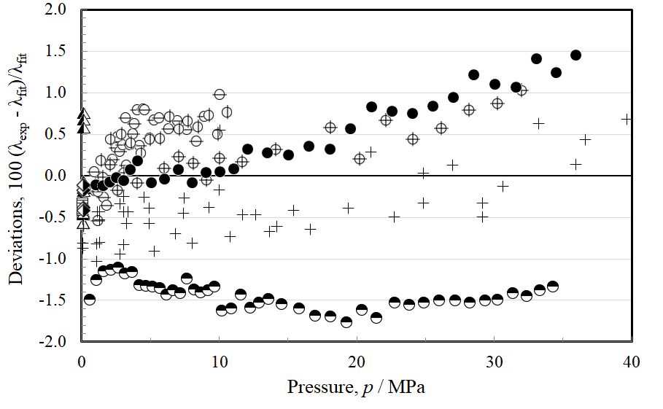
FIG. 7 Percentage deviations of primary experimental thermal-conductivity data of neon with uncertainties equal or less than 1%, from the values calculated by the present scheme, Eqs. 1 - 7, as a function of pressure, for pressures up to 40 MPa. Millat et al. [10] (), Hemminger [42] (), Assael et al. [44] (), Fleeter et al. [45] (), Kestin et al. [46] (), Shashkov et al. [47] (), de Groot et al. [50] (), Haarman [59] (), Sengers et al. [61] (+), Thomas and Golike [63] ().

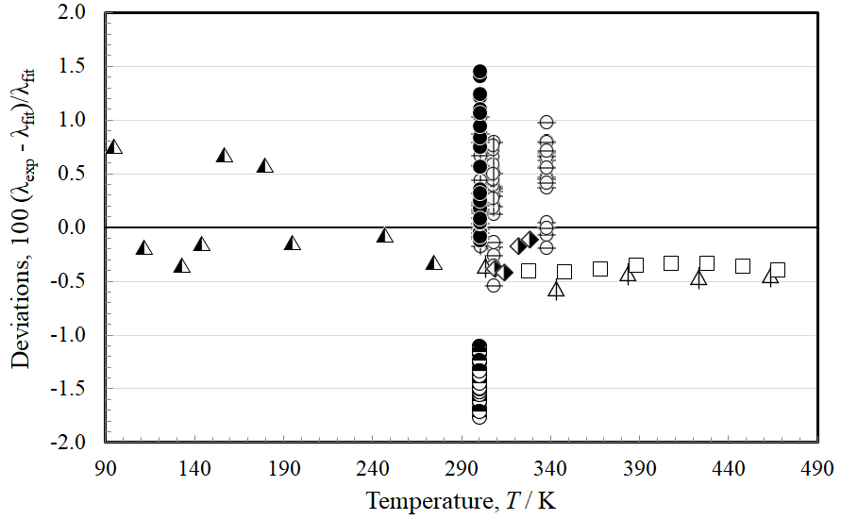
FIG. 8 Percentage deviations of primary experimental thermal-conductivity data of neon with uncertainties equal or less than 1%, from the values calculated by the present scheme, Eqs. 1 - 7, as a function of temperature, for pressures up to 40 MPa. Millat et al. [10] (), Hemminger [42] (), Assael et al. [44] (), Fleeter et al. [45] (), Kestin et al. [46] (), Shashkov et al. [47] (), de Groot et al. [50] (), Haarman [59] (), Sengers et al. [61] (+), Thomas and Golike [63] ().

4 Uncertainty
The full correlation is designed to be used with the EOS of Thol et al. [14] that is limited to temperatures up to 700 K and pressures of 700 MPa although the dilute gas correlation is valid over a much wider range of temperatures as discussed earlier. Fig. 9 summarizes the estimated relative expanded uncertainties (at k=2) for various T, p regions. As previously mentioned, the existing correlation by Huber [8] is characterized by an estimated uncertainty in the liquid phase of 15% at saturation, and 5% for the gas at atmospheric pressure. Although the proposed correlation could not improve the liquid-phase region as there are no new measurements, the remaining ranges as shown above are an improvement over the corresponding states correlation of Huber [8]. Additional measurements in the compressed liquid and compressed supercritical measurements at temperatures below about 85 K are needed as the present measurements at low temperatures are very limited. It also would be helpful to have additional measurements in the gas phase below 100 K. Although we lack experimental data to definitively assign an uncertainty level, based on our experience we think a reasonable estimate for regions within the recommended range of the EOS (outside of the critical region) is 15%, as shown in the shaded region on the plot. Since thermal conductivity diverges at the critical point, the uncertainty of the correlation as the critical point is approached can be extremely large.

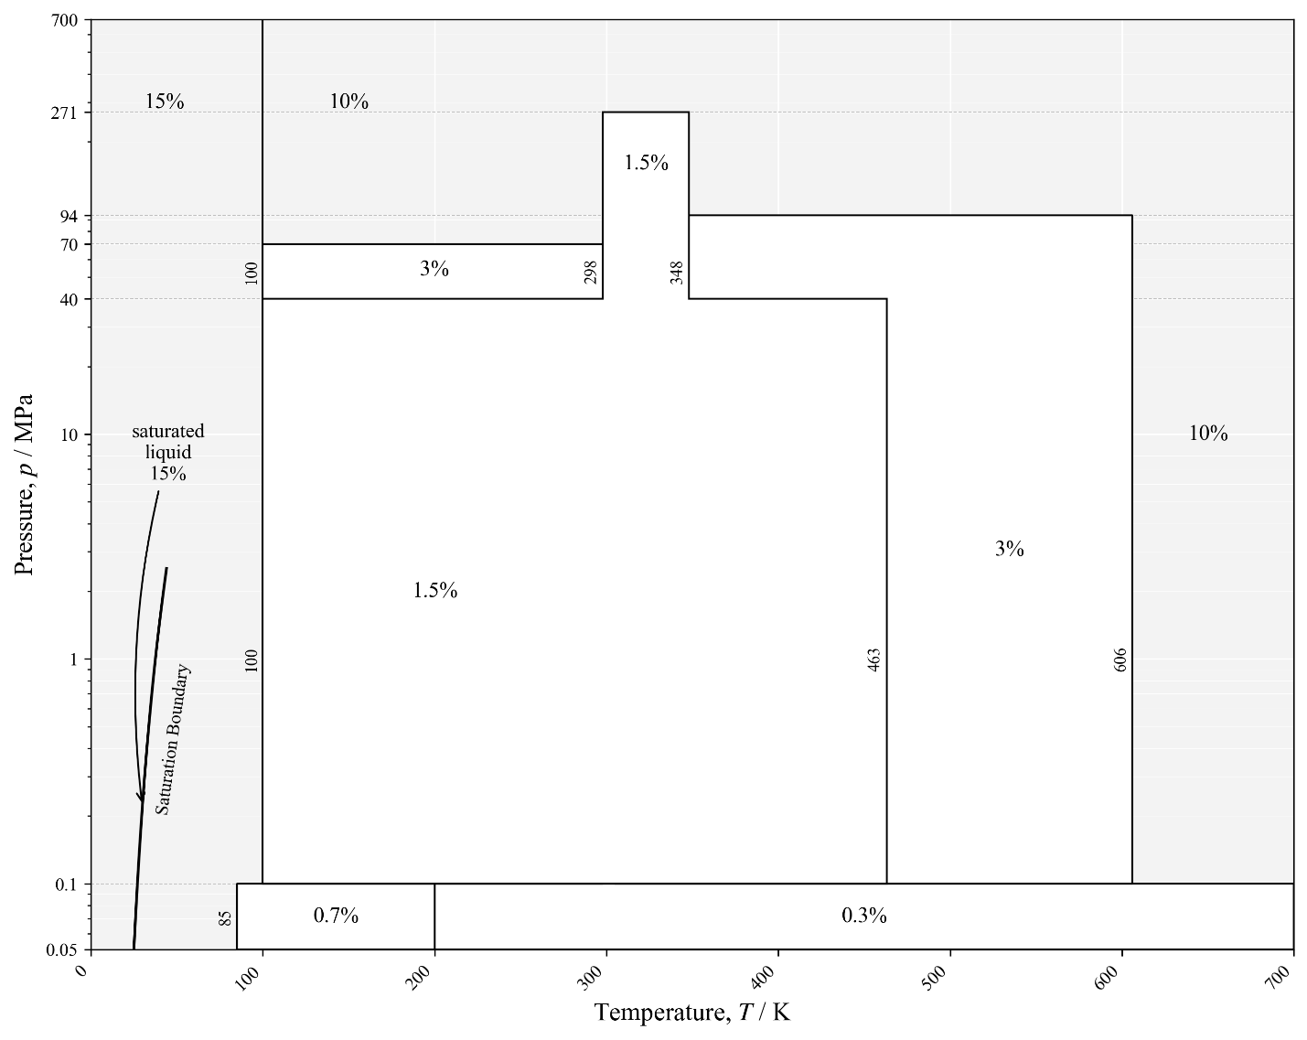
FIG. 9 Estimated uncertainties for the correlation in different temperature-pressure regions.

Figures 10 and 11 show plots of the thermal conductivity of neon as a function of the temperature for different pressures, and as a function of the density at different temperatures. The plots demonstrate reasonable behavior at pressures up to 900 MPa and temperatures to 3000 K, that exceed both the limits of pressure and temperature of the EOS by Thol et al. [14] (700 K and 700 MPa). For the supercritical fluid in regions where there are no experimental data or theoretical guidance, the behavior is physically reasonable. However, for the liquid region the current model shows behavior consistent with a normal fluid such as argon, and we suspect that with better data the behavior should be more like a quantum fluid such as hydrogen or helium where there is an inflection in the saturated liquid thermal conductivity; again emphasizing the need for more data at very low temperatures.

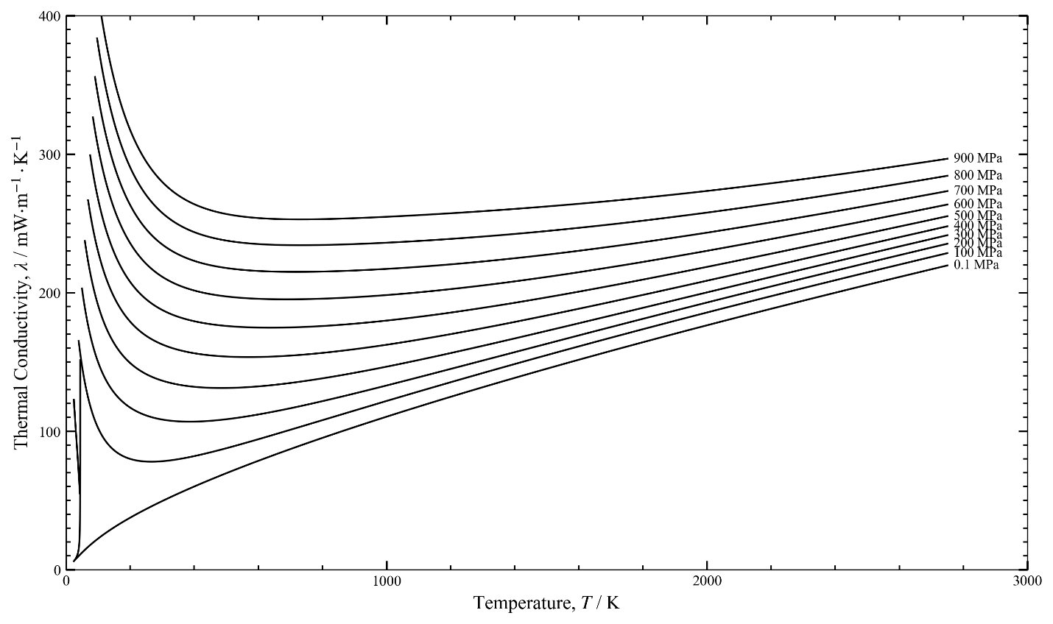
FIG. 10 Thermal conductivity of neon as a function of the temperature for different pressures.

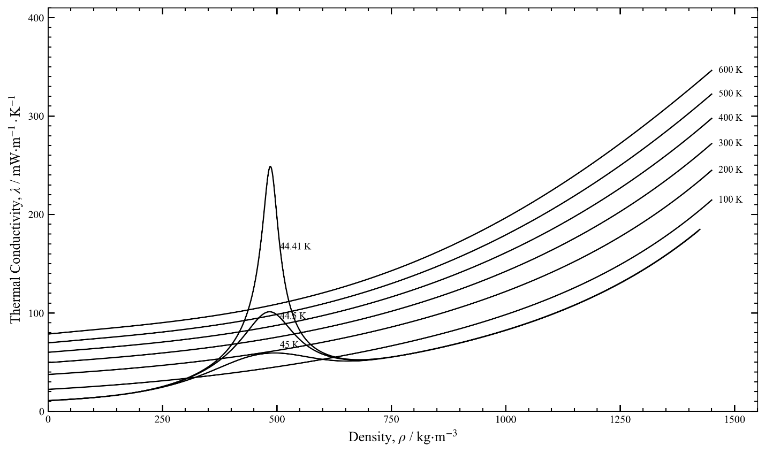
FIG. 11 Thermal conductivity of neon as a function of the density for different temperatures, including isotherms showing the critical enhancement at 44.41 K, 44.5 K, and 45 K.

5 Recommended Values and Computer-Program Verification

5.1 Recommended Values
In Table 7, thermal conductivity values are given along the saturation boundary, calculated from the present proposed correlation between 25 K and 40 K, while in Table 8, thermal conductivity values are given for temperatures between 25 K and 700 K and selected pressures. Saturation density values for selected temperatures, as well as the density values for the selected temperature and pressure are obtained from the equation of state of Thol et al. [14]. The values in the tables are calculated from the given temperatures and densities according to Eqs.1 – 6.

Table 7 Thermal conductivity values of neon along the saturation boundary, calculated by the present scheme.
Τ  (Κ) | ρ_{vap}  (kg·m⁻³) | ρ_{liq}  (kg·m⁻³) | λ_{vap}  (mW·m⁻¹·K⁻¹) | λ_{liq}  (mW·m⁻¹·K⁻¹)
25 | 0.050924 | 1242.2 | 5.1104 | 120.82
30 | 0.22334 | 1152.4 | 19.889 | 102.95
35 | 0.64641 | 1045.1 | 55.343 | 85.968
40 | 1.4649 | 896.15 | 135.51 | 67.894

Table 8 Thermal conductivity values of neon at selected temperatures and pressures, calculated by the present scheme.
p  (MPa) | T  (K) | ρ  (kg·m⁻³) | λ  (mW·m⁻¹·K⁻¹)
0.1 | 25 | 1242.457 | 120.88
 | 50 | 4.897 | 12.231
 | 75 | 3.243 | 17.613
 | 100 | 2.328 | 22.352
 | 200 | 1.213 | 37.425
 | 300 | 0.809 | 49.434
 | 400 | 0.607 | 59.953
 | 500 | 0.485 | 69.552
 | 600 | 0.404 | 78.507
 | 700 | 0.347 | 86.977
10 | 25 | solid | solid
 | 50 | 830.17 | 63.146
 | 75 | 371.18 | 32.143
 | 100 | 244.46 | 30.761
 | 200 | 115.08 | 41.157
 | 300 | 77.239 | 52.094
 | 400 | 58.395 | 62.127
 | 500 | 47.010 | 71.446
 | 600 | 39.361 | 80.220
 | 700 | 33.862 | 88.563
50 | 25 | solid | solid
 | 50 | 1163.10 | 112.34
 | 75 | 953.02 | 84.503
 | 100 | 785.06 | 70.187
 | 200 | 452.88 | 58.382
 | 300 | 322.99 | 63.113
 | 400 | 252.98 | 70.513
 | 500 | 208.61 | 78.443
 | 600 | 177.76 | 86.382
 | 700 | 154.97 | 94.179
100 | 25 | solid | solid
 | 50 | 1304.90 | 147.00
 | 75 | 1154.00 | 118.67
 | 100 | 1025.60 | 102.28
 | 200 | 699.07 | 79.905
 | 300 | 533.90 | 78.200
 | 400 | 434.08 | 81.893
 | 500 | 366.68 | 87.573
 | 600 | 317.91 | 94.075
 | 700 | 280.88 | 100.91
200 | 25 | solid | solid
 | 50 | 1463.90 | 202.75
 | 75 | 1350.60 | 169.87
 | 100 | 1253.40 | 149.83
 | 200 | 972.53 | 116.96
 | 300 | 799.08 | 108.30
 | 400 | 681.39 | 106.79
 | 500 | 595.58 | 108.50
 | 600 | 529.71 | 111.96
 | 700 | 477.30 | 116.44
500 | 25 | solid | solid
 | 50 | solid | solid
 | 75 | 1633.43 | 299.67
 | 100 | 1563.81 | 267.57
 | 200 | 1349.47 | 207.72
 | 300 | 1195.40 | 187.42
 | 400 | 1078.58 | 179.28
 | 500 | 986.09 | 175.87
 | 600 | 910.10 | 174.69
 | 700 | 846.00 | 174.81

5.2 Computer-Program Verification

For checking computer implementations of the correlation, the following points may be used for the given T, ρ conditions: T = 300 K, ρ = 0 kg·m⁻³, λ = 49.4064 mW·m⁻¹·K⁻¹, T = 300 K, ρ = 77.0 kg·m⁻³, λ = 52.0851 mW·m⁻¹·K⁻¹, and T = 300 K, ρ = 970 kg·m⁻³, λ = 136.3796 mW·m⁻¹·K⁻¹. To check the critical enhancement T = 44.5 K, ρ = 450 kg·m⁻³, λ = 89.2912 mW·m⁻¹·K⁻¹. A sample Python program to assist in calculating these points is included in the Supplemental Information, but it is limited to temperatures above 70 K since it does not include a critical enhancement contribution. In addition, the Supplemental Information includes a file NEON.FLD that can be used with the REFPROP or TREND [117] computer programs to calculate the thermal conductivity of neon over the full range of applicability including the critical region.

6 Conclusions
A new, wide-ranging correlation for the thermal conductivity of neon based on critically evaluated experimental data was presented. This correlation is designed to be used over the recommended range of applicability of the equation of state of Thol et al. [14], that extends from the triple-point temperature (24.5561 K) to 700 K at pressures up to 700 MPa. The estimated uncertainty of the correlation based on comparisons with the best experimental data varies over the T, p surface. The lowest values are for the gas in the limit of zero density where the uncertainty (at k = 2) varies from 0.15% at the triple point of neon (24.5561 K), to 0.014% at 298.15 K, and 0.028% at 5000 K. In other regions that could be validated with experimental data, the uncertainty of the thermal conductivity of the gas varies from 0.3 % (for pressures up to 0.1 MPa over temperatures from 200 K to 700 K) to 3%. In the liquid region along the saturation boundary the estimated uncertainty is 15%. This correlation offers an improvement over the extended corresponding states model of Huber [8] but could be improved in the future if new low-temperature data becomes available.

7 Acknowledgements
We thank Prof. Dr.-Ing. Karsten Meier (Helmut-Schmidt-Universität) for generously sharing his work prior to publication. We also wish to acknowledge Dr. Yannis Assael for his invaluable assistance with some of the computational aspects of this study. Finally, we thank our NIST colleague Dr. Richard Perkins for many helpful comments and valuable discussions.

Declarations
Author Contributions
All authors contributed equally to preparing and reviewing this manuscript.

Funding
No funding was used for this work.

Conflict of interest
Marc J. Assael is the Editor-in-Chief and Marcia L. Huber is Associate Editor of the International Journal of Thermophysics.

Supplementary information
The online version contains supplementary material available at https:// …….
Supplementary file NEON.FLD file containing the parameters for the calculation of the thermophysical properties of neon including the thermal-conductivity correlation in this work is available for use with the REFPROP [7] computer program and TREND [117]. A sample program Neon_thermal conductivity_testpoints.py is also included to assist in programming the correlation.

References
1. S.G. Sotiriadou, M.J. Assael, K.D. Antoniadis, M.L. Huber, V. Martinek, and M. Thol, Reference Correlation of the Viscosity of Neon, Int. J. Thermophys. 47, 77 (2026)
https://doi.org/10.1007/s10765-026-03745-3
2. V. Narayanan, G. Venkatarathnam, Cryogenics 106, 103039 (2020) https://doi.org/10.1016/j.cryogenics.2020.103039
3. N. Qian, C. Xu, X. Chen, Z. Li, K. Liang, Energy 334, 137840 (2025) https://doi.org/10.1016/j.energy.2025.137840
4. P. Dalakov, E. Neuber, J. Klier, R. Harzog, MATEC Web of Confereences 324, 01003 (2020) https://doi.org/10.1051/matecconf/202032401003
5. S. Ozaki, H. Hirai, M. Hirokawa, H. Kobayashi, IOP Conf. Series: Materials Science and Engineering 502, 012008 (2019) https://doi.org/10.1088/1757-899X/502/1/012008
6. S.Z.S. Al Ghafri, S. Munro, U. Cardella, T. Funke, W. Notardonato, J.P.M. Trusler, J. Leachman, R. Span, S. Kamiya, G. Pearce, A. Swanger, E.D. Rodriguez, P. Bajada, F. Jiao, K. Peng, A. Siahvashi, M.L. Johns, E.F. May, Energy Environ. Sci. 15, 2690 (2022) https://doi.org/10.1039/D2EE00099G
7. E.W. Lemmon, I.H. Bell, M.L. Huber, M.O. McLinden, REFPROP, NIST Standard Reference Database 23,Version 10.0, NIST, Standard Reference Data Program, Gaithersburg, MD (2018) https://doi.org/10.18434/T4/1502528
8. M.L. Huber, Models for the Viscosity, Thermal Conductivity, and Surface Tension of Selected Pure Fluids as Implemented in REFPROP v10.0, NISTIR 8209 (2018). https://doi.org/10.6028/NIST.IR.8209
9. L. Bewilogua, T. Yoshimura, J. Low Temp. Phys. 8, 255 (1972) https://doi.org/10.1007/BF00655082
10. J. Millat, M.J. Ross, W.A. Wakeham, Physica 148 A, 124 (1988) https://doi.org/10.1016/0378-4371(88)90138-0
11. S.C. Saxena, P.K. Tondon, J. Chem. Eng. Data 16 (2), 212 (1971) https://doi.org/10.1021/je60049a032
12. N.B. Vargaftik, L.V. Yakush, All-Union Thermodynamic Conference, Lenningrad, 193 (1968)
13. R. Hellmann, C. Gaiser, B. Fellmuth, T. Vasyltsova, E. Bich, J. Chem. Phys. 154, 164304 (2021) https://doi.org/10.1063/5.0047999
14. M. Thol, R. Beckmuller, R. Weiss, A.H. Harvey, E.W. Lemmon, R.T. Jacobsen, R. Span, Thermodynamic Properties for Neon for Temperatures from the Triple Point to 700 K at Pressures to 700 MPa, Int. J. Thermophys. (to be submitted)
15. C.-M. Vassiliou, M.J. Assael, M.L. Huber, R.A. Perkins, J. Phys. Chem. Ref. Data 44, 033102 (2015) https://doi.org/10.1063/1.4927095
16. M.J. Assael, S.K. Mylona, C.A. Tsiglifsi, M.L. Huber, R.A. Perkins, J. Phys. Chem. Ref. Data 42, 013106 (2013) https://doi.org/10.1063/1.4793335
17. M.J. Assael, I. Bogdanou, S.K. Mylona, M.L. Huber, R.A. Perkins, V. Vesovic, J. Phys. Chem. Ref. Data 42, 023101 (2013) https://doi.org/10.1063/1.4794091
18. M.J. Assael, T.B. Papalas, M.L. Huber, J. Phys. Chem. Ref. Data 46, 033103 (2017) https://doi.org/10.1063/1.4996885
19. S.A. Monogenidou, M.J. Assael, M.L. Huber, J. Phys. Chem. Ref. Data 47, 013103 (2018) https://doi.org/10.1063/1.5021459
20. M.J. Assael, A. Koutian, M.L. Huber, R.A. Perkins, J. Phys. Chem. Ref. Data 45, 033104 (2016) https://doi.org/10.1063/1.4958984
21. M.J. Assael, E.K. Michailidou, M.L. Huber, R.A. Perkins, J. Phys. Chem. Ref. Data 41, 043102 (2012) https://doi.org/10.1063/1.4755781
22. M.J. Assael, S.K. Mylona, M.L. Huber, R.A. Perkins, J. Phys. Chem. Ref. Data 41, 023101 (2012) https://doi.org/10.1063/1.3700155
23. S.K. Mylona, K.D. Antoniadis, M.J. Assael, M.L. Huber, R.A. Perkins, J. Phys. Chem. Ref. Data 43, 043104 (2014) https://doi.org/10.1063/1.4901166
24. A. Koutian, M.J. Assael, M.L. Huber, R.A. Perkins, J. Phys. Chem. Ref. Data 46, 013102 (2016) https://doi.org/10.1063/1.4974325
25. S. Sotiriadou, E. Ntonti, D. Velliadou, M.J. Assael, M.L. Huber, Int. J. Thermophys. 44, 108 (2023) https://doi.org/10.1007/s10765-023-03217-y
26. M.J. Assael, E.A. Sykioti, M.L. Huber, R.A. Perkins, J. Phys. Chem. Ref. Data 42, 023102 (2013) https://doi.org/10.1063/1.4797368
27. M. Mebellis, D. Velliadou, M.J. Assael, K.D. Antoniadis, M.L. Huber, Int. J. Thermophys. 42, 151 (2021) https://doi.org/10.1007/s10765-021-02904-y
28. R.A. Perkins, M.L. Huber, M.J. Assael, J. Chem. Eng. Data 62, 2659 (2017) https://doi.org/10.1021/acs.jced.7b00106
29. C.M. Tsolakidou, M.J. Assael, M.L. Huber, R.A. Perkins, J. Phys. Chem. Ref. Data 46, 023103 (2017) https://doi.org/10.1063/1.4983027
30. R.A. Perkins, M.L. Huber, M.J. Assael, J. Chem. Eng. Data 61, 3286 (2016) https://doi.org/10.1021/acs.jced.6b00350
31. R.A. Perkins, M.L. Huber, M.J. Assael, Int. J. Thermophys. 43, 12 (2021) https://doi.org/10.1007/s10765-021-02941-7
32. D. Velliadou, K.D. Antoniadis, M.J. Assael, M.L. Huber, Int. J. Thermophys. 42, 51 (2021) https://doi.org/10.1007/s10765-021-02803-2
33. M.J. Assael, J.A.M. Assael, M.L. Huber, R.A. Perkins, Y. Takata, J. Phys. Chem. Ref. Data 40, 033101 (2011) https://doi.org/10.1063/1.3606499
34. M.L. Huber, R.A. Perkins, D.G. Friend, J.V. Sengers, M.J. Assael, I.N. Metaxa, K. Miyagawa, R. Hellmann, E. Vogel, J. Phys. Chem. Ref. Data 41, 033102 (2012) https://doi.org/10.1063/1.4738955
35. M.L. Huber, R.A. Perkins, M.J. Assael, S.A. Monogenidou, R. Hellmann, J.V. Sengers, J. Phys. Chem. Ref. Data 51, 013102 (2022) https://doi.org/10.1063/5.0084222
36. M.L. Huber, E.A. Sykioti, M.J. Assael, R.A. Perkins, J. Phys. Chem. Ref. Data 45, 013102 (2016) https://doi.org/10.1063/1.4940892
37. M.J. Assael, A.E. Kalyva, S.A. Monogenidou, M.L. Huber, R.A. Perkins, D.G. Friend, E.F. May, J. Phys. Chem. Ref. Data 47, 021501 (2018) https://doi.org/10.1063/1.5036625
38. M.J. Assael, I.A. Koini, K.D. Antoniadis, M.L. Huber, I.M. Abdulagatov, R.A. Perkins, J. Phys. Chem. Ref. Data 41, 023104 (2012) – Erratum: J. Phys. Chem. Ref. Data 43, 039901 (2014) https://doi.org/10.1063/1.4708620
39. H. Preston-Thomas, Metrologia 27 (1), 3 (1990) https://doi.org/10.1088/0026-1394/27/1/002
40. H. Preston-Thomas, Metrologia 27 (2), 107 (1990) https://doi.org/10.1088/0026-1394/27/2/010
41. R.A. Perkins, H.M. Roder, NISTIR, 5088 (1999) https://doi.org/10.6028/NIST.IR.5088
42. W. Hemminger, Int. J. Thermophys. 8, 317 (1987) https://doi.org/10.1007/BF00503945
43. V.V. Tsarev, D.N. Nagorov, V.A. Nikonorov, V.N. Popov, Tr. Mosk. Energ. Inst., 5 (1986)
44. M.J. Assael, M. Dix, A. Lucas, W.A. Wakeham, J. Chem. Soc., Faraday Trans. 1 77, 439 (1981) https://doi.org/10.1039/F19817700439
45. R.D. Fleeter, J. Kestin, R. Paul, W.A. Wakeham, Physica 108A, 371 (1981) https://doi.org/10.1016/0378-4371(81)90138-2
46. J. Kestin, R. Paul, A.A. Clifford, W.A. Wakeham, Physica 100 A, 349 (1980) https://doi.org/10.1016/0378-4371(80)90125-9
47. A.G. Shashkov, T.I. Yaroshenko, N.A. Nesterov, R. Afshar, S.C. Saxena, Chem. Phys. Lett. 69, 555 (1980) https://doi.org/10.1016/0009-2614(80)85127-X
48. D. Vidal, R. Tufeu, Y. Garrabos, B. Le Neindre, High-Pressure Sci. Technol. 2, 692 (1980)
49. R. Tufeu, B. Le Neindre, Inzh.-Fiz. Zh. 36, 472 (1979)
50. J.J. de Groot, J. Kestin, H. Sookiazian, Physica 92A, 117 (1978) https://doi.org/10.1016/0378-4371(78)90024-9
51. E.I. Marchenkov, V.I. Aleinikova, Inzh.-Fiz. Zh. 33, 848 (1977)
52. B. Stefanov, L. Zarkova, D.A. Oliver, Teplofiz. Vys. Temp. 14, 56 (1976)
53. B.J. Jody, S.C. Saxena, Phys. Fluids 18, 20 (1975) https://doi.org/10.1063/1.860988
54. N.B. Vargaftik, Y.K. Vinogradov, N.A. Vanicheva, Tr. Mosk. Aviats. Inst., 59 (1975)
55. Y. Garrabos, R. Tufeu, B. Le Neindre, Proc. 4th Symp. Thermophys. Prop., 32 (1973)
56. I.F. Golubev, I.B. Shpagina, Trudy GIAP 8, 91 (1971)
57. T.N. Vasilkovskaya, I.F. Golubev, Trudy GIAP 8, 99 (1971)
58. R. Tufeu, B. Le Neindre, P. Bury, C. R. Acad. Sc. Paris B 271, 589 (1970)
59. J. W. Haarman, An Accurate Method for the Determination of the Thermal Conductivity Coefficient of Gases (The non-Stationary Wire Method), PhD, Delft University, Netherlands (1969)
60. V.K. Saxena, S.C. Saxena, J. Chem. Phys. 48, 5662 (1968) https://doi.org/10.1063/1.1668653
61. J.V. Sengers, W.T. Bolk, C.J. Stigter, Physica 30, 1018 (1964) https://doi.org/10.1016/0031-8914(64)90233-2
62. E. Löchtermann, Cryogenics 3, 44 (1963) https://doi.org/10.1016/0011-2275(63)90074-2
63. L.B. Thomas, R.C. Golike, J. Chem. Phys. 22, 300 (1954) https://doi.org/10.1063/1.1740056
64. D.L. Timrot, V.V. Makhrov, Inzh.-Fiz. Zh. 31, 965 (1976)
65. A.A. Clifford, L. Colling, P. Gray, J. Chem. Soc., Faraday Trans. 1 71, 1590 (1975) https://doi.org/10.1039/F19757101590
66. J.B. Irving, D.T. Jamieson, D.S. Paget, Trans. IChemE 51, 10 (1973)
67. G.S. Springer, E.W. Wingeier, J. Chem. Phys. 59, 2747 (1973) https://doi.org/10.1063/1.1680394
68. K.M. Dijkema, J.C. Stouthart, D.A. De Vries, Warme- Stoffubertrag. 5, 47 (1972) https://doi.org/10.1007/BF01000478
69. P. Gray, S. Holland, O.S. Maczek, Trans. Faraday Soc. 66, 107 (1970) https://doi.org/10.1039/TF9706600107
70. S.C. Saxena, G.P. Gupta, J. Chem. Eng. Data 15 (1), 98 (1970) https://doi.org/10.1021/je60044a042
71. P.K. Tondon, S.C. Saxena, Chem. Phys. Lett. 5 (9), 619 (1970) https://doi.org/10.1016/0009-2614(70)80063-4
72. H.L. Burge, L.B. Robinson, J. Appl. Phys. 19, 51 (1968) https://doi.org/10.1063/1.1655777
73. P. Correia, B. Schramm, K. Schafer, Ber. Bunsenges. Phys. Chem. 72, 394 (1968) http://doi.org/10.1002/bbpc.196800005/
74. Gibbons, R. M., Kuebler, G. P., Research on Materials Essential to Cryocooler Technology, Thermophysical and Transport Properties of Argon, Neon, Nitrogen and Helium-4, Wright-Patterson Air Force Base, Technical Report No. AFML-TR-68-370, Ohio, USA (1968)
75. S. Mathur, P.K. Tondon, S.C. Saxena, J. Phys. Soc. Jap. 25, 530 (1968)
76. S.C. Saxena, and P.K. Tondon, Thermal Conductivity of Multicomponent Mixtures of Rare Gases, 4th Symp. Thermophys. Prop. ASME, Univ. Maryland, April 1-4 (1968)
77. W. Van Dael, H. Cauvenbergh, Physica (Amsterdam) 40, 165 (1968) https://doi.org/10.1016/0031-8914(68)90014-1
78. R.S. Gambhir, J.M. Gandhi, S.C. Saxena, Ind. J. Pure. Appl. Phys. 5, 457 (1967)
79. J.M. Gandhi, S.C. Saxena, Mol. Phys. 12, 57 (1967) https://doi.org/10.1080/00268976700100071
80. S.C. Saxena, G.P. Gupta, Can. J. Phys. 45, 1418 (1967) https://doi.org/10.1139/p67-106
81. B.N. Srivastava, A. Das Gupta, Brit. J. Appl. Phys. 18, 945 (1967) https://doi.org/10.1088/0508-3443/18/7/309
82. D.J. Collins, W.A. Menard, J. Heat Transf. 88, 52 https://doi.org/10.1115/1.3691476
83. V.K. Saxena, P.M. Saksena, S.C. Saxena, Ind. J. Phys. 40, 597 (1966)
84. A.K. Barua, Indian J. Phys. 34, 169 (1960)
85. B.N. Srivastava, A.K. Barua, J. Chem. Phys. 32, 427 (1960) https://doi.org/10.1063/1.1730711
86. E. Thornton, Proc. Phys. Soc. 76, 104 (1960) 10.1088/0370-1328/76/1/313
87. A.K. Barua, Physica (Amsterdam) 25, 1275 (1959) https://doi.org/10.1016/0031-8914(59)90049-7
88. H. Von Ubish, Ark. Fys., 93 (1959)
89. L.S. Zaitseva, Zh. Tekh. Fiz. 29, 497 (1959)
90. F.G. Keyes, Trans. ASME 76, 809 (1954) https://doi.org/10.1115/1.4014978
91. B.N. Srivastava, M.P. Madan, Proc. Nat. Inst. Sci. India 20, 587 (1954)
92. J.M. Davidson, J. F., Music, Experimental thermal conductivities of gases and gaseous mixtures at zero degrees centigrade, U. S. A. E. C., Rep. HW-29021 (1953).
93. W.G. Kannuluik, E.H. Carman, Proc. Roy. Soc. London B 65, 701 (1952) https://doi.org/10.1088/0370-1301/65/9/307
94. W.G. Kannuluik, H.B. Donald, Austr. J. Sci. Res. A: Phys. Sci. 3, 417 (1950) https://doi.org/10.1071/CH9500417
95. W.G. Kannuluik, L.H. Martin, Proc. Roy. Soc. London A 144, 496 (1934) https://doi.org/10.1098/rspa.1934.0064
96. M. Curie, A. Lepape, J. Phys. Radium 2, 392 (1931) https://doi.org/10.1051/jphysrad:01931002012039200
97. S. Weber, Ann. Phys. (Leipzig) 82, 479 (1927) https://doi.org/10.1002/andp.19273870403
98. S. Weber, Ann. Phys. (Leipzig) 359, 437 (1917) https://doi.org/10.1002/andp.19173592203
99. E. Bannawitz, Ann. Phys. 48, 577 (1915) https://doi.org/10.1002/andp.19153532102
100. Diky, V., Chirico, R.D., Frenkel, M., Bazyleva, A., Magee, J. W., Paulechka, E., Kazakov, A., Lemmon, E. W., Muzny, C. D., Smolyanitsky, A.Y., Townsend, S., Kroenlein, K., ThermoData Engine (TDE) Version 10.4, NIST Standard Database #103b, National Institute of Standards and Technology, Gaithersburg, MD (2019). https://www.nist.gov/mml/acmd/trc/thermodata-engine/srd-nist-tde-103b
101. U. Kochan-Eilers, K. Meier, and E. Vogel, Wide-Ranging Measurements of the Viscosity and Density of Neon with a Combined Vibrating-Wire Viscometer and Single-Sinker Densimeter, (to be submitted, 2026)
102. E. Vogel, B. Jäger, R. Hellmann, E. Bich, Mol. Phys. 108, 3335 (2010) https://doi.org/10.1080/00268976.2010.507557
103. E. Bich, R. Hellmann, E. Vogel, Mol. Phys. 106, 813 (2008) https://doi.org/10.1080/00268970801964207
104. B. Jäger, R. Hellmann, E. Bich, E. Vogel, J. Chem. Phys. 144, 114304 (2016) https://doi.org/10.1063/1.4943959
105. R. Hellmann, B. Jäger, E. Bich, J. Chem. Phys. 147, 034304 (2017) https://doi.org/10.1063/1.4994267
106. W. Cencek, M. Przybytek, J. Komasa, J.B. Mehl, B. Jeziorski, K. Szalewicz, J. Chem. Phys. 136, 224303 (2012) https://doi.org/10.1063/1.4712218
107. J. Lang, M. Przybytek, M. Lesiuk, Physical Review A 109 (5), 052803 (2024) https://doi.org/10.1103/PhysRevA.109.052803
108. X. Xiao, D. Rowland, S.Z.S. Al Ghafri, E.F. May, J. Chem. Ref. Data 49, 013101 (2020) https://doi.org/10.1063/1.5125100
109. G.A. Olchowy, J.V. Sengers, Phys. Rev. Lett. 61, 15 (1988) https://doi.org/10.1103/PhysRevLett.61.15
110. R. Mostert, H.R. van den Berg, P.S. van der Gulik, J.V. Sengers, J. Chem. Phys. 92, 5454 (1990) https://doi.org/10.1063/1.458523
111. R.A. Perkins, H.M. Roder, C.A. Nieto de Castro, J. Res. Natl. Inst. Stand. Technol. 96, 247 (1991) https://doi.org/10.6028/jres.096.014
112. P.T. Boggs, R.H. Byrd, J.E. Rogers, R.B. Schnabel, ODRPACK, Software for Orthogonal Distance Regression, NISTIR 4834, v2.013, National Institute of Standards and Technology, Gaithersburg, MD (1992).
113. G.A. Olchowy, J.V. Sengers, Int. J. Thermophys. 10, 417 (1989) https://doi.org/10.1007/BF01133538
114. P.J. Mohr, D.B. Newell, B.N. Taylor, E. Tiesinga, J. Phys. Chem. Ref. Data 54 (3), (2025) https://doi.org/10.1063/5.0279860
115. R.A. Perkins, J.V. Sengers, I.M. Abdulagatov, M.L. Huber, Int. J. Thermophys. 34, 191 (2013) https://doi.org/10.1007/s10765-013-1409-z
116. V. Vesovic, W.A. Wakeham, G.A. Olchowy, J.V. Sengers, J.T.R. Watson, J. Millat, J. Phys. Chem. Ref. Data 19, 763 (1990) https://doi.org/10.1063/1.555875
117. R. Span, R. Beckmüller, J. Buchenfeld, F. Fiedler, A. Jäger, E. Mickoleit, T. Neumann, T.T.G. Nguyen, S.M. Pohl, S. Rath, F. Sabozin, B. Semrau, M. Thol, Monika, TREND. Thermodynamic Reference and Engineering Data 6.0 Thermodynamics, Ruhr-University Bochum, Germany (2025)

