Enhanced Genetically Variant Peptide Profiling from Human Hair Using Multiple Enzymes

Zheng Zhang¹*, William E. Wallace¹, Guanghui Wang¹, Meghan C. Burke¹, Stephen E. Stein¹

¹Mass Spectrometry Data Center, Biomolecular Measurement Division, National Institute of Standards and Technology, 100 Bureau Drive, Gaithersburg, Maryland 20899 USA

Correspondence to:
*E-mail: zheng.zhang@nist.gov Tel: +1 301-975-5828

KEYWORDS: Variant peptide discovery, multiple enzymes, alternative enzymes, trace detection, human hair

ABBREVIATIONS: NIST, National Institute of Standards and Technology; NCBI, National Center for Biotechnology Information; RPO, Research Protections Office; DE, Direct extraction; SDS, Sodium dodecyl sulfate; SDS-PAGE, Sodium dodecyl sulfate - Polyacrylamide gel electrophoresis; LC-MS/MS, Liquid chromatography-tandem mass spectrometry; SP3, Single-pot, solid-phase-enhanced sample preparation; AM, Asian male donor; GN, Gene Name; KRT, Keratin; KRTAP, Keratin-associated protein; PSM, Peptide-spectrum match; SAP, Single amino acid polymorphism; GVP, Genetically Variant Peptide; FASTA, a text-based format for representing protein sequences; T, Trypsin/LysC; C, Chymotrypsin; G, Glu-C; K, Keratinase; KT, Keratinase with trypsin/LysC; CT, Chymotrypsin with trypsin/LysC; GT, Glu-C with trypsin/LysC.

ABSTRACT
Genetically variant peptides (GVPs) derived from human hair proteins have been studied as evidence for forensic human identification. For this purpose, trypsin is generally routinely used as the protease for peptide generation. We hypothesized that the use of different proteases can expand sequence coverage in the hair proteome and therefore increase the chance of a variant peptide being identified as well as confirm the findings from tryptic digests. Since keratins and keratin-associated proteins are the main components of the hair proteome, we examined several alternative enzymes other than trypsin including keratinase, chymotrypsin, and Glu-C. We found that the use of multiple enzymes led to enhanced GVP profiling and, therefore, an increase in the confidence of GVP identification.

INTRODUCTION
Genetically variant peptides (GVPs) derived from human hair proteins have been proposed and studied for use as evidence for human identification in forensics.^{1,2} A significant impediment to this goal is the difficulty in digesting hair due to the high degree of cross-linking and poor solubility of hair keratins (KRTs) and keratin-associated proteins (KRTAPs).^{3,4} In prior work we developed a method called Direct Extraction (DE) method⁵ to efficiently extract hair proteins from a single 5 cm-long hair strand. This method simplified protein extraction by requiring only a single step and taking only 30 min.
At the time that we developed the DE method, we coupled it with sodium dodecyl sulfate - polyacrylamide gel electrophoresis (SDS-PAGE) for protein separation and purification, followed by in-gel digestion to generate digested peptides for downstream liquid chromatography-tandem mass spectrometry (LC-MS/MS) analysis. Since SDS-PAGE and in-gel digestion are time-consuming and laborious, we further simplified protein purification for digestion by optimizing a published bead-based single-pot, solid-phase-enhanced sample preparation (SP3) method.^{6,7} We demonstrated improved GVP discovery with the DE and optimized SP3 workflow, which was not only faster than the previous in-gel digestion method but also required significantly less instrument time depending on the number of gel slices processed. Additionally, it led to increased numbers of identified proteins and GVPs.⁷
In this work, we examine another potential means of enhancing the ability to identify GVPs by exploring the effects of other proteolysis enzymes. Trypsin is almost universally used to generate peptides from proteins for a variety of reasons, such as generating optimal sets of peptides for mass spectrometry via selectively cleaving at the C-terminus of arginine and lysine residues. Since it is known that the use of multiple enzymes can enhance sequence coverage in proteomics studies⁸ and KRT and KRTAP proteins are the main components of hair proteome,⁴ we then examined several alternative enzymes other than trypsin (keratinase, chymotrypsin, and Glu-C), alone or combined with trypsin, to explore their ability to expand the sequence coverage of hair KRTs and KRTAPs and to generate other identifiable peptides, including GVPs, as well as confirm the previous findings in tryptic digests.
METHOD
Human Hair Sample Preparation
We used hair shafts from a randomly selected Asian male donor (AM, 30 years old) to set up our methods. Hair samples were commercially obtained from BioreclamationIVT (LOT# BRH1363732) under the approval of the NIST Research Protections Office (RPO# MML-17-0016) on a yearly basis. We briefly washed hair shafts with 20% methanol and water, then dried and stored them at -20 ℃ (at -80 ℃ for a long-term storage).
Trypsin and Enzymes Other Than Trypsin
Proteins were extracted from single 5 cm-long hair shafts (about 100 ug each) of this AM donor by the DE method,⁵ reduced (dithiothreitol), and alkylated (iodoacetamide) using the workflow previously published,⁵ followed by purification and digestion with the optimized SP3 method.⁷
Several different enzymes were examined under the following conditions in 200 uL of 25 mM ammonium bicarbonate:
T) trypsin and LysC (T, Promega, V5111 and V1671) with enzyme-to-protein ratio 1: 20 and an overnight 18-h incubation period at 37 ℃
C) chymotrypsin (C, Promega, V1061): 1:10, 2-h incubation at room temperature
G) Glu-C (G, Promega, V1651): 1:10, an overnight 18-h incubation at 37 ℃
K) keratinase (K, Sigma, K4519): 1Unit (1U):20, 2-h incubation at 50 ℃
KT) keratinase with trypsin/LysC (KT): K, 1U:20, 2-h incubation at 50 °C, heat inactivation for 10 min at 95 °C, followed by T, 1:20, an overnight 18-h incubation at 37 °C
CT) chymotrypsin with trypsin/LysC (CT): C, 1:10, 2-h incubation at room temperature, heat inactivation of C for 10 min at 95 °C, then added T, 1:20, an overnight 18-h incubation at 37 °C
GT) Glu-C with trypsin/LysC (GT): G, 1:10, together with T, 1:20, an overnight 18-h incubation at 37 °C
Three replicates (labeled as 1, 2, and 3) were performed for each protease and combination.
Peptides were cleaned up with MonoSpin C18 columns (GL Sciences Inc., 5010-21701) for LC-MS/MS on an Orbitrap Fusion Lumos mass spectrometer.⁵
LC-MS/MS parameters: Digests were analyzed on a Thermo Dionex Ultimate 3000 LC with an Acclaim PepMap 100 C18 (75 µm x 25 cm, C18, 2 µm, 100 A) with a nanospray source connected to a Thermo Orbitrap Fusion Lumos Mass Spectrometer in the positive ion mode. Solvent A consisted of 0.1% formic acid in water, and Solvent B consisted of 0.1% formic acid in Acetonitrile. The peptides were eluted by increasing Solvent B using the following gradient over 230 min (min:B%): 0:2, 25:2, 142:32, 159:80, 165:98, 175:98, 180:2,230:2. Data was collected using a data-dependent mode with a dynamic exclusion of 20 sec. MS/MS HCD fragmentation spectra were acquired with a cycle time of 4 sec for precursor ions selected from 350-1600 m/z full survey scans. The resolution of full MS scan was set at 120,000, and the resolution of MS/MS scan was set at 30,000.
Expanded FASTA File
Human protein FASTA file (UniProtKB/SwissProt, downloaded from NCBI, January 2022) with 20,375 sequences was expanded by adding mutations reported by BioMuta⁹ for 54 KRTs with 7,554 proposed mutations and 92 KRTAPs with 4,534 proposed mutations. These mutations are either genetic variants or disease-related variants. For each mutation, a separate sequence entry was added to the FASTA file. For that purpose, we first used the reference protein sequence containing the mutation site and trimmed it to retain up to 40 flanking amino acids on both sides of the site. For a mutation site closer to the protein N- or C-terminus, the flanking amino acids could be less than 40. We then replaced the mutation site with the mutant (or variant) amino acid. Thus, most mutant sequence entries were 81 amino acids in length with the variant residue occupying the center position. An identified peptide was considered a GVP only if it was mapped to a mutant sequence and contained a mutant amino acid.
Sequence Database Searching
We used Sequest¹⁰ (Proteome Discoverer 2.4) for database searching with a precursor ion tolerance of 20 ppm and fragment ion tolerance of 50 ppm. The top-scoring peptide identification was selected, and the false discovery rate level was set at 1% (in the “Target-Decoy PSM Validator” node) using the FASTA file described above. Settings for modifications are: 1) dynamic modification: oxidation on methionine; 2) static modification: carbamidomethyl on cysteine. Settings for enzymes: 1) full enzymatic searching for T, C, G, CT, and GT; 2) non-specific searching for K and KT.
Applied GVP Filters
GVP identifications were filtered using the following criteria: 1) the GVP sequence is not in the reference sequences; 2) the precursor ion tolerance of GVP was set up to 5 ppm to accurately distinguish glutamine and lysine; 3) the GVP sequence cannot be accounted by a known common chemical modification in amino acid residues like isoleucine/leucine, asparagine/aspartic acid, glutamine/glutamic acid; 4) the length of GVP was set to 7 to 40 amino acids.
RESULTS AND DISCUSSION
Optimizing the Experimental Conditions of Keratinase
Keratinase, since it is not a highly specific protease, is not generally used in proteomic studies. However, it was selected for use in the present study since keratins and keratin-associated proteins are the main components of the hair proteome. It was surmised that keratinase could loosen or weaken the mechanically strong structure of human hair, making it more accessible to trypsin. To find an optimal way to use keratinase, we first conducted a series of experiments to optimize its use.
For optimizing the usage of keratinase alone, we first used it at 1U:20 dilution by mass at 50 °C following the manufacturer’s instructions. Next, we tested two incubation conditions to find the optimal incubation period. One was the 2-h incubation as we described in the METHOD section (K), and another was an overnight 18-h incubation. We found significantly less GVPs from the overnight 18-h incubation (GVPs from 2-h: 31 ± 6; from 18-h: 10 ± 3). The potential reason might be due to the over digestion of hair samples by the keratinase with the longer incubation that generated the shorter peptides (< 7 amino acids) which will be excluded by the downstream searching and data processing. Thus, we concluded that a 2-h incubation period for keratinase (1U:20) at 50 °C was the optimal experimental condition for the application of keratinase to the hair samples (K).
We also examined the usage of keratinase with trypsin. For testing the optimal enzymatic combination, besides the sequential combination of keratinase and trypsin/LysC as we described in the METHOD section (KT), we also put keratinase (1U:20) together with trypsin/LysC for a 2-h or an overnight 18-h incubation period to test the enzymatic performance if these enzymes were added at the same time. Since the optimal temperature was different for keratinase (50 °C) versus trypsin/LysC (37 °C), one specific temperature had to be selected. We used 50 °C for the together-2-h incubation (considering 2-h was an ideal incubation period for keratinase from the previous discussion) and 37 °C for the together- 18-h incubation (considering 18-h was a classic incubation period for trypsin/LysC). The average number of the identified GVPs was declined from 54 to 11 with the extension of the incubation period from 2 h to 18 h. Both numbers (54 ± 31 and 11 ± 3) were significantly lower than the average number of GVPs in the KT group (140 ± 17). The potential reason might be because K and T interfere with each other (particularly worse in the longer incubation period, K might have been mostly digested by T), resulting in poor enzymatic performance in the hair digests. On the other hand, if we used keratinase for a brief pretreatment under its optimal condition (1U:20, 50 °C, 2-h), then deactivated it before adding trypsin/LysC for a classic tryptic digestion that was also under the optimal condition (1:20, 37 °C, overnight 18-h), we achieved the best enzymatic performance of keratinase and trypsin/LysC in the hair digests (KT).
Since we obtained the best results from K and KT, we kept these experimental conditions (as K and KT) in the downstream sections in RESULTS AND DISCUSSION.
Enzyme Comparison for Hair Proteins, KRTs, and KRTAPs
Trypsin is typically the default enzyme for proteomic digestion.^{1,2,3,4,5} Here we examined trypsin/LysC (T) as well as several other alternative enzymes like chymotrypsin (C), Glu-C (G) as other specific enzymes, and keratinase (K) as a non-specific enzyme to explore their ability to generate both overlapping and additional identifiable regular or variant peptides from the hair proteome. All these non-trypsin enzymes belong to the different families of serine proteases with varying preferences as follows: 1) C tends to cleave at the C-terminus of tyrosine, phenylalanine, tryptophan, and leucine; 2) G tends to cleave at the C-terminus of either aspartic or glutamic acid residues; 3) K is a non-specific protease that cleaves non-terminal peptide bonds.¹¹
We first compared T to C, G, and K for the identified hair proteins, KRTs, KRTAPs, and GVPs. As shown in Table 1, T is still the best single enzyme due to finding the most hair proteins, hair keratin-related proteins (including cuticular KRTs, cytoskeleton KRTs, and KRTAPs), hair cuticular KRTs, as well as hair GVPs, from the hair proteome using the AM donor’s single 5 cm-long hair strand as the starting material for each experiment. Detailed lists of GVPs identified by each enzyme are provided in Supplementary Table S1. While for KRTAPs, K found more KRTAPs (average by T: 18, C: 3, G: 0, and K: 21) with corresponding more peptides/spectral counts (PSMs) (average by T: 35/154, C: 4/9, G: 0/0, and K: 388/1,039). The result was expected since KRTAPs include high sulfur proteins with 20% cysteine residues and ultra-high sulfur proteins with 30% to 40% cysteine residues,¹² thus the specific enzymes like T, C, and G will not work efficiently because they lack their specific cleavage sites. On the other hand, keratinase, as a non-specific enzyme,¹¹ is not limited to any specific cleavage sites. Therefore, keratinase was expected to digest KRTAPs better than the tested specific enzymes.
We then tested these alternative enzymes (C, G, and K) combined with T (KT, CT, and GT) for the identified hair proteins, KRTs, KRTAPs, and GVPs (Table 1). From these different enzymatic combination studies, KT performed best, identifying the most hair proteins, hair keratin-related proteins, hair cuticular KRTs, KRTAPs, as well as GVPs. The KT group (140) performed better than T or K alone by summing the GVP results of independent digestions (61(by T) + 31(by K) = 92). Furthermore, we identified approximately two times as many peptides in the KT group when compared to T or K alone (average peptides/PSMs for T, K, and KT: 680/7,942, 696/2,034, and 1,962/16,066). These results suggested the addition of keratinase pretreatment facilitated the downstream trypsin to digest hair proteins in a more efficient way possibly by making them more accessible to trypsin. Detailed lists of identified GVPs from these different enzymatic combination studies can be found in Supplementary Table S1.
Complementary Sequence Coverage by Different Enzymes
It is known that multiple enzymatic digestion⁸ will enhance sequence coverage in proteomics studies. From the above section, Table 1 clearly showed that trypsin remained the single best enzyme, but the introduction of alternative proteases expanded sequence coverage of the identified hair proteins and therefore increased the likelihood of identifying regular/variant peptides, in addition to confirming the findings from the tryptic digests. Here we examined several single enzymes (T, C, G, and K) as well as their combined groups (KT, CT, and GT) to explore their ability to generate both overlapping and additional identifiable peptides to expand the sequence coverage of the identified hair proteins (mainly KRTs and KRTAPs).
KRTs
Figure 1 shows the complementary sequence coverage of an example hair type I cuticular KRT (GN=KRT31), and Figure 2 shows the complementary sequence coverage of an example hair type II cuticular KRT (GN=KRT81) by three different enzymatic digestions (T, K, and KT). A single 5 cm-long hair strand from the same AM donor was used as the starting material in each experiment. The identified reference sequences were highlighted in green. The sequence coverage of KRT31 by T, K, and KT was 81%, 32%, and 96%, respectively, and the sequence coverage of KRT81 by T, K, and KT was 76%, 39%, and 83%, respectively. Both Figure I and Figure 2 illustrate the complementary nature of T and K. The combined KT group expanded the sequence coverage of two example major hair cuticular keratins (for KRT31: from 81% to 96%; for KRT81: from 76% to 83%) by increasing about 10% per each.
A more comprehensive view of the sequence coverage of KRT 31 and KRT 81 can be found in the Supplementary Figure S1, which lists the sequence coverage of KRT31 and KRT81, from all single enzyme experiments (T, C, G, and K), as well as all combined experiments (KT, CT, and GT) if KRT31 or KRT81 was identified in that experiment. Supplementary Figure S1 clearly indicates the complementary nature of these various enzymes, and the combined group like KT enhanced the sequence coverage of both KRT31 and KRT81.
KRTAPs
The KT group also showed the highest sequence coverage (average 64.7%) for the identified KRTAPs, better than the results obtained from the other enzymatic digestions (average for T, C, G, K, CT, and GT: 27.8%, 11.5%, 0%, 47.2%, 7%, and 12.2%). It was not surprising that the sequence coverage for the KRTAPs using K alone reached 47.2%, as this was consistent with the results shown in Table 1. As we discussed before, keratinase, as a non-specific enzyme,¹¹ was expected to digest KRTAPs more efficiently than the specific enzymes tested in this manuscript. Thus, introducing a brief keratinase pretreatment followed by trypsin digestion of the hair samples increases the sequence coverage percentiles for both KRTs and KRTAPs.
Enhanced GVP Profiling from Human Hair
Introducing enzymes other than trypsin has another advantage: it improves the identification of variant peptides and variant sites. Let us look at two examples as shown in Table 2 and 3.
Table 2 shows the identification of an example single amino acid polymorphism (SAP) site called KRT31_A270V. At amino acid position 270 of type I cuticular keratin 31, alanine was changed to valine (highlighted valine ‘V’ in red in Table 2). From the peptide column listed in Table 2, besides two tryptic peptides identified by T and KT, there are several other peptides, like three generated by G, one by both G and GT, two by CT, and two by GT, suggesting the identification of the same variant SAP site. The fact that this SAP site was identified by the overlapping GVP sequences generated by the various enzymatic digestions, greatly increased the confidence of the identification of this variant site.
Furthermore, each enzyme identified unique variant peptides representing variant sites that could be missed by trypsin, such as the SAP site KRTAP11-1_C111S shown in Table 3. At amino acid position 111 of keratin-associated protein 11-1, cysteine was changed to serine. Serine ‘S’ was highlighted in red. An improved discovery of this SAP site was achieved by introducing the alternative enzymatic digestions from C, K, and KT. From the peptide column listed in Table 3, we observed that none of these variant peptides were generated by T. Instead, two were generated by C, six peptides by K, and three peptides by KT. The fact that multiple variant peptides were identified via the different enzymes (C and K) or the combined group (KT), indicated the complementary nature of these non-trypsin enzymes and their unique capability for the identification of GVPs and SAPs that were missed by trypsin.
A combined GVP panel, as shown in Supplementary Table S1, listing all GVPs identified and filtered by the various enzymatic digestions (T, C, G, K, KT, CT, and GT), can be used to conveniently compare the results generated by these digestions. The mutated amino acid in each peptide was highlighted in red. Figure 3, as an example, showed a Venn diagram to compare the identification of GVPs found by three different enzymatic digestions (T, K, and KT): 1) T (102), the best of the single enzyme group; 2) K (62), the key non-specific enzyme that we introduced for the hair keratins; 3) KT (286), the best of the combined group and the best of all tested conditions in this manuscript. The large number of unique GVP identifications (235) found by the KT group was encouraging, as more GVPs we find, the better it can serve as a distinguishing tool for human identification. It confirmed our hypothesis that introducing keratinase will help trypsin in the tough tissues like hair, considering KRTs and KRTAPs are the main components of the hair proteome. It was notable that a good proportion of tryptic findings can be confirmed by the combined KT group (48 out of 102). On the other hand, the overlap between T and K, or between KT and K, was small (4 between T and K; 7 between KT and K), suggesting the complementary nature of T and K.
Several observations were summarized here by going through the combined GVP panel as shown in Supplementary Table S1: 1) we found a total of 472 GVPs, representing 279 SAP sites, from hair KRTs and KRTAPs when we combined all the experiments (T, C, G, K, KT, CT, and GT); 2) about 30% SAP sites were identified by two or more variant peptides from the same or different experiment(s); 3) for the 102 GVPs found by just T, 49 (48%) can also be confirmed by other digestions either using non-trypsin enzyme alone (4 by K) or combined with trypsin (48 by KT and 6 by CT); 4) each non-trypsin enzyme (K/C/G) also made the unique contribution in identifying its own GVPs (K: 55, C: 15, G: 34). Putting all these together, introducing multiple enzymes for hair protein digestion enhanced GVP profiling from human hair samples.
SUMMARY AND CONCLUSIONS
The Direct extraction method⁵ simplifies protein extraction from hair samples, and the optimized SP3 method⁷ further simplifies sample purification for enzyme digestion. These simplified and optimized sample preparation procedures enable us to perform proteomics experiments more efficiently and conveniently, including the comprehensive multiple enzyme digestions we tested in this manuscript. Enzymes other than trypsin expanded the sequence coverage in hair keratins and keratin-associated proteins, therefore increasing the chance of a regular or variant peptide being identified, as well as confirming the findings from the tryptic digests. Overall, we presented an enhanced variant peptide discovery workflow by coupling alternative enzymes with trypsin, resulting in superior identification of variant peptides and variant amino acid polymorphism sites in the human hair samples we tested. Presumably, the finding may have general applicability to other donors’ hair samples or other types of samples, such as human skin, which we would like to explore in our future studies. It is also conceivable that mass spectrometry-based proteomic methods, when combined with personalized next-generation genomic sequencing, could significantly speed up the discovery and validation of GVPs¹³ that may one day be used in the real world to identify victims and criminals when DNA evidence is lacking.
DATA AVAILABILITY STATEMENT
All raw data files are available on MassIVE (MSV000101400, Password: 9DQ3u0utslxhA9GR).
SUPPORTING INFORMATION:

Table S1. Comparison of the identified GVPs for various enzyme digestions.

Figure S1. Sequence coverage of KRT31 and KRT81 from each study.

ACKNOWLEDGMENTS

We acknowledge support from the NIST Special Programs Office forensics program as part of a Trace Evidence Research Program.

INSTITUTIONAL REVIEW BOARD STATEMENT

All work has been reviewed and approved by the National Institute of Standards and Technology Research Protections Office. This study was determined to be “not human subjects research” (often referred to as research not involving human subjects) as defined in U.S. Department of Commerce Regulations, 15 CFR 27, also known as the Common Rule (45 CFR 46, Subpart A), for the Protection of Human Subjects by the NIST Human Research Protections Office and therefore not subject to oversight by the NIST Institutional Review Board.

NIST COMMERCIAL DISCLAIMER

Points of view in this document are those of the authors and do not necessarily represent the official position or policies of the U.S. Department of Commerce. Certain commercial software, equipment, instruments, and materials are identified in order to specify experimental procedures as completely as possible. In no case does such identification imply a recommendation or endorsement by NIST, nor does it imply that any of the materials, instruments, or equipment identified are necessarily the best available for the purpose.

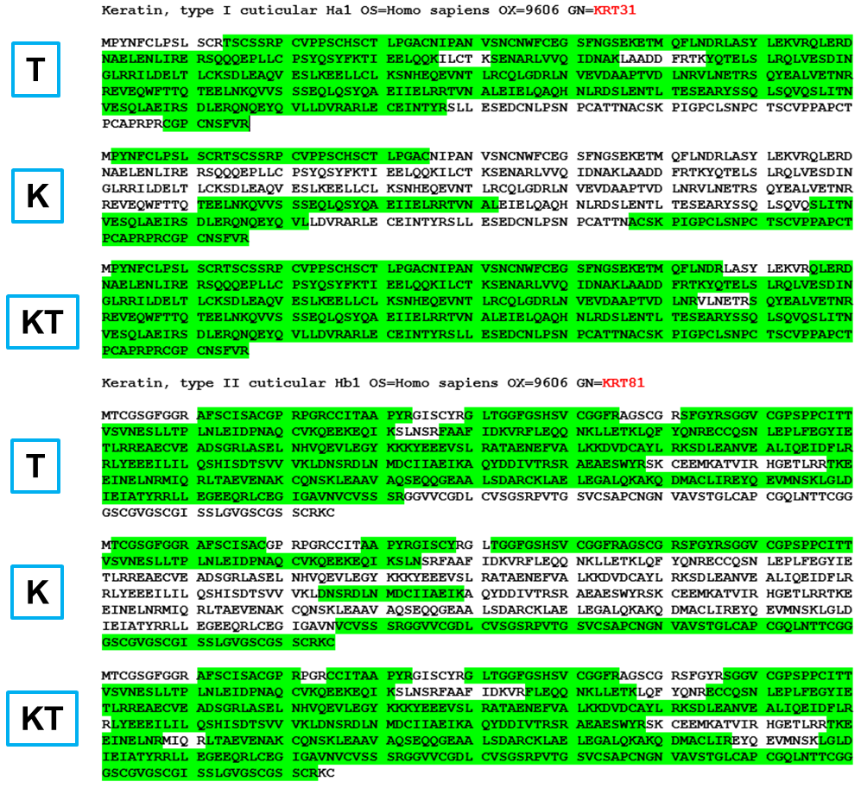

Figure 1. Complementary sequence coverage of an example hair type I cuticular KRT31 (sp|Q15323|K1H1_HUMAN Keratin, type I cuticular Ha1 OS=Homo sapiens) by different enzyme digestion studies (T, K, and KT) on hair samples from the same donor. Individual 5 cm-long hair strand was used as the starting material in each experiment. The identified reference sequences were highlighted in green. Sequence coverage of KRT31 by T, K, and KT: 81%, 32%, and 96%, respectively. Sequence coverage of KRT31 from each single/combined enzyme study can be found in Supplementary Figure S1.

Figure 2. Complementary sequence coverage of an example hair type II cuticular KRT81 (sp|Q14533|KRT81_HUMAN Keratin, type II cuticular Hb1 OS=Homo sapiens) by different enzyme digestion studies (T, K, and KT) on hair samples from the same donor. Individual 5 cm-long hair strand was used as the starting material in each experiment. The identified reference sequences were highlighted in green. Sequence coverage of KRT81 by T, K, and KT: 76%, 39%, and 83%, respectively. Sequence coverage of KRT81 from each single/combined enzyme study can be found in Supplementary Figure S1.

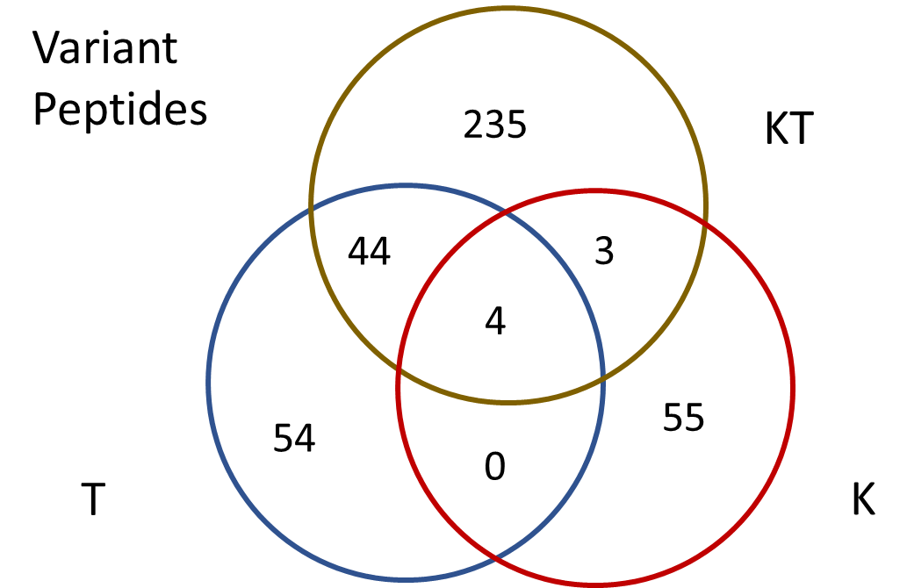
Figure 3. A Venn Diagram to Show the Identification of Variant Peptides by Different Enzymes. KT represents the variant peptides found by the combined KT group; T represents the variant peptides found by T; K represents the variant peptides found by K. The detailed variant peptide list with the mutated amino acid highlighted in red from each single or combined enzymatic experiment can be found in Supplementary Table S1.

Table 1. Enzyme Comparison of Human Hair Proteins, KRTs, KRTAPs, and GVPs
E | Hair Proteins |  |  | Hair Keratin-related |  |  | Cuticular KRTs |  |  | KRTAPs |  |  | GVPs*
E | Proteins | Peptides | PSMs | Proteins | Peptides | PSMs | Proteins | Peptides | PSMs | Proteins | Peptides | PSMs | GVPs*
T/C/G, Enzymatic
T1 | 131 | 698 | 8,059 | 42 | 561 | 7,859 | 13 | 447 | 7,526 | 17 | 34 | 155 | 64
T2 | 120 | 656 | 6,855 | 45 | 552 | 6,681 | 12 | 405 | 6,238 | 20 | 38 | 159 | 55
T3 | 109 | 686 | 8,911 | 39 | 573 | 8,726 | 13 | 468 | 8,424 | 16 | 33 | 147 | 64
C1 | 81 | 291 | 1,228 | 21 | 186 | 980 | 11 | 164 | 926 | 3 | 4 | 8 | 10
C2 | 66 | 185 | 582 | 16 | 106 | 407 | 7 | 89 | 378 | 4 | 7 | 13 | 8
C3 | 77 | 261 | 1,075 | 19 | 174 | 887 | 12 | 161 | 859 | 2 | 2 | 6 | 10
G1 | 69 | 283 | 2,852 | 15 | 204 | 2,724 | 9 | 181 | 2,378 | 0 | 0 | 0 | 20
G2 | 86 | 407 | 4,623 | 19 | 294 | 4,423 | 11 | 254 | 3,926 | 0 | 0 | 0 | 24
G3 | 92 | 394 | 4,487 | 18 | 271 | 4,264 | 11 | 239 | 3,770 | 0 | 0 | 0 | 25
K, Unspecific
K1 | 55 | 694 | 1,904 | 34 | 660 | 1,827 | 7 | 175 | 450 | 21 | 403 | 1,216 | 35
K2 | 49 | 572 | 1,745 | 34 | 550 | 1,706 | 8 | 213 | 673 | 21 | 300 | 945 | 24
K3 | 50 | 822 | 2,452 | 34 | 801 | 2,414 | 8 | 334 | 1,447 | 22 | 461 | 955 | 35
KT, Unspecific
KT1 | 127 | 2,114 | 12,403 | 56 | 2,023 | 12,267 | 15 | 856 | 7,381 | 32 | 1,110 | 4,677 | 159
KT2 | 155 | 1,885 | 19,142 | 52 | 1,741 | 18,917 | 12 | 1,012 | 16,124 | 30 | 669 | 2,579 | 129
KT3 | 152 | 1,888 | 16,652 | 59 | 1,762 | 16,448 | 15 | 990 | 14,047 | 33 | 689 | 2,107 | 132
CT/GT, Enzymatic
CT1 | 111 | 343 | 4,936 | 21 | 223 | 4,735 | 11 | 191 | 4,489 | 1 | 1 | 21 | 16
CT2 | 121 | 432 | 7,688 | 23 | 305 | 7,469 | 13 | 257 | 7,142 | 1 | 1 | 21 | 14
CT3 | 105 | 324 | 4,879 | 20 | 208 | 4,683 | 9 | 157 | 4,316 | 1 | 1 | 19 | 14
GT1 | 128 | 451 | 2,154 | 20 | 208 | 1,649 | 12 | 185 | 1,580 | 1 | 1 | 5 | 7
GT2 | 131 | 434 | 2,259 | 21 | 196 | 1,806 | 12 | 170 | 1,745 | 2 | 2 | 4 | 9
GT3 | 147 | 513 | 2,703 | 24 | 244 | 2,155 | 13 | 215 | 2,077 | 3 | 3 | 9 | 15
*The detailed GVP list was shown in Supplementary Table S1. Three replicates (labeled as 1, 2, and 3) were performed for each protease (T, C, G, and K) and combination (KT, CT, and GT).

Table 2. An Example Variant Site A270V in KRT31 Identified by Different Peptides Generated by Various Enzymes.
Peptide* | T1 | T2 | T3 | C1 | C2 | C3 | G1 | G2 | G3 | K1 | K2 | K3 | KT1 | KT2 | KT3 | CT1 | CT2 | CT3 | GT1 | GT2 | GT3
ELNKQVVSSSEQLQSYQVE |  |  |  |  |  |  | + | + | +
LNKQVVSSSEQLQSYQVE |  |  |  |  |  |  | + | + | +
LNKQVVSSSEQLQSYQVEIIE |  |  |  |  |  |  | + | + | +
QLQSYQVE |  |  |  |  |  |  |  | + |  |  |  |  |  |  |  |  |  |  |  |  | +
QVEIIELR |  |  |  |  |  |  |  |  |  |  |  |  |  |  |  | + | +
QVVSSSEQLQSYQVE |  |  |  |  |  |  |  |  |  |  |  |  |  |  |  |  |  |  | + | + | +
QVVSSSEQLQSYQVEIIE |  |  |  |  |  |  |  |  |  |  |  |  |  |  |  |  |  |  |  |  | +
QVVSSSEQLQSYQVEIIEL |  |  |  |  |  |  |  |  |  |  |  |  |  |  |  | + | + | +
QVVSSSEQLQSYQVEIIELR | + | + | + |  |  |  |  |  |  |  |  |  | + | + | +
QVVSSSEQLQSYQVEIIELRR | + | + | + |  |  |  |  |  |  |  |  |  |  | + | +
*The mutated amino acid ‘V’ was highlighted in red. “+” indicated the listed peptide was detected.

Table 3. An Example Variant Site C111S in KRTAP11-1 Identified by Different Peptides Generated by Various Enzymes.
Peptide* | T1 | T2 | T3 | C1 | C2 | C3 | G1 | G2 | G3 | K1 | K2 | K3 | KT1 | KT2 | KT3 | CT1 | CT2 | CT3 | GT1 | GT2 | GT3
GSQPLGGISSVCQPVGGIS |  |  |  |  |  |  |  |  |  | + |  | +
PCSTTYSRPLTFVSSGSQPLGGIS |  |  |  |  |  |  |  |  |  |  |  | +
PLTFVSSGSQPLGGIS |  |  |  |  |  |  |  |  |  |  |  |  | +
PLTFVSSGSQPLGGISSVCQPVGGIS |  |  |  |  |  |  |  |  |  |  |  |  |  | + | +
QTTCISNPCSTTYSRPLTFVSSGSQPLGGIS |  |  |  |  |  |  |  |  |  |  |  |  |  | +
SRPLTFVSSGSQPL |  |  |  |  | + | +
SRPLTFVSSGSQPLGGIS |  |  |  |  |  |  |  |  |  | + | + | +
SRPLTFVSSGSQPLGGISSVCQPVGGIS |  |  |  |  |  |  |  |  |  | + |  | +
TFVSSGSQPL |  |  |  | +
TFVSSGSQPLGGIS |  |  |  |  |  |  |  |  |  | + |  | +
VSSGSQPLGGIS |  |  |  |  |  |  |  |  |  | + | + | +
*The mutated amino acid ‘S’ was highlighted in red. “+” indicated the listed peptide was detected.

REFERENCES
(1) Parker G.J.; Leppert T.; Anex D.S.; Hilmer J.K.; Matsunami N.; Baird L.; Stevens J.; Parsawar K.; Durbin-Johnson B.P.; Rocke D.M.; Nelson C.; Fairbanks D.J.; Wilson A.S.; Rice R.H.; Woodward S.R.; Bothner B.; Hart B.R.; Leppert M. Demonstration of Protein-Based Human Identification Using the Hair Shaft Proteome. PLoS One. 2016, 11(9), e0160653.
(2) Goecker Z.C.; Salemi M.R.; Karim N.; Phinney B.S.; Rice R.H.; Parker G.J. Optimal processing for proteomic genotyping of single human hairs. Forensic Sci Int Genet. 2020, 47, 102314.
(3) Wong S.Y.; Lee C.C.; Ashrafzadeh A.; Junit S.M.; Abrahim N.; Hashim O.H. A High-Yield Two-Hour Protocol for Extraction of Human Hair Shaft Proteins. PLoS One. 2016, 11(10), e0164993.
(4) Lee Y. J.; Rice R. H.; Lee, Y. M. Proteome analysis of human hair shaft: from protein identification to posttranslational modification. Mol Cell Proteomics. 2006, 5, 789-800.
(5) Zhang Z.; Burke M.C.; Wallace W.E.; Sheetlin S.L.; Mirokhin Y.A.; Tchekhovskoi D.V.; Stein S.E. Sensitive Method for the Confident Identification of Genetically Variant Peptides in Human Hair Keratin. J Forensic Sci 2020, 65(2), 406-420.
(6) Hughes C.S.; Moggridge S.; Müller T.; Sorensen P.H.; Morin G.B.; Krijgsveld J. Single-pot, solid-phase-enhanced sample preparation for proteomics experiments. Nat Protoc. 2019, 14(1), 68-85.
(7) Zhang Z.; Wallace W.E.; Wang G.; Burke M.C.; Liu Y.; Sheetlin S.L.; and Stein S.E. Improved Sample Preparation Method for Protein and Peptide Identification from Human Hair. J Proteome Res. 2024, 23 (1), 409-417.
(8) Choudhary G.; Wu S.L.; Shieh P.; Hancock W.S. Multiple enzymatic digestion for enhanced sequence coverage of proteins in complex proteomic mixtures using capillary LC with ion trap MS/MS. J Proteome Res. 2003, 2(1), 59-67.
(9) BioMuta - single-nucleotide variations (SNVs) in cancer. https://hive.biochemistry.gwu.edu/biomuta (accessed December 20, 2021).
(10) Eng, J. K.; McCormack, A. L.; Yates, J. R. An approach to correlate tandem mass spectral data of peptides with amino acid sequences in a protein database. J. Am. Soc. Mass Spectrom. 1994, 5, 976−989.
(11) Su, C.; Gong, J.; Qin, J.; Li, H.; Li, H.; Xu, Z.; Shi, J. The tale of a versatile enzyme: Molecular insights into keratinase for its industrial dissemination. Biotechnology Advances. 2020, Volume 45, 107655
(12) Cruz C.F.; Azoia N.G.; Matamá T.; Cavaco-Paulo A. Peptide—protein interactions within human hair keratins. Int. J. Biol. Macromol. 2017, 101, 805-814.
(13) Woo S.; Cha S.W.; Na S.; Guest C.; Liu T.; Smith R.D.; Rodland K.D.; Payne S.; Bafna V. Proteogenomic strategies for identification of aberrant cancer peptides using large-scale next-generation sequencing data. Proteomics. 2014, 14, 2719-2730.

Table of Contents Graphic:


