Field Emission of Bulk Hexagonal Boron Nitride Via Extreme Ultraviolet Pulsed Atom Probe Tomography

Christopher Mead^{1*}, Benjamin W. Caplins ¹, Luis Miaja-Avila², Josh Avery³, James H. Edgar³, and Ann N. Chiaramonti¹

¹National Institute of Standards and Technology, Applied Chemicals and Materials Division, Boulder, CO, 80305, USA
²National Institute of Standards and Technology, Applied Physics Division, Boulder, CO, 80305, USA
³Tim Taylor Department of Chemical Engineering, Kansas State University, Manhattan, KS 66506, USA
* Corresponding author: Christopher.Mead@nist.gov

As modern transistors approach the atomic limit, the continued scaling of computational power has required significant efforts to develop next-generation device architectures at such small scales. 2D- materials, materials containing covalently bonded layers held together by interlayer van der Waals (vdW) forces, have been identified as promising candidates for these next-generation devices [1]. Despite their potential, device integration has been slow due to difficulties creating layers with the desired electric properties. Progress has been hindered by a lack of reliable characterization techniques for analyzing the spatially resolved chemical composition of 2D materials. For 3D materials, atom probe tomography (APT) has been widely adopted for mapping the spatial distribution of atomic species in complex structures; however, APT’s application to 2D materials remains limited. The same vdW bonding that makes 2D materials ideal for device applications often leads to delamination under the applied standing voltage (SV) and resulting Maxwell stress of APT analysis [2]. While some initial investigations have had success using a variety of sample preparation and processing procedures, reports remain sparse.
Among APT studies on 2D materials, there is a noticeable absence of insulating materials. Since 2D dielectrics, such as hexagonal boron nitride (hBN), are often incorporated into device architectures, the lack of dielectric studies is likely attributable to difficulties evaporating insulating materials in APT; a trend that is mirrored from their 3D counterparts. Recently, our group has developed APT instrumentation utilizing extreme ultraviolet (EUV) laser pulsing [3] that has enabled the easier evaporation of multiple dielectric materials [4], [5]. Here we report on the first known successful evaporation of hBN using the novel EUV APT system.
Samples were prepared from bulk hBN crystals grown from a molten solvent mixture of nickel plus chromium [6]. Nanoscale tips were fabricated using standard FIB-based procedures for the fabrication of APT tips with the basal plane of the crystal oriented parallel to the long axis of the sample [7]. The samples were evaporated at a base temperature of 50 K, target detection rate of 1 %, pulse energy of ~4 pJ, and pulse frequency of 25 kHz. A sample mass spectrum from a hBN sample with respect to the mass-to-charge ratio of the detected ions (m/z) is shown in Fig. 1. Peaks associated with elemental boron (5 m/z, 5.5 m/z, 10 m/z, and 11 m/z) and elemental nitrogen (7 m/z and 14 m/z) ions are both observed and contain the majority of peak-related counts. Most additional peaks present in the mass spectrum are attributable to ion clusters containing multiple boron and nitrogen atoms. The significant clustering is commonly observed in APT analysis of materials containing boron [8]. Additionally, no peaks associated with any contaminants from the metal solvent are observed. APT typically excels at the detection of dilute species, being capable of achieving part per million-level sensitivity, however, the combination of the dilute concentration, multiple nickel and chromium isotopes, and a relatively high number of background counts all contribute to any concentrations present below about a hundred parts per million not being detectable.
The measured composition of hBN from APT is approximately 40 % boron and 60 % nitrogen. The boron deficit from stoichiometry is likely caused by the known tendency for boron to preferentially evaporate in multi-hit detection events [9]. When two ions containing boron impact the detector closely to each other and/or within a short time span, the detector resolution can be insufficient to record both ions leading to an undercounting of boron.
During the experiment the actual detection rate measured during hBN evaporation often increased rapidly up to values as high as 6 %, Fig. 2. We attribute these spikes in detection rate to microfractures in which a portion of the tip delaminated and impacted the detector in a short time span. Microfractures reduce the spatial accuracy of the resulting tip reconstructions and can reduce the signal-to-noise ratio of the mass spectrum. While microfractures are not unusual in an APT experiment, the high number present during the evaporation of hBN is almost certainly attributable to the weak vdW bonding of the material. To reduce microfractures, additional steps such as optimizing run conditions and exploring alternative sample preparation methods will need to be explored.
While significant steps are still required to achieve smooth evaporation of hBN with the part per million concentration sensitivity desired from APT, this experiment marks a significant first step in enabling such analysis. Utilizing our novel EUV APT system, for what appears to be the first time, successful evaporation of hBN has been realized [10].

Fig. 1. Mass spectrum of the hBN experiment. The counts are for the uncorrected mass spectrum, binned at a value of 0.1 and displayed for the 0 m/z -55 m/z region. Major peaks are labeled.

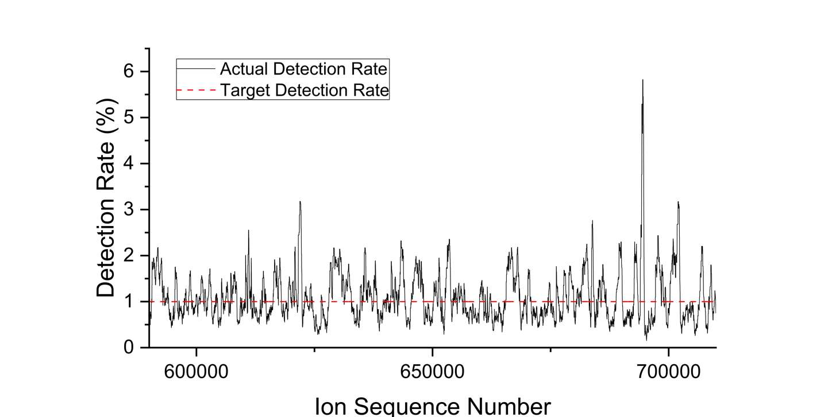

Fig. 2. Detection rate as a function of the number of ions evaporated taken from a subsection in the middle of the run.

References:

[1] IEEE IRDS Roadmap Committee. (2022) International Roadmap for Devices and Systems, 2022 Edition: IEEE
[2] Ren X. (2017) Atom Probe Tomography Analysis of Low-Dimensional Electronic Materials and Heterostructures [dissertation]. [Evanston (IL)]: Northwestern University.
[3] Caplins BW et al. Rev. Sci. Instrum. (2023) 94 093704. https://doi.org/10.1063/5.0160797
[4] Chiaramonti AN et al. Microsc. Microanal. (2020) 26 258–266. https://doi.org/10.1017/S1431927620000203
[5] Garcia JM et al. Microsc. Microanal. (2023) 29 83–84. https://doi.org/10.1093/micmic/ozad067.033
[6] Hoffman TB et al. J. Cryst. Growth (2014) 393 114–118. https://doi.org/10.1016/j.jcrysgro.2013.09.030
[7] Thompson K et al. Ultramicroscopy (2007) 107 131–139. https://doi.org/10.1016/j.ultramic.2006.06.008
[8] Nomoto K et al. J. Phys. Chem. C (2016) 120 17845–17852 https://doi.org/10.1021/acs.jpcc.6b06197
[9] Meisenkothen F et al. Ultramicroscopy (2015) 159 101–111. https://doi.org/10.1016/j.ultramic.2015.07.009
[10] Support for hBN crystal growth was provided by the Office of Naval Research, award number N00014-22-1-2582.

