Controlling Phase Transition Dynamics in Laser-Printed Perovskite Films via Additive-Driven Strain Engineering
Hurriyet Yuce-Cakir,^{1,2,3} Manikanta Makala,¹ Ganga R. Neupane,² Marielle Deconinck,^{4,5} Vladimir V. Shilovskikh,^{4,5} Xinyi Zhou,⁶ Rudolph Holley III,⁷ Quinn C. Burlingame,⁷ Yana Vaynzof,^{4,5} Yueh-Lin Loo,⁷ Behrang H. Hamadani,^{8*} Oana D. Jurchescu^{1*}
¹Deparment of Physics and Center for Functional Materials, Wake Forest University, Winston-Salem, North Carolina 27109, United States
²PREP Associate, Engineering Laboratory, National Institute of Standards and Technology, Gaithersburg, Maryland 20899, United States
³Ralph O’Connor Sustainable Energy Institute, Johns Hopkins University, Baltimore, Maryland 21218, United States
⁴Chair for Emerging Electronic Technologies, Technical University of Dresden, Nöthnitzer Str. 61, 01187 Dresden, Germany
⁵Leibniz-Institute for Solid State and Materials Research Dresden, Helmholtzstraße 20, 01069, Dresden, Germany
⁶Department of Electrical and Computer Engineering, Princeton University, Princeton, New Jersey 08544, United States
⁷Department of Chemical and Biological Engineering, Princeton University, Princeton, New Jersey 08544, United States
⁸Engineering Laboratory, National Institute of Standards and Technology, Gaithersburg, Maryland 20899, United States

*Corresponding Authors: Behrang H. Hamadani, behrang.hamadani@nist.gov; Oana D. Jurchescu, jurchescu@wfu.edu

ABSTRACT:
The structural phase transitions in hybrid perovskites are critical to their performance and stability, but controlling them remains a significant challenge. Here, we demonstrate that the dynamics of the low-temperature tetragonal-to-orthorhombic phase transition in laser-printed MAPbI₃ films can be controlled by tailoring additive chemistry. We show that the choice of charge control agent (CCA) directly impacts the intrinsic defect and strain landscape of the resulting film: an ionic CCA promotes a low-strain lattice that facilitates the phase transition. In contrast, a molecular CCA induces a high-strain, defect-rich lattice, which creates a high kinetic barrier that suppresses the transition and effectively “pins” the tetragonal phase. This work establishes a strategy to engineer strain and manage phase behavior in perovskite films, demonstrating that the ability to “lock” or “enable” a specific crystal phase by selecting additives provides a pathway to mitigate degradation and engineer stable, high-performance perovskite devices.

TOC GRAPHICS:
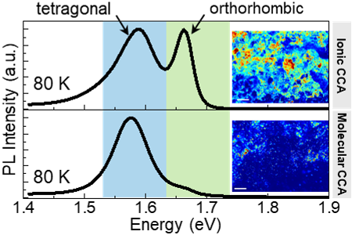

Methylammonium lead iodide (MAPbI₃) stands as one of the most common hybrid organic-inorganic perovskites (HOIPs), a class of materials that has fundamentally reshaped the landscape of photovoltaic research. The power conversion efficiencies (PCEs) of perovskite solar cells have rapidly increased,^{1,2} currently competing with established technologies but at a fraction of the cost.³ Notable advancements have also been demonstrated in light-emitting diodes (LEDs), optically-pumped lasers, transistors, phototransistors, and photodetectors.^{4–11} The inherent material “softness”, characterized by a low Young's modulus (e.g., G ≈ 20 GPa),¹² is advantageous for applications in flexible electronics, but it also results in low-energy phonon modes and strong electron-phonon coupling, which influence charge carrier dynamics, transport, and recombination pathways. Furthermore, the energetic ease with which the lattice can be distorted makes MAPbI₃ particularly prone to temperature-, light- and pressure-induced structural phase transitions. During these transitions, the crystal lattice undergoes reconfigurations linked to the tilting of the PbI₆ octahedra and the dynamic ordering/disordering of the methylammonium (MA⁺) cation within the inorganic framework (Figure 1).^{13,14} At temperatures below 160 K, it adopts an orthorhombic (γ-phase) centrosymmetric (space group Pnma, No. 62) structure. Upon heating, it transitions to a tetragonal (β-phase) structure (centrosymmetric space group I4/mcm, No. 140), generally stable between ~ 160 K and ~ 330 K, and above this temperature it transforms into a cubic (α-phase) structure (space group Pm-3m, No. 221).^{13,15–17} The transition temperatures can exhibit variability, often attributed to differences in defect density, internal strain, or grain size effects.¹⁴ These characteristics indicate that the phase transitions are not simple equilibrium switches but involve kinetic barriers, hysteresis, intermediate states, and a complex interplay of factors including intrinsic defects, crystal strain, and the entropy associated with cation dynamics. The potential for phase coexistence, especially near transition temperatures or under non-equilibrium conditions, is therefore significant. Since these changes are consequential to the physical properties, including the electronic band structure, optical absorption, photoluminescence (PL), electrical conductivity, charge carrier mobility, and dielectric response,^{15,18–20} a thorough understanding of phase transformation dynamics and control mechanisms is critical. This necessity is further underscored by the fact that these transformations are highly relevant to device operation, affecting both performance and stability. In particular, the presence of distinct structural states near ambient temperature creates stability challenges, especially when devices undergo temperature fluctuations across critical phase boundaries, such as the tetragonal-cubic transition.
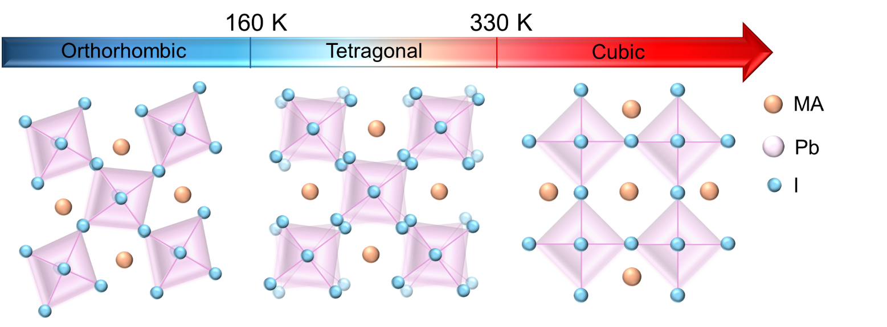
Figure 1. Temperature-dependent crystallographic phases of MAPbI₃. The material transitions from a low-temperature orthorhombic phase (below ~ 160 K) to a room-temperature tetragonal phase, and finally to a high-temperature cubic phase (above ~ 330 K).

Here, we demonstrate that phase transition pathways in MAPbI₃ films can be manipulated during processing to enhance or suppress intermediate states, providing a direct route to tailoring final film properties by controlling the dynamics of phase coexistence. This control is enabled by our laser-printing fabrication, which uses specific charge-control agents (CCAs) as functional additives. These CCAs are integral components of the printing toner and play a dual role: they govern the electrostatic transfer of the toner to the substrate, while concurrently influencing crystal growth and the defect landscape through the specific chemical interactions they introduce. We elucidate the physical properties and uniformity of the printed films using Grazing incidence wide-angle X-ray scattering (GIWAXS), electrical measurements, scanning electron microscopy (SEM), X-ray photoelectron spectroscopy (XPS), and PL mapping. Temperature-dependent PL measurements reveal the influence of CCAs on the phase transition characteristics and stress-relaxation dynamics of MAPbI₃. These results have several important implications in linking material processing, photophysics, and performance in soft perovskites. By controlling phase-dependent properties such as carrier lifetimes, mobilities, and diffusion lengths, our approach provides a pathway to mitigate performance fluctuations and manage residual stress, leveraging the material’s inherent “softness”. Furthermore, this control is achieved using a deposition method that presents profound technological advantages: the laser printing process is scalable, operationally safe, and sustainable, eliminating toxic solvents while simultaneously yielding films with high environmental and operational stability via in-situ self-encapsulation.^{21–23}
The films were fabricated using the solvent-free laser-printed technique established in our laboratory.^{21,22,24} The process starts with the mechanochemical synthesis of MAPbI₃ powder, which is subsequently blended with carnauba wax (for rheology modification), fumed silica (flow-control agent), and specific CCAs (for electrostatic transfer) to form the toner. This mixture is then ball-milled to achieve the fine particle size essential for print resolution. The laser printing process consists of the following steps: charging an organic photoconductor (OPC) drum, selective laser-induced discharging to create a latent image, toner development on the discharged areas, electrostatic transfer of the toner to the substrate, and thermal fusing of the toner to form the film. To investigate the influence on film properties, we selected two distinct CCAs: Solvent Black 7 (Orient Corporation, commercially known as Bontron N07) and Benzyltributylammonium 4-hydroxynaphthalene-1-sulfonate (Orient Corporation, referred to as P51); details on their chemical structures are included in Figures S1 and S2. Bontron N07 is a dye characterized by a nigrosine/azine-class structure that incorporates coordinated metal ions. In contrast, P51 is a quaternary ammonium salt composed of the bulky organic cation benzyltributylammonium, and the organic sulfonate anion 4-hydroxynaphthalene-1-sulfonate. Both CCAs function as positive charge toners, facilitating the acquisition and stabilization of a positive electrostatic charge on toner particles during the electrophoretic transfer from the developer unit to the discharged areas of the OPC drum during the laser printing process. However, given their distinct chemical compositions, we expect fundamentally different interactions with the perovskite. The structure of N07, with its multiple nitrogen heteroatoms and coordinated metal center, is anticipated to interact with the perovskite surface primarily through Lewis acid-base interactions, potentially involving coordination of nitrogen lone pairs or the chromium center with undercoordinated Pb²⁺ sites or iodide vacancies at the crystallite surface. Furthermore, the large, extended aromatic/heterocyclic ring systems inherent to its nigrosine/azine nature could lead to significant van der Waals forces and π-interactions (including potential π-π stacking if suitable surface ligands or dye self-assembly occurs) with the perovskite surface. Conversely, the interaction of P51 with MAPbI₃ is likely governed by a combination of electrostatic forces and more specific chemical interactions involving its constituent ions: the bulky benzyltributylammonium cation most likely exerts steric influences and/or engages in van der Waals interactions at the interface, potentially modifying surface energy or passivating certain defects, while the sulfonate anion offers sites for Lewis base interactions with surface Pb²⁺ ions or hydrogen bonding with the organic methylammonium (MA⁺) cations of the perovskite. These distinct interfacial chemistries are expected to yield different outcomes in perovskite crystal growth, surface defect densities, and strain, ultimately influencing the optoelectronic properties and phase transition behavior of the resulting films. For simplicity, we will refer to the interactions of P51 with the perovskite as “ionic”, and to those with N07 as “molecular”, driven by a combination of Lewis acid-base interactions and π-π stacking.
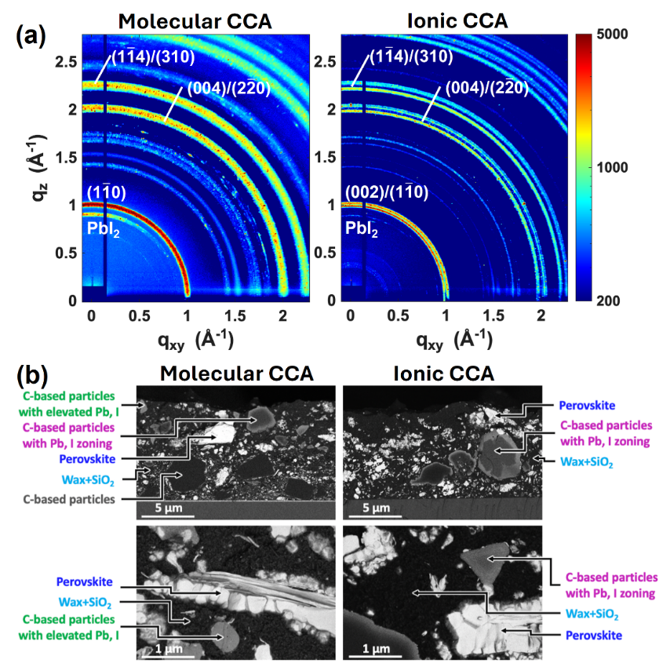
Figure 2. (a) 2D GIWAXS patterns of melt-cast MAPbI₃ films prepared with molecular CCAs (left column) and ionic CCAs (right column). The diffraction features corresponding to the tetragonal MAPbI₃ phase are indexed. (b) Phase contrast images of laser-printed perovskite films’ cross sections containing different charge control agents.

Structural characterization of the films was performed using grazing-incidence wide-angle X-ray scattering (GIWAXS). Because the laser printing process yields films with significant surface roughness, which makes them challenging for GIWAXS analysis, these samples were prepared by melt-casting the identically formulated toner, serving as a direct analogue of the printer's final thermal fusing stage. Experimental details of film preparation and GIWAXS measurements are provided in Supplementary Information. The resulting structural analysis, therefore, represents the crystalline phases formed during printing. The 2D GIWAXS patterns for films employing molecular and ionic as CCAs are shown in Figure 2a. The broad features observed in both films are due to their macroscopic roughness, which causes significant beam scattering. While both are rough, the film prepared with the molecular CCA is evidently rougher as several of the features which can be observed as separate from one another in ionic CCA perovskite film (Figure 2a, right) (e.g., features at q ≈ 2 Å, q ≈ 2.2 Å⁻¹, and those at q > 2.5 Å⁻¹) appear only as thick bands in molecular CCA perovskite films (Figure 2a, left). We note that neither film shows evidence of perovskite orientation, as the reflections appear as continuous rings in both cases. Azimuthally-integrating the 2D patterns and comparing them to reference patterns for tetragonal MAPbI₃, PbI₂, ‘molecular CCA only’, and ‘ionic CCA only’ films, as shown in Figure S3, allows us to assign many of the reflections further. Crystalline features from the CCA used in each film are present in its spectrum, as are features from PbI₂. The intensity of the PbI₂ features in the molecular CCA perovskite film is greater than that of the ionic CCA perovskite film, while the MAPbI₃ crystalline features are generally better resolved in the film with ionic CCA. Thus, structural analysis suggests that the perovskite film prepared with an ionic CCA is less rough than the film prepared with a molecular CCA and contains a larger fraction of tetragonal MAPbI₃ and a lower fraction of unreacted PbI₂.
Microstructural characterization of the films’ surface by SEM (Figure S4) revealed that both films exhibit a similar morphology. Phase-contrast images (Figure S4) revealed the presence of a small number of perovskite crystallites at the surface of the layers. XPS analysis (Figure S5) confirmed the presence of Pb and I, albeit at low levels, due to XPS's surface-sensitivity. To examine the films’ bulk structure, the cross sections of the layers were phase imaged (Figure 2b). A direct comparison of the phase-contrast images shows that, while both layers exhibit a composite microstructure comprising wax, silica, perovskite, and carbon-based particles, the main difference lies in the behavior of the charge-control agent particles. In the case of the molecular CCA, the absorption of heavy elements (e.g., Pb and I) occurs unevenly. Some particles have a uniformly increased content of heavy elements, some have a zonal structure, and some large particles show no such absorption (Figure 2b, left), which can lead to an uneven distribution of the elements in the film and a local distortion of the perovskite stoichiometry both during the preparation process and during the lifetime of the composite. At the same time, the ionic CCA leads to a uniform structure in which all carbon-based particles are zonally enriched with heavy elements via a similar mechanism, providing the film with a more uniform composition (Figure 2b, right).
Electrical characterization was conducted on films printed directly onto glass substrates. Gold (Au) contacts were thermally evaporated through a shadow mask on top of the films, defining lateral devices with a channel length of 30 µm and a width of 400 µm in an Au/MAPbI₃/Glass planar architecture.^{6,25,26} All current density-voltage (J-V) characteristics were acquired in the dark under ambient laboratory conditions using a probe station. Representative J-V curves for films incorporating the ionic and molecular CCAs are presented in Figure 3a, and it can be observed that they exhibit symmetrical behavior for positive and negative biases. While the overall electrical response was broadly comparable and no statistically significant differences in conductivity were resolved between the two CCA types within our measurement resolution, films formulated with the ionic CCA tended to exhibit slightly higher median current densities. However, these films also showed a notably larger statistical spread in current density at the maximum applied bias, as illustrated in the box plot in Figure 3b. These findings were consistent across multiple devices fabricated on the same substrate and on different substrates.
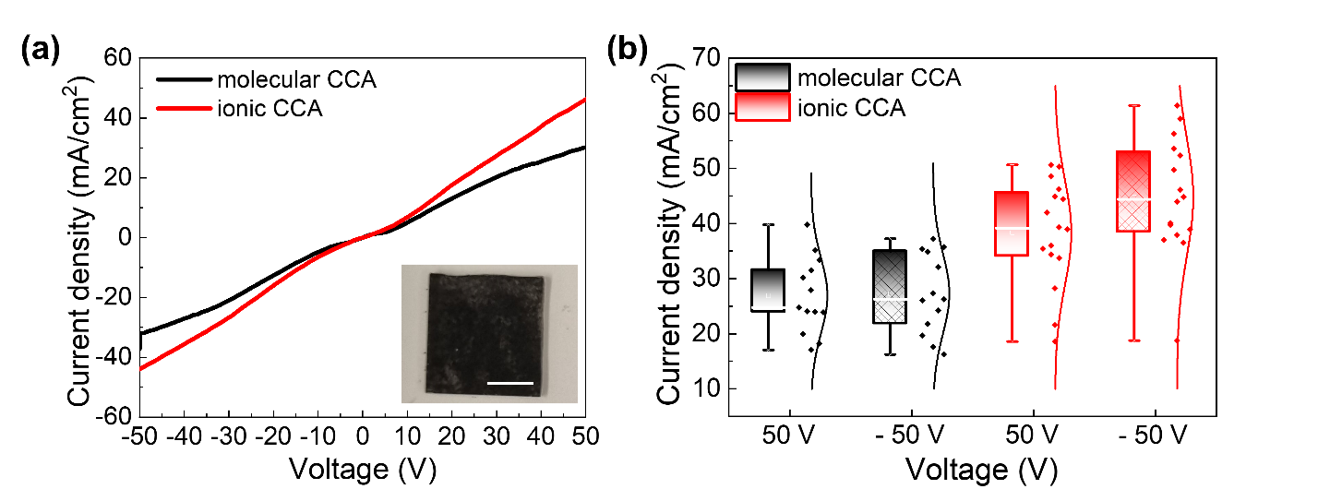
Figure 3. Electrical properties of MAPbI₃ films laser printed from toners with different charge control agents. (a) Current density versus voltage (J-V) plots for representative devices incorporating either the molecular CCA (black) or the ionic CCA (red). The inset is a photograph of a film. (b) Statistical distribution of current densities measured at ±50 V bias for multiple devices, comparing the performance of films made with the molecular versus the ionic CCA. Scalebar size is 1 cm.

Spatially resolved PL mapping was performed over a nominal area of 0.8 mm x 0.6 mm to assess the uniformity of the films. The results are presented in Figure 4a, b, which compares films printed with the molecular CCA (a) and the ionic CCA (b) at 300 K (top row) and 80 K (bottom row). A discernible PL signal was detected across all scanned regions for both sample types, confirming complete substrate coverage by the laser-printed perovskite films. Variations in PL intensity across the mapped area are primarily attributed to local fluctuations in film thickness and defect density. Discrete regions of high PL intensity were observed, likely corresponding to well-formed perovskite domains or agglomerates where radiative recombination is more efficient. Conversely, areas exhibiting lower PL intensity correspond to regions with a reduced volume fraction of active perovskite material, potentially intermixed with non-luminescent toner constituents (e.g., wax, SiO_{2,} or unreacted precursors like PbI₂₎, a finding consistent with SEM results. Visual inspection of the PL maps suggests differences in the spatial distribution of luminescence between films fabricated with molecular- and ionic-CCA, with the latter exhibiting greater heterogeneity in highly and poorly emissive regions. At 80 K, the PL maps (Figure 4a,b, bottom row) confirm the CCA’s impact on the tetragonal-to-orthorhombic phase transition. These images, filtered at the 1.66 eV orthorhombic-phase emission, reveal a clear difference: the molecular CCA film (Figure 4a) displays only weak, localized orthorhombic emission, while the ionic CCA film (Figure 4b) shows a strong and widely distributed orthorhombic-phase signal. Detailed spectra from representative spots (Figure S6) confirm this conclusion. In the molecular CCA film, the spectra remain dominated by the tetragonal phase, with the 1.66 eV orthorhombic peak appearing only as a weak shoulder (Figure S6a), suggesting a largely suppressed transition. The ionic CCA film, however, shows high-intensity regions dominated by the 1.66 eV peak (Figure S3b), indicating a pronounced, albeit incomplete, transition with clear phase coexistence. This conclusion is reinforced by complementary phase-specific maps (Figure S7), which spatially deconstruct the tetragonal (T, ~ 1.58 eV) and orthorhombic (O, ~ 1.66 eV) contributions. The visualization confirms that the molecular CCA film is predominantly tetragonal (T), whereas the ionic CCA film is dominated by the emergent orthorhombic (O) phase.
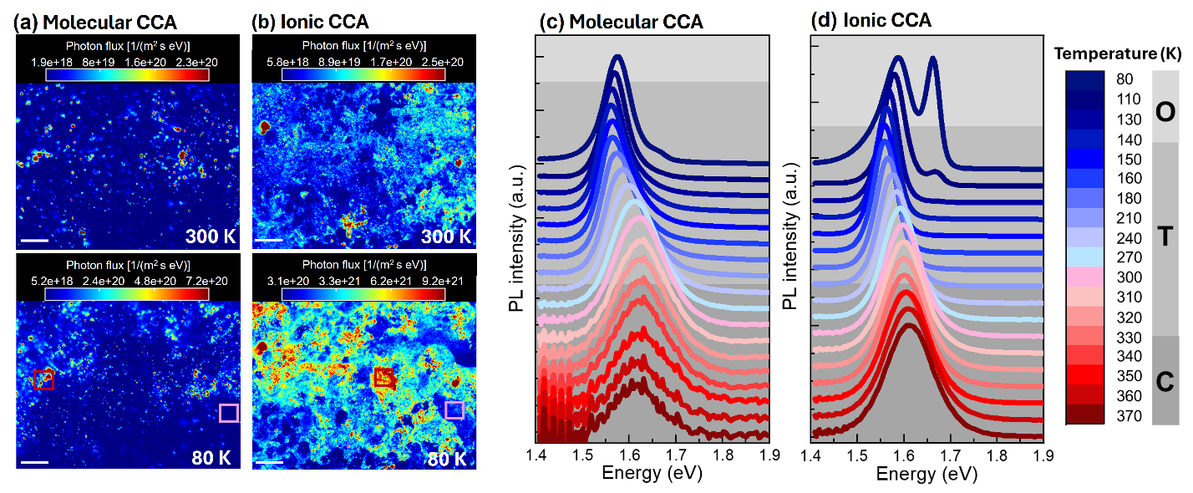
Figure 4. PL map obtained on the films laser printed using molecular CCA (a) and ionic CCA (b), respectively. Top panel corresponds to 300 K, bottom panel to 80 K. PL images for the samples at 80 K belong to the PL distribution at 1.66 eV. Bar size is 100 µm. Normalized PL photon flux spectra vs temperature of (c) molecular and (d) ionic CCA perovskite films.

Figure 4c,d presents the evolution of normalized PL spectra with temperature for films fabricated with molecular (c) and ionic (d) CCAs. Both films exhibit the expected tetragonal-phase peak (~ 1.60-1.62 eV) at room temperature, but the ionic CCA film exhibits a higher PL intensity than its molecular counterpart. The photon flux of the molecular CCA perovskite film increases by three orders of magnitude, while the ionic CCA film exhibits a two order of magnitude increase in photon flux over the temperature range of 370 K to 80 K (Figure S8 and S9). As the temperature decreases, nonradiative defect centers are mostly frozen out, and therefore, radiative recombination becomes more dominant. According to the comparison of photon flux variations of perovskite films, molecular CCA perovskites include more defects. Hence, freezing these defects results in a much larger enhancement in photon flux compared to the ionic CCA perovskite film. Since the emission in both samples originates from MAPbI₃, we attribute the weaker emission in the molecular CCA film to a higher density of non-radiative recombination centers in agreement with the structural analysis (Figure 2b). We attribute this difference to the specific chemical nature of the additives. The ionic CCA introduces two effects: its quaternary ammonium cation neutralizes negatively charged iodide-related defects, while its sulfonate and hydroxyl-containing anion can coordinate with and passivate undercoordinated Pb²⁺ (Lewis acid) sites. In contrast, the molecular CCA interacts primarily through Lewis-base (nitrogen) and broader van der Waals/π-interactions. This mechanism is likely less comprehensive, as the larger, more complex structure of this molecular additive may result in less specific binding and incomplete surface coverage. Consequently, the higher PL intensity of the ionic CCA film is a direct indicator of a lower density of non-radiative recombination centers, signifying a more effectively passivated, higher-quality perovskite film. In both sample types, the PL spectra exhibit a red-shift and spectral narrowing as the temperature is lowered; the temperature dependence of the PL peak position is plotted in Figure S8. The positive temperature coefficient of the band gap (dE_{g}/dT > 0), where it increases with temperature, is consistent with the literature reports,^{16,27–31} contrasting with the behavior observed in most conventional inorganic semiconductors.³² This behavior, while not yet fully understood, is attributed to factors including thermal expansion and strong electron-phonon coupling effects, particularly interactions with low-energy optical phonons associated with the organic cation dynamics and octahedral tilting.^{16,29} Other suggested mechanisms involve temperature-dependent changes in orbital overlap and electronic band structure arising from the dynamic orientational disorder of the MA⁺ cation and the tilting of the PbI₆ octahedra.²⁸ For both film types, the PL peak position exhibits no distinct discontinuity at the T-C phase transition, which is a result of the dynamic structural fluctuations (local octahedral tilting and MA⁺ disorder) that make the instantaneous electronic structure resemble that of the tetragonal phase on the ultrafast timescale relevant for optical transitions.^{31,33} As the temperature is lowered below the O-T transition temperature (~ 130 K), the PL spectra show distinct behavior, revealing apparent differences between the two samples: The ionic-CCA film undergoes a tetragonal-to-orthorhombic phase transition, as indicated by the appearance of a second, higher-energy PL peak and phase coexistence. In contrast, the molecular-CCA film exhibits a reduced transition, retaining a single tetragonal peak with only a weak orthorhombic shoulder at the lowest measured temperature. Additionally, the PL peak shift toward higher energies associated with orthorhombic phase formation in the molecular-CCA film occurs at lower temperatures than in the ionic-CCA film, indicating suppression of the O-T phase transition by the molecular CCA.
In conclusion, we have established that the phase transition pathways in MAPbI₃ can be actively suppressed or enabled by tailoring the chemical additives used during film fabrication. We demonstrate that these additives function as modulators of the film's final defect and strain profile, which in turn governs the kinetic barrier for the tetragonal-to-orthorhombic transition. Specifically, an ionic additive yields a low-strain lattice that readily transforms, whereas a molecular additive yields a high-strain, defect-rich lattice that kinetically arrests the transition. This control over phase behavior has direct implications for the critical challenges facing perovskite optoelectronics. The ability to manage internal strain and stabilize a desired crystal phase provides a promising strategy to mitigate the performance fluctuations and degradation pathways that currently hinder long-term operational stability. This work thus identifies a new, processing-level strategy to engineer the optoelectronic and mechanical properties of soft hybrid perovskites for stable, high-performance devices.

ASSOCIATED CONTENT
Supporting Information
Experimental methods and supporting figures.

AUTHOR INFORMATION
*Corresponding Authors: Behrang H. Hamadani, behrang.hamadani@nist.gov; Oana D. Jurchescu, jurchescu@wfu.edu

ACKNOWLEDGMENT
O.D.J. and Y.V. thank the National Science Foundation and the Deutsche Forschungsgemeinschaft for funding in the framework of a joint NSF-DFG grant in Advanced Manufacturing (NSF: CMMI-2135937 and DFG: VA 991/8-1). H.Y-C. acknowledges the generous support of the Professional Research Experience Program (PREP) under the award number PREP0002351. X.Z., R.H., Q.C.B., and Y.-L.L. acknowledge support from the U.S. Department of Energy’s Office of Energy Efficiency and Renewable Energy (EERE) under Solar Energy Technologies Office (SETO) Agreement Number DE-EE0010503, and thank Dr. Ruipeng Li for his help with GIWAXS measurements, which were conducted at the Center for Functional Nanomaterials (CFN) and the Complex Materials Scattering (CMS) beamline of the National Synchrotron Light Source II (NSLS-II), which are both US DOE Office of Science Facilities, at Brookhaven National Laboratory under Contract no. DE-SC0012704.
NIST disclaimer: Certain equipment, instruments, software, or materials are identified in this paper in order to specify the experimental procedure adequately. Such identification is not intended to imply recommendation or endorsement of any product or service by NIST, nor is it intended to imply that the materials or equipment identified are necessarily the best available for the purpose.

REFERENCES
(1) Kojima, A.; Teshima, K.; Shirai, Y.; Miyasaka, T. Organometal Halide Perovskites as Visible-Light Sensitizers for Photovoltaic Cells. J. Am. Chem. Soc. 2009, 131 (17), 6050–6051. https://doi.org/10.1021/ja809598r.
(2) Best Research-Cell Efficiency Chart | Photovoltaic Research | NREL (2026). https://www.nrel.gov/pv/cell-efficiency.
(3) Rong, Y.; Hu, Y.; Mei, A.; Tan, H.; Saidaminov, M. I.; Seok, S. Il; McGehee, M. D.; Sargent, E. H.; Han, H. Challenges for Commercializing Perovskite Solar Cells. Science (1979). 2018, 361 (6408). https://doi.org/10.1126/science.aat8235.
(4) Tyznik, C.; Lee, J.; Sorli, J.; Liu, X.; Holland, E. K.; Day, C. S.; Anthony, J. E.; Loo, Y. L.; Vardeny, Z. V.; Jurchescu, O. D. Photocurrent in Metal-Halide Perovskite/Organic Semiconductor Heterostructures: Impact of Microstructure on Charge Generation Efficiency. ACS Appl. Mater. Interfaces 2021, 13 (8), 10231–10238. https://doi.org/10.1021/acsami.0c21992.
(5) Mei, Y.; Zhang, C.; Vardeny, Z. V.; Jurchescu, O. D. Electrostatic Gating of Hybrid Halide Perovskite Field-Effect Transistors: Balanced Ambipolar Transport at Room-Temperature. MRS Commun. 2015, 5 (2), 297–301. https://doi.org/10.1557/mrc.2015.21.
(6) Tyznik, C.; Waldrip, M.; Sullivan, R. P.; Mirhosseini, M.; Berry, A.; Dwyer, S.; Cakir, H. Y.; Coffey, T.; Loo, Y. L.; Jurchescu, O. D. A Study on Contact Resistance as a Function of Surface Treatment in Perovskite Field-Effect Transistors. ACS Appl. Electron. Mater. 2023, 5 (10), 5343–5351. https://doi.org/10.1021/acsaelm.3c00149.
(7) Guo, Z.; Zhang, J.; Liu, X.; Wang, L.; Xiong, L.; Huang, J. Optoelectronic Synapses and Photodetectors Based on Organic Semiconductor/Halide Perovskite Heterojunctions: Materials, Devices, and Applications. Adv. Funct. Mater. 2023, 33 (46), 1–28. https://doi.org/10.1002/adfm.202305508.
(8) Dudipala, K. R.; Le, T. H.; Nie, W.; Hoye, R. L. Z. Halide Perovskites and Their Derivatives for Efficient, High-Resolution Direct Radiation Detection: Design Strategies and Applications. Advanced Materials 2024, 36 (8). https://doi.org/10.1002/adma.202304523.
(9) Paulus, F.; Tyznik, C.; Jurchescu, O. D.; Vaynzof, Y.; Paulus, F.; Tyznik, C.; Jurchescu, O. D.; Vaynzof, Y. Switched-On: Progress, Challenges, and Opportunities in Metal Halide Perovskite Transistors. Adv. Funct. Mater. 2021, 31 (29), 2101029. https://doi.org/10.1002/ADFM.202101029.
(10) Wu, S.; Liu, M.; Jen, A. K. Y. Prospects and Challenges for Perovskite-Organic Tandem Solar Cells. Joule 2023, 7 (3), 484–502. https://doi.org/10.1016/j.joule.2023.02.014.
(11) Pecunia, V.; Petti, L.; Andrews, J. B.; Ollearo, R.; Gelinck, G. H.; Nasrollahi, B.; Jailani, J. M.; Li, N.; Kim, J. H.; Ng, T. N.; Feng, H.; Chen, Z.; Guo, Y.; Shen, L.; Lhuillier, E.; Kuo, L.; Sangwan, V. K.; Hersam, M. C.; Fraboni, B.; Basiricò, L.; Ciavatti, A.; Wu, H.; Niu, G.; Tang, J.; Yang, G.; Kim, D.; Dremann, D.; Jurchescu, O. D.; Bederak, D.; Shulga, A. G.; Costa, P.; Perinka, N.; Lanceros-Mendez, S.; Chortos, A.; Khuje, S.; Yu, J.; Ren, S.; Mascia, A.; Concas, M.; Cosseddu, P.; Young, R. J.; Yokota, T.; Somoya, T.; Jeon, S. J.; Zhao, N.; Li, Y.; Shukla, D.; Wu, S.; Zhu, Y.; Takei, K.; Huang, Y.; Spiece, J.; Gehring, P.; Persaud, K.; Llobet, E.; Krik, S.; Vasquez, S.; Costa Angeli, M. A.; Lugli, P.; Fabbri, B.; Spagnoli, E.; Rossi, A.; Occhipinti, L. G.; Tang, C.; Yi, W.; Ravenscroft, D.; Kandukuri, T. R.; Abideen, Z. U.; Azimi, Z.; Tricoli, A.; Rivadeneyra, A.; Rojas, S.; Gaiardo, A.; Valt, M.; Galstyan, V.; Zappa, D.; Comini, E.; Noël, V.; Mattana, G.; Piro, B.; Strand, E.; Bihar, E.; Whiting, G. L.; Shkodra, B.; Petrelli, M.; Moro, G.; Raucci, A.; Miglione, A.; Cinti, S.; Casson, A. J.; Wang, Z.; Bird, D.; Batchelor, J. C.; Xing, L.; Johnson, L. S. J.; Alwattar, A. A.; Kyndiah, A.; Viola, F. A.; Caironi, M.; Albarghouthi, F. M.; Smith, B. N.; Franklin, A. D.; Pal, A.; Banerjee, K.; Johnson, Z. T.; Claussen, J. C.; Moudgil, A.; Leong, W. L. Roadmap on Printable Electronic Materials for Next-Generation Sensors. Nano Futures. Institute of Physics September 1, 2024, p 032001. https://doi.org/10.1088/2399-1984/ad36ff.
(12) Sun, S.; Fang, Y.; Kieslich, G.; White, T. J.; Cheetham, A. K. Mechanical Properties of Organic-Inorganic Halide Perovskites, CH3NH3PbX3 (X = I, Br and Cl), by Nanoindentation. J. Mater. Chem. A Mater. 2015, 3 (36), 18450–18455. https://doi.org/10.1039/c5ta03331d.
(13) Ong, K. P.; Goh, T. W.; Xu, Q.; Huan, A. Structural Evolution in Methylammonium Lead Iodide CH3NH3PbI3. Journal of Physical Chemistry A 2015, 119 (44), 11033–11038. https://doi.org/10.1021/acs.jpca.5b09884.
(14) Lee, K. J.; Turedi, B.; Giugni, A.; Lintangpradipto, M. N.; Zhumekenov, A. A.; Alsalloum, A. Y.; Min, J. H.; Dursun, I.; Naphade, R.; Mitra, S.; Roqan, I. S.; Ooi, B. S.; Mohammed, O. F.; Fabrizio, E. Di; Cho, N.; Bakr, O. M. Domain-Size-Dependent Residual Stress Governs the Phase-Transition and Photoluminescence Behavior of Methylammonium Lead Iodide. Adv. Funct. Mater. 2021, 31 (15), 1–10. https://doi.org/10.1002/adfm.202008088.
(15) Milot, R. L.; Eperon, G. E.; Snaith, H. J.; Johnston, M. B.; Herz, L. M. Temperature-Dependent Charge-Carrier Dynamics in CH3NH3PbI3 Perovskite Thin Films. Adv. Funct. Mater. 2015, 25 (39), 6218–6227. https://doi.org/10.1002/adfm.201502340.
(16) Wright, A. D.; Verdi, C.; Milot, R. L.; Eperon, G. E.; Pérez-Osorio, M. A.; Snaith, H. J.; Giustino, F.; Johnston, M. B.; Herz, L. M. Electron-Phonon Coupling in Hybrid Lead Halide Perovskites. Nat. Commun. 2016, 7, 11755. https://doi.org/10.1038/ncomms11755.
(17) Whitfield, P. S.; Herron, N.; Guise, W. E.; Page, K.; Cheng, Y. Q.; Milas, I.; Crawford, M. K. Structures, Phase Transitions and Tricritical Behavior of the Hybrid Perovskite Methyl Ammonium Lead Iodide. Sci. Rep. 2016, 6 (June), 1–16. https://doi.org/10.1038/srep35685.
(18) Dobrovolsky, A.; Merdasa, A.; Unger, E. L.; Yartsev, A.; Scheblykin, I. G. Defect-Induced Local Variation of Crystal Phase Transition Temperature in Metal-Halide Perovskites. Nat. Commun. 2017, 8, 34. https://doi.org/10.1038/s41467-017-00058-w.
(19) Osherov, A.; Hutter, E. M.; Galkowski, K.; Brenes, R.; Maude, D. K.; Nicholas, R. J.; Plochocka, P.; Bulović, V.; Savenije, T. J.; Stranks, S. D. The Impact of Phase Retention on the Structural and Optoelectronic Properties of Metal Halide Perovskites. Advanced Materials 2016, 28 (48), 10757–10763. https://doi.org/10.1002/adma.201604019.
(20) Parrott, E. S.; Milot, R. L.; Stergiopoulos, T.; Snaith, H. J.; Johnston, M. B.; Herz, L. M. Effect of Structural Phase Transition on Charge-Carrier Lifetimes and Defects in CH3NH3SnI3 Perovskite. Journal of Physical Chemistry Letters 2016, 7, 1321–1326. https://doi.org/10.1021/acs.jpclett.6b00322.
(21) Yuce-Cakir, H.; Dremann, D.; Morel, J. L.; Khan, S.; Deconinck, M.; Shilovskikh, V. V.; Nie, W.; Vaynzof, Y.; Jurchescu, O. D. Enabling Optoelectronics in Harsh Environments: Laser-Printed Perovskite Films with Exceptional Stability Under Extreme Radiation, Thermal Stress, and Humidity. Adv. Energy Mater. 2024, 15 (16), 2405370. https://doi.org/10.1002/aenm.202405370.
(22) Tyznik, C.; Lamport, Z. A.; Sorli, J.; Becker-Koch, D.; Vaynzof, Y.; Loo, Y.-L.; Jurchescu, O. D. Laser Printed Metal Halide Perovskites. J. Phys. Mater 2020, 3, 34010. https://doi.org/10.1088/2515-7639/ab9aac.
(23) Ji, R.; Mallick, A.; Rivkin, B.; Yuce-Cakir, H.; Jurchescu, O. D.; Vaynzof, Y. Solvent-Free Fabrication Methods of Metal Halide Perovskites. Advanced Materials. John Wiley and Sons Inc October 9, 2025, p 2416604. https://doi.org/10.1002/adma.202416604.
(24) Diemer, P. J.; Harper, A. F.; Niazi, M. R.; Petty, A. J.; Anthony, J. E.; Amassian, A.; Jurchescu, O. D. Laser-Printed Organic Thin-Film Transistors. Adv. Mater. Technol. 2017, 2 (11). https://doi.org/10.1002/ADMT.201700167.
(25) Li, T.; Zeidell, A. M.; Findik, G.; Dunlap-Shohl, W. A.; Euvrard, J.; Gundogdu, K.; Jurchescu, O. D.; Mitzi, D. B. Phase-Pure Hybrid Layered Lead Iodide Perovskite Films Based on a Two-Step Melt-Processing Approach. Chemistry of Materials 2019, 31 (11), 4267–4274. https://doi.org/10.1021/acs.chemmater.9b01265.
(26) Zeidell, A. M.; Tyznik, C.; Jennings, L.; Zhang, C.; Lee, H.; Guthold, M.; Vardeny, Z. V.; Jurchescu, O. D. Enhanced Charge Transport in Hybrid Perovskite Field‐Effect Transistors via Microstructure Control. Adv. Electron. Mater. 2018, 4 (12), 1800316. https://doi.org/10.1002/aelm.201800316.
(27) Yamada, Y.; Nakamura, T.; Endo, M.; Wakamiya, A.; Kanemitsu, Y. Near-Band-Edge Optical Responses of Solution-Processed Organic-Inorganic Hybrid Perovskite CH3NH3PbI3 on Mesoporous Tio2 Electrodes. Applied Physics Express 2014, 7 (3), 5–9. https://doi.org/10.7567/APEX.7.032302.
(28) Frost, J. M.; Walsh, A. What Is Moving in Hybrid Halide Perovskite Solar Cells? Acc. Chem. Res. 2016, 49 (3), 528–535. https://doi.org/10.1021/acs.accounts.5b00431.
(29) D’Innocenzo, V.; Grancini, G.; Alcocer, M. J. P.; Kandada, A. R. S.; Stranks, S. D.; Lee, M. M.; Lanzani, G.; Snaith, H. J.; Petrozza, A. Excitons versus Free Charges in Organo-Lead Tri-Halide Perovskites. Nat. Commun. 2014, 5, 3586. https://doi.org/10.1038/ncomms4586.
(30) Zhang, W.; Saliba, M.; Stranks, S. D.; Sun, Y.; Shi, X.; Wiesner, U.; Snaith, H. J. Enhancement of Perovskite-Based Solar Cells Employing Core-Shell Metal Nanoparticles. Nano Lett. 2013, 13 (9), 4505–4510. https://doi.org/10.1021/nl4024287.
(31) Foley, B. J.; Marlowe, D. L.; Sun, K.; Saidi, W. A.; Scudiero, L.; Gupta, M. C.; Choi, J. J. Temperature Dependent Energy Levels of Methylammonium Lead Iodide Perovskite. Appl. Phys. Lett. 2015, 106 (24), 243904. https://doi.org/10.1063/1.4922804.
(32) Hamadani, B. H.; Stevens, M. A.; Conrad, B.; Lumb, M. P.; Schmieder, K. J. Visualizing Localized, Radiative Defects in GaAs Solar Cells. Sci. Rep. 2022, 12 (14838), 1–10. https://doi.org/10.1038/s41598-022-19187-4.
(33) Quarti, C.; Mosconi, E.; Ball, J. M.; D’Innocenzo, V.; Tao, C.; Pathak, S.; Snaith, H. J.; Petrozza, A.; De Angelis, F. Structural and Optical Properties of Methylammonium Lead Iodide across the Tetragonal to Cubic Phase Transition: Implications for Perovskite Solar Cells. Energy Environ. Sci. 2016, 9 (1), 155–163. https://doi.org/10.1039/c5ee02925b.

