CIRP Template

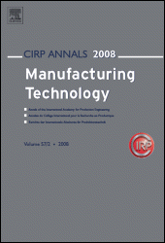
Contents lists available at SciVerse ScienceDirect

CIRP Annals Manufacturing Technology

Journal homepage: www.elsevier.com/locate/cirp



A Semi-Markov Process Approach to Quantify Material Content Over Multiple Product Lifecycles with Application to a Hard Disk Drive

Nehika Mathur¹ (3), Yong Han Kim², Ritbik Kumar², John W. Sutherland² (1)

¹Systems Integration Division, National Institute of Standards & Technology, Gaithersburg, MD 20899
²School of Sustainability Engineering & Environmental Engineering, Purdue University, West Lafayette, IN 47906

Critical materials (CMs) are used in many electronic, defense, and emerging technologies, e.g., hard disk drives (HDDs). Identifying, tracking, and quantifying potentially recoverable CM from secondary sources is necessary to plan for long-term CM supply security. A Semi-Markov Process (SMP) model is employed to temporally quantify and characterize individual material flows in HDD lifecycles. The model addresses knowledge gaps by tracking individual materials in complex products subject to different end-of-use (EoU) pathways and integrates product lifecycle ‘sojourn’ times to estimate retained material quantities. The SMP shows promise as a novel approach to characterize individual material flows across complex product lifecycles.

Manufacturing, Modelling, Semi-Markov approach

1. Introduction
The need to store and efficiently process relevant high-quality data generated by technologies such as artificial intelligence (AI), cloud computing, and e-commerce is driving the need for server farms. Server farms are, simply put, a collection of servers that function collectively to handle large volumes of data [1]. Each server farm can contain anywhere from a few hundred servers to hundreds of thousands of servers. A server comprises different subassemblies, namely, the Central Processing Unit (CPU), the motherboard or Printed Circuit Board (PCB), storage systems in the form of short-term Random Access Memory (RAM) and long-term Hard Disk Drive (HDD), and the Power Supply Unit (PSU) in addition to ancillary electronics components [2]. Many materials used to manufacture servers are considered critical [3]. Critical materials (CM) find applications across multiple industry sectors including the electronics and defense sectors. Efforts to secure the supply of CMs include expanding mining operations, identifying substitute materials, and diversifying CM supply by developing and scaling recovery (remanufacturing, recycling, etc.) operations with the objective of creating secondary CM streams.
Servers contain several high value materials (e.g., steel and CMs including Rare Earth Elements (REEs)). The HDD sub-assembly comprises Rare Earth Permanent Magnets (REPMs) made from REEs Nd, Pr and Dy. The main function of an HDD is to provide long-term storage of data and therefore the end-of-use (EoU) collection and management of used HDDs is particularly vital. Used HDDs need to be ‘wiped clean’ and are generally shredded. Shredded HDDs are segregated into ferrous and non-ferrous material streams. Any REEs in HDDs are lost as scrap during recycling. Depending on the type of server, the number of HDDs per server can vary from two HDDs to several dozens. HDD installation in servers do not require specialized tools thus facilitating quick replacement of defective/old HDDs with new ones. Given their material composition (Table 1) combined with the fact that HDDs require special handling at EoU, a unique opportunity to maximize HDD value presents itself thus making HDDs the focus of this study.

As is evident, there are a growing number of server farms, which are driving the demand for HDDs and in turn driving the demand for critical materials. Given the CM related supply chain brittleness, strategies to ensure a steady supply of CMs need to be developed. Owing to rapid technological advances in the electronics and semiconductor sector, 4–5-year-old HDDs are often considered outdated. New servers require maximum HDD capacity per slot owing to their better storage capacity-to-power ratio relative to older (lower capacity) drives. However, a used HDD may have value as a replacement for a defective HDD in an older server. Moreover, assuming methods are available to recover relatively pure material streams from used HDDs, used HDDs may be used to manufacture new HDDs.
(2)
This study develops a novel model to temporally track individual materials including CMs retained in server HDDs over time via a Semi-Markov Process (SMP). The model specifically applies the SMP to reflect the stochasticity across individual product lifecycle stages (states) to track CMs in a complex product that is subject to different recovery and/or disposal strategies. In doing so, this work overcomes limitations of past material flow analyses (MFA): (i) static or steady flow, (ii) monolithic product, and (iii) no differentiation among material streams [5]. The contributions of this paper are:
- An HDD system model which includes product lifecycle stages or “states” and has different EoU pathways.
- Quantifying the likelihood of three lifecycle pathways for an HDD.
- An SMP model that quantifies the different CMs retained in server HDDs across multiple lifecycles and corresponding time durations.
Section 2 describes the research methods. Section 3 details the data collection and model development steps. Results are presented and discussed in Section 4. Section 5 summarizes the findings and identifies future directions for this work.

Table 1: Elemental composition of a representative HDD [4]

HDD components | Mass (g) | Fe | Al | Cu | Cr | Pr | Nd | Dy | plastics
cover | 144.75 | 115.8 | 2.9 | 0 | 26.06 | 0 | 0 | 0 | 0
base casting | 305.25 | 6.105 | 293.04 | 0 | 0 | 0 | 0 | 0 | 6.11
platters | 56.93 | 0 | 56.93 | 0 | 0 | 0 | 0 | 0 | 0
magnets | 18 | 0 | 0 | 0 | 0 | 0.83 | 5.54 | 0.29 | 0
magnets carrying plates | 68.4 | 67.03 | 0 | 0 | 0 | 0 | 0 | 0 | 1.37
voice coil actuators | 25.575 | 0.64 | 0.64 | 24.3 | 0 | 0 | 0 | 0 | 0
spindle motor | 63 | 0 | 61.74 | 1.26 | 0 | 0 | 0 | 0 | 0
PCBs | 43.5 | 0 | 0 | 4.35 | 0 | 0 |  | 0 | 39.15
others | 24.15 | 0 | 0 | 0 | 0 | 0 | 0 | 0 | 70.77
Total (g) | 750 | 200.92 | 415.24 | 29.91 | 26.06 | 0.83 | 5.54 | 0.29 | 70.77
% share by mass | 100% | 26.79% | 56.37% | 3.99% | 3.47% | 0.11% | 0.74% | 0.04% | 9.44%

2. Semi-Markov Process for Modelling Product Lifecycles
Past work in modelling product lifecycles as Markov processes include the work by Paras and Pal [6] to quantify the number of times an article of clothing gets reused. Eckelman et al. [7] used a Markov approach to quantitatively track the flow of Ni across various geographic locations. Yamada et al. [8] explored the use of a Markov approach concurrently with Life Cycle Assessment (LCA) in the context of quantifying the number of product reuse cycles and suitably allocating environmental burdens. Matsuno et al. [9] built upon the work by Yamada et al. to quantify steel reuse in Japan while also quantifying the impacts associated with using steel once. Past applications of the Markov approach have largely not considered complex, multi-material products (especially those with CMs), and multiple EoU pathways that may be exploited to retain CMs in the economy [5]. The benefits of SMPs have likewise not be well-addressed in prior works; SMPs can yield a more accurate temporal understanding of individual material flows and retention quantities by incorporating sojourn times, i.e., the time spent by a system in a given state before it transitions to the next state [10]. It is these limitations that the developed SMP (Section 3) for tracking CMs in HDDs addresses.
A Markov chain is a stochastic process that satisfies the memoryless property, meaning that the probability of transitioning to the next state ($j$) depends solely on the current state ($i$), which can be expressed as:
$\operatorname{Pr}\left(S_{t+1}=j \right|S_{t}=i,S_{t-1}, …, S_{1})=Pr⁡(S_{t+1}=j \left| S_{t}=i\right)=p_{ij},$ (1)
where $S_{t}$ denotes the state at time $t$, $S_{t+1}$ the state at time $t+1$, and $p_{ij}$ the probability of transitioning from state $i$ to state $j$.

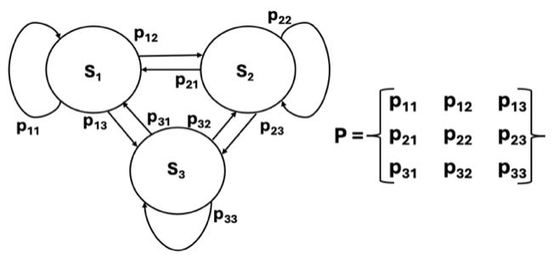

Figure 1. A representative Markov Process (MP) system model (left) and state transition probability matrix, P (right).

A MP is a probabilistic system whose state transitions occur in accordance with a transition probability matrix. In the case of a Discrete Time MP time progresses in distinct steps and the system transitions at these specific times. In contrast, for a Continuous Time MP, state changes can happen at any instant (t>= 0). For this case, a Markov process only holds if the holding times are exponential distributions. A detailed discussion of MPs is given by Oszczypała et al. [10].
Unlike a Markov process, with an SMP the time spent in each state, i.e., the residence, sojourn, or holding time, does not follow an exponential distribution. An SMP considers the probabilistic nature of both state transitions as well as holding times in states. These two probabilistic characteristics are jointly considered within an SMP via a renewal kernel matrix, Q(t) (Eq (2)) [10].

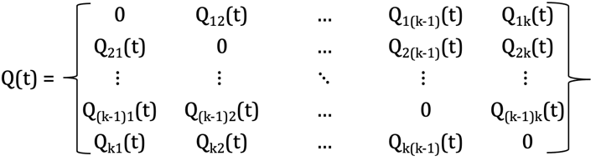 (2)
$Q_{ij}\left(t\right)= p_{ij}F_{ij}(t)$ (3)
$p_{ij}$ is the transition probability (i.e., the probability of the state $S_{i}$ going to state $S_{j}$), and $F_{ij}$(t) is the cumulative probability distribution associated with the time spent in state $S_{i}$ before transitioning to state $S_{j}$ [10]. To apply the SMP approach to an HDD, a product lifecycle model is needed (this will be discussed in the next section). Section 3 will also describe the information collected to estimate the transition probabilities and the holding time distributions for the HDD lifecycle. This information may then be used to find the SMP kernel matrix, Q, for the HDD lifecycle.

3. Semi-Markov Process Model for HDD Lifecycle
In the previous section the theory underpinning an SMP was established. An overarching goal of this work is to understand how much material content from an initial HDD is retained across successive “use” cycles, where the degree of retention is defined as the ratio of cumulative recovered mass (i.e., mass recovered over multiple cycles) to the initial mass. Understanding this aspect is important because evaluating how many times the initial material mass can be retained within the system over multiple cycles provides insight into material utilization efficiency and associated economic implications. System models representing the HDD lifecycle were developed for three EoU scenarios (Fig. 2):
- A Business-As-Usual (BAU) scenario: HDDs are reused in a limited manner; EoU HDDs are recycled via shredding and recovery of ferrous and non-ferrous materials.
- A Reuse-focused scenario: Longer HDD operational life is modeled, followed by recycling (some CMs recovered).
- A REE-focused recycling scenario: Emphasizes the recovery of CMs (e.g., Nd and Dy) from HDD REPMs and other materials.
A comparison of these scenarios will provide insight into how EoU strategy may shift retention patterns across materials. Input data for the model, i.e., the material composition of a typical HDD was determined from data sources and verified via discussions with industry personnel (J. Richter and L. Kotsakis, Microsoft Corp., personal communication, March 2026) [4]. Additionally, the state transition probabilities for each scenario were constructed based on data from the literature (Table 2). These probabilities are displayed on the lifecycle model of Fig. 2. Sojourn times, or the time spent in each state, were also obtained from the literature for the HDD product lifecycle. These are shown in Table 3.

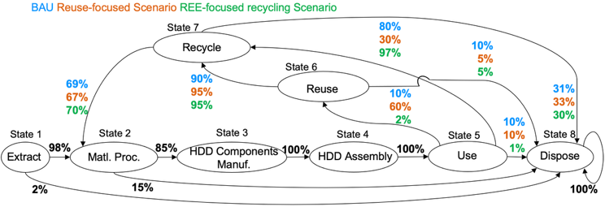

Figure 2. HDD system model depicting three lifecycle scenarios (states are labelled). The numbers represent the fraction of flow of material quantities between states and are expressed as probabilities to construct transition probability matrices.

Often the empirical information from the literature on sojourn times is somewhat unsubstantiated. In other cases, multiple distributions are proposed to describe the residence time. For our present purpose, we have estimated the minimum and maximum state duration times and used a uniform probability density function to characterize the statistical distribution.

Table 2: Lifecycle state transition probabilities

State i | State j | p_{ij} | Lit. Source
1 | 2 | 0.98 | [11] [12]
1 | 8 | 0.02 | [11] [12]
2 | 3 | 0.85 | [13] [14]
2 | 8 | 0.15 | [13]
3 | 4 | 1 | Assumed production yield is 100% post rework loops [15]
4 | 5 | 1 | [15]
5 | 6 | 0.1 (BAU), 0.6 (Reuse-focus), 0.02 (REE-focus) | [16]  [17]
5 | 7 | 0.8 (BAU), 0.3 (Reuse-focus), 0.97 (REE-focus) | 1 – (p₅₆ + p₅₈)
5 | 8 | 0.1 (BAU, Reuse-focus), 0.01 (REE-focus) | [17]
6 | 7 | 0.9 (BAU), 0.95 (Reuse-focus, REE-focus) | Based on HDD collection rate [17]
6 | 8 | 0.1 (BAU), 0.05 (Reuse-focus & REE-focus) | Based on HDD collection rate [17]
7 | 2 | 0.69 (BAU), 0.67 (Reuse-focus), 0.7 (REE-focus) | [4]  [18]
7 | 8 | 0.31 (BAU), 0.33 (Reuse-focus), 0.30 (REE-focus) | [4]  [18]
8 | 8 | 1 (BAU) | Assumed no recovery from landfill.

Table 3: Product lifecycle state residence time distributions (HDD)

State (Lifecycle stage) | Time, U[min, max] in yrs | Lit. Source
1. Extract | U[0.02, 0.04] | [19]
2. Material processing | U[0.01, 0.01] | [20] [21]
3. HDD Component Manufacturing | U[0.08, 0.16] | [22]
4. HDD Assembly | U[<0.01, <0.01] | [23]
5. Use | U[3, 6] | [24]
6. Reuse | U[0.5,1] (BAU)  U[0.5,2] (Reuse-focus) | [25]
7. Recycle | U[<0.01, <0.01] | [26]
8. Dispose | 0 | -
Table 4: Elemental recovery process yield rates

Element | Yield Rate | Lit. Source
Al | 75% (REE- focused recycling)  83.5-94% (BAU & Reuse-focus) | [4] [18] [27] [28]
Cu | 20% (REE-focused recycling)  75-97% (BAU & Reuse-focus) | [28] [29]
Fe | ~95% (BAU & Reuse-focus)  98% (REE- focused recycling) | [18] [28] [30]
REEs | 0% (BAU & Reuse-focus)  90% (REE-focused recycling) | [4][18]

Attention now shifts to using the developed SMP models that have been tuned to HDD data from the literature to calculate the degree of retention. For a given scenario, let $U_{k, l}$ denote the mass of material $k$ present in the HDD at the start of the l^{th} use stage, with $U_{k, 0}=M_{k}$ being the initial mass. After the initial use, if a HDD is not disposed, it may follow one of two pathways: (i) reuse, where the HDD is reconditioned and undergoes another use stage (often with a shorter life) or (ii) recycle, where the materials within the HDD are recovered, sent to material processing, undergo production, and ultimately directed to the use stage. At each stage there is some probability of loss that leads to material disposal.
The mass entering the reuse stage in loop $l$ is given by
$U_{k, l}*p_{56}$. The mass entering the recycling stage (RC) comes from both use and reuse, such that the total input to RC in loop $l$ is
$U_{k, l}*(p_{57}+ p_{56}p_{67})$. After applying the material-specific recycling yield $y_{k}(Table 4)$, the resulting fraction is transferred to material processing and subsequently flows through component production and product assembly before entering the use stage. As a result, the mass returning to use at the beginning of loop $l+1$ can be expressed as:
$U_{k, l+1}= U_{k, l}\left(p_{57} + p_{56} p_{67}\right)y_{k}p_{23}p_{34}p_{45}$(4)
Based on this formulation, the cumulative recovered mass of material $k$ after $n$ use cycles are defined as:
$R_{k}\left(n\right)= \sum_{l= 0}^{n-1}{[U_{k, l} p_{56}+ U_{k, l+1}]}$ (5)
where the first term represents direct-reuse flow and the second term represents return-to-use flow.
Owing to the probabilistic nature of the lifecycle pathways and the statistical distributions associated with the sojourn times, every HDD will “experience” a different lifecycle. To characterize the average behavior of a scenario across many HDDs, Monte Carlo simulations were performed. For each simulation, $r$, for a given scenario the retained mass of material $k$ at time $t$, $M_{k,r}\left(t\right)$, was recorded and interpolated onto a common time grid. The average retained mass over $N$ simulations was then computed as:
${\overline{M}}_{k}\left(t\right)=E\left[M_{k}\left(t\right)\right]= \frac{1}{N}\sum_{i=1}^{N}{M_{k, r}\left(t\right)}$ (6)
and the total retained mass across all materials as:
${\overline{M}}_{total, s}\left(t\right)= \frac{1}{N}\sum_{k}{\sum_{i=1}^{N}{M_{k, r}\left(t\right)}}$ (7)
In all, N = 3000 simulations were performed for each scenario. Plots for ${\overline{M}}_{k}\left(t\right)$ and ${\overline{M}}_{total}\left(t\right)$ allow us to visualize both the magnitude and composition of the retained material mass over time.

4. Results and Discussion
Figure 3 compares the ratio of cumulative recovered mass to the initial material mass for each material for each scenario. As a reminder, the cumulative recovered mass is the mass of an initial product that is successfully recovered and reused across multiple lifecycles. Under the BAU scenario, most of the recovered mass is attributable to the recycle pathway, with the reuse pathway having only a small share. For the reuse-focused scenario (which has a much larger probability associated with the use to reuse transition), both the recycle and reuse pathways make substantial contributions to the cumulative recovered mass. Under the REE-focused recycling scenario, the behavior seen in the BAU, where recovered mass is driven primarily by the recycle pathway with only limited reuse, becomes even more extreme. This scenario prioritizes the recovery of REE. Recovery yield rates for Fe, Nd, Pr, and Dy increase while the rate for Al and Cu reduce. Overall, the BAU scenario is reasonably effective at encouraging multiple uses of Fe, Al, and Cu. The reuse-focused scenario achieves even higher rates of recovering Fe, Al, and Cu. The REE recovery scenario makes it clear that to recover rare earths will likely come at the expense of recovering Al and Cu.

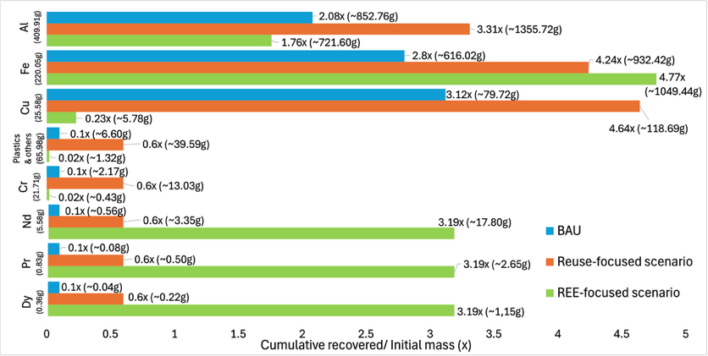
Figure 3. Material-wise cumulative recovered mass relative to initial mass.

Figure 4 (a-c) illustrates the composition of material mass retained in the system as a function of time for each of the three scenarios. These graphs are based on the Monte Carlo simulations; the masses shown are the averages across the simulations. All scenarios begin with an initial HDD mass of 750g and exhibit a gradual decline as material is lost across each lifecycle, with the behavior dictated by residence time distributions and each scenario’s transition probabilities and material-specific recycling yield rates.
4(a)
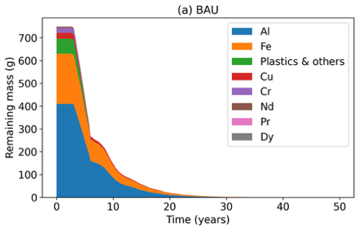
4(b)
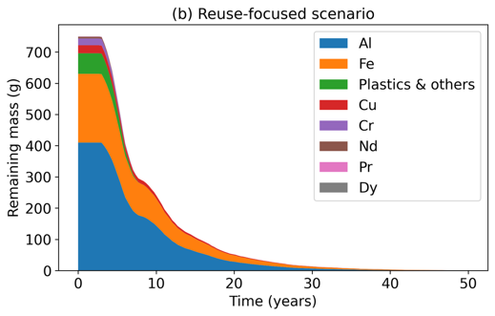
4(c)
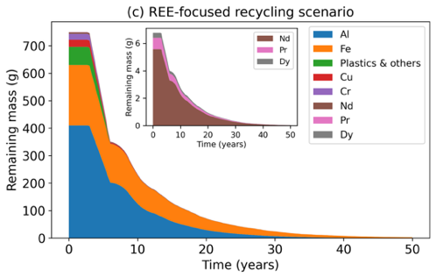

Figure 4. Retained material masses across time for three EoU scenarios.

For the BAU scenario (Fig. 4(a)), it is evident that the mass remains constant for the first few years – this is associated with the initial use stage of the HDD. Once end of life processing begins (recycling or reuse), the elements other than Al, Fe, and Cu quickly decline. At later times, Al, Fe, and Cu dominate the retained mass due to their relatively high recycling yield rates (0.85, 0.94, and 0.97), whereas other materials decline rapidly owing to their very low recycling yield rates (the reuse pathway does allow some of these materials to persist in the system). The total retained mass declines rapidly, dropping to about 57% of its initial value at 5 years and 20% at 10 years. Nearly all the mass leaves the system within 20 years. For the reuse-focused scenario (Fig. 4(b)), more material mass is retained in the system than for the BAU scenario because a greater fraction is directed to reuse. This extends material residence time in the system. In terms of the total retained mass, it drops to 73% at 5 years, 32% at 10 years, and 7% at 20 years. Like the BAU scenario, most of the material still exits the system within two decades. For the REE-focused recycling scenario (Fig. 4(c)), recovery of REEs is prioritized. Retaining REE mass comes at the cost of losing substantial amount of the other materials. In terms of total retained mass, it is 65% of the initial value 5 years, 31% at 10 years, and 9% at 20 years. Although recycling yield rates for the REEs are increased substantially, the overall retained mass is lower than for the other scenarios because the recycling yield rates for Al and Cu are considerably reduced. Owing to the better recycling yield rate for REEs, the retained mass for the REEs is 72% at 5 years, 40% at 10 years, and 14 % at 20 years. Going forward, developing industrial processes that recover high percentages of REEs, and Al and Cu is required.

5. Summary and conclusions
The developed SMP model is a generalized Markov model that quantifies individual material flows from HDDs temporally. The approach shows promise in resource management and can be adapted in the context of other complex products. One limitation of this study is obtaining detailed probability distributions for the residence times associated with each lifecycle state. Therefore, uniform distributions were assumed based on the ranges of residence times for each life cycle state from the literature. While this is a reasonable approximation, actual residence times may follow different statistical distributions. Future work aims to validate the model via rigorous sensitivity analyses, comparison with empirical data and alternate modeling approaches. There lies opportunity to extend this work to other server sub-assemblies, and indeed other complex products that comprise multiple components and materials. Extending this work to quantify economic and social implications, given complex CM geopolitics will be useful. Developing standardized means to record process relevant data (e.g., holding times, transition probabilities, and product compositions) will enable greater model reliability.

Declaration of competing interest
The authors declare that they have no known competing financial interests or personal relationships that could have appeared to the influence the work reported in this paper.

CRediT authorship contribution statement
NM, YHK & RK: Conceptualization, Data curation, Methodology, Formal Analysis, Writing – original draft. JWS: Methodology, Formal Analysis, Writing – review & editing, Supervision.
Acknowledgements
The authors gratefully acknowledge NIST DoC (Award#: 70NANB24H268) & USDoE NETL VTO (Award#: DE-EE0011185) to YHK and RK respectively. We are grateful to J. Richter (ex-Microsoft) & L. Kotsakis (Microsoft) for their insights.

References
[1] De Roucy-Rochegonde L, Buffard A (2025) AI, Data Centers and Energy Demand: Reassessing and Exploring the Trends. Ifri Papers, Ifri.
[2] Dell Technologies (2019, June 7) Life cycle assessment – Dell PowerEdge R740 https://www.delltechnologies.com/asset/en-us/products/servers/technical-support/Full_LCA_Dell_R740.pdf
[3] Nassar N-T, Pineault D, Allen S-M, McCaffrey D-M, Padilla A-J, Brainard J-L, Bayani M, Shojaeddini E, Ryter J-W, Lincoln S, Alonso, E (2025) Methodology and technical input for the 2025 US List of Critical Minerals—Assessing the potential effects of mineral commodity supply chain disruptions on the US economy (#2025-1047) USGS.
[4] Habib K, Parajuly K, Wenzel H (2015) Tracking the flow of resources in electronic waste-the case of end-of-life computer hard disk drives. Environmental science & technology, 49(20), 12441-12449.
[5] Afrinaldi F (2020) Exploring product lifecycle using Markov chain. Procedia Manufacturing, 43, 391-398.
[6] Paras M-K, Pal R (2018) Application of Markov chain for LCA: A study on the clothes ‘reuse’ in Nordic countries. The International Journal of Advanced Manufacturing Technology, 94(1), 191-201.
[7] Eckelman M-J, Reck B-K, Graedel T-E (2012) Exploring the global journey of nickel with Markov chain models. Journal of Industrial Ecology, 16(3), 334-342.
[8] Yamada H, Daigo I, Matsuno Y, Adachi Y, Kondo Y (2006) Application of Markov chain model to calculate the average number of times of use of a material in society: an allocation methodology for open-loop recycling-Part 1: Methodology development. International Journal of Life Cycle Assessment, 11(5), 354-360.
[9] Adachi Y (2007) Application of Markov chain model to calculate the average number of times of use a material in society: An Allocation methodology for open-loop recycling – Part 2: Case study for steel, Int J LCA, 12(1) 34-39.
[10] Oszczypała M, Ziółkowski J, Małachowski J (2023) Semi-Markov approach for reliability modelling of light utility vehicles. Eksploatacja i Niezawodność, 25(2).
[11] Luganov V-A, Chepushtanova T-A, Guseynova G-D, Merkibayev Y-S, Mamyrbaeva, K-K, Mishra B (2020) Processing of pyrite concentrates with the extraction of nonferrous metals: Nickel and Cobalt Technology elaboration. Sustainable Extraction and Processing of Raw Materials, (1), 53-58.
[12] Manning C, Chevrier V-F (2026) Maximizing Iron Unit Yield from Ore to Liquid Steel (Part 3) - Melting Practice | Midrex Technologies, Inc. Accessed: Jan. 09, 2026. [Online]. Available: https://www.midrex.com/tech-article/maximizing-iron-unit-yield-from-ore-to-liquid-steel-part-3-melting-practice/
[13] Allwood J-M, Music O (2024) Material efficiency at the component level: how much metal can we do without? Philosophical Transactions A, 382(2284), 20230245.
[14] Deng S, Zhu Y, Tsai A, Cooper D-R (2026) Decarbonizing the US aluminum ecosystem using a dynamic material flow simulation framework. Journal of Cleaner Production, 538, 147413.
[15] Bohn R-E, Terwiesch C (1999) The economics of yield-driven processes. Journal of Operations Management, 18(1), 41-59.
[16] Kenny R, Hands J, Hayhurst N (2024) From Waste to Resource: How Standardized Health Metrics Can Accelerate the Circular Economy in Storage Media. European Journal of Electrical Engineering and Computer Science, 8(4) pp. 1–5.
[17] Handwerker C, Olson W, Rifer W (2017) Value Recovery from Used Electronics. International Electronics Manufacturing Initiative, 90.
[18] Western Digital (2025) Advanced Recovery and Rare Earth Capture at Scale A blueprint for rare earth recovery that enhances supply chains and planetary resilience. White Paper. Accessed: January 2026
[19] U.S. Department of Energy (2002) Energy and environmental profile of the U.S. mining industry. https://www.energy.gov/eere/amo/mining
[20] Environmental Protection Agency (2019) Section 4.8 operational report. https://epawebapp.epa.ie/licences/lic_eDMS/090151b2806ec707.pdf
[21] Valmet (2003) Automation solutions for pulp and paper industry https://www.valmet.com/globalassets/sharepoint/imported/2911_03_07en.pdf
[22] Ibrahim K, Chik M, Hashim U (2016) Semiconductor Fabrication Strategy for Cycle Time and Capacity Optimization: Past and Present. In Proceedings of the 2016 International Conference on Industrial Engineering and Operations Management (No. 1, pp. 2798-2807).
[23] Ali A, de Souza R (2007) Modeling and simulation of hard disk dive final assembly using a HDD template. Winter Simulation Conference (pp. 1641-1650) IEEE.
[24] Schroeder B, Gibson G-A (2007) Understanding disk failure rates: What does an MTTF of 1,000,000 hours mean to you?ACM Transactions on Storage (TOS), 3(3) 8-es.
[25] Handwerker C, Olson W, Schaffer M (2018) Creating a circular economy for hard disk drives - A shared vision (iNEMI Report).
[26] Papetti M, Colledani M, Diani M (2025) HDD Disassembly Optimization for the Efficient Recovery of NdFeB Permanent Magnets. Procedia CIRP, 136, 153-158.
[27] Boin U-M-J, Bertram M (2005) "Melting standardized aluminum scrap: A mass balance model for Europe." Jom 57(8), 26-33.
[28] Nguyen R-T, Diaz L-A, Imholte, D-D, Lister T-E (2017) Economic assessment for recycling critical metals from hard disk drives using a comprehensive recovery process. Jom, 69(9), 1546-1552.
[29] Torrubia J, Parvez A-M, Sajjad M, Paz F-A-G, van den Boogaart K-G (2024) Recovery of copper from electronic waste: An energy transition approach to decarbonise the industry. Journal of Cleaner Production, 485, 144349.
[30] Bowyer J, Bratkovich S, Fernholz K, Frank M, Groot H, Howe J, Pepke E (2015) Understanding steel recovery and recycling rates and limitations to recycling. Dovetail Partners Inc.: Minneapolis, MN, USA, 1-12.

