Lessons learned from community-scale use of temporary refuge areas during the Camp Fire
Eric D. Link* and Alexander Maranghides
Fire Research Division, National Institute of Standards and Technology
100 Bureau Dr, Gaithersburg, MD, USA
*corresponding author: eric.link@nist.gov

Abstract
Background. Wildfires can quickly spread or ignite within wildland-urban interface areas, leading to life-threatening scenarios for people who cannot evacuate in time or who become trapped during evacuations. One such example of a dire scenario is the Camp Fire, which occurred in Butte County, California, in 2018.
Aims. To provide insight into lessons learned from the evacuation during the Camp Fire and introduce a contingency, called temporary fire refuge areas, that communities can incorporate into their evacuation planning and response.
Methods. An in-depth case study of the Camp Fire was conducted to reconstruct and understand the conditions and sequence of events of the evacuations during the incident.
Key results. The fire spread into communities within an hour after ignition, burning homes, blocking egress routes, and entrapping hundreds of evacuees. The ad hoc implementation of 31 temporary refuge areas saved the lives of at least 261 civilians and reduced the risk to at least 961 more.
Conclusions. Ad hoc temporary refuge areas facilitated a fortunate outcome with no known accompanying casualties. An intentional, pre-planned identification of suitable areas would enable emergency managers to reduce risk in their communities.
Implications. Communities should expressly consider no-notice and dire scenarios in their evacuation plans and community outreach programs, including temporary fire refuge areas in their fire response plans.

Keywords
case study, evacuation, improvisation, Paradise, TFRA, temporary fire refuge area, temporary refuge area, TRA, wildland-urban interface, WUI

Summary text
Thirty-one ad hoc temporary refuge areas (TRAs) were utilized during the Camp Fire, contributing to the life safety of more than 1200 evacuees. Implementing an intentional, pre-planned network of temporary fire refuge areas (TFRAs) can add resiliency to community evacuation plans and facilitate response during no-notice WUI fire events.
Introduction
Recent wildland-urban interface (WUI) fire incidents have repeatedly shown the critical life safety hazards of rapid fire spread into and through WUI communities, especially during evacuations. Within the past decade, high-profile examples across the United States include the Tubbs (2017), Camp (2018), Marshall (2021), Lahaina (2023), Palisades (2025), and Eaton Fires (2025). International examples include fires impacting Fort McMurray, Canada (2016), Pedrógão Grande, Portugal (2017), Mati, Greece (2018), Mallacoota, Australia (2019), and Viña del Mar, Chile (2024). While the details of each example incident are unique, a common theme is rapid fire spread outpacing the ability to notify and evacuate people safely before the fire impacts the community or evacuation routes. These catastrophic WUI fires spread too fast and burn too intensely to be suppressed before they impact communities and people.

While an early evacuation, completed before hazardous conditions impact the affected community or evacuation routes, is safest from the perspective of avoiding exposure, the variability of ignition locations, fire spread, and community specifics dictates that evacuation cannot be implemented as a “one solution fits all” approach. Individuals (and, by extension, communities) must have multiple response plans for various scenarios or eventualities, depending on the actual progression of the fire event. Fatalities have occurred in instances where a person’s primary plan to evacuate was not possible or successful, and they were not prepared for an alternative action (Hart 2014). In other cases, individuals’ primary plans may be to stay and defend their property or take shelter (Whittaker et al. 2013; Paveglio et al. 2014; Stasiewicz and Paveglio 2021). However, actual local conditions may become too intense to successfully shelter or defend property as planned (McLennan et al. 2011; Hart 2014), leading to casualties or attempts to evacuate later in dangerous fire conditions. Past studies have identified that delayed and late evacuations are a primary factor in civilian entrapments and fatalities (Haynes et al. 2010; Diakakis et al. 2016).

However, fast-moving, no-notice WUI fire incidents, when the fire develops so closely or quickly that there is little time to react before it affects life safety, may render even the most expedient evacuations “late.” The concept of wildfire required safe egress time (WRSET) (Ronchi et al. 2019), adapted from the required safe egress time (RSET) in building evacuations, represents the minimum time needed to evacuate a community and is independent of fire spread rate (Kalogeropoulos et al. 2025). From an incident command perspective, it takes time to develop situational awareness, make response decisions, and communicate emergency notifications (Maranghides and Link 2025). Once individual civilians become aware of the hazard, common delays to evacuation include the complex hazard assessment and decision-making process (McNeill et al. 2015; McCaffrey et al. 2018; Forrister et al. 2024) and side trips or intermediate tasks during evacuation (Liu et al. 2012, 2013; Wilkinson et al. 2013; Toledo et al. 2018). Even in an idealized evacuation, with immediate notifications and action taken by evacuees, and without any disturbances or slowdowns associated with smoke or fire, the fire may still arrive and impact evacuations before they can be completed. Dire scenarios can occur when WRSET is less than the available time before the fire impacts, threatening the life safety of evacuees (Cova et al. 2021; Kalogeropoulos et al. 2025).

Such scenarios can lead to burnovers and entrapments, situations where fire overtakes people or traps them in hazardous conditions, requiring protective action and sheltering (Cova et al. 2009; Page and Freeborn 2019); however, survival options are limited. This has been a concern for wildland firefighters for years, before WUI fires increased the direct risks to the public; therefore, safety tactics are an integral part of firefighting operations (Alexander and Thorburn 2015; Page et al. 2019). Two safety tactics include safety zones and temporary refuge areas (TRAs) (Gouette et al. 2014). Firefighters identify these locations as part of their tactical operations in case they need to take shelter from hazardous fire conditions. Safety zones are large areas clear of fuel that provide sufficient separation distance from surrounding fuels, such that personnel will be safe from radiant fire exposures without the use of an emergency fire shelter (Butler and Cohen 1998; Butler 2014; Campbell et al. 2022). [Note that emergency fire shelter refers to the packable aluminum, fiberglass, and silica fabric tent (National Wildfire Coordinating Group 2023), not a specific location or structure.] Guidance states that safety zones should provide a separation distance of eight times the vegetation height (approximately four times the expected flame height) (National Wildfire Coordinating Group 2025). A TRA is less protective yet often more accessible, particularly in the WUI, and may be “anything that protects firefighters from radiant or convective heat” (Gouette et al. 2014). They may be smaller than a safety zone, such as a cul-de-sac, or as simple as the lee side of a structure, which provides a temporary reduction in exposures so that a subsequent safety action may be taken.

When evacuating to safety is not possible, and dangerous exposures are expected based on fuels and the condition of egress routes, any available reduction in exposure can become an option for survival. Two often-discussed alternatives to evacuation include “stay and defend” and “shelter in place” (Paveglio et al. 2008; Paveglio et al. 2010), which have been implemented in past fires to varying extents and degrees of success, either as a primary plan or as an unintended contingency, more akin to a TRA. There is some overlap between the approaches; however, shelter in place is generally regarded as more passive compared to the actions required by a stay-and-defend approach (Handmer et al. 2010; Paveglio et al. 2010). Sheltering choices may include staying at home (often involving attempts to protect the home) or relocating to a refuge area or other safer space (Cova et al. 2009; Blanchi et al. 2018). These approaches may be beneficial in some circumstances, either as contingency plans for individual citizens or for specific community/fire scenarios (Paveglio et al. 2008; Cova et al. 2009; Paveglio et al. 2012; McCaffrey et al. 2015), or as a preplanned response in managed sub-communities or facilities, such as a university (Flynn 2025) or healthcare setting (Hobbs et al. 2025). However, communities and structures are not currently built in a way that prevents their ignition or widespread conflagrations, making shelter-in-place an unfeasible generalized solution (Hart 2014; Handmer et al. 2019; Maranghides and Link 2025). Furthermore, all but the most dedicated and prepared individuals are untrained and ill-equipped to defend against WUI fire conditions (Penman et al. 2013). Many structures are indefensible, further increasing the risks and making stay-and-defend similarly unfeasible as a community approach. Depending on the specific local conditions, different options will require different preparations and have varying efficacy and safety (Paveglio et al. 2008; Cova et al. 2009; Paveglio et al. 2010; Mutch et al. 2011; Hart 2014; Blanchi et al. 2018).

Civilians have also utilized TRAs, in an ad hoc manner out of necessity, when facing entrapment. There are many anecdotal reports of individuals seeking refuge in pools, shoreline areas, and structures (Weiss and Chawkins 2008; Harding 2013; Acarian 2017; Allday 2017; BBC News 2018; Gafni 2023). The detailed investigations of the catastrophic Black Saturday bushfires in Australia in 2009 describe the circumstances of emergency sheltering, survival, and fatalities of many victims who could not evacuate (McLennan 2010; Teague et al. 2010; Hart 2014; Whittaker et al. 2017). Based on the Commission's recommendations, a more formalized, preplanned version of a TRA or safety zone for community use has been implemented in Australia. Neighbourhood Safer Places (NSP) or Bushfire Places of Last Resort (BPLR) are intended to provide an increased chance of survival in dire situations where other options are no longer viable (NSW Rural Fire Service 2017; CFA (Country Fire Authority) 2020, 2025). Indicated in the name, “safer” indicates that these locations will not necessarily be safe and are not to be a primary plan of refuge. However, the initial study of informal refuge areas during the 2009 fires (McLennan 2010), undertaken to support the development of the NSP-BPLR, is the only known study, compilation, or published record documenting the use and performance of these areas in fire events.

Given the complexities of evacuations and the variable efficacy of alternatives, research has called for new methods for sheltering and protective actions that span the range of definitions and protection levels, as additional tools and approaches are developed and understood (Cova et al. 2011; Paveglio et al. 2012). This includes case studies of successful shelter use, implementation, and scope (Cova et al. 2009; Whittaker et al. 2017; Blanchi et al. 2018), research about effective placement and location of potential shelters or safe areas (Steer et al. 2017), and decision support tools for at-risk facilities such as healthcare (Hobbs et al. 2025). This study presents the findings and analysis of TRAs used by civilians during the Camp Fire, under the direction and supervision of first responders, which is believed to be the most widespread implementation of this life safety tactic.

The 2018 Camp Fire in Butte County, California, was a landmark WUI fire event characterized by rapid fire spread with near-immediate impacts on evacuations and life safety, leading to loss of life and property, and was the most catastrophic WUI fire in 100 years (Martinez 2018). The fire ignited at approximately 0615 hours on 8 November 2018 (Butte County District Attorney 2020) and had spread a distance of 6 km by 0800 hours, overrunning the community of Concow and burning into the town of Paradise and then Magalia. The quick progression resulted in numerous entrapments of evacuees as the fire burned over roadways and destroyed a majority of the town of Paradise (Maranghides et al. 2021). Much of the damage to the WUI occurred within the first 12 h, with nearly all of it happening within the first 30 h. In total, the fire burned for 17 days, claimed 85 lives, destroyed over 18000 structures, and encompassed more than 62000 ha.

Evacuation orders were requested as the fire spread; however, the rate of spread and extensive communication difficulties reduced the lead time that evacuees had to react. In many areas, fires were burning before an evacuation notice was received, if one was received at all (Maranghides et al. 2023). Regardless of the effectiveness of notifications in this event, the fire's spread rate and direction would have posed hazards to life safety and impacted evacuation.

This article is a distillation of the detailed accounting of the emergency ad hoc use of TRAs by civilians at the direction of first responders during the Camp Fire (Maranghides et al. 2023) and is the first study of community-scale civilian use of TRAs. This analysis illustrates the scope of TRAs and the lessons learned from this event and proposes a pathway forward for communities to increase preparedness for future events. The recent prevalence of these no-notice WUI fire events demonstrates that evacuation plans must account for WUI fire incidents that preclude safe evacuation, necessitating the development of alternative responses and contingency plans prior to a WUI fire. The authors propose incorporating intentional, pre-planned TRAs as another layer of safety and preparedness for communities at risk of WUI fires. While developed plans may not address or anticipate all incident complications, they can offer additional options for managing life safety in dire WUI fire situations and serve as an advanced starting point for improvisation and flexibility during disaster response (Kreps 1991; Kendra and Wachtendorf 2006; McEntire et al. 2014).

Methods
A detailed case study was initiated immediately after the fire to reconstruct the timeline of events, beginning with the fire progression timeline as a foundation (Maranghides et al. 2021) and expanding to understand the life safety aspects of the incident (Maranghides et al. 2023). Primary data collection methods included 151 technical discussions with 157 first responders and local officials (primarily firefighters, but also including law enforcement, local officials, public works, and transit service) to systematically document their observations, actions, and first-hand experience. Additional observations were gleaned from a review of available radio logs, photos and videos taken by first responders, Paradise Police Department dashboard cameras, as well as publicly available media and news reports. A survey of residents and evacuees was beyond the scope of the case study, as was a direct assessment of evacuee decision-making or specific behavior analysis.

Observations were categorized into three general groups: fire, evacuation/life safety, and defensive actions (i.e., firefighting). Evacuation-related data included observations and actions related to emergency notifications, evacuation, traffic, temporary refuge areas, and rescues. Integration of the fire and defensive action data categories with the evacuation-related observation data provided the context needed to understand the incident and the life safety implications (burnovers, entrapments, temporary refuge areas, and traffic flow/management). Specific findings of the fire observations data are available in (Maranghides et al. 2021), and defensive actions data are being analyzed for subsequent reporting. Data and documentation of relevant preparedness and pre-event conditions, such as the community evacuation plan and event response details, including radio logs and evacuation notification timelines, were also incorporated into the analysis.

Through a comprehensive integration and quality control process, each observation datapoint was assigned a time of day and location. Available radio logs and automatic vehicle location (AVL) tracking records from CAL FIRE (California Department of Forestry and Fire Protection) apparatus, obtained via public records request, were used to refine spatiotemporal observations. Of the 151 technical discussions, 56 had accompanying AVL data and 54 had photos/videos captured during the incident. The database is spatiotemporally precise, with 69 % of data points directly anchored by automatic vehicle location (AVL) tracking records or verified, timestamped, and geolocated media. The remaining 31 % of data points were reconciled within the complete dataset, and most occurred within narrow time windows with low uncertainty. Additional details of the case study methods and the distributions of data sources, times, and categories can be found in the comprehensive reports that are the foundation for this research article (Maranghides et al. 2021; Maranghides et al. 2023).

The data collection efforts resulted in more than 2500 data points each of fire spread and evacuation-related observations. In combination, the fire spread and behavior observations provided context for the requests for emergency notification and evacuation orders, as well as the progression of the evacuations, including dynamic traffic conditions, rescues, and the use of temporary refuge areas (TRAs).

TRAs were identified in the analysis as any location where civilians or first responders sought relief from fire exposures, or were directed to go to, for risk reduction or evacuation management. The data sources have a bias to include TRAs formed or formalized by first responders. While there are likely additional instances of temporary refuge or brief shelter-in-place by individuals or small groups, there is high confidence that most TRA events are accounted for in the data based on the spatiotemporal coverage of the data sources, and they are representative of the community-scale implementation of TRAs during the incident. All data points relating to each location were compiled and analyzed, along with relevant fire progression observations, to understand and describe the conditions and sequence of events at each TRA. Data density ranged from one to 141 data points at each location (median: 14). Basic details compiled for each TRA include the point location, type of location (parking lot, roadway, natural area, structure), start time, duration, and number of civilians or vehicles involved. Headcounts were determined by a combination of available data and may include exact counts or estimates from first responders who were on scene, as well as those obtained from photos or videos. As a conservative baseline, vehicles were considered to be occupied by a single person.

Not all TRAs experienced the same level of urgency or hazard due to local fire conditions and site-specific factors. The urgency with which a TRA was formed and the peak hazard level of fire exposures experienced while in the TRA were ranked on a relative scale of low, moderate, or high for each TRA, based on descriptions of the situation, actions, and localized fire conditions in the data. The urgency of formation represents how quickly the individuals present needed to seek safety. Examples of the two extremes include civilians and/or first responders caught in a burnover and needing instant shelter (high urgency), versus using a TRA in the absence of immediate fire exposures to wait for traffic or roadway conditions to improve (low urgency). The peak hazard level describes the maximum exposure level experienced by civilians and/or first responders while in the TRA. High peak hazard was defined as instances in which a TRA formed within a burnover and people were directly exposed to flames. Moderate conditions were defined as significant fire and/or ember exposures that did not pose an immediate danger to life, while low exposures described scenarios where the combination of local fire activity and the size of the TRA resulted in little danger to life safety. Duration of exposure was not a direct factor in determining urgency or peak hazard level.
Results
The integration and analysis of the combined fire and evacuation datasets enabled a reconstruction of the life safety aspects of the incident within the context of the fire progression. Findings provide insight into the overall evacuation sequence, complications and obstructions to the evacuation (i.e., fire and traffic), and the dynamic management of life safety risk to evacuees through traffic management and the utilization of TRAs directed by first responders.

Community evacuation plan
The community evacuation plan in place at the time of the fire divided the community into 33 evacuation zones, including 20 in Paradise and 13 in Magalia, and identified the evacuation routes (Butte County 2018). Figure 1 shows a map of the Camp Fire with the final perimeter outlined and shaded in red, and the ignition location and initial spread vector for reference. Evacuation routes are indicated with blue arrows. Notably, the communities within the Camp Fire are characterized by limited evacuation routes owing to the geography of the foothills. Concow has one route (#1), Paradise five (#2–6), and Magalia two (#6, or through Paradise). Within the town of Paradise, the plan was designed for evacuations of selected zones depending on the fire scenario and included maps, personnel and resource requirements, and communication plans. However, a simultaneous, full evacuation of the town was not considered in the plan; it was understood that such an evacuation would introduce excessive traffic to the road network (D. Hawks, pers. comm.). Also included in the plan were 18 pre-designated “public assembly points” across the three communities (2 in Paradise, 4 in Magalia, 9 in Concow and surroundings, and 3 in other nearby foothill communities). Four of the locations in Concow had signs labeling them as “wildfire safety zones.”

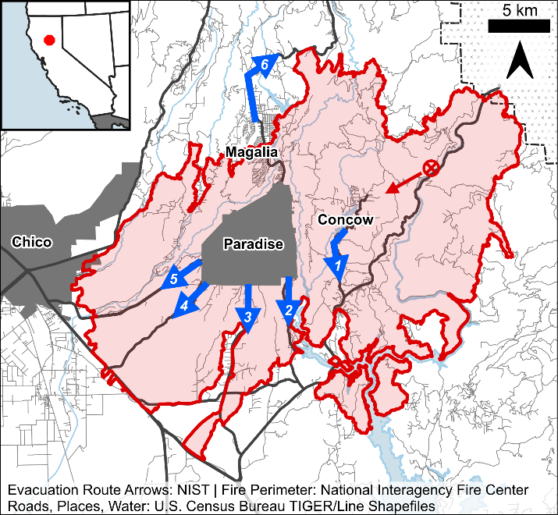
Figure 1. Map of the final Camp Fire perimeter with locations and roadways. The fire origin is marked by the ⨂ symbol, with the initial general fire spread direction indicated by the red arrow. The evacuation routes are indicated by blue arrows, and primary roads are marked with bolder black lines.

The community’s general preparedness reinforced the plan, including through recent multiagency emergency management scenario drills, a practiced implementation of contraflow (wherein inbound traffic lanes are reversed to expedite flow outward), and a community education campaign to inform citizens of their evacuation zone and plans. Additional fire preparedness efforts included paving of the northward evacuation route, a county-wide fuel break management program, and an active Fire Safe Council (www.buttefiresafe.net).

This background is provided as context for the catastrophic scenario that the community faced during the Camp Fire and the necessary incidental improvisations (Cunha et al. 2022) first responders made to adapt their training and utilize TRAs to save lives. This incident demonstrates that even communities considered relatively prepared compared to other at-risk communities can benefit from improvements, and highlights that many less-prepared communities would benefit from comprehensive evacuation and response planning.

Initial timeline
Conditions in the community of Concow, located over a ridge and 5 km from the ignition point, deteriorated quickly after the first spot fires were observed by 0725 hours, approximately one hour after the initial ignition. First responders attempted to notify the community with vehicle-mounted speakers and door-to-door messaging. Fire was well-established in the community by 0750 hours, blocking the lone evacuation route (#1 in Figure 1) for approximately 250 residences.

In Paradise, the rapid fire spread and widespread ignition of spot fires ahead of the main fire front increased the coverage of fire early in the evacuation process. The first spot fire in Paradise ignited 12 km southwest of the origin at 0749 hours, only three minutes after the first evacuation orders in Paradise were requested at 0746 hours. The direness of the incident became apparent, and first responders initiated a complete community evacuation at 0803 hours. Many people began evacuating before official orders were announced, and many never received an official notification. At least 30 spot fires had ignited in Paradise by 0830 hours when the main fire front impacted the eastern edge of the town (Maranghides et al. 2021). By 0900 hours, fire was blocking one of the evacuation routes (#2 in Figure 1), spot fires were continuing to ignite throughout the town (4 km and further into the community), and roadways were filled with people attempting to evacuate (Maranghides et al. 2023).

Conditions forced the use of TRAs
The arrival of fire preceded evacuations in Concow and was nearly coincident with the onset of evacuation in Paradise, quickly threatening the safety of evacuees and blocking evacuation routes. In Concow, the only evacuation route (#1) was blocked or impacted by fire between 0745 hours and 0930 hours. In Paradise, the northern route (#6) and multiple southern routes were blocked simultaneously (in varying combinations of #2–5) between 0945 hours and 1400 hours during the peak of evacuations (Maranghides et al. 2023). A significant number (n=23) of burnovers, events in which fire overtook or directly entrapped evacuees or first responders, were identified in the case study (mapped in Figure 2); 17 events directly impacted a total of 300–500 evacuating civilians (Maranghides et al. 2021; Link and Maranghides 2023).

In response to the hazardous conditions and blocked evacuation routes, first responders resorted to using ad hoc temporary refuge areas (TRAs) during the incident to protect evacuees. Thirty-one locations, mapped in Figure 2 and listed in Table 1, were identified through this post-fire case study. TRAs were selected to leverage immediately accessible natural and/or manmade features, and included 14 parking lots, 7 roadways, 6 structures, 3 unmaintained natural areas, and 1 maintained natural area. These locations played an influential role in the life safety of at least 1200 to 2100 evacuees by reducing exposures compared to unmitigated burnovers and by preventing travel on compromised evacuation routes. The estimate increases to as many as 3300 civilians (approximately 8 % of the population) if the average number of people per vehicle is assumed to be two instead of one.

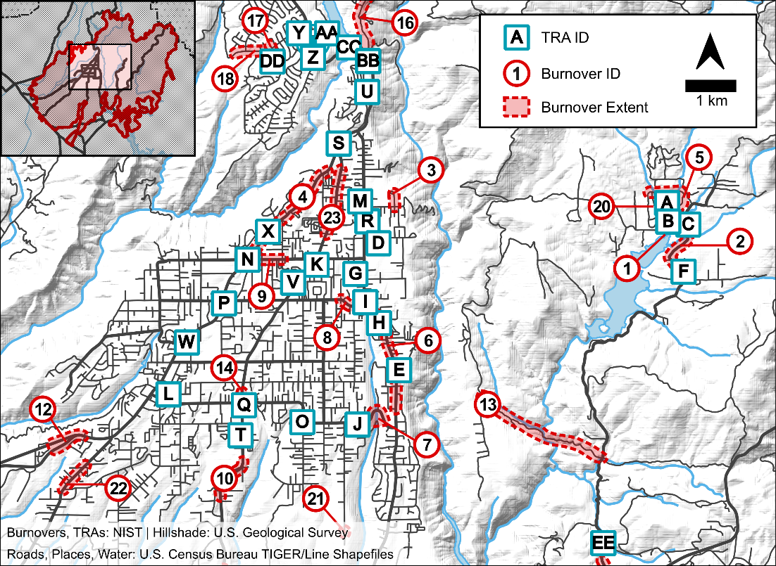
Figure 2. Map of Paradise, CA, showing the location of the 31 identified temporary refuge areas (letter ID in squares) and the extent of 23 identified roadway burnovers (red shaded areas with number ID in circles, not all visible on map). The inset at upper left shows the map area in relation to the final perimeter of the fire.

Table 1. Summary of temporary refuge areas utilized during the Camp Fire.
 |  |  |  |  |  |  |  |  | Civilian Headcount
ID | Location Name | Start  (hours) | End  (hours) | Urgency | Peak  Hazard | Relation to Burnover | Type | Area  (ha) | People | Vehicles | Duration  (hh:mm) | FF^{A}
A | Camelot Meadow | 0755 | 1000 | High | High | Direct & indirect | Natural (Maintained) | 3.37 | 70–85 | 24–30 | 02:05 | No
B | Hoffman Road | 0800 | 0823 | High | High | Direct | Natural | 0.06 | 24 | 10–15 | 00:23 | No
C | Concow Road (emergency bulldozed area) | 0827 | 0847 | High | High | Direct | Natural | 0.15 | 30–45 | — | 00:20 | No
D | Chris Court | 0845 | 0925 | Mod | Mod | n/a ^{B} | Roadway | 0.30 | — | 6 | 00:40 | Yes
E | Feather River Hospital | 0900 | 1500 | High | Mod | Direct & indirect | Parking Lot | 1.38 | 65–115 ^{C} | 50–110 | 06:00 | Yes
F | Concow Road (gravel parking area) | 0905 | 0930 | Mod | Mod | n/a | Parking Lot | 0.08 | 15–25 | — | 00:25 | —
G | Ponderosa Elementary School | 0907 | 1000 | High | Mod | n/a | Parking Lot | 0.28 | — | 6 | 00:53 | No
H | Chloe Court | 0920 | 1115 | High | High | Direct | Structure | 0.31 | 7–14 | 2 | 01:55 | Yes
I | Bille Road | 0930 | 1200 | High | High | Direct | Roadway | 0.31 | — | 70–100 | 02:30 | Yes
J | Pearson Road | 0935 | 1018 | High | High | Direct | Natural | 0.29 | — | 30–70 | 00:43 | No
K | Paradise Plaza Shopping Center | 0945 | 1745 | Low | Low | Indirect | Parking Lot | 2.32 | — | 350–550 | 08:00 | Yes
L | Paradise Police Dept/Fire Station 81 | 0945 | 1441 | Low | Low | n/a | Structure | 0.37 | 30–60 | 0 | 04:56 | Yes
M | Paradise Baptist Church | 1017 | 1245 | Mod | Mod | n/a | Parking Lot | 0.21 | — | 4–6 | 02:28 | Yes
N | Wagstaff Road | 1030 | 1255 | Mod | Mod | Direct & indirect | Roadway | 0.49 | — | 100–200 | 02:25 | —
O | Fire Station 82 | 1055 | 1200 | Low | Mod | n/a | Structure | 0.11 | 10–20 ^{C} | 20–30 | 01:05 | Yes
P | Walgreens | 1055 | 1430 | Mod | Mod | Indirect | Structure | 0.55 | 100–140 | — | 03:35 | Yes
Q | Ace Hardware | 1114 | 1300 | Low | Mod | Indirect | Parking Lot | 0.53 | — | — | 01:46 | Yes
R | Beyond Fitness | 1115 | 1230 | Mod | Mod | n/a | Parking Lot | 0.34 | — | 3 | 01:15 | No
S | Optimo | 1115 | 1630 | Low | Mod | Indirect | Structure | 0.34 | 180–220 | — | 05:15 | Yes
T | Best Western | 1130 | 1311 | Mod | Mod | Indirect | Parking Lot | 0.70 | — | 15–20 | 01:41 | Yes
U | Magalia Community Church | 1215 | 1241 | Mod | Mod | n/a | Parking Lot | 0.57 | — | — | 00:26 | Yes
V | CMA Church | 1220 | 1725 | Low | Low | n/a | Parking Lot | 2.56 | — | 50–250 | 05:05 | Yes
W | Paradise Shopping Center | 1300 | 1530 | Low | Mod | n/a | Parking Lot | 0.75 | 20–40 | — | 02:30 | No
X | Firland Drive | 1334 | 1358 | Mod | Mod | Direct | Roadway | 0.11 | n/a ^{D} | n/a | 00:24 | No
Y | Magalia Pines Baptist Church | 1337 | 2300 | Low | Mod | n/a | Parking Lot | 0.93 | 80–130 | — | 09:23 | Yes
Z | Magalia SavMor | 1715 | 2200 | Low | Low | n/a | Parking Lot | 0.39 | 10–40 | — | 04:45 | —
AA | Rite Aid | 1900 | 2800 | Low | Mod | n/a | Structure | 0.55 | 40–60 | — | 09:00 | Yes
BB | Skyway and Coutolenc Road | 2500 | 2600 | High | Mod | Direct | Roadway | 0.32 | n/a | n/a | 01:00 | No
CC | Magalia Dam (Skyway) | 2548 | 2557 | Mod | Low | Indirect | Roadway | 0.17 | — | 1 | 00:09 | No
DD | Pine Ridge School | 3124 | 3244 | High | Mod | Direct | Parking Lot | 1.25 | n/a | n/a | 01:20 | Yes
EE | Concow Road and Pinkston Canyon Road | 3127 | 3145 | High | High | Direct | Roadway | 0.06 | n/a | n/a | 00:18 | No
Mod, moderate; n/a, not applicable; FF, firefighting; —, no data/unknown. Start and end hours correspond to 8 November 2018, with times greater than 2400 hours corresponding to 9 November (e.g., 2500 hours corresponds to 0100 hours on 9 November).
^{A} FF: Firefighting; yes/no: were any defensive actions taken at or near the TRA to reduce fire exposures
^{B} n/a: the TRA was not used in relation to a specific burnover occurrence
^{C} the count of people and vehicles are additive in these instances
^{D} n/a: TRAs with n/a headcounts were utilized by first responders only
Some TRAs were necessary as a direct emergency response to a burnover (n=12). Generally, these instances were classified as having a high urgency due to the dangerous exposures from flames and radiation. In these cases, the peak level of hazard experienced in the TRA was often classified as high. Locations were chosen as the best immediately available option and may not have provided much protection or separation from the flames. Examples include TRA-B in Concow (Figure 3a), which consisted of 24 civilians who were directed to seek refuge in a creek bed using two emergency wildland fire shelters provided by firefighters as they were burned over, and TRA-J in Paradise, where stopped traffic was overtaken by fire (Figure 4a), and firefighters rushed 30–70 vehicles into a cleared residential property to get out of the flames. In total, 11 TRAs were formed with high urgency, and 7 experienced high peak hazard levels. It is estimated that between 261 and 416 individuals, assuming one person per vehicle, were involved in at least one high-urgency TRA. Three high-urgency TRAs involved only first responders.

Other TRAs were important for risk reduction but were relatively less urgent, as the immediate fire exposures were not as extreme. These areas were sometimes indirectly related to specific burnovers or, in other cases, were used primarily for risk and traffic management to prevent evacuees from encountering hazardous conditions known to be further down the road (such as fire, debris, and power lines), and to coordinate further evacuation. One example is TRA-K, located in the large parking lot of a shopping center in central Paradise (2.32 ha, with approximately 500 marked spaces, Figure 3b). The TRA was initially formed as an indirect response to nearby burnovers and to clear the roadway as the fire spread closer to stopped traffic. As a large, cleared area, it provided a relatively safe location to gather evacuees, and fire exposures were relatively low. Later in the morning, as the scope of TRA use in Paradise became evident, and in the afternoon and into the night, as subsequent operations and incident management progressed, this TRA became a central hub to which 7 other TRAs were consolidated to facilitate safety and coordinate the final evacuation.

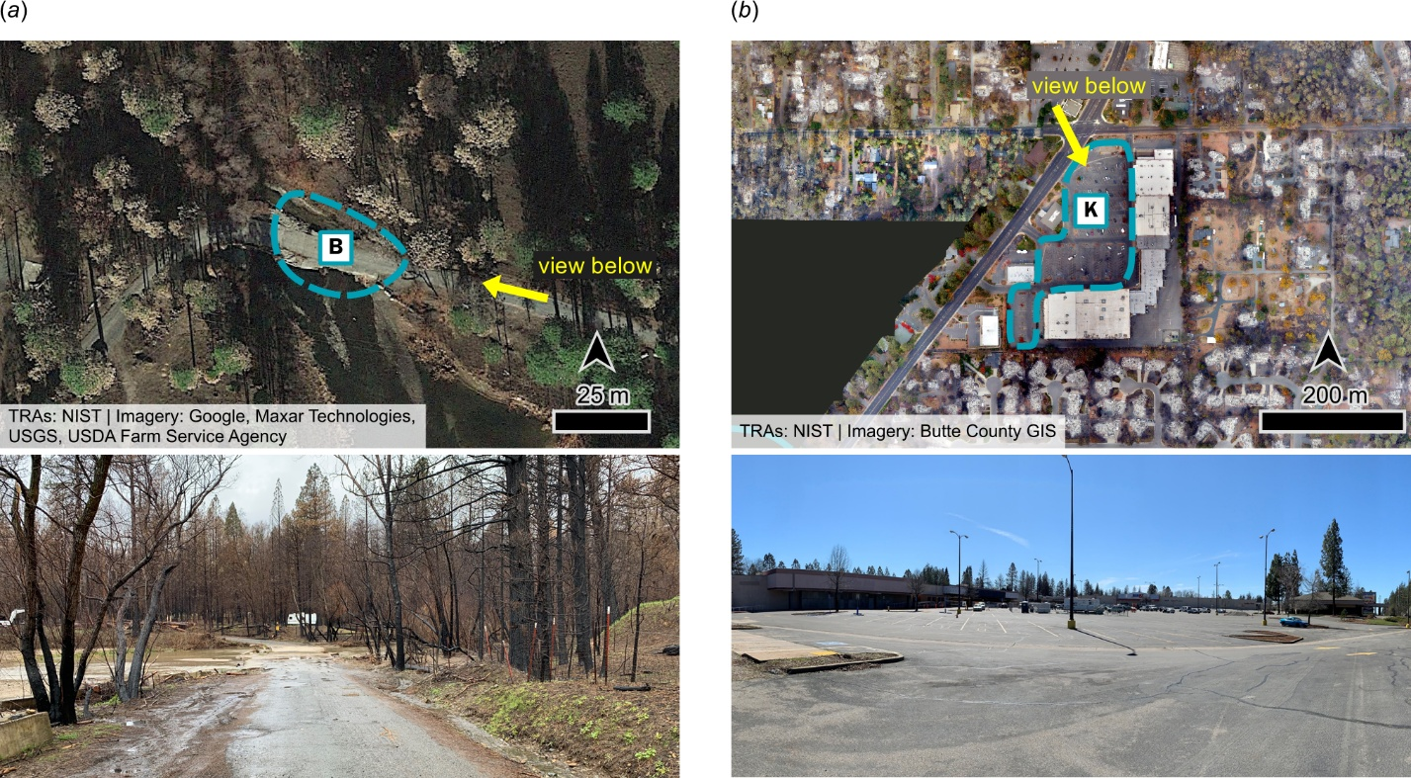
Figure 3. Post-fire aerial maps and ground-level photographs depicting the range of scales and locations of TRAs used during the Camp Fire. (a) TRA-B at the creek crossing along Hoffman Road in Concow; high urgency, high peak hazard, used for immediate life safety. (b) TRA-K at a large commercial parking lot in central Paradise; lower urgency, low peak hazard, used tactically to manage traffic and evacuations.

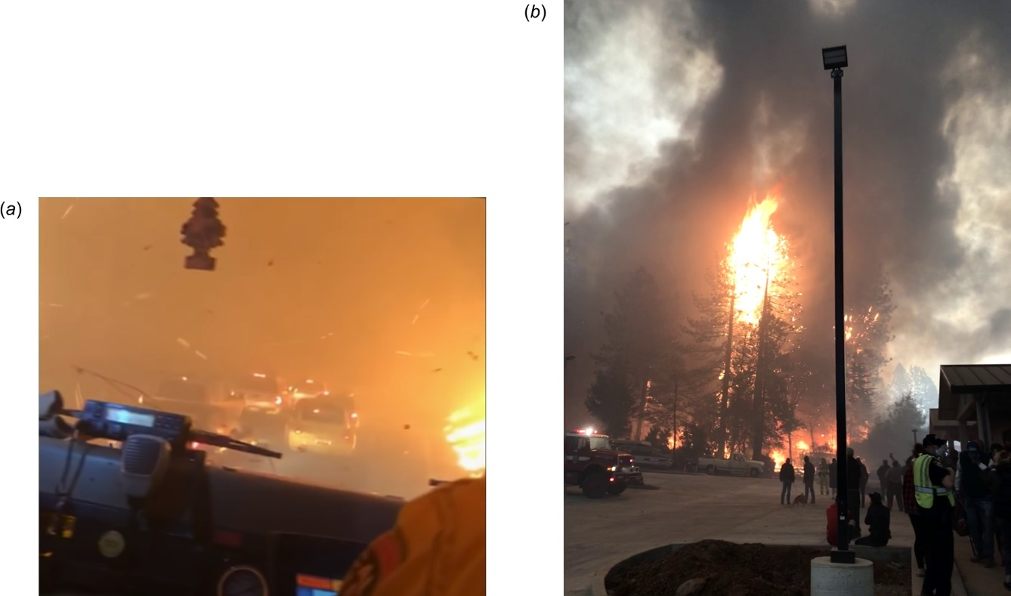
Figure 4. Photographs illustrate differences in local exposure conditions between two TRAs. (a) Extreme fire exposures to stopped traffic on Pearson Road necessitated the use of TRA-J (high urgency, high peak hazard). Photo courtesy of CAL FIRE. (b) Fire surrounding TRA-S presented a moderate hazard level to the TRA; civilians are seen gathered in the parking lot and commercial structure. Photo courtesy of Paradise Police Department.

Management of TRAs
TRAs were utilized for two primary reasons: 1) as an emergency refuge in response to local fire conditions, and 2) for risk management to prevent evacuees from encountering high exposures along evacuation routes and to coordinate traffic. In all but one documented case, TRAs were formed under the direction and supervision of first responders, including fire department and law enforcement personnel. While first responders were not always present at each location, TRAs were actively managed throughout their duration, including leadership and situational awareness, fire suppression, and coordination of their ultimate evacuation.

The large number of concurrent TRAs (up to 12) across a wide area presented a complex operational scenario. The dynamic nature of WUI fire incidents and rapidly changing local conditions made the expertise, situational awareness, and communication of first responders key to the success of the TRAs, both in determining when and where to implement them, and in the subsequent actions to move, consolidate, and defend them. Figure 5 shows a stylized map diagram illustrating the relationships between burnovers and TRAs (indicated by the red arrows), as well as between individual TRAs (indicated by the teal arrows).

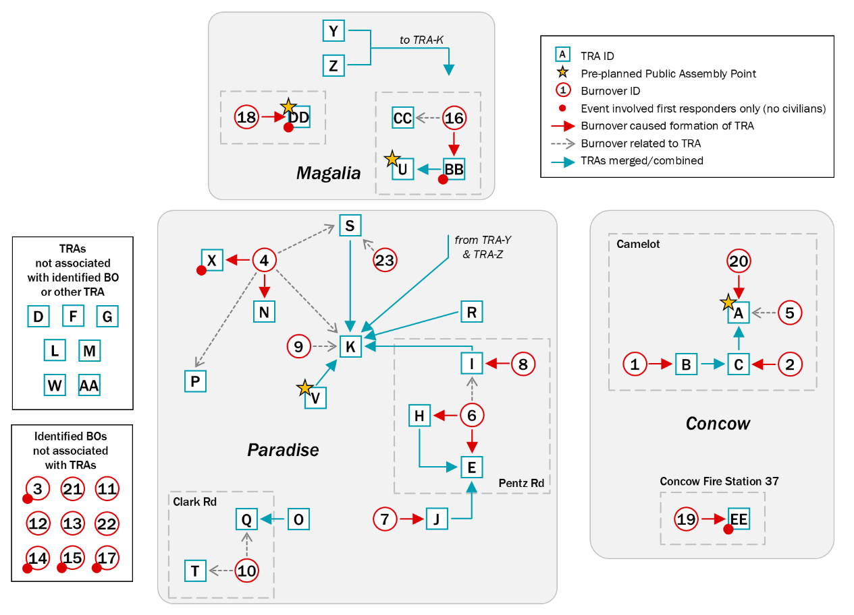
Figure 5. Diagram map showing the relationship among TRAs (letter ID in squares) and burnovers (number ID in circles).

Half of the TRAs (17/31) have a record of some type of defensive action taken by first responders to reduce or suppress fire exposures. Three locations stand out as examples, including a residential structure at Chloe Ct (TRA-H), the intersection of Bille Road and Pentz Road (TRA-I), and a small commercial parking lot at the “Optimo” restaurant and bar (TRA-S). Defensive actions at these locations were critical to maintaining the tenability of the TRAs and preventing fire from encroaching further. At TRA-H, first responders actively cleaned debris from the roof and around the structure, using garden hoses to extinguish embers and spot fires, while civilians sheltered in the garage. At TRA-I, a cluster of 70–100 vehicles were stuck in an intersection as fire burned against them. Luckily, a fire engine was able to connect to a working fire hydrant to shower the group of vehicles with a monitor nozzle. At TRA-S, traffic was gridlocked, and the three roadways were blocked by fire. Approximately 200 civilians were directed by first responders to abandon their vehicles to gather on foot in a small (0.3 ha) commercial parking lot and inside an unfinished 1-story commercial building under construction. Several fire engines patrolled the area, keeping the nearby gas station, restaurant, and commercial buildings from igniting, and putting out several spot fires (Figure 4b). Other known defensive actions taken at the 17 defended TRAs included infrastructure protection and exposure reduction, ranging in size from suppressing large structure fires to extinguishing small shrubs ignited by embers.

TRAs were monitored and supervised by first responders to manage risk and coordinate evacuations as safely and quickly as possible. TRAs formed in dangerous situations were as short in duration as required by the conditions. As soon as feasible, TRAs were relocated to a safer location, or civilians were completely evacuated from the fire area. Eleven TRA-to-TRA movements to consolidate evacuees in safer locations were identified, illustrated by the teal arrows in Figure 5. Fire and roadway conditions determined the immediate actions and occasionally required stops at intermediate TRAs before final evacuation was possible. For example, burnover BO-1 caused the need for TRA-B. In an attempt to reach the safer area at TRA-A, conditions again trapped the people involved, necessitating TRA-C. Ultimately, the group was able to access TRA-A, where they waited for the fire conditions along the evacuation route to improve, allowing them to be escorted out of the fire area.

Nine TRAs were ultimately evacuated by transporting people in emergency apparatus or buses, or by convoys of vehicles led by a first responder. The largest instance was the central hub at TRA-K, which operated for about 8 h, as people waited for the evacuation routes to become safe and first responders cleared a safe passage through debris, abandoned vehicles, and downed power lines. Facilitated by public transit buses organized through the incident command, between 350 and 550 people were transported or escorted out of TRA-K between 1700 hours and 2300 hours.

Discussion
Performance and limitations of TRAs
Overall, the TRAs used during the Camp Fire performed successfully, largely due to firefighter improvisation and adaptation of their training to enhance civilian life safety. However, the success of TRAs was not guaranteed, and it was fortunate that there were no significant injuries reported. Owing to the emergency circumstances, civilians were exposed to dangerous situations in several of the most urgent cases; many had high potential for casualties if circumstances were slightly different. While none of the identified TRAs were unsuccessful to the extent that they resulted in fatalities, some TRAs provided only a minimal reduction in exposures (e.g., TRA-B, TRA-C, TRA-J), requiring subsequent actions. Others benefitted from direct exposure reduction by firefighters (e.g., TRA-I).

No unsuccessful TRAs were identified in a review of the 85 incident fatalities (Butte County District Attorney 2020; Maranghides et al. 2023). Nineteen victims were believed to be attempting to evacuate or flee, including 10 in or near vehicles; however, they were not in locations that would be described as TRAs. For instance, a group of five victims were in and near their vehicles that were burned over on a one-lane, unpaved driveway through vegetation with no setback or cleared area. Most of the victims (59) were found inside their homes, although the circumstances and intentions of each victim are not known (such as whether they intentionally sheltered in place, were caught unaware, were unable to evacuate, or were otherwise forced to stay in place). Notably, at least half of these victims were reported to have a pre-existing condition limiting their ability to evacuate.

The ad hoc use of TRAs presents several limitations, including:
- Locations may not provide adequate protection or separation distances to surrounding fuels, leading to extreme exposures and potential casualties.
- Performance (i.e., exposure reduction or prevention) may rely on first responders to be present to provide instructions and defensive actions. This may not be achievable in fast-moving or large-scale incidents. Furthermore, fire suppression may not be effective in the highest exposures or for long durations.
- TRAs require additional ad hoc operational decisions that can challenge communications systems and make the management of life safety of occupants more difficult.
- Ad hoc TRAs do not provide for respiratory protection of occupants, who will likely be exposed to smoke for extended periods of time, even if fire exposures are minimized.
While the first three limitations were overcome during the Camp Fire, it may not be the case for future incidents. Therefore, thoughtful preplanning for events in which evacuation may not be possible can provide valuable improvements to life safety.

Pre-planned temporary fire refuge areas
The speed of the Camp Fire underscores the importance of evacuation and response plans that explicitly include scenarios where immediate evacuation out of the fire may not be possible. The extensive use of ad hoc TRAs during the incident was consequential in the life safety of trapped evacuees and illustrates a potential path forward in preparation and response for communities at risk. However, ad hoc implementation of TRAs in future events could lead to catastrophic outcomes, especially if they are implemented myopically (Cunha et al. 2022) and safer response options are available, or if subsequent rescue and TRA management operations do not develop favorably, as they did in the Camp Fire. In many cases, not all risks can be eliminated; however, if evacuation and response plans include provisions for how a community can respond in these events to mitigate the risks, fatal burnovers may be prevented.

One approach is to adapt from improvisation into pre-planning, formalizing the concept of ad hoc TRAs and creating a pre-identified network of refuge areas. For these locations, the authors propose the terminology of temporary fire refuge area (TFRA) to distinguish it from the existing concepts of TRAs, safety zones, and NSP-BPLR:
Temporary – use of TFRAs is not a “permanent” evacuation option or a long-term shelter; the duration of refuge will be dictated by the event and local conditions and will require a subsequent action.
Fire – specifies that the area is selected specifically for fire events and may not be suited to other disasters. For example, the area may not meet requirements to provide temporary refuge during a flooding event.
Refuge – this word choice differentiates TFRAs from safety zones. Taking refuge in a TFRA offers relative protection but still carries risk; it is not a guaranteed safe location.
Area – indicates that it’s the designated open space that is to be used, clarifying that the TFRA is not a building or a fire shelter.
TFRAs can serve as dedicated areas to bridge the current gap in life safety that occurs when there is not enough time for people to safely evacuate before the fire overruns their position or egress route, and people cannot safely shelter in their homes or other buildings, as they are likely to ignite and burn. TFRAs should not be viewed as a substitute for early evacuation when there is sufficient time to reach safety. Regardless of the eventual nomenclature, the intent of this pre-planning would be to mitigate the limitations of ad hoc TRAs by incorporating them into operational plans. For example, Marin County in California has recently (since 2023/2024) incorporated TRAs and “community refuge areas” (CRAs) into their evacuation planning, including schools, parks, and dozens of locations across the county (Fire Safe Marin 2025).

Assessment and use of TFRAs
Presently, there are no standards for the design or physical requirements of TFRAs; however, the best locations will have large open spaces clear of fuels. In many existing communities, the amount of space required to meet the definition of a safety zone may be prohibitive to establishing one or more safety zones (or NSP-BPLR (CFA (Country Fire Authority) 2020)). Alternatively, various existing locations may be suitable as a TFRA, including natural or manmade geographic features. Examples of areas that may be evaluated for potential use as TFRAs include clearings, gravel areas and parking lots, and well-maintained parks or other irrigated green spaces, such as golf courses or athletic fields. Areas to avoid using as TFRAs include heavily wooded areas with understory fuels, areas near combustible structures and objects, areas of flashy fuels (e.g., unburned tall dry grass), and high-density residential areas, which can ignite and result in structure-to-structure fire spread and very high exposures. Ignition-resistant buildings (e.g., cinder block-type construction) can act as buffers for radiation, but ignition of the buildings and their contents is possible even if firefighters are present. The presence of firefighters to reduce or protect TFRAs from surrounding exposures cannot be guaranteed in rapidly developing or large-scale incidents. Nevertheless, selecting locations near a water source or installing an emergency tank available for use by first responders may provide an added benefit in the event that it may be used for exposure reduction.

Consistent with the role of TRAs during the Camp Fire, the two main functions of TFRAs will be to prevent evacuees from being caught in burnovers (overrun by fire while evacuating) and to prevent people from being trapped in burning structures. Conditions in TFRAs can still be very dangerous, and they should only be used as a last resort. The potential dangers present in a TFRA can only be justified when compared to the severe conditions experienced in a burnover or when entrapped in a burning building. To mitigate some of the risks, established locations could be outfitted with a permanent storage cabinet containing particulate masks and emergency fire shelters, for example.

While the communities affected by the Camp Fire had identified 18 “public assembly areas,” some of which were labeled as “wildfire safety zones,” only four of them had documented use as TRAs during the incident (four others were exclusively used for operations staging; three others were completely inaccessible due to fire; one other was outside of the fire area). In comparison, the large number of 31 TRAs, and several instances where multiple TRAs were required, show that an expansive network of locations is beneficial. Depending on the fire scenario, individual TFRA locations may be inaccessible, or several may be needed to accommodate the number of evacuees or changing conditions. Community and first responder knowledge of these locations beforehand will contribute to their utility, and a comprehensive pre-incident education campaign will be necessary to inform everyone involved, including mutual aid responders. Signage marking the TFRAs will help familiarize both the public and first responders with their locations before and during an event.

As an integrated part of community evacuation plans, first responders will also need to be familiar with the location and use of TFRAs during incidents. It is unlikely that first responders will be available to protect each TFRA due to factors including incident speed, scale, and blocked access. However, first responders will need to monitor TFRAs as the incident develops and facilitate relocation or evacuation of civilians from TFRAs as conditions allow.

Conclusions
The training, awareness, and quick thinking of first responders during the Camp Fire resulted in the use of temporary refuge areas (TRAs) to protect the lives of hundreds of civilians when fire overtook the community at the height of evacuations. As a last resort, civilians were directed to take refuge in at least 31 different TRA locations, including parking lots, intersections, and open space natural areas. However, the fortunate outcome was not guaranteed. These dangerous situations could have resulted in dozens more fatalities if the individual circumstances were different and TRAs or first responders were not available. Even so, TRAs remain an important response action to manage life safety during future events, and first responders should be aware of suitable locations during their normal operations.

Looking forward, adapting the ad hoc use of TRAs from a firefighter safety operation into an intentional, pre-planned system of rapidly accessible fire safety zones and temporary fire refuge areas (TFRAs) can add a layer of resiliency to community evacuation plans and facilitate response during no-notice WUI fire events. Identifying, maintaining, and communicating the location and emergency conditions dictating the immediate use of pre-planned safety zones and TFRAs throughout communities will increase the safety of communities at risk of WUI fires. Given the similarities between several catastrophic WUI fires affecting evacuations in recent years, it is now unlikely that these are anomalous incidents, and future challenging fire/evacuation events are to be anticipated.

In the future, specifically designed and standardized fire shelters (ignition-resistant buildings for community-scale use) may be able to provide another option offering a higher level of protection, and more structures and communities may be mitigated against catastrophic fire spread. Until then, contingencies are necessary to provide for life safety in dire scenarios where safe evacuation or shelter-in-place is not possible.

Acknowledgements
The authors would like to acknowledge and thank the many first responders and community officials who contributed their time and information to the case study, as well as the data collection teams who participated in the technical discussions to collect much of the data used to compile the information in this report.

Data availability statement
Data are available in NIST Technical Note 2252 and its accompanying supplemental material, available at https://doi.org/10.6028/NIST.TN.2252 and https://doi.org/10.6028/NIST.TN.2252sup.

Conflicts of interest
The authors declare no conflicts of interest.

Declaration of funding
This work was funded by the U.S. government and was conducted as part of the mission of the National Institute of Standards and Technology, a bureau of the U.S. Department of Commerce.

References
Acarian, R (2017) California Journal: They survived six hours in a pool as a wildfire burned their neighborhood to the ground. Los Angeles Times, 12 October 2017.
Alexander, ME, Thorburn, WR (2015) LACES: Adding an "A" for ANCHOR POINT(S) to the LCES Wildland Firefighter Safety System. In 'Current International Perspectives on Wildland Fires, Mankind and the Environment.' (Eds B Leblon, ME Alexander) pp. 121–144. (Nova Science Publishers, Inc.: New York)
Allday, E (2017) Family's tragedy: In pool to escape flames, wife dies in husband's arms. San Francisco Chronicle, 13 October 2017.
BBC News (2018) Greece wildfires: Dozens dead in Attica region. 24 July 2018. Available at https://www.bbc.com/news/world-europe-44932366
Blanchi, R, Whittaker, J, Haynes, K, Leonard, J, Opie, K (2018) Surviving bushfire: the role of shelters and sheltering practices during the Black Saturday bushfires. Environmental Science and Policy 81, 86–94. doi:10.1016/j.envsci.2017.12.013
Butler, BW, Cohen, JD (1998) Firefighter Safety Zones: A Theoretical Model Based on Radiative Heating. International Journal of Wildland Fire 8, 73–77. doi:10.1071/WF9980073
Butler, BW (2014) Wildland firefighter safety zones: a review of past science and summary of future needs. International Journal of Wildland Fire 23, 295–308. doi:10.1071/WF13021
Butte County (2018) Butte County Public Safety Agency Evacuation Plan. CAL FIRE Butte Unit, Butte County, CA.
Butte County District Attorney (2020) The Camp Fire Public Report: A Summary of the Camp Fire Investigation. Butte County District Attorney, (Oroville, CA) Available at https://www.buttecounty.net/DocumentCenter/View/1881/Camp-Fire-Public-Report---Summary-of-the-Camp-Fire-Investigation-PDF?bidId [Verified May 2026].
Campbell, MJ, Dennison, PE, Thompson, MP, Butler, BW (2022) Assessing Potential Safety Zone Suitability Using a New Online Mapping Tool. Fire 5, 5. doi:10.3390/fire5010005
CFA (Country Fire Authority) (2020) CFA Neighbourhood Safer Place – Bushfire Place of Last Resort Assessment Guide. Available at https://www.cfa.vic.gov.au/ArticleDocuments/533/CFA-NSP-BPLR-Assessment-Guideline-November-2025.pdf [Verified May 2026].
CFA (Country Fire Authority) (2025) Neighbourhood Safer Places. (Updated 10 December 2025). Available at https://www.cfa.vic.gov.au/plan-prepare/your-local-area-info-and-advice/neighbourhood-safer-places [Verified May 2026]
Cova, TJ, Drews, FA, Siebeneck, LK, Musters, A (2009) Protective Actions in Wildfires: Evacuate or Shelter-in-Place? Natural Hazards Review 10, 151–162. doi:10.1061/(ASCE)1527-6988(2009)10:4(151)
Cova, TJ, Dennison, PE, Drews, FA (2011) Modeling Evacuate versus Shelter-in-Place Decisions in Wildfires. Sustainability 3, 1662–1687. doi:10.3390/su3101662
Cova, TJ, Li, D, Siebeneck, LK, Drews, FA (2021) Toward Simulating Dire Wildfire Scenarios. Natural Hazards Review 22, 06021003. doi:10.1061/(ASCE)NH.1527-6996.0000474
Cunha, MP, Clegg, S, Rego, A, Giustiniano, L, Abrantes, ACM, Miner, AS, Simpson, AV (2022) Myopia during emergency improvisation: lessons from a catastrophic wildfire. Management Decision 60, 2019–2041. doi:10.1108/MD-03-2021-0378
Diakakis, M, Xanthopoulos, G, Gregos, L (2016) Analysis of forest fire fatalities in Greece: 1977–2013. International Journal of Wildland Fire 25, 797–809. doi:10.1071/WF15198
Fire Safe Marin (2025) How to Evacuate. Available at https://firesafemarin.org/prepare-yourself/evacuation-guide/ [Verified May 2026]
Flynn, R (2025) Westmont College Calls Pepperdine’s Shelter-in-Place Protocol ‘The Gold Standard’. The Pepperdine Graphic, April 4, 2025 p A9.
Forrister, A, Kuligowski, ED, Sun, Y, Yan, X, Lovreglio, R, Cova, TJ, Zhao, X (2024) Analyzing Risk Perception, Evacuation Decision and Delay Time: A Case Study of the 2021 Marshall Fire in Colorado. Travel Behaviour and Society 35, 100729. doi:10.1016/j.tbs.2023.100729
Gafni, M (2023) One woman's harrowing escape from Lahaina: 7 hours in water, clinging to a wall. San Francisco Chronicle, 13 August 2023.
Gouette, K, Burke, J, Veneris, P, Martin, M, Chaney, R, Brand, J, Fowler, R, Peña, V (2014) 'Wildland Urban Interface Operating Principles.' (California Department of Forestry and Fire Protection: Sacramento, CA)
Handmer, J, O’Neil, S, Killalea, D (2010) Review of fatalities in the February 7, 2009, bushfires. Bushfire CRC.
Handmer, J, Van der Merwe, M, O'Neill, S (2019) The risk of dying in bushfires: A comparative analysis of fatalities and survivors. Progress in Disaster Science 1, 100015. doi:10.1016/j.pdisas.2019.100015
Harding, L (2013) Australian wildfires: clinging to life, a family defies wall of flame. The Guardian, 9 January 2013.
Hart, D (2014) Lessons Learnt From the Black Saturday Bushfires. Bushfire Cooperative Research Centre, (East Melbourne, Victoria).
Haynes, K, Handmer, J, McAneney, J, Tibbits, A, Coates, L (2010) Australian bushfire fatalities 1900–2008: exploring trends in relation to the ‘Prepare, stay and defend or leave early’ policy. Environmental Science & Policy 13, 185–194. doi:10.1016/j.envsci.2010.03.002
Hobbs, B, Hicik, A, Tochkin, J, Bloemink, A (2025) Evacuate or shelter-in-place? Applying a risk-informed decision support tool for long-term care facilities threatened by wildfire. Journal of Business Continuity & Emergency Planning 18, 253–267. doi:10.69554/IJET9958
Kalogeropoulos, N, Mitchell, H, Kuligowski, E, Ronchi, E, Rein, G (2025) Quantifying dire evacuations in case of wildfire using trigger boundaries and case study of the 2018 Mati wildfire in Greece. Safety Science 181, 106691. doi:10.1016/j.ssci.2024.106691
Kendra, J, Wachtendorf, T (2006) Improvisation, Creativity, and the Art of Emergency Management. University of Delaware, Disaster Research Center.
Kreps, GA (1991) Organizing for Emergency Management. In 'Emergency management: principles and practice for local government.' (Eds TE Drabek, GJ Hoetmer) (International City Management Association: Washington, D.C.)
Link, ED, Maranghides, A (2023) Burnover events identified during the 2018 Camp Fire. International Journal of Wildland Fire 32, 989–997. doi:10.1071/WF22115
Liu, S, Murray-Tuite, P, Schweitzer, L (2012) Analysis of child pick-up during daily routines and for daytime no-notice evacuations. Transportation Research Part A 46, 48–67. doi:10.1016/j.tra.2011.09.003
Liu, S, Murray-Tuite, P, Schweitzer, L (2013) Incorporating Household Gathering and Mode Decisions in Large-Scale No-Notice Evacuation Modeling. Computer-Aided Civil and Infrastructure Engineering 29, 107–122. doi:10.1111/mice.12008
Maranghides, A, Link, E, Mell, W, Hawks, S, Wilson, M, Brewer, W, Brown, C, Vihnaneck, B, Walton, WD (2021) A Case Study of the Camp Fire — Fire Progression Timeline. National Institute of Standards and Technology, NIST Technical Note 2135. (Gaithersburg, MD). doi:10.6028/NIST.TN.2135
Maranghides, A, Link, E, Mell, W, Hawks, S, Brown, C, Walton, W (2023) A Case Study of the Camp Fire — Notification, Evacuation, Traffic, and Temporary Refuge Areas. National Institute of Standards and Technology, NIST Technical Note 2252. (Gaithersburg, MD). doi:10.6028/NIST.TN.2252
Maranghides, A, Link, ED (2025) WUI Fire Evacuation and Sheltering Considerations: Assessment, Planning, and Execution (ESCAPE). National Institute of Standards and Technology, NIST Technical Note 2262r1. (Gaithersburg, MD). doi:10.6028/NIST.TN.2262r1
Martinez, G (2018) The California Fire That Killed 48 People Is the Deadliest U.S. Wildfire in a Century. (Updated 14 November 2018). Available at https://time.com/5453710/california-camp-fire-deadliest-wildfires-us-history/ [Verified May 2026]
McCaffrey, S, Rhodes, A, Stidham, M (2015) Wildfire evacuation and its alternatives: perspectives from four United States' communities. International Journal of Wildland Fire 24, 170–178. doi:10.1071/WF13050
McCaffrey, S, Wilson, R, Konar, A (2018) Should I Stay or Should I Go Now? Or Should I Wait and See? Influences on Wildfire Evacuation Decisions. Risk Analysis 38, 1390–1404. doi:10.1111/risa.12944
McEntire, DA, Boudrot, D, Webb, G, Burdick, B (2014) Planning and Improvisation in Emergency Management. In 'Critical Issues in Disaster Science and Management: A Dialogue Between Researchers and Practitioners.' (Eds JE Trainor, T Subbio) (FEMA Higher Education Program: Washington, D.C.)
McLennan, J (2010) Use of Informal Places of Shelter and Last Resort on 7 February 2009. Bushfire CRC, (Melbourne). doi:10.13140/RG.2.1.4283.5924
McLennan, J, Omodei, M, Elliott, G, Holgate, A (2011) “Deep Survival”: Experiences of some who lived when they might have died in the 7 February 2009 bushfires. Australian Journal of Emergency Management 26, 43–48.
McNeill, IM, Dunlop, PD, Skinner, TC, Morrison, DL (2015) Predicting delay in residents’ decisions on defending v. evacuating through antecedents of decision avoidance. International Journal of Wildland Fire 24, 153–161. doi:10.1071/WF12213
Mutch, RW, Rogers, MJ, Stephens, SL, Gill, AM (2011) Protecting Lives and Property in the Wildland-Urban Interface: Communities in Montana and Southern California Adopt Australian Paradigm. Fire Technology 47, 357–377. doi:10.1007/s10694-010-0171-z
National Wildfire Coordinating Group (2023) NWCG Standards for M-2002 Fire Shelters. PMS-411. Available at https://www.nwcg.gov/publications/pms411. [Verified May 2026]
National Wildfire Coordinating Group (2025) NWCG Incident Response Pocket Guide (IRPG). PMS 461 (NFES 1077). Available at https://www.nwcg.gov/publications/pms461 [Verified May 2026].
NSW Rural Fire Service (2017) Neighbourhood Safer Places: Guidelines for the Identification and Inspection of Neighbourhood Safer Places in NSW. Available at https://www.rfs.nsw.gov.au/__data/assets/pdf_file/0017/26135/NSP-Guidelines.pdf [Verified May 2026].
Page, WG, Freeborn, PH (2019) Entrapment. In 'Encyclopedia of Wildfires and Wildland-Urban Interface (WUI) Fires'. (Ed S Manzello) (Springer, Cham). doi:10.1007/978-3-319-51727-8_183-1
Page, WG, Freeborn, PH, Butler, BW, Jolly, WM (2019) A review of US wildland firefighter entrapments: trends, important environmental factors and research needs. International Journal of Wildland Fire 28, 551–569. doi:10.1071/WF19022
Paveglio, T, Carroll, MS, Jakes, PJ (2008) Alternatives to Evacuation—Protecting Public Safety during Wildland Fire. Journal of Forestry 106, 65–70.
Paveglio, T, Prato, T, Dalenberg, D, Venn, T (2014) Understanding evacuation preferences and wildfire mitigations among Northwest Montana residents. International Journal of Wildland Fire 23, 435–444. doi:10.1071/WF13057
Paveglio, TB, Carroll, MS, Jakes, PJ (2010) Adoption and perceptions of shelter-in-place in California's Rancho Santa Fe Fire Protection District. International Journal of Wildland Fire 19, 677–688. doi:10.1071/WF09034
Paveglio, TB, Boyd, AD, Carroll, MS (2012) Wildfire evacuation and its alternatives in a post-Black Saturday landscape: Catchy slogans and cautionary tales. Environmental Hazards 11, 52–70. doi:10.1080/17477891.2011.635185
Penman, TD, Eriksen, C, Blanchi, R, Chladil, M, Gill, AM, Haynes, K, Leonard, J, McLennan, J, Bradstock, RA (2013) Defining adequate means of residents to prepare property for protection from wildfire. International Journal of Disaster Risk Reduction 6, 67–77. doi:10.1016/j.ijdrr.2013.09.001
Ronchi, E, Gwynne, SMV, Rein, G, Intini, P, Wadhwani, R (2019) An open multi-physics framework for modelling wildland-urban interface fire evacuations. Safety Science 118, 868–880. doi:10.1016/j.ssci.2019.06.009
Stasiewicz, AM, Paveglio, TB (2021) Preparing for wildfire evacuation and alternatives: Exploring influences on residents’ intended evacuation behaviors and mitigations. International Journal of Disaster Risk Reduction 58,doi:10.1016/j.ijdrr.2021.102177
Steer, K, Abebe, E, Almashor, M, Beloglazov, A, Zhong, X (2017) On the utility of shelters in wildfire evacuations. Fire Safety Journal 94, 22–32. doi:10.1016/j.firesaf.2017.09.001
Teague, B, McLeod, R, Pascoe, S (2010) 2009 Victorian Bushfires Royal Commission Final Report. Parliament of Victoria, (Melbourne) Available at http://royalcommission.vic.gov.au/Commission-Reports/Final-Report.html. [Verified May 2026]
Toledo, T, Marom, I, Grimberg, E, Bekhor, S (2018) Analysis of evacuation behavior in a wildfire event. International Journal of Disaster Risk Reduction 31, 1366–1373. doi:10.1016/j.ijdrr.2018.03.033
Weiss, KR, Chawkins, S (2008) A long night of fear in the college gym. Los Angeles Times, 15 November 2008.
Whittaker, J, Haynes, K, Handmer, J, McLennan, J (2013) Community safety during the 2009 Australian ‘Black Saturday’ bushfires: an analysis of household preparedness and response. International Journal of Wildland Fire 22, 841–849. doi:10.1071/WF12010
Whittaker, J, Blanchi, R, Haynes, K, Leonard, J, Opie, K (2017) Experiences of sheltering during the Black Saturday bushfires: Implications for policy and research. International Journal of Disaster Risk Reduction 23, 119–127. doi:10.1016/j.ijdrr.2017.05.002
Wilkinson, C, Erikesen, C, Penman, T (2013) Into the firing line: civilian ingress during the 2013 "Red October" bushfires, Australia. Natural Hazards 80, 521–538. doi:10.1007/s11069-015-1982-5

Figure and Table Captions

Figure 1. Map of the final Camp Fire perimeter with locations and roadways. The fire origin is marked by the ⨂ symbol, with the initial general fire spread direction indicated by the red arrow. The evacuation routes are indicated by blue arrows, and primary roads are marked with bolder black lines.
Figure 2. Map of Paradise, CA, showing the location of the 31 identified temporary refuge areas (letter ID in squares) and the extent of 23 identified roadway burnovers (red shaded areas with number ID in circles, not all visible on map). The inset at upper left shows the map area in relation to the final perimeter of the fire.
Figure 3. Post-fire aerial maps and ground-level photographs depicting the range of scales and locations of TRAs used during the Camp Fire. (a) TRA-B at the creek crossing along Hoffman Road in Concow; high urgency, high peak hazard, used for immediate life safety. (b) TRA-K at a large commercial parking lot in central Paradise; lower urgency, low peak hazard, used tactically to manage traffic and evacuations.
Figure 4. Photographs illustrate differences in local exposure conditions between two TRAs. (a) Extreme fire exposures to stopped traffic on Pearson Road necessitated the use of TRA-J (high urgency, high peak hazard). Photo courtesy of CAL FIRE. (b) Fire surrounding TRA-S presented a moderate hazard level to the TRA; civilians are seen gathered in the parking lot and commercial structure. Photo courtesy of Paradise Police Department.
Figure 5. Diagram map showing the relationship among TRAs (letter ID in squares) and burnovers (number ID in circles).
Table 1. Summary of temporary refuge areas utilized during the Camp Fire.

