Experimental Comparison of Guideline 36 and Legacy Controller Sequences of Operation using Commercial-off-the-shelf Control Software
Amanda J. Pertzborn and Michael A. Galler
National Institute of Standards and Technology, Gaithersburg, MD
Corresponding author e-mail: amanda.pertzborn@nist.gov

Abstract
In this study, we test the performance of Guideline 36-compliant sequences of operation for the air system relative to sequences of operation that predate Guideline 36. For this study, the air system comprises air handling units (AHUs) that serve variable air volume terminal units (VAVs). We present a platform that can be used to study the impact on building operations of changing the control system in a building, while holding constant any other aspect of that building, such as equipment upgrades, internal load variations, and changes to weather. We use the Virtual Cybernetic Building Testbed (VCBT), which contains commercial BACnet-enabled controllers and an operator workstation, as well as the Intelligent Building Agents Laboratory (IBAL), which uses chillers to meet the loads in the AHU-VAV system and can generate repeatable weather conditions and zone loads. These facilities use a hardware-in-the-loop approach, which combines a simulation of a building with hardware. This is the first demonstration of the combined VCBT-IBAL platform, which provides a method to evaluate potential sequences of operation in hardware before deploying them in real buildings.
Keywords: Guideline 36; HVAC; controls; hardware-in-the-loop

Introduction
In the US, approximately 18 % of primary energy and 35 % of electricity generation are used in the operation of commercial buildings, at a cost of approximately $190 billion (U.S. Department of Energy, 2020). The heating, ventilating, and air conditioning (HVAC) systems account for approximately 35 % to 40 % of the energy required to operate a building. Research at the Pacific Northwest National Laboratory (PNNL) reviewed a large set of measures that, if implemented, could reduce the cost of energy usage in commercial buildings; using a cost-benefit analysis, they found that measures related to control had the greatest potential payoff (Fernandez et al., 2017). Commercial buildings tend to use a standard sequence of operation to control HVAC equipment; ASHRAE Guideline 36, High-Performance Sequences of Operation for HVAC Systems (G36), is a newer, high-performance sequence of operation designed to reduce the cost of operating the HVAC system, but it is not yet widely adopted, and there have been a limited number of studies of its benefits in real systems (ASHRAE, 2024).
There have been a multitude of simulation-based studies of the impact of G36 controls relative to a baseline, including (Faulkner et al., 2023; Lu et al., 2022; Zhang et al., 2020), but there have been fewer studies that examine the impact in field testing. Kirui and Stein report the results of the retrofit of a medical building in Vallejo, CA (Kiriu & Stein, 2021). The retrofit included both upgrading the system to G36 controls and replacing much of the equipment. They found a cost savings of around $200,000 per year and a payback period of 8.9 years, but the impact of the implementation of G36 controls cannot be isolated from the other retrofit measures. Yoon et al. tested G36 compliant control logic and a reinforcement learning approach in the FRP-2 test facility at Oak Ridge National Lab (Yoon et al., 2024). This is a two-story building that emulates a small to medium-sized commercial building with ten zones conditioned by a roof-top unit (RTU). They overrode the control signals in the building automation system (BAS) with the outputs of the control algorithms being tested. They found that the G36 control decreased energy consumption by 42 % relative to the baseline on/off control algorithm.
Another study (Taylor Engineers, 2015) looked at the retrofit of an office building in California that implemented G36 consistent controls, such as static pressure reset, dual maximum variable air volume (VAV) logic, and zone grouping. In this case, the only change was replacing the obsolete control system, and this measure alone resulted in a reduction in energy costs of $50,000 per year and a payback period of 7 years. The California Energy Commission funded a study of four building retrofits (Cheng et al., 2021) in California. Two of the retrofits were in buildings without existing direct digital control (DDC) systems, so they included a full installation of hardware and software, and the other two retrofits only included upgrading the existing DDCs. In the former buildings, it is not possible to determine how much of the performance gain was due solely to upgrading the control logic to G36, but in the latter set of buildings, it was possible. For this latter scenario, the software changes to upgrade to G36 resulted in an 11 % to 17 % reduction in whole building electricity, with a 2 to 7 year simple payback.
It can be difficult to study the impact of G36, or any control logic, on the cost of operating the HVAC system in an existing commercial building because, as shown by the studies cited here, typically, the control logic is not the only thing changed during a building retrofit. It can also be expensive and time-consuming to conduct such a study. In this study, we have two goals: 1) develop a platform in which commercial control systems can be tested using a hardware-in-the-loop approach, and 2) demonstrate this platform through a simple case study comparing a commercial implementation of G36 to baseline control logic. The long-term goal is to provide a place for rapid evaluation of commercial implementation of the portions of G36 (or any other proposed control scheme) that are currently of interest.
In this paper, we used two sets of control logic. The first is G36 implementations based on sections 5.16 (Multi-Zone VAV Air-Handling Unit) and 5.6 (VAV Terminal Unit with Reheat). The second is a baseline approach predating G36, referred to as PG36, which represents typical control logic in commercial buildings. First, we discuss the details of each set of control logic and the National Institute of Standards and Technology (NIST) facilities – the Virtual Cybernetic Building Testbed (VCBT) and the Intelligent Building Agents Laboratory (IBAL) – used in the testing. We then present the details of the test configuration and results, followed by a discussion of our findings, limitations of the current study, and proposed future work to fully develop this test platform.

Systems Overview

Control logic
The control logic is implemented in a proprietary commercial control platform, so some of the details of the controls are opaque to the user. The supervisory control decisions included in this study are:
- AHU supply air temperature (SAT) control,
- AHU static pressure control,
- VAV airflow control, and
- Outdoor air damper position control.
The commercial control system also controlled the VAV damper position and cooling coil valve position using a proprietary PI implementation. The basic logic for the supervisory control signals is detailed in Table 1. Note that there is substantial overlap between G36 and PG36, and this control logic is only for cooling mode; the heating mode logic for the airflow setpoint, for example, might differ. Both controllers use trim and respond logic for the AHU controllers, but the G36 supply air temperature setpoint controller also considers the outdoor air (OA) temperature to determine the mode. Further details are provided in the Test configuration section.
Table 1 Supervisory control logic.
Controller | G36 | PG36
AHU supply air temperature setpoint | Trim & Respond or constant value; Mode selection based on OA temperature (Section 5.16.2) | Trim & Respond based on reset requests
AHU static pressure setpoint | Trim & Respond (Section 5.16.1) | Same as G36
OA damper position | Mode dependent (Section 5.16.5) | Adjusted to meet the cooling setpoint
VAV airflow setpoint | Minimum required by area or occupancy, or temperature control (Section 5.6.3) | Same as G36

VCBT
The VCBT at NIST is a whole building emulator, including the various automation and control systems, in a laboratory. It allows researchers to examine the interactions of the various systems to see how the building reacts under normal operation and adverse events, such as equipment failure or fire. Tests are conducted under reproducible, carefully controlled conditions, including weather, without endangering the safety or comfort of occupants in a real building. The VCBT can be used to test new concepts for control strategies and prototype products in a way that is flexible, economical, efficient, and convenient (Bushby et al., 2009; Castro et al., 2003; Milesi-Ferretti et al., 2019).
The VCBT control hardware (see Figure 1) consists of commercial BACnet products that are used for building services, including HVAC control, energy management, security, lighting control, and fire detection. BACnet is a standardized open network communication protocol that has been widely adopted in industry (ASHRAE, 2020).
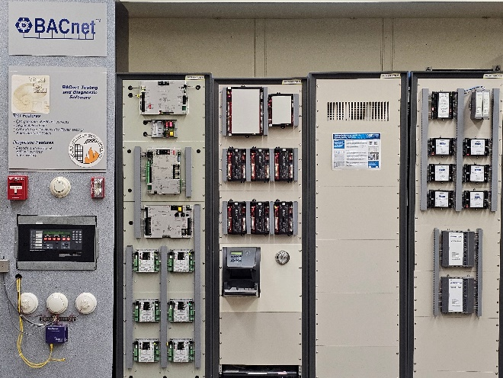
Figure 1 The VCBT control hardware.

The commercial control hardware connects to a simulated building, which can be developed according to the nature of the problem being investigated. For example, to investigate the reliability of building systems, a detailed simulation of HVAC system components can be used to investigate the faults in the HVAC system's operation, and a simulation that accurately represents fire physics can be used to investigate fire events.
In a real building, sensors measuring variables including temperature, pressure, and flow rate, are connected directly to the controllers, but in the VCBT, simulated sensor data are written to the controllers. The process of sending the signals to the controllers happens in one of two ways. When the controller input is a BACnet Analog Input, the simulation calculates the sensor reading, which is converted from the engineering units (i.e., °C, Pa, L/s) into a voltage that is presented to the controller’s input connector via a wired connection from a Data Acquisition (DAQ) system. Take airflow rate as an example. The airflow rate range is (0 to 1000) L/s in the simulation, but the BACnet Analog Input has a range of (0 to 5) V. So, the airflow rate in engineering units (EU) is converted from L/s to V using the following linear relationship:
$$m=\frac{(5-0)}{(1000-0)}=0.005,$$
$$V=m\left(EU\right).$$
This voltage is then generated by the DAQ and sent to the controller over a wire instead of over a network connection.
When the input is a BACnet Analog Value, it is sent to the controller over the network using a BACnet command instead of a wired connection.
The commercial controller's control logic generates command actions that control equipment, including valves, dampers, and fans. Like the input communication, these command actions are communicated in one of two ways. If the command is a BACnet Analog Output point, the command action is converted from the engineering unit (e.g., percent valve position) to a voltage that connects directly to the equipment. If the command is a BACnet Analog Value, the command action is sent to the equipment over the network as a BACnet command instead of a wired connection.

IBAL
The IBAL at NIST was designed and built for the purpose of exploring commercial HVAC control systems, including advanced AI-based approaches. The IBAL contains a system of chillers, air handling units (AHUs), variable air volume (VAV) terminal units, and ice-on-coil thermal energy storage. It also contains an AHU, called the outdoor air unit (OAU), that is used to generate repeatable weather conditions, and four zone emulators (Zones), which generate repeatable building loads.
The AHU-VAV system of the IBAL is configured as two circuits, each containing one AHU that serves two VAVs and two Zones. The equipment used in each circuit is identical, but the duct length and alignment relative to the AHU differ for each VAV and Zone. The cooling coils in the AHUs are connected to the same chilled water supply. The distribution piping system for the chilled water plant is configured as a primary-secondary system. Additional information about the IBAL is available on the website (NIST, 2026). A basic schematic of one circuit is shown in Figure 2. The key points controlled from the VCBT are highlighted; the return and exhaust dampers are set to fixed positions and are not controlled from the VCBT. T_{z1} and T_{z2} are the zone temperatures that the entire system is trying to control to the setpoint temperature of 24.4 °C.
AHU
Zone1
Zone2
VAV1
VAV2
Outdoor Air Damper (OAD)
Return Air Damper (RAD)
VAV Dampers
Exhaust Air Damper (EAD)
Cooling Coil Valve
T_{z1}
T_{z2}
Figure 2 Schematic flowchart of one circuit in the AHU-VAV system of the IBAL. The key control points are highlighted, and the supply and exhaust fans are shown.

The IBAL uses a hardware-in-the-loop approach that connects a virtual building model (VBM) to the hardware in the laboratory (Chen et al., 2022). The VBM serves a different purpose from the simulated building in the VCBT. In the VCBT, the simulated building provides all the information about the equipment and thermal zones in the building. In the IBAL, the VBM calculates the zone loads based on the simulated occupancy, plug loads, lighting loads, and solar loads, and the operation of the physical HVAC equipment.
The VBM contains an EnergyPlus (National Renewable Energy Laboratory (NREL), 2020) building model based on the DOE Medium Office Reference Building (U.S. Department of Energy, 2023) located in Atlanta, GA. The IBAL contains only four zones, so we selected four of the zones from the EnergyPlus model. The internal loads for the zones were set equal (occupancy, lighting, and plug loads), but their locations in the simulated office building were left unchanged, so the envelope loads differ for each zone. However, as will be shown later, the differences are minor.
Figure 3 is an illustration of the linkage between the simulated zones in the VBM and the IBAL zones. The temperature, T, humidity, ω, and airflow rate, $\dot{m}$, measured in the IBAL are input to the VBM model. Inside the VBM, these values are set to the thermal state of the air entering the simulated zone. The model then calculates the response of the zone to this thermal state, given the zone load. The resulting simulated zone temperature and humidity are sent from the VBM to the IBAL zone controllers as the temperature and humidity setpoints, T_{zone,sp} and ω_{zone,sp}, respectively. The actual zone temperature and humidity in the IBAL, T_{zone} and ω_{zone}, respectively, are also used by the zone controllers. The controllers calculate the control signals for the heater and humidifier, u_{heater} and u_{humidifier}, respectively, that will drive the IBAL so that T_{zone} à T_{zone,sp} and ω_{zone} àω_{zone,sp}. The IBAL operates on a 10 s control loop, while the communication with the VBM occurs every 1 min, so the IBAL has approximately 50 s to drive the system towards the setpoints.
The VBM also provides the temperature and humidity setpoints to the OAU from the EnergyPlus weather file. This process is simpler since there is no feedback from the IBAL to the VBM.

VBM
$$T, ω, \dot{m}$$
$$T_{zone}, ω_{zone}$$
PI Controllers
$$u_{heater}$$
$$u_{humidifier}$$
IBAL Zone
Simulated Zone
Control Signals
$$T_{zone,sp}, ω_{zone,sp}$$
Figure 3 Schematic illustrating the connection between the IBAL zones and simulated zones in the VBM.

Connection between the IBAL and VCBT
The IBAL and VCBT communicate using the BACnet communication protocol. The first step in connecting the IBAL and VCBT was to develop a points list that defines the BACnet information of all the sensor points required by the controllers in the VCBT and all the control points required by the IBAL. The full points list, containing all 54 points, is available at Reference (Pertzborn & Galler, 2025), while an abbreviated list is provided in Table 2. This table lists the device and a description of the point, and the BACnet label, type, and ID. The full list used in the test also includes BACnet address information (MAC address, IP address, etc.) and information specific to this experimental setup, such as the name that the IBAL uses for the point.
Table 2 Abbreviated points list.
Device | Description | Label | type | id
ahu1 | Cooling coil valve control signal | chw_valve_1 | AO | 1
ahu1 | Heating coil valve control signal | hw_valve_1 | AO | 3
ahu1 | Supply air temperature setpoint | sa_setpt_1 | AV | 23
ahu1 | Supply air temperature measurement | sa_temp_1 | AI | 6
ahu2 | Outdoor air damper control signal | oa_damper_1 | AO | 4
ahu2 | Cooling coil entering temperature | cce_temp_1 | AI | 2
ahu2 | Cooling coil leaving temperature | ccl_temp_1 | AI | 3
ahu2 | Heating coil entering temperature | hce_temp_1 | AI | 4
ahu2 | Heating coil leaving temperature | hcl_temp_1 | AI | 5
vav3 | VAV3 damper control signal | dmpr_pos | AV | 13
vav3 | Zone3 airflow setpoint | flow_sp | AV | 11
vav3 | Zone3 airflow measurement | flow_input | AI | 1
vav3 | Zone3 setpoint temperature | effective_cl_stpt | AV | 7
vav3 | Zone3 temperature measurement | zone_temp | AI | 4
vav3 | Zone3 supply air temperature | da_temp | AI | 2
vav3 | Zone3 airflow measurement | flow_1 | AV | 9
oa | Outdoor air temperature | oa_temperature_2 | AI | 2
oa | Outdoor air RH | oa_humidity_2 | AI | 1

The IBAL reads in the points list and uses the NIST-developed BACnet DLL (Galler, 2018) to read data from and write data to the VCBT controllers. The IBAL communicates with the VCBT every 10 s. The read data are the command actions, including supply air temperature setpoints and damper positions, that are used in the IBAL.
IBAL
VCBT
BACnet DLL
Sensor Data
Control Actions
Points list
Figure 4 Schematic showing the data flow between the IBAL and VCBT.

As previously mentioned, the VCBT communicates between its controllers and its simulation using wired connections to a DAQ or using BACnet. For the experiments in the present study, the IBAL stands in for the VCBT simulation, but it only communicates with the VCBT using BACnet; there are no wired connections between these facilities. During initial testing, we found that the airflow rate measurements, which are written as BACnet Analog Value objects via BACnet, were not correctly read by the controller. The airflow rate used by the control logic to determine the damper position was zero instead of the actual non-zero value. The cause of this issue is beyond the scope of this work, but we determined that if the airflow rate was sent as a wired input, the controller used the correct value for its calculations. It would be difficult to directly wire the airflow rate sensors to the VCBT, so instead, we developed a new software component that receives the airflow rate sensor output via BACnet, converts that reading to a voltage, and then uses the DAQ to send that voltage as a wired signal to the controller.
This study only examines the impact of the G36 sequences of operation as applied to the AHU-VAV system, so each test was conducted with the PG36 controls applied in the circuit of the IBAL with AHU1, and the G36 controls applied in the circuit with AHU2. Figure 4 is a picture of the AHU-VAV system and Figure 5 focuses on just the VAV section. The AHU outlets connect to a plenum, but this plenum is divided so that the AHU air streams do not mix, and the VAV ducts connect to the plenum as illustrated in Figure 6. The water side was set to deliver sufficient chilled water for the AHU-VAV system, so for all tests, the chiller setpoint was 5.6 °C (42 °F), and an additional load was applied to ensure that the chiller would not cycle. The chilled water temperature at the inlet to the cooling coils was approximately 5.8 °C (42.5 °F). In addition, because the IBAL uses electric heating coils, the minimum airflow was constrained to ensure safe operation.
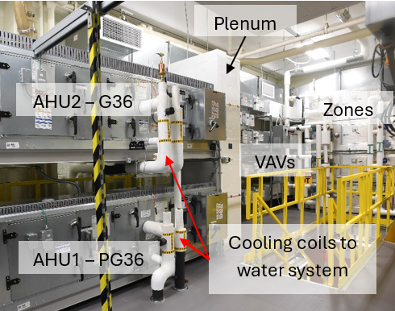
Figure 5 Overview of the two circuits in the IBAL.

AHU2
AHU1
VAV1
VAV2
VAV3
VAV4
Plenum
Plenum
Figure 6 Illustration of the AHU to VAV connection via a plenum.

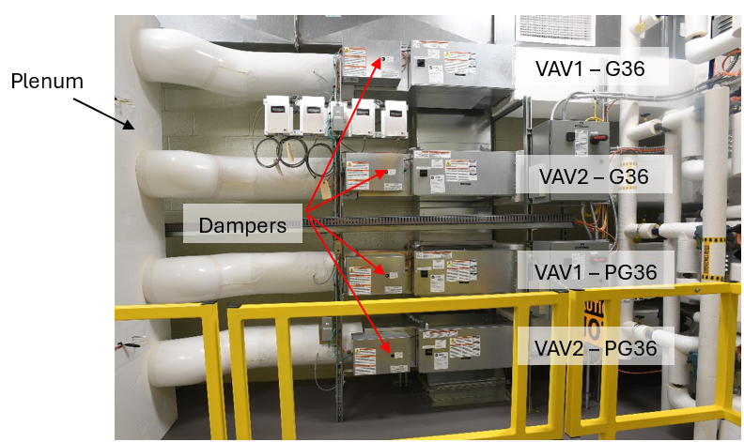
Figure 7 Layout of the four VAV terminal units.

In the IBAL, there are only two VAV dampers per AHU, and the duct lengths are relatively short. These two factors mean that in the IBAL the duct static pressure is very sensitive to both fan speed and damper position; this is unlikely to be an issue in a real commercial building. Static pressure is impacted by two controllers, if they are not tuned to work together, they will interfere with each other; this results in unstable oscillations. The solution to this problem is to separate the controlled-loop time scales of the dampers and fans. In the IBAL control system, this is achieved by tuning the fan speed controllers to respond more slowly than the damper position controllers.
When the VCBT was used to control both the fan speeds and the damper positions, this pressure sensitivity resulted in unstable oscillations. For a single AHU-VAV circuit, if the fan speed decreased to decrease the pressure, the dampers would open to increase the airflow, which would decrease the pressure below the setpoint. The fan speed would then increase to increase the pressure, the dampers would close to decrease the airflow, and the pressure would overshoot the setpoint. This process would repeat and result in sustained oscillations. While we have complete control of the IBAL control logic, we have limited control of the VCBT control logic, so we opted for a hybrid solution: the VCBT controls the damper positions and the IBAL controls the fan speeds. We then tuned the IBAL fan speed controllers to respond more slowly than the VCBT damper position controllers, thereby avoiding oscillations. The damper positions must be determined by the VCBT control logic because they are used in the VCBT as part of the trim and respond logic for the static pressure setpoint.
A major difference between the IBAL and a real building is the operation of the outdoor air, return air, and exhaust air dampers (OAD, RAD, and EAD, respectively). The IBAL has a supply fan and an exhaust fan, but the exhaust fan is not used. The key control variable is the amount of outdoor air, which is controlled through the coordinated action of the OAD, the RAD, and the EAD. Since there is no return fan, the amount of return air is solely dependent on the relative pressure drops between the return and exhaust branches of the duct system, and those pressure drops can be adjusted by modulating the RAD and EAD, respectively. We found that the pressure drop in the return branch of the duct system is generally greater than that in the exhaust, so if the RAD and EAD dampers are not positioned carefully, most of the air will exhaust out of the system. The amount of exhaust air is equal to the amount of outdoor air, so if the relative pressure drops in the return and exhaust are not correct, the outdoor air will not be correct (refer to Figure 2). Since three dampers control a single variable, the control system must be designed to prevent these three dampers from interfering with each other. In real buildings, the OAD and RAD dampers are often connected by a linkage, and, given the size of the duct system, the exhaust damper is not the key factor in the pressure drop, so this scenario does not arise. In the IBAL, we address the issue by using a PI loop to control the OAD, with the desired outdoor airflow rate as the setpoint, while limiting the movement of the RAD and EAD.
For example, the RAD is initially set 100 % open, and the EAD is set to about 6 % open. While these two dampers are fixed, the OAD modulates to bring the actual outdoor air to the setpoint. If the OAD is closed below 10 % or open above 68 % for more than 80 s, the RAD and/or EAD will step to new positions, at which point the counter will reset and the OAD will again be the only damper that moves. If the OAD is more than about 68 % open there is too little outdoor air, so the RAD will close by 6 % to increase the pressure drop in the return branch and the EAD will open by 3 % to reduce the pressure drop in the exhaust branch. This iterative process continues until the OAD is inside the 10 % to 68 % band, where it alone can control the outdoor airflow rate. In typical operation, the OAD is the sole controller for the outdoor airflow rate for the majority of a test. For tests with the VCBT, the OAD position is set by the VCBT control logic, but the RAD and EAD positions are set by the IBAL control logic.

Test configuration
Two tests were conducted to investigate the impacts of changing to a G36 sequence of operation from a standard PG36 approach, one using weather from a summer day and one using shoulder day weather in Atlanta, GA. The EnergyPlus building model was modified so that the occupancy profile and internal loads were the same for all zones; however, each zone is located in a different part of the simulated building, so the final zone loads were similar but not identical. In addition, the instantaneous loads in the IBAL are a function of the airflow rate, which is variable in the real equipment, and that led to some additional differences in the zone loads. Figure 6 shows the weather and loads generated in the IBAL for each test; the black lines are the setpoint, and the data points are the weather conditions that were generated. A direct expansion cooling coil with two compressors is used to cool and dehumidify the true outdoor air conditions at NIST to produce the required test conditions. When cooling and/or dehumidification are required, a trim heater reheats the air after the cooling coil as needed to maintain good temperature control. When heating is required, this heater simply heats the air. The brief spikes in the data for the summer day occurred when one of the compressors turned on or off; this has a greater impact on the humidity than the temperature.
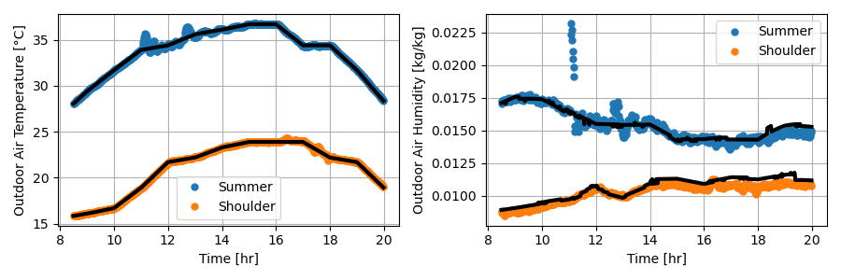
Figure 8 Outdoor air temperature and humidity for the summer and shoulder days for the two tests. The black lines are the setpoint, and the scatter data are the generated data.

Figure 7 shows the zone loads (both sensible and latent) generated by the IBAL for each zone and weather condition. The variability is due primarily to variability in the airflow rate, which, although not large in absolute terms (± 40 cfm), does lead to noticeable variations in the relatively small loads.
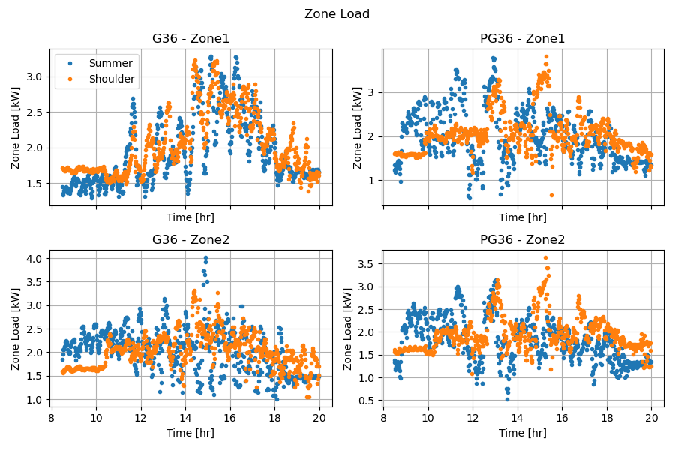
Figure 9 Zone loads for each zone and weather condition.

Both sequences were implemented using a proprietary commercial control system, so we had limited access to the control logic, and we mostly used the default settings. Table 2 lists the values that we changed and why we found it necessary to change them.

Table 3 Variables modified in the commercial control logic.
Variable | Setting | Explanation
VAV minimum airflow | 5.6 m³/min (200 cfm) | Minimum airflow set to ensure sufficient airflow for electric heating coil operation.
VAV maximum airflow | 21 m³/min (750 cfm) | Maximum airflow set to measured value with both dampers open and the fan speed at 60 Hz.
Zone temperature setpoint | 24.4 °C (76 °F) | Cooling setpoint based on simulated building loads.
Zone temperature deadband | ± 0.56 °C (1 °F) | The allowable deadband on the zone temperature. Set to reduce issues with damper oscillations.
Zone cooling and heating loop gain | 2 | Sets the sensitivity of the PI loop used to calculate the cooling (or heating) command. Adjusted higher because there are only two zones per AHU.
AHU static pressure range | 0.5 to 2.5 inH2O | Based on IBAL operations.

Results

Analysis methods/metrics
For this study, energy consumption is used as a proxy for cost for comparing the two algorithms; the specifics of the electrical tariff are unlikely to change the conclusions of a study based on a single day of operation. This study only implements the two control algorithms on the air side of the system, but the control of the AHU-VAV system also impacts the operation of the water system. For example, the G36 controller sets the supply air temperature lower than the PG36 controller, which would translate into a different operation of the water system (i.e., changes to the chilled water and secondary loop pressure setpoints). The results are presented then in terms of 1) the AHU-VAV system energy in isolation and 2) an estimate of the total system energy. For the former case, the energy consumption is just the sum of the fan energy from minute 510 (08:30) through 1200 (20:00). VCBT control of the IBAL began earlier, but waiting until minute 510 allows time for the equipment and control logic to reach a stable condition.
For the latter case, the calculation is more involved because the PG36 and G36 data are acquired simultaneously, and therefore, the chiller energy consumption is due to the operation of the two systems combined. In addition, there is a load added to the system to ensure that the chiller does not cycle during the test, so this load also needs to be accounted for in the calculations. The chiller energy assigned to a single circuit is represented by the following equation:
$E_{ch_est}=\frac{{\dot{Q}}_{coil}}{{\dot{Q}}_{pl}}E_{ch}$.
Where E_{ch} is the total energy consumption of the chiller. The fraction of that load that is due to a specific cooling coil (E_{ch_est}) is estimated by multiplying E_{ch} by the ratio of the load from the specific coil, ${\dot{Q}}_{coil}$, and the total load on the chiller, ${\dot{Q}}_{pl}$. The zone loads, ${\dot{Q}}_{z}$, are similar but not identical, and that can impact the energy required to cool each zone, so some of the results are normalized by dividing by the total zone load to allow for further comparison. The general equation for calculating the load in the water system is:
$$\dot{Q} \left[kW\right]={\dot{m}c}_{p}\left(T_{1}-T_{2}\right),$$
$$\dot{m}=ρ\dot{∀}.$$
Where $\dot{m}$ is the relevant mass flow rate in kg/s (calculated from the measured volumetric flow rate, $\dot{∀}$ [m³/s], and the density, $ρ$ [kg/m³]), c_{p} is the specific heat in kJ/kg-K, and T₁ and T₂ are the inlet and outlet fluid temperatures in °C, respectively. The water system uses a 30 % propylene glycol solution.
The total zone load is calculated as follows:
$${\dot{Q}}_{z} [kW]=\dot{m}\left(h_{1}-h_{2}\right).$$
Where h₁ and h₂ are the inlet and outlet enthalpies in kJ/kg and are functions of the measured temperature and humidity. The energy is calculated by summing the load or power over a time interval (e.g., hourly or total) and multiplying it by the timestep, dt, of 1 minute (0.017 hour).
$$Q [kWh]=dt\sum_{t=t0}^{tn}{{\dot{Q}}_{t}}.$$

The uncertainty calculations for each of these quantities are detailed in the Appendix.

Discussion
Table 3 is a summary of the energy consumption in the system. The ‘G36 savings’ column is the reduction in energy consumption for G36 relative to PG36, where a negative number indicates an increase in energy consumption. For all but one value, E_{ch_est} for the summer case, G36 uses less energy than PG36 even when uncertainty is considered. The G36 controller uses less fan energy because it uses a lower supply air temperature setpoint. For the summer day, this means that the G36 controller uses a larger portion of the chiller energy, but it uses less chiller energy for the shoulder day because it uses more outdoor air than the PG36 controller (see Figure 12 below).
Table 4 Summary results.
Weather | Summer |  |  | Shoulder
Controller | PG36 | G36 | G36 Savings | PG36 | G36 | G36 Savings
E_{fan} [kWh] | 7.1 ± 0.008 | 1.95 ± 0.008 | 73 % | 5.1 ± 0.0067 | 1.88 ± 0.008 | 63 %
E_{ch_est} [kWh] | 20.5 ± 0.04 | 22.4 ± 0.046 | -9 % | 13.5 ± 0.025 | 12.4 ± 0.024 | 8 %
E_{total} [kWh] | 27.5 ± 0.50 | 24.3 ± 0.06 | 12 % | 18.6 ± 0.26 | 14.3 ± 0.043 | 23 %
E_{total}/Q_{z,total} | 0.63 ± 0.01 | 0.53 ± 0.0061 | 16 % | 0.40 ± 0.005 | 0.31 ± 0.0034 | 25 %

The goal of both control systems is to maintain the zone temperature near setpoint, as shown in Figure 8. In general, both controllers keep the temperature near or below the cooling setpoint (24.4 °C (76 °F)) and above the heating setpoint (20 °C (68 °F)). The temperatures are lower in the earlier and later parts of the day, in part because the loads are lower, but also because of the minimum airflow restriction in the IBAL for safe operation of the electric heaters. This restriction means that there can be overcooling when the load is low. This minimum value will be investigated further in the future to see if it can be reduced. For the summer day, the G36 zones are cooler during the earlier hours relative to the PG36 zones because the SAT is lower.
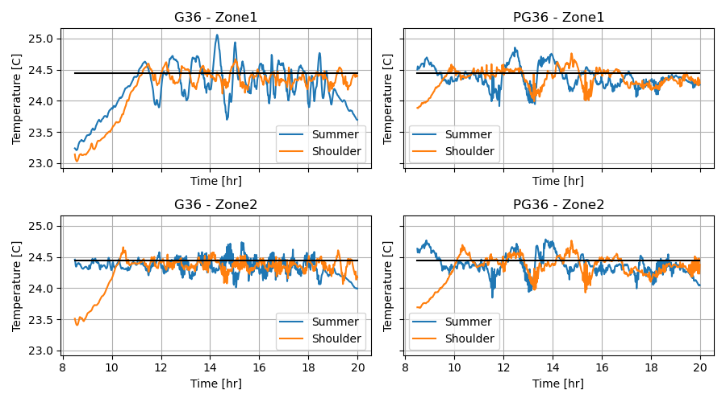
Figure 10 Zone temperatures. The setpoint is the line at 24.4 °C.

Figure 11 shows the SAT value and SAT setpoint (SP) for the two controllers and weather conditions. The cooling coil valves leak, so even when they are closed, some cooling occurs, most obviously in the shoulder day test. This may be the reason why the results are more similar between the two controllers for the shoulder day case than for the summer day case. The G36 SAT (T_{sat}) out of the box logic is based on the outdoor air temperature (T_{oa}) as follows:
$T_{sat}= \left\{\begin{aligned}18.3 °C T_{oa}<15.6 °C \\ 12.8 °C { T}_{oa}>21.1 °C \\ 12.8 °C to 18.3 °C otherwise\end{aligned}\right.$.
For the mode where T_{sat} can vary, the value is set based on trim and respond logic. The temperature thresholds used for mode selection are tuneable, but for this study, we left them at the default values. For the summer day, this meant that the setpoint was always 12.8 °C. For the shoulder day, T_{sat} varies as per the previously described logic, and for the G36 controller the setpoint is at the minimum value of 12.8 °C for much of the test. For the PG36 controller, the initial setpoint is typically 18.3 °C, decreasing only when demand increases using trim and respond logic, but generally staying around 18.3 °C. As shown in Figure 7, the zone loads are similar, so if the SAT is higher for the PG36 controller, the airflow must also be higher, as can be seen in Figure 12. For both the summer and shoulder days, the primary cause of the lower fan power consumption for the G36 cases is the lower airflow requirement because of the lower SAT setpoint.
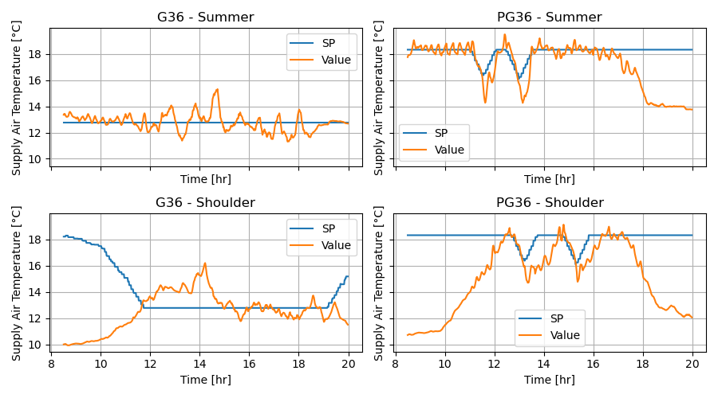
Figure 11 Supply air temperature.

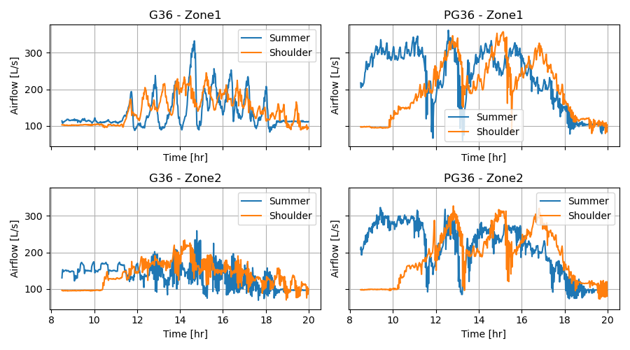
Figure 12 Airflow rate in each zone.

Figure 13 shows the static pressure setpoint and measurement for each of the AHU fans. The static pressure varies in response to the VAV damper positions – if the dampers are more closed, the pressure increases and the fan speed decreases to maintain the static pressure setpoint. The goal is for the fan speed to adjust to match the airflow demand. The noise in the airflow is due to the dampers being overactive, and, given the size of the system, that causes noticeable variation in the system.
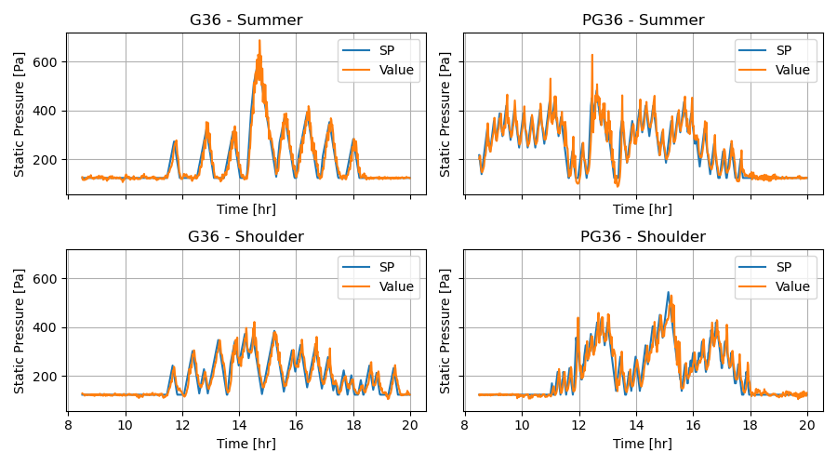
Figure 13 Static pressure used to control the supply fan speed.

Another difference in the logic between the two controllers is the control of the outdoor air damper. Figure 12 shows the outdoor and return airflow rates. The G36 controller took advantage of the cooler weather on the shoulder day, in which the temperature varied between 15 °C and 25 °C, and maximized the outdoor airflow. It is possible that the PG36 controller could operate in a similar manner, but it did not when using the default settings. For the summer day, the return airflow for the PG36 controller is higher than for the G36 controller, but that is because the overall airflow rate is higher.
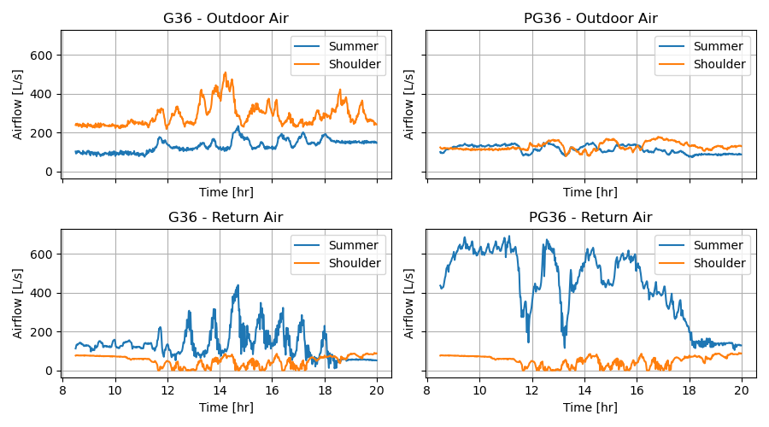
Figure 14 Outdoor and return airflow rates.

Summary
In this study, we demonstrated the energy savings realized relative to a typical commercial control sequence of operation by implementing Guideline 36 sequences of operation in an AHU-VAV system. We also presented a platform in which commercial implementations of sequences of operation can be quickly and repeatably tested on real equipment. Although the IBAL is a relatively small system, it can be used to gain an understanding of some of the nuances in the control logic. The VCBT also contains a building model, so although it was not used for these tests, the controllers can also be tested using a simulation with a larger building. This platform, therefore, allows the flexibility to probe different aspects of an implementation of control logic and determine what settings might need to be tuned.
This work identified areas for further refinement and improvements to address current limitations. Future work items include: 1) repeating the tests using the VCBT simulation instead of the IBAL to evaluate a building with more zones, 2) implementing G36 and PG36 controls in the water system for a full investigation of the G36 improvements, 3) testing a case with VAV reheat, and 4) investigating additional climate zones and zone loads. Additional testing may also be influenced by the needs of research collaborators.

References
ASHRAE. (2020). ASHRAE/ANSI Standard 135-2020: BACnet - A Data Communication Protocol for Building Automation and Control Networks.
ASHRAE. (2024). Guideline 36-2024 -- High-Performance Sequences of Operation for HVAC Systems.
Bushby, S. T., Galler, M. A., Milesi-Ferretti, N., & Park, C. (2009). The Virtual Cybernetic Building Testbed- A Building Emulator. ASHRAE Transactions. https://tsapps.nist.gov/publication/get_pdf.cfm?pub_id=902653
Castro, N. S., Schein, J., Park, C., Galler, M. A., & Bushby, S. T. (2003). NISTIR 6964: Results from simulation and laboratory testing of air handling unit and variable air volume box diagnostic tools. https://doi.org/10.6028/NIST.IR.6964
Chen, Z., Wen, J., Bushy, S. T., Calfa, C., Fu, Y., Grajewski, G., Li, Y., Lo, L. J., O’Neill, Z., Payne, W. V., & PeYang, Z. A. (2022). Development of a Hardware-in-the loop Testbed for Laboratory Performance Verification of Flexible Building Equipment in Typical Commercial Buildings,. ASHRAE Transactions - 2022 ASHRAE Annual Conference.
Cheng, H., Singla, R., & Paliaga, G. (2021). Final Project Report Demonstrating Scalable Operational Efficiency Through Optimized Controls Sequences and Plug-and-play Solutions.
Faulkner, C. A., Lutes, R., Huang, S., Zuo, W., & Vrabie, D. L. (2023). Simulation-based assessment of ASHRAE Guideline 36, considering energy performance, indoor air quality, and control stability. Building and Environment, 240. https://doi.org/10.1016/j.buildenv.2023.110371
Fernandez, N., Katipamula, S., Wang, W., Xie, Y., Zhao, M., & Corbin, C. (2017). Impacts of Commercial Building Controls on Energy Savings and Peak Load Reduction. https://buildingretuning.pnnl.gov/publications/PNNL-25985.pdf
Galler, M. A. (2018). TN 2023: Programmers guide to the BACnet communications DLL. https://doi.org/10.6028/NIST.TN.2023
Kiriu, R., & Stein, J. (2021, April). Medical office building thrives with advanced control sequences. ASHRAE Journal, 63. www.ashrae.org.
Lu, X., Fu, Y., Xu, S., Zhu, Q., O’Neill, Z., & Yang, Z. (2022). Comparison Study Of High-performance Rule-based HVAC Control With Deep Reinforcement Learning-based Control in A Multi-zone VAV System. International High Performance Buildings Conference. https://docs.lib.purdue.edu/ihpbc/407
Milesi-Ferretti, N., Galler, M. A., Bushby, S. T., & Sorra, J. (2019). TN2024: Commissioning ASHRAE high-performance sequences of operation for multiple-zone variable air volume air handling units. https://doi.org/10.6028/NIST.TN.2024
National Renewable Energy Laboratory (NREL). (2020). EnergyPlus v9.3.0. National Renewable Energy Laboratory (NREL).
NIST. (2026). IBAL Overview. Https://Www.Nist.Gov/El/Energy-and-Environment-Division-73200/Intelligent-Buildings-Agents-Project/Ibal-Overview. https://www.nist.gov/el/energy-and-environment-division-73200/intelligent-buildings-agents-project/ibal-overview.
Pertzborn, A. J. (2019). TN2037: Measurement uncertainty of the air system in the intelligent building agents laboratory. https://doi.org/10.6028/NIST.TN.2037
Pertzborn, A. J., & Galler, M. A. (2025). Data in support of the article: Experimental Comparison of Commercial Implementations of Guideline 36 and Legacy Controller. https://doi.org/doi:10.18434/mds2-3987
Taylor, B. N., & Kuyatt, C. E. (1994). NIST Technical Note 1297: Guidelines for Evaluating and Expressing the Uncertainty of NIST Measurement Results.
Taylor Engineers. (2015). Case Study: Advanced HVAC Controls-555 County Center. https://www.taylorengineers.com/case-studies
U.S. Department of Energy. (2020). About the Commercial Buildings Integration Program. https://www.energy.gov/eere/buildings/about-commercial-buildings-integration-program#:~:text=buildings%20is%20enormous.-,On%20average%2C%2030%25%20of%20the%20energy%20used%20in%20commercial%20buildings,gas%20emissions%2C%20of%20commercial%20buildings
U.S. Department of Energy. (2023). Commercial Prototype Building Models. Https://Www.Energycodes.Gov/Prototype-Building-Models.
Yoon, Y., Amasyali, K., Li, Y., Im, P., Bae, Y., Liu, Y., & Zandi, H. (2024). Energy performance evaluation of the ASHRAE Guideline 36 control and reinforcement learning–based control using field measurements. Energy and Buildings, 325. https://doi.org/10.1016/j.enbuild.2024.115005
Zhang, K., Blum, D. H., Grahovac, M., Hu, J., Granderson, J., & Wetter, M. (2020). Development and verification of control sequences for single-zone variable air volume system based on ASHRAE Guideline 36. The American Modelica Conference, 81–90.

Appendix
Table 4 lists the measurement uncertainty for the sensors used in calculations. For the chiller and fan power, the uncertainty is applied to the voltage measurement (V) based on the uncertainty in the data acquisition measurement and the manufacturer’s uncertainty of the power measurement. That uncertainty is converted from V to kW. For the fans, the uncertainty is a function of the fan speed, f, in Hz (Pertzborn, 2019).
Table 5 Measurement uncertainty of sensors used to derive other quantities.
Measurement |  | Uncertainty | Used to calculate | Variable in Equation
Chiller power | ch2_power | $$± \sqrt{{\left(0.00246\right)}^{2}+{\left(0.0047*V\right)}^{2}}*6.693 \left[\frac{kW}{V}\right]$$ | E_{ch}, E_{ch_est} | E_{ch}, E_{ch_est}
AHU1 fan power | ahu1_fan_power | $$± \frac{1}{0.132 -0.00164 f}$$ | E_{fan} | E_{fan}
AHU2 fan power | ahu2_fan_power | $$± \frac{1}{0.0755 -0.00074 f}$$ | E_{fan} | E_{fan}
Coil inlet temperature | pump3_out_rtd | ± 0.1 °C | $${\dot{Q}}_{coil,1}$$ | T₂
Coil outlet temperature | ahu1_cc_out_rtd | ± 0.1 °C | $${\dot{Q}}_{coil,1}$$ | T₁
Flow rate | ahu1_f_cc | ± 0.25 % of reading | $${\dot{Q}}_{coil,1}$$ | $$\dot{∀}$$
Coil inlet temperature | pump3_out_rtd | ± 0.1 °C | $${\dot{Q}}_{coil,2}$$ | T₂
Coil outlet temperature | ahu2_cc_out_rtd | ± 0.1 °C | $${\dot{Q}}_{coil,2}$$ | T₁
Flow rate | ahu2_f_cc_mag | ± 0.25 % of reading | $${\dot{Q}}_{coil,2}$$ | $$\dot{∀}$$
Inlet temperature | ch1_e_in_rtd | ± 0.1 °C | $${\dot{Q}}_{pl}$$ | T₂
Outlet temperature | pl_out_rtd | ± 0.11 °C | $${\dot{Q}}_{pl}$$ | T₁
Flow rate | pl_f | ± 0.25 % of reading | $${\dot{Q}}_{pl}$$ | $$\dot{∀}$$
Inlet temperature | vav1_out_rtd | ± 0.11 °C | $${\dot{Q}}_{z1,G36}$$ | h₂(T₂,ω₂)
Inlet humidity | ahu2_rh_down | 0.89 % RH | $${\dot{Q}}_{z1,G36}$$ | h₂(T₂,ω₂)
Outlet temperature | zs1_out_rtd | ± 0.1 °C | $${\dot{Q}}_{z1,G36}$$ | h₁(T₁,ω₁)
Outlet humidity | zs1_rh | 1.41 % RH | $${\dot{Q}}_{z1,G36}$$ | h₁(T₁,ω₁)
Flow rate | vav1_f | ± 10 % of reading | $${\dot{Q}}_{z1,G36}$$ | $$\dot{∀}$$
Inlet temperature | vav2_out_rtd | ± 0.11 °C | $${\dot{Q}}_{z2,G36}$$ | h₂(T₂,ω₂)
Inlet humidity | ahu2_rh_down | ± 0.89 % RH | $${\dot{Q}}_{z2,G36}$$ | h₂(T₂,ω₂)
Outlet temperature | zs2_out_rtd | ± 0.1 °C | $${\dot{Q}}_{z2,G36}$$ | h₁(T₁,ω₁)
Outlet humidity | zs2_rh | ± 1.05 % RH | $${\dot{Q}}_{z2,G36}$$ | h₁(T₁,ω₁)
Flow rate | vav2_f | ± 10 % of reading | $${\dot{Q}}_{z2,G36}$$ | $$\dot{∀}$$
Inlet temperature | vav3_out_rtd | ± 0.11 °C | $${\dot{Q}}_{z1,PG36}$$ | h₂(T₂,ω₂)
Inlet humidity | ahu1_rh_down | ± 0.72 % RH | $${\dot{Q}}_{z1,PG36}$$ | h₂(T₂,ω₂)
Outlet temperature | zs3_out_rtd | ± 0.1 °C | $${\dot{Q}}_{z1,PG36}$$ | h₁(T₁,ω₁)
Outlet humidity | zs3_rh | ± 0.69 % RH | $${\dot{Q}}_{z1,PG36}$$ | h₁(T₁,ω₁)
Flow rate | vav3_f | ± 10 % of reading | $${\dot{Q}}_{z1,PG36}$$ | $$\dot{∀}$$
Inlet temperature | vav4_out_rtd | ± 0.11 °C | $${\dot{Q}}_{z2,PG36}$$ | h₂(T₂,ω₂)
Inlet humidity | ahu1_rh_down | ± 0.72 % RH | $${\dot{Q}}_{z2,PG36}$$ | h₂(T₂,ω₂)
Outlet temperature | zs4_out_rtd | ± 0.1 °C | $${\dot{Q}}_{z2,PG36}$$ | h₁(T₁,ω₁)
Outlet humidity | zs4_rh | ± 0.54 % RH | $${\dot{Q}}_{z2,PG36}$$ | h₁(T₁,ω₁)
Flow rate | vav4_f | ± 10 % of reading | $${\dot{Q}}_{z2,PG36}$$ | $$\dot{∀}$$

The uncertainty calculations of the derived quantities are defined by the following equations; for full details of an uncertainty analysis, see (Taylor & Kuyatt, 1994). The summed uncertainty on the summed energy consumption is the sum of the squared errors:
$u_{sum}=\sqrt{\sum_{t= t0}^{tn}{u_{t}^{2}}}$.

Recall the equation for heat transfer in the water system, where c_{p} is specific heat and $\dot{m}$ is the mass flow rate calculated from the measured volumetric flow rate, $\dot{∀,}$multiplied by the density, $ρ$. The fluid properties are calculated for a 30 % propylene glycol brine, and, although their uncertainty is included in the uncertainty calculations, the contribution of that uncertainty is negligible.
$$\dot{Q} \left[kW\right]={\dot{m}c}_{p}\left(T_{1}-T_{2}\right)$$
$$\dot{m}=ρ\dot{∀}$$
$$u_{{\dot{Q}}_{coil}}=\sqrt{{\left(\frac{∂\dot{Q}}{∂\dot{∀}}\right)}^{2}u_{\dot{∀}}^{2}+{\left(\frac{∂\dot{Q}}{∂T_{1}}\right)}^{2}u_{T_{1}}^{2}+{\left(\frac{∂\dot{Q}}{∂T_{2}}\right)}^{2}u_{T_{2}}^{2}+{\left(\frac{∂\dot{Q}}{∂ρ}\right)}^{2}u_{ρ}^{2}+{\left(\frac{∂\dot{Q}}{∂c_{p}}\right)}^{2}u_{c_{p}}^{2}}$$

Recall the equation for the AHU-VAV system, where the enthalpies h are calculated from the measured temperature and humidity (φ) values.
$${\dot{Q}}_{z} [kW]=\dot{m}\left(h_{1}-h_{2}\right).$$

$$u_{{\dot{Q}}_{z}}=\sqrt{{\left(\frac{∂\dot{Q}}{∂\dot{∀}}\right)}^{2}u_{\dot{∀}}^{2}+{\left(\frac{∂\dot{Q}}{∂T_{1}}\right)}^{2}u_{T_{1}}^{2}+{\left(\frac{∂\dot{Q}}{∂T_{2}}\right)}^{2}u_{T_{2}}^{2}+{\left(\frac{∂\dot{Q}}{∂ρ}\right)}^{2}u_{ρ}^{2}+{\left(\frac{∂\dot{Q}}{∂∅_{1}}\right)}^{2}u_{∅_{1}}^{2}+{\left(\frac{∂\dot{Q}}{∂∅_{2}}\right)}^{2}u_{∅_{2}}^{2}}$$
The loads are used to calculate the estimated chiller energy, so their uncertainties feed into the uncertainty of that quantity.
$$E_{ch_est}=\frac{{\dot{Q}}_{coil}}{{\dot{Q}}_{pl}}E_{ch}$$
$$u_{E_{ch_est}}=\sqrt{{\left(\frac{∂E_{ch_est}}{∂{\dot{Q}}_{coil}}\right)}^{2}u_{{\dot{Q}}_{coil}}^{2}+{\left(\frac{∂E_{ch_est}}{∂{\dot{Q}}_{pl}}\right)}^{2}u_{{\dot{Q}}_{pl}}^{2}+{\left(\frac{∂E_{ch_est}}{∂E_{ch}}\right)}^{2}u_{E_{ch}}^{2}}$$
Finally, the normalized total energy and its uncertainty are calculated using these equations.
$$E_{norm}= \frac{E_{total}}{{\dot{Q}}_{z,total}}=\frac{E_{ch_est}+E_{fan}}{{\dot{Q}}_{z,1}+{\dot{Q}}_{z,2}}$$
$$u_{E_{norm}}=\sqrt{{\left(\frac{∂E_{norm}}{∂E_{ch_est}}\right)}^{2}u_{E_{ch_est}}^{2}+{\left(\frac{∂E_{norm}}{∂E_{fan}}\right)}^{2}u_{E_{fan}}^{2}+{\left(\frac{∂E_{norm}}{∂{\dot{Q}}_{z,1}}\right)}^{2}u_{{\dot{Q}}_{z,1}}^{2}+{\left(\frac{∂E_{norm}}{∂{\dot{Q}}_{z,2}}\right)}^{2}u_{{\dot{Q}}_{z,2}}^{2}}$$

