Energy Recovery Ventilator Free Cooling Strategies Across the U.S.

Abstract
High-performance buildings are gaining prevalence to combat grid load and save utility costs for residential customers. ERVs could save energy by enabling bypass mode when outdoor conditions are lower than indoor conditions during the cooling season. During these times, bypass mode reduces thermal loads added to the building, reducing heat pump operation. We compared the normal operation of an ERV to two forms of bypass control, temperature-based and enthalpy-based, using a tuned TRNSYS model of NIST’s Residential Test Facility. Simulations were performed for 15 cities in the United States. Temperature-based control saves between 1 % and 4.7 % of HVAC energy in hot/dry climates and marine climates. Enthalpy-based control limits latent loads but diminishes free-cooling potential, with between -1.5 % and 1.7 % of HVAC energy saved. The temperature-based control reduced PMVs beyond ± 0.5 by at least 3 % in hot-and-dry climates and up to 60 % in marine climates. The enthalpy-based control resulted in PMVs beyond ± 0.5 from 0.3 % more and up to 40 % less time for marine climates. Our temperature-based control provides more ventilation, improves thermal comfort across all climates, and saves energy in hot, dry, or marine climate zones.

Nomenclature
$f$ ratio
$h$ convection heat transfer coefficient (W/(m²·K))
$I$ thermal resistance ((m²·K)/W)
$\dot{m}$ mass flow rate (kg/s)
$M$ metabolic rate of heat production (W/m²)
$p$ pressure (Pa)
$P$ power (W)
$t$ temperature (°C)
$V$ velocity (m/s)
$W$ work rate (W/m²)
$ε$ effectiveness

Abbreviations
AC Alternating Current
AHRI Air-Conditioning, Heating, and Refrigeration Institute
ASHP Air-Source Heat Pump
CFM Cubic Feet per Minute
COP Coefficient of Performance
DC Direct Current
DHW Domestic Hot Water
EIA Energy Information Administration
ERV Energy Recovery Ventilator
HPWH Heat Pump Water Heater
HRV Heat Recovery Ventilator
HVAC Heating, Ventilation, and Air Conditioning
IECC International Energy Conservation Code
NIST National Institute of Standards and Technology
NLR National Laboratory of the Rockies
NSRDB National Solar Radiation Data Base
PEX Cross-linked polyethylene (tubing)
PMV Predicted Mean Vote
PPD Predicted Percentage of Dissatisfied
PV Photovoltaic
RTF Residential Test Facility
SHW Solar Hot Water
SI Supplemental Information
TMY3 Typical Meteorological Year 3
TRNSYS Transient System Simulation Tool

Background
Over eight million customers in the United States were affected by major disturbances and unusual occurrences in their electricity supply in 2023 (Electric Power Monthly - U.S. Energy Information Administration (EIA)). In 2025, the United States Department of Energy released its report titled, “Evaluating the Reliability and Security of the United States Electric Grid”, which stated that the present-day electric grid is not equipped to handle a predicted increase in electricity demand, especially as over 100 GW of generation is planned to be retired in the next five years (U.S. Department of Energy 2025). Residential buildings are responsible for 38 % of the electricity and 19 % of total energy use in the United States (U.S. energy facts explained - consumption and production - U.S. Energy Information Administration (EIA)). At the same time, residential electricity costs in the United States have on average increased by 41 % in the last ten years, slightly outstripping the average inflation rate of 38 % during that period (CPI Inflation Calculator; Electric Power Monthly - U.S. Energy Information Administration (EIA)). Reducing residential building energy use can both alleviate the financial burden on residential customers while also assisting in reducing grid load, leading to a more secure and reliable electrical grid.
With the need to reduce residential building electricity usage, high-performance buildings (including residential) have seen a significant increase in construction, at twice the rate in 2020 compared to 2018 (Zero Energy-Verified Commercial Buildings More Than Double Since 2018 - New Buildings Institute). These low-load residential buildings reduce electric grid demand with a robust building envelope, onsite electricity generation, and high-performance appliances such as heating ventilation and air conditioning (HVAC) equipment, and domestic hot water (DHW) equipment.
The robust building envelope significantly reduces the infiltration rate in the building, requiring mechanical ventilation to maintain indoor air quality for occupants per ASHRAE Standard 62.2 (Hunter Fanney et al. 2017; ASHRAE Standards 62.1 & 62.2). Previous work has shown the clear benefits of utilizing either a heat recovery ventilator (HRV) or energy recovery ventilator (ERV) to reduce the thermal loads added to the building relative to directly ventilating a building with fresh air (Ng and Payne 2016; Wu and Skye 2018; Ribé et al. 2019; Li et al. 2021). The HRV is best suited for dry climates (Wu and Skye 2018). In more mixed-moist climates, an HRV can save up to 36 % of HVAC energy in the heating season but sees a 5 % penalty due to the added loads in warmer months when a bypass mode would be beneficial. An ERV helps better maintain the moisture level in the building and reduces latent loads added to the building from the humid outdoor conditions or moisture removed from the building in drier conditions (Rasouli et al. 2010). An ERV can save up to 20 % of the HVAC-related space conditioning energy (Wu et al. 2018; Ribé et al. 2019; Li et al. 2021). This equipment offers a clear benefit for reduced building thermal loads and, therefore, is an integral part of reducing HVAC energy use in a low-load home.
However, in the evenings during swing seasons when cooling is still needed, the outdoor temperature frequently drifts below the indoor temperature. When an ERV is installed, this condition results in an increased thermal load to the building and wasted energy for further space conditioning (Rasouli et al. 2010). The main solution for this problem is to implement a bypass mode to cool the building using the outdoor air without any energy exchange through the ERV. A few studies have been performed to understand the potential energy savings of utilizing bypass mode, each focusing on a few climate zones (Lee et al. 2013; Zhang and Fung 2014; Guillén-Lambea et al. 2017; Kim et al. 2019; Shore 2025). The benefits are clear with up to 20 % energy savings in cooling mode compared to constant ERV operation. Energy savings in cooling mode could be increased further, up to 30 % in cold climates like Toronto by tripling the ventilation airflow rate with a dual core ERV (Zhang and Fung 2014). It should be noted that the total energy savings were about 100 kWh due to the high frequency of cool and dry air in the climate zone in this case study. Thermal comfort can easily be accomplished with an ERV, but meeting requirements depends on operating conditions and climate (Cho et al. 2023).
There are two main bypass control strategies: based on temperature or enthalpy. In either case, bypass mode is enabled if the outdoor conditions are less than the building setpoint while the return air conditions are greater than the building setpoint. There is potential for both strategies to yield savings, but they have only been evaluated for a few climate zones (Rasouli et al. 2010; Kim et al. 2019).
In this work, a validated Transient System Simulation Tool (TRNSYS) model of the National Institute of Standards and Technology’s (NIST) Residential Test Facility (RTF), a low-load home, is utilized to compare both temperature-informed and enthalpy-based bypass control strategies relative to a baseline no-bypass condition. These simulations will help understand both the electricity saving potential and thermal comfort impacts of using these control strategies across 14 climate zones in the United States.

NIST’s RTF
NIST’s RTF is a 4-bedroom, 3-bathroom high-performance residential house with 251 m² of living space on the first and second floors and a 140 m² conditioned basement (pictured in Figure 1). The building utilizes a photovoltaic array on the roof for site electricity generation and is reconfigurable, particularly the water heating and HVAC systems. Frequently, those systems utilize active solar thermal water pre-heating with a heat pump water heater and a multi-stage air-source heat pump (ASHP) for space conditioning. For a number of long-term tests, a virtual family was emulated by a control system to create a repeatable occupant load schedule that included appliance usage, water draws, sensible and latent heat gains, and lighting usage (Omar and Bushby). The building envelope exceeds International Energy Conservation Code (IECC) standards and based on blower door tests has an infiltration rate of 0.63 h⁻¹ at 50 Pa. Details of the design and equipment beyond what is described in this work can be found in (Fanney et al. 2015).
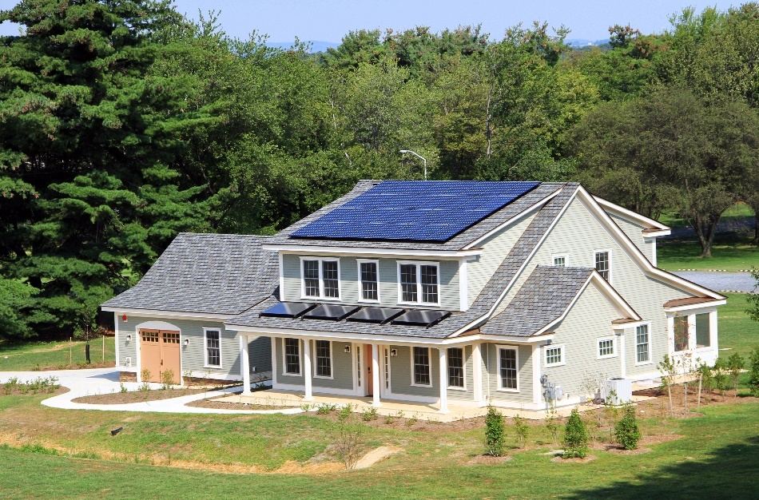
Figure 1. NIST’s Residential Test Facility.

HVAC
A two-stage ASHP with emergency electric heating and a dedicated dehumidifier is the main HVAC system providing heating and cooling for the house. Its rated full load cooling capacity is 7620 W with a cooling coefficient of performance (COP) of 3.82 under AHRI test A (AHRI 210/240 (I-P): Performance Rating of Unitary Air-conditioning and Air-source Heat Pump Equipment | AHRI 2024). It has a rated heating capacity of 7796 W with a COP of 3.52 based on AHRI test H1 (AHRI 210/240 (I-P): Performance Rating of Unitary Air-conditioning and Air-source Heat Pump Equipment | AHRI 2024). The heat pump’s operation is primarily dependent on the temperature measured in the house’s living room. The cooling setpoint was 23.9 °C (75 °F), the heating setpoint was 21.1 °C (70 °F), and the deadbands were 0.3 °C (0.5 °F) for first stage cooling and 0.6 °C (1.0 °F) for second stage cooling. The third stage electric heat deadband was 0.8 °C (1.5 °F). The dehumidifier was enabled when the relative humidity exceeded 53 % and was disabled once the relative humidity was below 47 %. Figure 2 shows the cooling setpoints and deadbands for this control scheme along with when each stage is enabled. Note that the hardware is controlled in degrees Fahrenheit so any difference in value shown in Figure 2 and the values above is due to rounding.
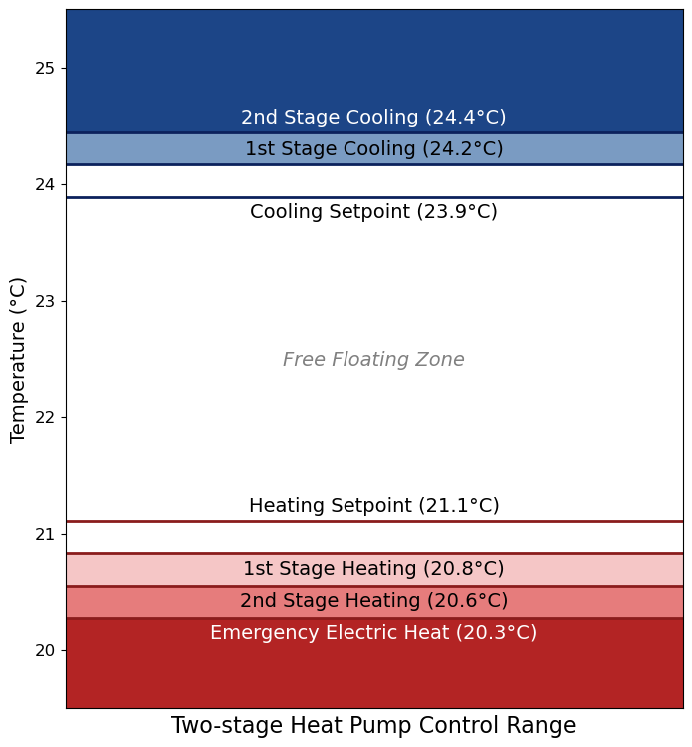
Figure 2. Operational temperature points for the two-stage heat pump with electrical resistance emergency heat.
Due to the low infiltration rate, the building requires mechanical ventilation to maintain indoor environmental health. Upon construction, the ventilation was supplied in the form of a Heat Recovery Ventilator (HRV) (Ng and Payne 2016). Ng & Payne showed that the HRV saved 5 % of annual energy compared to ventilation without energy recovery. Since then, the HRV was replaced with a new mechanical ventilation system with the option to install an HRV or ERV core. This newer system’s ERV core offers a higher sensible effectiveness of 0.87 compared to 0.74 of the previous HRV at a volumetric flow of 170 m³ h⁻¹. The ERV also provides the added benefit of moisture transfer to reduce latent loads in the building.
A schematic of the ASHP and ERV is shown in Figure 3. Note that this diagram is not to scale, but locations are correct by floor. The ERV, with ducting independent from the ASHP, supplies air to the bedrooms on the second floor as well as a region between the dining room and kitchen. The return/exhaust air is pulled from the three bathrooms. The ASHP supplies air to the basement, 1st floor, and 2nd floor. The schematic does not show the entire supply and return ductwork as multiple diffusers are in each room. The ASHP’s return air comes from the 1st and 2nd floors.
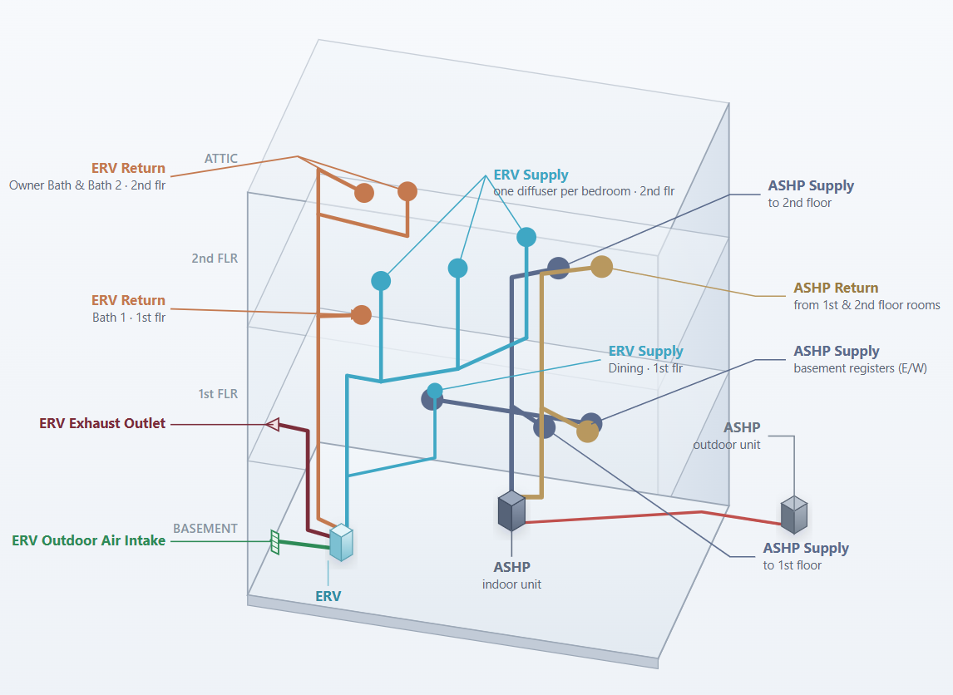
Figure 3. Schematic of the ERV and ASHP showing where supply and return air is directed in the RTF. Diagram developed as a Scalable Vector Graphic (SVG) with the assistance of Anthropic Claude Opus 4.8 and Google Gemini 3.1 Pro.

DHW
Two 2.2 m² flat plate solar thermal collectors were utilized on the 18.4° porch roof of the building as a solar hot water (SHW) system. A glycol-water solution was pumped through the collectors to preheat the water and then a heat exchanger to transfer heat to a 303 L SHW tank. The tank fed into a heat pump water heater (HPWH). The HPWH would heat the preheated water to its setpoint if necessary. The HPWH includes a backup electrical heater if necessary. The water from the HPWH was then sent through the house via a home-run plumbing system with PEX tubing.

Site Generation
The building has thirty-two 320 W mono-crystalline silicon photovoltaic modules installed in two strings of sixteen modules. The array is rated for 10.24 kW of power output. The array is mounted on the main roof which has an 18.4 ° pitch resulting in a total array efficiency of approximately 19 %. Each string feeds into a maximum-power-point controlled inverter with a 95.5 % inverter efficiency to convert the solar-generated DC power into AC power. The generation was either utilized by the building or sent to the grid if the site had a surplus of electricity.

Methods
The bypass control strategies were studied using a validated TRNSYS model of the RTF across 14 climate zones in the United States.

The RTF Energy Model
The TRNSYS model is based on field measurements of NIST’s RTF tuned across yearlong studies during the 2013-2014 testing period, with the 12-month data found at Healy et al. 2017. The model has gone through multiple iterations and adjustments and has been validated along each step (Leyde 2014; Balke 2016; Ng and Payne 2016; Balke et al. 2017; Wu et al. 2018). The model was further adjusted and validated using shorter measurement periods in 2024 to update the air-source heat pump performance curves and characterize the ERV that was installed in 2019 (Shore 2025). The model parameters are summarized in Table 1. This model is simulated in one-minute time steps to accurately reproduce the ERV control strategy.
Table 1. RTF TRNSYS Model Parameters
Type | Parameter | Value | Units
Multizone Building  Type 56 | Living Area | 251 | m²
Multizone Building  Type 56 | Basement Area | 135 | m²
Infiltration  Type 932 | Effective Leakage Area | 244 | cm²
PV array  Type 194b | Model area | 1.472 | m²
PV array  Type 194b | Module Maximum Power | 320 | W
PV array  Type 194b | Array slope | 18.4 | °
PV array  Type 194b | Inverter Efficiency | 95.5 | %
ASHP First and Second Stage  Type 922 | Total air flow rate – Low speed | 600 | CFM
ASHP First and Second Stage  Type 922 | Rated Total Cooling Capacity – Low Speed | 5425 | W
ASHP First and Second Stage  Type 922 | Rated Sensible Cooling Capacity – Low Speed | 4155 | W
ASHP First and Second Stage  Type 922 | Rated Cooling Power – Low Speed | 1351 | W
ASHP First and Second Stage  Type 922 | Rated Heating Capacity – Low Speed | 7034 | W
ASHP First and Second Stage  Type 922 | Rated Heating Power – Low Speed | 1379 | W
ASHP First and Second Stage  Type 922 | Total air flow rate – High Speed | 784 | CFM
ASHP First and Second Stage  Type 922 | Rated Total Cooling Capacity – High Speed | 7067 | W
ASHP First and Second Stage  Type 922 | Rated Sensible Cooling Capacity – High Speed | 5360 | W
ASHP First and Second Stage  Type 922 | Rated Cooling Power – High Speed | 2420 | W
ASHP First and Second Stage  Type 922 | Rated Heating Capacity – High Speed | 8041 | W
ASHP First and Second Stage  Type 922 | Rated Heating Power – High Speed | 2126 | W
ASHP Dehumidification  Type 922 | Total air flow rate – Low speed | 497 | CFM
ASHP Dehumidification  Type 922 | Rated Total Cooling Capacity – Low Speed | 3006 | W
ASHP Dehumidification  Type 922 | Rated Sensible Cooling Capacity – Low Speed | 286 | W
ASHP Dehumidification  Type 922 | Rated Cooling Power – Low Speed | 1531 | W
ASHP Dehumidification  Type 922 | Total air flow rate – High speed | 549 | CFM
ASHP Dehumidification  Type 922 | Rated Total Cooling Capacity – High Speed | 4765 | W
ASHP Dehumidification  Type 922 | Rated Sensible Cooling Capacity – High Speed | 1653 | W
ASHP Dehumidification  Type 922 | Rated Cooling Power – High Speed | 423 | W
ASHP 3rd Stage Heating  Type 922 | Rated Air Flowrate | 992 | CFM
ASHP 3rd Stage Heating  Type 922 | Rated Heating Capacity | 5056 | W
ASHP 3rd Stage Heating  Type 922 | Rated Heat Power | 2056 | W
Solar Thermal Collector  Type 1b | Collector Area | 2.2 | m²
Solar Thermal Collector  Type 1b | Intercept Efficiency | 0.744 | -
Solar Thermal Collector  Type 1b | 1st Order Efficiency Coefficient | 3.6707 | W/(m²·K)
Solar Thermal Collector  Type 1b | 2nd Order Efficiency Coefficient | 0.00543 | W/(m²·K²)
Solar Storage Tank  Type 534 | Volume | 0.295 | m³
Solar Storage Tank  Type 534 | Height | 1.594 | m
Solar Storage Tank  Type 534 | Loss coefficient | 1.00 | W/(m²·K)
Heat exchanger  Type 91 | Heat exchanger eﬀectiveness | 0.44 | -
HPWH  Type 938 | Blower Power | 5 | W
HPWH  Type 938 | Total air flow rate | 751 | m³/h
HPWH  Type 938 | Rated heat rejection | 2025 | W
HPWH  Type 938 | Rated compressor power | 794 | W
Electric heater  Type 1226 | Heating Capacity | 3600 | W
Electric heater  Type 1226 | Thermal efficiency | 1.0 | -
HPWH Tank  Type 534 | Volume | 0.1893 | m³
HPWH Tank  Type 534 | Height | 1.143 | m
HPWH Tank  Type 534 | Loss coefficient | 0.6 | W/(m²·K)

Type 56 is used to model the house, and it is divided into four zones for each level of the building: the basement (Zone 1), first floor of living space (Zone 2), second floor of living space (Zone 3), and passively conditioned attic space houses the PV inverters (Zone 4). Two Type 194b are utilized to generate the inverter thermal load in the attic and site electricity. Each inverter represents one of the strings of the array. Type 932 is used to model the infiltration in the building.
The ASHP is modeled using three separate Type 922 air-source heat pump models. The first one models the first and second stage heating and cooling, the second models the heat pumps’ dedicated dehumidifier, and the third model describes the electrical resistance third stage heating. A performance map was created for each type based on measured data at the facility. A separate custom type was utilized to model the defrost cycle when the outdoor temperature was very low. Further details on this custom type can be found in (Balke et al. 2017; Wu et al. 2018). The temperature setpoints, temperature deadbands, and dehumidification on and off percentages were set for the modeling the same as described above for the typical emulation setup used at the RTF. The model’s thermostat is informed by temperature from the first floor of the building.
The DHW is modeled using Types 1b, 534, 91, 114, and 31 for the solar collectors, storage tank, heat exchanger, pumps, and pipes, respectively. The HPWH system was modeled using Types 938, 534, 1226 for the heat pump water heater, storage tank, and auxiliary electrical heater.
The ERV is modeled using Type 667 along with Type 111b fans and a custom ERV control type. The sensible and latent effectiveness was fit following equation 1:
$$\begin{aligned}ε=ε_{0}\left[c_{0}+ c_{1}\frac{\dot{m}}{\dot{m_{0}}}+c_{2}{\left(\frac{\dot{m}}{\dot{m_{0}}}\right)}^{2}\right]\end{aligned}$$ | (1)
where $ε$ is the effectiveness for a given mass flow rate, $m$, $ε_{0}$ is the nominal effectiveness at nominal mass flow rate, $m_{0}$, and $c_{i}$ is the corresponding coefficient for the second-order polynomial fit. The latent effectiveness of this ERV core changed depending on outdoor conditions as show in Table 2 with an improved performance during humid conditions relative to dry outdoor conditions. The ERV fan power follows the same form as the effectiveness model, except that a third order polynomial is utilized based on fan affinity laws (see equation 2). The fitting coefficients are listed in Table 3. Further details of the ERV characterization can be found in Shore 2025.
$$P=P_{0}\left[c_{0}+ c_{1}\frac{\dot{m}}{\dot{m_{0}}}+c_{2}{\left(\frac{\dot{m}}{\dot{m_{0}}}\right)}^{2}+c_{3}{\left(\frac{\dot{m}}{\dot{m_{0}}}\right)}^{3}\right]$$ | (2)
Table 2. ERV Effectiveness Fit Parameters
Coefficient | Sensible Effectiveness | Latent Effectiveness
Coefficient | Sensible Effectiveness | Humid | Cold/Dry | Freezing
$$ε_{0}$$ | 0.870 | 0.601 | 0.302 | 0.364
$$c_{0}$$ | 1.11 | -0.264 | 2.88 | 1.677
$$c_{1}$$ | -0.129 | 2.27 | -2.65 | -0.842
$$c_{2}$$ | 0.019 | -1.004 | 0.771 | 0.165
Table 3. ERV Type 111b Fan Power Coefficients
Coefficient | Exhaust Air Fan | Fresh Air Fan
$$P_{0}$$ | 21.20 | 21.72
$$c_{0}$$ | 4.263 | 4.281
$$c_{1}$$ | -12.55 | -12.53
$$c_{2}$$ | 12.49 | 12.47
$$c_{3}$$ | -3.201 | -3.200

Measurement Uncertainty
The RTF measurements each come with their own uncertainty. Details on the 95 % confidence interval uncertainties taken at the RTF are detailed and discussed in Davis et al. 2014. Temperature measurements were made via thermocouple and are mostly ± 0.2 °C, except for the heat pump supply air and outdoor temperatures with uncertainties of ± 0.5 °C and ± 0.6 °C respectively. The measured heat pump capacities have uncertainties of about 5 % for sensible capacity and 9 % for total capacity. The heat pump power draw uncertainty is ± 120 W. These measurements lead to uncertainties of 7 % to 11 % for sensible and total capacity and approximately 10 % for heat pump power. It is important to note that these relative uncertainties are dependent on indoor and outdoor conditions. Further details are explained in Shore 2025.
The ERV measurements are performed similarly to those stated in Davis et al. 2014, except a pitot tube station is used for volumetric airflow measurements. The outdoor air, return air, and supply air duct flowrates have uncertainties of 14 %, 7.8 %, and 7.1 %. These are the main drivers of uncertainty when fitting the ERV’s sensible and latent effectiveness from the maximum potential and measured heat flows through the ERV. Details of this methodology and uncertainty calculation can be found in Shore 2025. The resulting sensible effectiveness has an uncertainty of 21 % and the latent effectiveness uncertainty ranges from 20 % to 32 %.

Bypass Mode Control Logic
The installed ERV can enable a bypass mode for free cooling applications where the outdoor air bypasses the energy recovery core and directly cool the indoor space. In this mode, if the outdoor conditions fall below a specified comfort setting and the return air from the conditioned space is above the comfort setting, then bypass mode will be enabled.
Our proposed control scheme, compared to the typical cooling scheme in Figure 3, would not only utilize this free cooling option when the outdoor conditions are conducive but also maximize the mechanical ventilation flow rate from 170 m³ h⁻¹ to 290 m³ h⁻¹ and enhance free cooling capacity. When enabled, the thermostat control treats this free cooling option as first-stage cooling, and the air-source heat pump’s two cooling stages are utilized for the second and third stages if the building’s temperature surpasses the second and third deadbands. The same value as the third stage heating deadband, 0.8 °C (1.5 °F) was used for this third stage cooling deadband. The comfort setting was 23 °C (73.4 °F) for the temperature-based control, as the installed ERV only allows for an integer value, and this is the largest value still less than the cooling setpoint. The enthalpy-based control utilized a comfort setting of 45 kJ/kg – equivalent to the cooling setpoint of 23.9 °C (75 °F) and 50 % relative humidity.
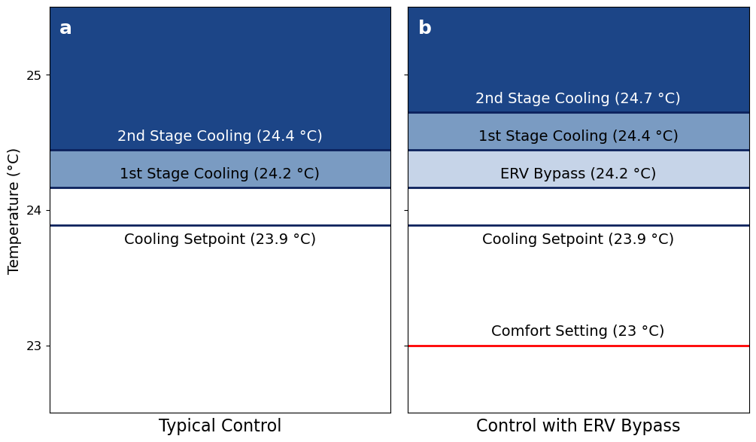
Figure 4. Comparison of setpoints and deadbands for two-stage cooling control without (a) and with (b) ERV bypass.
The ERV’s bypass mode performance was previously characterized and validated following the same form of equation 1 based on data acquired in 2024 during temperature-based bypass control testing (Shore 2025). The resulting curve fits are shown in Table 4. The resulting value is not an energy recovery effectiveness, rather a way to capture any energy gains or losses as the outdoor air moves through the ventilation system’s ductwork.
Table 4. ERV Bypass Mode Effectiveness Parameters
Coefficient | Sensible Effectiveness | Latent Effectiveness
$$ε_{0}$$ | 0.313 | 0.060
$$c_{0}$$ | 1.437 | 25.4
$$c_{1}$$ | -1.004 | -44.1
$$c_{2}$$ | 0.568 | 19.7

Climate Zones
ASHRAE 90.1 - 2022 and the IECC divide the United States into climate zones based on heating and cooling degree days and humidity levels (2021 International Energy Conservation Code (IECC); ASHRAE 90.1-2022 (SI)). There are 8 distinct zones in the United States starting at 1 for the warmest climate and progressing to the coldest climate in zone 8. The zones are subdivided into three humidity categories: A for moist climates, B for dry climates, and C for marine climates. Figure 2 geographically summarizes the climate zones for these regions.
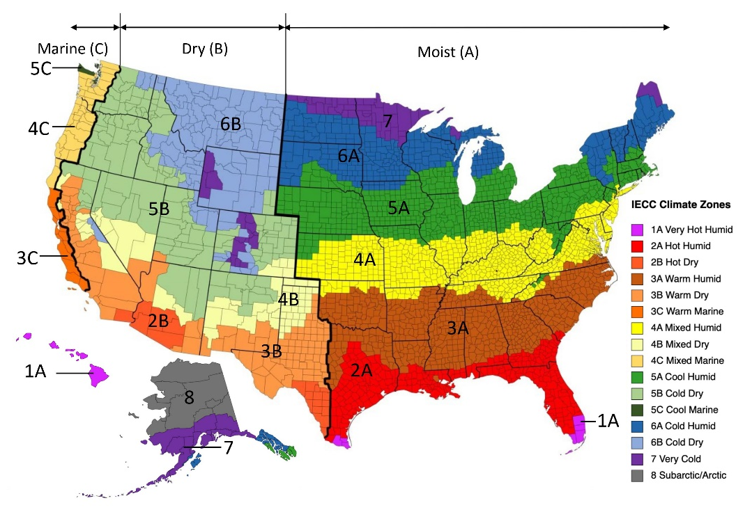
Figure 5. ASHRAE and IECC Climate Zones in the United States.
Fifteen cities were selected to represent 14 climate zones in the United States. Only climate zones 5C and 8 were not included, as there were no large population centers in these regions. The selected cities, including general weather characteristics, are summarized in Table 5. Simulations for the bypass control were run using hourly TMY3 weather data for each of these locations, originally from the National Laboratory of the Rockies (NLR) derived from the 1991-2005 National Solar Radiation Data Base (NSRDB) update (Wilcox and Marion 2008).
Table 5. Summary of Weather Data for 15 Cities
 | Climate Zone | Solar Radiation (MJ/m²) | Dry Bulb Temperature (°C) |  |  | Relative Humidity (%)
 | Climate Zone | Cumulative | Max | Min | Avg. | Max | Min | Avg.
Miami | 1A | 6311 | 35.6 | 5.0 | 24.5 | 100 | 20 | 72.6
Houston | 2A | 5859 | 39.4 | -6.1 | 20.4 | 100 | 15 | 73.0
Atlanta | 3A | 6069 | 36.7 | -12.8 | 16.7 | 100 | 13 | 65.7
Baltimore | 4A | 5358 | 35.0 | -14.4 | 13.2 | 100 | 15 | 64.6
Chicago | 5A | 5064 | 35.0 | -22.8 | 10.0 | 100 | 17 | 70.3
Minneapolis | 6A | 5036 | 37.2 | -31.1 | 7.7 | 100 | 19 | 65.7
Duluth | 7 | 4832 | 32.8 | -30.6 | 4.0 | 100 | 13 | 71.6
Phoenix | 2B | 7539 | 44.4 | 2.2 | 23.8 | 100 | 2 | 34.2
Las Vegas | 3B | 7316 | 44.4 | -3.3 | 19.8 | 100 | 4 | 29.6
Los Angeles | 3B | 6568 | 32.2 | 5.6 | 16.8 | 100 | 10 | 73.0
Albuquerque | 4B | 7129 | 38.9 | -9.4 | 13.7 | 100 | 4 | 42.4
Boulder | 5B | 5957 | 35.6 | -23.3 | 10.3 | 100 | 2 | 51.3
Helena | 6B | 5252 | 35.0 | -24.4 | 7.2 | 100 | 11 | 57.9
San Francisco | 3C | 6179 | 32.8 | 2.2 | 13.8 | 100 | 19 | 74.5
Seattle | 4C | 4463 | 31.8 | -5.6 | 11.2 | 100 | 15 | 74.3

Results
Simulations were run for the entire year with each locality’s TMY3 data. These bypass control strategies were compared in primarily three ways: the ERV load introduced to the building, the resulting energy consumption and cost associated with the ERV loads, and the thermal comfort of the occupants for each strategy.

ERV & Heat Pump Load
The change in sensible and latent loads introduced to the building underscores the differences between no-bypass control, temperature-based control, and enthalpy-based control. Figure 3 shows the monthly ERV loads introduced for each climate zone over the course of the simulated year. The total sensible and latent loads change based on the location’s climate – larger sensible and latent loads for hot and humid climates and negative values for cold and dry conditions. Any reduction in sensible load relative to the no-bypass condition can be considered the free cooling accessed by the control strategy. Table 6 lists the annual ERV loads added to the building relative to the baseline no-bypass condition. Negative loads represent a reduction in thermal load for the year. Temperature bypass maximizes the free cooling opportunities for all climate zones as it is designed to do. However, it does naturally lead to higher latent loads added to the building in climates with more moisture.
Table 6. Annual ERV Loads Added to Building relative to the no-bypass case.
 | Climate Zone | Sensible Load (kWh) |  | Latent Load (kWh)
 | Climate Zone | Temperature  Bypass | Enthalpy  Bypass | Temperature  Bypass | Enthalpy  Bypass
Miami | 1A | -144.1 | -55.5 | 141.4 | -1.5
Houston | 2A | -210.9 | -109.2 | 184.9 | -28.7
Atlanta | 3A | -330.4 | -91.5 | 333.7 | 11.9
Baltimore | 4A | -288.9 | -123.9 | 199.6 | 3.1
Chicago | 5A | -343.1 | -129.5 | 185.8 | -0.4
Minneapolis | 6A | -354.8 | -102.6 | 124.7 | 3.7
Duluth | 7 | -355.6 | -180.4 | 103.0 | 25.9
Phoenix | 2B | -216.2 | -4.1 | 2.3 | -0.4
Las Vegas | 3B | -263.5 | 0.0 | -5.6 | 0.0
Los Angeles | 3B | -706.0 | -412.8 | 320.9 | 57.2
Albuquerque | 4B | -433.8 | -3.7 | 153.0 | 1.6
Boulder | 5B | -420.5 | -3.9 | 108.3 | 1.0
Helena | 6B | -432.2 | -0.2 | 37.2 | 0.1
San Francisco | 3C | -587.1 | -343.8 | -38.5 | -6.1
Seattle | 4C | -417.0 | -208.3 | -14.5 | -14.4

The dry climates have very little difference in latent loads between control strategies, but the temperature-based control causes a significant decrease in sensible loads during warmer months. This results in at least 200 kWh of annual free cooling across the dry climates (Albuquerque, Boulder, Helena, Las Vegas, Los Angeles, Phoenix) relative to the baseline. The additional latent loads added for these climates are no more than 153 kWh except for Los Angeles, which is much more temperate than the other locations in dry climates. Its climate allows for 706 kWh of free cooling, but an added latent load of 321 kWh with temperature-bypass. The enthalpy-based bypass reduces the free cooling opportunities to 413 kWh with an additional latent load of 57 kWh. For the other dry climates, the enthalpy-based control limited free cooling to negligible amounts (no more than 5 kWh for the year) relative to no-bypass control for these climates with latent loads being similarly negligible.
In colder and moist climates (Chicago, Minneapolis, Duluth), the temperature-based control provides significant free cooling opportunities of over 340 kWh per year. But this comes at the cost of an additional 100 kWh or more of latent load to dehumidify. The enthalpy-based control removes these latent loads almost completely, with a more limited opportunity for free cooling (between 100 kWh and 180 kWh).
The warmer moist climates see a significant latent load penalty with temperature bypass, with the free cooling in Miami, Houston, and Atlanta being offset by the added latent loads. Since Baltimore is slightly further north, the latent load is slightly smaller. The enthalpy-based bypass control limits these significant latent loads but significantly reduces the free cooling.

Figure 6. Monthly sensible and latent loads added to the building via the ERV.
The change in total heat pump load due to bypass control strategy in each location, shown in Figure 6, follows the trends from the change in ERV loads. For warmer humid climates like Miami, Houston, Atlanta, and Baltimore, the temperature bypass control has a net negative effect where any free cooling realized is mitigated by a larger latent load introduced to the building. Hot and dry climates and temperate climates see the largest benefit for this control strategy. The enthalpic control effectively mitigates the higher latent loads in humid climates and prevents additional dehumidification, but it comes with the reduction in sensible cooling savings. More detailed monthly sensible and latent loads for each location are shown in Figure S1 of the Supplemental Information (SI).

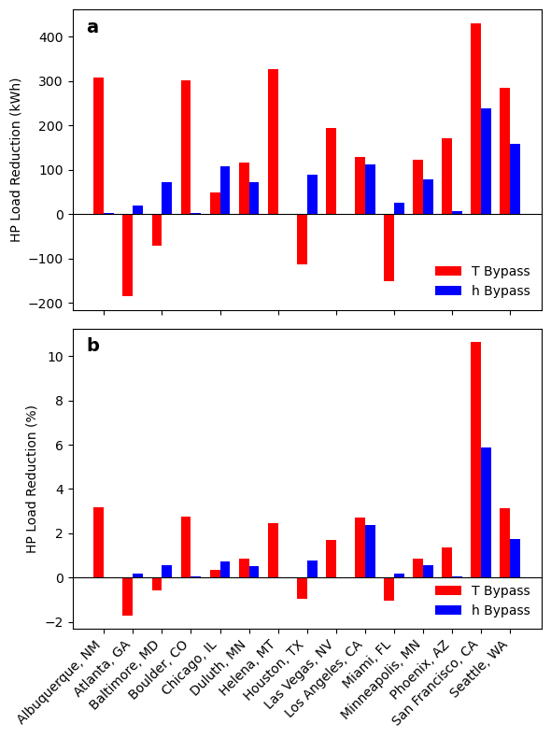
Figure 7. Heat Pump Load Reduction in (a) kWh and (b) percent for temperature and enthalpy bypass strategies relative to no bypass control.

Energy Consumption & Cost
A main purpose of free cooling is to limit the total HVAC energy use as a means of reducing cost to the consumer and relieving grid load so the electricity savings relative to the constant ventilation case were the focus of this analysis. The HVAC energy usage is considered the total of the ASHP energy use and the ERV ventilation fan energy. This value is heavily influenced by the ERV loads added to the building as can be seen when comparing the ERV loads in Figure 3 with the heat pump load reduction in Figure 6 and the HVAC thermal loads shown in Figure S1 of the Supplemental Information (SI). An increase in ERV latent loads leads to an increased dehumidification/latent load for the ASHP while any free cooling reduces the sensible cooling required of the heat pump.
Figure 4 compares the annual HVAC electricity consumption by the bypass control method for each location. Total energy usage is primarily a function of the local weather, with temperature being a primary indicator of energy usage – cold temperatures require the most energy and hot climates also increase energy usage. Humid climates add more energy requirements. The temperature bypass control saves electricity compared to no-bypass control in the drier and temperate climates while the enthalpy bypass holds the HVAC electricity consumption very close to baseline levels in dry climates as shown in Table 7. The temperature control saved up to 4.7 % of HVAC energy in temperate marine climates, 2 % in dry climates, while costing up to an additional 4.2 % in moist climates. Interestingly, the temperature-informed control increased HVAC electricity needs by 7.8 % in Los Angeles relative to the baseline no-bypass control. Since the dedicated dehumidifier is a more energy-intensive piece of equipment than standard cooling, the ASHP uses more energy in humid climates with a significant ERV latent load despite the free cooling being equal to or greater than the increased latent load listed in Table 6. The enthalpy-based informed control limited the dehumidification load but also limited the potential free cooling which gave very few opportunities for energy saving. The enthalpy-based control moderated latent loads and therefore total HVAC electricity needs so it only saved up to 1.7 % of HVAC energy and did not have a penalty of more than 1.5 %.
Figure 8. Annual HVAC Energy for each location.
Table 7 lists the HVAC electricity saved in terms of energy and cost relative to the baseline no-bypass control for all 15 cities. No moist climate saw savings beyond 28.5 kWh for the enthalpy-based bypass control meaning it has very limited potential. The drier climates and marine climates are where the temperature-based control has the most significant savings with up to 93.8 kWh saved. The enthalpy-based control limited any potential savings in these drier climates but still offered savings for the marine climates.
The cost savings were calculated as a product of the HVAC energy savings and the mean electrical utility cost for the location’s state from May 2025 EIA data (Electric Power Monthly - U.S. Energy Information Administration (EIA)). The maximum cost savings is $32.86 in San Francisco, CA. These savings are driven by the high average electricity cost in California ($ 0.3503 / kWh). Other localities with slightly lower energy savings result in between $7.87 and $12.07 in annual cost savings using temperature-informed free cooling.
Table 7. HVAC energy and cost savings for 2 bypass control strategies
Location | Climate Zone | HVAC Energy Savings (kWh) |  | HVAC Cost Savings ($)
Location | Climate Zone | Temperature  Bypass | Enthalpy  Bypass | Temperature  Bypass | Enthalpy  Bypass
Miami | 1A | -122.2 | 2.3 | -18.31 | 0.34
Houston | 2A | -115.4 | 28.5 | -17.88 | 4.41
Atlanta | 3A | -185.7 | -5.5 | -27.85 | -0.83
Baltimore | 4A | -116.3 | 5.1 | -22.13 | 0.98
Chicago | 5A | -78.5 | 20.2 | -14.61 | 3.76
Minneapolis | 6A | -39.4 | 11.2 | -6.26 | 1.77
Duluth | 7 | -28.1 | -1.1 | -4.46 | -0.17
Phoenix | 2B | 39.2 | 1.2 | 6.18 | 0.19
Las Vegas | 3B | 46.3 | 0.0 | 6.16 | 0.00
Los Angeles | 3B | -178.3 | -34.1 | -62.45 | -11.96
Albuquerque | 4B | 79.1 | 0.7 | 11.54 | 0.11
Boulder | 5B | 76.9 | 1.5 | 12.07 | 0.23
Helena | 6B | 82.0 | -0.1 | 10.58 | -0.01
San Francisco | 3C | 93.8 | 34.4 | 32.86 | 12.04
Seattle | 4C | 57.6 | 40.2 | 7.87 | 5.50

Figure 9. Monthly heat pump energy usage for each climate zone.

Thermal Comfort
A ventilation strategy must provide thermal comfort to be considered viable and feasible. Temperature and humidity are the two main considerations for occupant thermal comfort.
(ASHRAE Standard 55 – Thermal Environmental Conditions for Human Occupancy 2023) sets no upper humidity limit for thermal comfort. The 2017 version includes an upper limit of 0.012 kg_{water} / kg_{dry air} (ASHRAE 55-2017). This paper uses the 2017 version as a reference limit to evaluate occupant comfort. Only the Houston and Miami simulation runs recorded times when the indoor humidity ratio was above this limit as shown in Table 8. Temperature-based bypass control increased the number of hours beyond the upper humidity limit by 1 % for Houston, TX and 90 % for Miami, FL. Enthalpy-based control limited the additional hours of excessive humidity as intended. It is likely best to avoid employing these strategies in very humid environments, but the occupant’s comfort will not be significantly impacted in climate zones cooler than zone 1.
Table 8. Total hours with Humidity Ratio exceeding 0.012 kg_{water} / kg_{dry air}.
 | Zone 2 |  |  | Zone 3
 | Baseline (h) | T Bypass (h) | h Bypass (h) | Baseline (h) | T Bypass (h) | h Bypass (h)
Houston, TX | 483 | 489 | 485 | 140 | 168 | 144
Miami, FL | 506 | 963 | 476 | 306 | 812 | 299

The predicted mean vote (PMV) and predicted percentage of dissatisfied (PPD) are helpful estimations for occupant comfort based on the indoor temperature and the zone’s mean radiant temperature. A thermally comfortable room is generally considered to have a PMV between -0.5 and 0.5, with +3 being considered hot and -3 being considered cold. The corresponding PPD for a comfortable space is < 10 %. These metrics are calculated using the equations below based on Fanger’s PMV-PPD model (Fanger 1982; ASHRAE 55-2013; ASHRAE Handbook Online - Handbook):
$$PMV= (0.303e^{-0.036M}+0.028)\{\left(M-W\right)-3.05×{10}^{-3}\left[5733-6.99\left(M-W\right)-p_{a}\right]-0.42\left[\left(M-W\right)-58.15\right]-1.7×{10}^{3}M\left(5867-p_{a}\right)-0.0014M\left(34-t_{a}\right)-3.96×{10}^{-8}f_{cl}\left[{\left(t_{cl}+273\right)}^{4}-{\left(\overline{t_{r}}+273\right)}^{4}\right]-f_{cl}h_{c}(t_{cl}-t_{a})$$ | (3)
$t_{cl}=35.7-0.0275\left(M-W\right)$  $$-I_{cl}\{3.96×{10}^{-8}f_{cl}\left[{\left(t_{cl}+273\right)}^{4}-{\left(\overline{t_{r}}+273\right)}^{4}\right]+f_{cl}h_{c}\left(t_{cl}-t_{a}\right)\}$$ | (4)
$$h_{c}=\left\{\begin{aligned}2.38{\left(t_{cl}-t_{a}\right)}^{0.25}, 2.38{\left(t_{cl}-t_{a}\right)}^{0.25}>12.1\sqrt{V} \\ 12.1\sqrt{V}, 2.38{\left(t_{cl}-t_{a}\right)}^{0.25}>12.1\sqrt{V}\end{aligned}\right.$$ | (5)
$f_{cl}=\left\{\begin{aligned}1+1.29I_{cl}, I_{cl}<0.078\frac{m^{2}∙K}{W} \\ 1.05+0.645I_{cl}, I_{cl}≥0.078\frac{m^{2}∙K}{W}\end{aligned}\right.$ | (6)
$PPD=100-95e^{-0.03353PMV^{4}-0.2179PMV^{2}}$ | (7)

where $M$ is the metabolic rate of heat production in W/m², $W$ is the work rate in W /m² (set to zero here), $p_{a}$ is the water vapor partial pressure in Pa, $t_{a}$ is the indoor air temperature in °C, $f_{cl}$ is the ratio of area of the body clothed and unclothed, $t_{cl}$ is the clothing temperature in °C, $\overline{t_{r}}$ is the mean radiant temperature of the zone in °C, $h_{c}$ is the air convection coefficient in W/(m²·K) , $V$ is the air velocity is m/s, and $I_{cl}$ is the clothing thermal resistance in (m²·K)/W.
The PMV and PPD were calculated for every hour of the year using the house zone temperature as the indoor air temperature and assuming an activity level of 1.7 Met or 98.6 W/m². The selected activity level is equivalent to low-intensity activities in the home like walking or cooking. This activity level was selected to examine if thermal comfort was attainable when doing typical activities in the building during warmer months when bypass mode could be enabled. For May through September, the clothing thermal resistance was set to 0.36 (1 clo = 0.155 (m²·K)/W, equivalent to short sleeves and shorts, and all other months it was set to 0.64 (long sleeves and pants). From 7 am to 11 pm, the first-floor air and radiant temperatures were used, and the second-floor temperatures were used for the other times each day. The mean radiant temperature was calculated as the average of the wall temperatures in the zone. Since the thermostat control is dictated by the first-floor conditions, the second floor is generally warmer than the first floor. This leads to higher PMV values on the second floor which improves comfort in the heating season but less comfortable conditions in cooling season, when bypass mode would be enabled.
Table 9 lists the median PMV during months where bypass mode could be enabled in each location. Since this mode is utilized during cooling season, the baseline median PMV is greater than zero in these months. The temperature control decreases the PMV for each location while the enthalpy-based control shows modest decreases for environments with a moderate amount of humidity. Dry regions see virtually no thermal comfort improvements when using the enthalpy-based bypass control. The distribution of the PMV during these bypass months are shown in Figure 10 via boxplots. The corresponding distribution of PPD is shown in the SI, Figure S2. The minimum PPD value shown is 5 % because that is the minimum set by the equation. No location had the PMV exceed 1, and only in Miami and Houston was the PMV outside of -0.5 and 0.5 for more than half the year. Despite the total range of PMV remaining the same, both bypass controls shift the median PMV towards zero with the temperature bypass promoting more comfort than the enthalpy-based control. This is further shown by the total number of hours when the PMV is greater than 0.5 or less than -0.5 (Figure 11). The temperature bypass control reduces the number of hours when the space is uncomfortable. For the temperature-based control, the uncomfortable hours are reduced by between 3.4 % (124 h) and up to 60 % (746 h) while the enthalpy-based control varies from 0.3 % (-4 h) more hours with uncomfortable conditions to a 40 % (476 h) reduction in uncomfortable hours.
Table 9. Median PMV during months with bypass potential
Location | Climate Zone | Median PMV
Location | Climate Zone | Baseline | T Bypass | h Bypass
Miami | 1A | 0.646 | 0.643 | 0.645
Houston | 2A | 0.533 | 0.478 | 0.507
Atlanta | 3A | 0.399 | 0.316 | 0.376
Baltimore | 4A | 0.437 | 0.359 | 0.407
Chicago | 5A | 0.364 | 0.276 | 0.331
Minneapolis | 6A | 0.398 | 0.316 | 0.376
Duluth | 7 | 0.300 | 0.196 | 0.242
Phoenix | 2B | 0.404 | 0.337 | 0.404
Las Vegas | 3B | 0.430 | 0.390 | 0.430
Los Angeles | 3B | 0.320 | 0.218 | 0.252
Albuquerque | 4B | 0.374 | 0.308 | 0.373
Boulder | 5B | 0.329 | 0.263 | 0.331
Helena | 6B | 0.278 | 0.175 | 0.278
San Francisco | 3C | 0.031 | 0.000 | 0.023
Seattle | 4C | 0.023 | -0.015 | 0.010

Figure 10. Percent Mean Vote in months when bypass mode was enabled.
Figure 11. Hours when space is not comfortable for each location during months when bypass mode can be utilized.

Recommended Bypass Strategy
These findings inform a recommended bypass control strategy that considers energy savings and thermal comfort. Here we provide a suggested decision strategy which follows a three-step process. First, climates with a high average absolute humidity (i.e., above about 0.009 kg_{water} / kg_{dry air}) should not utilize a bypass control strategy to avoid exceeding the humidity ratio reference limit of 0.012 kg water / kg dry air. For other climates, equation 8 is used to determine if temperature-based bypass or enthalpy-based bypass is applicable:
$$Improvement \left(\%\right)=w_{savings}\left(\frac{Energy Saved \left[kWh\right]}{200 kWh}\right)+w_{comfort}\left(\frac{PMV reduction}{0.112}\right)$$ | (8)
where $w_{savings}$ is the weighting for energy savings and $w_{comfort}$is the weighting for thermal comfort. If the percent improvement when evaluating both bypass methods is small (e.g. 3 %), then neither control strategy provides a sufficient benefit, and no bypass strategy should be used. If either the temperature-based bypass or enthalpy-based bypass provides sufficient improvement over the no-bypass case, then the larger of the two should be utilized to reduce HVAC energy usage and/or improve thermal comfort.
In this work, we share an example scenario with weighting values of 0.75 for energy savings and 0.25 for thermal comfort selected to emphasize energy savings while keeping thermal comfort in mind. The decision point is shown relative to the annual dry bulb temperature range and the average absolute humidity in Figure 12. The dry bulb temperature range is the difference between maximum and minimum dry bulb temperatures for the year shown in Table 5. At lower average humidities, the temperature-based control is better for climates with a smaller total range in annual temperature, generally representing warmer or more temperature regions. Larger temperature ranges indicate a more pronounced heating season and higher cooling season humidities for a given average annual humidity. This leads to a suggested enthalpy-based control to the right side of the figure, if prioritizing utility cost is desired. However, if thermal comfort is the priority, then the regions with a suggested enthalpy-based control can utilize a temperature-based control instead.
It should also be pointed out that regions with limited or no data, like around 50 °C and 0.010 kg_{water} / kg_{dry air} or 60 °C and 0.008 kg_{water} / kg_{dry air} require further study to better understand the best suited ERV control strategy.
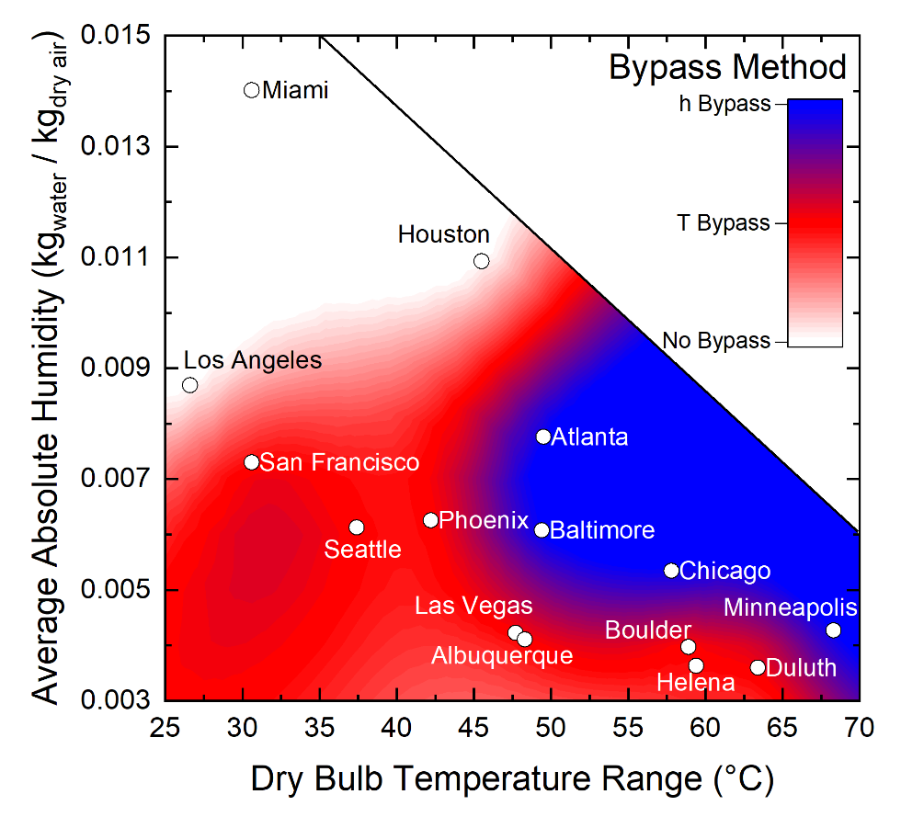
Figure 12. Recommended ERV bypass control strategy based on climate temperature range (the difference between maximum and minimum dry bulb temperatures for the year) and average absolute humidity.

Conclusions
This work evaluated bypass control of an ERV at NIST’s RTF across 15 cities in the United States for 14 unique ASHRAE climate zones ranging from very hot and humid to very cold. Temperature-based and enthalpy-based controls were compared with a baseline no-bypass condition using a validated TRNSYS model to understand how these control strategies affect both electricity savings and thermal comfort for occupants. There was a slight energy cost savings potential in mild and dry climates when using temperature-based free cooling. Moderate humid climates have the potential for modest utility savings when using an enthalpy-based control to limit the latent loads added to the building while also offering a mild improvement in thermal comfort relative to no-bypass control.
These results are specific to NIST’s RTF so the energy savings potential of other buildings will differ depending on the building envelope, rate of infiltration, heat pump, and ERV effectiveness. But the same control strategies can still be applied in low-load homes with an energy recover ventilator and the general trends observed can be expected. Temperature-based control shows clear improvements in thermal comfort, with lower PMV and PPD, during months when bypass mode could be used at all locations. The enthalpy-based control limits the potential energy savings or penalties while moderately improving thermal occupant comfort relative to baseline. If an HVAC energy use increase of up to 200 kWh per year (equaling $34.94 assuming median USA residential utility rates) can be tolerated, then the temperature-based control provides improved thermal comfort with minimal, or no humidity increases relative to baseline except for very hot and humid climates like Miami. A temperature-based control strategy reliably provides a more comfortable space than no-bypass conditions, supplying additional fresh air, and can provide energy savings in the right climate zone.

References
2021 International Energy Conservation Code (IECC). https://codes.iccsafe.org/content/IECC2021P2
AHRI 210/240 (I-P): Performance Rating of Unitary Air-conditioning and Air-source Heat Pump Equipment | AHRI. 2024. https://www.ahrinet.org/search-standards/ahri-210240-i-p-performance-rating-unitary-air-conditioning-and-air-source-heat-pump-equipment
ASHRAE 55-2013. [place unknown]: ASHRAE; [accessed 2025 Aug 21]. https://store.accuristech.com/ashrae/standards/ashrae-55-2013?product_id=1868610
ASHRAE 55-2017. [accessed 2025 Aug 20]. https://store.accuristech.com/ashrae/standards/ashrae-55-2017?product_id=1994974
ASHRAE 90.1-2022 (SI). [accessed 2025 Aug 20]. https://store.accuristech.com/ashrae/standards/standard-90-1-2022-si-edition-energy-standard-for-sites-and-buildings-except-low-rise-residential-buildings-ansi-approved-ies-co-sponsored?product_id=2522083
ASHRAE Handbook Online - Handbook. [accessed 2025 Feb 2]. https://handbook.ashrae.org/Handbook.aspx
ASHRAE Standard 55 – Thermal Environmental Conditions for Human Occupancy. 2023. [accessed 2025 Aug 20]. https://www.ashrae.org/technical-resources/bookstore/standard-55-thermal-environmental-conditions-for-human-occupancy
ASHRAE Standards 62.1 & 62.2. [accessed 2025 Mar 23]. https://www.ashrae.org/technical-resources/bookstore/standards-62-1-62-2
Balke E, Nellis G, Klein S, Skye H, Payne V, Ullah T. 2017. Detailed Energy Model of the NIST Net-Zero Energy Residential Test Facility: Development, Modification, and Validation. Sci Technol Built Environ [Internet].(7). https://doi.org/10.1080/23744731.2017.1381828
Balke EC. 2016. Modeling, Validation, and Evaluation of the NIST Net Zero Energy Residential Test Facility [Internet]. Madison: University of Wisconsin. https://sel.me.wisc.edu/publications-theses.shtml
Cho W, Heo J, Park MH, Seo HJ, Lee K, Lee DG, Kim Y. 2023. Energy performance and thermal comfort of integrated energy recovery ventilator system with air-conditioner for passive buildings. Energy Build [Internet]. [accessed 2025 Aug 19] 295:113302. https://doi.org/10.1016/J.ENBUILD.2023.113302
CPI Inflation Calculator. US Bureau of Labor Statistics [Internet]. [accessed 2025 Aug 19]. https://www.bls.gov/data/inflation_calculator.htm
Davis M, Healy W, Boyd M, Ng L, Payne V, Skye H, Ullah T. 2014. Monitoring Techniques for the Net-Zero Energy Residential Test Facility [Internet]. [accessed 2025 Mar 30]. https://doi.org/10.6028/NIST.TN.1854
Electric Power Monthly - U.S. Energy Information Administration (EIA). [accessed 2025a Aug 19]. https://www.eia.gov/electricity/monthly/
Electric Power Monthly - U.S. Energy Information Administration (EIA). [accessed 2025b Aug 12]. https://www.eia.gov/electricity/monthly/epm_table_grapher.php?t=epmt_5_6_a
Fanger PO. 1982. Thermal Comfort: Analysis and Applications in Environmental Engineering. Malabar, FL: R.E. Krieger Publishing Company.
Fanney AH, Payne V, Ullah T, Ng L, Boyd M, Omar F, Davis M, Skye H, Dougherty B, Polidoro B, et al. 2015. Net-zero and beyond! Design and performance of NIST’s net-zero energy residential test facility. Energy Build. 101:95–109. https://doi.org/10.1016/J.ENBUILD.2015.05.002
Guillén-Lambea S, Rodríguez-Soria B, Marín JM. 2017. Control strategies for Energy Recovery Ventilators in the South of Europe for residential nZEB—Quantitative analysis of the air conditioning demand. Energy Build. 146:271–282. https://doi.org/10.1016/j.enbuild.2017.04.058
Healy WM, Fanney AH, Dougherty BP, Ng L, Payne V, Ullah T, Omar F. 2017. Performance Data from the NIST Net-Zero Energy Residential Test Facility [Internet]. 122(14). https://doi.org/10.6028/jres.122.014
Hunter Fanney A, Healy W, Payne V, Kneifel J, Ng L, Doughety B, Ullah T, Omar F. 2017. Small Changes Yield Large Results at NIST’s Net-Zero Energy Residential Test Facility. Journal of Solar Energy Engineering, Transactions of the ASME [Internet]. 139(6). https://doi.org/10.1115/1.4037815/379755
Kim HR, Jeon JU, Kim KS. 2019. Performance measurements of an energy recovery ventilator (ERV) and effective ventilation strategy with ERV and hybrid desiccant system. Build Simul [Internet]. [accessed 2025 Aug 19] 12(3):489–504. https://doi.org/10.1007/S12273-018-0504-2/METRICS
Lee Joonghoon, Song D, Kim J, Lee Junghun. 2013. ENERGY SAVING EFFECT OF THE ERV (ENERGY RECOVERY VENTILATOR) WITH OUTDOOR AIR COOLING. In: Proceedings of the 34th AIVC - 3rd TightVent - 2nd Cool Roofs’ - 1st venticool Conference [Internet]. Athens: Air infiltration and Ventilation Centre. https://www.aivc.org/resource/energy-saving-effect-erv-energy-recovery-ventilator-outdoor-air-cooling
Leyde BP. 2014. TRNSYS Modeling of the NIST Net Zero Energy Residential Test Facility [Internet]. Madison: University of Wisconsin. https://sel.me.wisc.edu/publications-theses.shtml
Li J, Zmeureanu R, Ge H. 2021. Simulation of energy impact of an energy recovery ventilator in Northern housing. In: E3S Web of Conferences. Vol. 246. [place unknown]: EDP Sciences. https://doi.org/10.1051/e3sconf/202124610005
Ng LC, Payne WV. 2016. Energy use consequences of ventilating a net-zero energy house. Appl Therm Eng. 96:151–160. https://doi.org/10.1016/J.APPLTHERMALENG.2015.10.100
Omar F, Bushby ST. Simulating Occupancy in the NIST Net-Zero Energy Residential Test Facility [Internet]. [accessed 2025 Mar 17]. https://doi.org/10.6028/NIST.TN.1817
Rasouli M, Simonson CJ, Besant RW. 2010. Applicability and optimum control strategy of energy recovery ventilators in different climatic conditions. Energy Build. 42(9):1376–1385. https://doi.org/10.1016/j.enbuild.2010.03.006
Ribé O, Ruiz R, Quera M, Cadafalch J. 2019. Analysis of the sensible and total ventilation energy recovery potential in different climate conditions. Application to the Spanish case. Appl Therm Eng. 149:854–861. https://doi.org/10.1016/j.applthermaleng.2018.12.076
Shore AM. 2025. MODELING CONTROL STRATEGIES OF A HIGH-PERFORMANCE ENERGY RECOVERY VENTILATOR IN NIST’S NET ZERO ENERGY RESIDENTIAL TEST FACILITY [Internet]. College Park: University of Maryland; [accessed 2026 Jun 2]. https://doi.org/10.13016/6ulm-wqym
U.S. Department of Energy. 2025. Evaluating the Reliability and Security of the United States Electric Grid. [place unknown].
U.S. energy facts explained - consumption and production - U.S. Energy Information Administration (EIA). [accessed 2025 Feb 2]. https://www.eia.gov/energyexplained/us-energy-facts/
Wilcox S, Marion W. 2008. User’s Manual for TMY3 Data Sets. Golden, CO; [accessed 2025 Aug 20]. https://docs.nrel.gov/docs/fy08osti/43156.pdf
Wu W, Skye HM. 2018. Net-zero nation: HVAC and PV systems for residential net-zero energy buildings across the United States. Energy Convers Manag. 177:605–628. https://doi.org/10.1016/j.enconman.2018.09.084
Wu W, Skye HM, Domanski PA. 2018. Selecting HVAC systems to achieve comfortable and cost-effective residential net-zero energy buildings. Appl Energy. 212:577–591. https://doi.org/10.1016/j.apenergy.2017.12.046
Zero Energy-Verified Commercial Buildings More Than Double Since 2018 - New Buildings Institute. New Buildings Institute [Internet]. [accessed 2025 Feb 2]. https://newbuildings.org/news/zero-energy-verified-commercial-buildings-more-than-double-since-2018/
Zhang JL, Fung AS. 2014. Feasibility Study of Multiple-Pass Total Energy Recovery Ventilator with Built-in Economizer Using TRNSYS: A Case Study for Toronto, Ontario. In: Proceedings of eSim 2014: 8th Conference of IBPSA-Canada [Internet]. [place unknown]: IBPSA Canada; p. 360–369. https://publications.ibpsa.org/conference/paper/?id=esim2014_8B_3

