Depth Profiling Chemical Changes in Chemically Amplified Resists for EUV Lithography
Daniel F. Sunday,¹ Peter Dudenas,¹ Priyanka Ketkar,¹ Julia Murphy,¹ Cherno Jaye,² R. Joseph Kline,¹ Gurpreet Singh,³ Eungnak Han,³ Lauren Doyle,³ Florian Gstrein³
- Materials Science and Engineering Division, National Institute of Standards and Technology, Gaithersburg MD, 20899
- Materials Measurement Science Division, National Institute of Standards and Technology, Gaithersburg MD, 20899
- Intel, Hillsboro, OR, USA

Abstract
Photoresist patterning for semiconductor manufacturing is encountering new challenges with the move to extreme ultraviolet (EUV) lithography, driven by smaller pitches, thinner resists and fewer photons. Obtaining information about the nanoscale distribution of chemical changes in the resist will provide key information to optimize processing and resist development. Soft X-rays provide sensitivity to chemical functional groups at key atomic absorption edges, including carbon, oxygen and fluorine. By conducting specular reflectivity measurements at these energies, we can track the chemical depth profiles in a resist. This process is demonstrated by characterizing the optical constant profiles, which are proportional to the concentration of chemical bonds in a film at soft X-ray energies, of an EUV resist coated on a cross-linked polystyrene (CLPS) mat. The resist was exposed to blanket exposures with different doses and measured at different stages of the process, including post-exposure but before the bake, after the post-exposure bake, and after development. Segregation of resist components was observed in the as-coated case films, with a fluorinated component aggregating at the film surface. Stratification of the chemical changes that occur in the film is observed after exposure, but before the bake. The magnitude of this stratification is dose dependent. After a post-exposure bake the stratification is no longer observed and the optical constant profile is uniform with the exception of the fluorinated components. These results are complemented by near edge X-ray absorption fine structure (NEXAFS) spectroscopy obtained with an imaging microscope. Finally, we also examine the CLPS mat before and after the process, and observe evidence for chemical changes in the CLPS, with the possibility of residual resist components residing in the film after development.

Keywords: Photoresist, Metrology, Reflectivity, Soft X-rays, Directed Self-Assembly

Introduction
The implementation of extreme ultraviolet (EUV) lithography has resulted in new challenges for photoresists.^{1,2} Chemically amplified resists (CARs) are still the state of the art for high volume manufacturing, but the multicomponent nature of CARs is leading to new concerns about how the compositional heterogeneity can impact resist performance.^{3,4} CARs typically consist of at least three components, a polymer with a labile group that can be altered during exposure to switch the solubility, a photoacid generator (PAG) which catalyzes the chemical change, and a quencher which neutralizes the acid, thereby limiting its diffusion. Differences in interactions parameters and surface energies between each of these components will result in non-uniform component distributions in both the lateral and vertical directions.⁵ EUV patterning will produce smaller pitches with thinner resists due to the reduced depth of focus increasing the role that compositional heterogeneity plays in resist performance. Due to a combination of limited material absorbance and flux from EUV sources, the combination of these materials’ stochastics with the photon stochastics means that pattern roughness driven will be a key issue going forward.⁶ Furthermore, thinner resist stacks means that interface effects will become increasingly important and understanding resist-underlayer interactions will be key to optimizing patterning processes. Characterizing these interactions can be challenging, as it requires sensitivity to changes in nanoscale chemical distributions.⁷
In this study resonant soft X-ray reflectivity (RSoXR) will be used to characterize changes in the optical constant depth profiles of a CAR at different stages in the patterning process and relate those results to the changing chemical depth profiles of the components in the film. Reflectivity measurements will be complemented by near edge X-ray absorption fine structure (NEXAFS) spectroscopy, which provides important information about the chemical changes at the films surface. The target system will consist of a CAR on a cross-linked polymer mat (CLPS), where understanding interactions between the resist and CLPS are important for optimizing directed self-assembly (DSA), with DSA considered as a complementary process flow to EUV lithography.^{8,9}
Because photoresists are complex blends many different characterization techniques are used to investigate how exposure and processing results in changes to the chemical structure. Infrared spectroscopy (IR) is highly effective for understanding changes in certain chemical bonds but has limited resolution to interrogate how those chemistries are spatially distributed. Increasingly IR is being used in-situ in order to carefully study the effects of oxygen or moisture on resist performance, particularly for metal oxide resists.¹⁰ Time of flight (TOF) secondary ion mass spectrometry (SIMS) has also become an important tool; TOF-SIMS offers exceptional sensitivity to low concentrations of components in a depth profiling modality, although achieving sub 10 nm resolution is still challenging. There are also variations on the technique which provide insight into the lateral distributions of components based on analysis of the statistics from multiple impacts from nano-projectiles.^{11–14}
Soft X-ray based measurements provide additional tools to broaden the existing toolbox. Soft X-rays border the EUV spectrum and contain absorption edges for many of the key resist components, including the K-edges for carbon, nitrogen, oxygen and fluorine. The carbon spectra in particular contains fine features where the absorption peaks for different functional groups are shifted to different energies and are clearly differentiable in the spectra.¹⁵ The magnitude of the absorption peak for a given functional group will be proportional to the concentration of that functional group. As a result changing soft X-ray energies in a measurement allows you to probe both the type of chemistry in the system and also the concentration of specific functional groups. This is often measured by collecting a NEXAFS spectra; this can be done by exposing the beam to X-rays at either the magic angle (55° from the surface), where the spectra are sensitive to the composition, or at multiple incident angles in order to provide sensitivity to both composition and molecular orientation.¹⁶ There are several modes in which NEXAFS measurements can be conducted, including measuring electron yield and measuring the transmission through a sample. Electron yield modes are surface sensitive, reaching a depth of only a few nm, with some control over the depth sensitivity being achievable when biasing the detector voltage to reject lower energy electrons in partial electron yield (PEY) mode. Transmission absorption measurements provide sensitivity to the bulk of the film, but because of the high absorbance of soft X-rays need to be conducted on either a free-standing film, which can be challenging to prepare, or on a thin membrane. NEXAFS has been used to examine resists in the past, characterizing both surface segregation of individual components and monitoring changes in chemical bonds after exposure and development.^{17–19} A challenge for photoresist research is that soft X-rays have the potential to alter the samples being measured. The development of a novel soft X-ray microscope called the Large Area Rapid Imaging Analytical Tool (LARIAT) provides a route for low dose measurements of photoresists, where concerns about altering the photoresist due to exposure to soft X-rays can be significantly alleviated.²⁰
A different mode for utilizing soft X-rays is RSoXR, where specular reflectivity measurements are conducted at a series of different incident angles for a given energy near an absorption edge. This measurement is a variant of standard hard X-ray reflectivity, where fitting the reflectivity curve enables determination of the electron density profile, which can be related back to composition. Uniquely relating electron densities to composition is difficult for organic materials as there is often little differentiation between the electron density of different components in an organic material. Conducting reflectivity measurements at energies near an absorption edge provides a means to combine the nanometer scale spatial resolution of X-ray reflectivity measurements with the sensitivity to specific chemical bonds depending on the chosen X-ray energy. With an appropriate set of references to understand how changing concentrations impact the optical constants for a given material, this depth profile can be directly converted to a concentration profile of components in a film, or even a distribution of functional groups.^{21,22} This approach has been demonstrated to investigate the interface roughness between high-χ block copolymers (BCPs),²³ the distribution of components with complex architectures,²⁴ the additives in BCPs,^{21,25} and the molecular orientation in thin films.^{26–28}
The underlayer examined in this study is an CLPS mat, which is used as part of the guiding pattern for DSA. The DSA of BCPs has been explored as a patterning technique that takes advantage of the information chemically imprinted in the block copolymer (pitch and interface roughness) via the choice of polymer chemistry and molecular weight.^{29,30} Prior to the integration of EUV patterning, DSA was primarily explored as a density multiplication technique with the goal of a 3x or 4x reduction in the patterned pitch.^{31–33} Now that EUV patterning can produce patterns commensurate with the periodicity of BCPs, DSA is being considered as a roughness remediation technique, where a rough pattern can be made with the EUV tool, and the BCP “heals” the roughness.^{34,35} This technique has the potential to significantly reduce the dose required from the EUV tool, resulting in a significant increase in throughput at the costly EUV patterning step. The BCP needs to have nearly equivalent surface energies between the two blocks at the target annealing temperature, and the patterned surface needs to have different affinities for the two components.³⁶ When patterning with polystyrene-b-poly(methyl methacrylate) (PS-b-PMMA), the most common polymer explored for DSA, the process typically uses an CLPS mat, which has a greater affinity for polystyrene, and a neutral brush backfilling the region between the CLPS stripes.³³ For density multiplication, the neutrality of the backfilled brush is a key feature to ensure vertical orientation of the BCP throughout the pattern.^{37,38} However, for roughness remediation the optimal pattern structure in terms of the brush chemistry and composition has not been fully explored. In this study we examine whether any of the components from the resist will diffuse into the CLPS, which would potentially alter the CLPS surface energy and could lead to buried defects in the film.
Materials and Methods
Crosslinkable polystyrene was spin coated to achieve ~6nm film and baked under nitrogen environment at 250 °C degree for 30 min. Chemically amplified resists were exposed using a custom EUV flood-exposure metrology cluster tool. The coated wafers were loaded into a vacuum chamber where an array of sites 1 cm in diameter were exposed with 13.5nm light at the desired doses. Once removed from the chamber, post processing steps were completed.
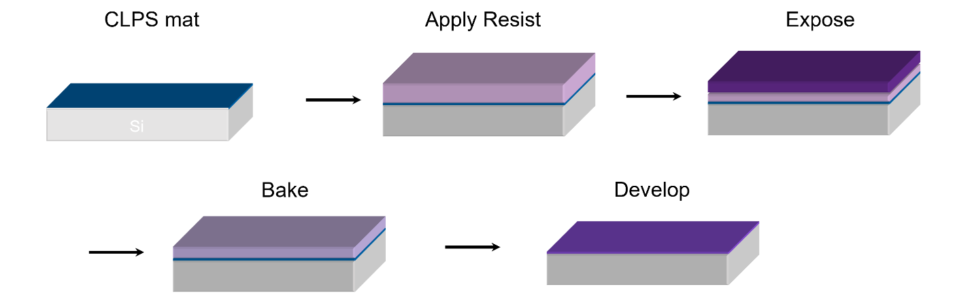
Figure 1: Samples were prepared as outlined in this schematic. Initially the surface is coated with a CLPS mat, which is approximately 10 nm thick. The resist is applied (at approximately 35 nm), then exposed with the target dose. As will be discussed later in the manuscript the exposed resist shows a depth dependent change in chemistry and two layers are included in the exposed step to illustrate this. Following this the resist is baked and then developed.
Resonant Soft X-ray Reflectivity (RSoXR): Samples were prepared according to the process shown in Figure 1. Reflectivity measurements were conducted on films taken from all steps of the patterning process, including the CLPS mat before resist deposition, unexposed resist on the CLPS mat, exposed resist on the CLPS mat before bake, exposed resist on CLPS mat with bake, and developed resist on CLPS mat. Exposed resist films were investigated with blanket EUV doses between 16 mJ, where incomplete clearing of the resist was observed, and 21 mJ, where the resist was fully cleared during development. In some cases, multiple measurements were taken at energies which are primarily sensitive to the same bond, such as 282 eV and 284 eV, both of which are highly sensitive to aromatic rings. In other cases, measurements were conducted at energies where there was sensitivity to different bonds, such as 288 eV, where the wavelengths are more sensitive to the concentrations of C=O bonds.^{39,40}
RSoXR measurements were collected at beamline 6.3.2 at the Advanced Light Source (ALS) at the Lawrence Berkeley National Laboratory (LBNL). Measurements were collected in sections, with the low angle data (typically sample angles less than 15°) being collected by a photodiode and higher angle data being collected by a channeltron. After collecting the highest angle data for a single energy, the low angle data was re-collected at the same spot and compared with the initial scan to check for beam damage (Figure S5). Measurement spots were translated between each energy to minimize the possibility of beam damage. The data was fit using Refnx.⁴¹ When modeling the reflectivity curves a series of models of increasing complexity were utilized, always starting with the simplest possible model. In this case that was often a two layer model, one for the CLPS and one for the photoresist. Additional layers were added to test variations in photoresist composition, and multiple models were tested to reduce the possibility of multiple valid solutions accurately recreating the reflectivity profiles. This modeling framework uses scattering length density (SLD) to characterize the optical constants, which is common in the neutron community. Therefore we will discuss the results in terms of the SLD rather than optical constants, δ and β, which are more commonly used in the X-ray community.
Samples were also characterized via LARIAT at beamline 7-ID-1 of the National Synchrotron Light Source II of Brookhaven National Laboratory operated by the National Institute of Standards and Technology (NIST).^{20,42} The beam was dithered 23 Hz in the horizontal direction and 2 Hz in the vertical direction to form a 1 cm x 1 cm spot size. Samples were mounted onto an aluminum bar, and the sample surface was placed 55° from the incident beam. The ejected electrons from the sample were channeled to the imaging detector via a 0.5 mT iron magnet energized to 30 V. The imaging detector consisted of a multichannel plate energized to 850 V and a phosphor energized to 3500 V. The images are normalized by the drain current of a gold mesh placed upstream of the sample.
Results and Discussion
Figure 2A shows the reflectivity curve collected at 282 eV from the as cast (unexposed) photoresist on top of a cross-linked CLPS. The models used to fit the data always include the buried silicon and native SiO₂ layer, whose optical constants are estimated from the Henke database. (for simplicity these layers will be omitted from the rest of the discussion, therefore a two layer model refers to the layers in addition to the Si/SiO₂ layers).⁴³ Initially the sample was modeled with two layers, one for the CLPS on the surface of the wafer and a second for the photoresist. While this model reasonably approximates the low q data, it is unable to fully capture the structure of the reflectivity curve even when the optical constants are allowed to explore values that are likely physically unrealistic. Adding a surface layer, with a much higher real SLD allows the model to accurately reconstruct the measured reflectivity. Fitting multiple energies provides additional evidence for the presence of the surface layer, as all of the energies require the surface layer to be present to fit the data (see Figures S1 and S2). Resists commonly have fluorinated components including the PAG and fluorinated surfactants used as levelling agents, both of which could accumulate at the film surface and produce the measured SLD profile. Fluorinated materials typically have higher densities on the order of 1.5 g/cm³ or greater, assuming a density of 1.7 g/cm³ the Henke database⁴³ estimates that the SLD for a fluorinated material would be approximately 3x greater than a non-fluorinated material with a density closer to 1 g/cm³. If the chemistries and optical constants of the individual components could be measured the exact distributions of the fluorinated components could be quantified, but the back of the envelope calculation for the difference in the SLDs supports the conclusion that a high concentration of fluorinated components is segregated to the film surface. The presence of a fluorinated component at the surface was confirmed through LARIAT measurements conducted at the fluorine edge (Figure S3).
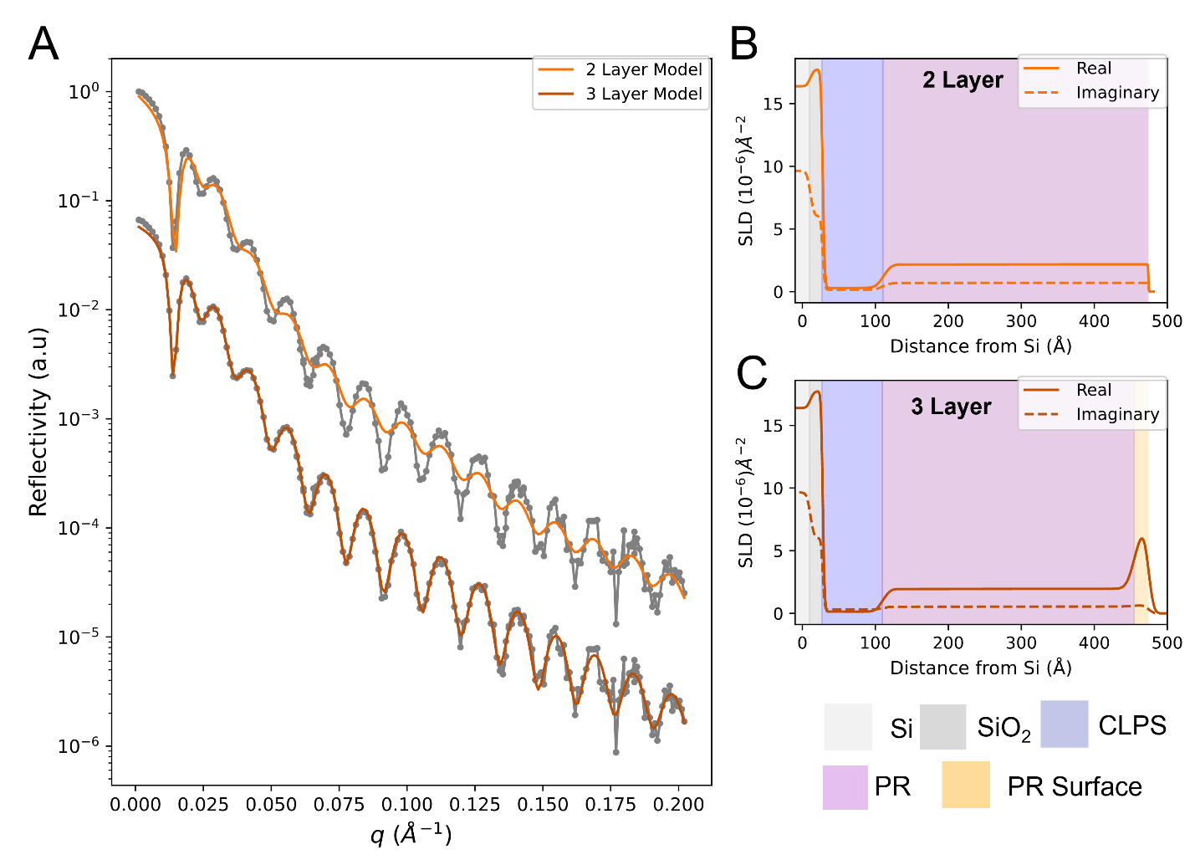
Figure 2: A) Reflectivity data collected on the as-cast photoresist at 282 eV, the data is shown in grey circles and the simulation from the optical profiles are shown in solid lines, corresponding to either a B) two layer model (light orange) or C) three layer model (dark orange). For the SLD profiles (Parts B and C) each layer is highlighted with a different color, indicated by the key at the bottom right of the figure.
RSoXR measurements at 282 eV were conducted on the samples after exposure, but before baking, to examine changes that occurred during this intermediate step of the process. The results of those measurements, along with the best fits are shown in Figure 3A, with SLD profiles corresponding to the best fits for each measured dose are shown in Figures 3B to 3E. Fitting this data required a four-layer model, one for the CLPS layer and three for the photoresist layer. In each sample there is a PR layer just above the CLPS (designated L1), followed by an additional layer located near the enriched layer at the PR surface (designated L2). For all doses the optical constants of the PR layer shifted lower during EUV exposure. L1 shifts significantly lower, down to SLDs < 1.3 Å⁻², while L2 remains higher, between 2.2 Å⁻² and 3 Å⁻², with the value increasing monotonically with dose. All of the models still require the enriched layer near the surface, although the SLD for the surface layer is reduced slightly compared to the as-cast film. The changes in the SLD depth profile suggest that a more complex behavior is occurring beneath the enriched layer, including depth dependent changes in the film chemistry that are a clear function of exposure dose. There are several possibilities for the origin of the stratification in the film including that proximity to the enriched surface layer results in a more rapid reaction rate for the local photoresist. A comparison between the three and four layer models is included in the SI to justify that the four layer model is the best representation of the data. The highlighted region in Figure S4 shows the shift in the position of the fringes relative to the data between q ~ 0.04 Å⁻¹ and 0.1 Å⁻¹ for the three layer model, and that the fourth layer is required to best fit the data. This shift is consistently observed for all doses, although the q region over which it occurs shifts slightly depending on the relative thickness of L1 and L2.
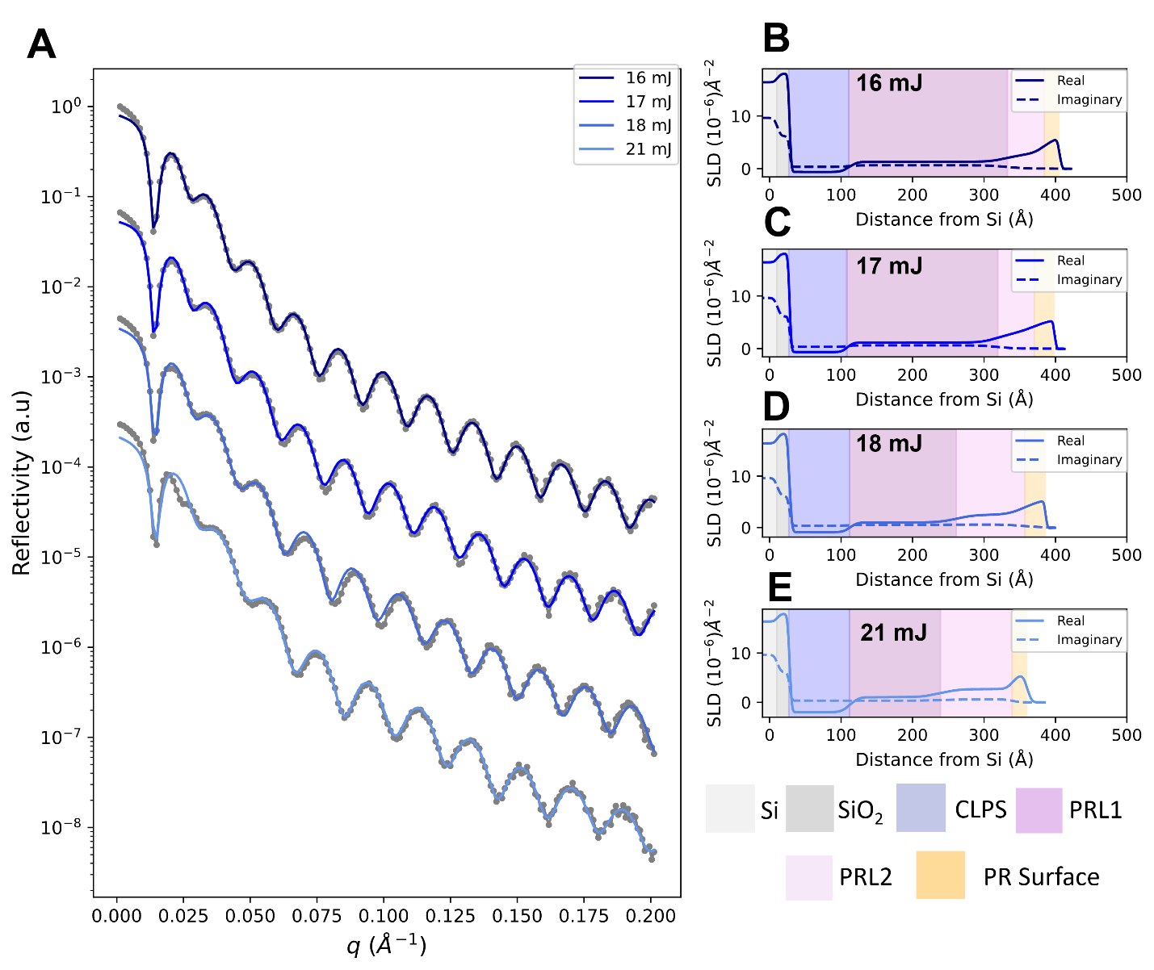
Figure 3: A) Reflectivity data (grey circles) collected on the exposed resist before baking at EUV doses between 16 mJ to 21 mJ. The fits are simulated from the SLD profiles shown in parts 3B to 3E. Each sample required a four layer model (1 for the CLPS, 3 for the photoresist) in order to best fit the data. A comparison with the three layer model is included in the SI. See Figure 6 for trends in SLD vs dose.
LARIAT measurements provide insight into the chemistry at the film surface and complement the depth profiles obtained via RSoXR. Figure 4A – 4C shows the carbon edge spectra obtained from LARIAT measurements of the unexposed, exposed, and baked samples (all with doses of 21 mJ). The inset shows an example of the exposed sample obtained at 285 eV, where clear differentiation between the exposed area and the surrounding unexposed area can be observed. The spectra were obtained by integrating over a 250 pixel x 250 pixel area at the center of the exposed region. The experimental curves are fit by a building block model which combines gaussian curves at peak positions with a step edge.⁴⁴ Using this type of approach the relative concentration between the different functional groups can be determined. Fits between samples are constrained so that the peak positions and widths are held to be identical and only the peak intensity is allowed to vary. Several important features can be observed in the spectra comparing the exposed and unexposed areas that provide insight into the chemical changes that occur at the film surface. Peaks are determined to be at 285.1 eV (generally associated with aromatic rings), 287.4 eV, 288.4 eV, a shoulder at 290.1 eV, and a peak at 296 eV (which likely corresponds to C-F bonds). Upon exposure the peak at 287.4 eV shows a reduction in intensity, as shown based on the peak area normalized to the step edge height in the bar graph in Figure 4E , likely due to the loss of that part of the resist during cleaving of a labile group during EUV exposure. This leads to an increase in the normalized intensity of the peaks at 285.1 and 288.4 eV, which corresponds to an increase in the concentration of those bonds relative to the total carbon content. A-priori knowledge of the chemistry combined with reference spectra can enable a more quantitative interpretation of these results. Simulations of NEXAFS spectra can also be useful in understanding these relationships, although it remains challenging to accurately predict both the peak intensity and position.⁴⁵ Coupled with knowledge of the chemical structure, these spectra can be used to assign specific chemical changes that occur at each step and can be used as a guide to interpret changes in the SLD from the RSoXR measurements.²⁷
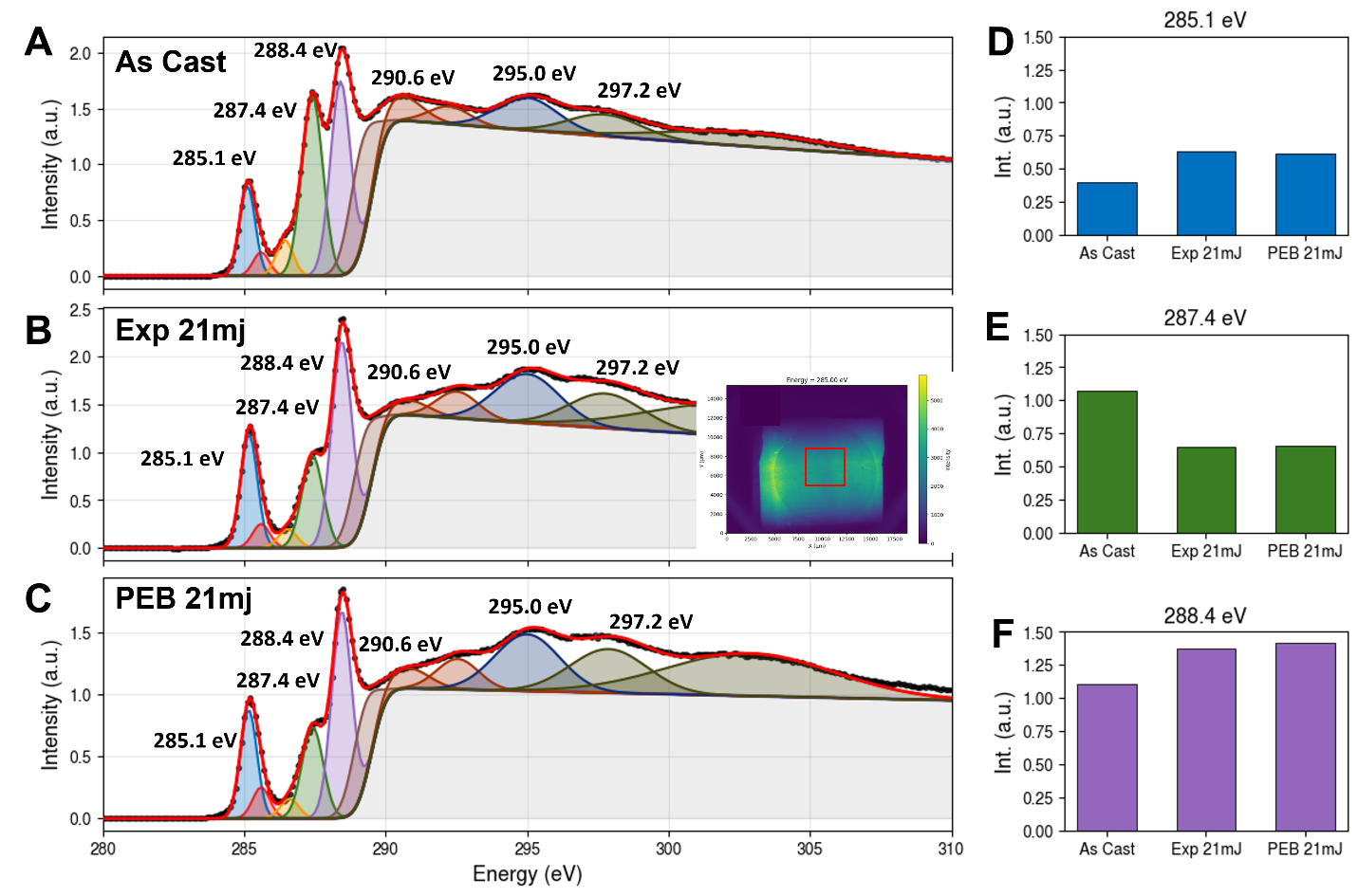Figure 4: Carbon edge spectra obtained from LARIAT measurements. Figures A (As cast), B (Exposed 21 mJ) and C (PEB 21 mJ) show the spectra integrated from a 250 pixel x 250 pixel area from the center of the image at each measured energy. The inset at the top right shows an image taken from the LARIAT microscope at 285 eV of the sample after exposure with a 21 mJ dose.Parts D,E, and F show the peak area for selected peaks normalized by the step edge height. Part D (285.1 eV) typically originates from aromatic rings, part E (287.4 eV) is generally correlated with C-H bonds, and part F (288.4 eV) is typically assigned to carbonyl groups.

Reflectivity measurements at 282 eV were also collected after the PEB step (Figure 5A, along with the corresponding SLD profiles for each fit in Figures 5B to 5E), revealing an interesting shift in the composition profile compared to the samples after exposure. The measurements no longer requires a four layer model to provide the best fit, instead three layers (1 for the CLPS and 2 for the PR) now result in complete fits to the data. Additional layers do not improve the fit and introduce significant parameter correlations. This result shows that the chemical reaction initiated by the EUV exposure is driven to completion by the PEB, and the only stratification remaining in the resist is the higher density layer at the film surface. There is a clear monotonic increase in the SLD of the PR as a function of dose that is observable in both the SLD plots and in the shift of the critical edge of the data (best observed by tracking the increase in the q position of the first minima as a function of dose). For easier comparison the SLD values of the resist layer, along with the SLD values of the unexposed resist and the L1/L2 for the exposed resist are shown in Figure 6.

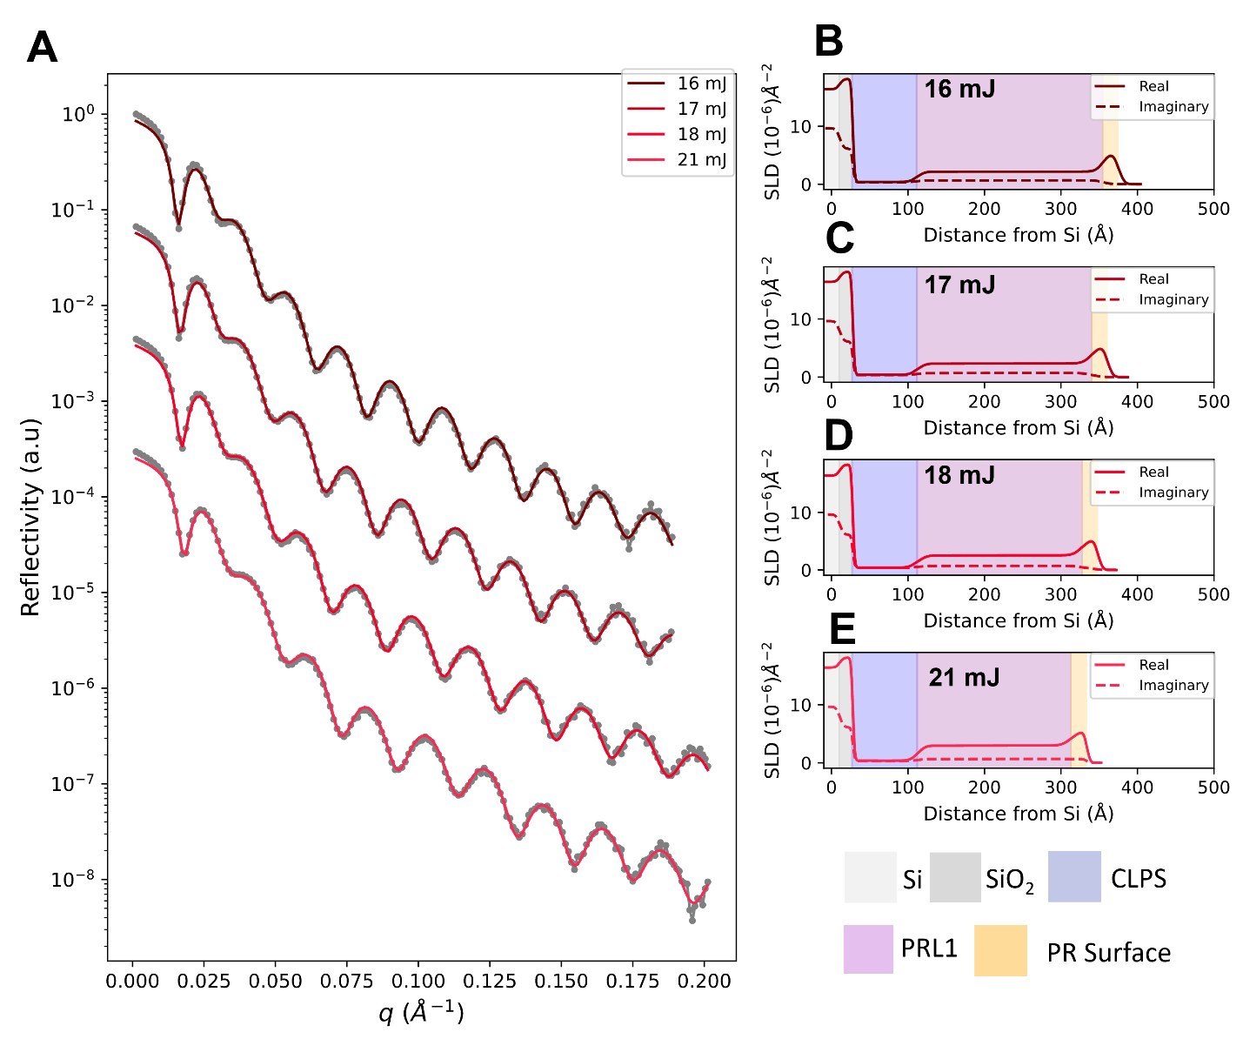Figure 5: A) Reflectivity data (grey circles) collected on the exposed resist after baking at EUV doses between 16 mJ to 21 mJ. The fits are simulated from the SLD profiles shown in parts 5B to 5E. Each sample required a three-layer model (1 for the CLPS, 2 for the PR) to best fit the data. See Figure 6 for trends in SLD vs dose.
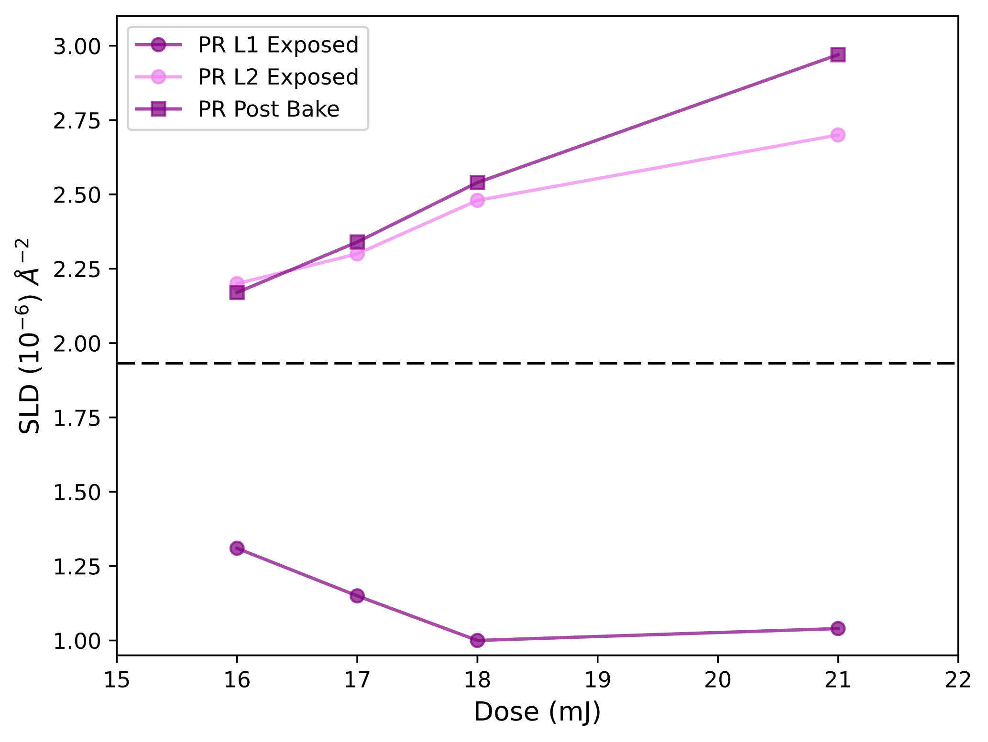
Figure 6: Real component of the SLD at 282 eV for each layer in the resist for the unexposed (dashed line), exposed (L1, L2 see SLD profiles in Figure 3) and exposed/baked resist (See SLD profiles in Figure 5).
After tracking the changes that occur in the PR during processing we now turn to examining the CLPS mat, which was characterized through a combination of both RSoXR and the LARIAT microscopy after the resist was stripped. Figure 7 shows the spectra at the carbon and oxygen edges before and after exposure, with the samples after exposure being compared at 16 mJ and 21 mJ. The carbon edge spectra of the CLPS mat matches well with other literature reports of PS, being dominated by a sharp peak for the aromatic rings at 285 eV.^{39,46} The oxygen edge spectra of the CLPS show a sharp peak at 532 eV and a broader peak at 540 eV. The peak at 532 eV corresponds with the position that carbonyl bonds are typically observed at, which likely occurs due to the glycidyl methacrylate that is often integrated into the CLPS mat in order to form the cross-links.⁴⁷ Characterization of the CLPS after development shows a number of interesting changes. The carbon edge spectra of the CLPS is nearly identical to the developed sample after a 21 mJ dose , suggesting that the chemistry is similar, although when this comparison is complemented with measurements at other edges and the reflectivity data its clear there are additional components present in the system. The measurements of the 16 mJ sample show a reduced intensity of the aromatic ring peak, indicating that there is likely some residual undeveloped resist still present, which would dilute the concentration of the aromatic ring. A small increase in the intensity of the peak at 288 eV corresponds to the presence of residual resist, since that peak was the most prominent in the resist. The oxygen edge spectra show changes in a key feature, the peak at 532 eV is significantly reduced after a 16 mJ exposure and then nearly eliminated at 21 mJ There are two possible explanations for the removal of this peak, the first is that there is a layer at the surface that obscures the presence of this peak, since LARIAT is surface sensitive (biased towards the top several nm, which for the CLPS layer still represents a significant fraction of the film). However, the carbon edge spectra at 21 mJ is very similar to the as-prepared CLPS, indicating that at the film surface there is minimal residual resist. The second is that a process associated with the EUV exposure breaks the carbonyl bonds in the CLPS mat, which could have significant repercussions on the performance of the CLPS layer for DSA, as its use is predicated on the cross-linking of the mat screening the interactions of the BCP from the underlying surface. It is unlikely the EUV exposure by itself would be sufficient to cause this change, however it may be possible that the PAG, activated by the EUV exposure, contributes to the breakdown of the carbonyl groups. A noticeable difference is also observed when comparing the fluorine edge between the as-cast film and the residual fluorine found on the CLPS mat (Figure S3). The fluorine edge in the as-cast resist shows a broad peak, which likely consists of at least two underlying chemistries that contribute to the overall peak shape. The fluorine edge spectra from the 16 mJ developed sample (dose with incomplete cure) shows a peak at 691 eV, followed by a broader peak. Again, there are several possible interpretations of this result; the broad peak could result from a minority component in the resist which is either less soluble in the developer and/or more miscible with the CLPS and therefore more likely to be present after incomplete development. Whether this is a component present in the original resist, or a byproduct of the reactions that occur during processing, would require further investigation.

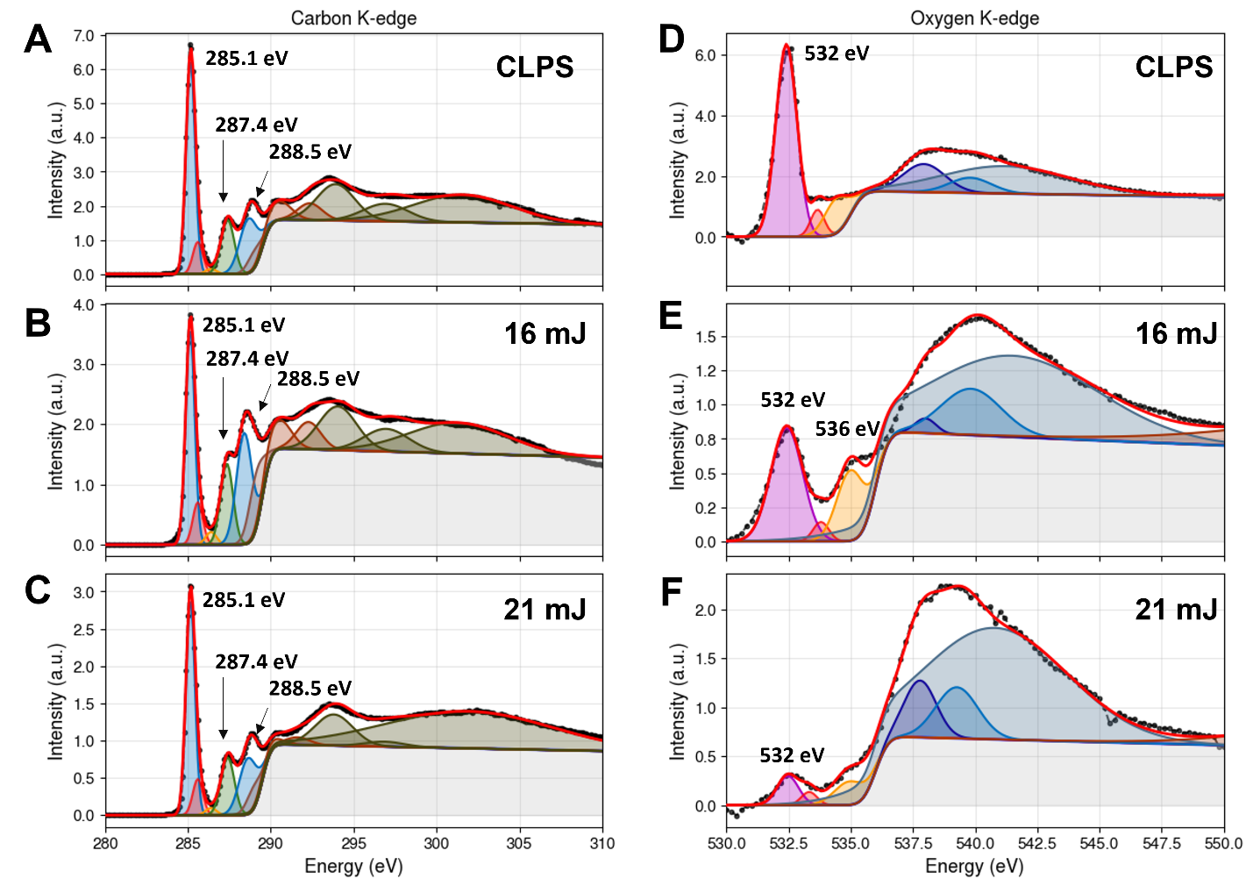
Figure 7: NEXAFS spectra obtained from LARIAT measurements at the carbon edge and oxygen edges for the CLPS and the resist stack after development for exposures of 16 mj and 21 mj. At the carbon characteristic peaks associated with PS are observed, in particular the peak at 285 eV which corresponds to the π* transition of the aromatic rings and the C-H σ* transition at 287.3 eV. At the oxygen edge peaks are observed at 532 eV, which typically corresponds to the C=O π* transition and a broad peak around 539 eV to 540 eV, which corresponds to C-O σ*. Measurements at 16 mj show a reduced intensity of the aromatic peaks relative to the step edge, indicating the presence of some residual resist in addition to the CLPS. Reduction of the peak at 532 eV in the oxygen edge with increased dose suggests removal of the C=O bonds, possibly due to a chemical change in the crosslinks.

RSoXR measurements were conducted on the CLPS mat, as well as on the developed samples at a series of energies between 270 eV and 290 eV. The real components of the SLD are shown in Figure 8, with parts 8B to 8E highlighting how the SLD changed at each energy as a function of dose. These measurements were performed on a sister set of samples from the previously described set, and probed doses between 17 mJ to 23 mJ. The films were found to be approximately 1 nm thicker compared with the original sample. Measurements at 270 eV show a monotonic increase in the SLD as a function of dose. The real component of the SLD at 270 eV is far enough below the edge that it can be considered mostly non-resonant, and the changes will occur primarily due to the change in density. Changes in other key energies are shown in Figures 8C, 8D and 8E. These correspond to energies that highlight changes in the concentration of the aromatic rings (8C) and sp2 hybridized bonds (8D, 8E). The results strongly suggest that subtle but meaningful changes are occurring in the concentration of chemical bonds within the CLPS. Changes in the sp2 bonds could correspond to the possible bond breaking that was speculated to be occurring based on the disappearance of the peak at 532 eV in the LARIAT spectra. The non-monotonic change in intensity in Figure 8E could be due to the convolution of changes in the intensity of multiple local peaks with the total carbon content. There are also likely contributions due to residual components from the CAR, as supported by the presence of fluorinated components in the LARIAT spectra. Either of these changes will contribute to the interactions of the resist with the BCP and potentially lead to defects after DSA.
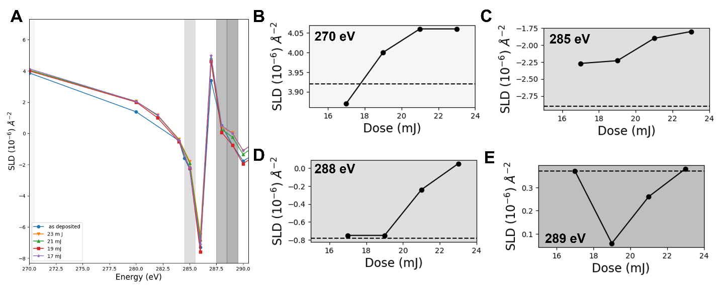
Figure 8: A) Real component of the SLD for the polymer brush measured both as cast and after development with different exposure doses. Highlighted energies correspond to parts B) 270 eV, C) 285 eV, D) 288 eV, and E) 289 eV. Different energies highlight changes in different functional groups, with 270 eV being more sensitive to density, 285 eV to the concentration of aromatic rings and 288 eV/289 eV being more sensitive to carbonyl bonds. Dashed lines in parts B-E indicate the SLD of the as-prepared CLPS.

Conclusions
EUV photoresists provide different characterization challenges compared to previous generations of resist materials. As resist layers become thinner it is becoming more important to interrogate the depth profile of resist/underlayer stacks to fully understand how EUV exposure changes the chemistry and how segregation of different components may play a role in those processes. In this study we observed segregation of one of the resist components to the top of the film stack. Exposed samples showed stratification in the chemical reaction, with a different change in the SLD near the surface of the film compared to the bottom. This raises a number of important questions, including whether the stratification in the reaction was due to the segregation of the resist component near the surface of the film. Further investigations of this phenomena could shed light on pathways to more efficiently exposing EUV resists and promoting complete reaction with lower EUV doses. Examining of the CLPS mat after exposure shows that there were a number of chemical changes, including the potential for infiltration via resist components, or cleaving of carbonyl bonds. These changes could lead to detrimental behavior of the CLPS mat as a guiding pattern for the DSA of BCPs.
While the exact chemistry of the materials used in this study cannot be disclosed, the process demonstrated here provides a roadmap to utilizing RSoXR to help probe distributions of different photoresist components in next generation resists. Very often individual photoresist components will have unique handles that can be used to track their distributions. The set of experimental methods described in this manuscript can be further expanded to provide a more complete characterization of the nanoscale chemical distribution within a film. This can include measurements at additional energies to target specific functional groups of interest and complementary energy scans at specific angles to collect data efficiently to reduce dose that occurs during the measurement.With the appropriate set of references the optical constant profiles obtained from this measurement can be converted directly to functional group concentrations, providing a direct measurement of the chemistry.²² A key result from these measurements is that it is possible to collect RSoXR curves without significant changes to the chemistry in the film, even for the as-cast resist (although exposing the film for too long does result in clear changes based on comparing measurements low angle measurements taken before and after the curves were collected). Going forward both RSoXR and NEXAFS have the potential to be important complements to the existing industrial toolbox and enable better characterization of novel EUV resists.
Data Availability
Data is available upon request.
Acknowledgements
This research used resources SST1 of the National Synchrotron Light Source II, a U.S. Department of Energy (DOE) Office of Science User Facility operated for the DOE Office of Science by Brookhaven National Laboratory under Contract No. DE-SC0012704. The Advanced Light Source is supported by the Director, Office of Science, Office of Basic Energy Sciences, of the U.S. Department of Energy under Contract No. DE-AC02-05CH11231. We thank Eric Gullikson for assistance at BL. 6.3.2.
Disclosures
The authors declare there are no financial interests, commercial affiliations, or other potential conflicts of interest that have influenced the objectivity of this research or the writing of this paper
References
1. S. Ghosh et al., “Recent advances in non-chemically amplified photoresists for next generation IC technology,” RSC Adv. 6(78), 74462–74481 (2016) [doi:10.1039/C6RA12077F].
2. C. K. Ober, F. Käfer, and C. Yuan, “Recent developments in photoresists for extreme-ultraviolet lithography,” Polymer 280, 126020 (2023) [doi:10.1016/j.polymer.2023.126020].
3. P. De Bisschop et al., “Impact of stochastic effects on EUV printability limits,” presented at SPIE Advanced Lithography, 17 April 2014, 904809 [doi:10.1117/12.2047827].
4. P. Naulleau et al., “Stochastics and EUV Patterning in the 1x-nm Regime,” 6, J. Photopol. Sci. Technol. 29(6), 797–802 (2016) [doi:10.2494/photopolymer.29.797].
5. E. D. Thilakarathna et al., “Controlling chemical segregation in EUV resists by varying viscosity and evaporation rate during the spin coating process,” in Advances in Patterning Materials and Processes XLI, D. Guerrero and G. R. Amblard, Eds., p. 8, SPIE, San Jose, United States (2024) [doi:10.1117/12.3010930].
6. M. Muramatsu et al., “Randomness of Polymer Microstructure in the Resist Film as Shot Noise,” J. Photopol. Sci. Technol. 34(1), 55–62 (2021) [doi:10.2494/photopolymer.34.55].
7. A. Tiwari et al., “The interface study of photoresist/underlayer using hybrid x-ray reflectivity and x-ray standing wave approach,” in Metrology, Inspection, and Process Control XXXVIII, M. J. Sendelbach and N. G. Schuch, Eds., p. 4, SPIE, San Jose, United States (2024) [doi:10.1117/12.3010917].
8. K. Lee et al., “High-resolution chemical patterns from negative tone resists for the integration of extreme ultraviolet patterns of metal-oxide resists with directed self-assembly of block copolymers,” Journal of Vacuum Science & Technology B 42(6), 062804 (2024) [doi:10.1116/6.0004046].
9. S. Yun et al., “Defect Rectification in High‐Density Patterns through Directed Self‐Assembly of Advanced Block Copolymer Architectures,” Adv Funct Materials, 2422231 (2025) [doi:10.1002/adfm.202422231].
10. I. Pollentier et al., “BEFORCE: a pathway to unravel metal oxide resist (MOR) reactions upon EUV exposure, bake, and environment,” in International Conference on Extreme Ultraviolet Lithography 2024, J.-H. Franke et al., Eds., p. 31, SPIE, Monterey, United States (2024) [doi:10.1117/12.3034708].
11. V. Spampinato et al., “SIMS Analysis of Thin EUV Photoresist Films,” Anal. Chem. 94(5), 2408–2415 (2022) [doi:10.1021/acs.analchem.1c04012].
12. H. Mei et al., “Characterization of polymeric surfaces and interfaces using time‐of‐flight secondary ion mass spectrometry,” Journal of Polymer Science 60(7), 1174–1198 (2022) [doi:10.1002/pol.20210282].
13. J. Cruz et al., “Evaluating nanoscale molecular homogeneity in extreme ultraviolet resists with nanoprojectile secondary ion mass spectrometry,” J. Micro/Nanopattern. Mats. Metro. 21(04) (2022) [doi:10.1117/1.JMM.21.4.044001].
14. G. Swieca et al., “Inspection of next generation EUV resists with nano-projectile SIMS,” in International Conference on Extreme Ultraviolet Lithography 2024, J.-H. Franke et al., Eds., p. 89, SPIE, Monterey, United States (2024) [doi:10.1117/12.3037084].
15. B. A. Collins and E. Gann, “Resonant soft X‐ray scattering in polymer science,” 7, Journal of Polymer Science 60(7), 1199–1243 (2022) [doi:10.1002/pol.20210414].
16. G. H?hner, “Near edge X-ray absorption fine structure spectroscopy as a tool to probe electronic and structural properties of thin organic films and liquids,” 12, Chemical Society Reviews 35(12), 1244 (2006) [doi:10.1039/b509853j].
17. R. Fallica et al., “Chemical changes in hybrid photoresists before and after exposure by in situ NEXAFS analysis,” in SPIE Proceedings 10146, C. K. Hohle and R. Gronheid, Eds., p. 101461F, SPIE, San Jose, California, United States (2017) [doi:10.1117/12.2258215].
18. J. L. Lenhart et al., “X-ray Absorption Spectroscopy To Probe Surface Composition and Surface Deprotection in Photoresist Films,” Langmuir 21(9), 4007–4015, American Chemical Society (ACS) (2005) [doi:10.1021/la047160z].
19. J. Y. Kim et al., “Spatial Control of the Self-assembled Block Copolymer Domain Orientation and Alignment on Photopatterned Surfaces,” 20, ACS Appl. Mater. Interfaces 12(20), 23399–23409 (2020) [doi:10.1021/acsami.0c02997].
20. J. E. Baio et al., “Multiplexed Orientation and Structure Analysis by Imaging Near-Edge X-ray Absorption Fine Structure (MOSAIX) for Combinatorial Surface Science,” Anal. Chem. 85(9), 4307–4310 (2013) [doi:10.1021/ac4003479].
21. D. F. Sunday and R. J. Kline, “Reducing Block Copolymer Interfacial Widths through Polymer Additives,” 3, Macromolecules 48(3), 679–686 (2015) [doi:10.1021/ma502015u].
22. D. F. Sunday et al., “Functional group quantification of polymer nanomembranes with soft x-rays,” 3, Physical Review Materials 2(3), 032601 (2018) [doi:10.1103/PhysRevMaterials.2.032601].
23. D. F. Sunday et al., “Characterizing the Interface Scaling of High χ Block Copolymers near the Order–Disorder Transition,” 1, Macromolecules 51(1), 173–180 (2018) [doi:10.1021/acs.macromol.7b01982].
24. D. F. Sunday et al., “Self-Assembly of ABC Bottlebrush Triblock Terpolymers with Evidence for Looped Backbone Conformations,” 18, Macromolecules 51(18), 7178–7185 (2018) [doi:10.1021/acs.macromol.8b01370].
25. D. F. Sunday et al., “Influence of Additives on the Interfacial Width and Line Edge Roughness in Block Copolymer Lithography,” Chem. Mater., acs.chemmater.9b04833 (2020) [doi:10.1021/acs.chemmater.9b04833].
26. T. J. Ferron et al., “Characterization of the Interfacial Orientation and Molecular Conformation in a Glass-Forming Organic Semiconductor,” 2, ACS Appl. Mater. Interfaces 14(2), 3455–3466 (2022) [doi:10.1021/acsami.1c19948].
27. T. J. Ferron et al., “Composition Dictates Molecular Orientation at the Heterointerfaces of Vapor-Deposited Glasses,” 7, JACS Au 3(7), 1931–1938 (2023) [doi:10.1021/jacsau.3c00168].
28. M. Mezger et al., “Molecular orientation in soft matter thin films studied by resonant soft x-ray reflectivity,” 15, Physical Review B 83(15), 155406 (2011) [doi:10.1103/PhysRevB.83.155406].
29. F. S. Bates and G. H. Fredrickson, “Block copolymer thermodynamics: theory and experiment,” 1, Annual Review of Physical Chemistry 41(1), 525–557 (1990).
30. A. N. Semenov, “Theory of block copolymer interfaces in the strong segregation limit,” 24, Macromolecules 26(24), 6617–6621 (1993) [doi:https://doi.org/10.1021/ma00076a047].
31. R. Ruiz et al., “Density Multiplication and Improved Lithography by Directed Block Copolymer Assembly,” 5891, Science 321(5891), 936–939 (2008) [doi:10.1126/science.1157626].
32. C.-C. Liu et al., “Towards an all-track 300 mm process for directed self-assembly,” 6, Journal of Vacuum Science & Technology B: Microelectronics and Nanometer Structures 29(6), 06F203 (2011) [doi:10.1116/1.3644341].
33. C.-C. Liu et al., “Chemical Patterns for Directed Self-Assembly of Lamellae-Forming Block Copolymers with Density Multiplication of Features,” 4, Macromolecules 46(4), 1415–1424 (2013) [doi:10.1021/ma302464n].
34. L. Verstraete et al., “Mitigating stochastics in EUV lithography by directed self-assembly,” in Novel Patterning Technologies 2023, J. A. Liddle and R. Ruiz, Eds., p. 27, SPIE, San Jose, United States (2023) [doi:10.1117/12.2657939].
35. J. Van Bel et al., “Rectification of extreme ultraviolet lithography patterns by directed self-assembly: a roughness and defectivity study,” J. Micro/Nanopattern. Mats. Metro. 23(04) (2024) [doi:10.1117/1.JMM.23.4.043001].
36. H. Feng et al., “Optimized design of block copolymers with covarying properties for nanolithography,” 12, Nat. Mater. 21(12), 1426–1433 (2022) [doi:10.1038/s41563-022-01392-1].
37. H. S. Suh et al., “Thickness Dependence of Neutral Parameter Windows for Perpendicularly Oriented Block Copolymer Thin Films,” 10, Macromolecules 43(10), 4744–4751 (2010) [doi:10.1021/ma100150j].
38. E. Han et al., “Effect of Composition of Substrate-Modifying Random Copolymers on the Orientation of Symmetric and Asymmetric Diblock Copolymer Domains,” 23, Macromolecules 41(23), 9090–9097 (2008) [doi:10.1021/ma8018393].
39. D. F. Sunday et al., “Determination of the Internal Morphology of Nanostructures Patterned by Directed Self Assembly,” 8, ACS Nano 8(8), 8426–8437 (2014) [doi:10.1021/nn5029289].
40. T. Ferron et al., “Absolute intensity calibration for carbon-edge soft X-ray scattering,” 6, J Synchrotron Rad 27(6) (2020) [doi:10.1107/S1600577520011066].
41. “Certain Commercial Equipment, Instruments, or Materials Are Identified in This Paper in Order to Specify the Experimental Procedure Adequately. Such Identification Is Not Intended to Imply Recommendation or Endorsement by the National Institute of Standards and Technology, nor Is It Intended to Imply That the Materials or Equipment Identified Are Necessarily the Best Available for the Purpose.”
42. D. A. Fischer et al., “Mapping Surface Chemistry and Molecular Orientation with Combinatorial Near‐Edge X‐Ray Absorption Fine Structure Spectroscopy,” Macromol. Rapid Commun. 25(1), 141–149 (2004) [doi:10.1002/marc.200300178].
43. B. L. Henke, E. M. Gullikson, and J. C. Davis, “X-ray Interactions: photoabsorption, scattering, transmission and reflection at E=50-30000 eV, Z=1-92,” 2, Atomic Data and Nuclear Data Tables 54(2), 181–342 (1993).
44. B. Watts et al., “Calibrated NEXAFS spectra of common conjugated polymers,” 2, The Journal of Chemical Physics 134(2), 024702 (2011) [doi:10.1063/1.3506636].
45. G. M. Su et al., “Chemical and Morphological Origins of Improved Ion Conductivity in Perfluoro Ionene Chain Extended Ionomers,” 34, J. Am. Chem. Soc. 141(34), 13547–13561 (2019) [doi:10.1021/jacs.9b05322].
46. H. Ade and A. P. Hitchcock, “NEXAFS microscopy and resonant scattering: Composition and orientation probed in real and reciprocal space,” 3, Polymer 49(3), 643–675 (2008) [doi:10.1016/j.polymer.2007.10.030].
47. C.-C. Liu et al., “Fabrication of Lithographically Defined Chemically Patterned Polymer Brushes and Mats,” 7, Macromolecules 44(7), 1876–1885 (2011) [doi:10.1021/ma102856t].

