How “pro” are probiotics for wildlife species? Novel data, lack of evidence, and future directions

Running title: Commercial probiotic use in wildlife

Sally L. Bornbusch^{1,2}*, Piper R. Thacher^{1,3}, Marlitza Francisque⁴, Alexandra L. DeCandia^{1,5}, Robyn Bortner⁶, Della Garelle⁶, Erin L. Kendrick², Michael T. Maslanka², Carly R. Muletz‐Wolz^{1,7}

¹ Smithsonian's National Zoo and Conservation Biology Institute, Center for Conservation Genomics, Washington, DC 20008, USA
² Smithsonian's National Zoo and Conservation Biology Institute, Department of Nutrition Science, Washington, DC 20008, USA
³ George Mason University, Smithsonian Mason School of Conservation, Department of Environmental Science and Policy, Fairfax, VA 22030, USA
⁴ Pennsylvania State University, Department of Biomedical Engineering, University Park, PA USA 16802, USA
⁵ Georgetown University, Department of Biology, Washington, DC USA 20057, USA
⁶ U.S. Fish and Wildlife Service, National Black-Footed Ferret Conservation Center, Carr, CO 80612, USA
⁷ National Institute for Standards and Technology, Complex Microbial Systems Group, Gaithersburg, MD 20899, USA

*Corresponding author

Corresponding author address:
Sally Bornbusch
Center for Conservation Genomics
Smithsonian’s National Zoo and Conservation Biology Institute
3001 Connecticut Ave NW
Washington, DC 20008 USA

Abstract

Treatments that aim to purposefully manipulate host-associated microbiomes are now prevalent in human and animal medicine. Probiotics that contain live bacteria are purported to improve microbiome function and host health. Although research is advancing, commercial probiotic development has outpaced empirical study of probiotic efficacy. Probiotics are widely used in ex-situ wildlife care despite a lack of empirical study or support. We interrogate the relevance of commercial probiotics in ex-situ wildlife by (a) sequencing the composition of commercial probiotics used to treat wildlife, (b) comparing the probiotic sequences to data on the microbiomes of > 900 animal species, and (c) characterizing the effects of a commercial probiotic on probiotic colonization, prevalence of a potential enteric pathogen (Clostridium perfringens), and metagenomic function in endangered black-footed ferrets (Mustela nigripes). We found mislabeling and potential contaminants in probiotics marketed for a range of species. The probiotic bacteria were rare or absent in published animal microbiomes. In ferrets, probiotic treatment induced minimal probiotic colonization, negligible functional change, and limited influence on the potential enteric pathogen. Given our findings, which reiterate concerns about the efficacy of commercial probiotics across human and animal sectors, greater effort must be put towards identifying species-specific probiotic candidates and studying alternative microbial therapies for wildlife under human care.

Keywords: Commercial probiotics, animal microbiomes, microbial therapies, conservation, husbandry, endangered species, wildlife, black-footed ferrets, applied microbial ecology

Introduction

The development of treatments that purposefully modulate host-associated microbiomes has accelerated dramatically, capitalizing on scientific and public awareness of microbiomes. Probiotics are increasingly marketed in products for humans and domesticated animals as supplements and in foods [1–3]. Recently, probiotics have been incorporated into the care of wildlife species at zoos and through conservation efforts [4–7], despite limited empirical research on commercial probiotic effects in wildlife species. We argue that the production and marketing of commercial probiotics, particularly for wildlife species, has outpaced empirical, safety and efficacy research. Given the variation in microbial structure and function across animal species [8–13], probiotics should be studied within microbial ecology frameworks and in the context of the recipient’s ecological, physiological, and microbial requirements.

To underscore the need for probiotic research in non-model animals, we provide brief context on commercial probiotic production. The definition of probiotics by the World Health Organization and the Food and Agriculture Organization of the United Nations is: “live microorganisms that, when administered in adequate amounts, confer a health benefit on the host” [14]. In the U.S., oversight of commercial probiotics falls under the purview of the Food and Drug Administration (FDA), which defines probiotics as “direct-fed microbial products that are purported to contain live (viable) microorganisms (bacteria and/or yeast)” (defined in 1988, updated in 1995; [15–17]. The FDA allows manufacturers to market probiotics as dietary supplements, which undergo minimal safety testing and are only subject to post-market FDA regulation. There is no requirement that probiotic supplements be effective at influencing host health nor be tested in the target host species. This has allowed for extensive production of commercial probiotics, most of which lack empirical evidence supporting their use in wildlife and other animal species.

Extensive study of human microbiomes has identified probiotic species, such as Lactobacillus and Bifidobacterium members, that are considered beneficial [18, 19] and are now used in animal probiotics either in single- or multi-strain probiotic products [1, 20–24]. Lactobacillus and Bifidobacterium, along with other single- and multi-strain probiotic products, have been used for a wide range of health and productivity outcomes in agricultural and companion animals, including the treatment of GI concerns and enteric infections [3, 25–28]. Bacteria in animal microbiomes are host-specific [29–31] and the interactions between probiotic species and an animals’ native microbiome will differ by host species and physiology. For example, Lactobacillus probiotics are considered beneficial in humans and, when used appropriately, can help maintain GI health in livestock [32, 33]. However, overabundances of lactobacilli in ruminants, combined with high-grain diets rich in fermentable carbohydrates, can cause an over-production of lactic acid and lead to potentially fatal ruminal acidosis [34, 35]. This highlights the importance of considering probiotics within the ecological and physiological contexts of the host species.

Identifying probiotics by mining host-specific microbial data, isolating, and preserving microbial candidates is an ecologically grounded approach that can yield probiotics that successfully promote health in the target host species [5]. Notable examples in wildlife include probiotic treatments for diseases such as chytridiomycosis in amphibians [36–39], white-nose syndrome in bats [40–42], snake fungal disease [43], and multiple pathogens and parasites in invertebrates such as corals [44, 45] and bees [46–48]. Nevertheless, most wildlife-care facilities lack the scientific capacity for developing targeted probiotics, instead relying on accessible commercial probiotics to treat animals. A primary reason for the use of commercial probiotics in ex-situ wildlife is the high prevalence of gastrointestinal issues (e.g., Clostridium, and Helicobacter spp., gastroenteritis), which mirror diseases seen in humans. Certain wildlife species and individuals are more vulnerable to gastrointestinal afflictions. Black-footed ferrets (Mustela nigripes; BFFs), for example, are endangered, obligate carnivores that are susceptible to GI distress and infection, with Clostridium perfringens being one of the causes of morbidity and mortality in ex-situ BFFs [49–52]. Previous research has demonstrated that C. perfringens is present and, in some cases, abundant among the microbiomes of clinically healthy ex situ BFFs [53], indicating that it is a native gut bacterium. Although acutely pathogenic C. perfringens infections are characterized by enterotoxin production, it is unclear why or how C. perfringens shifts from commensal to pathogenic [54]. There is thus a need for microbial therapies with the specific aim of improving GI health in ex-situ BFFs.

Our goal for this study was to assess probiotic products and practices being used in the care of diverse ex-situ wildlife. Given the regulation and rapid production of commercial probiotics, we hypothesized that probiotics used in wildlife care would not be congruent with wildlife microbial ecology. To test this hypothesis, we first identified commercial probiotics actively being used to treat wildlife species at U.S. zoos and performed 16S rRNA amplicon sequencing to assess probiotic membership. We then compared the commercial probiotic sequences to publicly available gut microbiome data for > 900 wildlife species [55]. Given the host specificity of gut bacteria, we expected that the commercial probiotic microbes would not be abundant in animal communities. Finally, to test the influence of a commercial probiotic in wildlife, we performed a control-treatment trial of a prophylactic probiotic in BFFs, using 16S rRNA amplicon and shotgun metagenomic sequencing to examine rates of colonization, changes in C. perfringens prevalence, bacterial network associations, and variation in microbial function. Given anecdotal indication that this specific commercial probiotic lowered BFF morbidity, we expected moderate colonization of probiotic microbes and shifts in microbial function reflecting health-promoting functional pathways.

Materials and Methods

Probiotic identification and processing

We surveyed 14 U.S. zoos on whether commercial probiotics were used in the care of their animal and, if so, which products were used. From this survey, we identified 11 probiotics that we actively being used in zoo wildlife species and purchased the 11 probiotics from the manufacturers. We prepared the probiotics for DNA extraction by homogenizing 1g of probiotic material with 250 uL of UV-sterilized, ultrapure type 1 MilliQ Q-POD® water. The probiotics were extracted in random order, in quadruplicate, and all probiotics were extracted, prepared, and sequenced in one batch (See Supplementary Information for additional probiotic handling and processing information).

Ferret experimental design and sample collection

Study subjects included 24 healthy BFFs housed at the U.S. Fish and Wildlife Ferret Conservation Center (FCC) (Table S1; See Supplementary Information for details on BFF husbandry). BFFs were split into two experimental groups with relatively even sex ratios and age ranges (Table S1): Controls (CON, n = 12) and probiotic-treated animals (PBX; n = 12). For probiotic treatment, we selected a multi-strain probiotic that had previously been used prophylactically in FCC BFFs, with anecdotal suggestion that it decreased incidences of GI distress. But the probiotic had never been empirically tested in BFFs. The probiotic was labeled with eight bacterial species - six Lactobacillus and two Bifidobacterium (see Table S2 for complete list of probiotic ingredients). For PBX animals, we followed the manufacturer’s instructions and mixed ~0.5 g of probiotic powder into the diet daily for 7 days during week three of the experiment (W3, Day 0 to 6) and animal caretakers monitored to ensure the diet was completely consumed.

Fresh fecal samples (<4 h post defecation) were collected from all ferrets twice weekly before, during, and after the probiotic trial, spanning six weeks (W1 to W6). Fecal samples were collected in sterile tubes and stored at -80 °C until being shipped on dry ice to the Center for Conservation Genomics at the Smithsonian’s National Zoo and Conservation Biology Institute. All animal protocols were approved by the U.S. Fish and Wildlife BFF Recovery Program and the National BFF Conservation Center IACUC committee (NBFFCC IACUC # 2022-4).

Preparation and sequencing of probiotic and ferret samples

DNA extractions of probiotic and ferret samples were performed using the DNeasy PowerSoil Pro QIAcube HT kit following the manufacturer’s protocol (QIAGEN, Germany). We additionally extracted negative controls (empty tubes) and positive controls (ZymoBIOMICS microbial community; Zymo, Irvine, CA, USA; Catalog No. D6300). For 16S rRNA amplicon sequencing of all samples, we prepared DNA libraries for the V3 to V5 region (515F-Y and 939R primers) using a previously published protocol [53] and sequenced on an Illumina MiSeq run (2 x 300 bp paired-end reads). For shotgun metagenomic sampling, extracted DNA from a subset of ferret samples (n = 72 samples; CON = 9 ferrets, PBX n = 9 ferrets, on Days -11, 3, 9, and 15 corresponding to W1, W3, W4, and W5) was sent to the Oklahoma Medical Research Foundation for library preparation and sequencing on the Illumina NovaSeq platform. See Supplementary Information for details on amplicon and shotgun library preparation methods.

16S amplicon bioinformatics

We used QIIME2 (v. 2023.9) [56] and RStudio (R v. 4.3.2) [57] to process the demultiplexed sequence data. Briefly, we used dada2 in QIIME2 to quality filter and trim sequences, merge forward and reverse reads, remove chimeric sequences, and generate amplicon sequence variants (ASVs) [58]. We assigned taxonomy using a Naïve Bayes classifier pre-trained on SILVA v. 138.1 99 % full-length sequences. We applied the NCBI BLASTn tool to query representative sequences of analytical interest against NCBI GenBank’s 16S rRNA sequences database. Using the decontam package in R [59], we removed 51 potential contaminant ASVs.(60) See Supplementary Information for additional filtering and assessment of spurious ASVs.

We identified potential contaminant ASVs in the commercial probiotics as ASVs that were (a) not present in our negative or positive controls, (b) not removed via decontam, (c) identified in all four replicates of a given probiotic but not present in all 44 probiotic samples (i.e., further ruling out contamination from laboratory protocols or reagents), and (d) not assigned to a genus listed in the probiotic ingredients.

We used Geneious to compare sequences from the commercial probiotics to sequences from a publicly available dataset by on the gut microbiomes of >900 animal species [55]. Given that only our forward primers matched those used in the Song et al. dataset, we only compared forward reads. Additionally, because the Song et al. sequences were trimmed to 100 bp whereas our sequences were over 300 bp, we only considered matching sequences that aligned at the forward end and matched with 100 % sequence identity for the full 100 bp length.

Metagenomic bioinformatics

Raw sequence data were processed using a read-based mapping approach. We first used bowtie2 [60] to remove sequences that mapped to the BFF genome [61]. We used fastp [62] to trim and quality filter reads, trimming Illumina adapters and removing sequences with fewer than 50 reads or phred quality scores less than 20. Resulting filtered data included a total of ~1.3 billion reads across 72 samples, with an average depth of ~18.6 millions reads.

To assign taxonomic identity, we used MetaPhlAn4 (v. 4.1) [63] on concatenated forward and reverse reads, using marker genes identified across microbial whole genomes and metagenome-assembled genomes and grouping into species-level genome bins. We used HUMAnN3 to identify functional gene pathways by mapping sequence reads to pangenomes using bowtie2 and the ChocoPhlAn database and subsequently aligning unmapped reads to non-organismal protein databases with DIAMOND and UniRef90 database [64]. Gene families and pathway abundances were, by default, normalized for gene length (i.e., reads per kilobase), and were normalized for sequencing depth by transforming abundances to copies per million (cpm).

Statistics

To characterize the influence of probiotic treatment on ferret gut microbiomes, we focused on the amplicon data – with greater temporal resolution – for longitudinal analyses and used the metagenomic data to assess variation between the two experimental groups at Days -11, 3, 9, and 15 in relation to probiotic treatment.

For the amplicon data, we calculated measures of bacterial diversity (ASV richness, Shannon diversity, and Faith’s phylogenetic diversity) and bacterial composition (Bray-Curtis, Jaccard, and generalized UniFrac (GUF). We visualized bacterial composition using Principal Coordinate Analysis (PCoA) and tested for variation using PERMANOVAs with experimental group and day as fixed effects and animal as a random effect (adonis2, R). To account for compositionality, we applied centered log-ratio (CLR) transformations to raw sequence counts. To assess variation in bacterial diversity and CLR-transformed abundances, we used hierarchical generalized additive models (HGAMs) across control and treated animals [65]. Our HGAM included terms for group-specific smoothers for each treatment that account for variable response trajectory over time, group-specific intercepts that represent random effects for different treatment intercepts, and random effects for the intercepts of each animal. Smoothing terms that are found to be significant indicate longitudinal trajectories that differ significantly from the null hypothesis of a flat, linear relationship.

To characterize associations between bacterial ASVs, we constructed seven association networks for each experimental group: one that included all samples for the respective group, and one for each of the six sampling weeks (W1-W6). We used Network Construction and Comparison for Microbiome Data (NetCoMi) [66], with CLR normalization, to construct association networks and compare networks between experimental groups. Using these association networks, we further performed differential association analysis and generated differential networks to identify and visualize pairs of taxa that had differential associations across multiple networks. See Supplementary Information for additional details on network construction.

For the shotgun metagenomic data, we calculated two measures of functional diversity (Shannon and Simpson diversity) and two measures of functional composition (Bray-Curtis and Jaccard). We used linear mixed-effect models for strain-level taxonomic and functional diversity and PERMANOVAs of composition to assess variation between treatment groups at specific time points. We additionally used MaAsLin 3 - microbiome multivariable associations with linear models – to assess variation in functional pathways between the two treatment groups across all four timepoints [67]. Our model formula included group and week as fixed effects with animal as a random effect to account for repeat sampling. We further analyzed variation in functional pathway abundance within each timepoint using linear models with group as a fixed effect.

Results

Commercial probiotic membership

The 11 probiotics were labeled for use in a wide variety of domestic animals and “wildlife” (Table 1). The labels included between 1 to 20 bacterial strains, encompassing 24 taxa from 5 genera: Lactobacillus, Bifidobacterium, Pediococcus, Streptococcus, and Enterococcus (Table 1). Enterococcus faecium was labeled in 9 out of 11 probiotics and at least one Lactobacillus sp. was labeled in 9 out of 11 probiotics. Five of the 11 probiotics (P1, P3, P7, P8, & P10) were manufactured by the same company, labeled for respective use in cats, dogs, horses, ruminants, and “multi-species”, and labeled to have the same four microbial members (Table 1). Among these five probiotics: (a) P1 for cats and P3 for dogs had similar membership, dominated by a single Enterococcus ASV, (b) P7 for horses and P8 for ruminants also had similar membership with more equitable representation of Enterococcus and Lactobacillus ASVs, and (c) P10 for “multi-species” had distinct membership. The two probiotics labeled for use in humans – P5 and P6 – showed the least variation in membership among their respective replicates (Figure 1).

We found evidence of 15 potential contaminant ASVs or mislabeled taxa across seven probiotics (Table 2). Although generally rare, contaminant relative abundance ranged from < 0.01 % to 22.1 % within a given sample. Despite not any members of the Streptococcus genus on the label, P10 included two Streptococcus ASVs (Figure 1), with ASV37 being highly abundant (6.77 % to 22.10 %). Streptococcus ASV37 was also found at low abundances in three probiotics made by the same manufacturer as P10 (P1, P3, and P8). Additionally, we identified a Pediococcus ASV with abundances between 16.17 % to 21.18 % in P9, despite the label not including Pediococcus members (Figure 1). P9 was manufactured by the same company as P11, with P11 labeled to include Pediococcus and harboring the same Pediococcus ASV in high abundances. P9 further listed Streptococcus faecium on its label, but we found no Streptococcus sequences. We did find an Enterococcus ASV that is likely Enterococcus faecium. Although E. faecium was previously placed in the Streptococcus genus, it had long previously been reassigned to the Enterococcus genus, suggesting potential mislabeling of this taxon.

Comparison of probiotic taxa to animal gut microbiomes

When comparing probiotic sequences to 16S rRNA data across animal species, we found that most probiotic taxa were rare or absent across host species. Comparing our probiotic sequences to the Song et al. dataset [55] of gut microbiomes from > 900 vertebrate species – 22 707 representative sequences and 6 141 samples – we identified 8 representative sequences that fully matched to probiotic sequences: Lactobacillus (4 sequences), Enterococcus (1), Streptococcus (1), Bifidobacterium (1), and Lactobacillaceae (1) (Table S3). In the Song et al. dataset, these eight sequences represented taxa with total read counts from 30 to 395 675. The Enterococcus sequence was present in 1 680 animal samples, spanning 605 host species. This same Enterococcus taxon was the most prevalent within animal guts, accounting for upwards of 99 % of reads in certain species (spotted free-tailed bat (Chaerephon bivitattus) and silver-beaked tanager (Ramphocelus carbo)), although other studies of these species’ microbiomes do not show Enterococcus dominance [68, 69].

Influence of commercial probiotic treatment on diversity and composition of ferret gut microbiomes

When examining the diversity and composition of ferret microbiomes using amplicon data, we found little variation according to treatment. During the treatment period, no measure of bacterial diversity varied between CON and PBX animals (Shannon diversity: t = 0.09, p = 0.93; ASV richness: t = -0.21, p = 0.83; Faith’s phylogenetic diversity: t = -1.78, p = 0.08; Figure 2). When examining longitudinal trajectories across the entire study period, observed ASVs and phylogenetic diversity both varied significantly over time, but only in the CON group (Table S4 HGAMs). There was also significant inter-individual variation in bacterial diversity within both treatment groups (Table S4). When examining composition of the microbiome (beta diversity), we found no significant difference between group or over time (PERMANOVA: all p > 0.05; Bray-Curtis: R² = 0.002, F = 0.76; Jaccard: R² = 0.003, F = 0.89; GUF: R² = 0.002, F = 0.70), nor during the treatment period (PERMANOVA: all p > 0.05; Bray-Curtis: R² = 0.014, F = 0.61; Jaccard: R² = 0.015, F = 0.66; GUF: R² = 0.018, F = 0.80).

Probiotic colonization – Lactobacillus and Bifidobacterium – in ferret microbiomes

We found little evidence of probiotic colonization in BFF microbiomes using both amplicon and shotgun metagenomic sequencing. When testing for colonization of probiotic taxa in the amplicon data, we found 45 ASVs that were identified as either Lactobacillus (33 ASVs) or Bifidobacterium (12 ASVs) (Figure 3; Figure S2). None of the Lactobacillus nor Bifidobacterium ASVs were present in every sample. During the treatment period, none of the 27 ASVs (21 Lactobacillus, 6 Bifidobacterium) that had non-zero CLR-transformed abundances varied significantly in abundance between the CON and PBX group (LMMs, Table 3, Figure S1). When examining longitudinal trajectories at the genus level, the CLR abundances of Lactobacillus and Bifidobacterium showed no significant variation in trajectory (HGAMs; Figure 4A, B). At the ASV level, three Bifidobacterium ASVs showed significant variation over time in the CON group, while one showed variation in the PBX group, reflecting lower abundance before probiotic treatment (Table S5, Figure 4D). One Lactobacillus ASV showed significant variation over time in the CON group, while two varied in the PBX group (Table S5, Figure S1), likely reflecting outlier samples occurring at the beginning and end of the study (Figure S1).

Using shotgun metagenomics to assess species- and strain-level variation, we identified three species of Lactobacillus, each with one strain (Table S6). Only L. acidophilus matched a species listed on the probiotic label (Table S2). We further found seven species of Bifidobacterium encompassing eight strains (two of B. animalis) (Table S6). B. bifidum and B. longum were listed on the probiotic label. Across all 12 Lactobacillus and Bifidobacterium strains, only one - B. pseudolongum, a species not on the probiotic label – showed mean relative abundance greater than 1 % and none were present in all individuals (Table S6; Figure S2). None of the Lactobacillus and Bifidobacterium strains varied significantly between CON and PBX groups at any of the four time points (Figure S2).

Probiotic influence on C. perfringens in ferret microbiomes

Probiotic treatment had minimal impact on the abundance of C. perfringens in BFF guts. Using amplicon data, we identified 18 ASVs that matched to C. perfringens using NCBI BLAST (> 99 % sequences identity, 100 % query cover, E-value = 0). Although none of the 18 ASVs were present in every sample, ASV554 had high relative abundances (mean > 1 %, max = 67.95 %). During the treatment period, none of the C. perfringens ASVs varied significantly in abundance between the CON and PBX group (LMMs, Table 3, Figure S3). The mean CLR abundance of all C. perfringens ASVs showed no significant variation during probiotic treatment (LMM, Table S5) nor in overall longitudinal trajectories (HGAMs; Table S5; Figure 4C). At the ASV level, we found that C. perfringens ASV554 had a significantly variable trajectory over time in both the CON and PBX groups (HGAMs) (Figure 3E; Table S5), but with trajectories reflecting changes that occurred prior to PBX treatment (Figure 4E). We additionally found that C. perfringens ASV558 had a significantly variable trajectory over time, but only in the PBX group and only in a few animals that had qualitatively greater abundances of this ASV compared to CON animals (Figure 4F). Results from shotgun metagenomics identified one strain of C. perfringens (mean = 7.2 %, max = 60.9 %; Table S6). However, the abundance of this C. perfringens strain did not vary between experimental groups as any of the four timepoints (Figure S2).

Probiotic treatment and bacterial association networks in ferret microbiomes

Bacterial associations of amplicon data varied within and between the CON and PBX groups over time. For the association networks that included all samples, Clostridium sensu stricto 1 ASV70 was identified as a hub for both the CON and PBX group and was the only hub for the PBX group. The CON group had two additional hubs, Lactobacillus ASV182 and an ASV in family Lachnospiracaeae (Figure S4). In bacterial networks of the probiotic treatment period (W3), the CON network hubs included ASVs in the genera Enterococcus (ASV147), Clostridium sensu stricto 1 (ASV57), and Escherichia-Shigella (ASV9), as well an ASV in family Erysipelotrichaceae. The PBX network hubs included ASVs in the genera Clostridium sensu stricto 1 (ASV42) and Ileibacterium (ASV115 and ASV 122) (Figure S4). Using differential network analysis, we identified 17 taxa – including 2 Bifidobacterium ASVs – comprising 88 pairwise associations that varied significantly between the CON and PBX networks during probiotic treatment (Figure 5, Table S7). Notably, despite the number of positive associations being similar between the CON and PBX differential networks (Figure 5; CON, n = 26, PBX, n = 29), the two Bifidobacterium ASVs had, on average, stronger positive associations in the CON network vs. the PBX network (CON mean association coefficient = 0.39 vs. PBX mean = 0.26). The number and strength of the Bifidobacterium negative associations was similar in both groups (CON, n = 34, mean = -0.24; PBX, n = 31, mean = -0.24).

Within the networks, potential probiotic taxa - Lactobacillus and Bifidobacterium ASVs - had varying associations between experimental groups and over time (Figure 5). Eight Lactobacillus and three Bifidobacterium ASVs were included in at least one of the weekly association networks. When analyzing network metrics for the Lactobacillus ASVs across the six weeks, the interaction between group and week was non-significant for eigenvector centrality (LM: F = 1.04, p = 0.41). During W3 and W6, however, Lactobacillus eigenvector centrality was significantly higher in the CON group compared to the PBX group (LM: W3, t = 6.67, p = 0.0001; W6, t = 7.05, p = 0.002). For the Bifidobacterium ASVs, the interaction between group and week was a significant predictor of eigenvector centrality (LM: F = 5.27, p = 0.005). The Bifidobacterium ASVs had greater eigenvector centrality in the PBX group during W4 (LM: t = 9.25, p = 0.01) but not during W3 (LM: t = -1.09 p = 0.38). The two Bifidobacterium ASVs driving this pattern were identified as B. pseudolongum, which was not a species list on the probiotic.

We found seven C. perfringens ASVs in at least one weekly association network. The interaction between group and week was non-significant for C. perfringens eigenvector centrality (LM: F = 1.39, p = 0.25). However, during probiotic treatment only (W3), the C. perfringens ASVs had lower eigenvector centrality in PBX compared to CON animals (LM: F = -2.57, p = 0.04), indicating the C. perfringens was temporarily less influential in the network of PBX animals during probiotic treatment.

Probiotic influence on BFF microbiome function

Metagenomic data showed minimal influence of probiotic treatment on ferret microbiome function. Across all samples, we identified 149 956 gene families (mean = 51 896), which grouped into 4 425 metabolic pathways. The most abundant pathways included glycolysis (PWY-1042; mean = 816 cpm), peptidoglycan maturation (PWY-1586; mean = 677 cpm), and L-valine biosynthesis (VALSYN-PWY; 631 cpm). The diversity of functional pathways did not vary between groups or over time (all p-values > 0.05; Figure 6). Similarly, functional composition showed no significant variation according to treatment group, day, nor their interaction (all p-values > 0.05; Table SX; Figure 6;)

When analyzing the trajectories of functional pathway abundance in the ferret microbiomes probiotic treatment, we found no significant variation in any pathway trajectory between the CON and PBX groups (Figure 6). During the period of probiotic treatment, we found only two pathways that varied in abundance - but not prevalence - between CON and PBX ferrets: Octanoyl-acyl carrier protein biosynthesis (PWY 7388) in E. coli (MaAsLin3: q = 0.013, p < 0.0001) and myristate biosynthesis (PWY66-430) also in E. coli (MaAsLin3: q = 0.014, p < 0.0001), both of which showed greater abundance in CON animals compared to PBX animals (Figure 6). Notably, this pattern was driven by greater abundance of these two pathways in CON animals, whereas the abundances in PBX animals showed little variation.

Discussion

Here we investigated the bacterial composition of multiple commercial probiotics, analyzed the prevalence of probiotic bacteria in wildlife gut microbiomes, and assessed the impact of a commercial probiotic on gut microbiome structure and function in ex-situ endangered wildlife. We found discrepancies in probiotic membership, including potential contaminants, reinforcing previous studies of commercial probiotics [70]. The probiotic taxa were largely absent from wildlife gut microbiomes, with exceptions being Enterococcus sp. Commercial probiotics had minimal effect on BFF gut microbiomes, with some evidence in the bacterial association networks but negligible impact on microbiome function. Although sparse, previous studies on commercial probiotic treatment in wildlife have found mixed results, with some showing shifted microbiota and improved health metrics and others showing minimal or no influence on microbiota and host health [6, 71–73]. Overall, evidence supporting the relevance of commercial probiotics to wildlife microbiomes is limited, emphasizing the need to consider probiotics through the lens of applied wildlife care.

Across the 11 commercial probiotics, microbial membership did not seem to reflect the target host species. Five probiotics produced by the same manufacturer but marketed for a range of animals, including “wildlife,” were labeled with the same four microbial constituents. However, the bacterial proportions were not equitable across these probiotics with the same label, and it was unclear whether this variation was purposeful. Regardless, it is unlikely that the same four bacterial species would similarly benefit host taxa spanning obligate carnivores (cats), omnivores (dogs), herbivores (equids and ruminants), and “multi-species” [5, 74–77]. This not only reflects on the probiotics specifically labeled for wildlife but also highlights potential concerns over the off-label use of probiotics not marketed for wildlife species. Additionally, we were not able to assess the viability of probiotic taxa in this study. Previous studies have demonstrated minimal and/or mislabeled viability in commercial probiotics marketed for animals [78, 79], adding to the potential limitations of commercial probiotics. Our results suggest that these probiotics were not tailored to the wildlife species for which they were being used, with future studies needed to assess probiotic quality, viability, and relevance across target host species.

Although contamination is difficult to assess, our stringent criteria – including use of laboratory controls, analytic decontamination, and taxonomic requirement of being in a genus not labeled on the probiotic - provided a robust foundation for identifying potential contaminants. Certain contaminants were only present in probiotics from the same company, such as the abundant Streptococcus contaminants. A Streptococcus species (S. oralis) was previously found as a contaminant in probiotic batches used in a neonatal intensive care units, with the manufacturer confirming contamination [80]. In an analysis of 92 animal-use probiotics from China, 33.7% of products were contaminated with potentially life-threatening pathogens [81]. In this study, four probiotics had no contaminants, two of which were marketed for humans, suggesting potentially stricter manufacturing practices for human-targeted probiotics. However, in a meta-analysis of human commercial probiotics, contamination was found in probiotics regulated as drugs (~ 18 % of 38 products) and as dietary supplements (~ 15 % of 114) [82]. Contamination of commercial probiotics has caused at least one human fatality from gastrointestinal mucormycosis in a premature neonate [83]. We did not assess multiple batches of probiotics nor identify the stage at which the contaminants may have entered the probiotic product, and so we cannot speak to whether these contaminants are consistent across probiotic production. Nonetheless, whether contamination of commercial probiotics could lead to health concerns in non-model animals has not been tested and warrants consideration.

We found further evidence of taxonomic mislabeling, an increasing concern for microbial studies and industries. The expansion of DNA-based microbial research has accelerated changes to bacterial taxonomy and nomenclature [84–86]. A study of commercial cultures used for probiotic formulation found that 28% of 213 were misidentified at the genus or species level [87]. A 2024 study using metagenomic sequencing of U.S. commercial probiotics found that ~33% of probiotics had label inaccuracies [88]. Here, we found that a taxon labeled as the obsolete Streptococcus faecium was likely Enterococcus faecium, which was reclassified over 40 years ago [89]. Given the commercial nature of probiotics and minimal regulations for dietary supplements, using appropriate nomenclature is critical to ensure accurate interpretation of probiotic content [85, 90].

When examining the presence of probiotic taxa in wildlife gut microbiomes, we found that most probiotic taxa did not match wildlife community members. Enterococcus sequences, however, were abundant in some animal hosts. Enterococcus members, such as E. faecium and F. faecalis, are abundant in the gut microbiomes of humans and some wild and domestic animals [91]. There are, however, important caveats to our comparison with the Song et al. dataset, which are mentioned in the Methods [55]. In addition, we could not assess species or strain specificity with the amplicon data, which likely would have reflected varying Enterococcus taxa across wildlife species. These results highlight the discrepancy between bacteria used for commercial probiotics and those present in animal microbiomes.

We found limited evidence of probiotic colonization in BFF gut microbiomes. Most of the Lactobacillus and Bifidobacterium species labeled on the probiotic were rare or absent in ferret microbiomes and showed minimal variation across experimental group or over time. When examining bacterial association networks, the probiotics may have increased the network centrality of Lactobacillus in PBX animal during probiotic treatment, but that level of centrality was still similar to control animals. Two Bifidobacterium ASVs in the PBX group showed a short-lived increase in network centrality following probiotic treatment. These ASVs were identified as B. pseudolongum, a species that was abundant in ferrets but was not on the probiotic label. Bifidobacterium show species- and strain-level specificity in their interactions with the host’s immune system and resident microbiome [92, 93]. In a study of the probiotic Bifidobacterium longum AH1206 – a native gut bacterium in humans – only 30% of human subjects showed persistent engraftment, which was dictated by the abundance of other genetically similar Bifidobacterium members. Greater prevalence of other Bifidobacterium strains was correlated with lower probiotic engraftment of B. longum. Our pattern of Bifidobacterium network centrality may reflect interactions between the closely related Bifidobacterium taxa. Given that B. pseudolongum is of animal origin whereas B. longum – one of the labeled probiotic taxa – is of human origin, our data may reflect increased activity in the ferret-native B. pseudolongum in response to non-native B. longum. These patterns demonstrate that microbial dynamics of host-specific native gut microbes may shape response to probiotic treatment.

In contrast to the rarity of Lactobacillus and Bifidobacterium species, C. perfringens was abundant in ferrets, reiterating previous findings [53] and indicating that certain strains or phenotypes are not acutely pathogenic. Although C. perfringens abundance did not respond to probiotic treatment, C. perfringens network centrality was significantly lower in the PBX group compared to the CON group during probiotic treatment. Given that we did not find a significant decrease in C. perfringens abundance, this shift in network centrality likely reflected changes in abundance and persistence of other bacterial taxa.(95, 96) In dairy calves, daily probiotic treatment with Lactobacillus, Propionibacterium, and Bacillus reduced incidences of severe C. perfringens-induced diarrhea and improved calf survival [94]. In contrast, a randomized, placebo-controlled study of neonatal foals reported that a three-week probiotic treatment increased diarrheal symptoms and did not decrease C. perfringens shedding [95]. Our study was testing the influence of prophylactic probiotics in clinically healthy ferrets without active C. perfringens infection. Further research is needed to better characterize the genomes of ferret-associated C. perfringens and identify probiotic strains with antagonistic effects on pathogenic C. perfringens in ferrets.

Probiotic treatment showed minimal impact on microbial function in BFF gut microbiomes. Octanoyl-acyl carrier protein biosynthesis and myristate biosynthesis pathways, are components of fatty-acid biosynthesis in bacteria [96–98]. These pathways were upregulated in CON animals compared to PBX animals, suggesting that the probiotic treatment may have had a stabilizing effect on microbiome function. Nevertheless, we found no evidence of upregulation of microbial functions in response to probiotic treatment. Previous research has shown that probiotics may exert influence on non-microbial aspects of host health, including via immune modulation and/or epigenetic modification [5]. A recent study of topical probiotic application in frogs demonstrated that short-term probiotic colonization occurred in tandem with altered immune gene expression, with specific probiotic taxa linked to distinct immune modulation [99]. Although beyond the scope of this study, future research on the influence of probiotics should consider such non-microbial influences and assess physiological or health outcomes in parallel with microbiome assessments. Pairing microbial data with host health metrics (e.g., inflammatory markers, immune responses) will provide critical insight into the role of probiotics in host-microbe interactions, which can lead to actionable recommendations for wildlife care. Moreover, we acknowledge that our one-week probiotic treatment – which aligned with our goal of assessing existing probiotic practices and manufacturer guidelines – was a relatively short period and may have truncated potential effects on microbial function.

Overall, we identified numerous scientific and practical concerns for commercial probiotics marketed for animals, with little support for use in wildlife. We emphasize the need for greater integration of empirical, microbial ecology research into probiotic development. We further encourage researchers to study such questions across multiple, larger populations of wildlife, to increase sample sizes and examine microbial dynamics under different environments. Robust guidelines for future research and application of probiotics in wildlife species have been proposed, with a focus on treating high-priority wildlife pathogens [5]. Generation of high-throughput genomic data, paired with advances in data mining techniques, provide promising avenues for future identification of wildlife-specific probiotics. There are, however, innumerable settings in which probiotics are used to treat animals, necessitating a balance between optimization and accessibility. For most facilities that manage the health and conservation of numerous wildlife species (e.g., zoos), identifying, isolating, and producing host-specific probiotics is infeasible. In these cases, alternative microbial therapies that are adaptable to specific hosts (e.g., prebiotics or fecal microbiota transplants) may currently provide greater efficacy compared to commercial probiotics [7].

Acknowledgements

We thank the staff at the FCC for collecting and preserving the black-footed ferret samples. We further acknowledge the assistance of Nancy McInerney, Rob Fleischer, and Jesus Maldonado at the NZCBI Center for Conservation Genomics. We thank the Smithsonian-Mason School of Conservation Research Course and the NZCBI Diversity in STEM internship programs for supporting PRT and MF internships. We additionally appreciate staff who provided information on probiotic use at the 14 zoos queried for this study.

Disclaimers

The findings and conclusions in this article are those of the author(s) and do not necessarily represent the views of the U.S. Fish and Wildlife Service.

Official contribution of the National Institute of Standards and Technology; not subject to copyright in the United States. All opinions expressed in this report are the authors’ and do not necessarily reflect the policies and views of the National Institute of Standards and Technology (NIST) or affiliated venues. Certain pieces of commercial equipment, instruments, or materials are identified in this paper to specify the experimental procedure adequately. Such identification is not intended to imply recommendation or endorsement by NIST, nor is it intended to imply that the materials or equipment identified are necessarily the best available for the purpose.

Funding statement

SLB was funded on a Smithsonian Postdoctoral Burch Fellowship and an NSF Postdoctoral Research Fellowship in Biology (Award # 2209096). Additional funding for this research was provided by the Smithsonian Women’s Committee. CRMW was supported by the NSF (grant number IOS-2131060).

Data Availability Statement

Raw sequencing data for this project have been deposited in NCBI’s Sequence Read Archive under BioProjects PRJNA1330301 (16S probiotic data: https://www.ncbi.nlm.nih.gov/bioproject/PRJNA1330301), PRJNA1330255 (16S ferret data; https://www.ncbi.nlm.nih.gov/bioproject/PRJNA1330255), and PRJNA1337465 (metagenomic ferret data; https://www.ncbi.nlm.nih.gov/bioproject/PRJNA1337465). Additional files and analysis scripts are available at Open Science Framework (https://osf.io/dh92x/?view_only=e2ad4be181d349a49cdee3bd7e971e03).

References

1. Anee IJ, Alam S, Begum RA, Shahjahan RM, Khandaker AM. The role of probiotics on animal health and nutrition. The Journal of Basic and Applied Zoology 2021;82:52. https://doi.org/10.1186/s41936-021-00250-x
2. Leistikow KR, Beattie RE, Hristova KR. Probiotics beyond the farm: Benefits, costs, and considerations of using antibiotic alternatives in livestock. Frontiers in Antibiotics 2022;1:1003912. https://doi.org/10.3389/frabi.2022.1003912
3. Jugan MC, Rudinsky AJ, Parker VJ, Gilor C. Use of probiotics in small animal veterinary medicine. J Am Vet Med Assoc 2017;250:519–528. https://doi.org/10.2460/javma.250.5.519
4. McKenzie VJ, Kueneman JG, Harris RN. Probiotics as a tool for disease mitigation in wildlife: insights from food production and medicine. Ann N Y Acad Sci 2018;1429:18–30. https://doi.org/10.1111/nyas.13617
5. Garcias-Bonet N, Roik A, Tierney B, García FC, Villela HDM, Dungan AM, et al. Horizon scanning the application of probiotics for wildlife. Trends Microbiol 2024;32:252–269. https://doi.org/10.1016/j.tim.2023.08.012
6. Miller EA, Amato R, Ponder JB, Bueno I. Survey of antimicrobial and probiotic use practices in wildlife rehabilitation in the United States. PLoS One 2024;19:e0308261. https://doi.org/10.1371/journal.pone.0308261
7. Bornbusch SL, Power ML, Schulkin J, Drea CM, Maslanka MT, Muletz‐Wolz CR. Integrating microbiome science and evolutionary medicine into animal health and conservation. Biological Reviews 2023;99. https://doi.org/10.1111/brv.13030
8. Kartzinel TR, Hsing JC, Musili PM, Brown BRP, Pringle RM. Covariation of diet and gut microbiome in African megafauna. Proceedings of the National Academy of Sciences 2019;116:23588–23593. https://doi.org/10.1073/pnas.1905666116
9. Suzuki TA. Links between Natural Variation in the Microbiome and Host Fitness in Wild Mammals. Integr Comp Biol 2017;57:756–769. https://doi.org/10.1093/icb/icx104
10. Maritan E, Quagliariello A, Frago E, Patarnello T, Martino ME. The role of animal hosts in shaping gut microbiome variation. Philosophical Transactions of the Royal Society B: Biological Sciences 2024;379:20230071. https://doi.org/10.1098/rstb.2023.0071
11. Ley RE, Hamady M, Lozupone C, Turnbaugh PJ, Ramey RR, Bircher JS, et al. Evolution of Mammals and Their Gut Microbes. Science (1979) 2008;320:1647–1651. https://doi.org/10.1126/science.1155725
12. Peixoto RS, Harkins DM, Nelson KE. Advances in Microbiome Research for Animal Health. Annu Rev Anim Biosci 2021;9:289–311. https://doi.org/10.1146/annurev-animal-091020-075907
13. Dallas JW, Warne RW. Captivity and Animal Microbiomes: Potential Roles of Microbiota for Influencing Animal Conservation. Microb Ecol 2023;85:820–838. https://doi.org/10.1007/s00248-022-01991-0
14. Hill C, Guarner F, Reid G, Gibson GR, Merenstein DJ, Pot B, et al. The International Scientific Association for Probiotics and Prebiotics consensus statement on the scope and appropriate use of the term probiotic. Nat Rev Gastroenterol Hepatol 2014;11:506–514. https://doi.org/10.1038/nrgastro.2014.66
15. US Food and Drug Administration. CPG Sec. 689.100 Direct-Fed Microbial Products. Compliance Policy Guide Sec. 689.100 . United States: https://www.fda.gov/regulatory-information/search-fda-guidance-documents/cpg-sec-689100-direct-fed-microbial-products, 1995.
16. Saldanha LG. US Food and Drug Administration Regulations Governing Label Claims for Food Products, Including Probiotics. Clinical Infectious Diseases 2008;46:S119–S121. https://doi.org/10.1086/523328
17. Garg V, Velumani D, Lin Y-C, Haye A. A comprehensive review of probiotic claims regulations: Updates from Asia-Pacific, United States, and Europe. PharmaNutrition 2024;30:100423. https://doi.org/10.1016/j.phanu.2024.100423
18. Bodke H, Jogdand S. Role of Probiotics in Human Health. Cureus 2022;14. https://doi.org/10.7759/cureus.31313
19. Maftei N-M, Raileanu CR, Balta AA, Ambrose L, Boev M, Marin DB, et al. The Potential Impact of Probiotics on Human Health: An Update on Their Health-Promoting Properties. Microorganisms 2024;12:234. https://doi.org/10.3390/microorganisms12020234
20. Ezema C. Probiotics in animal production: A review. Journal of Veterinary Medicine and Animal Health 2013;5:308–316. https://doi.org/10.5897/JVMAH2013.0201
21. Casas IA, Dobrogosz WJ. Validation of the Probiotic Concept: Lactobacillus reuteri Confers Broad-spectrum Protection against Disease in Humans and Animals. Microb Ecol Health Dis 2000;12:247–285. https://doi.org/10.1080/08910600050216246-1
22. Cheng J, Laitila A, Ouwehand AC. Bifidobacterium animalis subsp. lactis HN019 Effects on Gut Health: A Review. Front Nutr 2021;8:790561. https://doi.org/10.3389/fnut.2021.790561
23. Dempsey E, Corr SC. Lactobacillus spp. for Gastrointestinal Health: Current and Future Perspectives. Front Immunol 2022;13:840245. https://doi.org/10.3389/fimmu.2022.840245
24. Sharma M, Wasan A, Sharma RK. Recent developments in probiotics: An emphasis on Bifidobacterium. Food Biosci 2021;41:100993. https://doi.org/10.1016/j.fbio.2021.100993
25. Krysiak K, Konkol D, Korczyński M. Overview of the Use of Probiotics in Poultry Production. Animals 2021;11:1620. https://doi.org/10.3390/ani11061620
26. Lee D, Goh TW, Kang MG, Choi HJ, Yeo SY, Yang J, et al. Perspectives and advances in probiotics and the gut microbiome in companion animals. J Anim Sci Technol 2022;64:197–217. https://doi.org/10.5187/jast.2022.e8
27. Lambo MT, Chang X, Liu D. The Recent Trend in the Use of Multistrain Probiotics in Livestock Production: An Overview. Animals 2021;11:2805. https://doi.org/10.3390/ani11102805
28. Mârza SM, Munteanu C, Papuc I, Radu L, Purdoiu RC. The Role of Probiotics in Enhancing Animal Health: Mechanisms, Benefits, and Applications in Livestock and Companion Animals. Animals 2025;15:2986. https://doi.org/10.3390/ani15202986
29. Rühlemann MC, Bang C, Gogarten JF, Hermes BM, Groussin M, Waschina S, et al. Functional host-specific adaptation of the intestinal microbiome in hominids. Nat Commun 2024;15:326. https://doi.org/10.1038/s41467-023-44636-7
30. Teullet S, Tilak M-K, Magdeleine A, Schaub R, Weyer NM, Panaino W, et al. Metagenomics uncovers dietary adaptations for chitin digestion in the gut microbiota of convergent myrmecophagous mammals. mSystems 2023;8:e00388-23. https://doi.org/10.1128/msystems.00388-23
31. Mallott EK, Amato KR. Host specificity of the gut microbiome. Nat Rev Microbiol 2021;19:639–653. https://doi.org/10.1038/s41579-021-00562-3
32. Mansilla FI, Miranda MH, Uezen JD, Maldonado NC, D’Urso Villar MA, Merino LA, et al. Effect of probiotic lactobacilli supplementation on growth parameters, blood profile, productive performance, and fecal microbiology in feedlot cattle. Res Vet Sci 2023;155:76–87. https://doi.org/10.1016/j.rvsc.2023.01.003
33. Reuben RC, Elghandour MMMY, Alqaisi O, Cone JW, Márquez O, Salem AZM. Influence of microbial probiotics on ruminant health and nutrition: sources, mode of action and implications. J Sci Food Agric 2022;102:1319–1340. https://doi.org/10.1002/jsfa.11643
34. Elmhadi ME, Ali DK, Khogali MK, Wang H. Subacute ruminal acidosis in dairy herds: Microbiological and nutritional causes, consequences, and prevention strategies. Animal Nutrition 2022;10:148–155. https://doi.org/10.1016/j.aninu.2021.12.008
35. Goto H, Qadis AQ, Kim Y-H, Ikuta K, Ichijo T, Sato S. Effects of a bacterial probiotic on ruminal pH and volatile fatty acids during subacute ruminal acidosis (SARA) in cattle. Journal of Veterinary Medical Science 2016;78:1595–1600. https://doi.org/10.1292/jvms.16-0211
36. Bletz MC, Loudon AH, Becker MH, Bell SC, Woodhams DC, Minbiole KPC, et al. Mitigating amphibian chytridiomycosis with bioaugmentation: characteristics of effective probiotics and strategies for their selection and use. Ecol Lett 2013;16:807–820. https://doi.org/10.1111/ele.12099
37. Rebollar EA, Antwis RE, Becker MH, Belden LK, Bletz MC, Brucker RM, et al. Using “Omics” and Integrated Multi-Omics Approaches to Guide Probiotic Selection to Mitigate Chytridiomycosis and Other Emerging Infectious Diseases. Front Microbiol 2016;7:68. https://doi.org/10.3389/fmicb.2016.00068
38. Kueneman JG, Woodhams DC, Harris R, Archer HM, Knight R, McKenzie VJ. Probiotic treatment restores protection against lethal fungal infection lost during amphibian captivity. Proceedings of the Royal Society B: Biological Sciences 2016;283:20161553. https://doi.org/10.1098/rspb.2016.1553
39. Muletz CR, Myers JM, Domangue RJ, Herrick JB, Harris RN. Soil bioaugmentation with amphibian cutaneous bacteria protects amphibian hosts from infection by Batrachochytrium dendrobatidis. Biol Conserv 2012;152:119–126.
40. Cheng TL, Mayberry H, McGuire LP, Hoyt JR, Langwig KE, Nguyen H, et al. Efficacy of a probiotic bacterium to treat bats affected by the disease white‐nose syndrome. Journal of Applied Ecology 2017;54:701–708. https://doi.org/10.1111/1365-2664.12757
41. Hoyt JR, Cheng TL, Langwig KE, Hee MM, Frick WF, Kilpatrick AM. Bacteria Isolated from Bats Inhibit the Growth of Pseudogymnoascus destructans, the Causative Agent of White-Nose Syndrome. PLoS One 2015;10:e0121329. https://doi.org/10.1371/journal.pone.0121329
42. Hoyt JR, Langwig KE, White JP, Kaarakka HM, Redell JA, Parise KL, et al. Field trial of a probiotic bacteria to protect bats from white-nose syndrome. Sci Rep 2019;9:9158. https://doi.org/10.1038/s41598-019-45453-z
43. Hill AJ, Leys JE, Bryan D, Erdman FM, Malone KS, Russell GN, et al. Common Cutaneous Bacteria Isolated from Snakes Inhibit Growth of Ophidiomyces ophiodiicola. Ecohealth 2018;15:109–120. https://doi.org/10.1007/s10393-017-1289-y
44. Blackall LL, Dungan AM, Hartman LM, van Oppen MJ. Probiotics for corals. Microbiol Aust 2020;41:100–104. https://doi.org/10.1071/MA20025
45. Demko AM, Sneed JM, Houk LJ, Vekich T, Paul VJ. The effects of probiotics and stony coral tissue loss disease exposure on coral recruits. Coral Reefs 2025;44:411–422. https://doi.org/10.1007/s00338-024-02610-9
46. Motta EVS, Powell JE, Leonard SP, Moran NA. Prospects for probiotics in social bees. Philosophical Transactions of the Royal Society B 2022;377:20210156. https://doi.org/10.1098/rstb.2021.0156
47. Daisley BA, Pitek AP, Chmiel JA, Al KF, Chernyshova AM, Faragalla KM, et al. Novel probiotic approach to counter Paenibacillus larvae infection in honey bees. ISME J 2020;14:476–491. https://doi.org/10.1038/s41396-019-0541-6
48. Truong A-T, Kang JE, Yoo M-S, Nguyen TT, Youn S-Y, Yoon S-S, et al. Probiotic candidates for controlling Paenibacillus larvae, a causative agent of American foulbrood disease in honey bee. BMC Microbiol 2023;23:150. https://doi.org/10.1186/s12866-023-02902-0
49. Ferris RL, Stacy N, Stein AB, Chiles H, Goe A. COMPARISON OF FECAL CYTOLOGY AND PRESENCE OF CLOSTRIDIUM PERFRINGENS ENTEROTOXIN IN CAPTIVE BLACK-FOOTED FERRETS (MUSTELA NIGRIPES) BASED ON DIET AND FECAL QUALITY. Journal of Zoo and Wildlife Medicine 2021;51:814–824. https://doi.org/10.1638/2019-0208
50. Schulman FY, Montali RJ, Hauer PJ. Gastroenteritis Associated with Clostridium perfringens Type A in Black-footed Ferrets ( Mustela nigripes ). Vet Pathol 1993;30:308–310. https://doi.org/10.1177/030098589303000316
51. Bradley GA, Orr K, Reggiardo C, Glock RD. Enterotoxigenic Escherichia coli Infection in Captive Black-footed Ferrets. J Wildl Dis 2001;37:617–620. https://doi.org/10.7589/0090-3558-37.3.617
52. Rousselet E, Leclerc A. Overview of Clostridium perfringens in Zoo Animals. Fowler’s Zoo and Wild Animal Medicine Current Therapy. Elsevier, 2023, 187–196.
53. DeCandia AL, Adeduro L, Thacher P, Crosier A, Marinari P, Bortner R, et al. Gut bacterial composition shows sex-specific shifts during breeding season in ex situ managed black-footed ferrets. Journal of Heredity 2023;esad065.
54. Citino SB. Chronic, intermittent Clostridium perfringens enterotoxicosis in a group of cheetahs (Acinonyx jubatus jubatus). Journal of Zoo and Wildlife Medicine 1995;279–285.
55. Song SJ, Sanders JG, Delsuc F, Metcalf J, Amato K, Taylor MW, et al. Comparative analyses of vertebrate gut microbiomes reveal convergence between birds and bats. mBio 2020;11:e02901-19.
56. Bolyen E, Rideout JR, Dillon MR, Bokulich NA, Abnet CC, Al-Ghalith GA, et al. QIIME 2: Reproducible, interactive, scalable, and extensible microbiome data science. Nat Biotechnol 2019;37:852–857.
57. RStudio Team. RStudio: Integrated Development for R. 2020. Boston, MA: PBC, 2020.
58. Callahan BJ, McMurdie PJ, Rosen MJ, Han AW, Johnson AJA, Holmes SP. DADA2: high-resolution sample inference from Illumina amplicon data. Nat Methods 2016;13:581.
59. Davis NM, Proctor DM, Holmes SP, Relman DA, Callahan BJ. Simple statistical identification and removal of contaminant sequences in marker-gene and metagenomics data. Microbiome 2018;6:1–14.
60. Langmead B, Salzberg SL. Fast gapped-read alignment with Bowtie 2. Nat Methods 2012;9:357–359. https://doi.org/10.1038/nmeth.1923
61. Kliver S, Houck ML, Perelman PL, Totikov A, Tomarovsky A, Dudchenko O, et al. Chromosome-length genome assembly and karyotype of the endangered black-footed ferret ( Mustela nigripes ). Journal of Heredity 2023;114:539–548. https://doi.org/10.1093/jhered/esad035
62. Chen S, Zhou Y, Chen Y, Gu J. fastp: an ultra-fast all-in-one FASTQ preprocessor. Bioinformatics 2018;34:i884–i890. https://doi.org/10.1093/bioinformatics/bty560
63. Blanco-Míguez A, Beghini F, Cumbo F, McIver LJ, Thompson KN, Zolfo M, et al. Extending and improving metagenomic taxonomic profiling with uncharacterized species using MetaPhlAn 4. Nat Biotechnol 2023;41:1633–1644. https://doi.org/10.1038/s41587-023-01688-w
64. Beghini F, McIver LJ, Blanco-Míguez A, Dubois L, Asnicar F, Maharjan S, et al. Integrating taxonomic, functional, and strain-level profiling of diverse microbial communities with bioBakery 3. Elife 2021;10:e65088. https://doi.org/10.7554/eLife.65088
65. Pedersen EJ, Miller DL, Simpson GL, Ross N. Hierarchical generalized additive models in ecology: an introduction with mgcv. PeerJ 2019;7:e6876.
66. Peschel S, Müller CL, von Mutius E, Boulesteix A-L, Depner M. NetCoMi: network construction and comparison for microbiome data in R. Brief Bioinform 2021;22:bbaa290. https://doi.org/10.1093/bib/bbaa290
67. Nickols WA, Kuntz T, Shen J, Maharjan S, Mallick H, Franzosa EA, et al. MaAsLin 3: Refining and extending generalized multivariable linear models for meta-omic association discovery. bioRxiv . 2024. 2024.
68. García-Amado MA, Shin H, Sanz V, Lentino M, Martínez LM, Contreras M, et al. Comparison of gizzard and intestinal microbiota of wild neotropical birds. PLoS One 2018;13:e0194857. https://doi.org/10.1371/journal.pone.0194857
69. Lutz HL, Jackson EW, Webala PW, Babyesiza WS, Kerbis Peterhans JC, Demos TC, et al. Ecology and Host Identity Outweigh Evolutionary History in Shaping the Bat Microbiome. mSystems 2019;4:10–1128. https://doi.org/10.1128/msystems.00511-19
70. Merenstein D, Pot B, Leyer G, Ouwehand AC, Preidis GA, Elkins CA, et al. Emerging issues in probiotic safety: 2023 perspectives. Gut Microbes 2023;15:2185034. https://doi.org/10.1080/19490976.2023.2185034
71. Yang C, Huang W, Sun Y, You L, Jin H, Sun Z. Effect of probiotics on diversity and function of gut microbiota in Moschus berezovskii. Arch Microbiol 2021;203:3305–3315.
72. Koeppel KN, Bertschinger H, Van Vuuren M, Picard J, Steiner J, Williams D, et al. The use of a probiotic in captive cheetahs (Acinonyx jubatus). J S Afr Vet Assoc 2006;77:127–130.
73. Chharang D, Choudhary S, Rathore B, Chopra D, Meena K. Impact of Oral Probiotics on Faecal Profile in Endangered Asian Elephant (Elephas maximus). Indian Journal of Veterinary Sciences & Biotechnology 2023;19.
74. McFarland L V., Evans CT, Goldstein EJC. Strain-Specificity and Disease-Specificity of Probiotic Efficacy: A Systematic Review and Meta-Analysis. Front Med (Lausanne) 2018;5:124. https://doi.org/10.3389/fmed.2018.00124
75. Ward TL, Weber BP, Mendoza KM, Danzeisen JL, Llop K, Lang K, et al. Antibiotics and Host-Tailored Probiotics Similarly Modulate Effects on the Developing Avian Microbiome, Mycobiome, and Host Gene Expression. mBio 2019;10:10–1128. https://doi.org/10.1128/mBio.02171-19
76. Cui J, Xiao M, Liu M, Wang Z, Liu F, Guo L, et al. Coupling metagenomics with cultivation to select host-specific probiotic micro-organisms for subtropical aquaculture. J Appl Microbiol 2017;123:1274–1285. https://doi.org/10.1111/jam.13555
77. Johnson A, Miller EA, Weber B, Figueroa CF, Aguayo JM, Johny AK, et al. Evidence of host specificity in Lactobacillus johnsonii genomes and its influence on probiotic potential in poultry. Poult Sci 2023;102:102858. https://doi.org/10.1016/j.psj.2023.102858
78. Weese JS. Microbiologic evaluation of commercial probiotics. J Am Vet Med Assoc 2002;220:794–797.
79. Tran HM, Prathan R, Hein ST, Chuanchuen R. Microbiological quality and antimicrobial resistance of commercial probiotic products for food-producing animals. Antibiotics 2024;13:148.
80. Vermeulen MJ, Luijendijk A, van Toledo L, van Kaam AH, Reiss IKM. Quality of probiotic products for preterm infants: Contamination and missing strains. Acta Paediatr 2020;109:276–279. https://doi.org/10.1111/apa.14976
81. Fu S, Yang Q, He F, Lan R, Hao J, Ni P, et al. National safety survey of animal-use commercial probiotics and their spillover effects from farm to humans: an emerging threat to public health. Clinical infectious diseases 2020;70:2386–2395.
82. Mazzantini D, Calvigioni M, Celandroni F, Lupetti A, Ghelardi E. Spotlight on the Compositional Quality of Probiotic Formulations Marketed Worldwide. Front Microbiol 2021;12:693973. https://doi.org/10.3389/fmicb.2021.693973
83. Vallabhaneni S, Walker TA, Lockhart SR, Ng D, Chiller T, Melchreit R, et al. Notes from the field: Fatal gastrointestinal mucormycosis in a premature infant associated with a contaminated dietary supplement--Connecticut, 2014. MMWR Morb Mortal Wkly Rep 2015;64:155–6.
84. Oren A. On validly published names, correct names, and changes in the nomenclature of phyla and genera of prokaryotes: a guide for the perplexed. NPJ Biofilms Microbiomes 2024;10:20. https://doi.org/10.1038/s41522-024-00494-9
85. Gupta RS. Microbial Taxonomy: How and Why Name Changes Occur and Their Significance for (Clinical) Microbiology. Clin Chem 2021;68:134–137. https://doi.org/10.1093/clinchem/hvab188
86. Hugenholtz P, Chuvochina M, Oren A, Parks DH, Soo RM. Prokaryotic taxonomy and nomenclature in the age of big sequence data. ISME J 2021;15:1879–1892. https://doi.org/10.1038/s41396-021-00941-x
87. Huys G, Vancanneyt M, D’Haene K, Vankerckhoven V, Goossens H, Swings J. Accuracy of species identity of commercial bacterial cultures intended for probiotic or nutritional use. Res Microbiol 2006;157:803–810. https://doi.org/10.1016/j.resmic.2006.06.006
88. Gundogdu A, Karis G, Killpartrick A, Ulu‐Kilic A, Nalbantoglu OU. A Shotgun Metagenomics Investigation into Labeling Inaccuracies in Widely Sold Probiotic Supplements in the USA. Mol Nutr Food Res 2024;68:2300780. https://doi.org/10.1002/mnfr.202300780
89. Lebreton F, Willems RJL, Gilmore MS. Enterococcus Diversity, Origins in Nature, and Gut Colonization. Enterococci: From Commensals to Leading Causes of Drug Resistant Infection . Massachusetts Eye and Ear Infirmary, 2014.
90. Zheng J, Wittouck S, Salvetti E, Franz CMAP, Harris HMB, Mattarelli P, et al. A taxonomic note on the genus Lactobacillus: Description of 23 novel genera, emended description of the genus Lactobacillus Beijerinck 1901, and union of Lactobacillaceae and Leuconostocaceae. Int J Syst Evol Microbiol 2020;70:2782–2858. https://doi.org/10.1099/ijsem.0.004107
91. Silva N, Igrejas G, Gonçalves A, Poeta P. Commensal gut bacteria: distribution of Enterococcus species and prevalence of Escherichia coli phylogenetic groups in animals and humans in Portugal. Ann Microbiol 2012;62:449–459. https://doi.org/10.1007/s13213-011-0308-4
92. Ma B, Gavzy SJ, Saxena V, Song Y, Piao W, Lwin HW, et al. Strain-specific alterations in gut microbiome and host immune responses elicited by tolerogenic Bifidobacterium pseudolongum. Sci Rep 2023;13:1023. https://doi.org/10.1038/s41598-023-27706-0
93. Gavzy SJ, Kensiski A, Lee ZL, Mongodin EF, Ma B, Bromberg JS. Bifidobacterium mechanisms of immune modulation and tolerance. Gut Microbes 2023;15:2291164. https://doi.org/10.1080/19490976.2023.2291164
94. Cull C, Singu VK, Cull BJ, Lechtenberg KF, Amachawadi RG, Schutz JS, et al. Efficacy of Two Probiotic Products Fed Daily to Reduce Clostridium perfringens-Based Adverse Health and Performance Effects in Dairy Calves. Antibiotics 2022;11:1513. https://doi.org/10.3390/antibiotics11111513
95. Schoster A, Staempfli HR, Abrahams M, Jalali M, Weese JS, Guardabassi L. Effect of a Probiotic on Prevention of Diarrhea and Clostridium difficile and Clostridium perfringens Shedding in Foals. J Vet Intern Med 2015;29:925–931. https://doi.org/10.1111/jvim.12584
96. Penumutchu S, Korry BJ, Hewlett K, Belenky P. Fiber supplementation protects from antibiotic-induced gut microbiome dysbiosis by modulating gut redox potential. Nat Commun 2023;14:5161. https://doi.org/10.1038/s41467-023-40553-x
97. Li J, Barnes S, Lefkowitz E, Yarar-Fisher C. Unveiling the connection between gut microbiome and metabolic health in individuals with chronic spinal cord injury. Physiol Genomics 2024;56:317–326. https://doi.org/10.1152/physiolgenomics.00107.2023
98. Caspi R, Billington R, Keseler IM, Kothari A, Krummenacker M, Midford PE, et al. The MetaCyc database of metabolic pathways and enzymes - a 2019 update. Nucleic Acids Res 2020;48:D445–D453. https://doi.org/10.1093/nar/gkz862
99. Madison JD, Osborne OG, Ellison A, Garvey Griffith CN, Gentry L, Gross H, et al. Probiotic colonization of Xenopus laevis skin causes short-term changes in skin microbiomes and gene expression. Infect Immun 2025;93:e00569-24. https://doi.org/10.1128/iai.00569-24

Figures
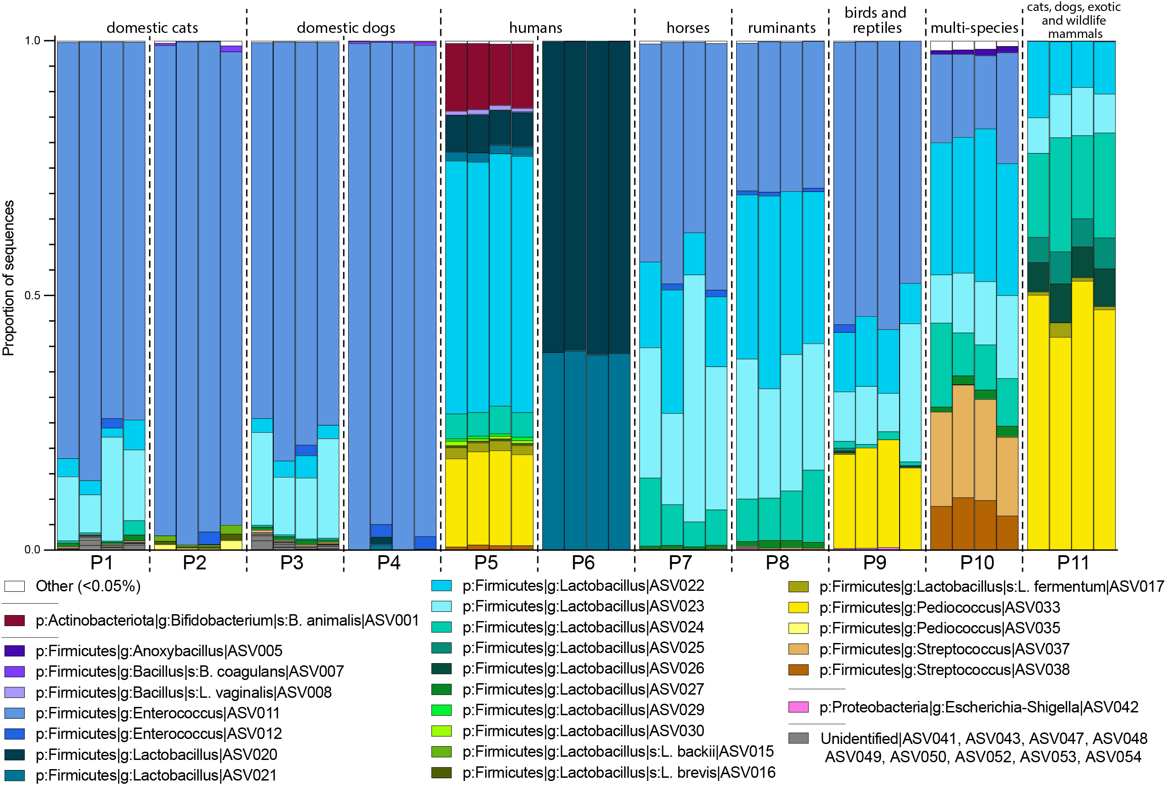

Figure 1. Relative abundances of amplicon sequence variants (ASVs) with greater than 0.5% of reads in 11 commercial probiotics (P1 to P11), sequenced in replicates of four. Colors denote individual ASVs, except for nine ASVs that could not be identified beyond the Kingdom Bacteria (in gray). For labeled ingredients in each probiotic, see Table 1.

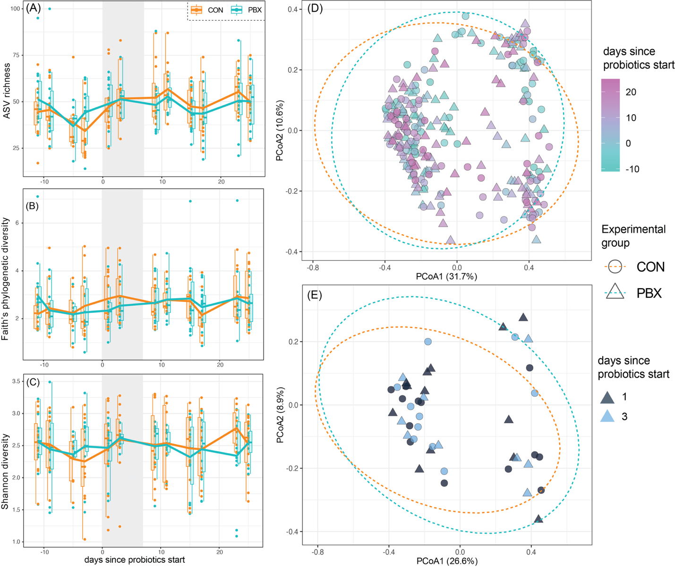
Figure 2. Alpha and beta diversity in microbiomes of black-footed ferrets in control (CON) or probiotic-treated (PBX) experimental groups. (A) Amplicon sequence variant (ASVs) richness, (B) Faith’s phylogenetic diversity, and (c) Shannon diversity over time, with the vertical gray bar representing the period of probiotic treatment (day 0 to day 6). Principal coordinate analyses of Bray-Curtis distance for (A) all samples and (B) during the period of probiotic treatment.

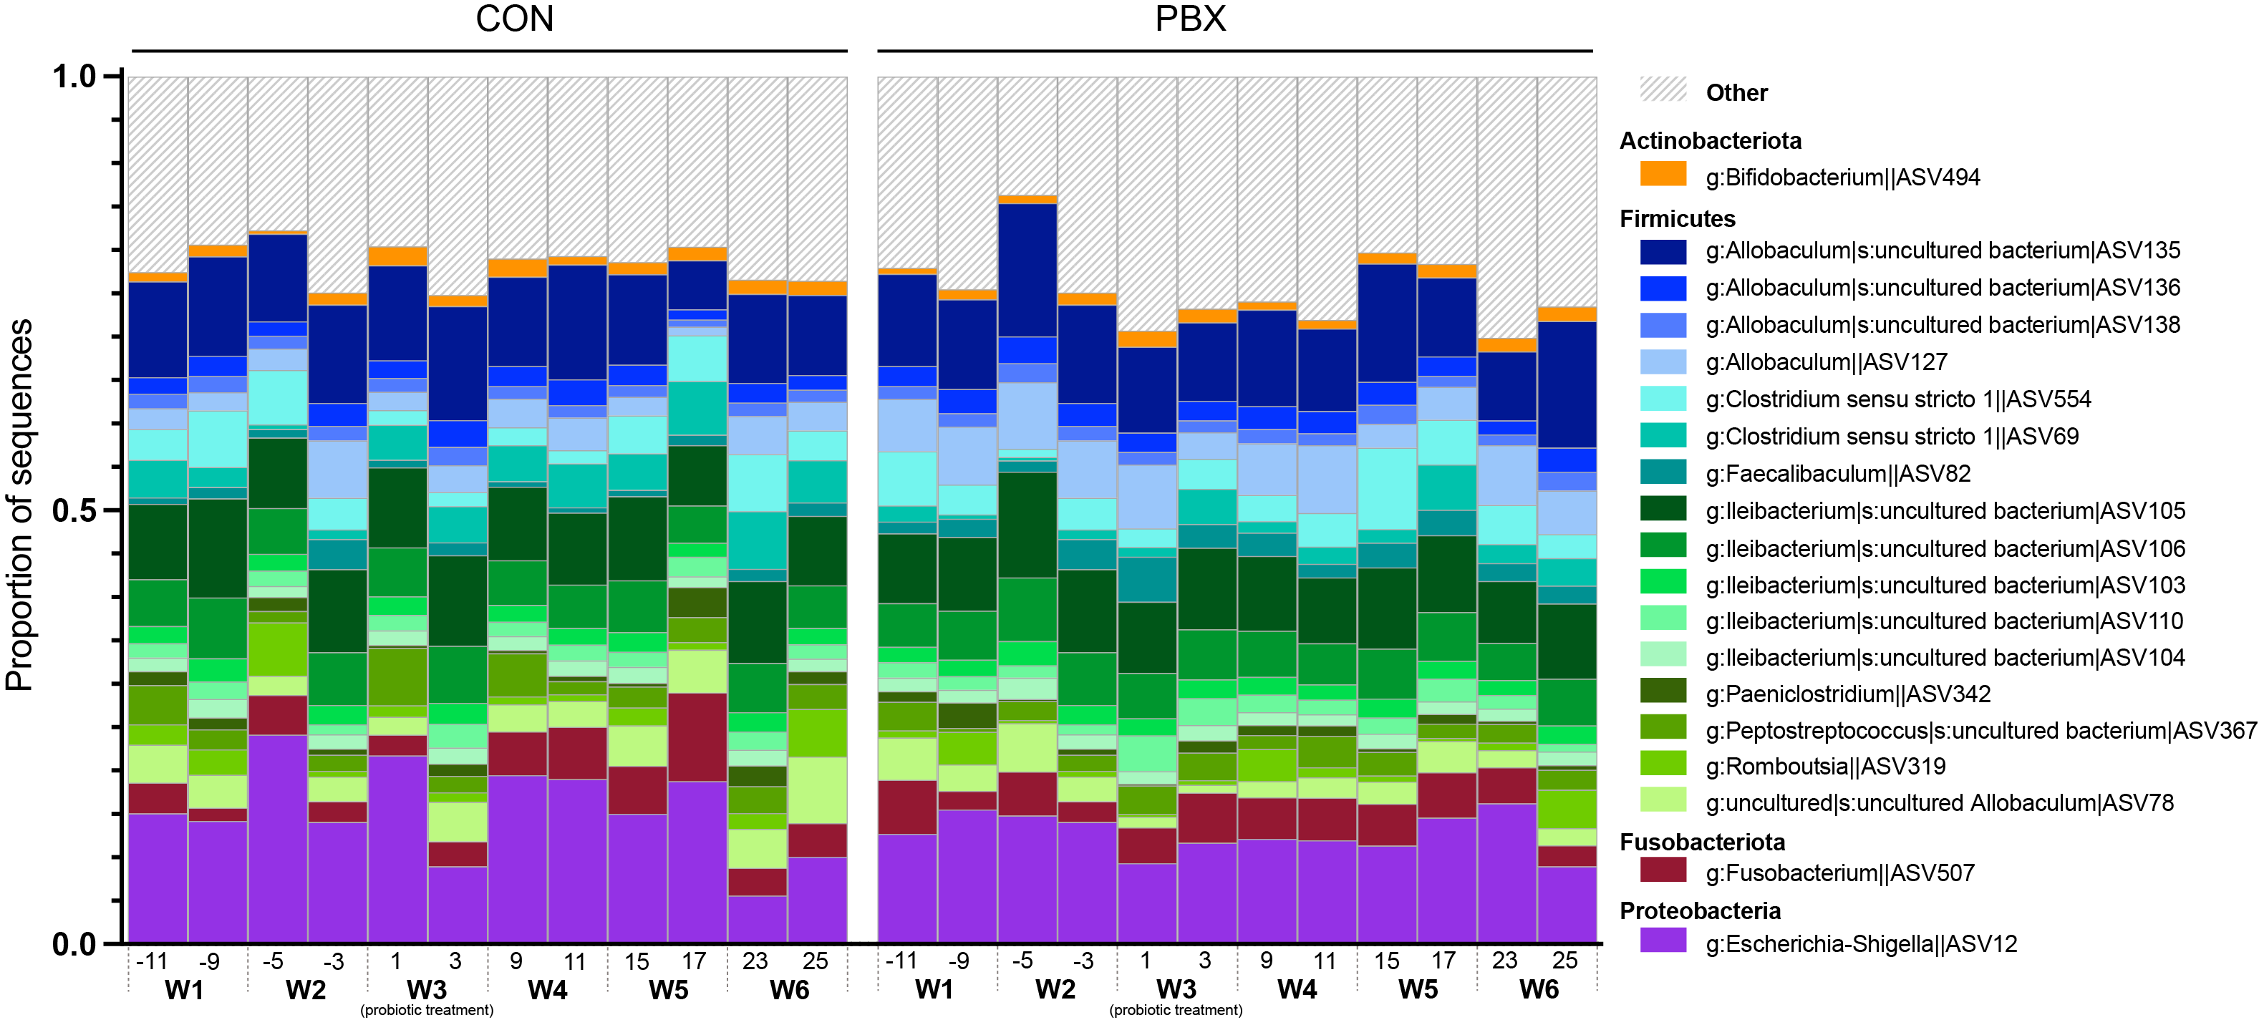
Figure 3. Relative abundances of ASVs in the gut microbiomes of black-footed ferrets in control (CON) or probiotic-treated (PBX) experimental groups. Colors denote individual ASVs, and the category Other denotes a conglomerate of rare taxa (representing less than 1 % of sequences). The x-axis represents the number of days since the start of probiotic treatment and the week (W1 to W6), with the first dose of probiotic on Day 0 and the final dose on Day 6, spanning week 3 (W3).
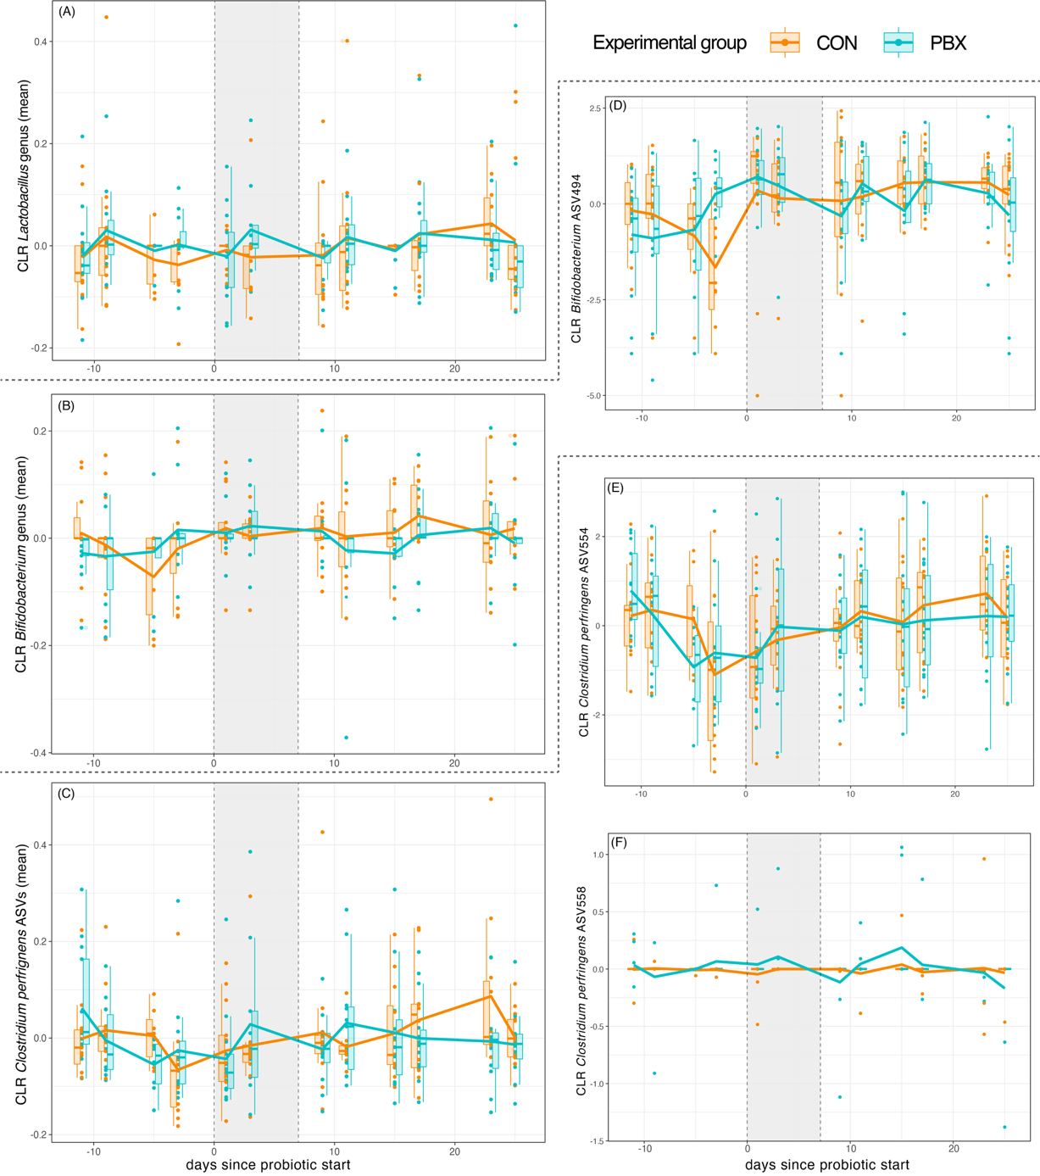
Figure 4. Center log-ratio (CLR) transformed abundances of bacterial taxa in the microbiomes of black-footed ferrets in control (CON) or probiotic-treated (PBX) experimental groups. (A) genus Lactobacillus, (B) genus Bifidobacterium, (C) combined Clostridium perfringens amplicon sequence variants (ASVs), and (D-F) specific ASVs with significant variation in longitudinal trajectories. The vertical gray bar represents the period of probiotic treatment (day 0 to day 6).

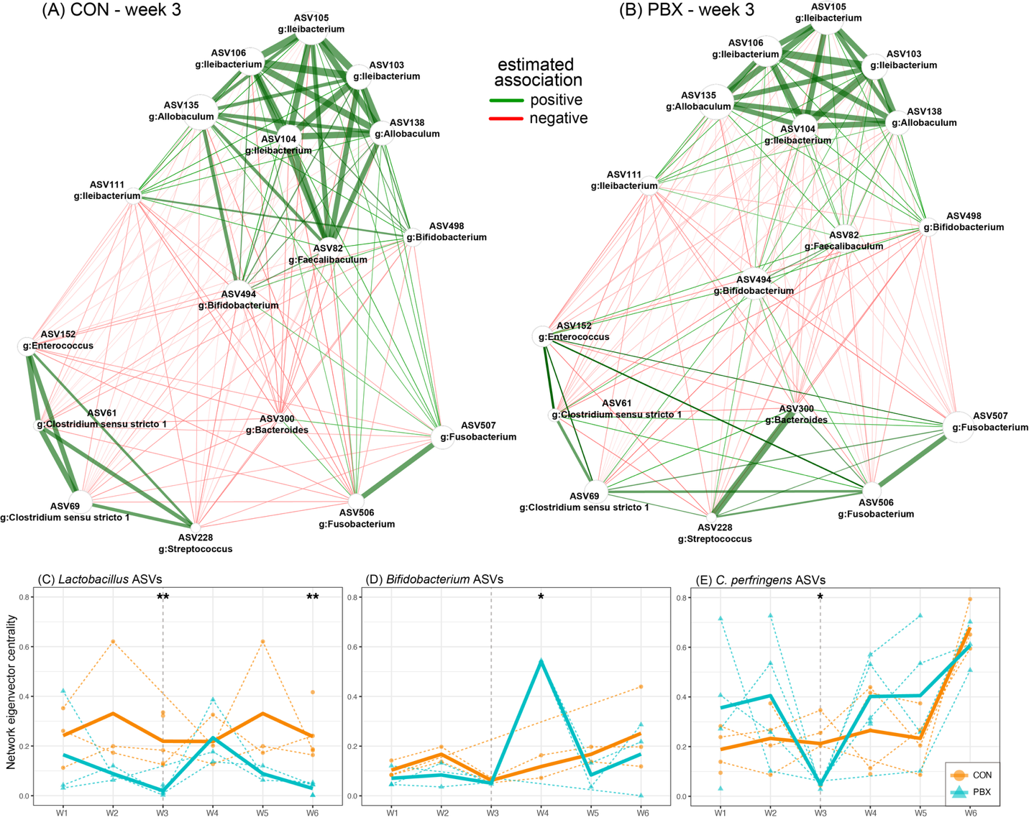
Figure 5. Differential association networks for the microbiomes of black-footed ferrets in (A) control (CON) or (B) probiotic-treated (PBX) experimental groups during the period of probiotic treatment (week 3). Networks were constructed with center log-ratio normalized abundances of amplicon sequence variants (ASVs) and differential pairwise associations were calculated using Fisher’s z-test. Edge weights are scaled to (non-negative) similarities, with negative associations colored red. (C-D) Longitudinal variation in eigenvector centrality across networks calculated for each week of the study (W1 to W6) for (C) Lactobacillus, (D) Bifidobacterium, and (E) Clostridium perfringens ASVs. Dashed colored lines are the trajectories of individuals ASVs, with the bold colored lines representing the mean of the ASVs within each genus, colored by experimental group. The vertical dashed line represents the week of probiotic treatment. * p < 0.05, **p < 0.01.ASVs within each genus, colored by experimental group. The vertical dashed line represents the week of probiotic treatment. * p < 0.05, **p < 0.01.

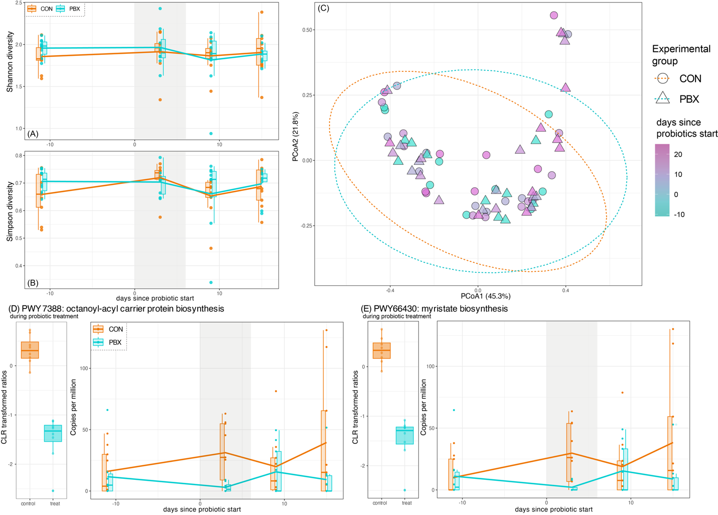

Figure 6. Functional diversity, composition, and pathway abundance for the microbiomes of black-footed ferrets in control (CON) or probiotic-treated (PBX) experimental groups. (A) Shannon diversity and (B) Simpson diversity of functional gene pathways over time, with the vertical gray bar representing the period of probiotic treatment (day 0 to day 6). (B) Principal coordinate analysis of Bray-Curtis distance of functional gene pathways, shaped according to experimental group and colored according to the number of days since the start of probiotic treatment. (D, E) Transformed abundance during probiotic treatment (center log-ratio, CLR) and longitudinal abundance (copies per million) for functional pathways found to vary significantly between experimental groups during the period of probiotic treatment (microbiome multivariable associations with linear models 3, MaAsLin3).

Tables and Table legends

Table 1. List of analyzed commercial probiotics (P1 to P11) with their target species, and the number and identity of taxa listed on the label. Asterisks denote probiotics made by the same manufacturer (* = manufacturer #1, etc.).

Probiotic (P#) | Target | # taxa on label | strains
P1* | cats | 4 | Enterococcus faecium, Lactobacillus acidophilus, Lactobacillus plantarum, Lactobacillus casei
P2** | cats | 1 | Enterococcus faecium
P3* | dogs | 4 | Enterococcus faecium, Lactobacillus acidophilus, Lactobacillus plantarum, Lactobacillus casei
P4** | dogs | 1 | Enterococcus faecium
P5 | humans | 20 | Lactobacillus acidophilus, Lactobacillus rhamnosus, Lactobacillus crispatus, Lactobacillus plantarum, Lactobacillus paracasei, Lactobacillus bulgaricus, Lactobacillus reuteri, Lactobacillus casei, Lactobacillus salivarius, Lactobacillus helveticus, Lactobacillus gasseri, BifidobacteriumLactis, Bifidobacterium breve, Bifidobacterium adolescentis, Bifidobacterium infantis, Bifidobacterium Longum, LactococcusLactis, Pediococcus pentosaceus, Pediococcus acidilactici, Streptococcus thermophiles.,
P6 | humans | 1 | Lactobacillus rhamnosus
P7* | horses | 4 | Enterococcus faecium, Lactobacillus acidophilus, Lactobacillus plantarum, Lactobacillus casei
P8* | ruminants | 4 | Enterococcus faecium, Lactobacillus acidophilus, Lactobacillus plantarum, Lactobacillus casei
P9*** | birds and reptiles | 5 | Lactobacillus Fermentum, Lactobacillus Casei (avian strain), Lactobacillus Plantarum, Lactobacillus Acidophilus, Streptococcus Faecium
P10* | multi-species | 4 | Enterococcus faecium, Lactobacillus acidophilus, Lactobacillus plantarum, Lactobacillus casei
P11*** | cats, dogs, exotic and wildlife mammals | 8 | Bifidobacterium bifidum, Lactobacillus fermentum, Lactobacillus acidophilus, Lactobacilluscasei, Lactobacillus plantarum, Enterococcus faecium, Bifidobacterium bifidum, Pediococcus Acidilactici

Table 2. List of potential contaminant amplicon sequence variants (ASVs), with taxonomy identification, range of relative abundance (percent of sequences) across all probiotic samples, and the probiotics in which the ASV is considered a contaminant. Contaminant ASVs are those that were (a) not present in our negative or positive controls, (b) not removed via decontam, (c) identified in all four replicates of a given probiotic but were not present in all 44 probiotic samples, and (d) not assigned to a genus listed in the probiotic ingredients.

ASV | Taxonomy | abundance | probiotics
ASV003 | g_Cutibacterium | ASV003 | 0.01 % to 0.11 % | P7, P8
ASV004 | g_Thermus | s_Thermus_thermophilus | ASV004 | 0.10 % to 0.22 % | P10
ASV005 | g_Anoxybacillus | ASV005 | 0.75 % to 1.28 % | P10
ASV007 | g_Bacillus | s_Bacillus_coagulans|ASV007 | 0.11 % to 1.15 % | P2, P4
ASV010 | g_Geobacillus | ASV010 | 0.14 % to 0.20 % | P10
ASV015 | g_Lactobacillus | s_Lactobacillus_backii | ASV015 | 0.35 % to 1.75 % | P2
ASV016 | g_Lactobacillus | s_Lactobacillus_brevis | ASV016 | 0.29 % to 1.26 % | P2
ASV035 | g_Pediococcus | ASV035 | 0.4 % to 1.95 % | P9
ASV042 | g_Escherichia Shigella | ASV042 | 0.01 % to 0.56 % | P7, P8, P9, P11
ASV037 | g_Streptococcus | ASV037 | 0.22 % to 22.1 % | P3, P10
ASV038 | g_Streptococcus | ASV038 | 0.09 % to 10.37 % | P1, P3, P8, P10
ASV039 | g_Streptococcus | ASV039 | 0.01 % to 0.31 % | P1, P3
ASV047 | Unidentified | ASV047 | 0.05 % to 0.26 % | P1, P3
ASV048 | Unidentified | ASV048 | 0.21 % to 0.98 % | P1, P3
ASV049 | Unidentified | ASV049 | 0.37 % to 1.68 % | P1, P3

Table 3. Results of linear models of center-log ratio (CLR) transformed abundances of genera and ASVs assigned to Bifidobacterium, Lactobacillus, or Clostridium sensu stricto 1. ASVs assigned to Clostridium sensu stricto 1 we further identified as C. perfringens using NCBI BLAST. “NA” values indicate taxa for which CLR values were namely zeros.
Taxonomy | ASV ID | Estimate | Std. Error | t value | p-value
Bifidobacterium genus mean |  | 0.003 | 0.018 | 0.179 | 0.858
Bifidobacterium | ASV494 | 0.355 | 0.417 | 0.851 | 0.399
Bifidobacterium | ASV495 | -0.017 | 0.011 | -1.599 | 0.117
Bifidobacterium | ASV496 | 0.000 | 0.000 | NA | NA
Bifidobacterium (Bifidobacterium_animalis) | ASV497 | -0.049 | 0.036 | -1.372 | 0.177
Bifidobacterium | ASV498 | 0.140 | 0.169 | 0.829 | 0.412
Bifidobacterium (Bifidobacterium_bifidum) | ASV502 | -0.042 | 0.041 | -1.023 | 0.312
Bifidobacterium | ASV504 | 0.000 | 0.000 | NA | NA
Lactobacillus genus mean |  | 0.015 | 0.024 | 0.618 | 0.540
Lactobacillus | ASV175 | 0.366 | 0.236 | 1.551 | 0.128
Lactobacillus | ASV177 | 0.000 | 0.000 | NA | NA
Lactobacillus | ASV178 | 0.000 | 0.000 | NA | NA
Lactobacillus | ASV179 | 0.038 | 0.032 | 1.213 | 0.232
Lactobacillus | ASV182 | -0.014 | 0.089 | -0.155 | 0.878
Lactobacillus | ASV183 | 0.000 | 0.000 | NA | NA
Lactobacillus (Lactobacillus_saerimneri) | ASV184 | -0.056 | 0.055 | -1.023 | 0.312
Lactobacillus | ASV187 | -0.181 | 0.199 | -0.907 | 0.370
Lactobacillus | ASV188 | 0.000 | 0.000 | NA | NA
Lactobacillus | ASV189 | 0.000 | 0.000 | NA | NA
Lactobacillus | ASV191 | -0.121 | 0.316 | -0.383 | 0.704
Lactobacillus (Lactobacillus_intestinalis) | ASV194 | 0.441 | 0.339 | 1.303 | 0.200
Lactobacillus | ASV195 | 0.000 | 0.000 | NA | NA
Lactobacillus | ASV196 | 0.000 | 0.000 | NA | NA
Lactobacillus (Lactobacillus_intestinalis) | ASV197 | 0.021 | 0.021 | 1.023 | 0.312
Lactobacillus (Lactobacillus_brevis) | ASV198 | 0.041 | 0.052 | 0.785 | 0.437
Lactobacillus | ASV199 | -0.150 | 0.101 | -1.478 | 0.147
Lactobacillus | ASV200 | 0.198 | 0.235 | 0.841 | 0.405
Lactobacillus | ASV201 | -0.067 | 0.067 | -1.003 | 0.321
Lactobacillus | ASV203 | 0.000 | 0.027 | 0.000 | 1.000
Lactobacillus (Lactobacillus_fermentum) | ASV204 | -0.018 | 0.017 | -1.055 | 0.297
Clostridium perfringens mean |  | 0.008 | 0.036 | 0.214 | 0.832
Clostridium_sensu_stricto_1 | ASV1 | -0.034 | 0.037 | -0.912 | 0.367
Clostridium_sensu_stricto_1 | ASV2 | -0.025 | 0.028 | -0.909 | 0.368
Clostridium_sensu_stricto_1 | ASV3 | -0.006 | 0.008 | -0.743 | 0.462
Clostridium_sensu_stricto_1 | ASV553 | 0.096 | 0.129 | 0.742 | 0.462
Clostridium_sensu_stricto_1 | ASV554 | 0.030 | 0.431 | 0.070 | 0.945
Clostridium_sensu_stricto_1 | ASV555 | 0.047 | 0.046 | 1.023 | 0.312
Clostridium_sensu_stricto_1 | ASV556 | -0.047 | 0.048 | -0.978 | 0.334
Clostridium_sensu_stricto_1 | ASV557 | 0.000 | 0.000 | NA | NA
Clostridium_sensu_stricto_1 | ASV558 | 0.094 | 0.049 | 1.895 | 0.065
Clostridium_sensu_stricto_1 | ASV559 | 0.128 | 0.087 | 1.472 | 0.148
Clostridium_sensu_stricto_1 | ASV560 | -0.074 | 0.052 | -1.411 | 0.165
Clostridium_sensu_stricto_1 | ASV561 | -0.029 | 0.037 | -0.784 | 0.437
Clostridium_sensu_stricto_1 | ASV562 | -0.145 | 0.103 | -1.415 | 0.164
Clostridium_sensu_stricto_1 | ASV563 | -0.021 | 0.056 | -0.375 | 0.709
Clostridium_sensu_stricto_1 | ASV564 | 0.000 | 0.000 | NA | NA
Clostridium_sensu_stricto_1 | ASV565 | 0.123 | 0.084 | 1.475 | 0.147
Clostridium_sensu_stricto_1 | ASV566 | 0.000 | 0.000 | NA | NA
Clostridium_sensu_stricto_1 | ASV567 | 0.000 | 0.000 | NA | NA

