Proceedings of the ASME 2026 21st International
Manufacturing Science and Engineering Conference
MSEC2026
June 14–18, 2026, State College, Pennsylvania

MSEC2026-181145

Towards a Digital Twin of a Coordinate Measuring Machine

Deogratias Kibira  University of Maryland  College Park, MD | Guodong Shao  National Institute of Standards and Technology  Gaithersburg, MD | Rishabh Venketesh  National Institute of Standards and Technology  Gaithersburg, MD | Emma Bair  University of Maryland  College Park, MD

Abstract
This paper presents the development of a digital twin for a Coordinate Measuring Machine (CMM) using open standards and supporting technologies. The approach is demonstrated through a case study in which a compact CMM inspects a machined part. Inspection data are collected and structured using the Quality Information Framework (QIF), providing semantic context for measurement results. Motion data capturing the position of the CMM probe tip along the X, Y, and Z axes are also collected. The MTConnect standard enables standardized machine data collection and synchronization with the digital twin through eXtensible Markup Language (XML). Validation is performed by comparing data from the digital twin with data from the physical CMM. The results demonstrate the feasibility of implementing CMM digital twins using open standards while highlighting the need for automated bidirectional data exchange between the digital twin and physical system. This study establishes and demonstrates a standards-based, interoperable architecture that integrates inspection- and motion-based digital twins within a unified framework, providing a foundation for future research on real-time data streaming, advanced analytics, and automated feedback to improve coordinate measurement and performance of manufacturing systems.
Keywords: Coordinate Measuring Machine, Standards, Data Collection, Digital Twins, Validation.

- INTRODUCTION
Part inspection, through coordinate measurement, is essential for producing high-quality parts and assemblies. While traditional CMMs are widely used, manufacturers can gain deeper insights by developing digital twins of CMM measurement systems. Digital twins enable real-time metrology data collection, visualization, analysis, and optimization. The purpose is to identify areas for improvement in real-time for the measurement process and for production optimization. Measurement process improvements encompass machine settings, material composition, and process speed, whereas production optimization includes training, production planning, and predictive maintenance.
However, existing literature is insufficient in describing how to build a digital twin of a CMM. Most related publications describe rigid-body simulation models of CMMs to support virtual metrology, with the results used to evaluate uncertainties associated with the geometrical and optical aspects of machine operations [1]. Another common application is to simulate the inspection process, investigate collision detection, and optimize the CMM measurement path. These efforts involve the flow of information and decisions from virtual models to the physical system.
This paper investigates how to collect data from the CMM, develop digital models of the CMM, the part, and fixtures, and leverage standards to create a data pipeline from the physical CMM to the digital twin. The data are analyzed against a test part, and the results are visualized in a virtual environment. Our motivation is to show how to capture both part inspection and CMM motion data and use them to (1) validate the inspection program, (2) monitor part or product quality with respect to Geometric Dimensioning and Tolerancing (GD&T), and (3) determine the state of the machine. These activities are essential for real-time decision-making in a workcell involving a CMM.
This paper uses a laboratory-scale testbed at the National Institute of Standards and Technology (NIST). The testbed includes two robot arms, a Computer Numerical Control (CNC) machine tool, a CMM, and supporting systems. The primary objective is to demonstrate how standards facilitate the development of a digital twin for the CMM and how inspection data communicated using the Quality Information Framework (QIF) can be collected, visualized, and interpreted.
The rest of the paper is organized as follows: Section 2 presents the background, literature review, and inspection-related standards; Section 3 presents the research framework and modeling methodology; Section 4 describes the development of the digital twin; Section 5 describes the data pipeline, data visualization, and validation of the digital twin model; Section 6 is the discussion, lessons learned, and conclusion of the paper.
- BACKGROUND AND LITERATURE REVIEW
A CMM maintains design conformance by measuring physical geometries against GD&T data embedded in 3D CAD models. This data are processed by a Computer-Aided Inspection System (CAIS) to identify deviations. The CMM’s core architecture consists of a machine frame, a probing system, a drive framework, a controller, and software. The probe accesses different areas of the part for measurement.
The phases involved in part inspection using a CMM are: (1) defining geometrical and dimensional specifications, (2) developing a measurement plan, (3) executing measurements, and (4) analyzing inspection results [2]. CMM inspection is now being integrated into Model-Based Systems Engineering and Model-Based Definition workflows [3]. As a result, digital twins are increasingly part of the coordinate measurement process, especially for high-precision parts production. The Digital Twin Consortium (DTC), a global organization dedicated to promoting digital twin technology adoption, defines the digital twin as “a virtual representation of real-world entities and processes, synchronized at a specified frequency and fidelity” [4]. Digital twins have been created for CMMs to support offline digital inspection [5]. These virtual environments enable the investigation and analysis of the measurement process before results are applied to physical machines to support precision manufacturing [6].

2.1 Digital Twins Role in Coordinate Measurement Systems
Typically, CMMs use tactile and optical sensors to capture 3D data, but face challenges with complex geometries and shop-floor changes. A digital twin mitigates these issues by (1) offline programming of the CMM for part inspection before production [7], (2) generating inspection data as support to the digital twin for geometry assurance [8], and (3) selecting the most relevant data features from a part and system for analysis [9]. In addition, a digital twin can monitor streamed data and enable iterative process optimization. However, there are challenges in building the digital twin, including accurately representing the CMM components, capturing CMM behaviors such as backlash and vibration, providing suitable interfaces, ensuring data accuracy, and accounting for thermal effects, among others.

2.2 Literature Review
This section provides an overview of the literature on digital twin applications in the part measurement process.

2.2.1 Digital Twins in Part Inspection Processes
Metrology ensures the reliability of digital twins by providing traceable, standard-aligned data [1]. Using ASME Y14.5-2018, geometric features are defined by parameters that specify tolerances [10, 11]. Poniatowska et al. [12] reviewed implementations and prospects for digital twins in dimensional metrology. The review, supported by case studies, demonstrated that digital twins for metrology measurements are feasible. Stojadinovic [13] developed Computer-Aided Design (CAD) models of (1) a measured part, (2) CMM, and (3) fixture clamps to measure the part’s geometric features and export the results using a Dimensional Measuring Interface Standard (DMIS) file
Gohari et al. [14] further used digital twins to estimate the local densities of the measured points needed for virtual sampling. Other research involved digital twin monitoring and control data to prevent measurement errors, including collisions [15]. The method includes converting the STEP-NC (Standard for Exchange of Product Model Data - Numerical Control) file for the machine and part into control data list instructions for a CMM. STEP-NC (ISO 14649) is a standard for data transfer between CAD/CAM systems and CNC machines [16]. Wärmefjord et al. [8] concentrated on selecting the appropriate data from manufacturing and inspection processes for inclusion in the digital twin. Stojadinovic et al. [17] developed a manufacturing metrology approach that uses Artificial Intelligence techniques, such as Genetic Algorithms, to optimize the measurement path, the number of workpiece setups, and the configuration of the measuring head and probes.

    - Standards Related to Design and Inspection
The STEP (ISO 10303) family of standards provides a neutral format for exchanging product data [18]. Specifically, STEP AP242 facilitates the sharing of 3D geometry and Product and Manufacturing Information (PMI). While NIST research [19] confirmed its benefits for CAD-to-CMM interoperability, gaps in tools, modeling knowledge, and PMI coverage limit the extensive transfer of CAM data for inspection using CMM.

    - Motivation, Contribution, and Scope
The literature review reveals that the focus of CMM digital twins is on creating a virtual model of the machine for virtual metrology, with results applied to the physical CMM. Additionally, research such as that by Samadi et al. [20] presents a framework for integrating data into digital twin models, allowing for real-time quality control, process optimization, and predictive maintenance. However, there is a lack of references to data-collection procedures and interfaces for the CMM digital twin system.
Data collection for a digital twin requires an architecture that supports data streaming. Additionally, CMM controllers are designed for specific machines and software ecosystems. Therefore, each digital twin must be tailored to a particular CMM. Moreover, low-level data such as motor torque, encoder raw counts, and internal sensor logs—necessary for a high-fidelity twin—are often not included. Based on these observations, this paper presents a data pipeline guided by a digital twin architecture for manufacturing, as defined by ISO 23247 [21]. The standards-supported pipeline enables the collection and transfer of data from the physical CMM to its digital representation. No such works are reported in the literature. This paper contributes by utilizing established standards for comprehensive system integration. The scope includes demonstrating data collection, standards, and interfaces; a digital twin for CMM based on probe positions and the part measurement process; and assessing the digital twin’s accuracy.
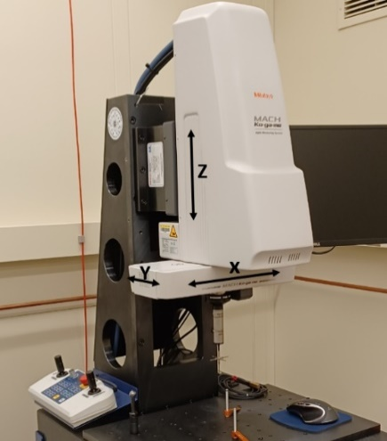

FIGURE 1: THE CMM SHOWING THE THREE AXES OF MOTION
3. RESEARCH FRAMEWORK
This section describes the standards, frameworks, and tools supporting the CMM’s digital twin.

3.1 CMM Description
The CMM is a Mitutoyo MACH Ko-ga-me that uses tactile touch-trigger probes to acquire dimensional measurements from a part. Figure 1 shows the CMM and its three axes of motion. The attached probe is a 5-way stylus probe. We perform a five-point calibration on a machined metal sphere to compensate for any tool wear on the probe tips.

3.2 Standards and Frameworks
ISO 23247: The ISO 23247 standard series provides the framework for developing digital twins. Part 2 of the standard, ISO 23247-2, outlines a reference architecture for digital twins in manufacturing, including (1) a reference model from the domain and entity perspectives and (2) a functional view that specifies the functional entities supported by the entity-based reference model [21]. The reference model explains how systems (and their digital representations) can interoperate and how data can be integrated. The framework comprises four domains, each represented by a corresponding application layer.
Figure 2 shows the entity-based digital twin reference model for manufacturing, with the four application layers summarized as follows:
- Observable Manufacturing Elements (OME): The base layer where physical data are collected.
- Data Collection and Control: Processes sensor data and sends commands to OME actuators.
- Digital Twin Entities: The modeling layer providing monitoring, simulation, and predictive services.
- User Domain: The interface for human users or external systems.

Data interoperability is managed through two key protocols:
- MTConnect (ANSI/MTC1.4-2018): Provides standardized XML interfaces and vocabulary for collecting data [22].
- Quality Information Framework (QIF / ISO 23952): An XML-based schema used to model inspection data, ensuring traceability across the product lifecycle [23].

Table 1: Standards and their application areas
Standard | Application
ISO 23247 | Part 2 of the standard series provides a reference architecture
MTConnect (ANSI/MTC1.4-2018) | Provides standardized XML interfaces and vocabulary for collecting data
(QIF) ISO 23952 | Provides an XML-based schema used to model inspection data
STEP-NC (ISO 14649) | Provides a feature-based standard to represent and exchange data to manufacture a part
STEP AP242 | Facilitates sharing 3D geometry and Product and Manufacturing Information

3.3 Technologies and Tools
Digital twin modeling, data acquisition and management, and data fusion technologies are essential tasks for digital twin development [24]. Different tools are needed (1) for modeling the physical CMM to create a virtual model of the CMM, and (2) for modeling, analyzing, communicating, and visualizing the measurement data. Creating a virtual model of the CMM starts with CAD modeling software. These are provided in the STEP format and imported into Autodesk Inventor. The test part, tools, and fixtures are also developed in the same environment. The assembly is then exported in the x_t format for import into the digital twin environment.
Two modules are used in this paper’s research: MotionSolve (the Inspire motion option) for modeling the CMM and Twin Activate. MotionSolve supports multibody simulation, which breaks down the physical system into rigid bodies, joints, constraints, drives, and other components. Twin Activate provides two services: (1) simulating the CMM by streaming motion data and (2) visualizing inspection data. MeasurLink enables the collection and analysis of inspection data.

- DIGITAL TWIN DEVELOPMENT
A digital twin of the CMM was developed in accordance with the ISO 23247 digital twin framework. Figure 3 shows the instantiation of the CMM framework. This section discusses the activities in each layer of the framework.

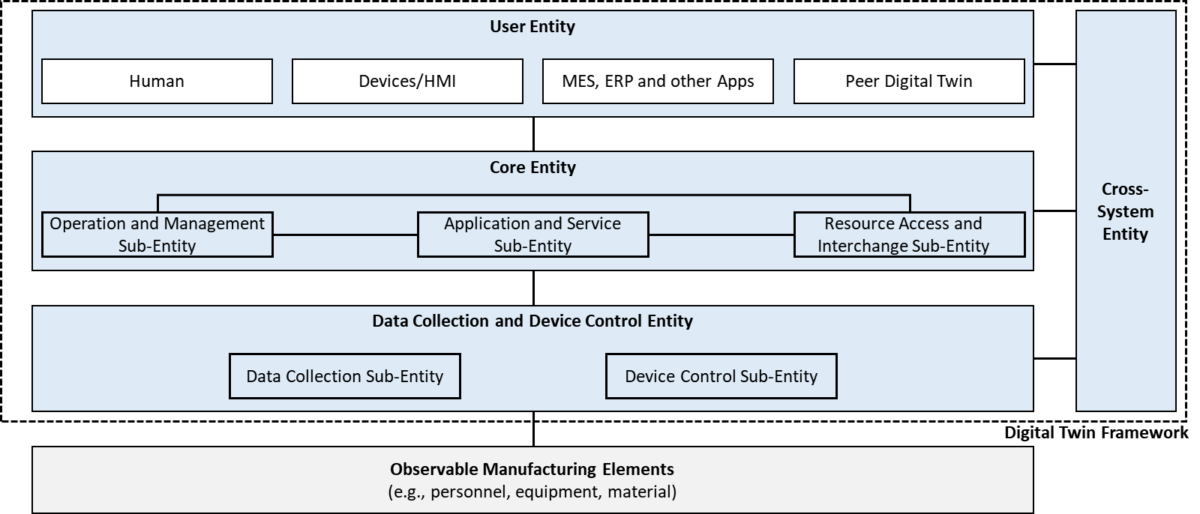
Figure 2: Entity-based Digital Twin reference model for manufacturing (ISO 2021b)

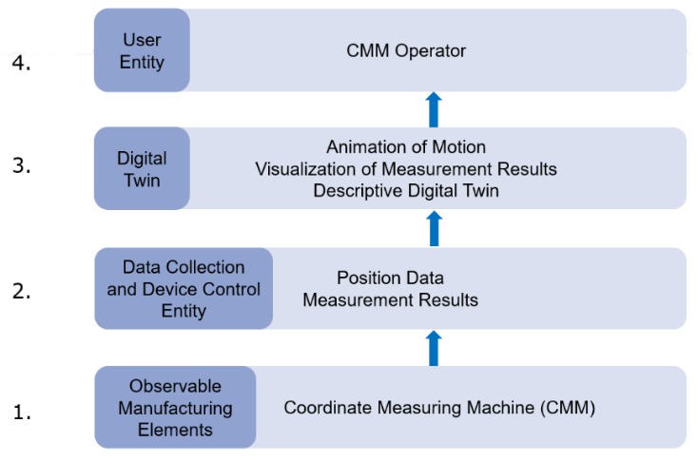
Figure 3: Instantiation of the ISO 23247 for the Coordinate Measuring Machine digital twin
4.1 Observable Manufacturing Elements: CMM
The observable manufacturing elements include the CMM with its attached probe, the workpiece, and the fixtures. The CMM (see Figure 1) is designed to access the part’s geometry, dimensions, and points within a designated area. It comprises a mechanical structure that moves a probe (which touches the part) in the X, Y, and Z directions. The axes are defined so that the X-axis moves from left to right, the Y-axis moves back and forth, and the Z-axis is perpendicular to the stage surface. This configuration provides easy access to the workpiece and a relatively large work volume while occupying a small footprint. The machine sits atop a granite table, which provides structural and thermal stability. The CMM is connected to a computer system running MeasurLink software to record and analyze measurements. The probe used is a five-point or 5-way star stylus. This probe is suitable for applications requiring contact with different surfaces without changing the stylus.
Each measurement point is described using the X, Y, and Z axes, which form a Cartesian coordinate system. The measured points for a single object are combined into a 3D point cloud. The parts are placed within the measuring volume and measured individually using an inspection program. This CMM can be integrated with other equipment in the workcell. Integrating the CMM to provide feedback is essential for effective process monitoring and quality control.

4.2 Data Collection and Device Control Entity
The data collected from the CMM during inspection include (1) position data along the axes of motion, following the inspection program, and (2) inspection data on the part that determines the quality of the inspected part with respect to GD&T. Position data are collected using an MTConnect Adapter developed in Python. The Adapter pulls data from the Mitutoyo CMM control software. Inspection data are collected and encoded in XML format for input into the data visualization tool. The generated inspection process on the part outputs results according to the framework provided by the QIF standard.

4.3 Digital Twin Entity: Motion, Animation, and Visualization
The digital twin comprises a virtual model that replicates the structure, attributes, behavior, 3D geometry, and animation of the physical CMM system. The CAD models of the CMM, provided in the STEP format, are imported and “assembled” within the digital twin environment. There are four main groups of CAD components of the CMM, excluding the probe, jigs, and fixtures (see Figure 4):
- Table on which the mounting bracket for the machine is located.
- X-mobile unit.
- Y-mobile unit.
- Z-mobile unit.

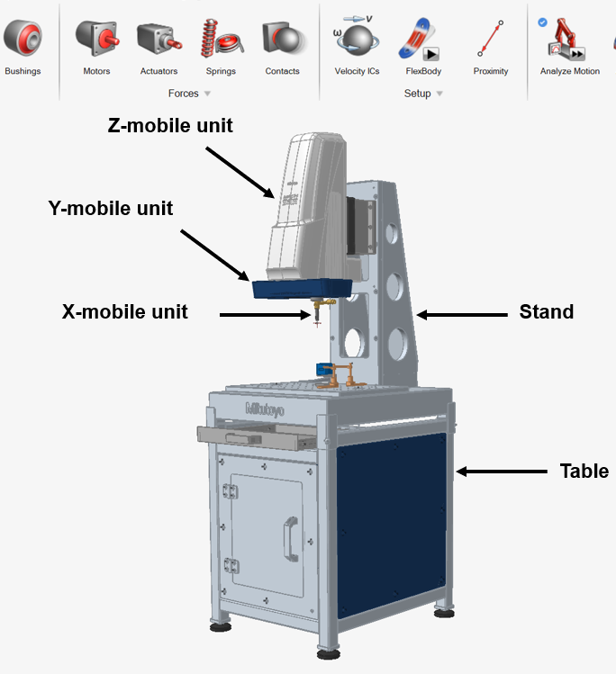
FIGURE 4: The digital model of the CMM.
The modeling environment is provided by MotionSolve, which is part of the HyperWorks software suite from Altair. The specific product used is called Inspire Motion. CAD models of physical objects, including clamping tools and probes, are imported and appropriately positioned in the modeling environment. The virtual assembly process accounts for the relative motion between machine components and the travel limits along each axis. This is followed by establishing kinematic links between the translational axes of the movable parts of the measuring machine. Linear movement along the desired axis is achieved using “slider” constraints. The final step before simulation and verification is to define the coordinate systems of the workpiece, the measuring probe, and the measuring machine.

4.4 User Entity: CMM Operator
The User entity uses the services provided by the digital twin entity. The human who interacts with the digital twin is the user entity. Users may include CMM operators, engineers, and other decision-makers. In our case, the user entity is the researcher who monitors the CMM's performance via the digital twin.

4.5 Case study
The case study involves inspecting a part with the CMM. Machine motion and part quality data are collected. The part is designed in Autodesk Inventor and machined on a Pocket NC desktop milling machine. The CAD model of the part is shown in Figure 5. The software for setting up the CMM is as follows:
- MCOSMOS (Mitutoyo Controlled Open Systems for Modular Operation Support): This is Mitutoyo’s proprietary metrology software suite. It features a modular architecture that allows the measurement software to be customized to specific use-case requirements. MCOSMOS is used to align the part with the datum and establish the ideal location of the measured features. Figure 6 shows the physical part aligned for inspection, along with its digital representation. The CMM is installed in a climate-controlled environment, and the MCOSMOS software compensates for temperature variations.
- MiCAT Planner: This module is part of MCOSMOS. It allows importing CAD models and creating inspection programs and paths using the PMI embedded in the CAD file. This is done by identifying GD&T and part geometry within the Model-Based Definition. The measurement programs generated by MiCAT Planner are then managed within MCOSMOS.
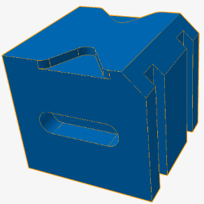
Figure 5: The test part
- DATA PIPELINE AND DATA VISUALIZATION
Data pipelines convey and aggregate data from a data source to where it is stored or used. The data source can be a manufacturing process or a database. The data may be available in various formats, but the pipeline converts it into a format suitable for the intended use, such as a digital twin. In this case, the data source is the CMM.
For this study, we focused primarily on two types of data – operational data from the CMM and test-part measurement data. The operational data consisted mainly of Cartesian coordinates of the active probe tip. The raw Cartesian coordinate data (x, y, and z) were collected from the machine, processed, and then sent to a central MTConnect agent via socket-to-socket communication. The raw data were first processed, transforming the coordinates into a common frame of reference. This was necessary because the raw data recorded the position of the specific probe used for inspection at that point in time. The five-star probe supports automated metrology, with the inspection program switching between probe tips. The raw data needed to be transformed so that the center of the five-star probe was the tool center position. Once the raw data was transformed to a consistent frame of reference, the current timestamp, the data tag, and the transformed data value were sent to the MTConnect agent in MTConnect-compliant format. The mapping of data tags to MTConnect linear data items was defined in a device configuration file used by the agent to ensure compliance with the standard.
Figure 7 illustrates the data pipeline. The digital twin of the CMM has two major capabilities:
- Visualization (and interpretation) of measurement results.
- Simulation and animation of the CMM.

5.1 Flow of Inspection Data
MeasurLink data-collection software was used to record data points during the inspection. QIF processes and makes this data available in XML format to support data integrity and process interoperability. The XML file from the inspection must be generated before the Python block can be run.
5.2 Visualization of Inspection Data
A Python script has been created to read and translate the inspection report (an XML file), outputting the results of comparing the measured features with the test part. The code runs as a software block in Altair Twin Activate. The purpose of visualization is to indicate which of the inspected features passed or failed the inspection. Any detected deviation from the nominal CAD geometry, along with associated tolerances, is instantly flagged, enabling immediate corrective action. This minimizes scrap, rework, and downstream failures. Figure 8 shows the inspection results. The inspected features are the five holes on the left side of the machined part. Only two tips of the five-way star stylus probe are used. Figure 9 shows the 5-way stylus probe.

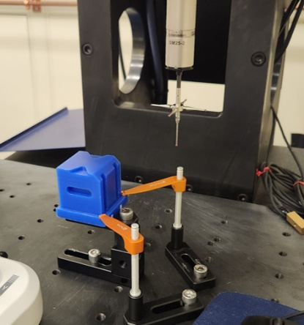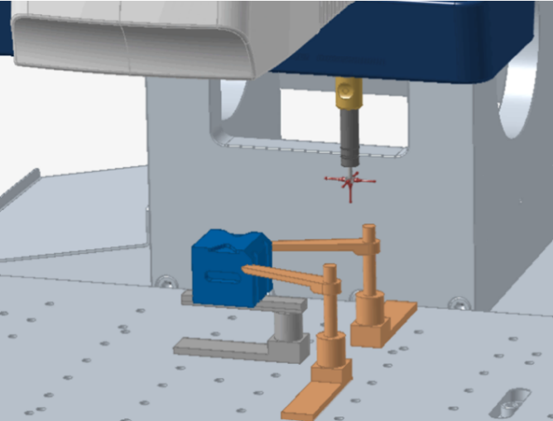
Figure 6: Arrangement of the inspection process: Real (left) and digital twin (right).
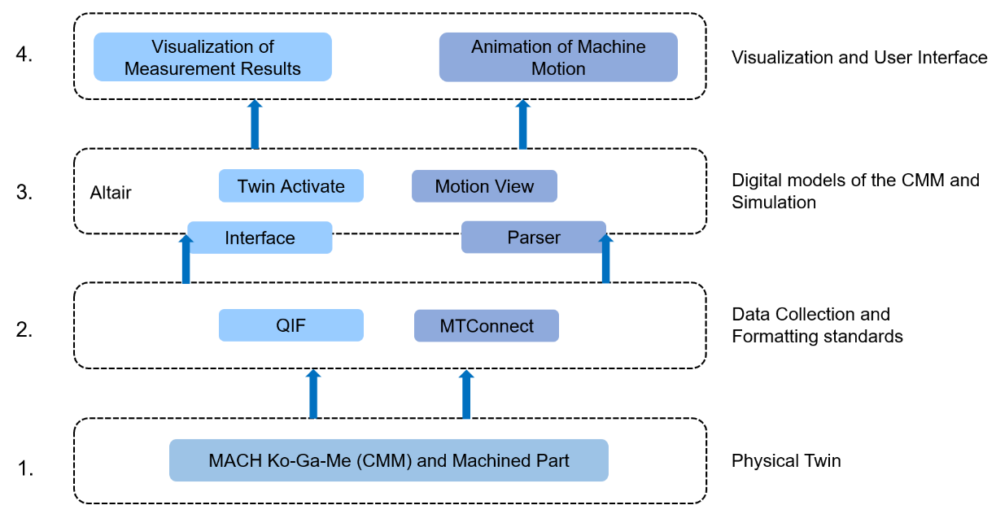
Figure 7: Data pipeline from real CMM to the digital twin
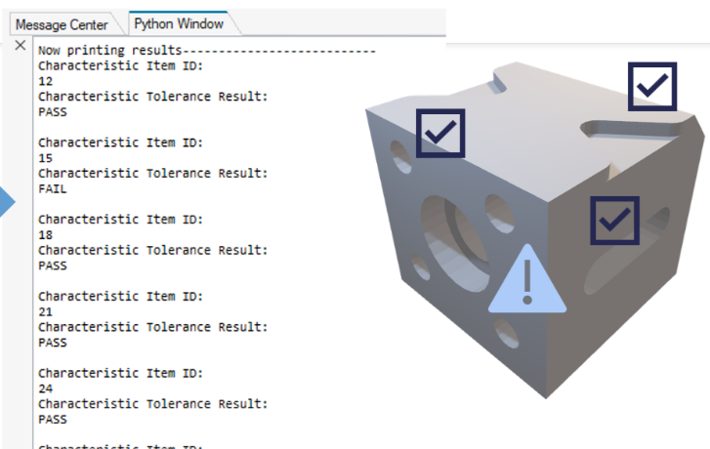Figure 8: inspection results of the test part
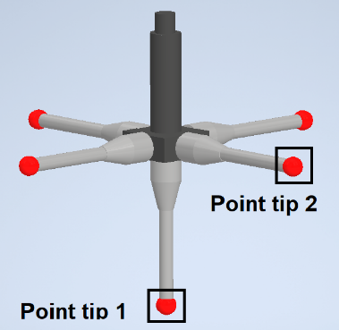
Figure 9: The stylus probe tips that are active during the inspection process
5.3 Validation of the Digital Twin using Position Data
Data visualization in a digital twin is often used alongside outputs from analytics models to provide additional insights. Verification and validation are among the most important activities performed on the models to ensure users can trust their outputs, such as predictions from a digital twin. In this paper, the activities involve visually comparing position data from the physical CMM with its digital twin and computing error parameters.
Generating digital twin data is achieved through co-simulation between the Inspire model and Twin Activate. Twin Activate features a “MotionSolveSignals” block to implement co-simulation by acting as a bridge that allows the control system developed for Twin Activate to interact with the MotionSolve model of the CMM. The input and output signals are specified as shown in Figure 10. The output signals are the positions of the axes from the digital twin.
The graphs in Figure 11 show the X-, Y-, and Z-position errors between the actual CMM and the digital twin. These data correspond to different probe tips being active. The probe tips contact the part sequentially, with tip 1 followed by tip 2. The data show minimal errors for most of the measurement process, indicating a valid representation of the physical CMM. Error peaks occur when the probe transitions from one feature to another. These peaks are attributed to the low sampling frequency of 25 Hz. As a result, a real-life data point may be compared to digital twin data that is not updated.

  - Error Parameters
The error parameters are mean absolute error (MAE), root mean square error (RMSE), and mean absolute percentage error (MAPE).

Mean absolute error (MAE). MAE is the average of the absolute differences between the physically collected data and the predicted data. The formula for computing MAE is as follows:
$$MAE=\frac{1}{n}\sum_{i=1}^{i=n}{\left|p_{i}-{\hat{p}}_{i}\right|}$$
Where$p_{i}$ are the measured positions of tip i. The ${\hat{p}}_{i}$are the corresponding digital twin predicted values, and n is the number of observations.

Root mean square error (RMSE). RMSE is a measure of the average magnitude of prediction errors. The RMSE is given by the formula:
$$RMSE=\sqrt{\frac{1}{n}\sum_{i=1}^{i=n}{{(p_{i}-{\hat{p}}_{i})}^{2}}}$$

Mean absolute percentage error (MAPE). MAPE is a measure of accuracy that calculates the average absolute percent difference in errors. The RMSE is given by the formula:
$$MAPE=100\frac{1}{n}\sum_{i=1}^{i=n}{\left|\frac{p_{i}-{\hat{p}}_{i}}{p_{i}}\right|}$$

5.5 Comment on the Error Parameters
Table 2 summarizes the measurement errors and shows that they are very small, supporting the validity of the CMM’s kinematic model. For the size of the test part measured on the Ko-ga-me CMM, the expected measurement precision at normal room temperature ranges from 2.5 × 10⁻³ mm to 5.0 × 10⁻³ mm.
The calculated errors in the digital twin—particularly the MAE and RMSE—fall within this same range. Therefore, they are consistent with the machine's inherent measurement uncertainty. These small deviations are due to normal system and measurement process variability rather than any deficiency in the kinematic model.

Table 2: Error parameters for position data
 | Probe tip 1 |  |  | Probe tip 2
 | MAE | RMSE | MAPE | MAE | RMSE | MAPE
X-Axis | 0.00209086 | 0.00526115 | 0.25222420 | 0.00032187 | 0.00214257 | 0.50382749
Y-Axis | 0.00142478 | 0.00335540 | 2.97066799 | 0.00114624 | 0.00151585 | 0.13026920
Z-Axis | 0.00068114 | 0.00234272 | 0.57400330 | 0.00136709 | 0.00282778 | 0.39348320

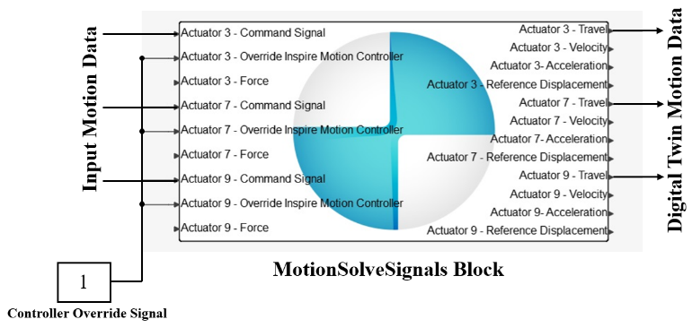
Figure 10: Input and output of signals into the digital twin

6 DISCUSSIONS, lessons learned, and Conclusion
This study demonstrated the methods, tools, and standards for developing a digital twin of a CMM. The case study assessed the quality of a machined part per GD&T and the accuracy of the CMM. Much of the previous work on the CMM digital twin used virtual models of CMMs to generate and validate part measurement paths for the physical twin and to determine measurement uncertainty. Information flowed primarily from the virtual environment to the physical CMM. This work established a data pipeline from the physical environment to the virtual environment of the digital twin. This demonstration represents the initial step toward a CMM digital twin driven by the actual CMM’s operational and measurement data. This work could support simultaneous optimization of the manufacturing process and CMM health monitoring. To date, no description of this approach has been reported in the literature.
The current scope supports monitoring and analysis, with the framework designed to support future bidirectional control. To create a closed-loop digital twin for the CMM, trained models based on data are needed. These models should have analytics capabilities for optimization, diagnostics, and prognostics to process incoming data and develop courses of action for the part's production process or for the CMM itself. Examples of additional resources are:
- Higher fidelity models that include drive mechanisms such as the barycentric drive, bearings, and motors.
- Additional data such as vibration, temperature, motor status, motor torque, and bearing friction.
- Standardized protocols, such as those provided by MTConnect and the Asset Administration Shell (AAS), allow the CMM to communicate data to machine tools.
- A software and protocol to send a command automatically to the CMM controller to change operational settings.
- Dynamic calibration and error compensation to change the offset of the machine to maintain measurement precision.

The main lessons learned are that it is possible to create a digital twin of a CMM using open standards such as MTConnect and QIF, with a reference architecture based on ISO 23247. However, several challenges have also been observed, particularly in integration. First, MTConnect data from the CMM probe position, in XML format, had to be saved to a file before being entered into the CMM digital twin. Second, gaps remain in using current metrology tools to automatically generate an inspection program, even when PMI is embedded in the part CAD file. Previous research has shown that several iterations and changes to the CAD model-embedded PMI were required to achieve an acceptable transformation into downstream CAM and CMM formats. Third, while software platforms and tools such as PC DMIS, Renishaw MODUS, and Silma X4 provide the capability to create a kinematic virtual twin of the CMM to simulate measurement paths, detect collisions, and create inspection programs, they do not provide full capability to stream data from the physical world to the virtual environment of the digital twin. These issues need to be further addressed to attain fully automated bidirectional data flows between the physical and virtual CMM. Potential applications of a bidirectional digital twin include error compensation, monitoring environmental conditions, supporting calibration, prognostics and health management, and autonomous inspection systems.

Disclaimer: Certain commercial products and systems are identified in this paper to facilitate understanding. Such identification does not imply that these software systems are necessarily the best available for the purpose. No approval or endorsement of any commercial product by NIST is intended or implied.
.

 | Probe tip 1 | Probe tip 2
X-Axis | 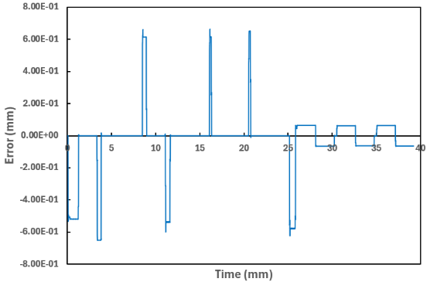 | 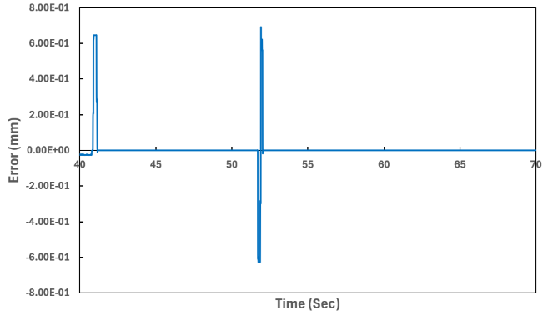
Y-Axis | 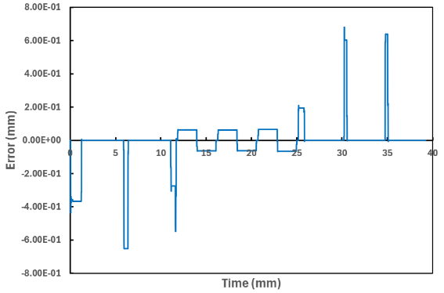 | 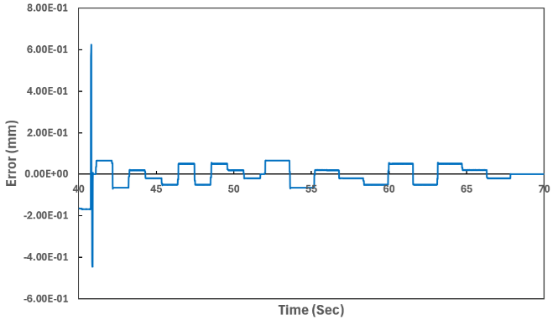
Z-Axis | 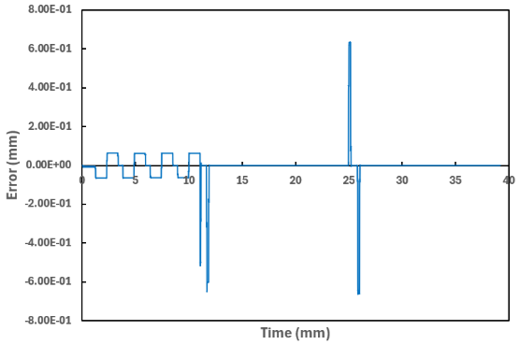 | 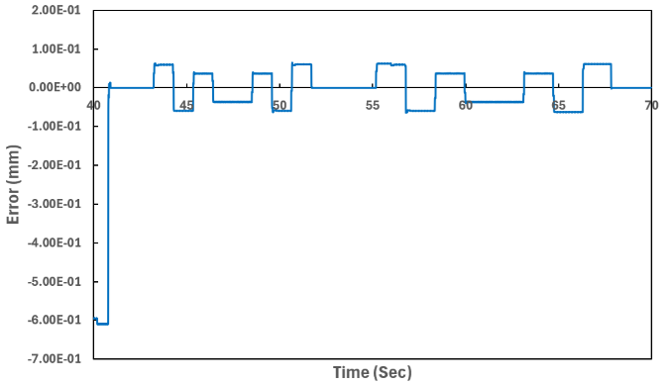
Figure 11: Errors in the positions of the axes during the inspection process

REFERENCES
- Wright, L., and Davidson, S., 2024, “Digital twins for metrology; metrology for digital twins,” Measurement Science and Technology, 35(5), pp. 051001.
- Gaha, R., Durupt, A., and Eynard, B., 2021, “Towards the implementation of the digital twin in CMM inspection process: opportunities, challenges and proposals,” Procedia Manufacturing, 54, pp. 216-221.
- Trainer, A., 2015, “Validation for downstream computer-aided manufacturing and coordinate metrology processes,”, GCR, NIST. from http://dx.doi.org/10.6028/NIST.GCR.16-003 [Accessed: Oct. 2, 2025].
- van Schalkwyk, P., 2022, “Digital Twin capabilities periodic table,” Digital Twin Consortium, from https://www.digitaltwinconsortium.org/initiatives/capabilities-periodic-table/ [Accessed: Sept. 21, 2025].
- Stojadinovic, S. M., Majstorovic, V. D., and Durakbasa, N. M., 2021, “An approach to the development of the digital inspection twin based on CMM,” Measurement: Sensors, 18, pp. 100300.
- Skulan, D. 2023, “Advancing precision: Exploring the impact of coordinate measurement machines in industry,” Quality, 62(12), pp. 15-15.
- Söderberg, R., Wärmefjord, K., Carlson, J. S. and Lindkvist, L., 2017, “Toward a Digital Twin for real-time geometry assurance in individualized production,” CIRP Annals, 66(1), pp.137-140.
- Wärmefjord, K., Söderberg, R., Lindkvist, L., Lindau, B., Carlson, J. S., 2017, “Inspection data to support a digital twin for geometry assurance,” ASME International Mechanical Engineering Congress and Exposition, Volume 2: Advanced Manufacturing: V002T02A101, from doi:10.1115/IMECE2017-70398. [Accessed: Februay 7, 2026].
- Wärmefjord, K., Söderberg, R., Schleich, B., and Wang, H., 2020, “Digital twin for variation management: A general framework and identification of industrial challenges related to the implementation,” Applied Sciences, 10(10), p.3342.
- ASME Y14.5-2018 (R2024), 2018, “Dimensioning and tolerancing”, from: https://www.asme.org/codes-standards/find-codes-standards/y14-5-dimensioning-tolerancing [Accessed: June 20, 2025].
- Stojadinovic, M., Majstorovic, V. D., Zivkovic, S., Kasalica, V., and Stanic, D. “An Approach of development Digital Twin based on CMM as support Industry 4.0,” Industry 4.0, 7(2), 2022, pp.50-53.
- Poniatowska, M., Mazurkiewicz, D., and Sobecki, P., 2024. “Digital twin in metrology: Opportunities, current Implementations and research challenges,” from https://www.gum.gov.pl/wye/content/current-volume [Accessed: August 20, 2025].
- Stojadinovic, S. M., Majstorovic, V. D., Durakbasa, N. M. and Stanic, D., 2022a, “Contribution to the development of a digital twin based on CMM to support the inspection process,” Measurement: Sensors, 22, pp.100372.
- Gohari, H., Berry, C., and Barari, A., 2019, “A digital twin for integrated inspection system in digital manufacturing,” IFAC-PapersOnLine, 52(10), pp.182-187.
- Stojadinovic, S. M., Majstorovic, V. D., Gąska, A., Sładek, J., and Durakbasa, N. M., 2021b, “Development of a coordinate measuring machine—based inspection planning system for industry 4.0,” Applied Sciences, 11(18), pp. 8411.654243
- ISO 14649-1: 2003, “Industrial automation systems and integration – Physical device control – Data model for computerized numerical controllers: Part 1 – Overview and fundamental principles”, from https://www.iso.org/standard/34743.html [Accessed: August 11, 2025].
- Stojadinovic, S.M., Majstorovic, V.D., and Durakbasa, N.M., 2021. “Toward a Cyber-Physical manufacturing metrology model for industry 4.0. Ai Edam, 35(1), pp.20-36.
- ISO 10303-1: 2024, “Industrial automation systems and integration–Product data representation and exchange–Part 1: Overview and fundamental principles”, from https://www.iso.org/standard/83105.html [Accessed: August 10, 2025].
- Fischer, K., Rosche, P., and Trainer, A, 2016, “Investigating the impact of standards-based interoperability for design to manufacturing and quality in the supply chain, NIST GCR 15-1009”, from https://doi.org/10.6028/NIST.GCR.15-1009 [Accessed: August 10, 2025].
- Samadi, H., Ahsan, M. M., and Raman, S., 2024, “Metrology and manufacturing-Integrated digital twin (MM-DT) for advanced manufacturing: Insights from CMM and FARO arm measurements”, from https://arxiv.org/html/2411.05286v1 [Accessed: June. 6, 2025].
- ISO 23247-2: 2021, “Automation Systems and Integration - Digital Twin framework for manufacturing – Part 2: Reference architecture,” International Organization for Standardization, from https://www.iso.org/standard/78743.html [Accessed: August 16, 2025].
- AMT, 2024, (Association for Manufacturing Technology), “MTConnect R© Standard Part 2.0 – Device Information Model,” from https://www.mtconnect.org [Accessed: August 16, 2025].
- ISO 23952:2020(en) “Automation systems and integration — Quality information framework (QIF) — An integrated model for manufacturing quality information,” [Online]. from https://www.iso.org/standard/77461.html [Accessed: August 20, 2025].
- Lai, X., Zhou, Y., Jiang, L., and Ding, G., 2021, “A review: machine tools digital twin modeling and application”, Proceedings of the 26th International Conference on Automation and Computing (ICAC), September 2nd – 4th, Portsmouth, UK, pp. 1-6.

