Understanding the electronic structure of ruthenium oxides during redox cycling with high energy resolution X-ray absorption spectroscopy
R. Soyoung Kim,¹ Oscar A. Paredes Mellone,² John Vinson,³ Angel T. Garcia-Esparza,² Mengxin Liu,⁴ Ikenna Chris-Okoro,⁴ Sheilah Cherono,⁴ Eric Jiahan Zhao,⁵ Yiming Ding,⁵ Haoyi Li,¹ Lei Zhang,^{6,7,8} Geoffroy Hautier,^{6,7,8} Tanja Cuk,⁹ Jin Suntivich,⁵ Dhananjay Kumar,⁴ Dimosthenis Sokaras,²* Junko Yano^{1,10}*
¹Chemical Sciences Division, Lawrence Berkeley National Laboratory, Berkeley, California 94720, United States
²Stanford Synchrotron Radiation Lightsource, SLAC National Accelerator Laboratory, Menlo Park, California 94025, United States
³Material Measurement Laboratory, National Institute of Standards and Technology, Gaithersburg, Maryland 20899, United States
⁴North Carolina Agricultural and Technical State University, Greensboro, North Carolina 27411, United States
⁵Department of Materials Science and Engineering, Cornell University, Ithaca, New York 14850, United States
⁶Thayer School of Engineering, Dartmouth College, Hanover, NH 03755, United States
⁷Department of Materials Science and NanoEngineering, Rice University, Houston, TX 77005, United States
⁸Rice Advanced Materials Institute, Rice University, Houston, TX 77005, United States
⁹Department of Chemistry, University of Colorado, Boulder, Boulder, Colorado 80308, United States
¹⁰Molecular Biophysics and Integrated Bioimaging Division, Lawrence Berkeley National Laboratory, Berkeley, California 94720, United States

KEYWORDS: ruthenium oxide, high energy resolution fluorescence-detected X-ray absorption spectroscopy, in situ X-ray absorption spectroscopy, polarized X-ray absorption spectroscopy, first-principles calculation.

ABSTRACT
Ruthenium oxides are essential catalysts and charge storage materials whose performance across reactions, from the oxygen evolution reaction to the chlor-alkali process, depends critically on reversible Ru redox cycling and the associated electronic structure changes. Although the Ru K-edge X-ray absorption spectroscopy (XAS) is routinely used for in situ studies, it provides limited information due to the low spectral resolution. This work reveals direct insights on the electronic structure of crystalline and amorphous/hydrous ruthenium oxide under electrochemistry using high energy resolution fluorescence-detected (HERFD) XAS and first-principles density functional theory with the Bethe–Salpeter equation. The pre-edge peak, which is buried in conventional XAS, is well-resolved with HERFD-XAS, enabling the assignment of specific electronic transitions visualized in real and reciprocal space. Polarized HERFD-XAS measurements on single-crystal RuO₂ are accurately reproduced by the first-principles calculations. Ultimately, in situ HERFD-XAS of hydrous ruthenium oxide at different electrochemical potentials shows the reversible filling and emptying of d-states accompanied with structural changes. Our work sheds light on the now accessible wealth of electronic structure information for the in situ characterization of 4d transition metals at their K edges via HERFD-XAS.
TOC Graphic
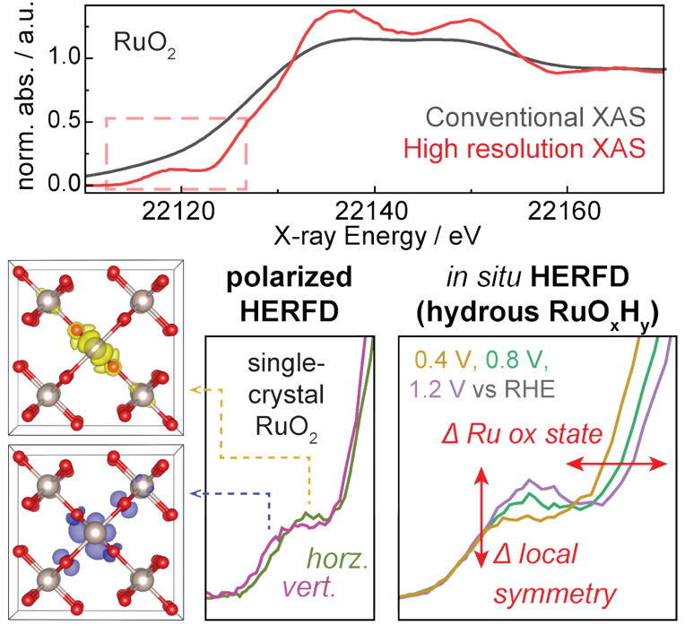

Ruthenium oxide (RuO₂), the stable solid oxide of the versatile transition metal ruthenium,¹ plays an important role in the modern world as a catalyst. It is an essential component of catalytic converters for the oxidation of carbon monoxide,^{2,3} and with its excellent electronic conductivity, serves as an electrocatalyst in the industrial chlor-alkali process that oxidizes Cl⁻ to Cl₂.^{4–6} RuO₂, along with IrO₂, is also one of the few highly functional oxygen evolution reaction (OER) electrocatalysts in acidic electrolytes. The growing interest in generating fuels using electrolyzers has led to numerous studies focused on understanding the OER mechanism of RuO₂ and related materials and developing strategies to enhance its activity and stability. It is proposed that surface-adsorbed oxygen intermediates (Ru_{s}−O) formed from deprotonation of surface-adsorbed water (Ru_{s}−OH₂) or hydroxide (Ru_{s}−OH) play a key role in these oxidation reactions.^{7–9}
An important aspect of RuO₂ chemistry is its ability to exist in a hydrous form (RuO₂•xH₂O or RuO_{x}H_{y}), which exhibits properties of a supercapacitor material. The hydrous/amorphous form conducts both electrons and protons, and it is thought to store charge by binding and releasing electron/proton pairs.^{10–12} Electrochemical capacitance associated with faradaic reactions, known as pseudocapacitance, was in fact first discovered in hydrous ruthenium oxide.^{11,13} This amorphous and hydrated form of ruthenium oxide is typically prepared by hydrolysis of Ru³⁺ salts,¹⁴ but it can also be generated from repeated electrochemical oxidation/reduction of RuCl₃ solutions^{15,16} or ruthenium metal in aqueous electrolytes.¹⁷ The hydrous oxide was also suggested to play a role in catalysis; for example, the active state of PtRu nanoparticles during methanol oxidation electrocatalysis was proposed to be hydrous ruthenium oxide,¹⁸ and hydrous ruthenium oxide was reported to form from RuO₂ during the catalytic hydrodeoxygenation of bio-oil,¹⁹ as well as from RuTe nanorods during water oxidation.²⁰ Hydrous ruthenium oxide was also used as a catalyst for the oxidation of benzyl alcohol, and a positive correlation between its catalytic activity and specific capacitance was observed.²¹ Fundamentally, the catalytic activity and pseudocapacitive behavior of ruthenium oxide both depend on redox reactions. Hence, our ability to probe the electronic structure of ruthenium oxide in its different forms and operational states is key to understanding its performance as a catalyst and energy storage material.
X-ray absorption spectroscopy (XAS), particularly the X-ray absorption near-edge structure (XANES), offers an element-specific probe for characterizing the electronic structure. Moreover, in situ/operando XAS provides direct insights into the dynamic electronic structure of catalysts in action.²² The penetrating nature of high-energy X-rays at the Ru K edge (>22 keV) allows relatively straightforward experimental setup under operating conditions. With Ru K-edge XANES, researchers have investigated the oxidation state of Ru in Ru-Ir mixed pyrochlore oxides²³ and 2D oxides,²⁴ Li⁺-intercalated RuO₂,²⁵ RuO₂ with a series of M⁴⁺ substitutions (Sn, Ce, Cr),²⁶ Ru oxides with cation and anion vacancies,²⁷ and more. Studies of Rh-doped²⁸ and W-inter-doped²⁹ Ru oxides have indicated a connection between catalyst stability and the extent of Ru oxidation state variation during OER catalysis. Ru K-edge XANES also played a key role in showing the in situ formation of hydrous ruthenium oxide during bio-oil hydrodeoxygenation¹⁹ and in interpreting the potential-dependent processes accompanying the discharge of RuO₂ as a lithium-ion battery anode.³⁰
Although Ru K-edge XANES has been widely used, its utility is fundamentally limited by broad spectral features. Unlike 3d transition metal K-edges that typically exhibit a core-hole broadening of around 1 eV, 4d transition metal K-edges suffer from significantly lower resolutions due to their shorter core-hole lifetimes. For the Ru 1s core hole, it leads to an intrinsic linewidth of approximately 6.6 eV.³¹ As a result, functionally important electronic changes, such as those arising from redox transitions, ligand-field variations, or symmetry distortions, are obscured.
In principle, XANES is sensitive not only to the oxidation state but also to the spin state, local geometry, and bond covalency of the element of interest.³² As an example of the limited spectral contrast, the Ru K-edge XANES of a series of molecular ruthenium complexes showed minor changes in a pre-edge shoulder that was correlated with variations in bonding geometry, expected to arise from 1s-to-4d transitions which are dipole-forbidden under octahedral symmetry.³³ A few other studies have also noted subtle increases in absorption before the main edge and interpreted them as plausible indicators of either geometry distortion or changes in the d-orbital occupancy.^{28,34,35} However, for six-fold coordinated Ru centers with a nearly octahedral geometry such as those in ruthenium oxides, the Ru K-edge pre-edge feature is typically unresolved due to the low energy resolution of conventional Ru K-edge XAS (vide infra). Notably, spectral broadening due to short core-hole lifetimes can be significantly suppressed by applying the high energy resolution fluorescence-detected (HERFD-XAS) scheme.³⁶ This technique involves the use of precisely aligned X-ray analyzer crystals to collect fluorescent X-ray photons with a specific energy only (e.g., the Kα line for K-edge excitations).³⁷
We report the Ru K-edge HERFD-XAS of ruthenium oxides in combination with first-principles calculations. The enhanced spectral resolution enabled quantitative analysis of the pre-edge peak, making it possible to resolve clear spectral differences between polycrystalline versus amorphous/hydrous forms of ruthenium oxide and between different X-ray polarization on single-crystal RuO₂. First-principles calculations with DFT and the Bethe-Salpeter equation using the ocean code³⁸ showed high fidelity in reproducing the spectral features of single-crystalline RuO₂. A detailed analysis of the electronic transitions that contribute to the pre-edge region, including visualization of the electron density of corresponding excited states, is herein presented to provide a benchmark for interpreting the Ru K-edge XANES of ruthenium-related energy materials. Ultimately, the analysis informed our interpretation of the in situ spectra of hydrous ruthenium oxide biased at different electrochemical potentials in 0.1 M HClO₄, showing the involvement of Ru 4d t_{2g}-like states and key changes in the degree of structural disorder during the reversible redox reactions.

Figure 1 compares the Ru K-edge XAS of polycrystalline RuO₂ powder measured with conventional fluorescence yield and with HERFD-XAS. While the regular XAS spectrum was broad and rather featureless with an unresolved pre-edge region, the HERFD-XAS spectra revealed a well-resolved pre-edge peak and sharper XANES features overall. The first derivative of the edge (Figure 1, bottom) further highlights the difference in spectral resolution.
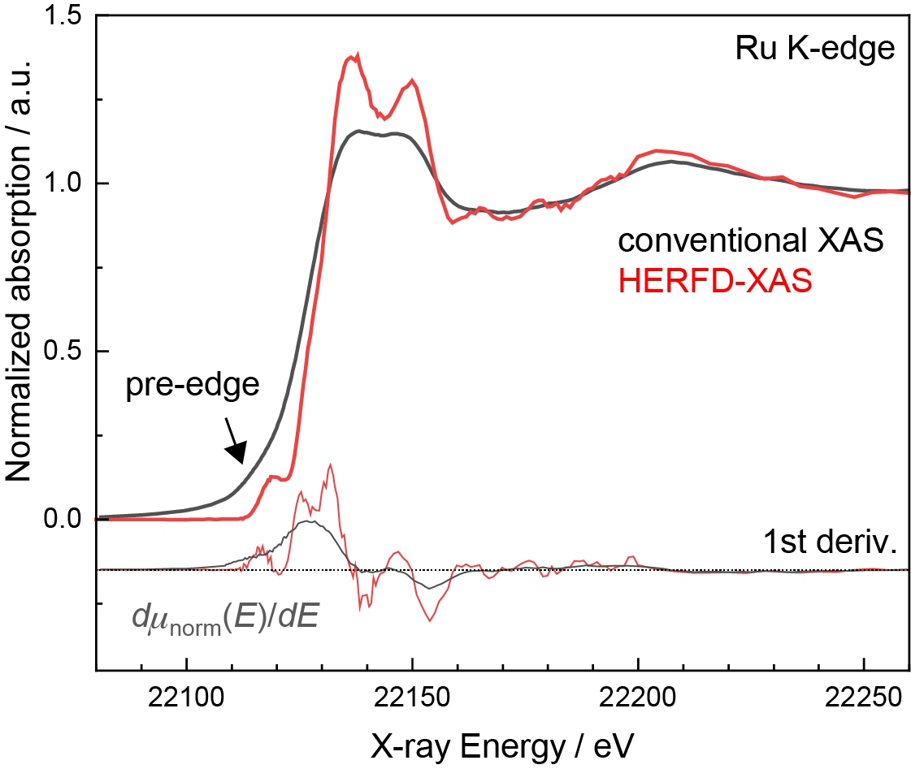
Figure 1. Ru K-edge XAS of polycrystalline RuO₂ powder recorded in conventional fluorescence yield and HERFD. The first derivative spectra are shown at the bottom with the dashed line denoting the zero position.

To investigate the sensitivity of the Ru K-edge HERFD-XAS to chemical state, we measured a related sample, the hydrous form of ruthenium oxide (RuO_{x}H_{y}) (Figure 2). Conventional XAS of polycrystalline RuO₂ and hydrous/amorphous RuO_{x}H_{y} were nearly identical except for a slight difference in edge position (Figure S2). In contrast, the HERFD spectra showed differences between the two forms of ruthenium oxide. The inflection point in the rising edge at around 22130 eV disappeared in the spectrum of the hydrous sample, reflected as a plateau in the first derivative spectrum between 22126 eV and 22132 eV. In addition, the two main peaks at 22136 eV and 22150 eV became less pronounced. The loss of fine structure is likely due to the greater disorder in RuO_{x}H_{y}.
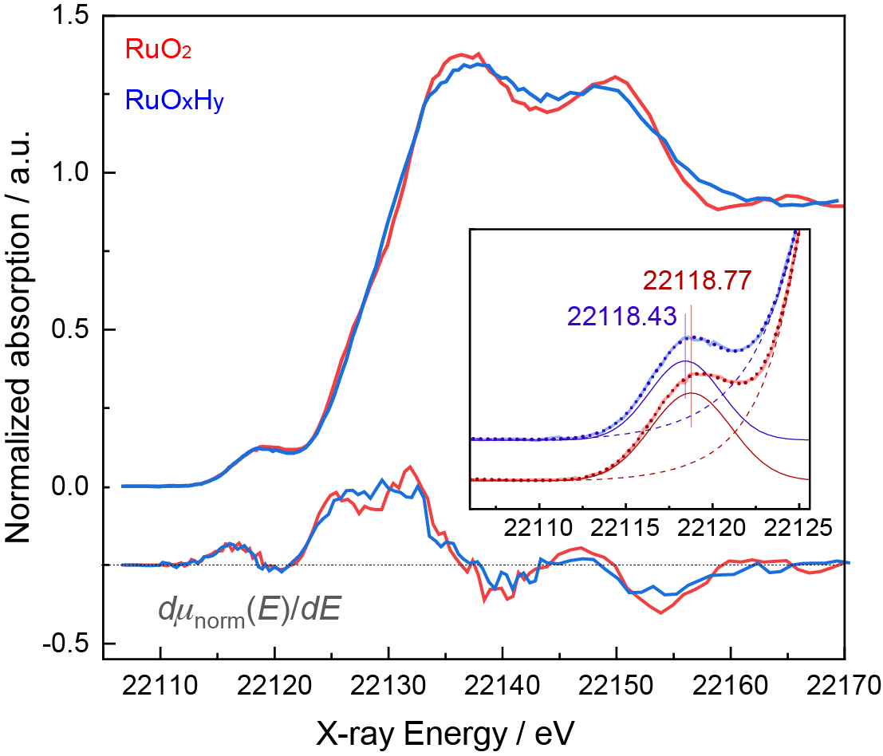
Figure 2. Ru K-edge HERFD-XAS of polycrystalline ruthenium oxide (RuO₂, red) and hydrous (RuO_{x}H_{y}, blue) ruthenium oxide. The first derivative spectra are shown at the bottom with the dashed line denoting the zero position. The inset shows pre-edge peak fitting results; experimental data (thick solid lines in light colors) and the fit (thick dots) are shown alongside the baseline modeled as a Lorentzian + linear function (thin dashed lines) and the peak modeled as a Gaussian function (thin solid lines). Vertical lines and the numbers denote the center of the fitted Gaussian peaks in eV.

The pre-edge peaks in the HERFD-XAS of the two ruthenium oxides were further analyzed by peak fit (Figure 2 inset, Table S1). They fit best to a single Gaussian; fitting to Voigt or pseudo-Voigt peak profiles led to negligible Lorentzian components and slightly lower-quality fits according to statistical criteria (reduced χ², Akaike info criterion, R-factor), whereas fitting with more than one peak gave large standard errors. Since the intrinsic line shape of XAS transitions due to the core-hole lifetime is considered Lorentzian, this indicates that Gaussian broadening due to experimental, instrument-related factors dominates the spectra rather than lifetime broadening, which is what the HERFD technique seeks to suppress.³⁹ The calculated natural core-hole lifetime broadening at the Ru K edge is 6.6 eV,³¹ while the full-width-half-maximum (FWHM) for our HERFD-XAS experiment, estimated based on the experimentally measured resolution, was 2.8 eV (see the SI).
The pre-edge peak arises from Ru 1s→4d transitions that are, in principle, dipole-forbidden. Its intensity increases with higher Ru oxidation state (which corresponds to a higher density of unoccupied d states) and more distortion from perfect octahedral geometry (which increases the p-d mixing). The pre-edge peak area obtained from the fitting was 30% larger for RuO₂ compared to RuO_{x}H_{y}, and the peak position was also more than 0.3 eV higher for RuO₂. These results suggest that RuO₂ exhibits a higher average oxidation state of Ru compared to RuO_{x}H_{y}, which is likely to have partially reduced Ru atoms due to adsorbed protons.⁴⁰
In the O K-edge XAS (Figure S11), two pre-edge peaks are observed that correspond to transitions from the O 1s core level to O 2p states hybridized with Ru 4d states having t_{2g} and e_{g} symmetry.⁴¹ The two peaks were well-separated and had comparable intensity for RuO₂, whereas for RuO_{x}H_{y}, the first peak (Ru 4d t_{2g}-O 2p) was heavily diminished. In contrast, in the Ru K-edge HERFD-XAS, the pre-edge was not resolved into two peaks either for RuO₂ or RuOxHy, due to the larger core-hole lifetime broadening at the Ru K-edge compared to the O K-edge. Nevertheless, the broader pre-edge FWHM observed for RuO₂ (5.7±0.1 eV) compared to RuOxHy (4.9±0.1 eV) is consistent with the larger t₂_{g}–e_{g} splitting directly resolved in the O K-edge, since both reflect the same crystal field splitting of the Ru 4d unoccupied manifold, probed directly through Ru-O covalent hybridization in the O K-edge and indirectly through the unresolved envelope of the Ru K pre-edge.
Furthermore, polarized HERFD-XAS measurements on single-crystal RuO₂, along with polarization- and momentum-dependent first-principles calculations, allowed to resolve the contributions arising from states of t_{2g} and e_{g} symmetries at the Ru K edge. Changing the polarization and momentum of X-ray photons incident on an oriented sample (Figure 3a) leads to different contributions of the dipole and quadrupole transitions to the cross section for orbitals of different symmetry and orientation.³⁸ In particular, this can lead to a large variation in the t_{2g}:e_{g} peak ratio as a function of X-ray polarization direction as reported for the O K-edge XAS of single-crystal RuO₂.⁴¹ Figure 3b (solid lines) shows the Ru K-edge HERFD-XAS of single-crystal RuO₂ obtained at two different measurement geometries as described in Figure 3a. The pre-edge peak center appeared at 1 eV lower in energy in the vertical orientation compared to the horizontal orientation (Figure 3b, inset). The double-peak feature of the main edge appeared at higher energies in the vertical orientation (Figure 3b, 22139/22152 eV versus 22137/22150 eV).
First-principles calculations with the ocean code using density functional theory (DFT) and the solution of the Bethe-Salpeter equation (BSE) were engaged to interpret the rich spectral features revealed with HERFD-XAS.^{38,42} Figure 3b shows excellent agreement between experiment and theory (see the SI for details of the calculation and the calculated spectrum of polycrystalline RuO₂ in Figure S12).^{43,44} All the main features observed in the experimental HERFD-XAS at the two orientations were captured by the calculations along with the relative differences associated with the X-ray polarization and momentum vector.
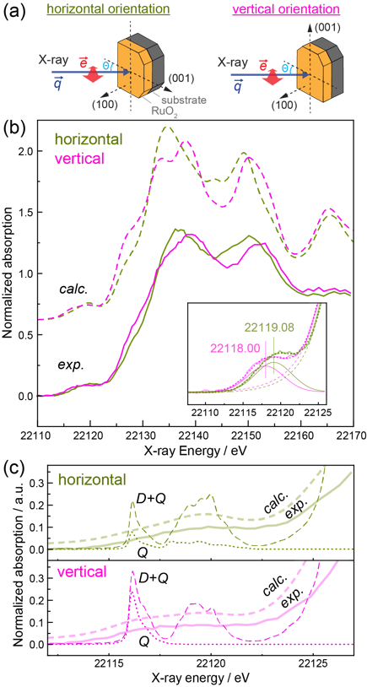
Figure 3. (a) Measurement geometry of the (100)-oriented single-crystal RuO₂ thin film. The e vector denotes the X-ray’s electrical field vector (i.e., the polarization direction), and the q vector denotes the X-ray’s momentum (i.e., the direction of beam propagation). “Horizontal” and “vertical” correspond to the direction of the sample’s (001) vector (i.e., the c-axis of the rutile lattice of RuO₂. The synchrotron X-ray beam was linearly polarized horizontally to probe the sample at θ = 45° for both orientations. (b) Experimental Ru K-edge HERFD-XAS of single-crystal RuO₂ measured at the two orientations (solid lines, bottom) and ocean simulated Ru K-edge XAS with broadening (dashed lines, top). The inset shows pre-edge peak fitting results of the experimental HERFD-XAS similar to Fig. 2 inset. (c) Raw ocean calculation with a reduced core-hole lifetime broadening of 0.2 eV (dashed lines, “D+Q”) and quadrupole-only calculation with the same broadening (dotted lines, “Q”). The spectra in (b) are shown alongside for reference.

Having confirmed the reliability of our theoretical protocol for capturing the details of the experimental spectra, we then probed the nature of the pre-edge transitions by deliberately reducing the broadening in the calculated spectra (Figure 3c, dashed lines) to resolve the transitions constituting the spectra. Two pre-edge features became visible, which match the pattern of the experimental O K-edge XAS pre-edge region (Figure S11). In Figure 4, we show that each contain transitions to t_{2g}-like and e_{g}-like states. We also calculated spectra with only quadrupole transitions (Figure 3c, dotted lines). The quadrupole transitions contributed significantly to the Ru K pre-edge, and they showed a strong orientation dependence. This is because the quadrupole-to-dipole amplitude ratio scales with the effective nuclear charge experienced by the frontier orbitals in the near-nucleus region, which grows across the transition metal series and leads to a roughly twofold increase in quadrupole intensity at 4d K-edges compared to 3d.
The spectral features were further analyzed in terms of their corresponding excitons, i.e., the electron densities of excited states resulting from X-ray absorption at specific X-ray energies. While ocean does not give distinct orbital compositions for the core-excited states, we can however visualize the excitons at specified X-ray energies either in real space or reciprocal space. Figure 4a shows the calculated XAS pre-edge for the vertical orientation (also shown in Figure 3c) along with the Ru 4d projected density of states (pDOS) (Figure 4b) and the RuO₂ band structure (Figure 4c) on the same energy axis. The pDOS shows the t_{2g} and e_{g} symmetry states appearing at lower and higher energies, respectively. Excitons were calculated at two representative X-ray energies: one at the peak of the lower-energy group of transitions (color-coded with blue) and another at the center of the higher-energy group of transitions (color-coded with yellow). The reciprocal-space densities of these excitons are projected onto the RuO₂ band structure in Figure 4c, while isosurfaces showing their real-space densities are shown in Figure 4d. The exciton plots confirm that the symmetry of the lower-energy transitions are t_{2g}-like and that of the higher-energy transitions are e_{g}-like.

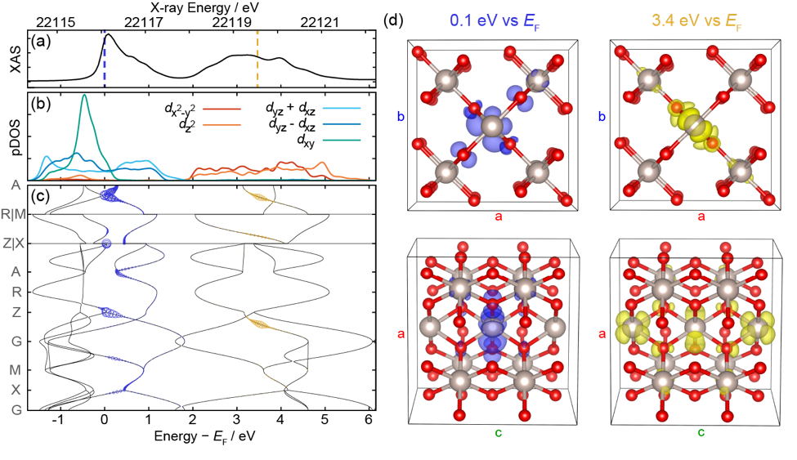
Figure 4. (a) The calculated Ru K-edge pre-edge region of single-crystal RuO₂ in the vertical orientation (see Figure 3a) with an artificially reduced broadening of 0.2 eV (black; also shown in Figure 3c). The spectrum’s X-ray energy axis (top) is aligned with the energy axis of the diagrams in (b) and (c). The vertical dashed lines denote the two representative X-ray energies at which the excitons are visualized, color-coded as blue (0.053 eV above the Fermi level, E_{F}) and yellow (3.433 eV above E_{F}). (b) The partial density of states (pDOS) projected onto the Ru 4d orbitals with the axes rotated such that z points along the shorter Ru−O bonds in the RuO₆ octahedra. (c) The band structure of RuO₂ along three high-symmetry paths, showing the Ru 4d bands. The blue and yellow circles denote the k-space density of the excitons at the two X-ray energies denoted in (a). (d) Real-space plot of the two excitons in (a) produced with the VESTA code.⁴⁵ The blue (0.1 eV) exciton shows a clear t_{2g}-like shape on the absorbing Ru atom (in the center), while the yellow (3.4 eV) exciton is more extended, showing p-like density around the absorbing Ru atom and a d_{x2−y2}-like shape around the neighboring Ru atoms. Both excitons also reveal hybridization with the neighboring oxygen p orbitals.

With this detailed understanding of the Ru K-edge XAS pre-edge, in situ HERFD-XAS was carried out on polycrystalline (RuO₂) and hydrous (RuO_{x}H_{y}) ruthenium oxides under electrochemical conditions to probe Ru redox changes (Figure 5). The ruthenium oxide powders were mixed with Nafion, deposited on current collectors, and measured in a custom-designed electrochemical XAS cell. Both powders consisted of sizes on the order of 100 nm (Figure S3). The two forms of ruthenium oxide were subjected to different electrochemical biases in aqueous 0.1 mol/L (M) HClO₄. Both of them are thought to undergo proton-coupled electron transfer according to Equation 1, giving rise to the corresponding cyclic voltammograms (CVs, Figure 5 insets)^{7,8,10,11}:

Ru^{n+}−OH₂/OH ⇄ Ru^{(n+1)+}−OH/O + H⁺ + e⁻ (1)

In situ Ru K-edge HERFD-XAS of RuO₂ were identical at different applied potentials (Figure 5a), even though the CV showed redox features. The amount of charge passed (Figure S5a) suggested that the redox processes are confined to the surface, consistent with literature.⁴⁰ A prior Ru L₃-edge XAS study had also shown that potential-dependent changes could not be seen for RuO₂ even in 5 nm-diameter particles with a higher surface-to-bulk ratio.⁴⁶ We also explored higher applied potentials up to 2.0 V vs the reversible hydrogen electrode (RHE) where vigorous OER ensued (visible bubbles generation), but no clear spectral changes were identified (Figure S6), and the harsh conditions led to delamination of the RuO₂ particle film.

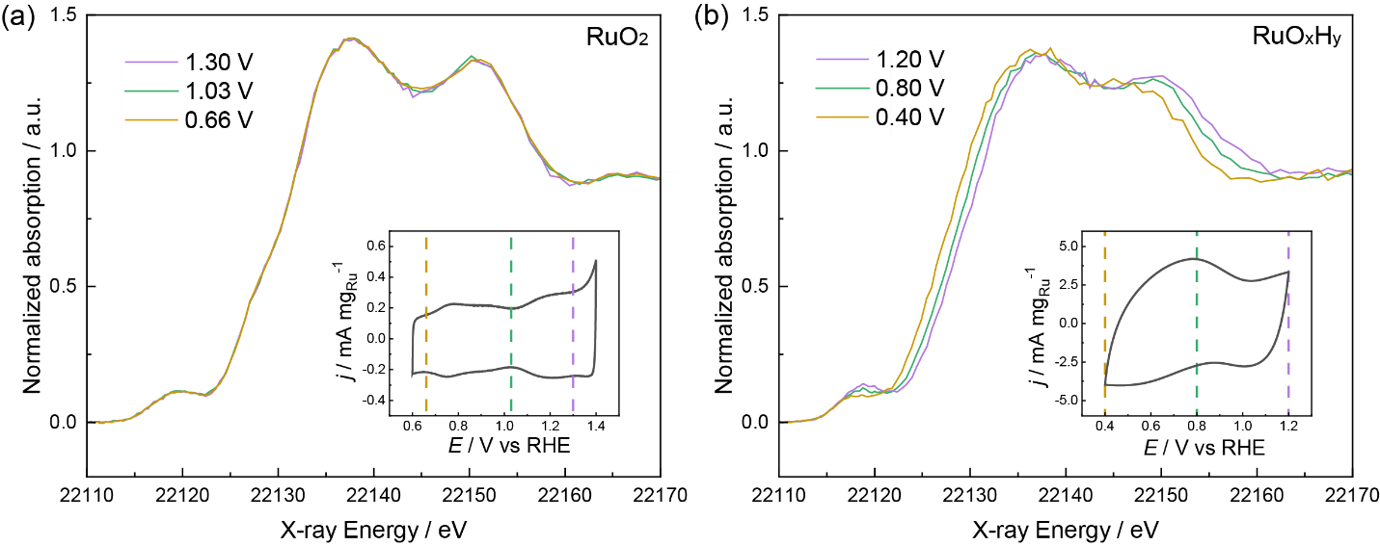
Figure 5. In situ HERFD-XAS of (a) RuO₂ and (b) RuO_{x}H_{y} at constant applied potentials (vs RHE) in 0.1 M HClO₄. Inset CVs were collected at (a) 20 mV/s and (b) 2 mV/s, respectively.

On the other hand, in situ HERFD-XAS of RuO_{x}H_{y} changed clearly with applied potential (Figure 5b). These spectral changes were highly reversible; alternating the potential between 0.4 V and 1.2 V yielded essentially identical spectra at each potential (Figure S6). At lower applied potentials, both the pre-edge peak and main edge of amorphous ruthenium oxide shifted to lower energies, and the pre-edge peak decreased in intensity. These changes indicate a decrease in the average oxidation state of Ru, consistent with prior reversible peak shifts at the Ru L₃- and L₂-edges observed as a function of applied potential.⁴⁷ The total amount of charge passed between 0.4 V and 1.2 V vs RHE was on the order of 1 e⁻ per Ru atom (Figure S5b). Although this is a rough estimate based on the approximate amount of RuO_{x}H_{y} that was deposited and the charge obtained by integrating the electrical current, it suggests that the redox reaction (Equation 1) occurs throughout the bulk of the particles, rather than only on the surface. The exact structure of RuO_{x}H_{y} that enables bulk redox is a debated topic where two extreme views of (i) water permeating a network of Ru ions and (ii) water surrounding RuO₂ nanoparticles at grain boundaries have been discussed;⁴⁸ we defer a rigorous clarification to future work.
To analyze the in situ spectra of RuO_{x}H_{y}, we first hypothesized that a change in the Ru oxidation state shifts the spectrum due to changes in the electrostatic potential around the core hole.⁴⁹ The energy shifts due to such electrostatic potential changes were extracted by comparing the center of the first derivative peak corresponding to the rising edge (Figure S8), which was very similar in shape at all applied potentials. Figure 6a shows the RuO_{x}H_{y} in situ spectra translated along the energy axis to align their rising edges. The inset shows the Gaussian peak fitting results of the pre-edge region after the alignment. The aligned spectra showed (Figure S9 and Table S1) the centroid of the pre-edge peak appear at X-ray energies closer to the main edge at lower applied potential. A similar peak centroid shift after rising-edge alignment was also observed in our calculations of electron-injected RuO₂ (Figure S13).
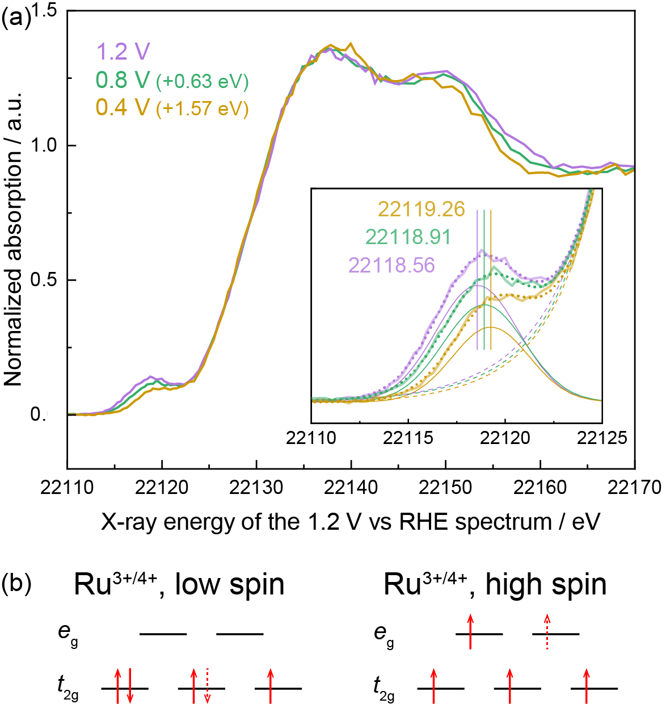
Figure 6. (a) In situ HERFD-XAS of RuO_{x}H_{y} shifted along the x-axis to align the rising edges to that of the 1.2 V vs RHE spectrum. The inset shows pre-edge peak fitting results similar to those in Figure 2 inset. (b) Electron configurations of Ru redox at different spin states.

Since the experimentally observed single pre-edge peak in Ru K HERFD-XAS consists of transitions to unoccupied t_{2g}- and e_{g}-like states, the centroid shifting to higher X-ray energies at lower applied potentials is consistent with electron being added to the lower-energy t_{2g}-like states upon Ru reduction. Deka et al. have reported a consistent observation using in situ O K-edge XAS of hydrous ruthenium oxide where the relative intensity of the “t_{2g} peak” (the peak from transitions into O 2p hybridized with Ru 4d t_{2g}-like states), which was insignificant at 0.25 V vs RHE, increased at higher applied potentials up to 1.25 V vs RHE.¹⁷ A similar peak centroid shift was also observed in our calculations of electron-injected RuO₂ (Figure S13). Redox occurring on t_{2g}-like states implies that Ru in RuO_{x}H_{y} is low spin (Figure 6b), if average Ru oxidation states of Ru³⁺ and Ru⁴⁺ are assumed at the low and high potential limits. This is consistent with the integrated charge between 0.4 V and 1.2 V vs RHE of ~1 e⁻/Ru (Figure S5).
In addition to the Ru spin state, pre-edge of the in situ HERFD-XAS also revealed local geometry changes. The area of the Gaussian peak fitted to the 1.2 V vs RHE spectrum was much greater than that fitted to the 0.4 V vs RHE spectrum (1.7 or 2.0 times depending on fit parameters). As this large difference cannot be attributed solely to the different density of unoccupied Ru 4d states (Table S2 and Figure S13), it indicates greater distortion of the Ru coordination environment from the symmetric octahedral geometry at higher Ru oxidation states. This conclusion is supported by our complementary extended X-ray absorption fine structure (EXAFS) results (Figure S10) that are also consistent with prior literature.¹⁶ The first peak in the Fourier-transformed (FT) EXAFS of hydrous ruthenium oxide showed weaker and broader magnitude at higher applied potentials, which suggests increasing heterogeneity in the first coordination shell bond lengths.

Ruthenium's catalytic versatility across a wide range of reactions, from the oxygen evolution reaction and water oxidation to CO oxidation and the chlor-alkali process, originates from its unique electronic structure as a 4d transition metal. Its ability to access a broad range of stable oxidation states, enables facile redox cycling that underpins both its activity and its pseudocapacitive charge storage behavior. The position of the Ru d-band center moreover confers intermediate binding energies for key oxygen-containing adsorbates such as O* and OH*, placing RuO₂ near the apex of the activity volcano for oxidative electrocatalysis.
In this work, we resolve the previously concealed pre-edge and near-edge features in the Ru K-edge XAS of crystalline and hydrous ruthenium oxides by overcoming the energy resolution limitations of conventional XAS (~ 6 eV at Ru K-edge) with HERFD (~ 2.8 eV). Advanced first-principles calculations and exciton simulations, along with polarized HERFD-XAS measurements, allowed the assignment of spectral features to specific bands and orbital symmetries generating a benchmark and fundamental reference for future studies. Moreover, we report a quantitative analysis of electrochemical in situ XAS with respect to changes in oxidation state, orbital occupancy, and local coordination symmetry. The electronic structure insights reported here, that resolve the occupancy and symmetry of Ru 4d t_{2g}-like states under electrochemical cycling, provide a direct spectroscopic window into precisely these properties, establishing a foundation for understanding how oxidation state, local geometry, and structural disorder collectively govern catalytic and charge storage performance in Ru-based materials.
Overall, the combination of experimental and theoretical tools at high energy resolution provides a detailed electronic picture of ruthenium oxides, advancing a molecular-scale understanding of proton-coupled electron transfer processes underlying their performance as catalysts and charge storage materials. More broadly, this study highlights the potential of high-resolution K-edge spectroscopy to reveal subtle electronic and structural transformations during redox reactions. The approach is applicable to a broader class of 4d transition metal compounds where conventional XAS fails to resolve key features due to intrinsic spectral broadening, opening a path toward decoding structure–function relationships in high-Z elements with orbital and symmetry specificity. HERFD XAS of 4d elements such as Ru benefits from hard X-ray penetration depth, minimal overlap with light element absorption edges, and ready access to extended EXAFS ranges, advantages that, combined with the resolution gains demonstrated here, make this approach broadly attractive for operando studies of 4d transition metal systems. The primary practical constraint is photon throughput, which currently favors higher-flux sources, but ongoing developments at fourth-generation synchrotrons are expected to make such measurements increasingly routine.

ASSOCIATED CONTENT
Supporting Information
The Supporting Information is available free of charge at XXX. Sample information, experimental procedures, data analysis method, computational method, additional XAS, electrochemistry, and computational results (Figures S1−S13 and Tables S1−S2) (PDF).
AUTHOR INFORMATION
Corresponding Author
Dimosthenis Sokaras; Stanford Synchrotron Radiation Lightsource, SLAC National Accelerator Laboratory, Menlo Park, California 94025, United States; dsokaras@slac.stanford.edu
Junko Yano; Molecular Biophysics and Integrated Bioimaging Division, Lawrence Berkeley National Laboratory, Berkeley, California, 94720, USA; jyano@lbl.gov
Present Addresses
Haoyi Li; Stanford Synchrotron Radiation Lightsource, SLAC National Accelerator Laboratory, Menlo Park, California 94025, United States
Author Contributions
The manuscript was written through contributions of all authors. All authors have given approval to the final version of the manuscript.
Notes
Certain equipment, instruments, software, or materials are identified in this paper in order to specify the experimental procedure adequately. Such identification is not intended to imply recommendation or endorsement of any product or service by NIST, nor is it intended to imply that the materials or equipment identified are necessarily the best available for the purpose. The authors declare no competing financial interest.
ACKNOWLEDGMENT
This work was supported in part by the Center for Electrochemical Dynamics and Reactions on Surfaces (CEDARS), an Energy Frontier Research Center funded by the U.S. Department of Energy, Office of Science, Basic Energy Sciences at the North Carolina A&T State University under award DE-SC0023415. Use of the Stanford Synchrotron Radiation Lightsource, SLAC National Accelerator Laboratory, was supported by the U.S. Department of Energy, Oﬃce of Science, Oﬃce of Basic Energy Sciences under Contract No. DE-AC02-76SF00515. This research used resources of the National Energy Research Scientiﬁc Computing Center (NERSC), a U.S. Department of Energy Oﬃce of Science User Facility operated under Contract No. DE-AC02-05CH11231 and award BES-ERCAP0028800. This research also used resources at the Advanced Light Source of Lawrence Berkeley National Lab, supported by the Director, Office of Science, Office of Basic Energy Sciences, of the US Department of Energy under Contract No. DE-AC02-05CH11231.
ABBREVIATIONS
HERFD, high energy resolution fluorescence-detected; XAS, X-ray absorption spectroscopy; OER, oxygen evolution reaction; XANES, X-ray absorption near-edge structure; FWHM, full-width-half-maximum; BSE, Bethe-Salpeter equation; CV, cyclic voltammogram or cyclic voltammetry; RHE, reversible hydrogen electrode.
REFERENCES
(1) Over, H. Surface Chemistry of Ruthenium Dioxide in Heterogeneous Catalysis and Electrocatalysis: From Fundamental to Applied Research. Chem. Rev. 2012, 112 (6), 3356–3426. https://doi.org/10.1021/cr200247n.
(2) Wang, J.; Fan, C. Y.; Jacobi, K.; Ertl, G. The Kinetics of CO Oxidation on RuO₂ (110): Bridging the Pressure Gap. J. Phys. Chem. B 2002, 106 (13), 3422–3427. https://doi.org/10.1021/jp014109k.
(3) Timmer, P.; Glatthaar, L.; Weber, T.; Over, H. Identifying the Active Phase of RuO2 in the Catalytic CO Oxidation Reaction, Employing Operando CO Infrared Spectroscopy and Online Mass Spectrometry. Catalysts 2023, 13 (8), 1178. https://doi.org/10.3390/catal13081178.
(4) López, N.; Gómez-Segura, J.; Marín, R. P.; Pérez-Ramírez, J. Mechanism of HCl Oxidation (Deacon Process) over RuO2. Journal of Catalysis 2008, 255 (1), 29–39. https://doi.org/10.1016/j.jcat.2008.01.020.
(5) Crihan, D.; Knapp, M.; Zweidinger, S.; Lundgren, E.; Weststrate, C. J.; Andersen, J. N.; Seitsonen, A. P.; Over, H. Stable Deacon Process for HCl Oxidation over RuO₂. Angew Chem Int Ed 2008, 47 (11), 2131–2134. https://doi.org/10.1002/anie.200705124.
(6) Kuo, D.-Y.; Paik, H.; Nelson, J. N.; Shen, K. M.; Schlom, D. G.; Suntivich, J. Chlorine Evolution Reaction Electrocatalysis on RuO2(110) and IrO2(110) Grown Using Molecular-Beam Epitaxy. The Journal of Chemical Physics 2019, 150 (4), 041726. https://doi.org/10.1063/1.5051429.
(7) Fang, Y.-H.; Liu, Z.-P. Mechanism and Tafel Lines of Electro-Oxidation of Water to Oxygen on RuO2(110). J. Am. Chem. Soc. 2010, 132 (51), 18214–18222. https://doi.org/10.1021/ja1069272.
(8) Kuo, D.-Y.; Paik, H.; Kloppenburg, J.; Faeth, B.; Shen, K. M.; Schlom, D. G.; Hautier, G.; Suntivich, J. Measurements of Oxygen Electroadsorption Energies and Oxygen Evolution Reaction on RuO2(110): A Discussion of the Sabatier Principle and Its Role in Electrocatalysis. J. Am. Chem. Soc. 2018, 140 (50), 17597–17605. https://doi.org/10.1021/jacs.8b09657.
(9) Rao, R. R.; Kolb, M. J.; Giordano, L.; Pedersen, A. F.; Katayama, Y.; Hwang, J.; Mehta, A.; You, H.; Lunger, J. R.; Zhou, H.; Halck, N. B.; Vegge, T.; Chorkendorff, I.; Stephens, I. E. L.; Shao-Horn, Y. Operando Identification of Site-Dependent Water Oxidation Activity on Ruthenium Dioxide Single-Crystal Surfaces. Nature Catalysis 2020, 3 (6), 516–525. https://doi.org/10.1038/s41929-020-0457-6.
(10) Ardizzone, S.; Fregonara, G.; Trasatti, S. “Inner” and “Outer” Active Surface of RuO2 Electrodes. Electrochimica Acta 1990, 35 (1), 263–267. https://doi.org/10.1016/0013-4686(90)85068-X.
(11) Augustyn, V.; Simon, P.; Dunn, B. Pseudocapacitive Oxide Materials for High-Rate Electrochemical Energy Storage. Energy Environ. Sci. 2014, 7 (5), 1597–1614. https://doi.org/10.1039/C3EE44164D.
(12) Yamada, A.; Goodenough, J. B. Keggin‐Type Heteropolyacids as Electrode Materials for Electrochemical Supercapacitors. J. Electrochem. Soc. 1998, 145 (3), 737–743. https://doi.org/10.1149/1.1838339.
(13) Trasatti, S.; Buzzanca, G. Ruthenium Dioxide: A New Interesting Electrode Material. Solid State Structure and Electrochemical Behaviour. Journal of Electroanalytical Chemistry and Interfacial Electrochemistry 1971, 29 (2), A1–A5. https://doi.org/10.1016/S0022-0728(71)80111-0.
(14) Zheng, J. P.; Cygan, P. J.; Jow, T. R. Hydrous Ruthenium Oxide as an Electrode Material for Electrochemical Capacitors. J. Electrochem. Soc. 1995, 142 (8), 2699–2703. https://doi.org/10.1149/1.2050077.
(15) Jow, J.-J.; Lee, H.-J.; Chen, H.-R.; Wu, M.-S.; Wei, T.-Y. Anodic, Cathodic and Cyclic Voltammetric Deposition of Ruthenium Oxides from Aqueous RuCl3 Solutions. Electrochimica Acta 2007, 52 (7), 2625–2633. https://doi.org/10.1016/j.electacta.2006.09.018.
(16) Mo, Y.; Antonio, M. R.; Scherson, D. A. In Situ Ru K-Edge X-Ray Absorption Fine Structure Studies of Electroprecipitated Ruthenium Dioxide Films with Relevance to Supercapacitor Applications. J. Phys. Chem. B 2000, 104 (42), 9777–9779. https://doi.org/10.1021/jp002355a.
(17) Deka, N.; Jones, T. E.; Falling, L. J.; Sandoval-Diaz, L.-E.; Lunkenbein, T.; Velasco-Velez, J.-J.; Chan, T.-S.; Chuang, C.-H.; Knop-Gericke, A.; Mom, R. V. On the Operando Structure of Ruthenium Oxides during the Oxygen Evolution Reaction in Acidic Media. ACS Catal. 2023, 7488–7498. https://doi.org/10.1021/acscatal.3c01607.
(18) Rolison, D. R.; Hagans, P. L.; Swider, K. E.; Long, J. W. Role of Hydrous Ruthenium Oxide in Pt−Ru Direct Methanol Fuel Cell Anode Electrocatalysts: The Importance of Mixed Electron/Proton Conductivity. Langmuir 1999, 15 (3), 774–779. https://doi.org/10.1021/la9807863.
(19) Naranov, E.; Sadovnikov, A.; Arapova, O.; Kuchinskaya, T.; Usoltsev, O.; Bugaev, A.; Janssens, K.; De Vos, D.; Maximov, A. The In-Situ Formation of Supported Hydrous Ruthenium Oxide in Aqueous Phase during HDO of Lignin-Derived Fractions. Applied Catalysis B: Environmental 2023, 334, 122861. https://doi.org/10.1016/j.apcatb.2023.122861.
(20) Wang, J.; Han, L.; Huang, B.; Shao, Q.; Xin, H. L.; Huang, X. Amorphization Activated Ruthenium-Tellurium Nanorods for Efficient Water Splitting. Nat Commun 2019, 10 (1), 5692. https://doi.org/10.1038/s41467-019-13519-1.
(21) Yu, H.; Fu, X.; Zhou, C.; Peng, F.; Wang, H.; Yang, J. Capacitance Dependent Catalytic Activity of RuO 2 · x H 2 O/ CNT Nanocatalysts for Aerobic Oxidation of Benzyl Alcohol. Chemical Communications 2009, 0 (17), 2408–2410. https://doi.org/10.1039/B820063G.
(22) Lassalle-Kaiser, B.; Gul, S.; Kern, J.; Yachandra, V. K.; Yano, J. In Situ/Operando Studies of Electrocatalysts Using Hard X-Ray Spectroscopy. Journal of Electron Spectroscopy and Related Phenomena 2017, 221, 18–27. https://doi.org/10.1016/j.elspec.2017.05.001.
(23) Sardar, K.; Petrucco, E.; Hiley, C. I.; Sharman, J. D. B.; Wells, P. P.; Russell, A. E.; Kashtiban, R. J.; Sloan, J.; Walton, R. I. Water-Splitting Electrocatalysis in Acid Conditions Using Ruthenate-Iridate Pyrochlores. Angewandte Chemie International Edition 2014, 53 (41), 10960–10964. https://doi.org/10.1002/anie.201406668.
(24) Zhu, W.; Song, X.; Liao, F.; Huang, H.; Shao, Q.; Feng, K.; Zhou, Y.; Ma, M.; Wu, J.; Yang, H.; Yang, H.; Wang, M.; Shi, J.; Zhong, J.; Cheng, T.; Shao, M.; Liu, Y.; Kang, Z. Stable and Oxidative Charged Ru Enhance the Acidic Oxygen Evolution Reaction Activity in Two-Dimensional Ruthenium-Iridium Oxide. Nat Commun 2023, 14 (1), 5365. https://doi.org/10.1038/s41467-023-41036-9.
(25) Qin, Y.; Yu, T.; Deng, S.; Zhou, X.-Y.; Lin, D.; Zhang, Q.; Jin, Z.; Zhang, D.; He, Y.-B.; Qiu, H.-J.; He, L.; Kang, F.; Li, K.; Zhang, T.-Y. RuO2 Electronic Structure and Lattice Strain Dual Engineering for Enhanced Acidic Oxygen Evolution Reaction Performance. Nat Commun 2022, 13 (1), 3784. https://doi.org/10.1038/s41467-022-31468-0.
(26) Shi, Z.; Li, J.; Wang, Y.; Liu, S.; Zhu, J.; Yang, J.; Wang, X.; Ni, J.; Jiang, Z.; Zhang, L.; Wang, Y.; Liu, C.; Xing, W.; Ge, J. Customized Reaction Route for Ruthenium Oxide towards Stabilized Water Oxidation in High-Performance PEM Electrolyzers. Nat Commun 2023, 14 (1), 843. https://doi.org/10.1038/s41467-023-36380-9.
(27) Yang, J.; An, K.; Yu, Z.; Qiao, L.; Cao, Y.; Zhuang, Y.; Liu, C.; Li, L.; Peng, L.; Pan, H. Effect of Cation and Anion Vacancies in Ruthenium Oxide on the Activity and Stability of Acidic Oxygen Evolution. ACS Catal. 2024, 17739–17747. https://doi.org/10.1021/acscatal.4c02779.
(28) Wang, Y.; Yang, R.; Ding, Y.; Zhang, B.; Li, H.; Bai, B.; Li, M.; Cui, Y.; Xiao, J.; Wu, Z.-S. Unraveling Oxygen Vacancy Site Mechanism of Rh-Doped RuO2 Catalyst for Long-Lasting Acidic Water Oxidation. Nat Commun 2023, 14 (1), 1412. https://doi.org/10.1038/s41467-023-37008-8.
(29) Deng, L.; Hung, S.-F.; Lin, Z.-Y.; Zhang, Y.; Zhang, C.; Hao, Y.; Liu, S.; Kuo, C.-H.; Chen, H.-Y.; Peng, J.; Wang, J.; Peng, S. Valence Oscillation of Ru Active Sites for Efficient and Robust Acidic Water Oxidation. Advanced Materials 2023, 35 (48), 2305939. https://doi.org/10.1002/adma.202305939.
(30) Kim, Y.; Muhammad, S.; Kim, H.; Cho, Y.-H.; Kim, H.; Kim, J. M.; Yoon, W.-S. Probing the Additional Capacity and Reaction Mechanism of the RuO₂ Anode in Lithium Rechargeable Batteries. ChemSusChem 2015, 8 (14), 2378–2384. https://doi.org/10.1002/cssc.201403488.
(31) Keski-Rahkonen, O.; Krause, M. O. Total and Partial Atomic-Level Widths. Atomic Data and Nuclear Data Tables 1974, 14 (2), 139–146. https://doi.org/10.1016/S0092-640X(74)80020-3.
(32) Baker, M. L.; Mara, M. W.; Yan, J. J.; Hodgson, K. O.; Hedman, B.; Solomon, E. I. K- and L-Edge X-Ray Absorption Spectroscopy (XAS) and Resonant Inelastic X-Ray Scattering (RIXS) Determination of Differential Orbital Covalency (DOC) of Transition Metal Sites. Coordination Chemistry Reviews 2017, 345, 182–208. https://doi.org/10.1016/j.ccr.2017.02.004.
(33) Getty, K.; Delgado-Jaime, M. U.; Kennepohl, P. Assignment of Pre-Edge Features in the Ru K-Edge X-Ray Absorption Spectra of Organometallic Ruthenium Complexes. Inorganica Chim Acta 2008, 361 (4), 1059. https://doi.org/10.1016/j.ica.2007.07.029.
(34) Jeon, Y.; Kwon, O.; Lee, C.; Lee, G.; Myung, J.; Sun Park, S.; Irvine, J. T. S.; Shul, Y. Positional Influence of Ru on Perovskite Structured Catalysts for Efficient H2 Production Process by Heavy-Hydrocarbon Source. Applied Catalysis A: General 2019, 582, 117111. https://doi.org/10.1016/j.apcata.2019.117111.
(35) Lyu, Y.; Hu, E.; Xiao, D.; Wang, Y.; Yu, X.; Xu, G.; Ehrlich, S. N.; Amine, K.; Gu, L.; Yang, X.-Q.; Li, H. Correlations between Transition-Metal Chemistry, Local Structure, and Global Structure in Li2Ru0.5Mn0.5O3 Investigated in a Wide Voltage Window. Chem. Mater. 2017, 29 (21), 9053–9065. https://doi.org/10.1021/acs.chemmater.7b02299.
(36) Bauer, M. HERFD-XAS and Valence-to-Core-XES: New Tools to Push the Limits in Research with Hard X-Rays? Physical Chemistry Chemical Physics 2014, 16 (27), 13827–13837. https://doi.org/10.1039/C4CP00904E.
(37) Sokaras, D.; Weng, T.-C.; Nordlund, D.; Alonso-Mori, R.; Velikov, P.; Wenger, D.; Garachtchenko, A.; George, M.; Borzenets, V.; Johnson, B.; Rabedeau, T.; Bergmann, U. A Seven-Crystal Johann-Type Hard x-Ray Spectrometer at the Stanford Synchrotron Radiation Lightsource. Review of Scientific Instruments 2013, 84 (5), 053102. https://doi.org/10.1063/1.4803669.
(38) Vinson, J. Advances in the ocean -3 Spectroscopy Package. Phys. Chem. Chem. Phys. 2022, 24 (21), 12787–12803. https://doi.org/10.1039/D2CP01030E.
(39) Nehzati, S.; Dolgova, N. V.; James, A. K.; Cotelesage, J. J. H.; Sokaras, D.; Kroll, T.; George, G. N.; Pickering, I. J. High Energy Resolution Fluorescence Detected X-Ray Absorption Spectroscopy: An Analytical Method for Selenium Speciation. Anal. Chem. 2021, 93 (26), 9235–9243. https://doi.org/10.1021/acs.analchem.1c01503.
(40) Tang, J.; Guan, D.; Xu, H.; Zhao, L.; Arshad, U.; Fang, Z.; Zhu, T.; Kim, M.; Pao, C.-W.; Hu, Z.; Ge, J.; Shao, Z. Undoped Ruthenium Oxide as a Stable Catalyst for the Acidic Oxygen Evolution Reaction. Nat Commun 2025, 16 (1), 801. https://doi.org/10.1038/s41467-025-56188-z.
(41) Occhialini, C. A.; Bisogni, V.; You, H.; Barbour, A.; Jarrige, I.; Mitchell, J. F.; Comin, R.; Pelliciari, J. Local Electronic Structure of Rutile RuO 2. Phys. Rev. Research 2021, 3 (3), 033214. https://doi.org/10.1103/PhysRevResearch.3.033214.
(42) Vinson, J.; Rehr, J. J.; Kas, J. J.; Shirley, E. L. Bethe-Salpeter Equation Calculations of Core Excitation Spectra. Phys. Rev. B 2011, 83 (11), 115106. https://doi.org/10.1103/PhysRevB.83.115106.
(43) Woicik, J. C.; Weiland, C.; Jaye, C.; Fischer, D. A.; Rumaiz, A. K.; Shirley, E. L.; Kas, J. J.; Rehr, J. J. Charge-Transfer Satellites and Chemical Bonding in Photoemission and x-Ray Absorption of SrTi O 3 and Rutile Ti O 2 : Experiment and First-Principles Theory with General Application to Spectroscopic Analysis. Phys. Rev. B 2020, 101 (24), 245119. https://doi.org/10.1103/PhysRevB.101.245119.
(44) Meng, F.; Maurer, B.; Peschel, F.; Selcuk, S.; Hybertsen, M.; Qu, X.; Vorwerk, C.; Draxl, C.; Vinson, J.; Lu, D. Multicode Benchmark on Simulated Ti K-Edge x-Ray Absorption Spectra of Ti-O Compounds. Phys. Rev. Materials 2024, 8 (1), 013801. https://doi.org/10.1103/PhysRevMaterials.8.013801.
(45) Momma, K.; Izumi, F. VESTA : A Three-Dimensional Visualization System for Electronic and Structural Analysis. J Appl Crystallogr 2008, 41 (3), 653–658. https://doi.org/10.1107/S0021889808012016.
(46) Pedersen, A. F.; Escudero-Escribano, M.; Sebok, B.; Bodin, A.; Paoli, E.; Frydendal, R.; Friebel, D.; Stephens, I. E. L.; Rossmeisl, J.; Chorkendorff, I.; Nilsson, A. Operando XAS Study of the Surface Oxidation State on a Monolayer IrOx on RuOx and Ru Oxide Based Nanoparticles for Oxygen Evolution in Acidic Media. J. Phys. Chem. B 2018, 122 (2), 878–887. https://doi.org/10.1021/acs.jpcb.7b06982.
(47) Stefan, I. C.; Mo, Y.; Antonio, M. R.; Scherson, D. A. In Situ Ru LII and LIII Edge X-Ray Absorption Near Edge Structure of Electrodeposited Ruthenium Dioxide Films. J. Phys. Chem. B 2002, 106 (48), 12373–12375. https://doi.org/10.1021/jp026300f.
(48) Ozoliņš, V.; Zhou, F.; Asta, M. Ruthenia-Based Electrochemical Supercapacitors: Insights from First-Principles Calculations. Acc. Chem. Res. 2013, 46 (5), 1084–1093. https://doi.org/10.1021/ar3002987.
(49) Grunes, L. A. Study of the K Edges of 3 d Transition Metals in Pure and Oxide Form by X-Ray-Absorption Spectroscopy. Phys. Rev. B 1983, 27 (4), 2111–2131. https://doi.org/10.1103/PhysRevB.27.2111.

