Title: Plastic ingestion by North Pacific Garbage Patch fishes: Highest occurrences and quantities in upper trophic pelagics

Running title: Plastic ingestion by North Pacific Garbage Patch fishes

Authors:
Katherine R. Shaw^{1,2*}, Zachary D. Bramble^{2*}, Sarah-Jeanne Royer³, Matthias Egger^{3,4}, Matthew Iacchei², Jennifer M. Lynch^{1,2}, and K. David Hyrenbach²

*co-first authors. Both authors contributed equally to this manuscript. To be cited as “Shaw and Bramble et al. 2025”

Affiliations
¹Chemical Sciences Division, National Institute of Standards and Technology, Waimānalo, HI
² Center for Marine Debris Research, Hawaiʻi Pacific University, Waimānalo, HI
³ The Ocean Cleanup, Rotterdam, The Netherlands
⁴ Empaqtify, St. Gallen, Switzerland

Corresponding Author: Katherine R. Shaw, katherine.shaw@nist.gov

Katherine R. Shaw: Data curation; Formal analysis; Investigation; Methodology; Supervision; Writing - review & editing

Zachary D. Bramble: Data curation; Formal analysis; Investigation; Methodology; Project Administration; Visualization; Writing - original draft

Sarah-Jeanne Royer: Formal analysis; Funding acquisition; Project administration; Resources; Supervision; Validation; Visualization; Writing - review & editing

Matthias Egger: Conceptualization; Formal analysis; Funding acquisition; Project administration; Resources; Writing - review & editing

Matthew Iacchei: Methodology; Resources; Validation

Jennifer M. Lynch: Formal analysis; Funding acquisition; Methodology; Project administration; Resources; Supervision; Validation; Visualization; Writing - review & editing

K. David Hyrenbach: Formal analysis; Investigation; Methodology; Project administration; Supervision; Writing - review & editing

Declaration of Interests: S-J.R. and M.E. are employed by The Ocean Cleanup, a non-profit organization aimed at advancing scientific understanding and developing solutions to rid the oceans of plastic, headquartered in the Netherlands. The other authors declare that they have no known competing financial interests or personal relationships that could have appeared to influence the work reported herein.

Funding: This work was funded by the donors of The Ocean Cleanup.

ABSTRACT

Plastic marine debris (PMD) is rapidly accumulating in the North Pacific Subtropical Gyre, exposing fishes living in the North Pacific Garbage Patch (NPGP) to extremely high PMD concentrations. We dissected and analyzed the gastrointestinal tract of 204 fish from 13 taxa sampled as bycatch during plastic pollution cleanup operations in the NPGP for plastics > 1 mm. Additionally, forty-six prey fish were retrieved from the stomachs of the primary fish and dissected separately to quantify secondary plastic ingestion and potential trophic transfer. A total of 154 plastic items were detected in 56 fishes. Plastics ranged in size from 10 mm to 8.4 cm. Plastic ingestion (frequency of occurrence percent, mean number of particles ± standard deviation) varied significantly across taxa and was highest in upper trophic pelagic species, including blue sharks (78 %, 6.78 ± 2.80 particles/fish) and amberjacks (44 %, 1.07 ± 0.34 particles/fish). Moderate plastic ingestion was observed in pygmy sharks (36 %, 0.68 ± 0.19 particles/fish), lanternfishes (25 %, 0.23 ± 0.06 particles/fish), and flying fishes (9 %, 0.47 ± 0.40 particles/fish). There was a single occurrence of plastic ingestion in two of the mid-level predators (cookiecutter shark and sargassumfish) and no plastic ingestion by two lower trophic reef-associated species (fang blenny and Indo-Pacific sergeant fish).

Running Title: Plastic ingestion by the North Pacific Garbage Patch fishes

6 Key Words: marine plastic debris, plastic ingestion, North Pacific Garbage Patch, polymer identification, FTIR

Highlights:
- Pervasive plastic ingestion (78% of taxa, 7 of 9) in North Pacific Garbage Patch fish assemblage
- Highest plastic ingestion (78% incidence, 6.78 ± 2.80 particles/fish) in blue sharks
- First records of plastic ingestion by pygmy and cookiecutter sharks, and sargassumfish
- Secondary ingestion of plastics through predation of lanternfish by amberjacks

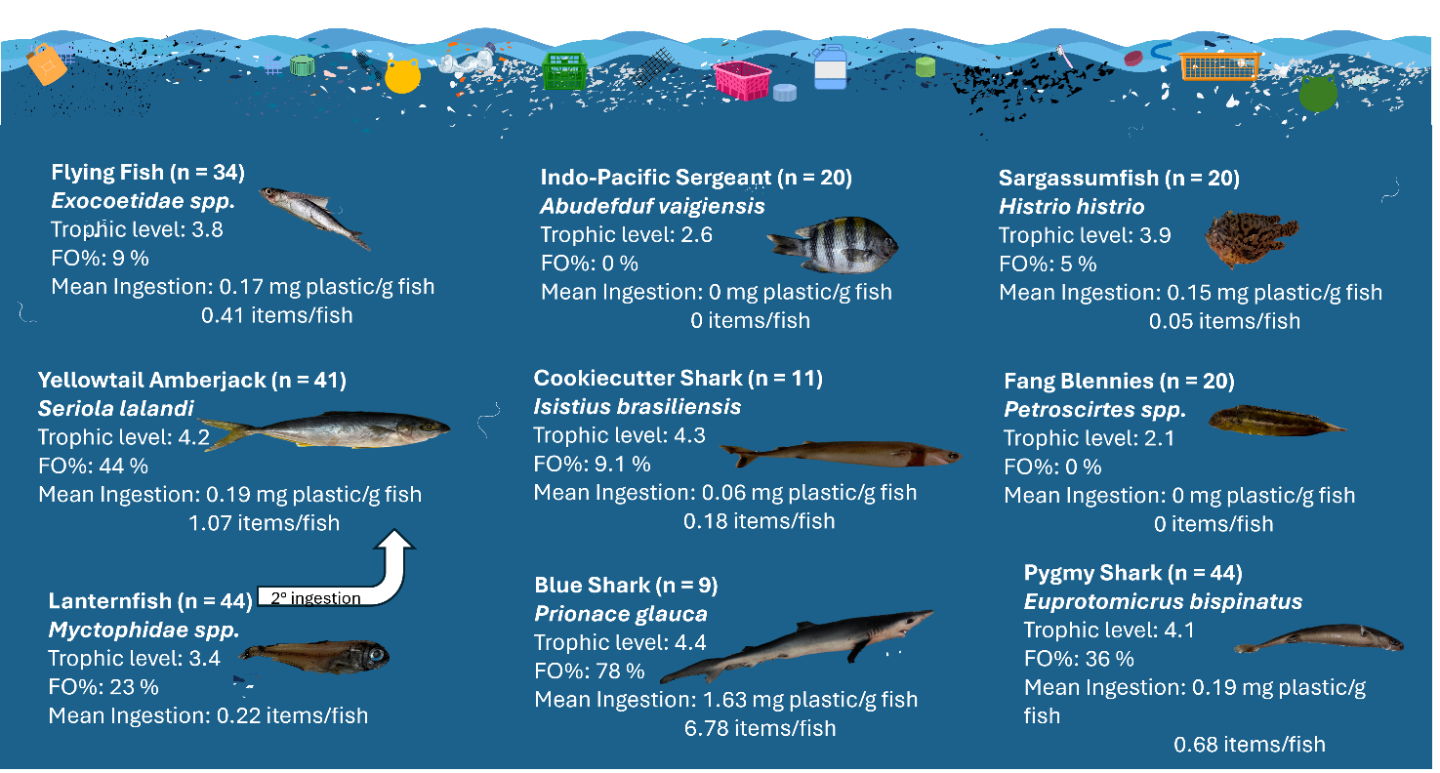

1. Introduction
Floating plastic marine debris (PMD) accumulates within Subtropical Gyres, with average concentrations of over 1,500,000 pieces/km² and the highest concentrations exceeding tens of millions of pieces per km² (Lebreton et al. 2024). In the North Pacific Ocean, the highest densities of meso- and microplastic particles occur within the North Pacific Garbage Patch (NPGP), a region of surface convergence between Hawai’i and the West Coast of North America (Titmus and Hyrenbach, 2011; Howell et al., 2012; Law et al., 2014; Lebreton et al., 2018 and 2024).
This accumulation has formed a synthetic habitat attracting a wide range of species, including oceanic and coastal invertebrates and fish assemblages with diverse feeding habits (Haram et al., 2021; Haram et al. 2023; Benadon et al. 2024). The PMD provides a habitat for invertebrates to settle (e.g., Lepas oceanic barnacles; Gill and Pfaller, 2016) and lay eggs (e.g., Halobates water striders; Andersen and Cheng, 2004), and epipelagic fish species may seek shelter from predators or forage around natural floating items (e.g. logs, leaves, sargassum) that also associate with PMD (Hamner 1995).
The high exposure of fishes to PMD makes it more likely for ingestion to occur (Savoca et al. 2021). The ingestion of PMD can have lethal or sublethal effects in many marine vertebrates including sea turtles (Rice et al. 2021), seabirds (Kibria 2024), and marine mammals (Puig-Lozano et al. 2018), but direct lethal effects of plastic ingestion have yet to be shown for fishes in the wild (Markic et al. 2019). Though plastic ingestion has been documented in many fish species, many more undocumented species likely eat plastic. Thus, sampling fish assemblages for plastic ingestion addresses a primary data gap to determine the full extent of exposure.
The mechanisms of transfer of ingested PMD through marine food webs are poorly understood, because predators can ingest plastic directly (primary ingestion) and indirectly (secondary ingestion), via their prey (Lusher et al. 2017). While secondary plastic ingestion has been documented in the literature, such as when yellowfin tuna (Thunnus albacares) consume flying fish (Cheilopogon rapanouiensis) containing PMD in Rapa Nui (Easter Island) (Chagnon et al. 2018), the distinction between primary and secondary ingestion remains a critical knowledge gap.
In this study, we examined 250 fish opportunistically collected as bycatch from marine debris cleanup missions in the NPGP. The goals of this study were to: 1) determine the occurrence and quantities (mass (g), number) of ingested plastic (> 1 mm) per fish and per fish mass and the relationship between ingested PMD quantities and fish characteristics (length, mass, sex, maturity); 2) Empirically test for secondary ingestion by analyzing the stomach contents of intact prey found in piscivorous predators; and 3) Compare the physical characteristics of the ingested plastic (type, polymer, color, size class) with surface net trawls previously sampled from the NPGP.
2.0 Methods
2.1 Field sampling and sample selection
Between July 2021 and December 2022, The Ocean Cleanup™, extracted 190,249 kg of plastic from the NPGP using the System 002 plastic extraction device equipped with 10 mm, 16 mm, and 50 mm mesh sizes (The Ocean Cleanup, 2023). Seventeen extractions occurred during 12 trips from Vancouver to the NPGP’s hotspot territory, an aggregation region where PMD concentrations often exceed 100 kg per km². The extent of the NPGP and the hotspot territory are defined as the areas containing 75 % and 25 % of modeled particle visits within the domain 20° to 45° latitude and -120° to -160° longitude (Lebreton et al., 2024; Jean-Michel et al. 2021; Egger et al., 2024). During this study, the NPGP and the hotspot territory were mapped by merging 18 contours and predicting their monthly extent from July 2021 through December 2022. Because of this compositing, the resulting areas are expected to be larger than the extent of the actual features at any specific month, illustrating their range of motion during the study (Figure 1).

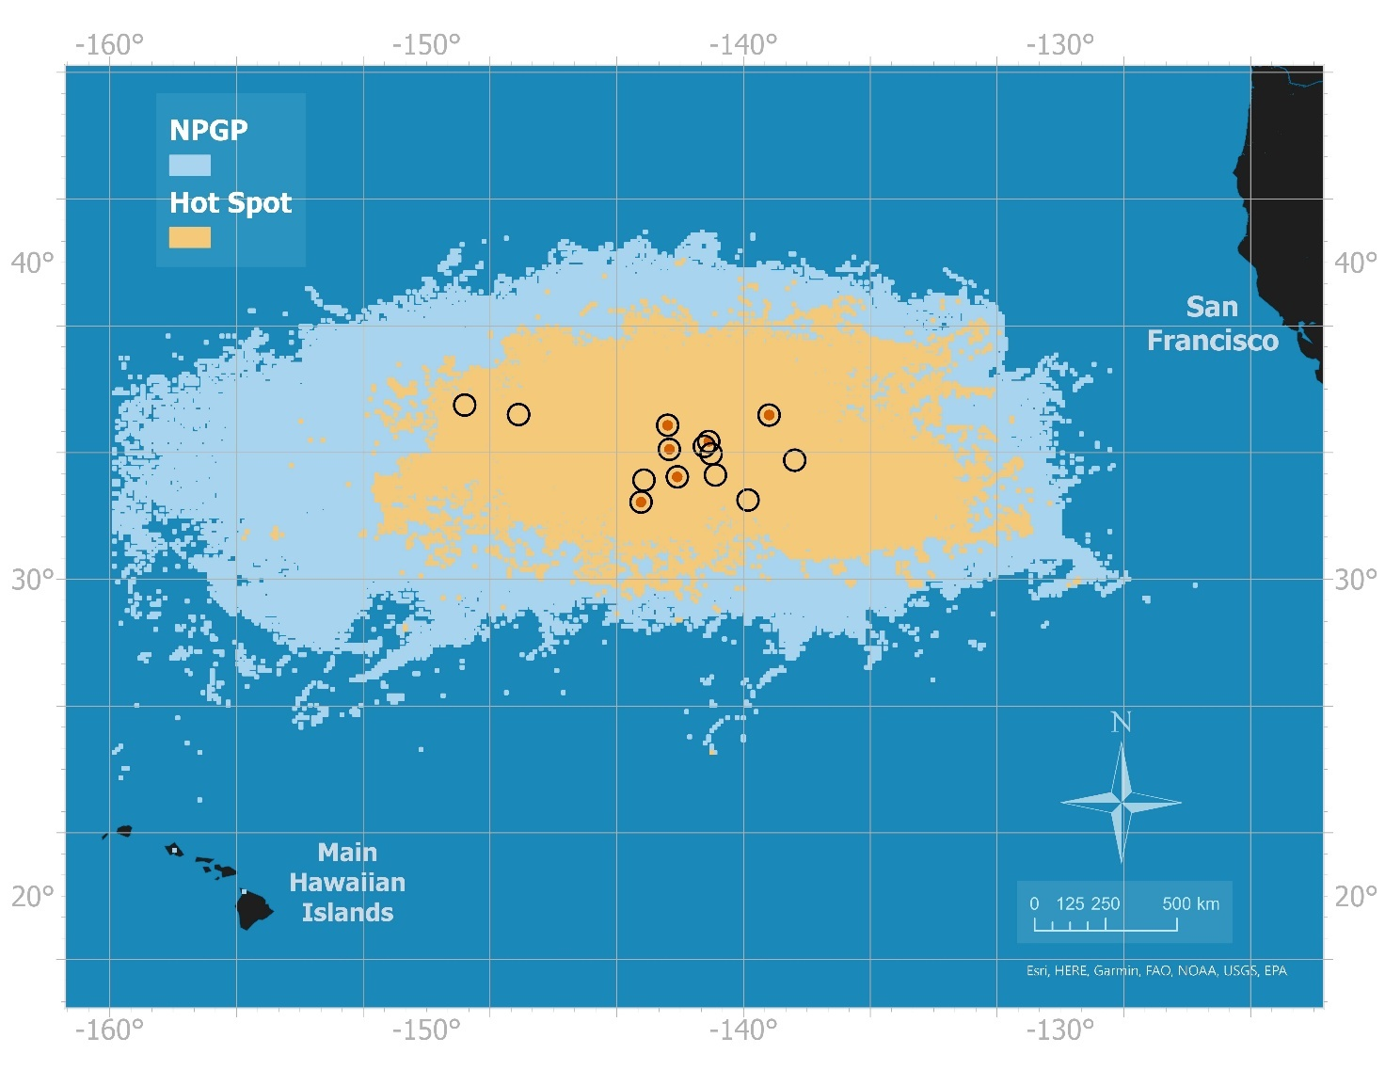
Figure 1. Sampling locations of 14 selected plastic extractions where the fish specimens examined in this study were opportunistically collected to assess plastic (> 1 mm) ingestion are plotted within the NPGP (light blue) and its plastic hotspot territory (yellow). Orange dots (6) and black circles (8) indicate extraction sites where ingested plastics were observed or absent from examined specimens, respectively.

Each extraction by System 002 was brought onboard the vessel and deposited on the deck. The bycaught fish specimens were manually sorted from the plastic catch, visually identified and labelled by scientists, and frozen on board at -20 °C. No further processing of samples was done onboard. When the boat reached port, fish were shipped on dry ice to the Center for Marine Debris Research. Upon receipt, specimens were inventoried and stored at -20 °C until they were thawed at room temperature for dissection. Twelve fish taxa were selected for examination (Table 1).
Species | Common Name | n
Abudefduf vaigiensis | Indo-Pacific sergeants | 20
Petroscirtes spp | Fang blennies | 20
Euprotomicrus bispinata | Pygmy sharks | 44
Seriola lalandi | Yellowtail amberjacks | 41
Exocoetidae | Flying fishes | 30
Histrio histrio | Sargassumfish | 20
Prionace glauca | Blue sharks | 9
Isistius brasiliensis | Cookiecutter sharks | 11
Brama japonica | Pacific pomfret | 1
Aluterus scriptus | Leatherjacket | 1
Oplegnathus punctatus | Spotted knifejaw | 1
Kyphosus spp. | Sea chub | 1

Additionally, we examined prey fish ingested by these primary fish for ingested plastic: 44 lanternfish (family Myctophidae) and two yellowtail amberjacks.
2.2 Quality control
A variety of laboratory protocols and controls were used to prevent microplastic contamination (Hermsen et al., 2018, Cowger et al. 2020). These protocols include careful cleaning of all materials, working in a laminar flow hood, and negative control samples. Additional information can be found in the SI File 2.
2.3 Fish morphometrics and dissections
Fish morphometrics were taken prior to dissection. Standard and total length, mass, and gape size were taken from every fish. The trophic level was assigned according to FishBase (Froese and Pauly, 2024) and sex and maturity determined when possible. The entire gastrointestinal tract (GIT) was removed from the fish and opened over a 1 mm sieve. Suspected PMD items were rinsed with high purity water and set aside for analysis. Additional details can be found in SI File 2.
2.4 Secondary ingestion
Fish prey (44 lanternfish and two yellowtail amberjacks) recovered from dissected specimens were set aside within the sieve during primary fish dissections. Due to their partially digested condition, morphometric measurements of these fish were not taken. These ingested fish were examined for the presence and completeness of a GIT. If intact, the GIT was removed and examined for plastic ingestion in the same manner described above. If the GIT was not complete that fish was not dissected and was excluded from the analysis. The ingested yellowtail amberjacks were not investigated further due to their low sample size (N = 2).
2.5 Genetic sequencing
Genetic sequencing was performed for 38 fish whose taxonomic identification was ambiguous. Fish were identified to the species level when possible, or the genus level when species identification was not possible. Additional information is available in SI File 2.
2.6 Plastic Marine Debris (PMD) characterization
Suspected PMD items were placed into baked tin cups, covered with baked foil, and dried at 40 °C for a minimum of three days or until dry (Shaw et al. 2024). Items were categorized by type, based on their form: hard plastic (fragment), line, pellet, foam, and sheet. Plastics were also categorized by visual weathering codes: mild (1), moderate (2), and severe (3) based on square fracturing as described in Brignac et al. (2019). The color of the plastic was visually assigned from a preset color list (Corniuk et al. 2023). PMD items were also measured by hand with a ruler to record their longest dimension (0.1 mm resolution) and weighed using a Sartorius MC210 S analytical balance (0.00001 g resolution). Plastics were categorized into five size classes based on Egger et al. (2020a) and Lebreton et al. (2018): (i) small microplastics (0.5 mm to 1.5 mm), (ii) large microplastics (1.5 mm to 5.0 mm), (iii) small mesoplastics (5 mm to 15 mm), (iv) large mesoplastics (15 mm to 50 mm), and (v) macroplastics (> 50 mm).
All 222 suspected PMD items were analyzed via attenuated total reflection- Fourier transform infrared spectroscopy (ATR- FTIR; Thermo Fisher Scientific iS5; Madison, WI USA). Spectra were collected from wavenumber 4000 cm^{–1} to 550 cm^{–1} with a data interval of 0.482 cm^{–1}. The resolution was set to 4 cm^{–1}. The ATR diamond crystal was cleaned with 70 % (volume fraction) isopropanol, and a background scan was taken before running each sample. Spectral peaks of particles were visually confirmed to identify the polymer type (e.g., polyethylene, polypropylene). Visual inspection of spectra identified additional peaks unique to other polymer types and characteristics of blended polymers that spectral library searches might miss (Jung et al. 2018). After visual identification, all polymers were confirmed using 11 commercial libraries and an in-house spectral library consisting of 248 different items (33 natural materials and 36 polymers; Table S3). The highest percent match (> 90 %) for each plastic piece was recorded. Non-plastic particles were identified based on matches to natural materials (e.g., aragonite) greater than 80 % and/or a lack of a polymer match and therefore were excluded from further analysis.
2.7 Plastic ingestion comparison with manta trawls
The composition of PMD ingested by fishes in this study weas compared to the composition of PMD collected using manta trawls in Lebreton et al. (2024). Only data from manta trawls conducted inside the NPGP and between 2021 and 2022 (Lebreton et al. 2024) were included in the comparison. Our study categorized plastics as hard plastic (fragment), line, pellet, and sheet. These categories were adjusted when comparing with Lebreton et al. (2024) in which the sheet category was combined with fragments and the line category includes both net and line.
2.8 Statistical analyses
To facilitate statistically significant comparisons of plastic occurrence and loads, we focused the analyses on nine taxa with sample sizes greater than nine fish. All statistical analyses were performed using the statistical software program JMP 17.2.0 (SAS Institute) with alpha = 0.05 to determine statistical significance. A list of all the statistical tests is provided in the Supporting Information (Table S4).
Plastic frequency of occurrence (FO%) was calculated for each taxon separately, by dividing the number of specimens with ingested plastic by the total number of specimens examined and multiplying by 100. The FO% from this study was compared to previously reported values in fish from the Pacific Ocean listed in the review of Savoca et al. (2021). Ingested plastic amounts were calculated using four standardized metrics: (i) the number of plastic items per fish, (ii) the mass of plastic per fish (g), (iii) the number of items per kilogram of fish (# of items/mass of fish (kg)), and (iv) the mass of plastic per kilogram of fish (mass of plastic (g)/ mass of fish (kg), Table S1). Fish that were found with no plastics were assigned a zero for these four units. Nonparametric Spearman rank correlation tests were performed to explore pairwise relationships of these four metrics for each taxa, as well as between ingested plastic loads (mass and number of particles) and the size of the fish (mass (g), standard length (cm), and total length (cm)) (Table S4). Spearman correlations were also used for relationships between the average plastics ingested by each taxa and their trophic level. In addition, the mean and standard deviation of plastic pieces ingested was determined for each species. For four taxa with ≥ 5 males and ≥ 5 females, the mass of plastic (mg), number of plastic pieces ingested, and mass of plastic (g)/mass of fish (kg) by sex were compared using a Kruskal-Wallis Test with the ChiSquared approximation. The same analysis was done for mature vs. immature fish, using the fish size at maturity from FishBase.
3.0 RESULTS
3.1 Species and fish sampled
A total of 250 fish from 13 taxa were included in this study. Six of these taxa have large sample sizes (≥ 20), as suggested by National Research Council (NRC, 2009), while another two taxa have sample sizes of nine and 11. Five taxa with n ≤ 2 (Pacific pomfret, scribbled leatherjacket, spotted knifejaw, sea chub, and ingested yellowtail amberjack) were excluded from further analysis; the raw data are available in Tables S1 and S2. Thus, the analyses focus on 199 primary fish from eight taxa, ranging in total length from 7 cm to 57 cm (Figure 2), and 44 ingested fish, found in the stomachs of the primary fish.
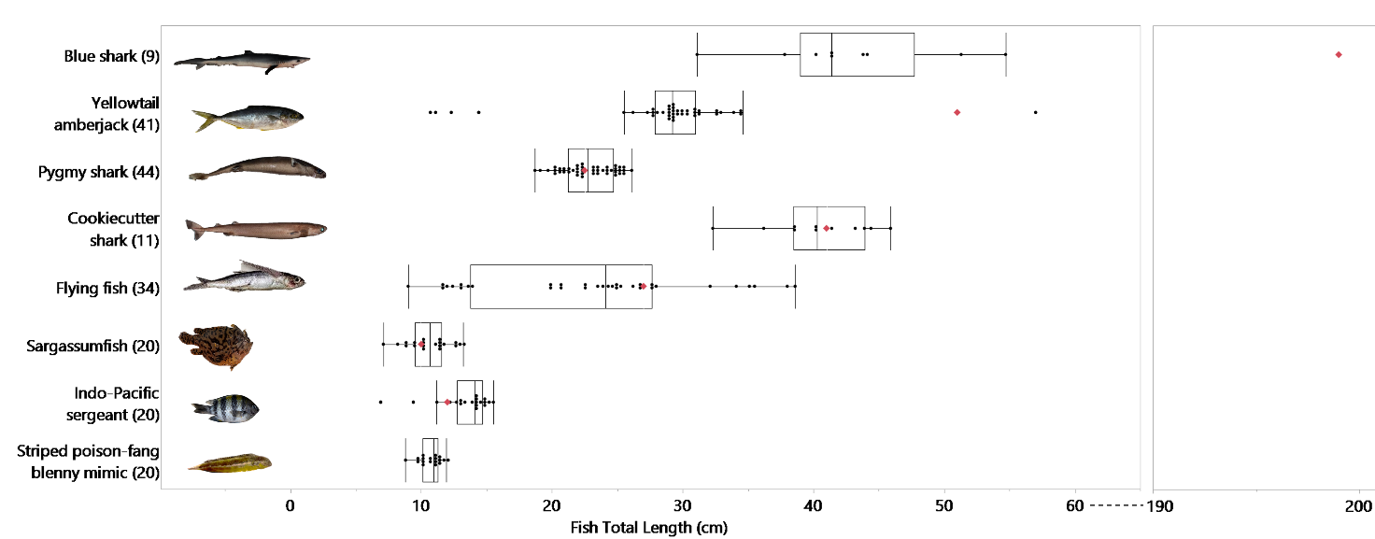
Figure 2: Total length of primary fish included in this study. Common names (n) are listed by decreasing % frequency of plastic ingestion occurrence (FO %) with the greatest FO % at the top. Red diamond indicates the average length at maturity for each taxon (Froese and Pauly 2024).

All examined blue sharks (n = 9) were pups, with a mean ± standard deviation (SD) total length (42.9 ± 7.0 cm) within the range of lengths at birth (35 to 45 cm) and a maximum total length (54.7 cm) well below the average size at maturity (199 cm; Froese & Pauly, 2024). Amberjacks were also almost all juveniles, with a mean ± SD total length (28.8 ± 7.3 cm) well below their length at maturity (51.0 cm), except for one individual with a total length of 57.0 cm (Froese & Pauly, 2024). All fish sampled from the remaining taxa were a combination of mature and immature fish. Four metrics (the number of plastic items per fish, the mass of plastic per fish (g), the mass of plastic per gram of fish (mass of plastic (mg)/ mass of fish (g)), and the FO% were significantly correlated with trophic level (⍴ = 0.75 to ⍴ = 0.95, p < 0.05, Table S4).
Genetic sequencing (Table S1) confirmed the visual taxonomic identification of the blue shark (Prionace glauca), Cookiecutter shark (Isistius brasiliensis), Indo-Pacific Sergeant (Abudefduf vaigiensis), and Sargassumfish (Histrio histrio) and provided more details regarding the species within some taxa, especially for flying fish and striped poison-fang blenny mimics. Flying fish visually identified as part of the Family Exocoetidae (n = 21) were genetically identified as Hirundichthys rondeletii (n = 7), Cheilopogon pinnatibarbatus (n = 2), Exocoetus monocirrhus (n = 2), Cheilopogon californicus (n = 1), or Cheilopogon unicolor (n = 1). Seven flying fish were only able to be identified to the genus level. Of the six fang blennies submitted for genetic analysis, one was identified as Petroscirtes breviceps, four as either P. breviceps or P. variabilis, and one as P. breviceps, P. variabilis, or P. xestus.

3.2 Plastic ingestion and characterization
In total, 222 potential plastic particles were removed from the GIT of fish and analyzed by ATR-FTIR for polymer identification. Of these, 154 particles were identified as plastic. The 154 plastic particles were recovered from 46 of 199 primary specimens, across six of the eight taxa assessed. The highest FO% of primary ingestion occurred in the blue shark (77.8 %) while no plastic was found in the GIT of Indo-Pacific sergeants or fang blennies. Plastic was found in 23 % (10 of 44) of lanternfish recovered as yellowtail amberjack prey, demonstrating trophic transfer of plastic (Table 2). For some taxa, the FO% of plastic ingestion was greater in NPGP fish than in previously assessed fish elsewhere in the Pacific Ocean. This was true for blue sharks, which had a FO% 24-times greater than previous values from waters off Baja California, Mexico (Markaida and Sosa-Nishizaki 2010). Yellowtail amberjacks in this study had a FO% four times greater than smaller amberjack fish collected 12 years before the current study in the NPGP (Gassel et al. 2013). Several previous studies are available for comparison for lanternfish. We detected 22.7 FO%, which is comparable with several previous reports from lanternfish sampled from the NPGP (0 % to 100 %, Boerger et al 2010; Davison and Asch 2011) and the Mariana Islands (1 % to 41 %, Van Noord et al 2013), but greater than lanternfish from the South Pacific near Australia (0 %, Cannon et al. 2016) and lesser than from Chinese waters (100 %, Zhu et al 2019). Flying fish from the NPGP had approximately half the FO% (8.8 %) than those from the South Pacific gyre (16.3 % to 18 %, Changnon et al. 2018 and Garnier et al., 2019) and much less than flying fish from markets in the South Pacific (100 %, Ding et al., 2019). Indo-Pacific sergeants in our study, as well as those from the South Pacific gyre (Forrest and Hindell 2018), did not ingest detectable plastics. No previous studies are available to compare with the detected plastic ingestion in the pygmy shark, cookiecutter shark, and sargassumfish, nor to the striped poison-fang blenny mimic which did not eat detectable plastics.
Table 2: Morphometric and plastic ingestion data for 199 primary fish and 46 ingested fish (gray shading). Means +/- SDs and ranges (in parentheses) are shown for morphometric and plastic ingestion metrics. The species are ordered in decreasing % frequency of occurrence (FO %) with the greatest FO % at the top. Three first known records of plastic ingestion are indicated with an asterisk.

Common Name | Primary Fish or Ingested Fish | n | Fish Mass (g) | Fish Total Length (cm) | Trophic Level | Plastic FO % | Plastic Mass (g) / fish | # pieces plastic / fish | plastic mass (g) / fish mass (kg) | # pieces plastic/gram of fish
Blue Shark | Primary | 9 | 235.2 ± 111.1  (85.2 - 447.8) | 42.87 ± 6.974  (31.1 - 54.7) | 4.4 | 77.8 | 0.3917 ± 0.4715  (0 - 1.45) | 6.78 ± 8.41  (0 - 27) | 1.629 ± 1.549  (0 - 4.06) | 0.0329 ± 0.0357  (0 - 0.11)
Yellowtail Amberjack | Primary | 41 | 243.2 ± 225.8  (9.9 - 1553) | 28.79 ± 7.264  (10.7 - 57.0) | 4.2 | 43.9 | 0.0642 ± 0.1846  (0 - 1.030) | 1.07 ± 2.18  (0 - 12) | 0.194 ± 0.4960  (0 - 2.473) | 0.00364 ± 0.05455  (0 - 0.0236)
Pygmy Shark * | Primary | 44 | 53.52 ± 16.84  (24.4 - 82) | 22.79 ± 1.953  (18.7 - 26.1) | 4.1 | 36.4 | 0.01015 ± 0.02180  (0 - 0.0863) | 0.682 ± 1.29  (0 - 6) | 0.1797 ± 0.4254  (0 - 2.302) | 0.01155 ± 0.01938  (0 - 0.0732)
Cookiecutter Shark * | Primary | 11 | 258.8 ± 88.24  (127.6 - 376.5) | 40.44 ± 3.969  (32.3 - 45.9) | 4.3 | 9.1 | 0.01530 ± 0.05074  (0 - 0.17) | 0.182 ± 0.603  (0 - 2) | 0.05634 ± 0.1869  (0 - 0.6918) | 0.0006697 ± 0.002221  (0 - 0.01)
Flying Fish | Primary | 34 | 101.1 ± 103.2  (6.9 - 403.5) | 23.04 ± 8.143  (9.0 - 38.6) | 3.9 | 8.8 | 0.01399 ± 0.07658  (0.00159 - 0.4466) | 0.412 ± 2.06  (0 - 12) | 0.1479 ± 0.8170  (0.0 - 4.766) | 0.004583 ± 0.0221  (0.00 - 0.13)
Sargassumfish * | Primary | 20 | 68.45 ± 33.39  (24.2 - 133.3) | 10.59 ± 1.631  (7.1 - 13.2) | 3.9 | 5.0 | 0.006982 ± 0.03122  (0 - 0.1396) | 0.05 ± 0.224  (0 - 1) | 0.1521 ± 0.6802  (0 - 3.042) | 0.001089 ± 0.004872  (0 - 0.0218)
Indo-Pacific Seargent | Primary | 20 | 17.96 ± 4.014  (6.1 - 76.4) | 13.29 ± 2.095  (6.9 - 15.5) | 2.6 | 0.0 | 0 | 0 | 0 | 0
Striped Poison-fang Blenny Mimic | Primary | 20 | 9.485 ± 2.314  (4.9 - 13.2) | 10.68 ± 0.7960  (8.8 - 11.9) | 2.1 | 0.0 | 0 | 0 | 0 | 0
Lanternfish | Ingested | 44 | - | - | 3.4 | 22.7 | 0.002219 ± 0.007420  (0.0029 - 0.0425) | 0.2174 ± 0.4170  (0 - 1) | - | -

Ingested plastic was found in three previously undocumented taxa: pygmy sharks, cookiecutter sharks, and sargassumfish. Blue sharks exhibited the greatest amounts of plastic ingestion by both count (27 items in D016) and mass (1.45 g in D013). Only one sargassumfish ingested plastic, a single mesoplastic particle.
No relationship was found between the sex of the fish and the amount of plastic (by count or mass) ingested for each taxon (Table S4). When considering only the fish that ingested plastics and excluding those that didn't, a Spearman rank test showed a significant positive correlation between the total length of the fish and # of ingested plastics by yellowtail amberjack (⍴ = 0.498, p = 0.0496) and between the total length of the fish and the mass of plastic (g) eaten by blue sharks (⍴ = 0.7928, p = 0.0334). We used a simple linear regression to explore the predictive power of this significant correlation in blue sharks (Figure 3). Based on Sshapiro-Wilk tests, the regression residuals were normally distributed for blue sharks (W = 0.89, p = 0.29). However, the largest individual blue shark did influence the regression, as the Cook’s distance was > 1 (1.73). 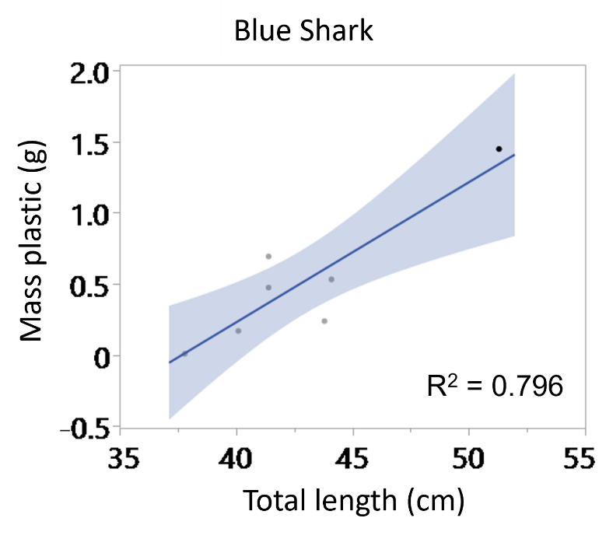
Figure 3: Linear regressions of the mass of ingested plastic by the total length of the fish. The R² is 0.796.

The remaining taxa did not exhibit any significant relationship between fish length and the number or mass of ingested plastics.
The type, color, polymer, and size of ingested plastic was compared between species and to net trawls in the NPGP (Figure 4).

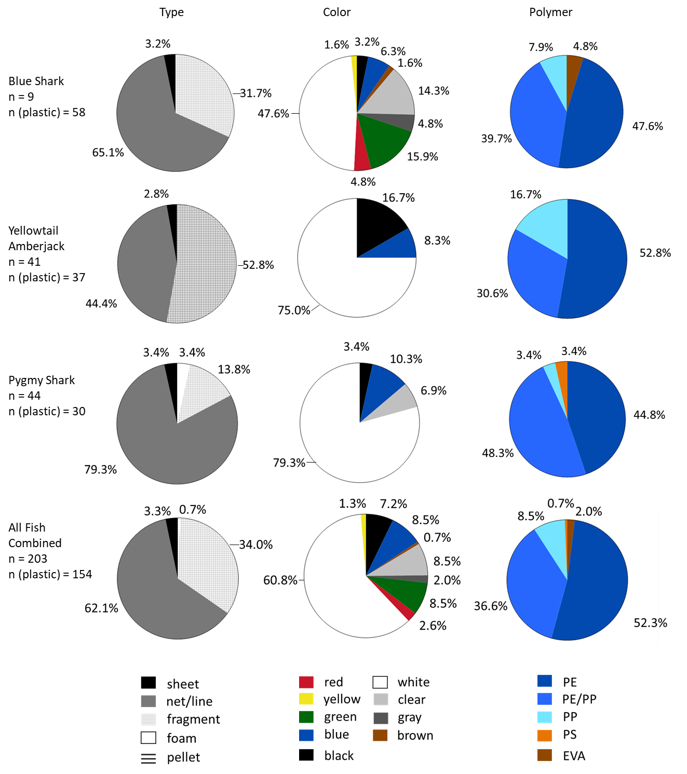
Figure 4: The type, color, polymer composition, and size categories of ingested plastic separated by species. The number of fish is indicated as “n = “ and the number of ingested plastic pieces as “n (plastic) =” under the common name of the species. *The bottom row contains data from manta trawls in the NPGP (Lebreton et al. 2024).

The majority of ingested plastics were net (62.1 %) followed by hard plastics (37.3 %) and foam (0.7 %). In contrast, the most common type of plastic found during manta trawl trawls (with a 500 μm mesh size) was hard plastic (92.5%), followed by net/line (5.8 %), and pre-production pellets (1.6 %), and foam (<0.1 %; Lebreton et al. 2024).
The most commonly ingested plastics were white (61.0 %). The remainder were blue (8.5 %), green (8.5 %), clear (8.5 %), black (7.1 %), red (2.6 %), gray (1.9 %), yellow (1.3 %), and brown (0.6). Blue sharks ingested the most diverse colors of plastic, 9 colors in total, while most other species ate plastic of only 3-5 colors. Over 97% of the ingested plastics (150/154) exhibited weathering (code 2 or 3), indicative of environmental degradation.
The polymer identified for all plastics had a hit quality index (FTIR match %) of ≥ 83 %. All ingested plastics were buoyant polymers, including polyethylene (PE; 52 %), polyethylene-polypropylene blends (PE/PP; 36 %), polypropylene (PP; 9 %), ethylene vinyl acetate (EVA; 2 %), and polystyrene (PS; 1 %).
When the sizes of ingested plastics for all species were combined, the sizes of ingested plastics (1 mm to 84 mm) were dissimilar to those collected in the manta trawls. By count, the manta trawls were 54.5 % small microplastics (500 µm to 1.5 mm) and 40.9 % large microplastics (1.5 mm to 5 mm; Lebreton et al. 2024), while ingested plastics were primarily mesoplastics (5.0 mm to 50 mm).

3.3 Secondary ingestion of plastics
Forty-four lanternfish were documented inside the GITs of 18 yellowtail amberjacks. (Table S1). Twelve of these yellowtail amberjacks had ingested more than one lanternfish. Only ten lanternfish (22.7 %) ingested PMD, resulting in eight cases of secondary ingestion (Figure 5).
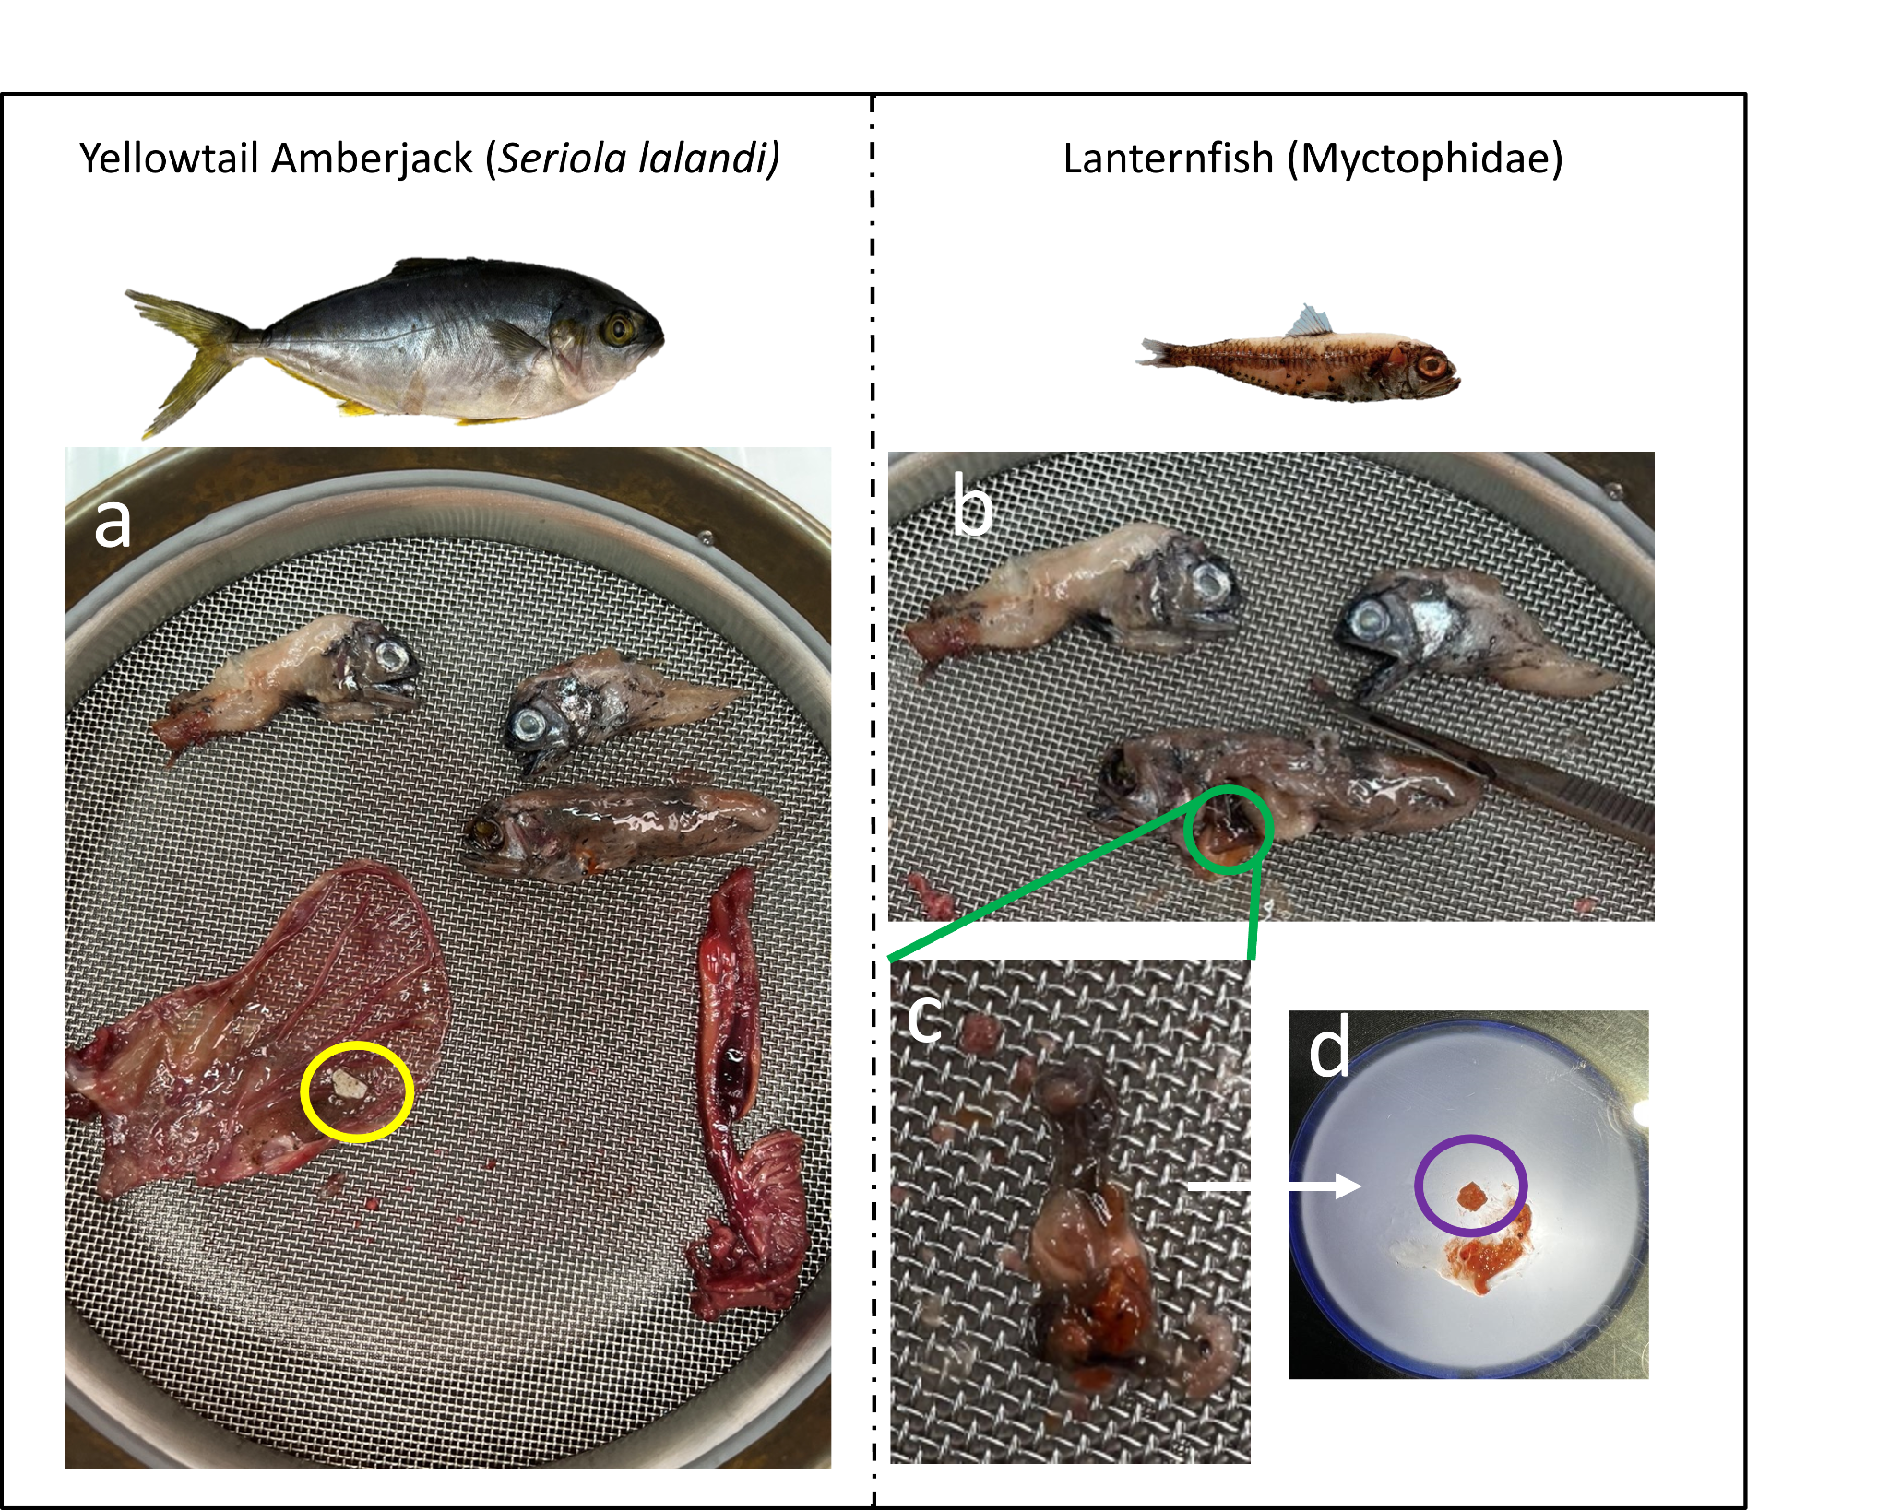
Figure 5: Example of secondary ingestion in yellowtail amberjack via lanternfish. 3a) Stomach of yellowtail amberjack containing three ingested lanternfish and one primary-ingested plastic circled in yellow. 3b) The three lanternfish found in the stomach of the yellowtail amberjack in 3a. The lanternfish's stomach is circled in green. 3c) Lanternfish stomach as it is being dissected. 3d) Microplastic fragment from myctophid stomach (circled in purple) at 4x magnification.

4.0 DISCUSSION
4.1 Plastic ingestion in the NPGP
Our study shows that plastic ingestion was highest in three upper-level predators: blue sharks, yellowtail amberjack, and pygmy sharks. Because these predators are opportunistic feeders eating prey within the water column, they may be more likely to consume PMD. All three are higher trophic level consumers, indicating the higher trophic levels may be at a greater risk of plastic ingestion in the NPGP. Notably, our observations of plastic ingestion in pygmy sharks, cookiecutter sharks, and sargassumfish represent the first known and quantified records of plastic ingestion by these taxa. The two species that did not ingest plastic, the Indo-Pacific sergeant and fang blenny, were among the smallest specimens sampled and of the lowest trophic level. Both species have the smallest average gape size in this study, and thus may not be eating particles > 1 mm.
The most frequently ingested type of plastic in this study was line at 62 % of total ingested plastics and was the majority of ingested plastic in three species: pygmy shark, flying fish, and blue shark. The prevalence of ingested line could indicate a potential preference for line compared to hard fragments by these species in the NPGP. In addition, flying fish are known to lay their eggs on floating debris, including line, potentially attracting these species. However, pygmy and blue sharks eat smaller prey like flying fishes and myctophids, providing an alternate route of exposure through secondary ingestion. It is difficult to determine if these species are intentionally eating line or are only appearing to because of trophic transfer.
The majority of ingested plastics were PE, PP, or a PE/PP mix, regardless of the species (Figure 4, Figures S1-S4), which aligns with global production trends where PE (36 %) and PP (21 %) remain the most commonly produced polymers (Geyer et al. 2017). These results also correlate with evidence from manta trawls taken from the NPGP, which indicate that PE or PP are the dominant primary polymers for all size classes (Lebreton et al. 2018, 2024; Egger et al., 2020). The species studied in the NPGP likely don’t prefer one polymer over another; they simply eat the most commonly available polymers.
The plastic ingestion data and mantra trawl data are comparable in terms of the polymer found but not by the type of plastic. The most frequent type of plastic collected at the surface of the NPGP using 0.5 mm mesh manta net trawls was hard plastic, not line (Lebreton et al. 2024). This discrepancy is likely caused by the inherent biases of the different sampling methods. Line pieces ingested by these species have a small diameter and can slip through the mesh and thus are too small to be caught in the manta net trawls.
The comparison of plastic ingestion across studies is extremely difficult due to the lack of standardization in the field. Comparing studies that include fibers or fragments below 1 mm to those that only consider particles greater than 1 mm would be misleading. Microfibers often make up the majority of ingested particles (Sacco et al. 2024, Lim et al. 2022, Marmara et al. 2023, Markick et al. 2018), and when included during analyses, can skew the data, making a species or location seem more affected by plastic ingestion than others. Thus, we compared our results to studies of similar-sized (> 1 mm) plastic ingestion by fish in the same families. Sergeant fish (Pomacentridae family) did not ingest any plastic in either the North or South Pacific Oceans (Forrest and Hindell 2018), but a study in the Red Sea showed ingestion of one microplastic by an individual, though it is unclear whether it was a fragment or fiber (Baalkuyur et al. 2018). Flying fish (Exocoetidae family) ingested an average of 0.26 microplastics/fish in the South Pacific (Changon et al. 2018), while our study in the North Pacific showed an average ingestion of 0.41 plastics/fish. In contrast, fish from the Carangidae family (Decapterus muroadsi, amberstripe scads) showed a higher ingestion amount in the South Pacific than our study in the North Pacific (2.2 plastics/fish vs. 1.1 plastics/fish, respectively; Ory et al. 2017). The South Pacific scads were collected from an area offshore of Rapa Nui, where water samples contained approximately 65,000 particles/km² (Ory et al. 2017) while fish in the NPGP are exposed to average concentrations of PMD more than one order of magnitude higher, at approximately 1,700,000 particles/km² (Lebreton et al. 2024). The habitat concentration of PMD being higher in the North compared to the South Pacific would predict higher ingestion in North vs. South Pacific fish, but the opposite result was found, indicating there are more factors than just proximity to plastic to predict ingestion, including fish size. The NPGP yellowtail amberjacks were twice the size (28.79 ± 7.264 cm) of amberstripe scad from the South Pacific (14.0 ± 0.2 cm, Ory et al. 2017). Perhaps smaller amberjacks eat proportionally more PMD than larger ones, as observed previously for blue sharks (Bernardini et al. 2018; Lipej et al. 2022). In support of the size and habitat concentration comparisons, the NPGP blue shark pups ingested 340 times more than South Pacific juvenile and adult blue sharks ( Fernandez and Anastasopoulos 2019) and more than large juveniles and adults in the Eastern Tropical Pacific (, Huang et al. 2022). This is particularly concerning due to the near threatened status of blue sharks (Rigby et al. 2019; Huang et al. 2022).
Nevertheless, despite the lower plastic loads in yellowtail amberjacks from the NPGP, the length of these fish was significantly correlated to the number of ingested plastic pieces (p = 0.0496), and blue sharks showed marginal significance between total length and mass of plastic consumed (p = 0.058), implying that the larger fish eat more plastic. The large size range of the yellowtail amberjacks sampled in our study included both adults and juveniles, and these fish were engaged in secondary plastic ingestion via lanternfish. The average total length of yellowtail amberjacks with secondary plastic ingestion was 29.4 cm, while the average total length of all amberjacks was 30.8 cm, indicating the size of the yellowtail amberjack did not influence if an individual engaged in secondary plastic ingestion. While the pygmy sharks we sampled also included mature and immature specimens, the length range was much smaller than the yellowtail amberjack and cannot provide as much information. With a wider range of sizes, the correlation between plastic ingestion and fish size may have been stronger.
4.2 Secondary ingestion of plastics
The ingestion of plastics by lanternfish may increase plastic exposure in upper-level predators through another pathway of plastic ingestion. Lanternfish ingest and may transport PMD vertically during their diel vertical migration, ascending to the epipelagic zone to feed at night and returning to the mesopelagic zone during the day (Gong et al. 2024). Because the plastics ingested by the lanternfish in this study were PE and PP, two polymers that are less dense than seawater, our results suggest that they ingested these plastics near the surface. Lanternfish also make smaller plastic items bio-available to larger predators that predate on them, like fur seals (Eriksson and Burton 2003) or larger fish. Our results provide additional evidence of lanternfish-mediated secondary ingestion of plastics by predators.
4.3 Limitations and future directions
This study specifically focused on plastics greater than one millimeter in size that were ingested by fish species associated with floating natural or plastic debris. A limitation in this study is the exclusion of particles < 1 mm in diameter. Many studies have shown very small microplastics (< 1 mm) make up the majority of ingested plastic (Markic et al. 2018; Marmara et al. 2023; Lim et al. 2022). Had this study sampled particles less than 1 mm in diameter, higher plastic ingestion or ingestion by additional species may have been observed. We exclusively focused on bycaught fish living within or near floating plastic debris and acknowledge that this represents a specific subset of pelagic fish. This targeted scope was intentional, as our objective was to characterize plastic ingestion within the NPGP community specifically. The results may not be comparable to deep-sea fish that do not come to the meso-or epipelagic zones.

5.0 CONCLUSION
This study contributed to critical baseline data of plastic ingestion by the assemblage of fishes living in the NPGP and documented three new records of plastic ingestion by pygmy sharks, cookiecutter sharks, and sargassumfish. Moreover, we documented secondary plastic ingestion by yellowtail amberjacks, mediated by the predation of lanternfish. Yellowtail amberjack may be more at risk from the effects of plastic ingestion since they are exposed in two different ways. Like lanternfish, cookiecutter sharks, and pygmy sharks, they also engage in diel vertical migrations, with the potential vertical transport of the plastic ingested at the surface. This behaviorally mediated transfer of PMD from the epipelagic to the mesopelagic layer or deeper suggests even deep-sea fish are not immune to plastics floating near the sea surface. The high amount of plastic ingestion by juvenile blue sharks is concerning due to the near-threatened status and potential PMD bioindicator value of this high-trophic-level and wide-ranging species. Though PMD concentrations are higher in the NPGP than other locations, fish worldwide are consuming large amounts of plastic, making it difficult to focus on one location over another. Ongoing monitoring of plastic accumulation and consumption within the NPGP and beyond is essential for quantifying its long-term environmental impact.

ACKNOWLEDGEMENTS

The authors thank The Ocean Cleanup donors who helped fund this research. We further appreciate the contributions of the captains and crew of the System 002 campaigns as well as Ashlee Ellsworth, Isabelle Cramer, Marjolein van Vulpen, and Débora Fanzeres for their logistical support. Additionally, we acknowledge Kellie Teague, Raquel Corniuk, and HPU and NIST employees for their contributions to resource management, equipment maintenance, and laboratory safety. Additionally, we are thankful to Jenny Saito from the University of Hawaiʻi at Mānoa ASGBP Sequencing Lab for Sanger DNA sequencing of our PCR products.

NIST Disclaimer:
Certain commercial equipment, instruments, or materials are identified in the present study to specify adequately the experimental procedure. Such identification does not imply recommendation or endorsement by the National Institute of Standards and Technology, nor does it imply that the materials or equipment identified are necessarily the best available for the purpose.

Ethics approval and consent to participate:
Not Applicable

Data Availability:
All data is available in the supplementary information.
REFERENCES
Andersen NM, Cheng L. 2004. The marine insect Halobates (Heteroptera: Gerridae): Biology, adaptations, distribution, and phylogeny. Oceanogr Mar Biol. 42:119–180. doi: 10.1201/9780203507810.
Baalkhuyur, F.M., Dohaish, E.J.A.B., Elhalwagy, M.E., Alikunhi, N.M., AlSuwailem, A.M., Røstad, A., Coker, D.J., Berumen, M.L. and Duarte, C.M. 2018. Microplastic in the gastrointestinal tract of fishes along the Saudi Arabian Red Sea coast. Marine Pollution Bulletin. 131:407-415.
Benadon, C, Zabin CJ, Haram L, Carlton JT, Maximenko N, Nelson P, Crowley M, and Ruiz GM. 2024. Marine debris facilitates the long-distance dispersal of fish species. Mar Biol. 171(2):43. doi: 10.1007/s00227-023-04365-3
Bernardini, I., Garibaldi, F., Canesi, L., Fossi, M.C. and Baini, M. 2018. First data on plastic ingestion by blue sharks (Prionace glauca) from the Ligurian Sea (North-Western Mediterranean Sea). Marine Pollution Bulletin. 135:303-310.
Benson DA, Karsch-Mizrachi I, Lipman DJ, Ostell J, and Wheeler DL. 2005. GenBank. Nucleic Acids Research. 33 (suppl_1): D34–D38. doi: 10.1093/nar/gki063
Boerger, C.M., Lattin, G.L., Moore, S.L. and Moore, C.J. 2010. Plastic ingestion by planktivorous fishes in the North Pacific Central Gyre. Marine Pollution Bulletin, 60(12):2275-2278.
Brignac K.C., Jung MR.., King C., Royer S.J., Blickley L., Lamson M.R., Potemra J.T., Lynch J.M. 2019. Marine debris polymers on main Hawaiian island beaches, sea, surface, and seafloor. Environ Sci Technol. 53:12218-12226. doi: 10.1021/acs.est.9b03561
Camacho C., Coulouris G., Avagyan V., Ma N., Papadopoulos J., Bealer K., Madden T.L. 2009. BLAST+: Architecture and applications. BMC Bioinformatics. 10(1): 421. doi: 10.1186/1471-2105-10-421
Cannon, S.M., Lavers, J.L. and Figueiredo, B. 2016. Plastic ingestion by fish in the Southern Hemisphere: A baseline study and review of methods. Marine Pollution Bulletin, 107(1):286-291.
Cardeñosa D., Hyde J., Caballero S. 2014. Genetic diversity and population structure of the pelagic thresher shark (Alopias pelagicus) in the Pacific Ocean: evidence for two evolutionarily significant units. PloS One. 9(10): e110193. doi: 10.1371/journal.pone.0110193
Chagnon, C., Thiel, M., Antunes, J., Ferreira, J.L., Sobral, P., & Ory, N.C. 2018. Plastic ingestion and trophic transfer between Easter Island flying fish (Cheilopogon rapanouiensis) and yellowfin tuna (Thunnus albacares) from Rapa Nui (Easter Island). Environmental Pollution. 243:127-133.
Corniuk, R.N., Shaw, K.R., McWhirter, A., Lynch IV, H.W., Royer, S.J. and Lynch, J.M. 2023. Polymer identification of floating derelict fishing gear from O'ahu, Hawai'i. Marine Pollution Bulletin, 196:115570.
Davison, P. and Asch, R.G., 2011. Plastic ingestion by mesopelagic fishes in the North Pacific Subtropical Gyre. Marine Ecology Progress Series, 432:173-180.
Ding, J., Jiang, F., Li, J., Wang, Z., Sun, C., Wang, Z., Fu, L., Ding, N.X. and He, C. 2019. Microplastics in the coral reef systems from Xisha Islands of South China Sea. Environmental Science & Technology. 53(14):8036-8046.
Egger, M., Nijhof, R., Quiros, L., Leone, G., Royer, S.J., McWhirter, A. C., Kantakov, G.A., Radchenko, V.I., Pakhomov, E.A., and Hunt, B.P.V. 2020. A spatially variable scarcity of floating microplastics in the eastern North Pacific Ocean. Environ. Res. Lett. 15:114056. doi: 10.1088/1748-9326/abbb4f
The Ocean Cleanup 2023. System 002 and marine life: Prevention and mitigation [press release]. https://theoceancleanup.com/updates/system-002-and-marine-life-prevention-and-mitigation/ Accessed June 21, 2024.
Eriksen M., Lebreton L.C.M., Carson H.S., Thiel M., Moore C.J., Borerro J.C., Galgani F., Ryan, P.G., and Reisse J. 2014. Plastic Pollution in the World's Oceans: More than 5 Trillion Plastic Pieces Weighing over 250,000 Tons Afloat at Sea. PLoS ONE 9(12): e111913. doi: 10.1371/journal.pone.0111913
Eriksson, C. and Burton, H. 2003. Origins and biological accumulation of small plastic particles in fur seals from Macquarie Island. AMBIO: A Journal of the Human Environment. 32(6):380-384.
Fernández C., and Anastasopoulou A. 2019. Plastic ingestion by blue shark Prionace glauca in the South Pacific Ocean (south of the Peruvian Sea). Mar Pollut Bull. 149: 110501. doi: 10.1016/j.marpolbul.2019.110501
Forrest, A.K. and Hindell, M., 2018. Ingestion of plastic by fish destined for human consumption in remote South Pacific Islands. Australian Journal of Maritime & Ocean Affairs, 10(2):81-97.
Froese R, Pauly D [editors]. 2024. FishBase. World Wide Web electronic publication. www.fishbase.org
Garnier, Y., Jacob, H., Guerra, A.S., Bertucci, F. and Lecchini, D., 2019. Evaluation of microplastic ingestion by tropical fish from Moorea Island, French Polynesia. Marine Pollution Bulletin, 140:165-170.
Geyer, R., Jambeck, J.R. and Law, K.L., 2017. Production, use, and fate of all plastics ever made. Sci Adv 3: e1700782 [online]
Gil, M.A., and Pfaller, J.B. 2016. Oceanic barnacles act as foundation species on plastic debris: implications for marine dispersal. Sci. Rep., 6(1):19987. doi: 10.1038/srep19987
Gong, Y., Wang, Q., Xiang, Y., Liu, B., Chen, X., and Zhang, Y., 2024. Invisible threat to mesopelagic fish: Microplastics and artificial cellulose particles in bigfin lanternfish Symbolophorus californiensis from the Northwest Pacific Ocean. Regional Studies in Marine Science, 78:103799.
Hamner, W. M. 1995. Predation, cover, and convergent evolution in epipelagic oceans. Marine & Freshwater Behaviour & Phy, 26(2-4):71-89.
Haram, L.E., Carlton, J.T., Centurioni, L., Choong, H., Cornwell, B., Crowley, M., Egger, M., Hafner, J., Hormann, V., Lebreton, L., Maximenko, N., McCuller, M., Murray, C., Par, J., Shcherbina, A., Wright, C., and Ruiz, G.M. 2023. Extent and reproduction of coastal species on plastic debris in the North Pacific Subtropical Gyre. Nat Ecol Evol. 7:687-697. doi: 10.1038/s41559-023-01997-y
Haram, L.E., Carlton, J.T., Centurioni, L., Crowley, M., Hafner, J., Maximenko, N., Murray, C.C., Shcherbina, A.Y., Hormann, V., Wright, C., and Ruiz, G.M. 2021. Emergence of a neopelagic community through the establishment of coastal species on the high seas. Nat Commun. 12:6885. doi: 10.1038/s41467-021-27188-6
Hermsen, E., Mintenig, S.M., Besseling, E., and Koelmans, A.A. 2018. Quality criteria for the analysis of microplastic in biota samples: a critical review. Environmental Science and Technology. 52(18): 10230-10240.
Howell, E.A., Bograd, S.J., Morishige, C., Seki, M.P., and Polovina, J.J. 2012. On North Pacific circulation and associated marine debris concentration. Marine Pollution Bulletin, 65(1-3):16-22. doi: 10.1016/j.marpolbul.2011.04.034
Huang, X., Gao, H., Li, Z., Wu, F., Gong, Y., and Li, Y. 2022. Microplastic contamination and risk assessment in blue shark (Prionace glauca) from the eastern tropical Pacific Ocean. Marine Pollution Bulletin, 184:114138. doi: 10.1016/j.marpolbul.2022.114138
Jean-Michel, L., Eric, G., Romain, Bé-B,, Gilles, G., Angélique, M., Marie, D., Clément, B., Mathieu, H., Olivier, L.G., Charly, R., Tony, C., Charles-Emmanuel, T., Florent, G., Giovanni, R., Mounir, B., Yann, D., and Pierre-Yves, L.T. 2021. The Copernicus Global 1/12° Oceanic and Sea Ice GLORYS12 Reanalysis. Front. Earth Sci. 9:698876. doi: 10.3389/feart.2021.698876
Jung, M., Horgen, F.D., Orski, S.V., Rodriguez, C.V., Beers, K.L., Balazs, G.H., Jones, T.T., Work, T.M., Brignac, K.C., Royer, S.J., Hyrenbach, K.D., Jensen, B.A., and Lynch, J.M. 2018. Validation of ATR FT-IR to identify polymers of plastic marine debris, including those ingested by marine organisms. Mar Pollut Bull. 127: 704-716. doi: 10.1016/j.marpolbul.2017.12.061
Kibria, G. 2024. Contamination of coastal and marine bird species with plastics: Global analysis and synthesis. Mar Pollut Bull, 206:116687. https://doi.org/10.1016/j.marpolbul.2024.116687
Law, K.L., Morét-Ferguson, S.E., Goodwin, D.S., Zettler, E.R., DeForce, E., Kukulka ,T., and Proskurowski, G. 2014. Distribution of surface plastic debris in the eastern Pacific Ocean from an 11-year data set. Environmental science & technology, 48(9):4732-4738. doi: 10.1021/es4053076 |
Lebreton, L., Slat, B., Ferrari, F., Sainte-Rose, B., Aitken, J., Marthouse, R., Hajbane, S., Cunsolo, S., Schwarz, A., Levivier, A., Noble, K., Debeljak, P., Maral, H., Schoeneich-Argent, R., and Reisser, J. 2018. Evidence that the Great Pacific Garbage Patch is rapidly accumulating plastic. Sci Report. 8:4666. doi: 10.1038/s41598-018-22939
Lebreton, L., de Vries, R., Pham, Y., Wolter, H., van Vulpen, M., Puskic, P., Sainte-Rose, B., Royer, S.J. and Egger, M., 2024. Seven years into the North Pacific garbage patch: legacy plastic fragments rising disproportionally faster than larger floating objects. Environmental Research Letters, 19(12):124054.
Lewallen, E.A., Pitman, R.L., Kjartanson, S.L., Lovejoy, N.R. 2011. Molecular systematics of flying fishes (Teleostei: Exocoetidae): evolution in the epipelagic zone. Biological Journal of the Linnean Society: 102(1):161-74. doi: 10.1111/j.1095-8312.2010.01550.x
Lim, K.P., Lim, P.E., Yusoff, S., Sun, C., Ding, J., and Loh, K. H. 2022. A meta-analysis of the characterisations of plastic ingested by fish globally. Toxics, 10(4), 186.
Lipej, L., Cumani, F., Acquavita, A. and Bettoso, N. 2022. Plastic impact on sharks and rays. Plastic pollution and marine conservation. 153-185. Academic Press.
Lusher, A.Á., Welden, N.A., Sobral, P. and Cole, M., 2020. Sampling, isolating and identifying microplastics ingested by fish and invertebrates. In Analysis of nanoplastics and microplastics in food (pp. 119-148). CRC Press.
Markaida. U., and Sosa-Nishizaki, O. 2010. Food and feeding habits of the blue shark Prionace glauca caught off Ensenada, Baja California, Mexico, with a review on its feeding. Journal of the Marine Biological Association of the United Kingdom. 90(5):977-994. doi:10.1017/S0025315409991597
Markic, A., Niemand, C., Bridson, J. H., Mazouni-Gaertner, N., Gaertner, J.-C., Eriksen, M., & Bowen, M. 2018. Double trouble in the South Pacific subtropical gyre: Increased plastic ingestion by fish in the oceanic accumulation zone. Marine Pollution Bulletin. 136:547–564. Doi: 10.1016/j.marpolbul.2018.09.031
Markic, A., Gaertner, J.-C., Gaertner-Mazouni, N., & Koelmans, A. A. (2019). Plastic ingestion by marine fish in the wild. Critical Reviews in Environmental Science and Technology. 50(7):657-697. https://doi.org/10.1080/10643389.2019.1631990
Marmara, D., Katsanevakis, S., Brundo, M. V., Tiralongo, F., Ignoto, S., & Krasakopoulou, E. (2023). Microplastics ingestion by marine fauna with a particular focus on commercial species: a systematic review. Frontiers in Marine Science, 10, 1240969.
National Research Council (NRC). 2009. Tackling Marine Debris in the 21st Century. Washington, DC: The National Academies Press. doi: 10.17226/12486.
Ory, N.C., Sobral, P., Ferreira, J.L. and Thiel, M., 2017. Amberstripe scad Decapterus muroadsi (Carangidae) fish ingest blue microplastics resembling their copepod prey along the coast of Rapa Nui (Easter Island) in the South Pacific subtropical gyre. Science of the Total Environment. 586:430-437.
Puig-Lozano, R., Bernaldo de Quiros, Y., Diaz-Delgado, J., Garcia-Alvarez, N., Sierra, E., De la Fuente, J., Sacchini, S., Suarez-Santana, C. M., Zucca, D., Camara, N., Saavedra, P., Almunia, J., Rivero, M. A., Fernandez, A., & Arbelo, M. 2018. Retrospective study of foreign body-associated pathology in stranded cetaceans, Canary Islands (2000-2015). Environ Pollut, 243(Pt A):519-527. https://doi.org/10.1016/j.envpol.2018.09.012
Rice, N., Hirama, S., and Witherington, B. 2021. High frequency of micro- and meso-plastics ingestion in a sample of neonate sea turtles from a major rookery. Mar Pollut Bull, 167:112363. https://doi.org/10.1016/j.marpolbul.2021.112363
Rigby, C.L., Barreto, R., Carlson, J., Fernando, D., Fordham, S., Francis, M.P., Herman, K., Jabado, R.W., Liu, K.M., Marshall, A., Pacoureau, N., Romanov, E., Sherley, R.B. and Winker, H. 2019. Prionace glauca. The IUCN Red List of Threatened Species 2019: e.T39381A2915850. https://dx.doi.org/10.2305/IUCN.UK.2019-3.RLTS.T39381A2915850.en. Accessed on 02 February 2025.
Sacco, V.A., Zuanazzi, N.R., Selinger, A., da Costa, J.H.A., Lemunie, É.S., Comelli, C.L., Abilhoa, V., de Sousa, F.C., Fávaro, L.F., Mendoza, L.M.R. and de Castilhos Ghisi, N., 2024. What are the global patterns of microplastic ingestion by fish? A scientometric review. Environmental Pollution. 123972.
Santos, L., Veloso, J.V., Santos, T.B., Bezerra, N.P., Oliveira, P. and Hazin, F.H., 2024. An equatorial mid‐Atlantic Ocean archipelago as nursery area for the cookiecutter shark: Investigating foraging strategies of neonates through bite mark inferences. Journal of Fish Biology. 104(5):1290-1298.
Savoca, M.S., McInturf, A.G., and Hazen, E.L. 2021. Plastic ingestion by marine fish is widespread and increasing. Glob Chang Biol. 27(10):2188-2199. doi: 10.1111/gcb.15533
Shaw, K.R., Sandquist, R., Fairclough, C., Black, J., Fitzgerald, A., Shaw, J.T., Gallager, S. and Lynch, J., 2024. Separation of microplastics from deep-sea sediment using an affordable, simple to use, and easily accessible density separation device. Microplastics and Nanoplastics, 4(1), p.16.
Titmus, A.J., and Hyrenbach, K.D. 2011. Habitat associations of floating debris and marine birds in the North East Pacific Ocean at coarse and meso spatial scales. Marine Pollution Bulletin. 62(11):2496-2506. doi:10.1016/j.marpolbul.2011.08.007
van Franeker, J.A., Jensen, J.K., Simonsen, P.J., Bravo Rebolledo, E.L. and Kühn, S., 2022. Plastics in stomachs of northern fulmars Fulmarus glacialis collected at sea off east Greenland: latitude, age, sex and season. Marine Biology, 169(4), p.45.
Van Noord, J.E., 2013. Diet of five species of the family Myctophidae caught off the Mariana Islands. Ichthyological research, 60:89-92.
Ward, R.D., Zemlak, T.S., Innes, B.H., Last, P.R., and Hebert, D.N. 2005. DNA barcoding Australia’s fish species. Philos Trans R Soc Lond B Biol Sci. 360:1847-1857. doi: 10.1098/rstb.2005.1716
Zhu, L., Wang, H., Chen, B., Sun, X., Qu, K. and Xia, B.. 2019. Microplastic ingestion in deep-sea fish from the South China Sea. Science of the Total Environment, 677:493-501.

