Value Assignment of Vitamin D and 25-Hydroxyvitamin D in Food-Matrix Standard Reference Materials (SRMs) using Isotope Dilution Liquid Chromatography - Tandem Mass Spectrometry (ID LC-MS/MS)

Carolyn Q. Burdette^{1*}, James H. Yen², Adam J. Kuszak³, and Stephen A. Wise⁴
¹ Chemical Sciences Division, National Institute of Standards and Technology (NIST), Charleston, SC 29412, carolyn.burdette@nist.gov, *Corresponding author
² Statistical Engineering Division, National Institute of Standards and Technology (NIST), Gaithersburg, MD 20899, james.yen@nist.gov
³ Office of Dietary Supplements (ODS), National Institutes of Health (NIH), Bethesda, MD 20817, adam.kuszak@nih.gov
⁴ IFC contractor in support of the Office of Dietary Supplements (ODS), National Institutes of Health (NIH), Bethesda, MD 20817, stephen.wise@nih.gov

Author contributions
CQB was responsible for the overall design and execution of the study, developed the analytical method and conducted all measurements, and wrote the manuscript.
JHY was responsible for the statistical analysis and combination of data for final values assignment of NIST SRMs.
AJK contributed to the study design and interpretation of the results and provided a critical review of the manuscript.
SAW validated the findings, visualized the results, and wrote the manuscript.

Abstract
Vitamin D is an essential nutrient, well understood in its importance in calcium absorption and bone health; however, discrepancies exist between reported dietary intake and measured vitamin D status. Research suggests that 25(OH)D from dietary intake may be more bioavailable than non-hydroxylated vitamin D forms for increasing 25(OH)D serum levels, but there is limited information on the content of 25(OH)D in food sources. To address this knowledge gap and support the validation of new analytical methods, an isotope dilution liquid chromatographic tandem mass spectrometric (ID LC-MS/MS) method was used to simultaneously determine vitamin D and its metabolite 25(OH)D in several food matrix Standard Reference Materials® (SRMs). Sample preparation for the method uses either an enzymatic digestion or mild hydrolysis, followed by liquid-liquid extraction (LLE) and derivatization with 4-phenyl-1,2,4-triazoline-3,5-dione (PTAD). The extracts are analyzed by LC using a pentafluorophenyl (PFP) or C₁₈ stationary phase with detection by atmospheric pressure chemical ionization MS/MS using ¹³C-labeled internal standards to facilitate ID quantification. The ID LC-MS/MS method was used to determine vitamin D₂, vitamin D₃, and 25(OH)D₃ in existing food matrix SRMs including SRM 1546a Meat Homogenate, SRM 1549a Whole Milk Powder, SRM 1577c Bovine Liver, SRM 1845a Whole Egg Powder, and SRM 3235 Soy Milk. Vitamin D₃ and 25(OH)D₃ content in these food matrices ranged from 0.498 µg/kg to 49.5 µg/kg and 0.53 µg/kg to 12.1 µg/kg, respectively. Results from the ID LC-MS/MS method were used in conjunction with consensus mean results from previous multi-laboratory studies to assign values for vitamin D₃ and 25(OH)D₃ in four SRMs and vitamin D₂ in a single SRM. The added value assignments for these food matrix SRMs enables the validation of analytical methods and supports accurate, comparable measurements of vitamin D and its metabolites in foods across laboratories, which advances nutritional science and facilitates a better understanding of the relationship between dietary intake and vitamin D status.

Keywords: vitamin D, vitamin D metabolites, 25-hydroxyvitamin D₃, vitamin D₂, vitamin D₃, cholecalciferol, ergocalciferol

Introduction
Vitamin D is a fat-soluble vitamin well understood for its importance in calcium absorption and bone metabolism, as well as other important roles in the body, including modulation of cell growth, regulation of immune function, and the reduction of inflammation [1,2]. The two forms of vitamin D, vitamin D₂ and vitamin D₃, differ only in their side chain structures. Vitamin D₃ (cholecalciferol) is produced in the epidermis of the skin upon exposure to ultraviolet radiation (sunlight) and can also be obtained through dietary intake, whereas vitamin D₂ (ergocalciferol) is obtained almost exclusively through supplementation. Both vitamin D₂ and vitamin D₃ undergo bioactivation, starting with hydroxylation in the liver to 25-hydroxyvitamin D₂ [25(OH)D₂] and 25-hydroxyvitamin D₃ [25(OH)D₃] and both have epimers that are present in human serum at about 5% of the concentration of the non-epimeric form [3,4]. Clinically, vitamin D status is assessed by measuring the serum total 25(OH)D, which is the sum of 25(OH)D₂ and 25(OH)D₃ not including the 3-epimers. Determination of an individual’s vitamin D status is an important topic with significant current discussions and debate on the accuracy and comparability of test methods [5-8]. Concerns about the accuracy of 25(OH)D measurements in clinical samples to assess vitamin D status have been addressed by improved methodologies [9,10], performance assessment schemes [11,12], and the use of calibration and validation tools such as certified reference materials (CRMs) [13,14].
Vitamin D activity derived from food is based primarily on the content of vitamin D₃ with additional contributions attributed to vitamin D₂ and/or 25(OH)D₃ [15,16]. Only a limited number of foods contain endogenous vitamin D, primarily as vitamin D₃, including fish liver oils, flesh tissue of fatty fish, and eggs among the best sources [17,18]. Mushrooms are the only food source with significant endogenous vitamin D₂ content [19]. Fortified foods provide the most abundant source of consumed vitamin D in the U.S., where most milk and breakfast cereals and some brands of orange juice, yogurt, and margarine contain added vitamin D, typically as vitamin D₃. Plant-based milk alternatives (e.g., soy, oat, or almond) are often fortified with vitamin D at an equivalent level as in fortified cow’s milk.
Discrepancies have been reported between vitamin D intake and the measured serum total 25(OH)D levels with serum levels generally higher than estimated based on dietary intake information [15,16,18]. Differences in sun exposure, genetic polymorphisms in vitamin D metabolizing enzymes [20,21], underreporting of dietary intake, and potential differing bioavailability and nutritive value of vitamin D₃ versus vitamin D₂ [22,23] may all contribute to these observed discrepancies. However, the reliability of vitamin D dietary intake estimations remains a concern, specifically the accurate measurement and inclusion of the 25(OH)D content in food sources. Recent reports have highlighted the challenges and knowledge gaps in assessing total vitamin D activity in food and the contribution of 25(OH)D to dietary status [15,16,18].
Estimation of vitamin D dietary intake relies on international food composition databases [24,25] to establish the total vitamin D content in dietary sources. Although these databases generally contain information on vitamin D₃ content in foods, significantly fewer database entries exist for 25(OH)D₃. Currently, the U.S. Department of Agriculture’s (USDA) FoodData Central [26] contains only eight unique food records that include values for 25(OH)D₃ (egg, beef, and butter) [26], while the Danish Frida food composition database [27] currently reports the most extensive compilation of 25(OH)D content in foods with over 100 entries based on laboratory analyses. Food composition databases have traditionally applied a five-fold activity factor to 25(OH)D₃ in foods relative to vitamin D₃ [28-30], suggesting that 25(OH)D₃ is more effective in increasing and maintaining 25(OH)D serum levels. However, there is a lack of international consensus. Jakobsen et al. [16,15] have advocated that vitamin D vitamers should be regarded as equal in activity and the vitamin D should be the sum of all vitamin D vitamers. Conversion factors in global databases have varied significantly, ranging from 1 to 5 for 25(OH)D and 1 to 2.5 for vitamin D₂ and vitamin D₃ [27,26]. The Danish Frida food composition database transitioned from using a factor of 5 to using 2.5, following European Food Safety Association (EFSA) recommendations [27,16]. USDA FoodData Central does not include 25(OH)D₃ in calculations of total vitamin D activity since its biological activity “has not been definitively determined” [26]. These discrepancies underscore the critical need for accurate, harmonized measurement and reporting of all vitamin D content in foods to reconcile potential differences in bioavailability between isoforms and metabolites and provide consistent nutritional data [31,15,16].
Analytical methods for the simultaneous determination of vitamin D₂, vitamin D₃, and 25(OH)D₃ in foods and dietary supplements have been reported [32-36]. However, until the work described in this report, few matrix-matched CRMs were available with values assigned for vitamin D₃, and no food-matrix CRMs were available with values assigned for 25(OH)D₃ content to validate analytical techniques and support the accuracy of these measurements. As part of the National Institutes of Health, Office of Dietary Supplements (NIH ODS) Vitamin D Initiative [37], an isotope dilution (ID) liquid chromatography – tandem mass spectrometry (LC-MS/MS) method was implemented to measure vitamin D₂ or vitamin D₃ and 25(OH)D₃ in existing food-matrix CRMs and assign certified values. The following Standard Reference Materials® (SRMs), which are CRMs issued by NIST, were analyzed: SRM 1546a Meat Homogenate [38], SRM 1549a Whole Milk Powder [39], SRM 1577c Bovine Liver [40], SRM 1845a Whole Egg Powder [41], and SRM 3235 Soy Milk [42]. The results obtained using this ID LC-MS/MS method were combined with results from a USDA-coordinated interlaboratory study [43] in which several of these SRMs were analyzed by five laboratories with experience in measuring vitamin D and vitamin D metabolites in foods and dietary supplements and with measurements from other collaborators. The availability of food-matrix SRMs with values assigned for vitamin D₂, vitamin D₃, and 25(OH)D₃ provides essential tools to for validation of new analytical methodologies and ultimately to assure the accuracy of food composition data used to estimate dietary intake.

Materials and Methods
Chemicals
Vitamin D₃ (cholecalciferol), vitamin D₂ (ergocalciferol) and 25-hydroxyvitamin D₃ (25(OH)D₃, as monohydrate) reference standards were acquired from United States Pharmacopeia (USP, Rockville, MD, USA). 25-hydroxyvitamin D₂ (25(OH)D₂), 3-epi-25(OH)D₃ and 3-epi-25(OH)D₂ were obtained from Sigma-Aldrich (St. Louis, MO, USA). The isotopically labeled compounds, vitamin D₃-¹³C₅, 25(OH)D₃-¹³C₅, and 3-epi-25(OH)D₃-d₃ were obtained from IsoSciences (King of Prussia, PA, USA). 4-phenyl-1,2,4-triazoline-3,5-dione (PTAD), lipase (from Candida rugosa, Type VII), potassium phosphate (KH₂PO₄), butylated hydroxytoluene (BHT), dipotassium oxalate monohydrate, and magnesium sulfate (MgSO₄) were obtained from Sigma-Aldrich (St. Louis, MO, USA). Potassium carbonate (K₂CO₃) was obtained from Fluka Chemika (Honeywell, Morris Plains, NJ). Phosphate buffer with a mass density of 2.72 % was prepared with KH₂PO₄ and deionized water and adjusted to pH 7.9 - 8.0 using 50 % KOH (aqueous). A 35 % (mass density) dipotassium oxalate solution was prepared in deionized water. HPLC grade acetonitrile, ethanol, ethyl acetate, hexane, isopropanol, methanol, tert-butyl methyl ether (tBME), petroleum ether (PE), and water were used for solution preparation, sample preparation, and LC mobile phase preparation.
Standard Reference Materials
Food materials analyzed were existing SRMs produced and distributed by NIST (Gaithersburg, MD, USA) including SRM 1546a Meat Homogenate, SRM 1549a Whole Milk Powder, SRM 1577c Bovine Liver, SRM 1845a Whole Egg Powder, and SRM 3235 Soy Milk. SRM 1549a and SRM 3235 are fortified with vitamin D₃ and vitamin D₂, respectively, and the remaining SRMs contain only endogenous vitamin D₃ and 25(OH)D₃. SRM 1849a Infant/Adult Nutritional Formula (milk-based hybrid infant/adult nutritional powders), which is fortified with vitamin D₃, was used as a control material for the determination of vitamin D₃. SRM 3280 Multivitamin/Multielement Tablets (since replaced by SRM 3289 and SRM 3294) was used as a control material for vitamin D₂ for the measurements in SRM 3235. No food matrix-matched control materials were available for 25(OH)D₃ at the time of this study; therefore, SRM 1577c was used as a surrogate control material, based on a target value established in the USDA interlaboratory study [43].
Optimization of digestion and extraction
For sample preparation to release the fat-bound analytes from the food matrix, two different approaches were used: (1) a lipase initiated enzymatic hydrolysis [44] for SRM 1546a, SRM 1549a and SRM 1577c, and (2) a modified Röse-Gottlieb extraction with ethyl ether and petroleum ether in the presence of ammonia solution [45] for SRM 1845a and SRM 3235. The lipase approach is an alternative for analyte release under milder conditions, thereby minimizing the potential for analyte degradation. In both approaches, the released fat-soluble vitamins are then isolated from the matrix through precipitation and liquid-liquid extraction (LLE).
The amount of lipase required and the number of LLE cycles for complete extraction were investigated. Lipase optimization was initially performed using SRM 1546a. Eight 2-g subsamples were treated with varying lipase amounts ranging from approximately 0.1 g to 1.0 g, followed by four hexane LLE extraction cycles. The mass fractions of vitamin D₃ and 25(OH)D₃ were determined using ID LC-MS/MS, and the amounts measured did not significantly increase above an addition of 0.7 g of lipase, as illustrated in Figure S1 (Supporting Material). Similar findings were observed in an additional study using SRM 1549a. Since the fat content SRM 1549a and SRM 1577c are comparable to or lower than that of SRM 1546a, the addition of 0.7 g to 1.0 g of lipase per 2 g sample was used for all subsequent value assignment measurements.
The number of LLE cycles was evaluated for each SRM matrix to ensure exhaustive recovery of vitamin D₃ and 25(OH)D₃. To isolate extraction efficiency from enzymatic digestion effects, an excess of lipase (1.5 g per 2 g sample) was used during these optimization studies. For hexane-based extractions (SRMs 1546a, 1577c, and 1549a), each cycle consisted of adding 20 mL to 30 mL of hexane followed by 15 min of sonication, 30 min of rotary mixing, and 10 min of centrifugation. Two to seven cycles were tested, with the first volume extracted overnight, and it was observed that analyte mass fractions did not increase significantly after the fourth cycle for SRM 1546a and SRM 1577c, and after the third cycle for SRM 1549a (Figure S2, Supporting Material). The extraction of vitamin D₃ and 25(OH)D₃ from SRM 1845a and vitamin D₂ from SRM 3235 focused on the number of tBME:PE extraction volumes. Comparison of four and six volumes demonstrated that there was no increase in levels of vitamin D₃ or 25(OH)D₃ after four extractions (Figure S2, Supporting Material), therefore, four volumes were used for the final analysis of these materials.
Sample preparation
To minimize the potential for analyte degradation, all sample preparation steps were completed in subdued lighting with samples shielded from light when possible. Prior to sample preparation, each sample was thoroughly homogenized. Ten packages of each food-matrix SRM, which were selected using a stratified random sampling scheme, and two packets of SRM 1849a and 1 bottle of SRM 1577c (as control materials) were prepared in duplicate on subsequent days for analysis.
For SRMs 1546a, 1549a, and 1577c, a 2 g to 3 g subsample was accurately weighed into a vessel and appropriate volumes of internal standard solutions were gravimetrically added to match the target value of each analyte. The enzymatic digestion was initiated with addition of 20 mL of phosphate buffer (mass density of 2.7 %) and ≈ 1.0 g lipase per 2 g of food material and then incubated at 40 °C for 2 h while stirring. Samples were cooled to room temperature, and a 10 mL aliquot of ethanol (containing ≈ 30 mg/g BHT) and 1.0 g of potassium carbonate was added. Analytes were extracted from the matrix by adding 20 mL to 30 mL hexane (containing ≈ 30 mg/g BHT) and stirring overnight (15 h to 18 h) at room temperature. The samples were then transferred to 50-mL polypropylene tubes and centrifuged (1450 x g_{n}) for 10 min. The top organic layers were transferred to clean polypropylene tubes. An additional 20 mL to 30 mL aliquot of hexane was added to each sample, the tubes placed in an ultrasonic bath for 30 min (no heat) followed by rotary mixing for 30 min. The samples were again centrifuged for 10 min and the organic layers were combined with the previous volumes. The process was repeated for a total of 3 to 4 extractions, depending on the matrix. MgSO₄ was added to the pooled organic layers, which were then vortexed for 1 min, centrifuged (2000 x g_{n}) for 10 min, and dried under N₂ at 45 °C. The analytes were derivatized by adding 200 µL of PTAD solution (≈2.5 mg/g in acetonitrile) and 400 µL of acetonitrile. The samples were vortexed for 30 s and allowed to stand at room temperature for 30 min. The PTAD solution should be a bright red/pink color when added. As the PTAD is consumed, either by derivatization or degradation, the pink color dissipates. After 30 min, an additional 200 µL of PTAD solution was added and the samples were vortexed for 30 s and allowed to stand at room temperature for another 30 min. Samples were dried under N₂ (at 45 °C) and reconstituted with a solution of 400 μL to 500 μL of methanol and ethyl acetate, with a volume fraction of 50 % methanol. Particulate matter was removed by centrifugation at 161,000 x g_{n} for 10 min, and 400 μL of each sample was transferred to an amber autosampler vial with a 500 μL glass insert.
For SRM 1845a and SRM 3235, ≈ 2 g of sample material was weighed into a 50-mL polypropylene centrifuge tube and appropriate volumes of internal standard solutions were gravimetrically added by mass to match the target value of each analyte. The sample and internal standards were suspended in ≈ 5 mL of HPLC grade water and shaken until the sample had visibly dispersed. A 0.2-mL aliquot of a dipotassium oxalate aqueous solution (mass density of 35 %) was added to the sample followed by 10 mL of ethanol and 12 mL of a solution of tBME and PE, with a volume fraction of 58 % PE. The sample was mixed with rotational agitation for 30 min then centrifuged at 1450 x g_{n} for 5 min. Following centrifugation, the upper tBME:PE phase was transferred to a clean 50-mL polyethylene centrifuge tube and the lower phase was extracted with another 12 mL aliquot of fresh tBME:PE. This process was repeated for a total of four extractions and the tBME:PE fractions were combined. MgSO₄ was added to the pooled organic layers, which were then vortexed for 1 min, centrifuged (2000 x g_{n}) for 10 min, and dried under N₂ at 45 °C. Derivatization with PTAD was performed as described above for the other SRMs.
The sample preparation steps described were not optimized for green chemistry and broad adoption, but to value assign reference materials. These reference materials can be used to help validate other techniques including those that focus on green analytical principles.
ID LC-MS/MS analysis
LC Instrumental Method 1: The LC separation was performed on an Ascentis Express F5 (pentafluoropropyl) column (Supelco (Bellefonte, PA), 5 cm x 4.6 mm, 2.7 μm particles) with an F5 guard column with the same stationary phase material and temperature controlled at 30 ºC with a flow rate of 1.1 mL/min. Mobile phase component A was water, mobile phase component B was methanol. The gradient elution began with a 1 min hold at 70 % B, then 70 % B to 95 % B over 11 min, immediately followed 5 min at 100 % B and a 5 min equilibration at the initial conditions.
LC Instrumental Method 2: LC separation was achieved by a gradient method using a Pack Pro C₁₈ RS (YMC, 5 cm x 4.6 mm, 3 μm particles) equipped with an F5 guard column, temperature controlled at 30 ºC with a flow rate of 1.0 mL/min. Gradient elution began with 75 % B for 10 min, 75 % B to 95 % B over 10 min, followed by a 5 min wash at 100 % B and a 5 min equilibration at the initial conditions. Mobile phase component A was water, mobile phase component B was methanol.
MS/MS Instrumental Method: Mass Spectrometric detection was performed using an AB Sciex API 5000 LC-MS/MS system (Sciex, Framingham, MA) equipped with an Agilent 1260 Series LC (Agilent Technologies, Santa Clara, CA). Analyte ionization was achieved with atmospheric pressure chemical ionization (APCI) and the ions were detected with positive polarity in multiple reaction monitoring (MRM) mode. The parameters for each MRM transition (Table 1) were as follows: dwell time 200 ms, curtain gas 276 kPa (40 psi), collision gas 55 pKa (8 psi), ion source gas1 517 pKa (75 psi), needle current 5 μA, source temperature 375 ºC, declustering potential 60 V, entrance potential 13 V, collision energy 15 V, and exit potential 20 V. Mass spectral data were acquired using Analyst software (v 1.6.2; Sciex). Blank injections were monitored for sample carry-over. Injection volumes were 5 μL for samples and calibrants and 10 μL for blanks. The autosampler tray temperature was set between 15 °C and 20 °C depending on the sample matrix.
Table 1. MRM transitions used for APCI LC-MS/MS method
Analyte | Precursor ion (m/z) | Precursor ion (m/z)
25(OH)D₃ | 558 | 298
3-epi-25(OH)D₃ | 558 | 298
25(OH)D₃-¹³C₅ | 563 | 298
3-epi-25(OH)D₃-d3 | 561 | 298
25(OH)D₂ | 570 | 298
3-epi-25(OH)D₂ | 570 | 298
Vitamin D₃ | 560 | 298
Vitamin D₃-¹³C₅ | 565 | 298
Vitamin D₂ | 572 | 298

Analyte mass fractions of vitamin D and 25(OH)D were determined in each food material with three to six independently prepared calibration solutions. Stock solutions of each analyte and internal standard were prepared in ethanol, then gravimetrically mixed with 1:1 mass ratio of unlabeled to labeled compound at representative levels of each of the samples. The mixtures were dried under N₂ at ≈ 45 °C and derivatized by adding 200 µL of PTAD working solution, vortexing for 30 s, and standing at room temperature for 30 min to 1 h (depending on the time required for the food samples). The derivatized calibrants were then dried and reconstituted with 500 μL of methanol and ethyl acetate (80:20, v:v) or 500 μL of ethanol containing 30 ppm BHT, depending on the corresponding sample preparation used. After centrifugation (161,000 x g_{n}) for 10 min, calibrants were transferred to amber autosampler vials. Each calibration solution was injected in duplicate, and peak areas were used to calculate response factors for each analyte for each injection. % CVs for the response factors were < 6 % for 25(OH)D₃, < 4 % for vitamin D₃, and 16 % for vitamin D₂, which were used to calculate analyte concentrations in each sample. The limits of detection (LoD) and limits of quantification (LoQ) were calculated using a single point approach for each matrix.
Analysis of Control Materials
For the analysis of each food-matrix SRM batch, SRM 1849a was included as a control material for the determination of vitamin D₃. SRM 1577c was included as a control material for the determination of 25(OH)D₃ for SRM 1549a and SRM 1845a since an appropriate reference material was not available (was not included for SRM 1546a). Since SRM 1577c was used as a control material before a certified value was assigned, the consensus mean value of 0.0151 mg/kg ± 0.00021 mg/kg (SD) (see Table 3) from the USDA interlaboratory study [43] was used as a target value. For the determination of vitamin D₂ in the soy milk (SRM 3235), SRM 3280 Multivitamin/Multielement Tablets was used as a control material.
Results and Discussion
The goal was to implement a state-of-the-art ID LC-MS/MS method to simultaneously measure vitamin D₂, vitamin D₃, 25(OH)D₂, 25(OH)D₃, and 3-epi-25(OH)D₃ with sufficient sensitivity and selectivity to determine endogenous levels in food matrices. The first analytical methods for vitamin D and 25(OH)D in foods were based on LC with UV detection after saponification, extraction, and chromatographic separation using vitamin D₂ as an internal standard for vitamin D₃ and 25(OH)D₃ [34,35,46,47]. Recent methods developed for vitamin D and 25(OH)D in food matrices have been based on LC with MS or MS/MS detection [36,48], and some methods for simultaneously determining vitamin D and 25(OH)D are based on methods developed for 25(OH)D in serum and have been adapted for use with food matrices [33,49]. For example, Burild et al. [33,32] developed an ID LC-MS/MS method for simultaneous determination of vitamin D₃, 25(OH)D₃, and 24,25(OH)₂D₃ in human serum using PTAD derivation, SPE cleanup, separation on a C₁₈ stationary phase column and deuterated analogues of vitamin D₃ and 25(OH)D₃ as internal standards. The quantification principle developed for serum was combined with the extraction procedure commonly used for food matrices, specifically saponification [35], and applied to porcine fat and liver samples [34].
After analyte release, through either the lipase enzymatic hydrolysis or modified Röse-Gottlieb protocol, and liquid-liquid extraction (LLE), a PTAD derivatization time of 30 min was used to ensure full derivatization of the analytes in the complex food extract matrices. Two different LC separations were evaluated using a PFP (Method 1) and a C₁₈ (Method 2) stationary phase as illustrated in Figure 1.
Figure 1. Representative chromatograms for the analysis of a calibrant solution containing vitamin D₃ and 25(OH)D₃ after derivatization with PTAD using (a) LC Method 1 on a pentafluorophenyl (PFP) column and (b) LC Method 2 on a C₁₈ column. Peak 1 is 25(OH)D₃+PTAD (solid dark blue trace, 558 m/z → 298 m/z) and 25(OH)D₃-¹³C₅+PTAD (dashed light blue trace, 563 m/z → 298 m/z). Note that in LC Method 2 (b) the 25(OH)D₃ and the 25(OH)D₃-¹³C₅+PTAD are each two chromatographic peaks. Peak 2 is vitamin D₃+PTAD (solid orange trace, 560 m/z → 298 m/z) and vitamin D₃-¹³C₅+PTAD (dashed red trace, 565 m/z → 298 m/z).
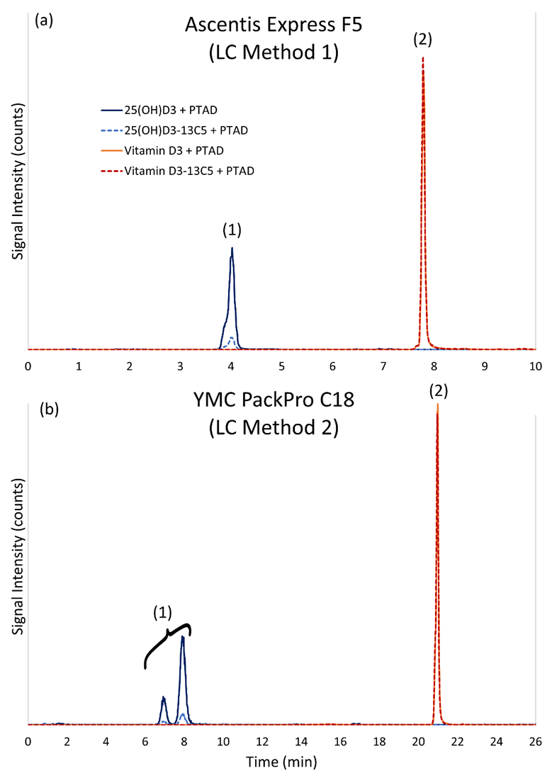
Method 1 using the PFP stationary phase achieved separation of the 25(OH)D₃-PTAD and vitamin D₃-PTAD in less than 10 min (Figure 1a) whereas the C₁₈ column achieved the same separation in 22 min (Figure 1b) and provides a better separation of the 3-epi-25(OH)D₃-PTAD from the 25(OH)D₃-PTAD (Figure 2).

Figure 2. Representative chromatograms for the analysis of a calibrant solution containing 25(OH)D₂, 25(OH)D₃, 3-epi-25(OH)D₂, and 3-epi-25(OH)D₃ after derivatization with PTAD using (a) LC Method 1 on a pentafluorophenyl (PFP) column and (b) LC Method 2 on a C₁₈ column. Peaks 1 and 2 in (a) and 1a and 1b and 2a and 2b in (b) are 25(OH)D₃+PTAD (solid dark blue trace, 558 m/z → 298 m/z) and 3-epi-25(OH)D₃+PTAD (dashed light blue trace, 563 m/z → 298 m/z), respectively. Peaks 3 and 4 in (a) and 3a and 3b and 4a and 4b in (b) are 25(OH)D₂+PTAD (solid dark blue trace, 570 m/z → 298 m/z) and 3-epi-25(OH)D₂+PTAD (dashed light blue trace, 570 m/z → 298 m/z), respectively. Note that in LC Method 2 (b) the 25(OH)D₃-¹³C₅+PTAD is two chromatographic peaks.
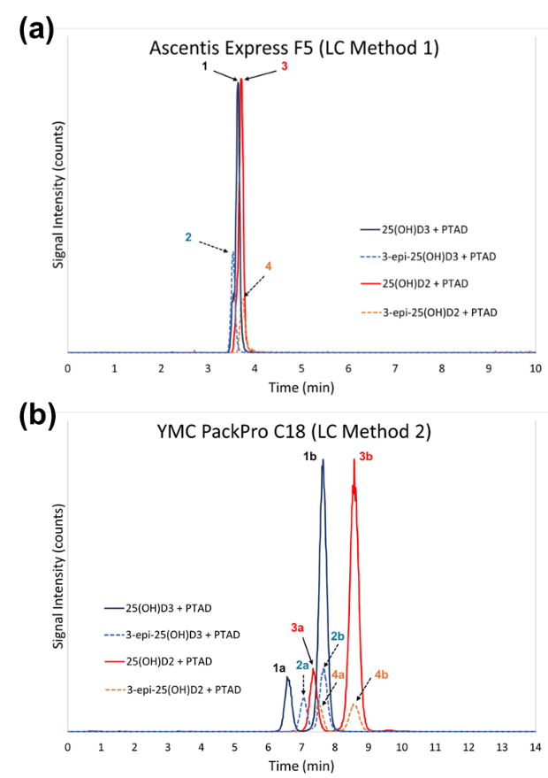
As shown in Figure 1b and Figure 2b, during the derivatization, 6(R) and 6(S) enantiomers of the 25(OH)D₃-PTAD and 25(OH)D₃-¹³C₅-PTAD are formed in a 1:4 ratio as reported previously [50-52], and they are separated on the C₁₈ column but not on the PFP column. The separation of the PTAD enantiomers for 25(OH)D₂, 25(OH)D₃, 3-epi-25(OH)D₂, and 3-epi-25(OH)D₃ is illustrated in Figure 2b for the C₁₈ column. When using the C₁₈ column, chromatographic peaks for both enantiomers must be quantified. For the non-fortified food matrices investigated, only vitamin D₃ and 25(OH)D₃ were present in quantifiable amounts, and 3-epi-25(OH)D₃ was not detected. Vitamin D₂ and 25(OH)D₂ were observed in SRM 1577c and SRM 1546a; however, the measurement variability was significant, and the results were not used for value assignment. Therefore, Method 1, with its shorter analysis time and the lack of detectable 3-epi-25(OH)D₃, was used for the analyses of these food-matrix SRMs to assign concentration values for vitamin D₃ and 25(OH)D₃.
Initial method development utilized deuterated internal standards for vitamin D₃ and 25(OH)D₃; however, hydrogen-deuterium exchange was observed following PTAD derivatization. This was observed by the detection of unlabeled MRM transitions in solutions containing exclusively labeled standards, as shown in Figure S3 (Supporting Material). The exchange was notably more significant for vitamin D₃-d₃ than for 25(OH)D₃-d₆. In contrast, analysis of ¹³C₅-labeled compounds showed no isotopic loss or exchange. While the exact timing of the exchange, whether during chemical derivatization, reconstitution, LC solvent exposure, or within the mass spectrometer, remains unconfirmed, these findings suggested a transition to ¹³C₅-labeled internal standards to ensure analytical robustness. It is understood that other methods have successfully used deuterium labeled internal standards, but the potential of this deuterium/hydrogen exchange should be considered when developing new methods for vitamin D and metabolites [53].

Analysis of Food-matrix SRMs for Determination of Vitamin D and 25(OH)D₃
The ID LC-MS/MS method was used to determine both vitamin D₃ and 25(OH)D₃ in three non-fortified food matrices (meat homogenate, bovine liver, egg powder) and in a single fortified matrix (whole milk powder) and to determine vitamin D₂ in a single fortified matrix (soy milk). Three of these SRMs (bovine liver, meat homogenate, and whole egg powder) were identified as high priority food-matrix SRMs for vitamin D measurements based on the results of the USDA interlaboratory study [43]. Representative chromatograms from the ID LC-MS/MS analysis of the four food-matrix SRMs and the control material (SRM 1849a) for the determination of vitamin D₃ and 25(OH)D₃ are shown in Figure 3, and the results of the analysis are summarized in Table 2. As observed in the USDA Interlaboratory Study [43], the bovine liver has the highest content of 25(OH)D₃ and the lowest content of vitamin D₃ of the four matrices investigated, while the whole egg material has high content for both vitamin D₃ and 25(OH)D₃. The mass fractions in the four matrices for vitamin D₃ range over two orders of magnitude from 0.498 µg/kg to 49.5 µg/kg and for 25(OH)D₃ range a factor of 25 from 0.53 µg/kg to 12.1 µg/kg. The application of the ID LC-MS/MS method for determining vitamin D₂ is illustrated in Figure 4 for the analysis of SRM 3235 Soy Milk with SRM 3280 Multivitamin/Multielement Tablets as the control material.

Table 2. Determination of vitamin D₃, vitamin D₂, and 25(OH)D₃ in five food-matrix SRMs using ID LC-MS/MS Method
 |  | SRM 1577c  Bovine Liver |  | SRM 1546a  Meat Homogenate |  | SRM 1845a  Whole Egg Powder |  | SRM 1549a  Whole Milk Powder |  | SRM 3235  Soy Milk
Samples |  | Mass Fraction, µg/kgª (as-received basis)
Box^{b} | Rep^{c} | Vitamin D₃ | 25(OH)D₃ | Vitamin D₃ | 25(OH)D₃ | Vitamin D₃ | 25(OH)D₃ | Vitamin D₃ | 25(OH)D₃ | Vitamin D₂
1 | 1 | 0.399 | 13.01 | 2.24 | 0.75 | 49.16 | 11.07 | 1.536 | 0.596 | 13.9
1 | 2 | 0.307 | 11.99 | 3.75 | 1.54 | 50.97 | 10.62 | 1.616 | 0.537 | 13.7
2 | 1 | 0.711 | 12.90 | 2.73 | 1.01 | 47.03 | 11.35 | 1.676 | 0.636 | 12.5
2 | 2 | 0.994 | 14.07 | 2.35 | 0.73 | 59.67 | 11.95 | 2.095 | 0.511 | 11.6
3 | 1 | 0.604 | 12.90 | 3.41 | 0.74 | 46.76 | 11.60 | 1.802 | 0.539 | 11.4
3 | 2 | 0.992 | 12.52 | 2.05 | 0.80 | 53.17 | 9.85 | 2.149 | 0.579 | 11.5
4 | 1 | 0.613 | 11.64 | 8.89 | 0.55 | 47.67 | 11.05 | 1.908 | 0.558 | 10.7
4 | 2 | 0.300 | 10.87 | 2.09 | 0.81 | 51.75 | 11.26 | 1.943 | 0.459 | 11.1
5 | 1 | 0.939 | 12.57 | 1.75 | 0.90 | 46.71 | 11.09 | 2.086 | 0.469 | 11.8
5 | 2 | 1.906^{c} | 12.52 | 2.29 | 0.67 | 46.78 | 10.59 | 1.901 | 0.543 | 11.4
6 | 1 | 0.324 | 12.99 | 1.82 | 0.90 | 48.73 | 11.59 | 1.850 | 0.592 | 11.8
6 | 2 | 0.289 | 12.03 | 3.46 | 0.89 | 47.19 | 10.96 | 2.882^{c} | 0.473 | 12.4
7 | 1 | 0.777 | 18.98^{c} | 2.13 | 0.84 | 48.60 | 9.25 | 1.903 | 0.450 | 10.7
7 | 2 | 0.335 | 11.29 | 4.56 | 0.57 | 50.54 | 11.26 | 2.016 | 1.090^{c} | 10.5
8 | 1 | 0.255 | 10.88 | 1.81 | 0.65 | 48.57 | 10.88 | 1.807 | 0.673 | 11.2
8 | 2 | 0.262 | 10.08 | 2.53 | 0.92 | 53.07 | 9.23 | 1.598 | 0.603 | 11.3
9 | 1 | 0.299 | 12.48 | 1.86 | 1.12 | 46.95 | 11.36 | 0.794^{c} | 0.600 | 10.5
9 | 2 | 0.433 | 12.09 | 2.69 | 0.77 | 54.29 | 12.20 | 2.075 | 0.177 | 10.7
10 | 1 | 0.337 | 13.85 | 2.10 | 0.71 | 45.01 | 11.18 | 1.726 | 0.583 | 11.7
10 | 2 | 0.294 | 10.06 | 1.84 | 0.94 | 47.88 | 10.70 | 1.928 | 0.571 | 11.8
Mean |  | 0.498 | 12.14 | 2.82 | 0.84 | 49.52 | 10.95 | 1.867 | 0.534 | 11.6
SD |  | 0.263 | 1.12 | 1.61 | 0.22 | 3.48 | 0.77 | 0.183 | 0.106 | 0.9
% RSD |  | 52.8 % | 9.2 % | 57.3 % | 25.9 % | 7.0 % | 7.1 % | 9.8 % | 19.8 % | 8.1 %
ª Results are presented in units of µg/kg for presentation convenience rather than in mg/kg as the assigned values in Table 3.
^{b} Box numbers in table are only a sequential designation of the 10 boxes sampled; actual box numbers are as follows: SRM 1577c (1, 4, 7, 10, 13, 16, 19, 22, 25, and 28); SRM 1546a (1, 38, 52, 111, 151, 240, 247, 297, 379, and 484); SRM 1845a (1B, 1T, 2B, 3B, 3T, 4B, 5B, 5T, 6B, and 6T where B = bottom and T = top of box); SRM 1549a (1, 3, 6, 10, 12, 16, 20, 24, 27, and 33); and SRM 3235 (1, 3, 5, 6, 7, 9, 10, 15, 17, and 19).
^{c} Duplicate sample preparation and analysis.
^{d} Replicate measurement was determined to be an outlier based on the Grubbs test and result not used in the value assignment of the SRM.
Figure 3. Representative chromatograms using LC method 1 for the analysis of (a) SRM 1849a Infant/Adult Nutritional Formula, (b) SRM 1546a Meat Homogenate, (c) SRM 1577c Bovine Liver, (d) SRM 1549a Whole Milk Powder, and (e) SRM 1845a Whole Egg Powder. Peak 1 is 25(OH)D₃+PTAD (solid dark blue trace, 558 m/z → 298 m/z) and 25(OH)D₃-¹³C₅+PTAD (dashed blue trace, 563 m/z → 298 m/z). Peak 2 is vitamin D₃+PTAD (solid orange trace, 560 m/z → 298 m/z) and vitamin D₃-¹³C₅+PTAD (dashed red trace, 565 m/z → 298 m/z).
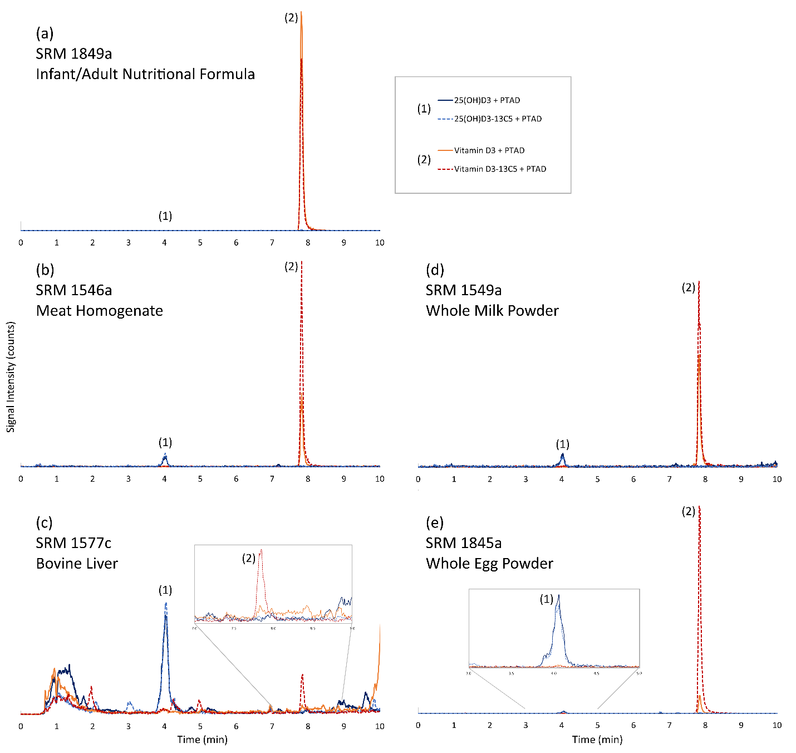
Figure 4. Representative chromatograms using LC method 1 for the analysis of (a) a calibrant solution containing vitamin D₂-PTAD and vitamin D₃-¹³C₅ + PTAD, (b) SRM 3235 Soy Milk, and (c) SRM 3280 Multivitamin/Multielement Tablets (control material). Solid orange trace is vitamin D₂ + PTAD (572 m/z → 298 m/z) and dashed orange trace is vitamin D₃-¹³C₅ + PTAD (565 m/z → 298 m/z).
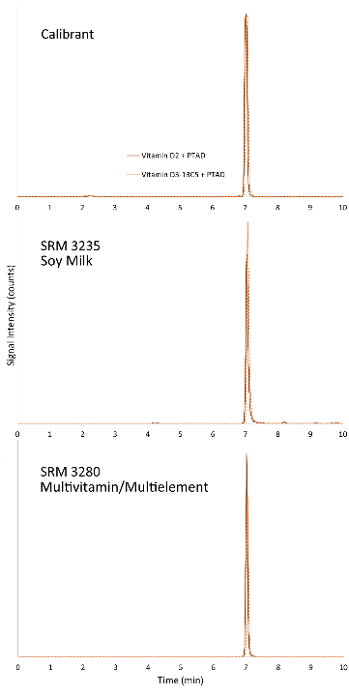
The results in Table 2 represent measurements of 10 different samples in duplicate which reflect both the homogeneity of the different food-matrix SRMs and demonstrate the precision of the ID LC-MS/MS method. For the two powdered matrices (egg and milk) and the liquid soy milk, the %RSDs for the vitamin D measurements were between 7.0 % and 9.8 %. For the bovine liver and meat homogenate matrices, the %RSDs were 53 % and 57 %, respectively, demonstrating the complexity and relative inhomogeneity of these matrices, as well as their challenging low mass fractions of vitamin D₃ (particularly in the bovine liver) and 25(OH)D₃. When the measurements were evaluated relative to the selection of samples across the complete inventory of SRM units related to packaging, sample preparation, or run order, no trends were observed as illustrated for SRM 1845a and SRM 1549a in Figures S4 and S5 (Supporting Material).
For the determination of vitamin D₃ in the food-matrix SRMs, SRM 1849a Infant/Adult Nutritional Formula was used as a control material, and the results for the four SRMs were all within (or with overlapping SD) with the certified value as shown in Figure 5 and Table S1 (Supporting Material).

Figure 5. Results for the analysis of SRM 1849a Infant/Adult Nutritional Formula as a control material during the analysis of food-matrix SRMs for determining vitamin D₃. Certified value for vitamin D₃ is solid black line and the uncertainty of the certified value is represented by the dashed red line. Yellow circles represent the mean of the 4 to 8 measurements, and the error bars represent ±SD of the measurements.
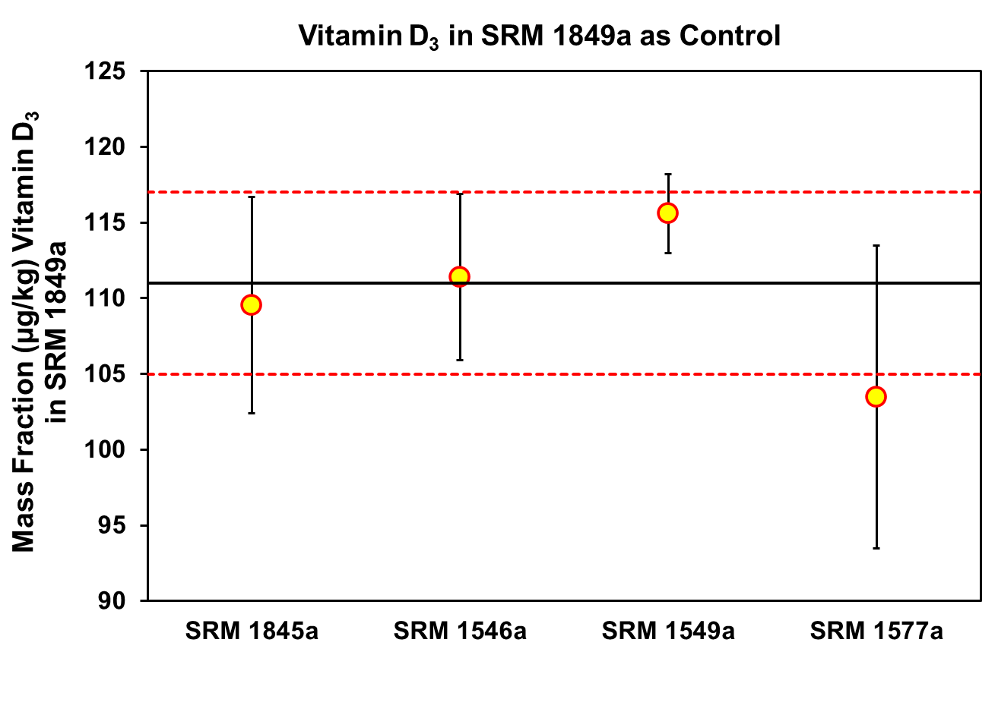
Since no control material was available with a value assigned for 25(OH)D₃ in a food matrix, SRM 1577c Bovine Liver was used as a control material using the consensus mean value obtained from the USDA Interlaboratory Study [43] as the target control value, i.e., 0.0151 mg/kg ± 0.0021 mg/kg (SD). Results for the analyses of SRM 1577c as a control material for determination of 25(OH)D₃ are shown in Figure S6 and Table S1 (Supporting Material). For the 25(OH)D₃ control measurements, the measurements overlapped the SD of the target value for two of three SRMs (black lines, Figure S6, Supporting Material). However, after assignment of a certified value for 25(OH)D₃ (red lines, Figure S6, Supporting Material) using these measurements and the USDA consensus value, results are all within the uncertainty of the assigned value. For the analysis of the soy milk SRM, which contains vitamin D₂ rather than vitamin D₃, SRM 3280 Multivitamin/Multielement Tablets was used as the control material and the mean result was within the uncertainty of the certified value (Figure S7, Supporting Material).
The mean value of the NIST measurements, the mean from collaborative data, and the resulting certified and reference values assigned for vitamin D₂, vitamin D₃, and 25(OH)D₃ are provided in Table 3.
Table 3. Mass fraction values for vitamin D₃ and 25(OH)D₃ from a USDA Interlaboratory Study and NIST in this study and the resulting values assigned in the SRM Certificate of Analysis
SRM | Description | USDA Interlab Study (SD)ª | This Study (SD)^{b} | Assigned Value^{c}
 |  | Vitamin D₃ (Cholecalciferol) Mass Fraction (mg/kg) as-received basis
1546a | Meat Homogenate | 0.00233 (0.00034) | 0.00282 (0.00161) | 0.00256 ± 0.00053 (21 %)^{d}
1549a | Whole Milk Powder | ND | 0.00187 (0.00018) | 0.00188 ± 0.0035 (19 %)^{e}
1577c | Bovine Liver | 0.00043 (0.00025) | 0.000498 (0.000263) | 0.000464 ± 0.000363 (78 %)^{f}
1845a | Whole Egg Powder | 0.0449 (0.0045) | 0.0495 (0.0035) | 0.0488 ± 0.0047 (10 %)^{g}
 |  | 25(OH)D₃ Mass Fraction (mg/kg) as-received basis
1546a | Meat Homogenate | 0.00093 (0.00019) | 0.0084 (0.0022) | 0.00090 ± 0.00012 (13 %)^{g}
1549a | Whole Milk Powder | ND | 0.000534 (0.00011) | 0.00053 ± 0.00005 (9%)^{e}
1577c | Bovine Liver | 0.0151 (0.0021) | 0.01214 (0.00112) | 0.0137 ± 0.0031 (23%)^{g}
1845a | Whole Egg Powder | 0.0125 (0.0020) | 0.01095 (0.00077) | 0.0122 ± 0.0015 (12%)^{g}
 |  | Collaborating Laboratories^{h} | This Study (SD)^{b} | Assigned Value
 |  | Vitamin D₂ (Ergocalciferol) Mass Fraction (mg/kg) as-received basis
3235 | Soy Milk | 0.0127 (0.0006) | 0.0116 (0.0009) | 0.0120 ± 0.0024 (20%)^{g}
ª USDA Interlaboratory study consensus value from results from four to five laboratories using LC-MS/MS [43], which was combined with the NIST measurements to assign certified values. SD = standard deviation of the four to five results in parentheses
^{b} SD = standard deviation of the 10 samples x 2 replicate measurements in Table 2.
^{c} Assigned values reported on the Certificate of Analysis for each SRM; numbers in bold are certified values, whereas numbers in normal face type are reference values; number in parentheses is the percent relative uncertainty.
^{d} Each reference mass fraction value is the mean from the combination of mean of results from analyses by NIST and mean of the means of results provided by collaborating laboratories. Values are expressed as x ± U95% (x) where x is the reference value and U95% (x) is the expanded uncertainty of the value. The method-specific value of the analyte lies within the interval x ± U95% (x) with about a 95 % confidence.
^{e} The reference mass fraction value is the mean result of NIST analyses. Values are expressed as x ± U95% (x) where x is the reference value and U95% (x) is the expanded uncertainty of the value. The method-specific value of the analyte lies within the interval x ± U95% (x) with about a 95 % confidence.
^{f} No value for vitamin D₃ in SRM 1577c was assigned and reported on the COA. The value in the table is for information only and is the mean of the collaborating laboratory value and the NIST measurements with a combined expanded uncertainty.
^{g} The certified mass fraction value is the mean from the combination of the mean results from analyses by NIST ID LC-MS/MS and the median or mean of the means of results provided by collaborating laboratories. Values are expressed as x ± U95% (x), where x is the certified value and U95% (x) is the expanded uncertainty of the certified value. The true value of the analyte lies within the interval x ± U95% (x) with 95 % confidence. To propagate this uncertainty, the certified value should be treated as a normally distributed random variable with mean x and standard deviation U95% (x)/2 [55-58].
^{h} Collaborating laboratories in interlaboratory study reported methods included LC-absorbance, LC-MS, and LC-MS/MS. Results reported are from Grocery Manufacturers Association Food Industry Analytical Chemists (FIAC) Share Group results; outliers removed. n=5, uncertainty is standard deviation.
ND = Not Determined
These certified and reference values were added to the Certificate of Analysis for these SRMs between 2016 and 2018 with a brief description of the analytical methods [42,40,41,39,38]. Although no values were assigned for vitamin D₂ or 25(OH)D₂ in SRM 1546a and SRM 1577c due to significant variability in the measurements, these two materials could be useful for these measurements. In the USDA interlaboratory trial, a consensus mean value for 25(OH)D₂ of 0.00064 mg/kg (SD = 0.00015 mg/kg, n = 5) (as received basis) was reported for SRM 1577c [43]. Cashman et al. [48] recently reported measurable levels of both vitamin D₂ and 25(OH)D₂ in beef and lamb steaks and used SRM 1546 Meat Homogenate to validate measurements of vitamin D₃ and 25(OH)D₃. The importance of accurate measurements of all vitamin D and 25(OH)D species was emphasized by the statement that “one-third of the total vitamin D activity of Irish beef was attributable to its combined vitamin D₂ and 25(OH)D₂ content, estimates of which are largely or completely missed in food composition tables [48].” Since the assignment of values for vitamin D₃ and 25(OH)D₃ in food matrix SRMs reported in this paper, Švarc et al. [54] investigated extensively the quantification of vitamin D₃ and 25(OH)D₃ in food and the effect of eluent additives and the use of labeled internal standards in the LC-MS/MS methods using three food matrix SRMs (SRM 1546a, SRM 1845a, and SRM 1549a) for method validation and comparison. In comparing three ID LC-MS/MS methods with both deuterated and ¹³C-labeled internal standards, they found the method using ¹³C-labeled to be the preferred method [54].
With the addition of vitamin D₃ and 25(OH)D₃ values in these food matrix SRMs ranging from 0.498 µg/kg to 49.5 µg/kg and 0.53 µg/kg to 12.1 µg/kg, respectively, these SRMs have and will continue to assist researchers in assessing the accuracy of vitamin D measurements in food.

Supporting Information: Additional tables and figures, including method optimization results, internal standard hydrogen-deuterium exchange, and control material analyses (DOC).

Acknowledgements
The authors would like to thank the participants of the USDA interlaboratory trial and their contribution of data used in the assignment of the values for vitamin D and 25(OH)D in these food-matrix SRMs. The authors acknowledge Catherine Rimmer (NIST), Lane C. Sander (NIST), and Hannah Simon Stindt (formerly NIST) for helpful discussions, and Melissa M. Phillips (NIST) for coordination of the NIST food SRM program. This work was supported in part by the National Institutes of Health, Office of Dietary Supplements as part of the Analytical Methods and Reference Materials Program.

Conflict of Interest
The authors declare no competing financial interest.

Disclaimers
The opinions expressed in this article are the authors’ own and do not reflect the view of the National Institute of Standards and Technology (NIST), National Institutes of Health (NIH), the Department of Commerce, the Department of Health and Human Services, or the United States government. Certain commercial materials and equipment are identified to adequately specify experimental procedures. Such identifications neither imply recommendation or endorsement by NIST or NIH nor does it imply that the material or equipment identified is the best available for the purpose. Any citations of commercial organizations and trade names in this report do not constitute an official NIST or NIH endorsement of approval of the products or services of these organizations.
References

1. Bouillon R, Van Schoor NM, Gielen E, Boonen S, Mathieu C, Vanderschueren D, Lips P (2013) Optimal Vitamin D Status: A Critical Analysis on the Basis of Evidence-Based Medicine. J Clin Endocrinol Metab 98 (8):E1283–E1304. doi:https://doi.org/10.1210/jc.2013-1195
2. DeLuca HF (2004) Overview of general physiologic features and functions of vitamin D. Am J Clin Nutr 80 (6):1689S–1696S. doi:https://doi.org./10.1093/ajcn/80.6.16895
3. Lensmeyer G, Poquette M, Wiebe D, Binkley N (2012) The C-3 epimer of 25-hydroxyvitamin D3 Is present in adult serum. J Clin Endocrinol Metab 97 (1):163–168. doi:https://doi.org/10.1210/jc.2011-0584
4. Stepman HCM, Vanderroost A, Stöckl D, Thienpont LM (2011) Full-scan mass spectral evidence for 3-epi-25-hydroxyvitamin D3 in serum of infants and adults. Clin Chem Lab Med 49 (2):253–256. doi:https://doi.org/10.1515/cclm.2011.050
5. Cavalier E, Makris K, Heijboer AC, Herrmann M, Souberbielle JC (2024) Vitamin D: Analytical Advances, Clinical Impact, and Ongoing Debates on Health Perspectives. Clin Chem. doi:https://doi.org/10.1093/clinchem/hvae056
6. Giustina A, Bilezikian JP, Adler RA, Banfi G, Bikle DD, Binkley NC, Bollerslev J, Bouillon R, Brandi ML, Casanueva FF, di Filippo L, Donini LM, Ebeling PR, Fuleihan GE, Fassio A, Frara S, Jones G, Marcocci C, Martineau AR, Minisola S, Napoli N, Procopio M, Rizzoli R, Schafer AL, Sempos CT, Ulivieri FM, Virtanen JK (2024) Consensus Statement on Vitamin D Status Assessment and Supplementation: Whys, Whens, and Hows. Endocrine Reviews. doi:https://doi.org/10.1210/endrev/bnae009
7. Wise SA, Camara JE, Sempos CT, Burdette CQ, Hahm G, Nalin F, Kuszak AJ, Merkel J, Durazo-Arvizu R, Hoofnagle AN, Williams EL, Ivison F, Fischer R, Van den Ouweland JMW, Ho CS, Law EWK, Simard J-N, Gonthier R, Holmquist B, Meadows S, Cox L, Robyak K, Creer MH, Fitzgerald R, Clarke MW, Breen N, Lukas P, Cavalier E (2022) Interlaboratory comparison of 25-hydroxyvitamin D assays: Vitamin D Standardization Program (VDSP) intercomparison study 2 – Part 1 Liquid chromatography – tandem mass spectrometry (LC-MS/MS) assays – Impact of 3-epi-25-hydroxyvitamin D3 on assay performance. Anal Bioanal Chem 414:333–349. doi:https://doi.org/10.1007/s00216-021-03576-1
8. Wise SA, Camara JE, Sempos CT, Burdette CQ, Hahm G, Nalin F, Kuszak AJ, Merkel J, Durazo-Arvizu R, Williams EL, Popp C, Beckert C, Schultess C, Van Slooten G, Tourneur C, Pease C, Kaul R, Villarreal A, Batista MC, Pham H, Bennett A, Jansen E, Khan DA, Kilbane M, Freeman J, Parker N, Yuan J, Mushtaq S, Simpson C, Lukas P, Cavalier E (2022) Interlaboratory comparison of 25-hydroxyvitamin D assays: Vitamin D Standardization Program (VDSP) intercomparison study 2 - Part 2 Ligand binding assays – Impact of 25-hydroxyvitamin D2 and 24R,25-dihydroxyvitamin D3 on assay performance. Anal Bioanal Chem 414:351–366. doi:https://doi.org/10.1007/s00216-021-03577-0
9. Alexandridou A, Schorr P, Stokes CS, Volmer DA (2021) Analysis of vitamin D metabolic markers by mass spectrometry: Recent progress regarding the "gold standard" method and integration into clinical practice. Mass Spectrom Rev:1–41. doi:https://doi.org/10.1002/mas.21768
10. Volmer DA, Mendes L, Stokes CS (2015) Analysis of vitamin D metabolic markers by mass spectrometry: Current techniques, limitations of the "gold standard" method and anticipated future directions. Mass Spectrom Rev 34 (1):2–23. doi:https://doi.org/10.1002/mas.21408
11. Carter GD, Berry J, Durazo-Arvizu R, Gunter E, Jones G, Jones J, Makin HLJ, Pattni P, Sempos CT, Twomey P, Williams EL, Wise SA (2018) Hydroxyvitamin D assays: An historical perspective from DEQAS. J Steroid Biochem Mol Biol 177:30–35. doi:https://doi.org/10.1016/j.jsbmb.2017.07.018
12. Erdman P, Palmer-Toy DE, Horowitz G, Hoofnagle A (2019) Accuracy-based vitamin D survey six years of quality improvement guided by proficiency testing. Arch Pathol Lab Med 143 (12):1531–1538. doi:https://doi.org/10.5858/arpa.2018-0625-CP
13. Wise SA, Kuszak AJ, Camara JE (2024) Evolution and impact of Standard Refrernce Materials (SRMs) for determining vitamin D metabolites. Anal Bioanal Chem 416:2335–2358. doi:https://doi.org/10.1007/s00216-024-05143-w
14. Camara JE, Wise SA, Hoofnagle AN, Williams EL, Carter GD, Jones J, Burdette CQ, Hahm G, Nalin F, Kuszak AJ, Merkel J, Durazo-Arvizu RA, Lukas P, Cavalier E, Popp C, Beckert C, Schultess J, Van Slooten G, Tourneur C, Pease C, Kaul R, Villarreal A, Ivison F, Fischer R, van den Ouweland JMW, Ho CS, Law EWK, Simard JN, Gonthier R, Holmquist B, Batista MC, Pham H, Bennett A, Meadows S, Cox L, Jansen E, Khan DA, Robyak K, Creer MH, Kilbane M, Twomey PJ, Freeman J, Parker N, Yuan JY, Fitzgerald R, Mushtaq S, Clarke MW, Breen N, Simpson C, Sempos CT (2021) Assessment of serum total 25-hydroxyvitamin D assay commutability of Standard Reference Materials and College of American Pathologists Accuracy-Based Vitamin D (ABVD) Scheme and Vitamin D External Quality Assessment Scheme (DEQAS) materials: Vitamin D Standardization Program (VDSP) Commutability Study 2. Anal Bioanal Chem 413:5067–5084. doi:10.1007/s00216-021-03470-w
15. Jakobsen J, Christensen T (2021) Natural Vitamin D in Food: To What Degree Does 25-Hydroxyvitamin D Contribute to the Vitamin D Activity in Food? JBMR Plus 5 (1). doi:https://doi.org/10.1002/jbm4.10453
16. Jakobsen J, Melse-Boonstra A, Rychlik M (2019) Challenges to Quantify Total Vitamin Activity: How to Combine the Contribution of Diverse Vitamers? Current Developments in Nutrition 3 (10). doi:https://doi.org/10.1093/cdn/nzz086
17. Exler J, Phillips KM, Patterson KY, Holden JM (2013) Cholesterol and vitamin D content of eggs in the US retail market. Journal of Food Composition and Analysis 29 (2):110–116. doi:https://doi.org/10.1016/j.jfca.2012.11.001
18. Taylor CL, Patterson KY, Roseland JM, Wise SA, Merkel JM, Pehrsson PR, Yetley EA (2014) Including Food 25-Hydroxyvitamin D in Intake Estimates May Reduce the Discrepancy between Dietary and Serum Measures of Vitamin D Status. J Nutr 144 (5):654–659. doi:https://doi.org/10.3945/jn.113.189811
19. Cardwell G, Bornman JF, James AP, Black LJ (2018) A Review of Mushrooms as a Potential Source of Dietary Vitamin D. Nutrients 10 (10). doi:https://doi.org/10.3390/nu10101498
20. Bahrami A, Mehramiz M, Ghayour-Mobarhan M, Bahrami-Taghanaki H, Ardekani K, Tayefi M, Sadeghzade M, Rashidmayvan M, Ghalezou M, Ferns G, Avan A, Sadeghnia H (2019) A genetic variant in the cytochrome P450 family 2 subfamily R member 1 determines response to vitamin D supplementation. Clinical Nutrition 38 (2):676–681. doi:https://doi.org/10.1016/j.clnu.2018.03.018
21. Roizen JD, Levine MA (2024) The role of genetic variation in CYP2R1, the principal vitamin D 25-hydroxylase, and CYP3A4 in vitamin D homeostasis. In: Hewison M, Bouillon R, Giovannucci E, Goltzman D, Meyer M, Welsh J (eds) Feldman and Pike's Vitamin D. 5th edn. Academic Press, pp 341–357. doi:https://doi.org/10.1016/B978-0-323-91338-6.00017-3
22. Tripkovic L, Wilson LR, Hart K, Johnsen S, de Lusignan S, Smith CP, Bucca G, Penson S, Chope G, Elliott R, Hyppönen E, Berry JL, Lanham-New SA (2017) Daily supplementation with 15 μg vitamin D2 compared with vitamin D3 to increase wintertime 25-hydroxyvitamin D status in healthy South Asian and white European women: a 12-wk randomized, placebo-controlled food-fortification trial. Am J Clin Nutr 106 (2):481–490. doi:https://doi.org/10.3945/ajcn.116.138693
23. Tripkovic L, Lambert H, Hart K, Smith CP, Bucca G, Penson S, Chope G, Hyppönen E, Berry J, Vieth R, Lanham-New S (2012) Comparison of vitamin D2and vitamin D3 supplementation in raising serum 25-hydroxyvitamin D status: a systematic review and meta-analysis. Am J Clin Nutr 95 (6):1357–1364. doi:https://doi.org/10.3945/ajcn.111.031070
24. Delgado A, Issaoui M, Vieira MC, de Carvalho IS, Fardet A (2021) Food Composition Databases: Does It Matter to Human Health? Nutrients 13 (8). doi:https://doi.org/10.3390/nu13082816
25. Brinkley S, Gallo-Franco J, Vázquez-Manjarrez N, Chaura J, Quartey N, Toulabi S, Odenkirk M, Jermendi E, Laporte M, Lutterodt H, Annan R, Barboza M, Amare E, Srichamnong W, Jaramillo-Botero A, Kennedy G, Bertoldo J, Prenni J, Rajasekharan M, de la Parra J, Ahmed S (2025) The state of food composition databases: data attributes and FAIR data harmonization in the era of digital innovation. Frontiers in Nutrition 12. doi:https://doi.org/10.3389/fnut.2025.1552367
26. USDA FoodData Central Foundation Foods Documentation. https://fdc.nal.usda.gov/Foundation_Foods_Documentation. Accessed January 15, 2026
27. (DTU) NFID Frida Food Data, frida.fooddata.dk. Accessed July 19, 2024
28. Jakobsen J, Maribo H, Bysted A, Sommer HM, Hels O (2007) 25-Hydroxyvitamin D3 affects vitamin D status similar to vitamin D3 in pigs: but the meat produced has a lower content of vitamin D. British Journal of Nutrition 98 (5):908–913. doi:https://doi.org/10.1017/s0007114507756933
29. Blunt JW, Tanaka Y, Deluca HF (1968) Biological activity of 25-hydroxycholecalciferil -A metabolite of vitamin D3. Proc Natl Acad Sci U S A 61 (4):1503–&. doi:https://doi.org/10.1073/pnas.61.4.1503
30. Cashman KD, Seamans KM, Lucey AJ, Stöcklin E, Weber P, Kiely M, Hill TR (2012) Relative effectiveness of oral 25-hydroxyvitamin D3 and vitamin D3 in raising wintertime serum 25-hydroxyvitamin D in older adults. Am J Clin Nutr 95 (6):1350–1356. doi:https://doi.org/10.3945/ajcn.111.031427
31. Uusitalo U, Kronberg-Kippilä C, Aronsson CA, Schakel S, Schoen S, Mattisson I, Reinivuo H, Silvis K, Sichert-Hellert W, Stevens M, Norris JM, Virtanen SM, Grp TS (2011) Food composition database harmonization for between-country comparisons of nutrient data in the TEDDY Study. Journal of Food Composition and Analysis 24 (4-5):494–505. doi:https://doi.org/10.1016/j.jfca.2011.01.012
32. Burild A, Frandsen HL, Jakobsen J (2014) Simultaneous quantification of vitamin D3, 25-hydroxyvitamin D3 and 24,25-dihydroxyvitamin D3 in human serum by LC-MS/MS. Scand J Clin Lab Invest 74 (5):418–423. doi:https://doi.org/10.3109/00365513.2014.900694
33. Burild A, Frandsen HL, Poulsen M, Jakobsen J (2014) Quantification of physiological levels of vitamin D3 and 25-hydroxyvitamin D3 in porcine fat and liver in subgram sample sizes. J Sep Sci 37 (19):2659–2663. doi:https://doi.org/10.1002/jssc.201400548
34. Jakobsen J, Clausen I, Leth T, Ovesen L (2004) A new method for the determination of vitamin D3 and 25-hydroxyvitamin D3in meat. Journal of Food Composition and Analysis 17 (6):777–787. doi:https://doi.org/10.1016/j.jfca.2003.10.012
35. Jakobsen J, Saxholt E (2009) Vitamin D metabolites in bovine milk and butter. Journal of Food Composition and Analysis 22 (5):472–478. doi:https://doi.org/10.1016/j.jfca.2009.01.010
36. Strobel N, Buddhadasa S, Adorno P, Stockham K, Greenfield H (2013) Vitamin D and 25-hydroxyvitamin D determination in meats by LC-IT-MS. Food Chemistry 138 (2-3):1042–1047. doi:https://doi.org/10.1016/j.foodchem.2012.08.041
37. Wise SA, Tai SSC, Burdette CQ, Camara JE, Bedner M, Lippa KA, Nelson MA, Nalin F, Phinney KW, Sander LC, Betz JM, Sempos CT, Coates PM (2017) Role of the National Institute of Standards and Technology (NIST) in support of the vitamin D initiative of the National Institutes of Health, Office of Dietary Supplements. J AOAC Int 100 (5):1260–1276. doi:https://doi.org/10.5740/jaoacint.17-0305
38. NIST (2024, original certificate issued ) Certificate of Analysis Standard Refernce Material 1546a Meat Homogenate. National Institute of Standards and Technology (NIST), Gaithersburg, MD
39. NIST (2022, original certificate 2013) Certificate of Analysis Standard Refreence Material 1549a Whole Milk Powder. National Institute of Standards and Technology (NIST), Gaitherburg, MD
40. NIST (2018, original certificate issued 2009) Certificate of Analysis Standard Reference Material 1577c Bovine Liver. National Instituteof Standards and technology (NIST), Gaithersburg, MD
41. NIST (2020, original Certificate issued 2014) Certificate of Analysis Standard Reference Material 1845a Whole Egg Powder. National Institute of Standards and Technology (NIST), Gaithersburg, MD
42. NIST (2017) Certificate of Analysis Standard Reference Material 3235 Soy Milk. National Institute of Standards and technology (NIST),
43. Roseland JM, Patterson KY, Andrews KW, Phillips KM, Phillips MM, Pehrsson PR, Dufresne GL, Jakobsen J, Gusev PA, Savarala S, Nguyen QV, Makowski AJ, Scheuerell CR, Larouche GP, Wise SA, Harnly JM, Williams JR, Betz JM, Taylor CL (2016) Interlaboratory Trial for Measurement of Vitamin D and 25-Hydroxyvitamin D 25(OH)D in Foods and a Dietary Supplement Using Liquid Chromatography-Mass Spectrometry. J Agric Food Chem 64 (16):3167–3175. doi:https://doi.org/10.1021/acs.jafc.5b05016
44. Woollard DC, Indyk HE, Fong BY, Cook KK (2019) Determination of Vitamin K1 Isomers in Foods by Liquid Chromatography with C30 Bonded-Phase Column. J AOAC Int 85 (3):682–691. doi:https://doi.org/10.1093/jaoac/85.3.682
45. Balz MK, Schulte E, Thier HP (1993) Simultaneous determination of alpha-tocopherol acetate, tocopherols and tocotrienols by HPLC with fluorescence deterction in foods. Fat Sci Technol 95 (6):215–220. doi:https://doi-org.ezproxy.nihlibrary.nih.gov/10.1002/lipi.19930950603
46. Mattila PH, Piironen VI, Uusirauva EJ, Koivistoinen PE (1995) Contents of cholecalciferol, ergocalciferal and their hydroxylated metabolites in milk products,and raw meat and liver as determined by HPLC. J Agric Food Chem 43 (9):2394–2399. doi:https://doi.org/10.1021/jf00057a015
47. Bilodeau L, Dufresne G, Deeks J, Clément G, Bertrand J, Turcotte S, Robichaud A, Beraldin F, Fouquet A (2011) Determination of vitamin D3 and 25-hydroxyvitamin D3 in foodstuffs by HPLC UV-DAD and LC-MS/MS. Journal of Food Composition and Analysis 24 (3):441–448. doi:https://doi.org/10.1016/j.jfca.2010.08.002
48. Cashman KD, O'Sullivan, S. B., Galvin, K., Ryan, M. (2020) Contribution of vitamin D2 aned D3 and their respective 25-hydroxy Metabolites to the total vitamin D content of beef and lamb. Current Developments in Nutrition 4 (7):1–6. doi:https://doi.org/10.1093/cdn/nzaa112
49. Lipkie TE, Janasch A, Cooper BR, Hohman EE, Weaver CM, Ferruzzi MG (2013) Quantification of vitamin D and 25-hydroxyvitamin D in soft tissues by liquid chromatography-tandem mass spectrometry. Journal of Chromatography B-Analytical Technologies in the Biomedical and Life Sciences 932:6–11. doi:https://doi.org/10.1016/j.jchromb.2013.05.029
50. Teegarden MD, Riedl KM, Schwartz SJ (2015) Chromatographic separation of PTAD-derivatized 25-hydroxyvitamin D3 and its C-3 epimer from human serum and murine skin. Journal of Chromatography B-Analytical Technologies in the Biomedical and Life Sciences 991:118–121. doi:https://doi.org/10.1016/j.jchromb.2015.04.011
51. Higashi T, Shibayama Y, Fuji M, Shimada K (2008) Liquid chromatography-tandem mass spectrometric method for the determination of salivary 25-hydroxyvitamin D3: a noninvasive tool for the assessment of vitamin D status. Anal Bioanal Chem 391 (1):229–238. doi:https://doi.org/10.1007/s00216-007-1780-3
52. Alexandridou A, Schorr P, Volmer DA (2023) Comparing derivatization reagents for quantitative LC-MS/MS analysis of a variety of vitamin D metabolites. Anal Bioanal Chem 415 (19):4689–4701. doi:https://doi.org/10.1007/s00216-023-04753-0
53. Landvatter SW, Tyburski R (2021) Isotec stable isotopes - Labeled standards- Comparison of deuterium, 13C, and 15N isoptopic labels in mass spec standards, Lit. No. MS_AN7768EN. Sigma-Aldrich Application Note
54. Svarc PL, Barnkob LL, Jakobsen J (2021) Quantification of vitamin D3 and 25-hydroxyvitamin D3 in food-The impact of eluent additives and labelled internal standards on matrix effects in LC-MS/MS analysis. Food Chemistry 357. doi:https://doi.org/10.1016/j.foodchem.2021.129588
55. Efron B, Tibshirani RJ (1993) An Introduction to the Bootstrap. Chapman & Hall, London, UK
56. JCGM (2008) Evaluation of measurement data - Guide to the Expression of Uncertainty in Measurement (2008). vol 100:2008(E). doi:https://doi.org/10.59161/JCGM100-2008E
57. JCGM (2008) JCGM 101:2008 Evaluation of Measurement Data - Supplement 1 to the "Guide to the Expression of Uncertainty in Measurement" - Propagation of Distributions using a Monte Carlo Method. doi:https://doi.org/10.59161/JCGM101-2008
58. Taylor BN, Kuyatt CE (1994) Guidelines for Evaluating and Expressing the Uncertainty of NIST Measurement Results, NIST Technical Note 1297. U.S. Government Printing Office, Washington, DC; available at http://www.nist.gov/pml/pubs/tn1297/index.cfm (accessed January 16, 2026)

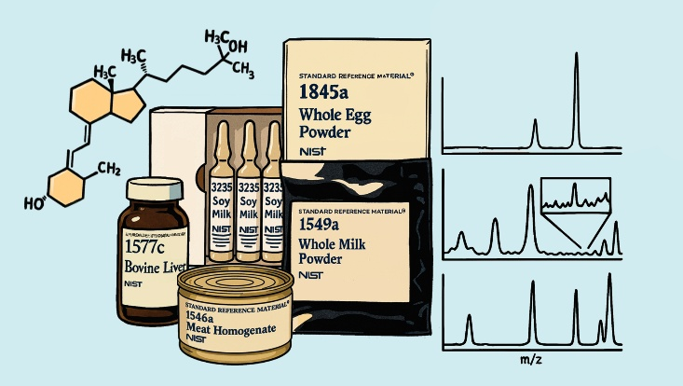
Table of Contents (TOC) Graphic

