Broadband Dielectric Spectroscopy for Reliability Assessment in Integrated Electronic Devices *

Christopher E. Sunday, Yaw S. Obeng

Physical Measurement Laboratory,
National Institute of Standards and Technology
100 Bureau Drive, Gaithersburg, MD 20899

*Certain commercial equipment, instruments, or materials are identified in this report to specify the experimental procedure adequately. Such identification is not intended to imply recommendation or endorsement by the National Institute of Standards and Technology, nor is it intended to imply that the materials or equipment identified are necessarily the best available for the purpose.

Official contribution of the National Institute of Standards and Technology; not subject to copyright in the United States.

Abstract
Recent innovations in materials and semiconductor technologies have led to a paradigm shift in integrated circuit (IC) design, moving from traditional two-dimensional (2D) planar structures to three-dimensional (3D) system-in-package (3D-SIC) architectures with stacked chips. While these advanced systems offer enhanced performance, they highlight a myriad of significant reliability challenges. The emerging devices operate at higher current densities with reduced voltage excursion tolerances and have increased susceptibility to failure under high electric fields and high in-service internal temperatures. Furthermore, reliability concerns have transitioned from transistor-centric to interconnect-dominated issues, including resistivity variations, electromigration, and stress-induced premature failures - many of which are fundamentally materials-related. Conventional metrology tools often fall short in capturing the real-time evolution of these failures. On the other hand, Broadband dielectric spectroscopy (BDS), as an in-situ metrology technique, can probe such material-level degradation, in operando, in some cases. This chapter catalogues some of our recent research in applying BDS to investigate failure pathways across various reliability concerns in 3D integrated electronic devices.

Introduction
Physical scaling may no longer serve as the primary driver of semiconductor advancement, as emerging applications such as the Internet of Things (IoT), cyber-physical systems, autonomous vehicles, cloud computing and big data, renewable energy, and medical technologies, are expected to influence the design and manufacturing strategies [1]. Advances in materials science and semiconductor designs have significantly enhanced computational efficiency, largely through higher transistor densities and the transition from conventional planar to three-dimensional (3D) chip stacking. In these systems, vertically stacked dies deliver greater functionality, performance, and design flexibility compared with traditional two-dimensional systems. These emerging heterogeneous integrated system-in-package (3D-SIC) devices, such as multi-chiplet architectures, are anticipated to function under increasingly demanding conditions characterized by elevated current densities, higher within-package temperatures, and intensified electric fields. Such aggressive operating conditions exacerbate intrinsic reliability limitations and impose considerable stress on material boundaries. The resulting challenges encompass a broad spectrum of reliability concerns, including electromigration arising from higher current densities in smaller interconnects, thermo-mechanical stress induced by material mismatches and steep thermal gradients across stacked dies, power delivery challenges due to noise and complex networks, and signal integrity degradation caused by crosstalk and high interconnect density [2].

Reliability concerns in such advanced systems are further compounded by extended testing and complex manufacturing processes, both of which introduce additional opportunities for defect formation and contribute to early-life device failures. The performance and long-term reliability of such systems are fundamentally determined by the properties of their constituent materials, particularly within advanced microelectronics packaging where diverse materials are integrated across disparate length scales. As device dimensions continue to shrink, reliability challenges have shifted from transistor-level concerns to back-end-of-line (BEOL) issues such as interconnect degradation, dielectric property variations arising from material aging, and interfacial breakdown. These degradation pathways manifest as resistivity fluctuations, structural fatigue, and eventual loss of functionality under demanding operating conditions. Addressing these concerns requires not only a deeper understanding of material behavior but also the development of advanced metrology techniques capable of probing structural and electrical properties in realistic environments [3].

Traditional reliability models have typically associated yield losses with extrinsic defects occurring in individual dies or packaged devices [4]. Early failures were often attributed to uncontrolled process variations, which could be described using statistical modelling approaches [5, 6]. While such methods remain useful for capturing defect-driven yield limitations, they fail to fully account for the evolving reliability challenges of modern integrated circuits. This gap stems largely from the absence of appropriate metrology tools and measurands capable of characterizing emerging material- and interface-related degradation modes [2]. The lack of robust, non-destructive, and real-time in-line metrology further constrains predictive modelling capabilities. Consequently, there is a critical need for comprehensive reliability analysis methodologies that can identify dominant failure mechanisms, monitor material-level degradation, and enable accurate lifetime predictions. In this context, broadband dielectric spectroscopy (BDS) emerges as a powerful impedance spectroscopy technique that characterizes frequency-dependent dielectric properties by measuring a material’s response to an alternating electric field [7, 8]. As discussed below, BDS has been successfully employed to non-destructively detect and monitor BEOL reliability issues, many of which arise from electrical and structural changes in insulating dielectrics, metallic conductors, and their interfaces [9].

The materials used in integrated systems exhibit distinct electrical characteristics, governed primarily by their dielectric properties, which can be probed with high fidelity using broadband dielectric spectroscopy (BDS) [10]. Microwave–material interactions arise from changes in a material’s electric dipole moment when exposed to an external electromagnetic field. Since microwaves possess orthogonal electric and magnetic components, their interactions enable frequency-dependent dielectric measurements. Such measurements provide valuable information on material chemistry [11, 12] and other scattering phenomena[13], extending insights across multiple structural levels. This principle underlies the strength of BDS as a diagnostic tool for probing buried structures and interfacial properties within integrated circuits - areas typically inaccessible to conventional metrology techniques [14]. Beyond probing material-specific responses, microwave RF-based metrology provides an additional advantage by allowing interrogation of the entire device under test (DUT). This holistic approach delivers a comprehensive, non-destructive means of assessing material behavior, energy dissipation pathways, and the influence of structural and interfacial factors on device performance [15]. Importantly, broadband microwave measurements can reveal subtle physical changes, including defects, degradation modes, and emergent failure mechanisms, without the need for destructive failure mode analysis (FMA) [16]. Such capabilities are particularly valuable for next-generation ICs, where conventional diagnostic tools often lack the resolution or non-invasive capability required to monitor in-situ behavior. By enabling precise characterization of dielectric responses, BDS offers the ability to identify performance-limiting mechanisms, enable proper material integration, and can facilitate effective monitoring of semiconductor manufacturing processes.

Theory
Microwave radiation (MW), like all electromagnetic waves, comprises mutually orthogonal electric and magnetic fields, and its interaction with materials inevitably results in energy dissipation. When microwaves propagate through a dielectric medium, they induce polarization proportional to the dipole moment per unit volume [19, 18]. The resulting internal electric fields drive the translational motion of bound and free species such as ions, electrons, or molecular dipoles. These dynamic processes lead to measurable energy dissipation within the material. In electronic and dielectric systems, additional energy loss occurs through eddy current generation, which is predominantly dissipated as heat, while strong dielectric repolarization further enhances microwave absorption [19]. These interactions can be quantified through analysis of complex permittivity and permeability, parameters that provide insight into the fundamental mechanisms of microwave signal loss. In principle, both dielectric and conductive contributions of complex permittivity are possible; however, for most integrated devices studied, the dielectric loss dominates [20]. This arises because the loss tangent of the dielectric under test is sufficiently large that absorption into the dielectric film far exceeds conductor-related losses [10]. Accordingly, insertion loss is primarily attributed to dielectric absorption, and the attenuation constant is employed as a quantitative measure of MW energy absorption within the device [21].

As mentioned above, the absorption is directly governed by a material’s complex permittivity, defined as ε =ε₀(ε - iε″), where ε₀ is the permittivity of free space, ε′ represents the dielectric constant, and ε″ denotes the dielectric loss factor [22]. Analysis of complex permittivity, together with permeability, if magnetic materials are involved, provides critical insights into the mechanisms underlying microwave signal dissipation in the device under test. Mechanistically, attenuation reflects the reorientation of dipolar species under the applied field, while associated changes in attenuation and group velocity (v_{g}) are related to the group refractive index (n_{g}). Deviations in these parameters indicate alterations in the chemical or electrical characteristics of the materials, e.g., dielectric matrix, particularly under conditions where polar defects are generated.

For the case studies presented in this chapter, a uniform transmission line model is assumed, enabling the governing differential equations for line voltage (V) and current (I) to be expressed in the frequency domain [23] as follows:

$\frac{dV}{dx}=-ZI$ (1)

$\frac{dI}{dx}=-YV$ (2)

Where, $Z=R+jωL$, $Y=G+jωC$, and $R, L, C, and G$ are the line resistance, inductance, capacitance, and dielectric conductance per unit length, respectively.

This framework allows systematic correlation between dielectric properties and observed signal losses, establishing a foundation for applying broadband dielectric spectroscopy to probe energy dissipation, interfacial processes, and defect-driven reliability challenges in 3D integrated systems. The quantities in Equations (1) and (2) above are frequency dependent, and their general solution can be respectively expressed as:

$V=V_{A}e^{-Γx}+V_{B}e^{Γx}$ (3)

$I=I_{A}e^{-Γx}+I_{B}e^{Γx}$ (4)

Where, $Γ$ is the propagation constant, and it is defined as [23]:

$Γ=\sqrt{ZY}=\sqrt{\left(R+jωL\right)\left(G+jωC\right)}$ (5)

Electrically, the propagation constant $Γ$ can also be written as [23]:

$Γ=α+jβ$ (6)

Where,

$α=\frac{R}{2\sqrt{L/C}}+\frac{G}{2}\sqrt{\frac{L}{C}}$ (7)

$β=ω\sqrt{LC}+\left(\frac{R}{2\sqrt{\frac{L}{C}}}\right)\frac{R}{4ωL}+\left(\frac{G}{2}\sqrt{\frac{L}{C}}\right)\frac{G}{4ωC}-\frac{RG}{4ω\sqrt{LC}}$ (8)

$α=α_{c}+α_{i}$ (9)

Where,
$α_{c}= \frac{\sqrt{\frac{ωμ_{0}ε_{r}}{2σμ_{r}}}}{n_{0}AZd}\frac{\sqrt{\frac{ωμ_{0}ε_{r}}{2σμ_{r}}}}{nAZd}$ (10)

$α_{i}= \frac{ω\sqrt{μ_{r}ε_{r}\tan{δ}}}{2c}$ (11)

Here, $μ_{0}$ denotes the permeability of free space, while $μ_{r}$ represents the relative permeability of the medium. The characteristic impedance of free space is given by n = 377 Ω. The relative permittivity, $ε_{r}$, defines the dielectric constant, and $σ$ is the electrical conductivity of the metal. The parameter d specifies the separation distance between the signal line and its return path (dielectric thickness), and c is the speed of light in vacuum. The dielectric loss tangent, $\tan{δ}=ε_{r}^{''}/ε_{r}^{'}$, quantifies electromagnetic energy dissipation relative to energy stored during propagation [24].

From materials perspectives, we can define the attenuation constants ($α$) as [24]:

$α=\frac{k^{2}tanδ}{2β}$ (12)

Where, 𝑘 = $β=$ω$\sqrt{u_{0}ε_{0}ε_{r}}$

The attenuation constant was extracted from the microwave insertion loss parameter (S₂₁) and utilized as a primary metric for quantifying the electrical and chemical properties of devices under varying experimental conditions. This methodology enables systematic evaluation of material responses, such as the impact of modest heating on dielectric behavior.

As illustrated in Figure 1, unpatterned samples were mounted on ground-signal-ground (GSG) waveguides fabricated from highly conducting metal (i.e., gold, aluminum, etc.) traces on high dielectric constant (e.g. alumina and PCB) substrates, The GSG structure can be treated as a uniform transmission line, and when loaded with a dielectric sample, it is modeled as a homogeneous dielectric-filled waveguide [25]. Within this framework, the propagation constant (Γ) is effectively described by Equation (6). While both dielectric and conductor contributions affect microwave energy dissipation, dielectric absorption dominates when the loss tangent of the device under test (DUT) is sufficiently large, particularly in the higher-frequency regimes.

The attenuation constant (α, Equation 7) describes the decay of microwave electric field amplitude as a function of propagation distance and represents the real part of the propagation constant. Physically, α quantifies dielectric absorption processes, arising largely from the reorientation of dipolar species under the applied field [26]. This makes attenuation particularly sensitive to the relative permittivity of materials such as low-k dielectrics, providing a reliable measure of dielectric polarization mechanisms and their dependence on material composition. Complementarily, the phase constant ($β$) which is related to the group delay (Γ_{g}), measures the time required for signal transmission through the network, and provides valuable insight into dispersion and temporal dynamics, complementing α as a measure of dielectric loss mechanisms

Modern integrated systems, including high-speed interconnects and ultra-wideband devices, operate across wide frequency ranges where signal fidelity is paramount. Signal distortion in these systems is strongly influenced by group delay (Γ_{g}), defined as the negative derivative of phase with respect to angular frequency [27]. Substantial variation in group delay across frequency leads to temporal dispersion and waveform distortion, particularly in systems employing impulse-based signaling. Accordingly, group delay emerges as an essential performance parameter, linking dielectric properties to circuit-level reliability and guiding the design of advanced interconnect systems. The group velocity (v_{g}, Equation 13) is determined from the derivative of the transmission phase shift with respect to angular frequency, serving as a critical parameter for characterizing signal propagation. Both v_{g} and α are intrinsically linked to the group refractive index (n_{g}), which is highly sensitive to modifications in the dielectric matrix. Structural or chemical alterations, such as the formation of polar defects, induce measurable variations in n_{g}, thereby providing a pathway for probing defect dynamics and reliability degradation in dielectric films. This sensitivity underscores the dual utility of group velocity and attenuation as diagnostic parameters for monitoring material stability.

v_{g} $= \frac{c}{(n\left(ω\right)+ ω\frac{dn}{dω}}$ 13

Where, $c$ is the velocity of light in vacuum and $n\left(ω\right)$ is refractive index (group or phase it was defined as n_{g} above for group)

In the following sections, we present several case studies to illustrate our recent applications of broadband dielectric spectroscopy (BDS) for non-destructive characterization and reliability assessment of material systems relevant to back-end-of-the-line (BEOL) interconnects in advanced integrated circuits.

Case Study 1: BDS Application for Detecting Mechanical Defects in 3D Integrated System [28]
This study demonstrates radio frequency (RF/MW) signal propagation as a prognostic tool for evaluating thermomechanical defect evolution in Through-Silicon Vias (TSVs) interposer in stacked dies [29]. A custom two-level structure, bonded with benzo-cyclobutene and in which the TSVs were located at the top chip, as shown in Figure 1, was investigated. Time-domain reflectometry was first employed to determine the low-frequency characteristic impedance of the TSV daisy-chain test structure, yielding ~45 Ω. Baseline RF characteristics were established in the “as-received” state, prior to thermal cycling. The test structures were subsequently subjected to repeated heating and cooling cycles between 30 °C and 150 °C, simulating service-relevant thermal stress conditions.

Measurements were performed every 500 cycles, up to 2000 total, with all measurements conducted at room temperature. A vector network analyzer (VNA, PNA N5230A) served as both RF source and detector, while a through-reflect-line (TRL) calibration method was applied to eliminate systematic errors from cables and connectors, thereby establishing the reference plane at the ground-signal ground (GSG) probe tips. Two-port measurements were performed to acquire both magnitude and phase of the frequency-dependent scattering parameters (S₁₁, S₁₂, S₂₁, S₂₂). These S-parameters, representing how RF energy propagates within a multiport network, were obtained from 34 samples drawn from a single wafer [28].
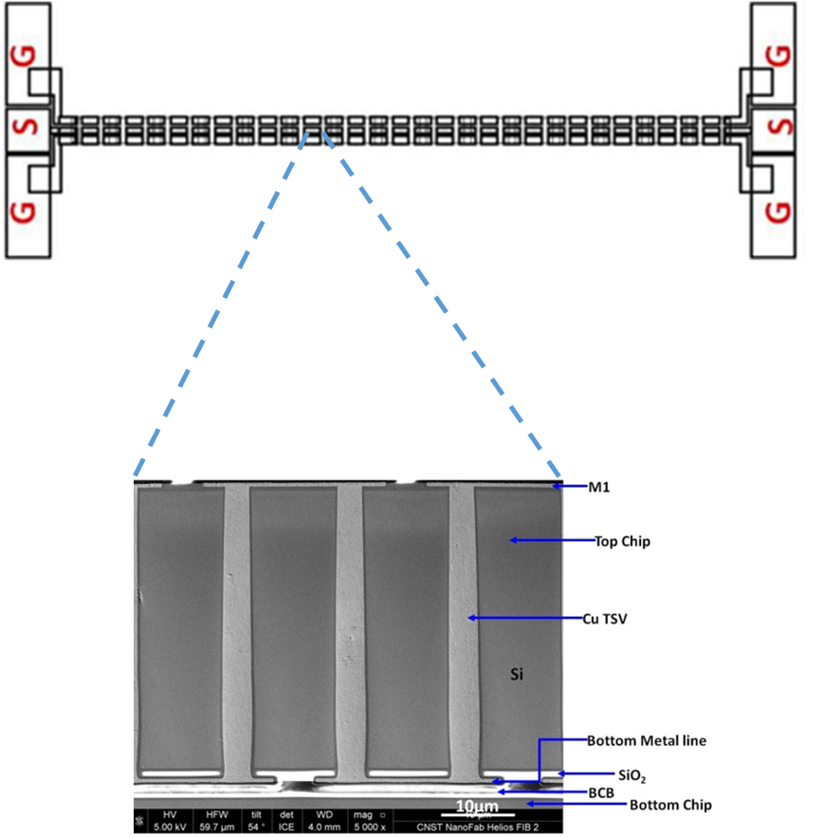
Figure 1: Two-level stacked dies, benzo-cyclobutene-bonded, incorporating 5.5 µm × 50 µm TSVs within the top chip.

The signal insertion loss (S₂₁) exhibited systematic degradation with increasing thermal cycles, as illustrated in Figure 2. In the as-received state, the coefficient at 20 GHz measured approximately 5.2 dB. After 500 thermal cycles, this value increased to 5.6 dB, reflecting a modest degradation. However, extended cycling accelerated the deterioration, with S₂₁ rising to 6.0 dB at 1000 cycles and further to 8.0 dB after 2000 cycles. Notably, the data obtained at 1000 and 2000 cycles displayed a marked frequency-dependent divergence compared to the baseline, with degradation most pronounced beyond 20 GHz. These observations indicate that signal integrity within TSV structures becomes increasingly unreliable under high-frequency operation following extensive thermal stress. Importantly, such degradation trends, revealed through broadband dielectric spectroscopy, cannot be captured by conventional dc resistivity measurements, underscoring the diagnostic value of RF-based methods.

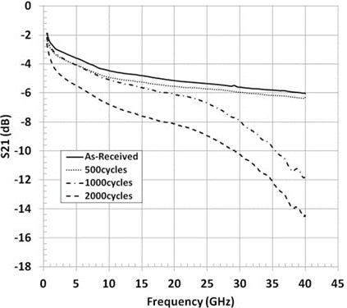

Figure 2: Degradation of S₂₁ transmission magnitude under progressive thermal cycling

The insertion loss depends on the instantaneous electrical characteristics of the device under test. We attribute insertion loss (which affects device reliability) to reorientation of electrically active defects, cracks, voids, dielectric constant variation, and adsorbed water molecules affected by heat. We have modeled insertion losses with equivalent circuit models of varying complexity with a stochastic optimization implementation of the Levenberg-Marquardt method. We compared results determined with global and local models fit to low-frequency and high-frequency subsets of the full spectrum. The modeling also revealed that the dominant mechanism of insertion loss in these test structures is a slow-surface wave propagation along the interface between TSV metal-fill and the Si host [30]. To illustrate the relevance of this methodology, for TSV-interconnects from two different providers, we quantify how estimated model parameters vary with thermal cycles for TSV-interconnects fabricated at particular wafer locations [30, 31, 32].

Case Study 2: Evolution of Chemical Defects in dielectric isolation liner in TSV-interposer for 3D Integrated System [14]
Dielectric materials such as amorphous silica (O₃/TEOS), composed of bulk tetrahedral SiO₄ units terminated by functional groups including silanols (R₃Si-OH), siloxane bridges (R₃Si-O-SiR₃), and other hydrated surface moieties (as shown in Figure 3) exhibit defects. The figure suggests that there are at least three distinct classes of defects, each with a distinct microwave signature as shown in Figure 4, in the “as-manufactured” devices we studied. The defect Type-I converts to Type-II with modest thermal treatment; ultimately, all the defects convert into the Type-III with time, but this transformation can be accelerated with temperature [33, 34]. Such defects are frequently implicated in electrical reliability issues, through various mechanisms such as electron trapping, hot-carrier degradation, and time-dependent dielectric breakdown, with early failure often linked to silanol- and non-bridging siloxane–related defects [35, 36]. Since microwave response depends on intrinsic composition and interfacial properties, such materials are particularly amenable to broadband dielectric spectroscopy probing.

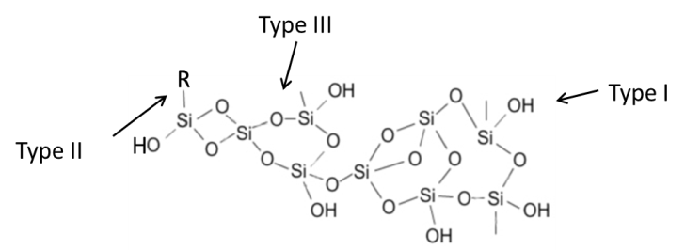

Figure 3: Illustration of the three defect types in the “as received” (zero thermal cycles) material.

In this study, BDS was employed to detect and characterize electrically active defects in fully integrated 3D devices with two-level stacked dies that utilized ozone-TEOS derived isolation liner in the TSV interposer, as shown in Figure 1. The samples underwent thermal cycling as described in Study 1. Here, microwave fields interact with device materials, inducing transient non-equilibrium events such as dipolar polarization, molecular vibration, reorientation, and translation. These interactions modify local and macroscopic fields through relaxation processes, including surface charge depolarization, which oppose the applied field and yield net energy absorption. The resulting RF loss spectra (insertion losses) were analyzed to probe the dominant polarization–depolarization mechanisms governing the dielectric response of materials [37]. Insertion losses at low-frequency (<300 MHz) served as defect-sensitive metrics; with a failure criterion defined as 50% signal loss (S₂₁ < 3 dB) at 210 MHz. Figure 5 compares failure rates of ‘as received’ and up to 2000 thermal cycles. It was observed that the number of failing dies decreased with thermal anneal after 500 thermal cycles [14].

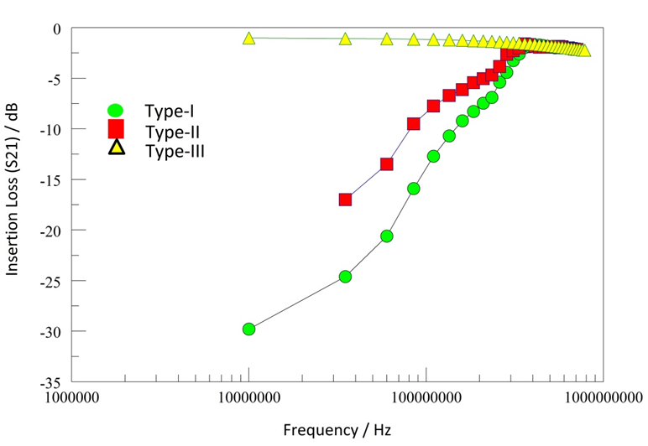
Figure 4: Comparison of the microwave signatures of the three defect types in the “as-received” (zero thermal cycles) material.

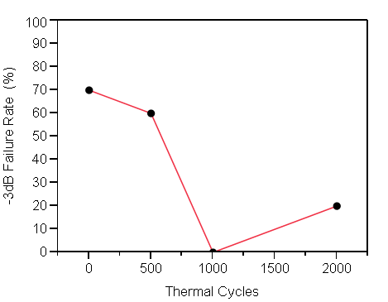
Figure 5: Device population fraction failing the 50% signal loss (S₂₁ < 3 dB) criterion

The observed monotonic decrease in failing dies with increasing thermal cycles, reaching a minimum at approximately 1000 cycles, suggests progressive structural transformations within the dielectric materials of construction [38]. The changes observed after about 500 cycles are attributed to condensation reactions and the elimination of water involving vicinal (hydrogen-bonded) silanols (Equation 14) [39]. With further thermal cycling, non-bridging silanol bonds are presumed to convert into more stable charge-transfer species (Equation 15), thereby modifying the dielectric’s electrical characteristics. These atomistic processes remove dangling bonds, suppress dominant energy-loss pathways, and consequently reduce device failure rates by improving material stability.

R₃-Si-O-Si-R₃ + H₂O → 2 R₃-Si-OH (14)

R₃-Si-OH + MX → R₃-Si-M + XOH (15)

It is also noted that not all dies in the studied population transitioned into less lossy devices after thermal cycling, indicating that the dielectric material in the hard-failed area of the wafer did not undergo the same atomistic transformation that resulted in improved device performance. For the devices examined, these chemical transformations predominantly involve the dielectric rather than the metal fill, as TSV RF characteristics at low frequency (<1 GHz), have been shown to be dictated by the capacitance of the isolation liner [40]. This study demonstrates a new approach for detecting and characterizing different bond types and dielectric defects. By analyzing changes in low-frequency (<300 MHz) RF scattering, the method provides quantitative insights into chemical and structural transformations occurring within dielectrics during post-processing thermal treatments, revealing mechanisms underlying reduced energy loss and enhanced device stability.

Case Study 3: Thermal Decomposition of Silico-organic Low Dielectric Constant (low-K) Materials
[41].
Low-dielectric (low-k) materials have become essential to high-performance integrated circuits (ICs), as they are critical for reducing signal delay and power consumption [42]. The class of low-k dielectric materials studied consisted of hybrid porous carbon-doped inorganic oxides (p-SiOCH, POSS-based, k < 4) [43]. These open-cage poly (methyl silsesquioxane) structures are reminiscent of amorphous SiOx films, in which the silanol ‘defects’ (defect Type-I above) are terminated with organic functional groups to create Si-R bonds (where R is an organic terminal group). These terminal groups designed to be thermally labile such that thermal degradation of these pendant groups induces porosity, enabling reduction of the dielectric constant to as low as 2.83 [44].

For this study, various types of porous organo-silicate (POSS) dielectric films deposited on highly resistive silicon wafer substrates were studied. Sample 106 (S106) represents a fully cured POSS (where R = CH₃, without -OH), deposited via spin-on from liquid precursors, while samples S117 and S129 are similar POSS (R = CH₃) films fabricated by chemical vapor deposition (CVD) using gaseous organosilane precursors with oxygen. Samples S86 and S111 are polymethyl sesquiloxane (PMSQ) POSS materials that have been post-deposition post processed through plasma etch, ashing, and cleaning; S86 was PECVD-deposited, while S111 was spin-on deposited dielectric films (SOD) [45], respectively. Broadband dielectric spectroscopy (BDS) was employed to investigate the thermal stability of the low-k dielectric films, considering both material composition and deposition method. The electrical properties of the thin films were evaluated through evanescent microwave attenuation, by placing the samples on ground-signal-ground (GSG) waveguides comprised of aluminum traces on a PCB board.

During thermal stability studies, samples were placed in an N₂-purged, preheated oven at 200 °C for up to nine hours, with intermittent removal for MW and Fourier transform infrared spectroscopy (FTIR) measurements. The selected temperature reflects typical through-silicon via (TSV) processing conditions. Electrical properties were evaluated via evanescent MW attenuation on ground-signal-ground (GSG) aluminum waveguides on PCBs, using a calibrated Teledyne LeCroy SPARQ-3004e+ network analyzer. Room-temperature MW and FTIR spectra were recorded at defined intervals, with samples cooled in a vacuum desiccator prior to measurement. Attenuation constants were extracted from S₂₁ scattering parameters using MATLAB+ software (MathWorks, Natick, MA). Thermally induced chemical transformations within the films were correlated with variations in microwave (MW) insertion loss as functions of time and temperature provided insight into the interplay between chemical structure, dielectric response, and overall device performance [46].

The thermal behavior of POSS-based low-k dielectric films is strongly influenced by precursor chemistry and deposition method. SOD films, exemplified by S106, displayed modest thermal decomposition involving POSS sublimation, residual water and CO₂ release, and homo-polymerization reactions (Si-O-Si condensation, Si-C cleavage, and carbon-carbon chain scission) forming unsaturated moieties [47]. As shown in Figure 6, attenuation spectra for S106 exhibited stable resonance peaks near 7.8 and 9.2 GHz during the first six hours of 200 °C storage, with intensities varying non-systematically. A new peak at 8.5 GHz emerged after eight hours, indicating delayed decomposition and formation of new microwave absorbing species, demonstrating thermal robustness that establishes sample S106 as a benchmark. In contrast, CVD films, exemplified by sample S129, exhibited rapid spectral changes within one hour at 200 °C (Figure 7). The attenuation peak broadened between 7.5-9.0 GHz, with increased intensity and frequency shifts, reflecting rapid transformation of polar groups.

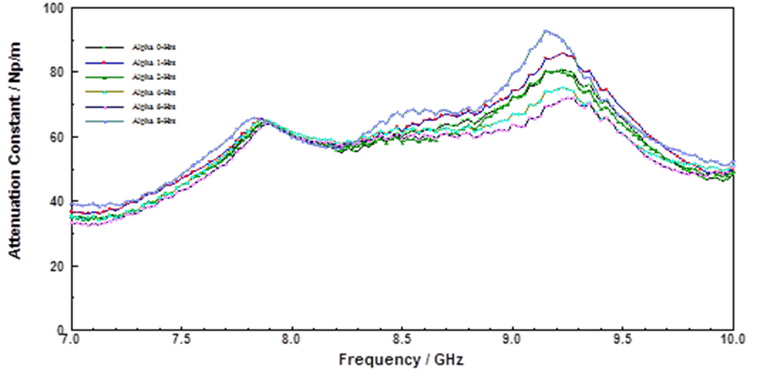

Figure 6: Attenuation constant spectra of S106 at 200 ºC for various times.
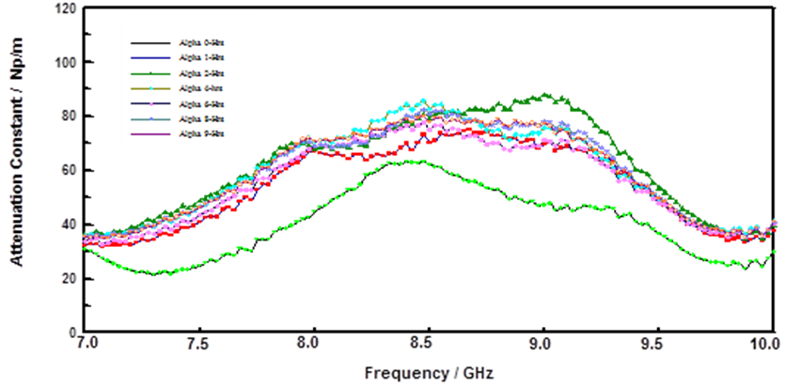

Figure 7: Attenuation constant spectra of S129 in the 7 to 10 GHz range of S129 stored at 200ºC for various times. The data suggest changing MW absorption with storage time at 200ºC.

The FTIR spectra of sample S129 before and after nine-hour storage are compared in Figure 8. The difference spectrum (insert) showed new bands at ~2900 cm⁻¹ and 1323, 1277, 1206 cm⁻¹, corresponding to Si-CHₙ and Si-C cage-like stretches [48], which suggest chemical restructuring of the SiOCH backbone and formation of hydrogenated carbon domains within the POSS film.

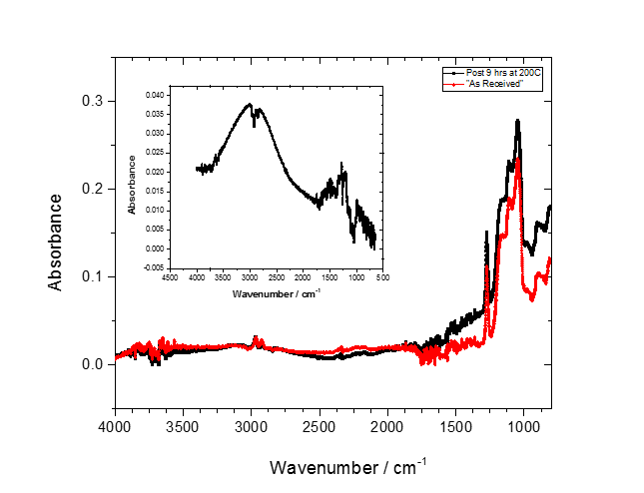
Figure 8: FTIR of sample S129 before (red) and after 9-hour (black) storage at 200 °C under Nitrogen. The insert is difference spectrum of sample before and after 9-hour storage.
These observations demonstrate that thermally induced chemical changes in low-k films directly impact MW insertion loss, interconnect resistivity, and group delay, potentially affecting high-speed device performance. The study highlights how variations in microwave propagation can serve as sensitive indicators of structural transformations in low-k dielectric backbones under thermal stress, linking dielectric response changes to underlying chemical modifications.

Case Study 4: Microwave Monitoring of Atmospheric Corrosion of Interconnects [49]
Broadband microwave spectroscopy provides unique opportunities for probing and understanding the impact of thermal energy on devices. Thermal exposure can induce changes in the electrical and physical properties of an interconnect, e.g., metal resistivity change, oxidation / corrosion, void formation, etc. [50] which result in changes in the device’s impedance and are easily monitored with the insertion losses extracted from scattering parameters (S₁₂ or S₂₁) of broadband microwave spectrum. Furthermore, phase change in the propagating microwave signal can yield additional mechanistic information, such as film transformation, passivation failure, and chemical changes in dielectric properties of the materials surrounding the metal lines[14]. It would be expedient to relate the chemical changes to mechanical artifacts such as void formation, decohesion, delamination, dielectric degradation, etc. of a material system (conductor, cladding, dielectric, processing condition etc.), to environmental factors. Such a link would provide rapid feedback for process and material integration optimization during device fabrication[51].

We have demonstrated that broadband microwave-based techniques afford detailed insights into the thermo-mechanical reliability issues [14, 52, 53, 54], as well as to probe the impact of temperature and current on the pre-catastrophic failure in of Cu interconnects in 3D-ICs [55]. Here, we characterize heat-induced failure of the encapsulating material and the consequent atmospheric corrosion of metal interconnects a purpose-built test structure [56], To monitor atmospheric corrosion of copper interconnects, was employed under controlled thermal and electrical conditions. The device was mounted on a heated chuck, stabilized within ±1 °C of the target temperature in open laboratory ambient, while a direct current (DC) was applied to the signal line. Concurrently, microwave signals were intermittently monitored using a two-port network analyzer (PNA-L N5230C, 10 MHz-40 GHz, Agilent Inc.) [57]. and thermal stress were terminated, and recovery was monitored at room temperature for up to 72 hours through re-measurement of insertion loss and DC resistance (R_{DC}).
For integrated circuits on silicon substrates, simulations indicate that while isolation dielectric issues dominate low frequency behavior (10 to 300 MHz), the resistance of the silicon substrate dominate 300 MHz-1 GHz region, and the capacitance of the silicon dominates the high frequency (> 1 GHz) region of the microwave spectrum as observed by increased insertion loss behavior, respectively[58]. For spectral interpretation, the S₂₁ response emphasis was placed on insertion loss at 350 MHz, where the most consistent and pronounced changes were observed. In the low-frequency regime, microwave losses primarily originated from dielectric scattering in the SiO₂ and TiN cladding, as well as interfacial scattering near the copper through-silicon via (TSV) interface with the silicon host [16, 59, 60, 61].

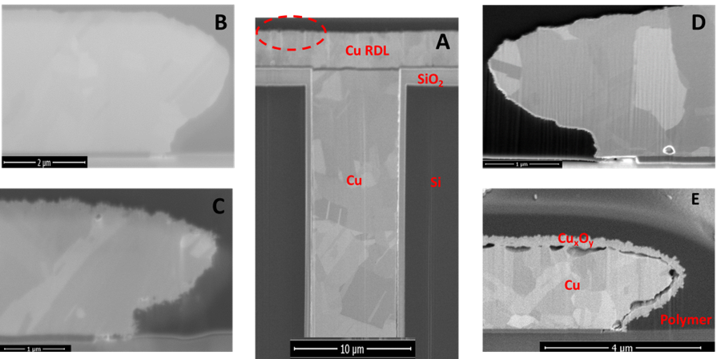

Figure 9: SEM micrographs showing the development of copper oxide films around interconnects as a function of stress temperature and time: (A) the dashed red circle is a visual aid showing the general location of magnified segment of interconnect, (B) “as-received” DUT, (C) after 343 TC-2 cycles (i.e., ~18 days), (D) 3 days at a static temperature of 125 °C, and (E) after 4 days at a static temperature of 200 °C. The thickness copper oxide film that formed around the Cu interconnect traces was measured from scanning electron micrographs (SEM) of focused ion beam (FIB) cross-sectioned samples.

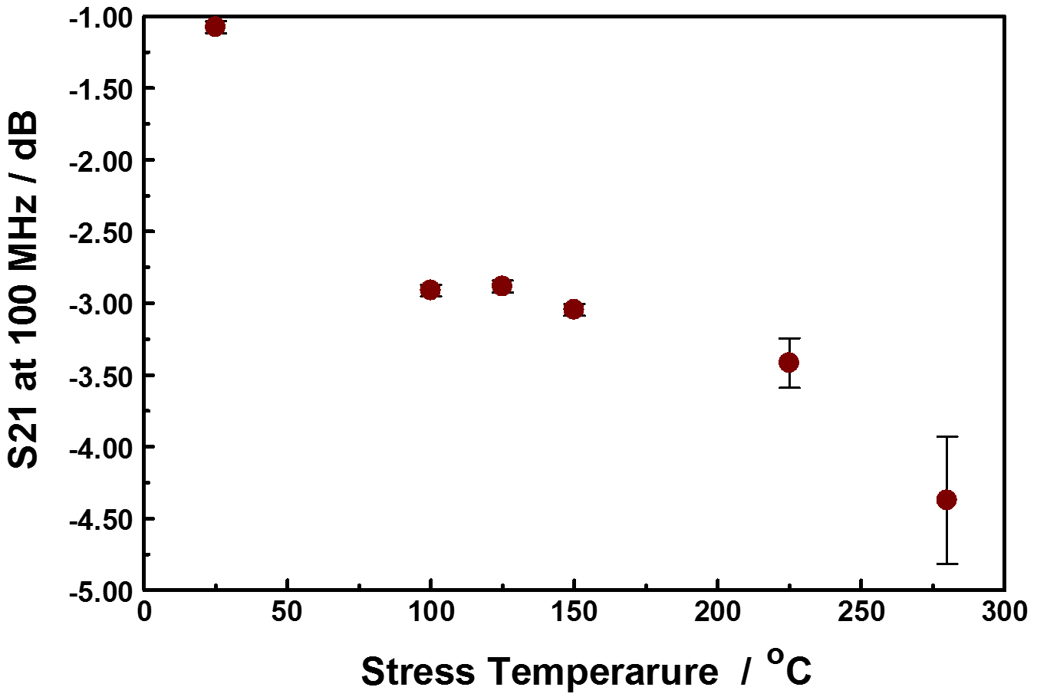
Figure 10: Evolution of the S₂₁ at 100 MHz with device stress temperature for at least 3 days. The copper-oxide film thickness was independent of stress time after 2 days. The error bars are entirely attributable to the different stress current used.

The extent of oxidation, as measured by the thickness of the copper oxide film formed around the copper trace, shown in Figure 9, increased with increasing temperature and duration of stress, as shown in Figure 10. Figure 10 shows the evolution of the S₂₁ at 100 MHz as a function of device stress temperature. The plot shows a sigmoidal trace, indicating that there are at least two, probably competing, processes in the range of temperature studied. Although the samples studied in this work were stressed for different durations, between 3 to 18 days, the measured copper oxide thickness did not show time dependence. Thus, the formation of the copper-oxide film appears to be self-limiting. This is consistent with Platzman et al. who divide the overall Cu-oxide thin film formation into three major stages: an initial formation of a copper (I) oxide layer, followed by a hydrolysis of the oxide-air interface to create metastable copper(II) hydroxide phase, and finally the transformation of the Cu(OH)₂ metastable phase to the stable copper (II), CuO layer[62]. The formation of the copper (I) oxide layer is induced by an electric field (as a driving force at low-temperature conditions) formed by positive ions of Cu at the metal/oxide interface and negative ions at the oxide/air interface. As the oxide layer thickness increases, the electric field drops across the film and ceases to be strong enough to induce the metal cations to migrate, thus limiting the native copper-oxide film growth. The native copper oxide then undergoes chemical transformation towards the stable CuO film. Figure 11 shows the correlation between the insertion loss (S₂₁) and the extent of copper interconnect oxidation. Thus, using the S₂₁ as an index for copper oxide film thickness, we could monitor the extent of corrosion RDL as a function of stress temperature with BDS.

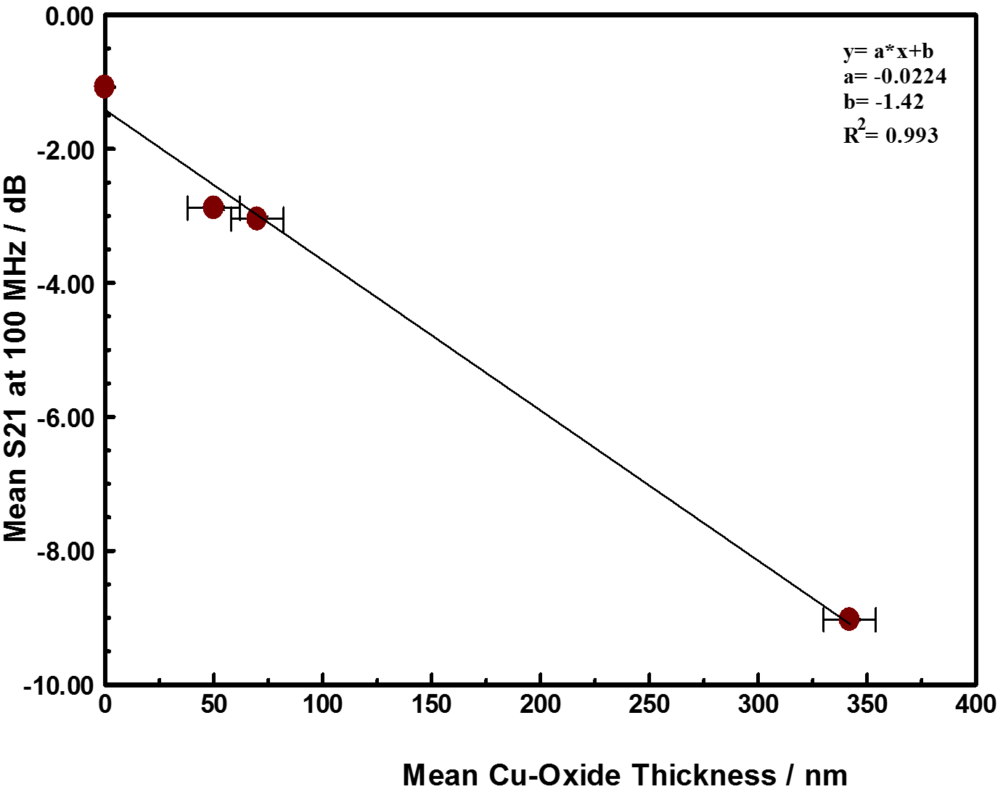

Figure 11: Correlation between the thickness of copper oxide film formed around Cu interconnect trace in samples maintained at stress temperature for at least 3 days and the Insertion loss (S₂₁) at 100 MHz. The intercept on the y-axis represents the room temperature insertion loss of the "as-received” material, prior to any stress.

In summary, the insertion loss data demonstrate that scattering variations in TSV-enabled interconnects are governed primarily by device temperature, with weaker contributions from current magnitude. Joule heating induced by forced current perturbs dielectric and interfacial properties, producing frequency-dependent effects that are partially reversible. The extent of reversibility depends on prior thermal conditioning, which influences the activation energy of defect formation. These results suggest that microwave propagation signatures can serve as predictive, non-destructive indicators of EM-driven degradation in 3D-IC interconnects, warranting further exploration for reliability monitoring applications.

Case Study 5: BDS of Subsurface Metal interconnects using Scanning Microwave Microscopy [63]
For 3D-ICs to be mass produced with confidence there is a need for metrology tools to help develop an understanding of the physics of failure; for example, there is considerable concern about the thermo-mechanical reliability of TSVs from stress-related failures. The frequent variation of the device temperature under use conditions invariably leads to device failure from thermal fatigue due to stress originating from the thermo-mechanical mismatch of the different materials of construction. A sub-surface metrology will enable non-destructive evaluation and monitoring of TSVs. When an electromagnetic wave propagating in a transmission line encounters a discontinuity, parts of the wave are either scattered, transmitted or reflected. The transmitted and reflected signal changes are related to the complex impedance of the discontinuity. Since microwave-based measurements interrogate the entire device under test, detailed study of the transmitted and reflected signal provides insight into physical changes in the device under test (DUT). BDS can be coupled to Atomic Force Microscopy (AFM) platform to create Scanning microwave microscope (SMM), that enables atomic level quantitative electrical measurements. The response of the SMM can be modeled by the lumped-element complex impedance of the tip-to-sample junction, which depends on the tip geometry, the electromagnetic properties of the sample and the tip-to-sample spacing.

This impedance arises not only from the tip-to-sample contact interface (as in the scanning tunneling microscope), but also from the structure of the sample beneath the tip. Thus, the SMM has some potential to gather subsurface information with the positional spatial resolution of a scanning probe microscope (SPM); the technique is discussed extensively elsewhere [64]. The sub-surface imaging capabilities of SMM may have some applications for investigating and monitoring back-end-of-line (BEOL) integrated circuit processes which consist of all the parts of the integrated circuit from the transistor contact upwards, including all the levels of interconnect metallization, the inter-level dielectric layers, and the various contact pads and bump structures. For BEOL, a non-destructive, high spatial resolution sub-surface metrology would be useful for the verification of buried metal line dimensions, determination of the frequency spectrum of the interaction between lines, and for the identification of shorts and opens for failure analysis. Another important emerging application where a sub-surface metrology SPM, such as SMM, could contribute is in characterizing three-dimensional integrated circuits (3D-ICs), such as chiplet integration,

Here, we have used SMM to investigate sub-surface metal-lines buried beneath dielectric layers by using intermittent-contact scanning capacitance microscopy [65]. The test chips used in this work were manufactured at commercial foundry based on our design, with four different levels of Al–Si–Cu metallization comprised of Ti (barrier) /Al-1.0%Si-0.5%Cu/ TiN (cap). CF₄ plasma or O₂ plasma post-etch treatment was probably performed after metal etch to passivate the Al lines. The inter-level dielectric consists of a plasma-enhanced chemical vapor deposited-tetraethylorthosilicate (PECVD-TEOS) layer. The four different metal levels of lines are in alignment and connected with vias.

The SMM (Keysight Technologies Inc., Santa Clara, CA) consists of a model 5420 SPM, model N9416S SMM nosecone, and a vector network analyzer (VNA) (PNA-L, Keysight Model N5230C) with a frequency range of 10 MHz to 40 GHz. The nosecone is designed to pass frequencies as high as 20 GHz to the tip. Etched solid platinum probe tips with a tip apex diameter of about 40 nm and spring constant of 0.3 N m−1 (model RMN 12Pt400A, Rocky Mountain Technologies, Salt Lake City, UT) were used to acquire all images and data. The Pt cantilever was approximately 400 μm long and 60 μm wide. The VNA is connected via a transmission line through a resonant circuit to the conductive AFM probe. The nosecone holds the cantilevered AFM probe and provides electrical shielding so that the transmission line can be connected to the sample surface with minimal leakage or transmission.

An evanescent, broadband (10 MHz to 40 GHz) SMM to acquire S₁₁ reflected amplitude and S₁₁ reflected phase images of electrically ungrounded, conducting regions (Al-Si-Cu lines) buried and encased in up to 2300 nm of planarized inter-metal dielectric. A special test chip [23] with well-defined metal lines was fabricated as the test vehicle. The SMM implementation as discussed here applies a high frequency signal through a 50 Ω transmission line terminated with a scanning SPM tip to the sample. The SMM generates spatially resolved images from the reflected microwave (S₁₁) signal amplitude and phase, usually at its resonance frequencies of the AFM nosecone system (around 7 GHz for the set-up used in these studies). At the frequencies used in this work, the electromagnetic wave from the tip can propagate deep into the sample (predominantly dielectric) and interact with buried structures with a portion of the signal transmitted and reflected at each interface. Experimental results are compared to a simple transmission line, lumped element model of the SMM and test structure with good agreement.

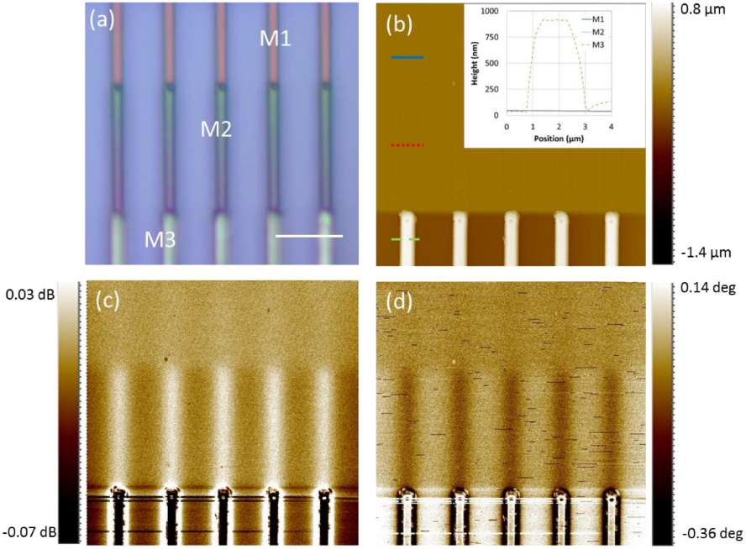

Figure 12: (a) Optical image of ‘as-received’ 4-level BEOL test structure: M3 is on the surface, while M2 and M1 lines are buried in TEOS (M4 is not shown). The white scale bar is equal to 10 μm. (b) AFM topography shows the middle lines are totally buried by the planarized TEOS without any surface topography. The inset displays topographic line profiles at the site indicated with red, blue and green lines, showing that the M3 is 900 nm above the dielectric surface while M2 and M1 has no topography. (c) Reflected S₁₁ signal amplitude of the exposed M3 metal line and the buried M2 and M1 metal lines. (d) Reflected S₁₁ phase of the exposed M3 metal line and the two buried metal lines. First order flattening has been applied to images (b)–(d).

Figure 12 compares the optical, AFM topography, reflected microwave amplitude, and reflected microwave phase of the multi-level subsurface features on the ‘as received’ test structure. In the optical plan view micrograph of the structure, figure 12(a), the different levels of Al interconnect have different contrast depending on the amount of the covering interlayer dielectric. The M4 layer is not shown in figure 12. The AFM topography image, in figure 12(b), was collected in the same area as the optical micrograph area. Besides the exposed metal lines (M3) which have pronounced topography, the image shows a very flat surface where the buried lines are located, suggesting very good planarization over the buried metal lines. Most importantly, the flatness assures us that there will be no topography related artifacts in the microwave scans in the same area. Figure 12(c) shows the reflected microwave amplitude (S₁₁) in dB and figure 12(d) shows the reflected phase in degrees of the same area.

The maximum change in SMM reflected amplitude between the reference level (region with no buried metal) and the region above M2 is 0.04 dB; and between the reference level and M1 was 0.006 dB. Likewise, the maximum change in the SMM reflected phase between the reference level and M2 was about 0.13 degrees (2 × 10−3 rad). The SMM phase change between the reference level and M1 was near the detection limit (0.02 degrees) of the instrument. Defining the spatial resolution of the line edge as the distance between the 25% and 75% maximum contrast intensity levels, the edge of M2 is resolved to within about 900 ± 70 nm and the edge of M1 to within 1200 ± 260 nm.

Currently, subsurface (buried interfaces) characterization is not fully understood. In our SMM experiments, the S₁₁ amplitude is determined by two competing effects, viz., the resonance position is shifted in frequency and the amplitude signal may be altered, both in shape and height, due to quality factor changes. These two competing effects can cause the amplitude and phase measured by the SMM to vary in complex ways. Since there is little topography variation above the buried lines, we are sure that the change in S₁₁ amplitude and phase signal are due to the buried structure and not any topography effect.

Summary: To address the limitations of traditional metrology in reliability assessment of 3D integrated devices, broadband dielectric spectroscopy (BDS) has emerged as a promising in-situ diagnostic tool. BDS enables the non-destructive, frequency-dependent probing of dielectric and conductive responses in materials, offering valuable insights into their physical and chemical evolution under electrical and thermal stress. These studies illustrate our comprehensive application of BDS to investigate material transformations and failure mechanisms in integrated systems. For example, BDS can elucidate subtle changes in dielectric properties that precede catastrophic failure, thereby enabling predictive assessments of device reliability. The findings contribute to the development of more robust materials and architectures for next-generation electronic systems.
References
- Salahuddin, S., et al, The Era of Hyper-Scaling in Electronics. Nature Electronics, 2018. 1(8): p. 442-450.
- Zhuang, Z., et al. Multi-Package Co-Design for Chiplet Integration. in 2022 IEEE/ACM International Conference on Computer Aided Design (ICCAD). 2022.
- Orji, N.G., et al., Metrology for the Next Generation of Semiconductor Devices. Nature Electronics, 2018. 1(10): p. 532-547.
- Wheeler, D., e. al., Spatial-Temporal Modelling of Extreme Bottom-up Filling of Through-Silicon-Vias. Journal of The Electrochemical Society, 2013. 160(12): p. 3260-3265.
- Hassan, B. T., et al., A Poisson Lognormal-Lindley Model for Simultaneous Estimation of Multiple Crash-types: Application of Multivariate and Pooled Univariate Models, Analytic Methods in Accident Research, 2024, 41, p. 100315.
- Ibrahim, A., et al., A Data-driven Modelling Framework for Predicting the Quality of Semiconductor Devices to Support Burn-in decisions, Computers & Industrial Engineering, 2025, 204, p. 111115.
- Woodward, W.H.H., ed. Broadband Dielectric Spectroscopy. ACS Symposium Series, 1947-5918; 1375, 2021, American Chemical Society,: Washington, DC.
- Kremer, F. and Schönhals, A., Broadband Dielectric Spectroscopy. 1 ed. 2003: Springer, Berlin, Heidelberg.
- Okoro, C.A., et al., Measurement Science for "More-Than-Moore" Technology Reliability Assessments, in International Symposium on Functional Diversification of Semiconductor Electronics, Y. Obeng, et al., Editors. 2012. p. 71-79.
- Selcuk, I., et al., Dielectric Properties and Electrical Characteristics of a Triphenylamine Thin Film Deposited onto a Silicon Substrate via Spin Coating, ACS Appl. Electron. Mater., 2024. 6(7): p. 5057−5066.
- Krupka, J., Microwave Measurements of Electromagnetic Properties of Materials. Materials (Basel), 2021, 14(17): p. 5097.
- Madiha F. E., et al, A Review on Electromagnetic Microwave Absorption Properties: their Materials and Performance, Journal of Materials Research and Technology, 2022. 20, p. 2188-2220.
- Obrzut, J., et al., Resonant Microwave Absorption in Thermally Deposited Au Nanoparticle Films Near Percolation Coverage. Langmuir, 2013. 29(28): p. 9010-9015.
- Obeng, Y.S., et al., Dielectric Spectroscopic Detection of Early Failures in 3-D Integrated Circuits. ECS Transactions, 2015. 69(6): p. 69-78.
- You, L., et al., Microwave-Based Metrology Platform Development: Application of Broad-Band RF Metrology to Integrated Circuit Reliability Analyses. ECS Transactions, 2014. 61(6): p. 113-121.
- Obeng, Y.S., et al., Low Frequency Radio Wave Detection of Electrically Active Defects in Dielectrics. ECS Journal of Solid-State Science and Technology, 2016. 5(4): p. P3025-P3030.
- Okoro, C., et al., Use of RF-based Technique as a Metrology Tool for TSV Reliability Analysis. in Electronic Components and Technology Conference (ECTC), 2013 IEEE 63rd. 2013. IEEE.
- Baker-Jarvis, J. and Kim, S., The Interaction of Radio-Frequency Fields with Dielectric Materials at Macroscopic to Mesoscopic Scales. Journal of Research of the National Institute of Standards and Technology, 2012. 117(1): p. 1-60.
- Jing, S., et al., Review on Microwave-Matter Interaction Fundamentals and Efficient Microwave-Associated Heating Strategies. Materials, 2016. 9(4): p. 231
- Hunter-Woodward, W. H., Broadband Dielectric Spectroscopy-A Practical Guide, ACS Symposium Series, 2021, 1375, p 3-59
- Yuzhang D., et al., Research Progress and Future Perspectives on Electromagnetic Wave Absorption of Fibrous Materials, iScience, 2023, 26(10), p.107873.
- Janezic, M.D. and Jargon, J. A., Complex Permittivity Determination from Propagation Constant Measurements. IEEE Microwave and Guided Wave Letters, 1999. 9(2): p. 76-78.
- Deutsch, A., et al., High-speed Signal Propagation on Lossy Transmission Lines. IBM Journal of Research and Development, 1990. 34(4): p. 601-615.
- Kohl, P.A., Low-Dielectric Constant Insulators for Future Integrated Circuits and Packages. Annu. Rev. Chem. Biomol. Eng., 2011. 2(1): p. 379-401.
- Pozar, D.M., Microwave Engineering 4th Edition ed. 20121, Hoboken, NJ: J. Wiley.
- Komarov, V., et al., Permittivity and Measurement, in The Wiley Encyclopedia of RF and Microwave Engineering, K. Chang, Editor. 2005, John Wiley & Sons, Inc: New York. p. 3693-3711.
- Murase, K., et al., Group Delay Equalized Monolithic Microwave Integrated Circuit Amplifier for Ultra-wideband Based on Right/left-handed Transmission Line Design Approach. IET Microwaves, Antennas & Propagation, 2009. 3(6): p. 967-973.
- Okoro, C., et al., Accelerated Stress Test Assessment of Through-silicon Via using RF Signals. Electron Devices, IEEE Transactions on, 2013, 60(6): p. 2015-2021.
- Lyu, S., et al., Scaling Effects on the Microstructure and Thermomechanical Response of Through Silicon Vias (TSVs). Journal of Applied Physics, 2025. 137(8).
- Coakley, K.J., et al., Understanding Early Failure Behavior in 3D-Interconnects: Empirical Modelling of Broadband Signal Losses in TSV-Enabled Interconnects. IEEE Transactions on Electron Devices, 2022. 69(11): p. 6270-6276.
- Coakley, K.J., et al., (Invited) Comparison of Empirical Models for Broadband Insertion Losses in TSV-Interconnects. ECS Meeting Abstracts, 2023. MA2023-02(17): p. 1190.
- Coakley, K.J., et al., Understanding Early Failure Behavior In 3D-Interconnects 2: Empirical Modelling of Broadband Signal Losses In TSV-Enabled Interconnects. ECS Journal of Solid-State Science and Technology, 2024. 13(11): p. 115003.
- Obeng, Y.S., et al., Low Frequency Radio Wave Detection of Electrically Active Defects in Dielectrics. ECS Journal of Solid-State Science and Technology, 2016. 5(4): p. P3025-P3030.
- Obeng, Y.S., et al., Low Frequency Radio Wave Detection of Electrically Active Defects in Dielectrics. ECS Journal of Solid-State Science and Technology, 2015. 5(4): p. P3025-P3030.
- Chua, L.-L., et al., General Observation of N-Type Field-Effect Behavior in Organic Semiconductors. Nature, 2005. 434(7030): p. 194-199.
- Mathijssen, S.G.J., et al., Charge Trapping at the Dielectric of Organic Transistors Visualized in Real Time and Space. Advanced Materials, 2008. 20(5): p. 975-979.
- Jonscher, A.K., Dielectric Relaxation in Solids. Journal of Physics D: Applied Physics, 1999. 32: p. 57.
- Olson, S. and Hummler, K., 3D Systems Integration Conference (3DIC). in TSV Reveal Etch for 3D Integration. 2012. IEEE International.
- Mania, P., et al., Thermal Restructuring of Silica-Grafted TiClx Species and Consequences for Epoxidation Catalysis. Chemistry - A European Journal, 2013. 19: p. 9849-9858.
- Joohee, K., et al., High-Frequency Scalable Electrical Model and Analysis of a Through Silicon Via (TSV). Components, Packaging and Manufacturing Technology, IEEE Transactions on, 2011. 1(2): p. 181-195.
- Christopher, E. S., et al., Broadband Dielectric Spectroscopic Characterization of Thermal Stability of Low-k Die-lectric Thin Films for Micro- and Nanoelectronic Applications. ECS Journal of Solid State Science and Technology, 2017, 6(9), p. 155-162.
- Cao, L., et al., Recent Advances in Porous Low-k Materials for Integrated Circuits. ACS Applied Materials & Interfaces, 2025. 17(31): p. 43983-44010.
- Shamiryan, D., et al., Low-K Dielectric Materials. Materials Today, 2004. 7(1): p. 34-39.
- Su, K., et al., Low-k Interlayer Dielectric Materials: Synthesis and Properties of Alkoxy-Functional Silsesquioxanes. Chemistry of Materials, 2005. 17(10): p. 2520-2529.
- Mikhail, B. and Martin, k. M., Green Dielectric Films for Advanced Microelectronics. Materials for Electronic and Optoelectronic Applications, ed. P.C. Arthur Willoughby, Safa Kasap 2007: Wiley.
- Obrzut, J., Surface Conductance and Microwave Scattering in Semicontinuous Gold Films. ACTA IMEKO 2015. 4(3): p. 42-46.
- Fina, A., et al., Polyhedral Oligomeric Silsesquioxanes (POSS) Thermal Degradation. Thermochimica Acta, 2006. 440(1): p. 36-42.
- Yang, C.S., et al., The Influence of Carbon Content in Carbon-doped Silicon Oxide Film by Thermal Treatment. Thin Solid Films, 2003. 435(1-2): p. 165-169.
- Amoah, P.K., et al., Microwave Monitoring of Atmospheric Corrosion of Interconnects. ECS Journal of Solid State Science and Technology, 2018. 7(12): p. N143.
- Kang, S.H., et al., Effect of Annealing on the Surface Microstructural Evolution and the Electromigration Reliability Of Electroplated Cu Films. Journal of Electronic Materials, 2001. 30(12): p. 1506-1512.
- Janezic, M.D., et al., Permittivity Characterization of Low-K Thin Films from Transmission-Line Measurements. IEEE Transactions on Microwave Theory and Techniques, 2003. 51(1): p. 132-136.
- Okoro, C., et al., A Detailed Failure Analysis Examination of the Effect of Thermal Cycling on Cu TSV Reliability. Electron Devices, IEEE Transactions on, 2014. 61(1): p. 15-22.
- Okoro, C., et al. Use of RF-Based Technique as A Metrology Tool for TSV Reliability Analysis. in Electronic Components and Technology Conference (ECTC), 2013 IEEE 63rd. 2013. IEEE.
- Marro, J.B., et al., Temperature Dependence of Defect Evolution and Distribution in Thermally Cycled Cu-TSVs. ECS Transactions, 2014. 61(2): p. 177-184.
- 24. Sunday, C.E., et al., Microwave Evaluation Of Electromigration Susceptibility In Advanced Interconnects. Journal of Applied Physics, 2017. 122(17): p. 174504.
- Frank, T., et al., Reliability of TSV interconnects: Electromigration, thermal cycling, and impact on above metal level dielectric. Microelectronics Reliability, 2013. 53(1): p. 17-29.
- Moreau, S. and Bouchu, D., Reliability of Dual Damascene TSV for High Density Integration: the Electromigration Issue. IEEE International Reliability Physics Symposium (IRPS), 2013. 58
- al, M.L.e., Temperature-Dependent Through-Silicon Via (TSV) Model and Noise Coupling. EEE 20th Conference on Electrical Performance of Electronic Packaging and Systems, 2011: p. 3.
- Yadav, S. K., et al., First-Principles Study of Cu/Tin and Al/Tin Interfaces: Weak Versus Strong Interfaces. Modelling and Simulation in Materials Science and Engineering, 2014. 22(3): p. 11.
- Yasushi, I., et al., Thermal Stability of Interconnect of TiN/Cu/TiN Multilayered Structure. Japanese Journal of Applied Physics, 1994. 33(1S): p. 462. 61.
- Lee, W.-J., et al., Adhesion and Interface Chemical Reactions of Cu/polyimide and Cu/TiN by XPS. Applied Surface Science, 2003. 205(1-4): p. 128-136. 62.
- Platzman, I., et al., Oxidation of Polycrystalline Copper Thin Films at Ambient Conditions. The Journal of Physical Chemistry C, 2008. 112(4): p. 1101-1108.
- You, L., et al., Subsurface Imaging of Metal Lines Embedded in a Dielectric With A Scanning Microwave Microscope*. Journal of Physics D: Applied Physics, 2016. 49(4): p. 045502.
- Measurement Techniques for Radio Frequency Nanoelectronics, in Measurement Techniques for Radio Frequency Nanoelectronics, T.M. Wallis and P. Kabos, Editors. 2017, Cambridge University Press: Cambridge.
- Kopanski, J.J. and S. Mayo, Intermittent-Contact Scanning Capacitance Microscope For Lithographic Overlay Measurement. Applied Physics Letters, 1998. 72(19): p. 2469-2471.

