Block-copolymer photonic crystal gel for mechanical strain sensing

Edwin P. Chan, Christopher M. Stafford
Polymers Division, National Institute of Standards and Technology, Gaithersburg, MD, USA
chris.stafford@nist.gov

Joseph Walish, Edwin L. Thomas
Department of Materials Science and Engineering, Massachusetts Institute of Technology, Cambridge, MA, USA

Introduction

Photonic crystals are a class of nanostructured composite materials having a periodic variation in refractive index. Due to their defined dielectric structure, these materials provide interesting means to manipulate and control light, thus giving rise to structural color. Over the past decade, self-assembled block copolymers have been demonstrated as candidate materials for photonic crystal applications.¹ However, practical applications of these materials been challenged by limited tunability in the self-assembled nanostructures that can provide sufficient index contrast and domain spacing.
Recently, photonic block copolymer gels have been developed that have broadened their applications due to the enhancement in the responsivity and tunability of the photonic stop band.^{2,3} Additionally, they have been demonstrated as chemical sensors that makes advantageous use of the dynamic change in structural color upon interaction with the local environment. An interesting application of these materials is for local mechanical sensing based on changes in the photonic stop band. In this work, we present the application of a BCPG as a local mechanical sensor by investigating the changes in structural color as a function of mechanical deformation. The BCPG consists of a hydrophobic block (polystyrene) – hydrophilic polyelectrolyte (poly(2-vinyl pyridine)) block copolymer to form a periodic lamellar structure that functions as a one dimensional Bragg reflector. Contact adhesion test is used to measure and relate the changes in structural color of the BCPG films as a function of mechanical deformation. We explore the effects of solvent conditions and applied deformation in determining the relationships between structural color changes and microdomain response.

Experimental

The BCPG is a polystyrene-b-poly(2-vinyl pyridine) (P(S-b-2VP)) block copolymer film swollen with a preferential solvent for the P2VP block. The P(S-b-2VP) (M_{n,PS} = 100,000 g/mole, and M_{n,P2VP} = 100,000 g/mole), was purchased from Polymer Source. A 5 % by mass of block copolymer solution was prepared by dissolving it in propylene glycol monomethyl ether acetate (PGMEA). The block copolymer films were prepared by spin coating this filtered solution onto silane-treated glass substrates. Specifically, 3-Iodopropyl trimethoxysilane was used as the silane agent that prevents delamination of the block copolymer film during swelling. Following spin casting, the films were solvent annealed by exposing to chloroform vapor at 40 ºC for 8 hrs. The samples are used without further processing.

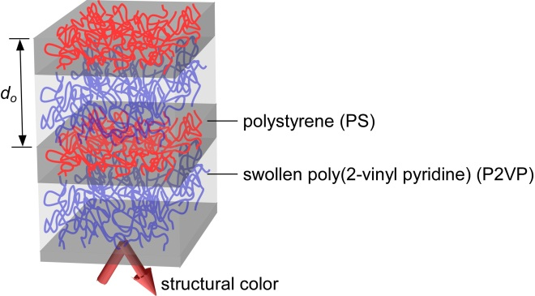
Figure 1. A block copolymer photonic crystal gel (BCPG) consisting of a diblock of glassy polystyrene and poly(2-vinyl pyridine) swollen with a preferential solvent. The microdomains of the copolymers have sufficiently high refractive index contrast and domain spacing to manipulate light, which gives rise to structural color.

Following fabrication of the materials, we quantify the mechanical response of the BCPG films using a custom-designed contact adhesion testing (CAT) instrument. Figure 2 illustrates the testing approach. First, ~0.1 mL of 1 M acetic acid is deposited onto the film surface to form the BCPG via preferential swelling of the P2VP microdomain. Then, a 5 mm radius hemispherical glass probe is brought into contact with the BCPG by compressing the gel film at a fixed displacement rate (~0.5 μm/s) that is controlled by a nanopositioner stepper motor. The force (P), displacement (δ), and contact area (A=πa²) are monitored throughout the course of the test. Optical micrograph contact area images are recorded via a color CCD camera. Upon reaching a defined compressive load, the probe retracts and the test is completed when the probe is completely separated from the gel surface.
To analyze the changes in structural color as a function of applied deformation, a custom-designed LabVIEW image analysis software is used. Briefly, the image analysis software performs an azimuthal averaging of the contact area images into a color spectrum as a function of radial distance. Each pixel of this spectrum is then correlated to an estimated dominant optical wavelength.
The transfer matrix method (TMM) was used to determine the theoretical photonic stop band. In the transfer matrix method calculations, we assume that the lamellar structures are oriented parallel with the substrate. The P2VP layers are assumed to be swollen by the acetic acid and the index of refraction of the P2VP microdomain is calculated based on volumetric rule of mixtures.

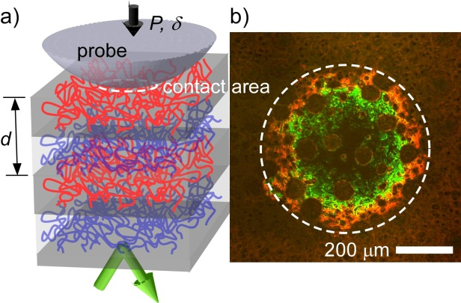
Figure 2. a) Contact adhesion testing of the BCPG swollen with 1 M acetic acid. b) Optical micrograph of the deformed gel. The gradient in photonic stop band is related to the stress distribution defined by the probe.

Results and Discussion

Equipment and instruments or materials are identified in this work in order to adequately specify the experimental details. Such identification does not imply recommendation by the National Institute of Standards and Technology (NIST), nor does it imply that the materials are necessarily the best available for the purpose.
Figure 2b demonstrates the changes in structural color as a function of applied deformation for the BCPG. Prior to contact between the BCPG and the probe, the initially colorless film develops a red color due to swelling by the acetic acid. This structural color corresponds to the initial photonic stop band defined by the dimensions of the PS and swollen P2VP microdomain. Then, the probe is brought into contact with the gel surface and a defined contact area develops characterized by a distribution of photonic stop bands. We observe that the specific wavelength of the stop band is dependent on the radial position of the contact area. In general, the photonic stop band shifts to shorter wavelengths from the edge of the contact area to the center.
The distribution in stop band wavelength versus radial position is consistent with the stress distribution experienced by the BCPG due to deformation by a spherical probe. Based on the experimental results from the CAT, we approximate the deformation of the BCPG-probe interface with Hertizan contact mechanics. Specifically, we focus on the stress distribution as a function of radial position within the area of contact, which is defined as:⁴
(1)
This stress distribution leads to a quadratic distribution in the displacement.
(2)
To estimate the strain distribution, we normalize this displacement distribution by the applied displacement (δ).
(3)
Eqn. (3) is used to describe the mechanical deformation of the BCPG. In order to correlate the changes in stop band wavelength with applied deformation, we make two assumptions in regards to the deformation of the block copolymer microdomain. First, we assume that the change in wavelength is primarily attributed to local deformation of the swollen P2VP microdomains. Thus, the glassy PS microdomain is assumed to be undeformed relative to the deformation experienced by the swollen P2VP microdomain. Second, the deformation of the microdomain layers is considered to be an affine deformation process with the individual PV2P microdomain experiencing a similar degree of strain. Based on the total displacement, along with the approximation of the strain distribution, we can estimate the amount of strain experienced by P2VP microdomain. When coupled with the predictions from TMM, we correlate the changes in the photonic stop band to the local deformation of the microdomain. The specific approach of this analysis will be presented in our presentation.

Acknowledgements

EPC acknowledge the National Research Council for financial support. The authors thank Dr. Peter M. Johnson for helpful discussions. Contribution of the National Institute of Standards and Technology, not subject to copyright in the United States.

References
1 Edrington, A. C. et al. Polymer-based photonic crystal. Adv. Mater. 13, 421-425 (2001).
2 Valkama, S. et al. Self-assembled polymeric solid fi lms with temperature-induced large and reversible photonic-bandgap switching. Nat. Mater. 3, 872-876 (2004).
3 Kang, Y., Walish, J. J., Gorishnyy, T. & Thomas, E. L. Broad-wavelength-range chemically tunable block-copolymer photonic gels. Nat. Mater. 6, 957-960 (2007).
4 Johnson, K. L. Contact Mechanics. 9th edn, 452 (Cambridge University Press, 2003).

