Monitoring and Controlling Oxygen Levels in Microfluidic Devices
Peter C. Thomas1, 2, Srinivasa R. Raghavan3 and Samuel P. Forry1
¹ National Institute of Standard and Technology/Biochemical Science Division, Gaithersburg, MD
² University of Maryland/Fischell Department of Bioengineering, College Park, MD
³ University of Maryland/Department of Chemical and Biomolecular Engineering, College Park, MD

Abstract— Mammalian cell culture has been traditionally performed in a static oxygen concentration of 20%. However, oxygen level in vivo is significantly more hypoxic with an average oxygen concentration of 3%-5%. In addition, many cells within the body are found in dynamic oxygen environment. Such differences in oxygen tension have been shown to affect cell behavior, and controlling and monitoring oxygen level is crucial in creating biomimetic cell culture conditions. Previously, we have developed a luminescence-based oxygen sensor capable of monitoring cellular oxygen consumption rates in multi-well plate format that is compatible with conventional cell microscopy techniques (e.g. phase contrast and fluorescence imaging).
In the current study, we demonstrate successful integration of the oxygen sensor into a multi-layer microfluidic cell culture device. The oxygen sensor provides a facile method for continuous monitoring of on-chip oxygen levels. Polydimethylsiloxane (PDMS) based microfluidic cell culture devices are permeable to oxygen, allowing physiologically relevant oxygen environments to be generated. Control channels are incorporated to enable on-chip control of dissolved oxygen tension. Finite element simulations and experimental measurements are in excellent agreement in monitoring oxygen diffusion through the PDMS for generating stable oxygen gradients and rapidly changing oxygen levels on-chip. Further, calibration on-chip match expected sensitivities determined outside of the microfludic environment. Cells will be monitored during culture in this microfluidic system under physiologically relevant oxygen environments.
Keywords— Microfluidics, oxygen control, PDMS, oxygen sensor.

INTRODUCTION
Oxygen is a critical parameter to the behavior and function of cells. Cells in vivo are found in oxygen environment that are tightly regulated. In general, the average oxygen concentration in tissue is around 3-5% (P_{O2} = 0.03-0.05).[1, 2] In comparison, in vitro cell cultures are generally performed at ~ 21% (P_{O2} = 0.21, ambient oxygen level). Such differences in oxygen levels have consistently been shown to alter cell responses leading to unreliable experimental results [1-3]. These findings reinforce the importance of oxygen in cell culture and the critical need of controlling oxygen levels.
Microfluidic devices made from polydimethylsiloxane (PDMS) are highly permeable to oxygen, allowing control of oxygen levels on-chip. The ability to generate oxygen gradients was demonstrated by flowing gas through a control line and allowing diffusion to control the oxygen level in the adjacent flow line. These gas gradients is usually confirmed by observing the fluorescence of an oxygen sensitive molecule dissolved in the solution within the flow line [4]. Without an on-chip indicator, real-time oxygen measurements cannot be made and any changes in overall oxygen levels will be unnoticed. We have previously developed a PDMS based oxygen sensor that is compatible with phase contrast and fluorescence imaging [5].
The current work is focused on the successful integration of the oxygen sensor into a multi-layer microfluidic cell culture device. Control lines were incorporated into the device to allow control of dissolved oxygen tension in the fluidic channel. Finite element simulations and experimental results showed excellent agreement in monitoring the changing oxygen level on-chip. Based on the simulation results, various device geometries were developed that allow generation of a wide range of oxygen gradient and oxygen levels to be examined.

Experimental section

Sensor Preparation and Integration
Oxygen sensors were prepared as previously described with slight modification [5]. All components were spin-coated onto a 3 × 2 microscope slide (Fisher Scientific) and allowed to cure before integration with the device.
The microfluidic device is a two layer system consisting of a fluidic layer with a single channel and a control layer with multiple pneumatic valves and gas control lines (Figure 1). Oxygen sensor was integrated into the floor of the device through plasma bonding and subsequently placed in 80ºC oven overnight (Figure 1).

Figure 1. Microfludic device with integrated oxygen sensor. The schematic illustrates the top-down view of the device with a fluid channel, control lines and pneumatic valves (top). Cross sectional view of the dotted box shows the two control lines above the fluidic channel (bottom). All oxygen measurements were made within this section (box) of the device.

On-Chip Sensor Calibration
Calibration of on-chip oxygen sensor was accomplished by placing the entire device inside a continuous flow chamber with different gas concentrations (10%, 5%, 2%, 1% or 0% O₂ in N₂) in the head space. The emission intensity from the sensor was captured using a 10× (0.3NA) objective on an inverted microscope (Zeiss Axiovert 200, Thornwood, NJ) with the focus on the floor of the fluidic channel/surface of the oxygen sensor (Figure 1a, enclosed box). Device was illuminated using an X-cite metal halide light source and captured using a Color IEEE-1394 camera (Scion Corporation, Frederick MD) as previously described.
All images were analyzed using MATLAB software. A pixel by pixel analysis performed on each image to determine the oxygen level captured in the pixel.

Finite Element Simulation
To verify the measured oxygen values, a finite element model utilizing FlexPDE software was generated. A 2D steady state model based on the cross section of the device geometry was developed (Figure 1b). To simulate gas control in the device, the boundary conditions for the control lines were set at 0% or 21% O₂ for N₂ or air.

Figure 2. Actuation of pneumatic valves controls fluid flow within device. When valves are opened, fluid is transported through the device continuously (left). When pressured is applied, the valves closed and flow is disconnected (right).

Results and Discussion

Sensor Integration and Calibration
Through plasma bonding, the oxygen sensor was successfully integrated into the floor of the microfluidic device. The bond formed between the sensor and the channels was very robust and the device did not delaminate. Pneumatic valves, incorporated within the device, remained functional as demonstrated by the control of fluid flow during actuation (Figure 2).
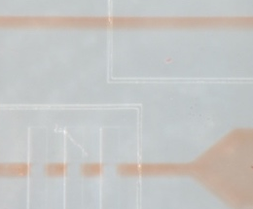
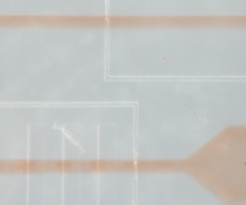
The oxygen sensor incorporated into microfluidic devices is quenched in the presence of oxygen and the response can be described using the Stern-Volmer equation:

where I_{o} is the phosphorescence intensity in the absence of oxygen, I is the quenched intensity at a higher oxygen level, K_{sv} is Stern-Volmer constant, and P_{O2} is the partial pressure of oxygen. The K_{sv} value was found to be 535.08 ± 60.57 atm⁻¹ and is in close agreement with the calibration made off-chip.

Oxygen Monitor and Control
Control line designed into the chip allows the control of dissolved oxygen tension in the adjacent fluid channel. Utilizing the high gas permeability of PDMS, oxygen in the fluid channel equilibrates with the gas content in the control line. Any changes in the overall oxygen level can be observed with the incorporated oxygen sensor in real time. When air was pumped through the control lines, the oxygen level in the fluid channel remained constant at P_{O2} = 0.21 atm (data not shown). In comparison, the oxygen tension in the fluid channel equilibrated to a lower level, P_{O2} = 0.68-

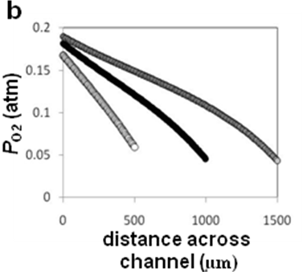
Figure 3. Oxygen control and monitor on-chip. When N₂ was pumped into the control lines, the overall oxygen tension across the fluidic channel decreased and was measured by the oxygen sensor (solid circles). Finite element simulation showed excellent agreement with the experimental results (white circles). Data shows mean and standard deviation across the channel.
0.43 atm, when N₂ was pumped through the control line (Figure 3). As previous studies have shown, the high permeability of PDMS makes it difficult to reduce the overall oxygen tension in the device below 4%.[6] Simulation using the geometry of the current device confirmed the measured oxygen level (Figure 3).

Simulation and New Device Geometry
While mean tissue oxygen level is 3-5%, however, cancer cells, adult stem cells, and embryonic stem cells are found in niche oxygen environment that are much lower. Therefore, to study these cell lines, hypoxic environment need to be generated within the device. Based on the mathematical simulation, different device geometries were generated in order to produce these oxygen levels.
By increasing the width of the control line the oxygen tension in the fluid channel was reduced below 4% (Figure 4a) when N₂ was present. Furthermore, increasing the distance between the control line and the fluid channel produced more uniform oxygen environments and lowered the overall oxygen level across the channel (Figure 4a). Oxygen gradient was simulated in different fluidic channel geometries (Figure 4b). Such result can assist in the design of devices to produce an optimal oxygen profile for cell studies.

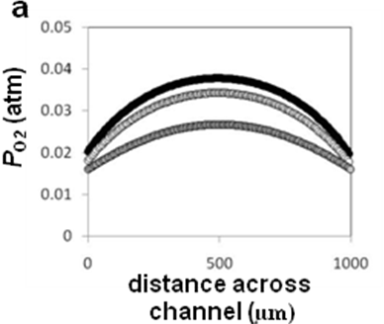
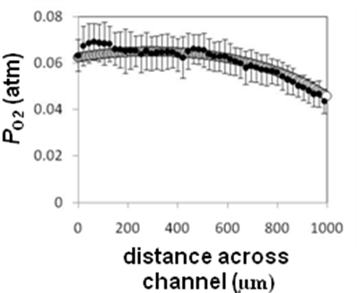
Figure 4. Design of different device geometries based on model simulation. By increasing the width of the control lines, the simulation shows that the overall oxygen level across the channel can be reduced significantly when N₂ is present in the control lines (a). In addition, the convex oxygen profile across the channel was reduced when the distance between the control lines and the fluidic channel is increased (black circle 20 µm, white circle 60 µm, grey circle 200 µm). Oxygen gradient was simulated in different fluidic channel geometries (500 µm, 1000 µm, 1500 µm). Control line on the left was set at air, while the N₂ was set on the opposite line.

CONCLUSIONS
Controlling oxygen is critical to creating more biomimetic environment for cell based assays. Gas permeable PDMS based microfluidic device allows control and generation of oxygen environment that is not easily accomplished in conventional cell culture format. In the current study, an oxygen sensor was incorporated into a PDMS microfluidic device. The oxygen sensor allows monitoring of oxygen environment in real time. The measured oxygen level showed excellent agreement with finite element simulation. While hypoxic environment has been difficult to generate on chip, we utilized the simulation to produce different device geometries that are capable of creating low oxygen environment.
The current work provides the initial work for the development of an accurate oxygen-controllable microfluidic cell culture device capable of real time oxygen measurments.

REFERENCES
- M. Csete, 2005 "Oxygen in the cultivation of stem cells," in Stem Cell Biology: Development and Plasticity, vol. 1049, Annals of the New York Academy of Sciences, 2005, pp. 1-8.
- K. R. Atkuri, L. A. Herzenberg, A. K. Niemi, et al., 2007 "Importance of culturing primary lymphocytes at physiological oxygen levels," Proc. Natl. Acad. Sci. U. S. A., 104, 4547-4552
- B. Sahaf, K. Atkuri, K. Heydari, et al., 2008 "Culturing of human peripheral blood cells reveals unsuspected lymphocyte responses relevant to HIV disease," Proc. Natl. Acad. Sci. U. S. A., 105, 5111-5116
- M. Polinkovsky, E. Gutierrez, A. Levchenko, et al., 2009 "Fine temporal control of the medium gas content and acidity and on-chip generation of series of oxygen concentrations for cell cultures," Lab Chip, 9, 1073-1084
- P. C. Thomas, M. Halter, A. Tona, et al., 2009 "A Noninvasive Thin Film Sensor for Monitoring Oxygen Tension during in Vitro Cell Culture," Anal. Chem., 81, 9239-9246
- G. Mehta, J. Lee, W. Cha, et al., 2009 "Hard Top Soft Bottom Microfluidic Devices for Cell Culture and Chemical Analysis," Anal. Chem., 81, 3714-3722

Author: Samuel P. Forry
Institute: National Institute of Standard and Technology
Street: 100 Bureau Dr
City: Gaithersburg, MD
Country: U.S.A
Email: sam.forry@nist.gov

